KENYA CERTIFICATE OF SECONDARY EDUCATION

1. Definition of geography
- Study of earth and home of man
- Destruction of distribution and interrelationships between various phenomena in relation to man. (2mks)
2. Environment
-External conditions that surround a plant or an animal. (2mks)
3. Branches of Geography (2mks)
- Physical geography
- Human geography
4. Other heavenly bodies
- Asteroids
-Comments
Meteors and meteorites (2mks)
5. Longitudes are imaginary lines that run across the globe from north pole to south pole. (2mks)
6a) E – Gutenberg discontinuity
F Mantle
G Core (3mks)
7b) Silicon and Magnesium (2mks)

b) 21st March
23rd September (2mks)
Nebula theory
Passing star theory
Creation theory (2mks)
9. Thermo hygrometer/Psychrometer (1mk)
ii) F Muslim (1mk)
ii) Water (1mk)
10. E – stratosphere
F stropause
G thermosphere/ Imosphere (3mks)
11. Areas studied in human geography
- Forestry
- Wildlife/Tourism
- Mining
- Population (3mks)
b) To explain the origin of the earth solar system and internal structure of the earth
- It helps learners to have skills of observing reading analysis and interpretation of maps charts diagrams and statistical data.
- Geography helps learners to understand and appreciate different environmental influence or different societies.
- Helps learners to manage time wisely especially study of field work.
- it creates awareness in management and conservation of the environment
-Helps learners in career development
- Learners are able to develop skills and knowledge for national development 4x2 = 12mks)
11. Agriculture
Chemistry
- Meteorology and climatology
- Civil engineering
- History
- Demography
12a) Effects of rotation
-It causes day and night
-It causes difference of 1 hour between meridians 150 part
-It caused deflections of winds and ocean currents
- It causes variations in the speed of our masses
- It causes rising and falling of ocean currents.
- Circumnavigation theories
- Disappearance and appearance
-Shadow of the earth across spherical on the moon during moons eclipse
-Standing on a tower the earth horizon appears circular
-Earth being a heavenly body must be circular like other heavenly bodies
-Satellites photographs show the earth is spherical 3x 2 = 6mks)
13a) Weather define
Weather is average atmospheric conditions of a place for a short period of time usually 24 hours (2mks)

b) Prepetition
- Humidity
- Air pressure
-Wind
Sunshine
c) Factors for citing weather station
- Open space allow free flow of air
- Not near objects to cause obstruction
- Relatively flat to avoid flooding
-Secure. (3mks)
d) Gases that make the atmosphere
- Nitrogen
- Oxygen
Water vapor
- Argon
- Carbon dioxide
13. Importance of weather forecast
- It helps to determine farmers calendar
- Helps people to choose suitable clothing
- Helps pilots and captains in cur and water frames
- Helps to plan oporting activites
-It helps fishermen to determine their fishing habits (2mks)

14 a)
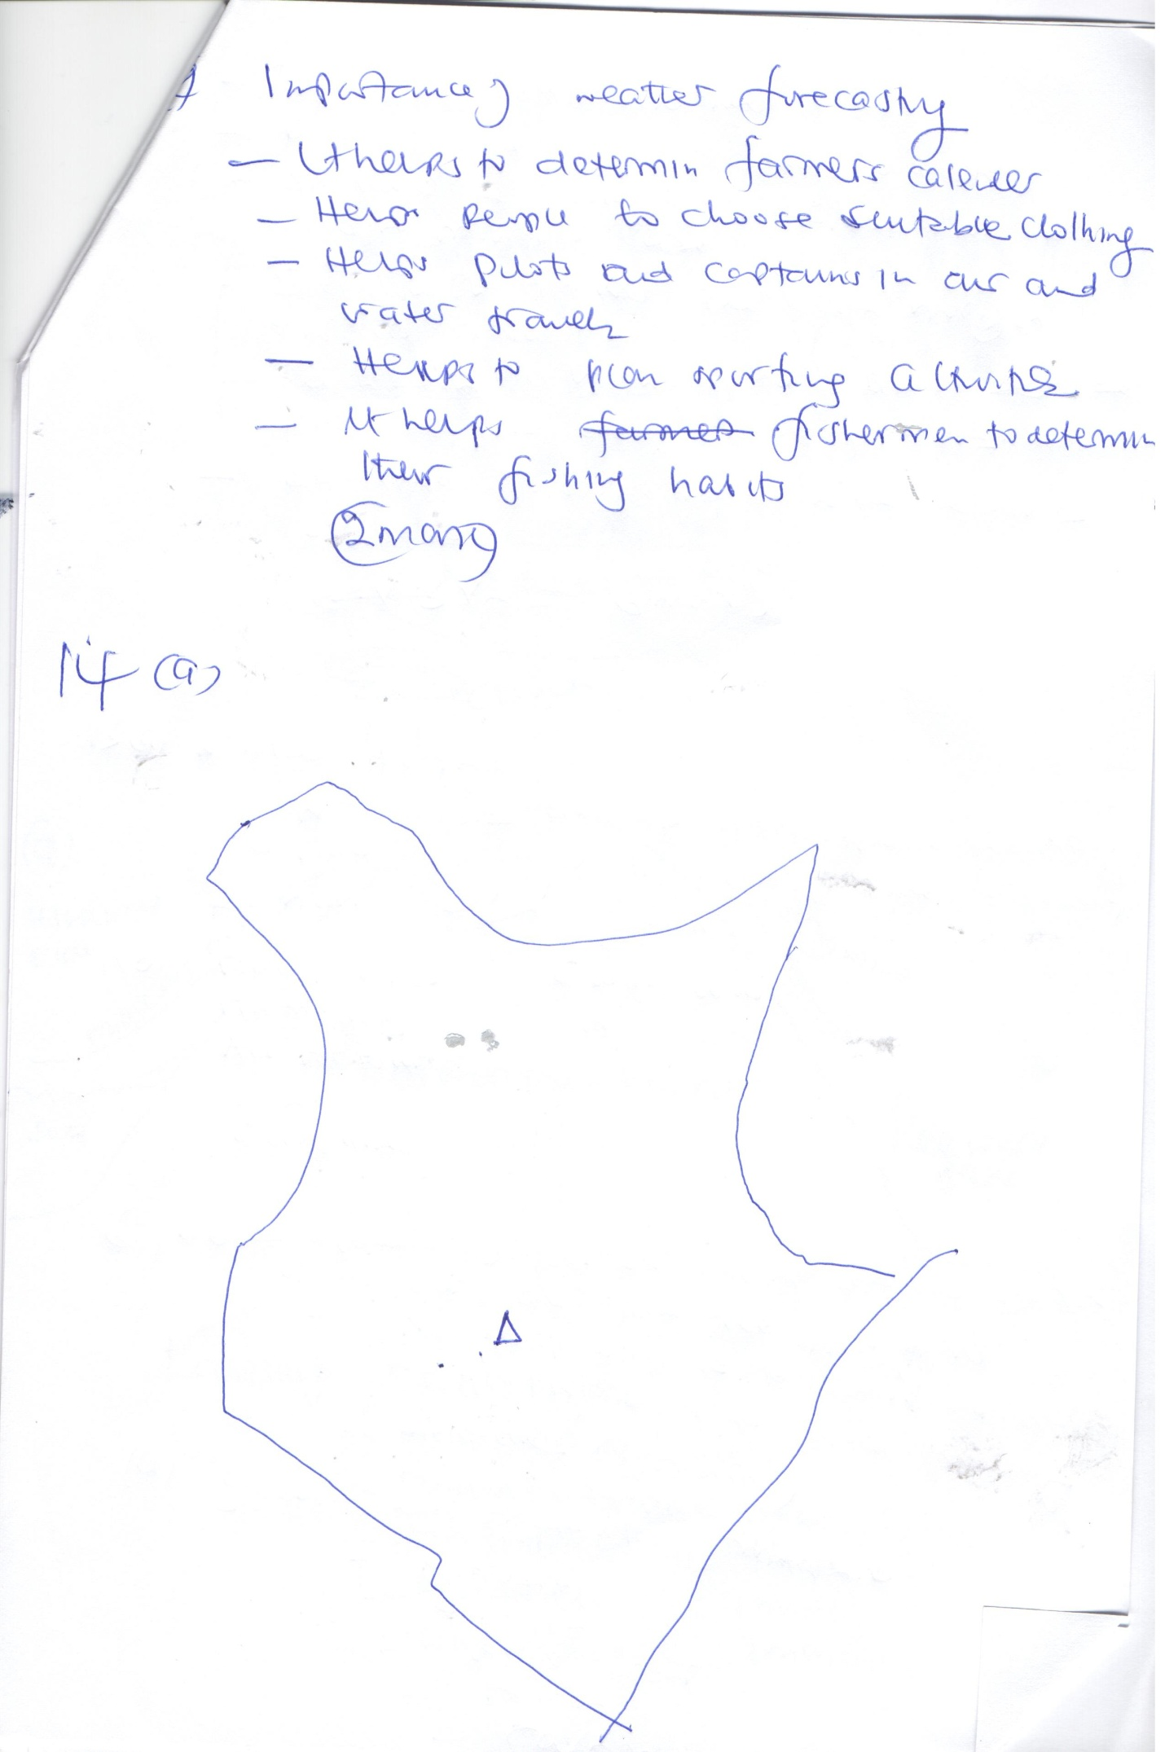

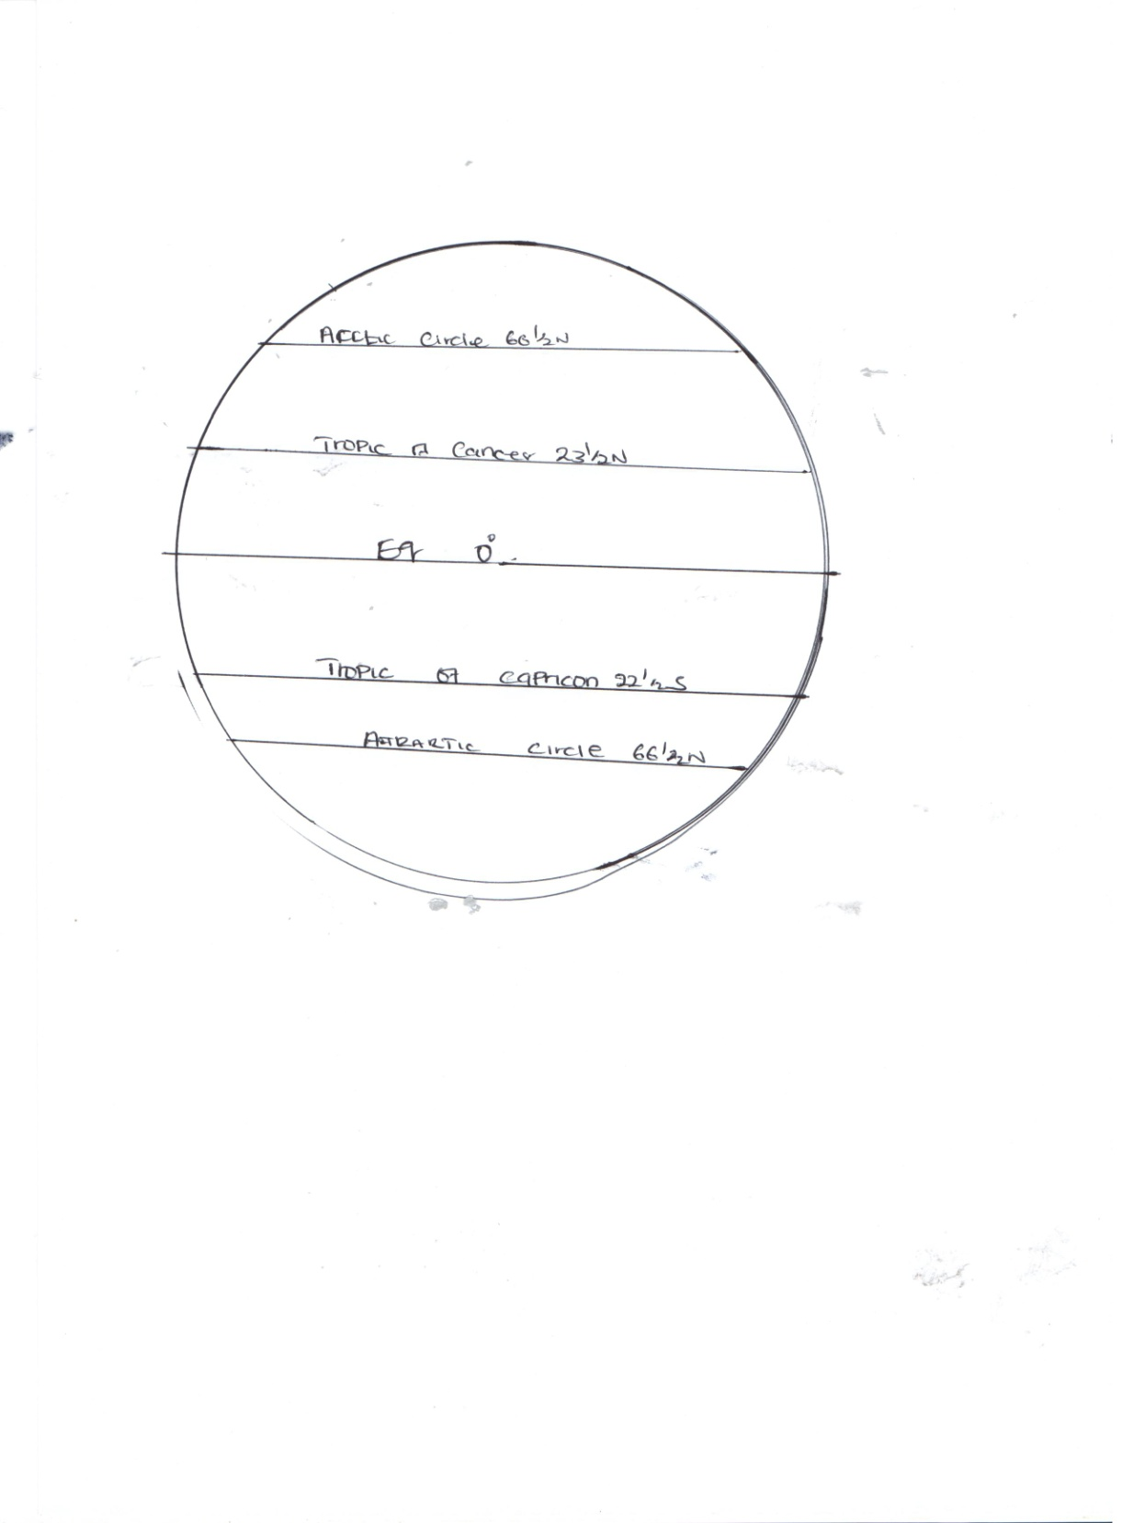

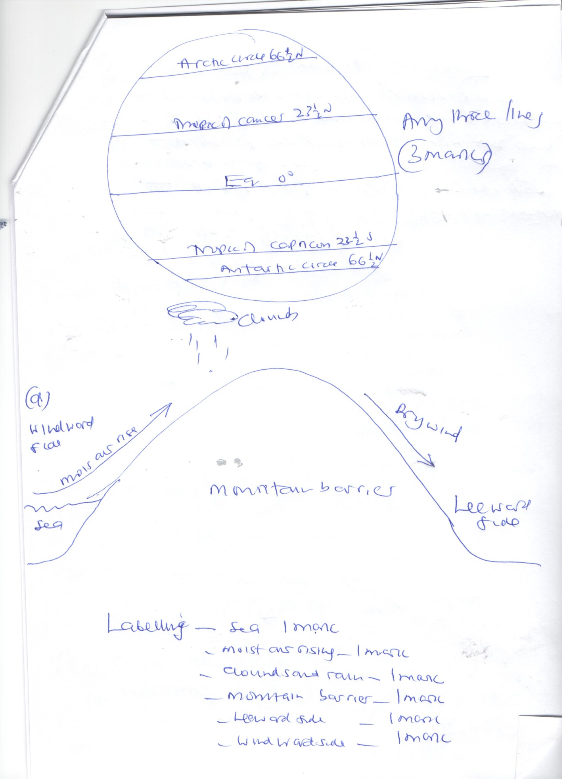
Labeling - Sea 1mk
Moist arising (1mk)
Clouds and rain (1mk)
Mountain barrier (1mk)
Leeward side (1mk)
Windward side (1mk)
a) Factors that influence racharion
- amount of insulation
Transparency of atmosphere
Position of the earth on its orbit which purchces different seasons
-Inclination an angle of surface on which the rays fall
-The area or nature of the surface on which the rays fall. (3mks)
b) Instrument kept in the stevenson screen
- Maximum thermometer
-Minimum thermometer
-Six thermometer
-Hygrometer (3mks)
d) i) Duranal range 20⁰c – 15⁰c = 5⁰c (2mks)

ii) Mean daily temperature 20+5 = 25 = 12.5⁰C
2 2

E) Anenometer - Wind speed ( 1mk)
Barometer - Air pressure (1mk)

