22 Heredity
Self-assessment questions 22.01

NOTE: Alleles are alternative forms of a gene which occupies a particular position in a chromosome. Alleles affect the same characteristic (e.g. blood group) but not necessarily in
the same way. l^{A}, I^{B} and i are alleles of a gene which controls the ABO blood groups.

1 A plant with red flowers is crossed with a white-flowered plant of the same species. All the
seeds, when grown, produce plants with red flowers. Assuming that the flower colour is
controlled by a single pair of alleles, which allele is dominant and which is recessive?

2 If a dominant allele for tall plants is represented by the letter D, what letter should
represent the corresponding recessive allele?

3 In cats, the allele (S) for short fur is dominant to the allele (s) for long fur.
(a) What is the genotype of a true-breeding, long-furred cat?
(b) What is the phenotype of a cat with the genotype Ss?
(c) In an Ss genotype, which allele is expressed in the phenotype?
(d) Which of the fo1lowing genotypes is (i) heterozygous (ii) homozygous dominant?
SS, Ss, ss

4 In rabbits, assume that the dominant allele (B) produces black fur. The allele (b) for white fur is recessive to B.
(a) What colour fur will each of the following rabbits have?

Rabbit 1 Rabbit 2 Rabbit 3 Rabbit 4
genotype BB Bb bB bb

(b) Which of them will breed true?
(c) Which rabbits are homozygous for coat colour?
(d) If rabbits 1 and 4 were mated together and had 12 babies, how many of these would you
expect to be black?
(e) If rabbits 2 and 3 are interbred and produce several litters, totalling 48 babies, how
many white babies would be predicted by the laws of genetics?
(f) If rabbits 3 and 4 are mated together on several occasions and have 50 babies altogether,
how many of their babies would you 'expect' to be black?

NOTE: In this context, 'expect' implies the perfect Mendelian ratio. In practice you would
not expect to achieve this ratio with as few as 50 offspring.

5 The alleles controlling the ABO blood groups are given the letters I^{A} (group A), I^{B} (group B) and i (group O). On the drawings below, write in the alleles on the chromosomes for each of the blood groups. (The first one has been done for you)
group O
group AB
group B
group A
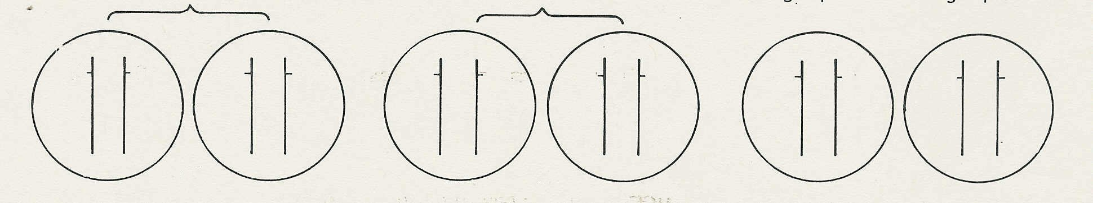

I^{A}
I^{A}

or
or

Heredity (continued)
Self-assessment questions 22.02

6 In shorthorn cattle, the coat colours red or white are controlled by a single pair of alleles. A
calf which receives the allele for red coat from its mother and the allele for white coat from its father is called a 'roan'. It has an equal number of red and white hairs in its coat.
(a) Is this an example of codominance or of incomplete dominance?
(b) Give a reason for your answer.
(c) Give one example in each case of (i) codominance, (ii) incomplete dominance, in
humans.

7 Give three examples of human disorders which are caused by the action of a single pair of
alleles. In each case say whether the harmful allele is dominant or recessive to the
non-harmful allele.

8 In humans, maleness or femaleness is determined by a pair of sex chromosomes called
X and Y.
(a) What is the genotype for males?
(b) What is the genotype for females?

9 (a) In humans, is it the sperm or the ovum which determines the sex of the offspring?
(b) Give a reason for your answer.

10 In fruit flies, the allele (n) for ebony (black)
body is recessive to the allele (N) for normal
(grey) body.
(a) Complete the Punnett square, for a
cross between normal (grey-bodied)
flies which are heterozygous for this
allele (i.e. Nn genotypes).
(b) State the expected proportion of normal
and ebony-bodied flies in a large sample of
the offspring.
(c) State the proportion of the normal
phenotypes which would be true breeding.

11 When a particular gene is said to be ‘sex-linked’, on which chromosome is that gene usually present?

Self-assessment questions 22.03

Heredity (continued)

12 The genetic disorder phenylketonuria (PKU) is caused by a recessive allele (n). The family
tree below shows the incidence of the disease over three generations.
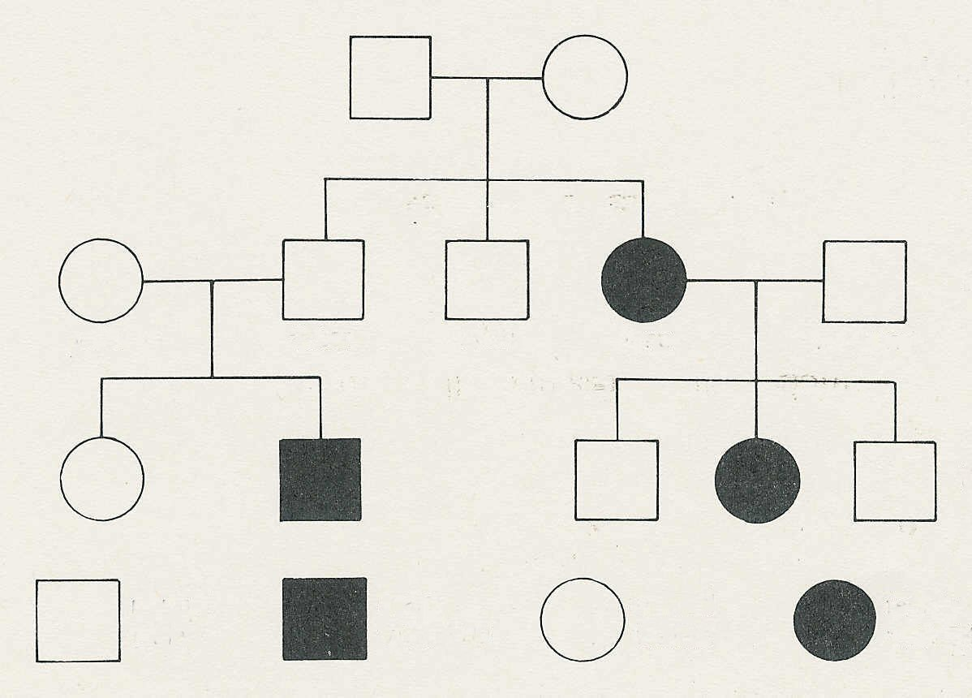
grandparents

parents

husband
Jane
Alan
Peter
wife

children

female with PKU
male with PKU
normal female
normal male
KEY

(a) What can you deduce about the genotypes of the grandparents?
(b) Explain your reasoning.
(c) What is the genotype of Jane's husband?
(d) Explain your reasoning.
(e) What are the chances that Peter is the carrier of the PKU allele that resulted in his
having an affected son?
(f) If Jane had been normal, what are the possible genotypes of the grandparents?
(g) Is it possible that the allele for PKU is sex-linked?

13 One form of colour-blindness is a sex-linked inherited condition controlled by a recessive
allele. Use the symbols X and Y for the sex chromosomes and N and n for the alleles for
normal or defective colour vision to show the genotypes of
(a) a normal male (d) a colour-blind female
(b) a colour-blind male (e) a normal (carrier) female.
(c) a normal (non-carrier) female

14 Use the genotypes you have written for your answer to question 13 to show the chances of
(a) a son being colour blind, (b) a daughter being a carrier, resulting from a marriage
between a normal man and a carrier woman.

