RECEPTION, RESPONSE AND CO-ORDINATION
PAST KCSE QUESTIONS ON THE TOPIC
- State one structural and one functional differences between motor and sensory neurons
Structural differences
Functional differences ( 2 marks)
- The table below shows two mammalian hormones. For each hormone, state the site of production and its function in the body.

Hormone | Site of production | Function
Oestrogen
Aldosterone

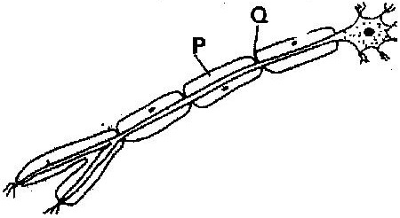

(i) With an arrow, indicate on the diagram the direction of the impulse through the neurone ( 1 mark)
(ii) State the functions of parts labeled P and Q ( 2 marks)
- (a) How are structures of the human eye adapted to their functions ( 14 marks)
(b) State three defects of the eye and how each can be corrected ( 6 marks)
- State the changes that occur in a nerve axon to produce an action potential
( 3 marks)
- In an accident a victim suffered brain injury. Consequently he had loss of memory. Which part of the brain was damaged? ( 1 mark)
- The diagram below shows surface view of a human brain
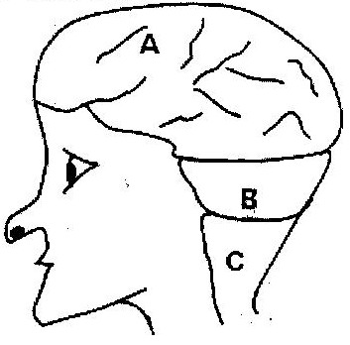

(a) Name the parts labeled B and C ( 2 marks)
(b) State three functions of the part labeled A ( 3 marks)
(c) State what would happen if the part labeled B was damaged. ( 1 mark)
- What is the function of the following cells in the retina of the human eye?
(2 marks)
(a) Cones
(b) Rods
- (a) State the functions of the following parts of the mammalian ear
(i) Tympanic membrane ( 3 marks)
(ii) Eustachian tube ( 1 mark)
(iii) Ear ossicles ( 2 marks)
(b) Describe how semi- circular canals perform their functions ( 2 marks)
- State the importance of tactic response among some members of Kingdom Protista? ( 1 mark)
(a) What name is given to response to contact with surface exhibited by
tendrils and climbing stems in plants? ( 1 mark)
(b) State three biological importances of tropisms to plants (3 marks)
- The diagram below represents a reflex arc in human
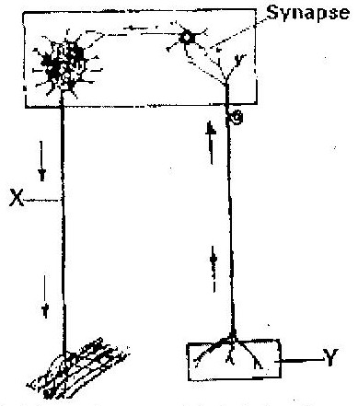

(a) Name the parts labeled X and Y ( 2 marks)
X __________________________
Y __________________________
(b) Name the substance that is responsible for the transmission of an impulse across
the synapse ( 1 mark)
- (a) State the function of the ciliary muscles in the human eye. (1 mark)
(b) State two functional differences between the rods and cones in the human eye ( 2 marks)
- State the function of each of the following parts of human ear ( 4 marks)
  - Ear ossicles
  - Cochlea
  - Semi- circular canals
  - Eustachian tube
- (a) Where in the human body are relay neurons found? ( 1 mark)
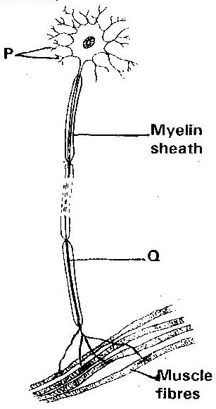
(b) The diagram below represents a neurone

(i) Name the neurone ( 1 mark)
(ii) Name the parts labeled P and Q ( 2 marks)
- (a) Name the hormone that is responsible for apical dominance ( 1 mark)
(b) What is thigmotropism? ( 1 mark)
- Describe the structure and functions of the various parts of the human ear
( 20 marks)
- Nocturnal animals such as the owl are capable of seeing fairly well at night
What two retinal adaptations have made this possible? ( 2 marks)
- State two functions of the human ear? ( 2 marks)
- State four differences between co- ordination of the human eye’s internal response to light and that of tropic movement of the flowering plant in response to light. ( 4 marks)

- The figure below shows a stem of a plant growing round a tree trunk
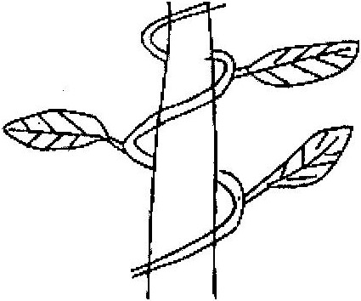

(i) What is the name of the response, which causes the twisted growth?
( 1 mark)
(ii) Explain how the twisting process is accomplished ( 2 marks)
(iii) Identify the state of leaves if the plant is autotrophic ( 2 marks)
- Euglena is positively phototactic. Of what biological significance is this characteristics? ( 1 mark)
- State the function of acetylcholine ( 2 marks)
- Where in the human body is the relay neurone located? ( 1 mark)
- State three effects of nicotine to human health ( 3 marks)
- state the part of the eye involved in
(i) Colour vision
(ii) Maintaining shape of the eyeball
(iii) Change in diameter of the lens

