8 Reproduction in flowering plants - answers
Self-assessment questions 8.04

1 The most accurate statement is (b). A flower's principal role is seed production.
Statements (a), (c) and (d) are true of many plants but these are functions which may help bring about seed production.

2 A-stigma, B-style, C-sepal, D-petal, E-anther, F-filament, G-stamen, H-ovary,
I-ovule, J-receptacle.

3 (a) The male gamete in a flowering plant is the pollen grain (strictly, the gamete is the male
nucleus in the pollen grain).
(b) The female gamete is the egg cell in the ovule.

4 Pollination is the transfer of pollen from the anthers (or stamens) to the stigma in a flower. In cross-pollination, the pollen from a flower on one plant is transferred to the stigma of another plant of the same species.

5 In a flowering plant, fertilisation occurs when the nucleus of the pollen grain fuses with the nucleus of the egg cell. After fertilisation, the ovule becomes the seed and the ovary becomes the fruit.

6 Statement (a) is correct, though normally fertilisation will follow pollination if the pollen and stigma are compatible.

7 Characteristics which are regarded as adaptations to pollination by bees are: (a) white or coloured petals, (c) spiky or sticky pollen grains, (d) anthers and stigma inside the flower,
(g) production of nectar, (i) production of scent. Some of these features could equally well be adaptations to pollination by butterflies.

8 Transfer of pollen between flowers on the same plant is self-pollination; so is transfer of pollen
within the same flower.
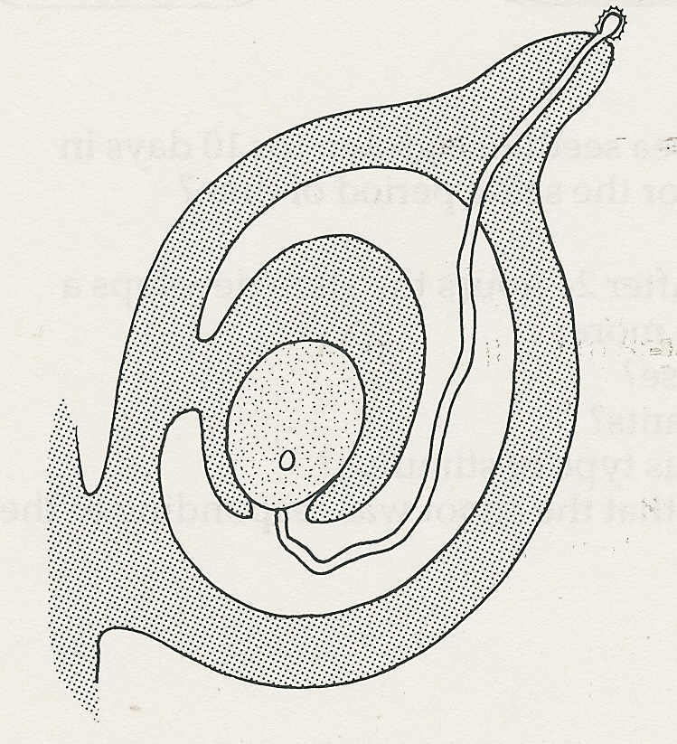

9 The drawing should show a pollen tube growing from
the pollen grain to reach the micropyle of the ovule.

10 A (willow herb) and D (Asclepias) have seeds dispersed
by the wind. The fine fluffy hairs act as parachutes. E (Agrimone)
and F (herb bennet) are dispersed by animals.. The fruits have
hooks which catch in the animal's fur. B (lime) and C (campion)
are also wind dispersed. The lime has a bract which functions as
a wing, slowing down the fruit's rate of fall. The campion is an
example of the censer mechanism in which seeds are shaken out
of the fruit capsule when the wind sways the long stalk.

Reproduction in flowering plants - answers (continued)
Self-assessment questions 8.05

11
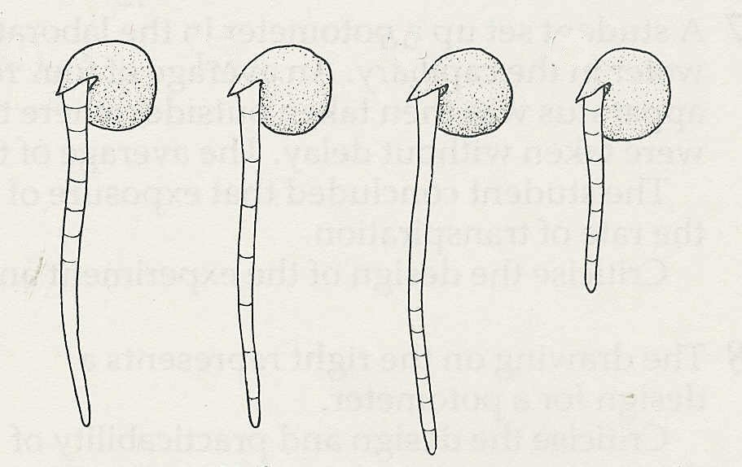
(d)
(a)
(c)
(b)

Uniform growth
Growth at the tip
No growth
Growth at the top

12 (a) Most seeds need water, oxygen and a certain minimum temperature (warmth) to start
germinating.
(b) To grow to maturity the seedlings will also need mineral salts from the soil and sunlight for
photosynthesis.

13 You would need as large a sample of seeds as was convenient for counting, say 30. The seeds would be provided with water and a suitable temperature. The seeds, in a suitable container, would be placed in a light-proof box or cupboard for a period long enough to allow germination.
The box or cupboard would not be opened during this period.
The same number of seeds, from the same batch (same packet), would be given identical
conditions of moisture and temperature but placed in daylight for the same period of time.
At the end of this period the numbers of seeds which germinated in each case would be
counted and compared.

14 Figure 1: A-plumule, will form the plant's shoot;
B-radicle, will form the plant's first root; C- cotyledon, stores food, mainly starch and protein.
Figure 2: D-plumule, E-testa, F-lateral root, G-radicle (root), H-root hairs.

15 In the early stages of germination, the seedling derives the materials for its growth and energy from food stored in the cotyledons (for dicotyledonous plants).

16 (a) To compare the extent of germination at each temperature you would need to measure the
height of the shoots and the lengths of the roots of the seedlings from each pot. The
measurements for each temperature would then be averaged and compared. You could
also count the number of leaves and lateral roots, if any.
(b) Because the seeds in the refrigerator and incubator would be in darkness, it was necessary
to keep the ones at room temperature in darkness as well; otherwise, any difference in
germination might be attributed to a difference in light rather than to a difference in
temperature.

Reproduction in flowering plants - answers (continued)
Self-assessment questions 8.06

17 Starch is insoluble and has to be converted, by enzymes, to soluble sugars before it can be transported and used in the seedling.

18(a) The liquid in flask A is a mixture of pyrogallic acid and sodium hydroxide in water
(a solution of sodium pyrogallate). This solution absorbs oxygen (and carbon dioxide) from
the air in the flask.
(b) The liquid in B is sodium hydroxide solution. It absorbs carbon dioxide from the air in the
flask.
(Some experiments may use water rather than sodium hydroxide solution, but this is less
satisfactory.)
(c) Flask B represents the control. It shows that, if oxygen is present, cress seeds can germinate
even in these artificial conditions and also in the absence of carbon dioxide (if sodium
hydroxide is used).
(d) (i) If oxygen is necessary for germination the cress seeds should germinate in B but
not in A.
(ii) If oxygen is unnecessary, the cress seeds should germinate in both flasks.

19 The seedlings grown in darkness will have long, thin, white stems (long internodes) and small, unopened leaves.
The seedlings grown in the light will have shorter, thicker greenish stems (short internodes). The leaves will have opened up and will be green, and larger than those of the seedlings in darkness.

