REPRODUCTION IN PLANTS AND ANIMALS
PAST KCSE QUESTIONS ON THE TOPIC
- At what stage of mitosis do chromosomes replicate to form daughter chromatid?
( 1 mark)
- Fill in the blank spaces in the statement below
After fertilization of an ovule _________ develops into a testa and _________ develops into a testa and _____________ develops into endosperm. ( 2 marks)
- State the difference between the composition of maternal blood entering the placenta and material blood leaving the placenta ( 3 marks)
- After four months of pregnancy the ovaries of a woman can be removed without terminating pregnancy. However during the first four months of pregnancy the ovaries must remain intact if pregnancy is to be maintained. Explain these observations ( 3 marks)
- Name two mechanisms that prevent self pollination in flowers that have both male and female parts ( 2 marks)
- State three characteristics that ensure cross pollination takes place in flowering plants ( 3 marks)
- Give a reason why it is necessary for frogs to lay many eggs ( 1 mark)
- A flower was found to have the following characteristics
  - Inconspicuous petals
  - Long feathery stigma
  - Small light pollen grains
- What is the likely agent of pollination of the flower? ( 1 mark)
- What is the significance of the long feathery stigma in the flower ( 1 mark)
- State two ways by which the human Immuno Deficiency virus (HIV) is transmitted other than sexual intercourse? ( 2 marks)
- Explain why sexual reproduction is important in organisms ( 3 marks)
- State two disadvantages of self- pollination ( 2 marks)

- The chart below shows the number of chromosomes before and after cell division and fertilization in a mammal.

2n 2n
z z
n n n n

2n

n n

(a) What type of cell division takes place at Z? ( 1 mark)
(b) Where in the body of a female does process Z occur? ( 1 mark)
(c) On the chart indicate the position of parent and gametes ( 2 marks)
- (a) What is meant by the terms
(i) Epigynous flower ( 1 mark)
(ii) Staminate flower (1 mark)
(b) How are the male parts of wind- pollinated flowers adapted to their function?
( 4 marks)
- Name the part of a flower that developed into:
(a) Seed ( 1 mark)
(b) Fruit ( 1 mark)
- (a) State two processes which occur during anaphase of mitosis ( 2 marks)
(b) What is the significance of meiosis? (2 marks)
- (a) Explain how the following prevents self- pollination:
(i) Protoandry ( 1 mark)
(ii) Self- sterility ( 1 mark)
(b) Give three advantages of cross- pollination ( 3 marks)
- The diagram below represents a human foetus in a uterus
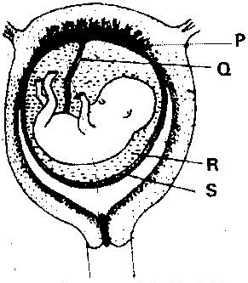

(a) Name the part labeled S ( 1 mark)
(b) (i) Name the types of blood vessels found in the structure labeled Q
( 2 marks)
(ii) State the difference in composition of blood in the vessels named (b) (i) above ( 2 marks)
- Name two features that enable the structure labeled P carry out its function
( 2 mark)
- State the role of the part labeled R ( 1 mark)
- The diagram below represents a stage during cell division
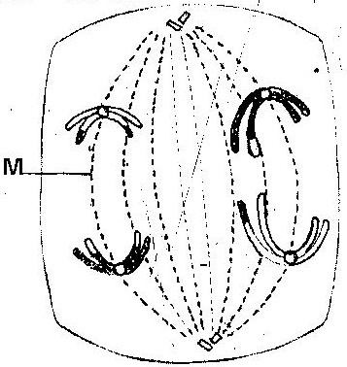

(a) (i) Identify the stage of cell division ( 1 mark)
(ii) Give three reasons for your answer (a) (i) above ( 2 marks)
(b) Name the structure labeled M ( 1 mark)
- State two disadvantages of sexual reproduction in animals ( 2 marks)

- What is meant by the following terms?
(i) Protandry ( 1 mark)
(ii) Self- sterility ( 1 mark)
- The diagram below shows a stage during fertilization in plant

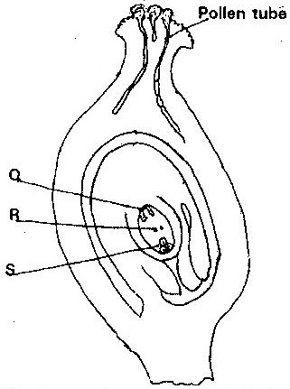

(i) Name the parts labeled Q, R, and S ( 3 marks)
(ii) State two functions of the pollen tube ( 2 marks)
- On the diagram, label the micropyle ( 1 mark)

- (a) Describe how insect pollinated flowers are adopted to pollination
( 6 marks)
(b) Describe the role of each of the following hormones in the human menstrual
cycle.
(i) Oestrogen
(ii) Progesterone
(iii) Luteinizing hormone ( 3 marks)
- Describe the role of hormones in the human menstrual cycle (20 marks)
- What part does the placenta play in the
(i) Nutrition of the embryo
(ii) Protection of the embryo ( 4 marks)

