ECOLOGY
PAST KCSE QUESTIONS ON THE TOPIC
- State how excessive use of pesticides may affect soil fertility
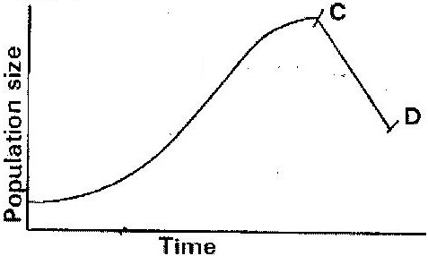
- The graph below represents a population growth of a certain herbivore in a grassland ecosystem over a period of time.

Suggest three factors that could have caused the population change between C and D
( 3 marks)
- A biologist carried out a study to investigate the growth of a certain species of herbivorous bony fish and the factors influencing plant and animal life in four lakes A, B, C and D. The lakes were located in the same geographical area.
Two of the lakes A and B were found to contain hard water due to presence of high content of calcium slats. The mean body length of 2 year old fish, amount of plant life and invertebrates biomass in each lake were determines. The data was as shown in

Lakes | Mean body length (cm) | Type of water | Amount of plant life | Invertebrate biomass (g/cm³)
 |  |  |  | Insects | Snails | Crabs | Worms
A  B  C  D | 31.2  28.6  18.4  16.3 | Hard  Hard  Soft  Soft | 1050  950  1.2  0.5 | 11  72  97  99 | 300  100  0  0 | 10  9  2  1 | 180  90  20  10

  - Describe the procedure that may have been used to determine the mean body length of the fish ( 6 marks)
  - What are the likely reasons for the difference in the mean body length of the fish living in lakes A and D? ( 4 marks)
  - Suggest one reason for the absence of snails in lakes C and D?
( 1 mark)
  - (i) Name any six abiotic (physical) factors that are likely to influence
the plant and animal life in lake A. ( 3 marks)
(ii) Explain how each of the factors named in (i) may influence the plant and animals life in Lake A. ( 6 marks)

- During an ecological study of a lake a group of students recorded the following observations.
  - Planktonic crustaceans feed on planktonic algae
  - Small fish feed on planktonic crustaceans worms and insect larvae
  - Worms feed on insect larvae
  - Bird species feeds on small fish planktonic crustaceans and worms
  - Insect larvae feed on small fish
(a) From this record of observations construct a feed web (5 marks)

(b) From the food web you have constructed in (a) above isolate and write down a food chain that ends with
(i) Bird species as a secondary consumer (1 mark)
(ii) Large fish as tertiary consumer (1 mark)

(c) The biomass of the producers in the lake was found to be greater than that of primary consumers. Give an explanation for this observation? (1 mark)

(d) Using either the observations recorded by the students or the food web you have constructed name (1 mark)

(i) Two organisms that compete for food in the lake. (2 marks)
(ii) The source of food the organisms in d (i) above compete for ( 1 mark)

(e) (i) State three ways by which many may interfere with this lake
ecosystem ( 3 marks)
- Explain how each of the ways you have states may affect life in the
lake? ( 6 marks)
- In an investigation, a student collected two plants A and B. Plant A had hairy leaves and epidermis. Leaves of plant B
(i) Plant A ( 1 mark)
(ii) Plant B ( 1 mark)
- An investigation was carried out between 1964 and 1973 to study the changes of fish population in a certain small lake. Four species of fish A, B, C and D were found to live in this lake. In 1965 a factory was built near the lake and was found to discharge hot water into the lake raising the average temperature from 25⁰C to 30⁰C. In 1967 sewage and industrial waste from a nearby town was diverted into the lake was stopped. The fish population during the period of investigation is shown in the table below.
Fish species | Fish populations during the period
 | 1964 | 1966 | 1969 | 1970 | 1971 | 1972 | 1973
A  B  C  D | 6102  208  36  4521 | 223  30  100  272 | 26  11  0  23 | 106  22  0  27 | 660  63  0  79 | 4071  311  0  400 | 7512  405  0  617
- (i) In which year were the fish populations lowest?
(ii) State the factors that might have caused the lowest fish populations during the year you have stated in (a) (i) above ( 3 marks)
(iii) Explain how each factor you have stated in (a) (ii) above could have brought about the changes in fish populations (11 marks)

- (i) What is the difference in the rate of population recovery of species A and
D? (1 mark)
(ii) Suggest two biological factors that could have led to this difference
(2 marks)
- (i) State a method that might have been used to estimate the fish population
in the lake ( 1 mark)
(ii) State one disadvantage of the method you have stated in (c) (i) above
( 1 mark)
- Industrial wastes may contain metallic pollutants. State how such pollutants may indirectly reach and accumulate in the human body if the wastes were dumped into rivers.

- State three measures that can betaken to control infection of man by protozoan parasites ( 3 marks)

- The chart below shows a feeding relationship in a certain ecosystem

Green plants Hawks

- Construct two food chains ending with a tertiary consumer in each case (2 marks)
- Which organisms has the largest variety of predators in the food web? (1 mark)
- Name secondary consumers in the food web ( 2 marks)
- Suggest three ways in which the ecosystem would be affected if there was prolonged drought ( 3 marks)

- To estimate the population size of crabs in a certain lagoon, traps were laid at random. 400 crabs were caught, marked and released back into the lagoon. Four days later, traps were laid again and 374 crabs were caught. Out of the 374 crabs, 80 were found to have been marked.
- Calculate the population size of the crabs in the lagoon using the formula below
N = n x M
M
Where
N= Total population of crabs in the lagoon
n= Total number of crabs in the second catch
M= Number marked crabs during the first catch
M= Number of marked crabs in the second catch. ( 2 marks)

(b) State two assumptions that were made during the investigation ( 2 marks)
- What is the name given to this method of estimating the population size?
( 1 mark)
- The figure below represents a feeding relationship in an ecosystem

Termites

Gazelles Leopards

- Write down the food chains in which the guinea fowls are secondary consumers
( 1 mark)
- What would be the short term effects on the eco- system of lions invaded the area? ( 3 marks)
- Name the organisms through which energy from the sun enters the food web.
( 1 mark)
- The diagram below represents a simplified nitrogen cycle

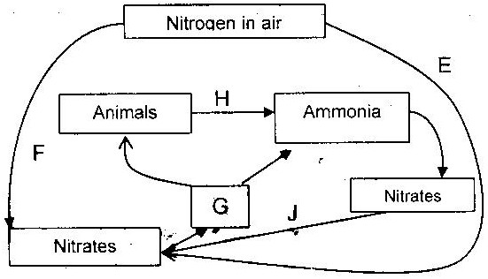

(a) Name the organisms that causes processes E and J ( 2 marks)
(b) Name the processes represented by F and H (2 marks)
- Name the group of organisms represented by c (i)
- (a) Distinguish between a community and a population (2 marks)
(b) Describe how a population of grasshopper in a given area can be estimated
(5 marks)
- Explain how the various activities of man have caused pollution of air ( 20 marks)
- Explain how birds of prey are adapted to obtaining their food ( 2 marks)
- (a) Name the crop infested by phytophthora infestants and the disease it
causes
Crop -
Disease -
(b) State four control measures against the diseases ( 4 marks)
- Explain why the carrying capacity for wild animals is higher than for cattle in a given piece of land ( 2 marks)
- (a) What is meant by
(i) Autecology ( 1 mark)

(ii) Synecology ( 1 mark)
(b) The number and distribution of stomata on three different leaves are shown in
the table below

Leaf | Number of stomata
 | Upper epidermis | Lower Epidermis
A  B  C | 300  150  02 | 0  200  13
Suggest the possible habitat of the plants from which the leaves were obtained.
( 3 marks)
Leaf Habitat
A ____________________
B ____________________
C ____________________
(c) State the modification found in the stomata of leaf C

- After an ecological study of feeding relationships students constructed the food web below

Large birds

Bird J Bird K Bird L Bird M Bird N

Small fish Mussels Snails

Zooplankton
Algae Green plants

- Name the process through which energy from the sun is incorporated into the food web ( 1 mark)
- State the mode of feeding of the birds in the food web (1 mark)
- Name two ecosystem in which the organisms in the food web live( 2 marks)
- From the information in the food web construct a food chain with the large bird as a quarter – nary consumer ( 1 mark)
- What would happen to the organisms in the food web if bird N migrated?
- Not all energy from one trophic level is available to the next level. Explain
( 3 marks)
- (i) Two organisms, which display a role in the ecosystems, are not included
in the food web. Name them. ( 1 mark)
(ii) State the role played by the organisms named g (i) above. (1 mark)
- (i) State three human activities that would affect the ecosystems ( 3 marks)
(ii) How would the activities stated in h (i) above affect the ecosystems?
( 3 marks)
- How is aerenchyma tissue adapted to its functions? ( 2 marks)
- Explain how abiotic factors affect plants ( 20 marks)
- What is the importance of the following in an ecosystem? ( 3 marks)
    - Decomposers
    - Predation

- Chart below represents a simplified nitrogen cycle
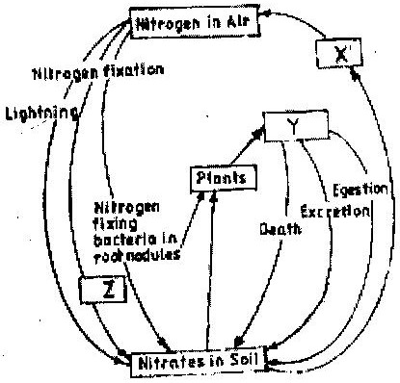

What is represented by X, Y and Z? ( 3 marks)

(a) Distinguish between pyramid of numbers and pyramid of Biomass
( 2 marks)
(b) Give three reasons for loss of energy from one trophic level to another in a food chain. ( 3 marks)
(c) Describe how the belt transect can be used in estimating the population of a shrub in a grassland ( 2 marks)

(a) Distinguish between population and community ( 2 marks)
(b) Name a method that could be used to estimate the population size of the following organisms
(i) Fish in a pond ( 1 mark)
(ii) Black jack in a garden ( 1 mark)

State two ways in which schistosoma species is adapted to parasitic mode of life

Describe causes and methods of controlling water pollution ( 20 marks)
- (a) What is biological control of population growth? ( 2 marks)
(b) Describe one example where biological control has been used successfully
( 2 marks)
(c) Explain why the number of predators in nay ecosystem is less than the number of their prey ( 1 mark)
- Suggest reasons to account for the following observations.
(b) Antelopes are more commonly found in open grassland while giraffe while giraffes are commonly found in wooded areas. ( 2 marks)
(b) In the savannah there is a wider variety of herbivores in wooded areas than in open grassland ( 1 mark)
(c) Removal of predators for an herbivore may in the long run lead to a decrease in its population
- Explain why primary productivity decreases with depth in aquatic environments.
( 2 marks)
- The following is a simplified drawing of nitrogen cycle.

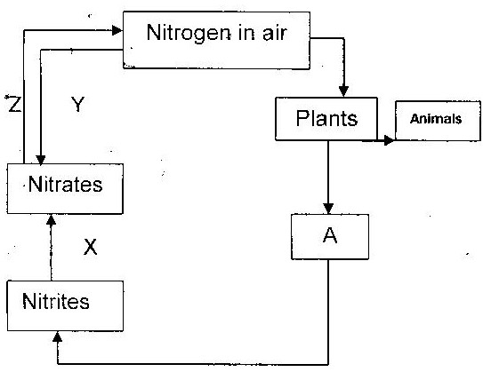

(a) Identify the compound named A ( 1 mark)
(b) Name the processes
X _________________
Y _________________
Z _________________
(c) In what form is nitrogen found in plants and animals?
- An investigation was carried out to study the type of food eaten by birds found in forest and savannah in a certain area. The table below compares the feeding habitats of the birds found in a closed forest area and an open dry savannah of the area.

Diet | Percentage of birds
 | Forest | Savannah
Insects only  Vertebrates  Seeds  Fruits  Other plant materials  Number | 60  10  5  25  5  120 | 50  10  20  10  5  60
- Work out the difference in the number of bird species the feed on:
(i) Fruits found in forest and savannah ( 2 marks)
(ii) Seed found in forest and savannah ( 2 marks)
- State two factors that may cause this difference in (a) above ( 2 marks)
- In another investigation two vertebrate species from the savannah were counted and recorded on monthly basis as shown below.

Year | Month | Species A | Species B
1998  1998  1998  1998  1998  1998  1998  1998  1998  1998  1998  1998 | July  August  September  October  November  December  January  February  March  April  May  June | 96  79  75  87  -  99  129  96  99  79  135  104 | 240  590  900  750  230  80  200  330  300  320  90  450

(i) Which species show more fluctuation in numbers? ( 1 mark)
(ii) Suggest an explanation of this ( 3 marks)
- Suggest two ways by which the savannah environment can be destroyed and how
it can be conserved ( 4 marks)

