CLASSIFICATION II
PAST KCSE QUESTIONS ON THE TOPIC
- State two ways in which some fungi are harmful to man ( 2 marks)
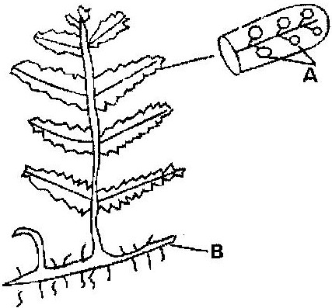
- The diagram below represents a fern

Name
(a) Parts labeled A and B ( 2 marks)
(b) The division which the plant belongs ( 1 mark)
- An organism with an exoskeleton, segmented body, two pairs of legs per segment, a pair of eyes and a pair of eyes and a pair of short antennae belongs to the phylum ( 1 mark)
- When are two organisms considered to belong to the same species? ( 2 marks)
- A student caught an animal which had the following characteristics;
  - Body divided into two parts
  - Simple eyes
  - Eight legs
The animal belongs to the class ( 1 mark)
- Below is a list of organisms, which belong to classes insecta, myriapoda and arachnida. Tick, centipede, praying mantis, tsetse fly. Millipede and spider. Place the organisms in their respective classes in the table below. Give reasons in each case.
Class | Organisms | Reasons
Insecta
Myriapoda
Arachnida

- State two characteristics features of members of division bryophyte
( 2 marks)
- State two ways in which some fungi are beneficial to humans ( 2 marks)
- Other than having many features in common state the other characteristics of species ( 1 mark)
- Beside the abdomen, name the other body part of members of arachnida
( 1 mark)
- Name the phylum whose members possess notochord. ( 1 mark)
- Name the class in the phylum arthropoda which has the largest number of individuals ( 1 mark)
- To which class does an animal with two body parts and four pairs of legs belong? ( 1 mark)
- (a) Name two organisms that cause food spoilage ( 2 marks)
(b) Name two methods of food preservation and for each state the biological principal behind it. ( 2 marks)
- (a) List two characteristics that mammals share with birds ( 2 marks)
(b) State two major characteristics that are unique to mammals ( 2 marks)
- What two characteristics distinguish animals in phylum chordata? ( 2 marks)
- The diagram below shows a plant
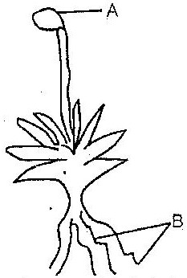

(a) Name the parts labeled A and B (2 marks)
(b) Name the division to which the plant belongs ( 1 mark)
(c) Which is the dominant generation of the plant in the diagram? (1 mark)
(d) State three characteristics of the organisms in the division named (b)
above?
- What three characteristics are used to divide the arthropods into classes?
( 3 marks)
- (a) Write two differences between algae and fungi ( 2 marks)
(b) Give the economic importance of algae ( 1 mark)
- (a) What is alteration of generations? ( 3 marks)
(b) Name two divisions in plant kingdom that shows alternation of generation
( 2 marks)
- (a) A millipede, grasshopper and crayfish all belong to phylum arthropoda.
Mention three major characteristics that they have in common. (3 marks)
(b) The specific name of Irish potato is solanum Tuberrasum
(i) Identify two errors that have been made when writing the name
(ii) What is the species name of Irish potato?
(c) An ecologist came across a plant with the following characteristics, green in colour, non- flowering, compound leaves and sori on the underside of the leaflets. State the probable division of the plant. ( 1 mark)
- An organism with an exoskeleton, segmented body, two pairs of legs per segment, a pair of eyes and a pair of short antennae belongs to the class ( 1 mark)
- List the main characteristics that are used to sub- divide arthropods into classes
( 2 marks
- Name the main method of reproduction among bacteria. ( 1 mark)

