Self-assessment questions 7.01

7 Transport in plants

1 All of the following statements are true but which one is the most precise?
Water is conducted through plant stems in
(a) the xylem, (b) vascular bundles, (c) vessels, (d) veins.

2 Which of the following statements is the most accurate?
(a) Food can travel up the stem in the phloem.
(b) Food can travel down the stem in the phloem.
(c) Food can travel up or down the stem in the phloem.
(d) Food can travel up or down the stem in the xylem.

3 Roots have no chlorophyll and grow in darkness. So how do roots obtain their food?

4 Which of the following conditions is least likely to increase the rate of transpiration in a
plant?
(a) a rise in temperature (c) increased air movement
(b) an increase in humidity (d) increased sunlight

5 Which of the following statements are true of transpiration
(a) it draws water up the stem
(b) it draws dissolved salts up the stem
(c) it draws food up the stem
(d) it has a cooling effect on the leaves
(e) it speeds up photosynthesis?

6 Osmosis and transpiration both play a part in the movement of water through a plant.
Which of these two processes makes the greater contribution to the movement of water up
the trunk of a tree?

7 Which of the following statements are true?
A potometer is an apparatus which can be used to:
(a) measure the rate of water uptake in a shoot
(b) measure the rate of transpiration in a shoot
(c) measure the rate of photosynthesis in a shoot
(d) compare rates of transpiration in different conditions

8 Most of the water taken up by a plant passes through it and is evaporated to the atmosphere. What use is made of the tiny fraction of this water which is retained by the plant?

9 A student set up a potometer in the laboratory and measured the rate of movement of water in the capillary. An average of four readings gave a rate of 50mm per minute. The apparatus was then taken outside, where there was a light breeze. Four more readings were taken without delay. The average of these readings was 130 mm per minute.
The student concluded that exposure of the shoot to rapid air movement had increased the rate of transpiration.
Criticise the design of the experiment and the student's conclusions.

Self-assessment questions 7.02

Transport in plants - continued

10 The drawing on the right represents a design for
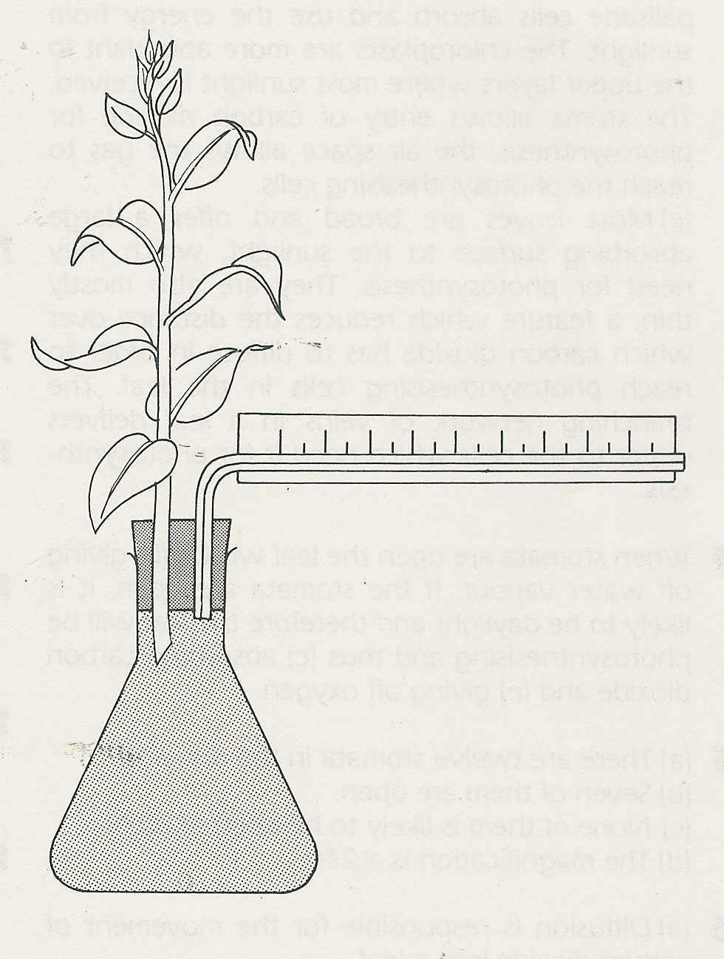
a potometer.
Criticise the design and practicability of the apparatus.

11 A pot plant was watered and the pot
enclosed in a plastic bag tied securely
round the base of the stem. The plant was
weighed at 9 a.m. and 4 p.m. During this
time it lost 32g in weight.
(a) From these results, what was the plant's
rate of transpiration?
(b) Why might this calculated rate be slightly
inaccurate (i) in daylight, (ii) in darkness?
(c) What was the point of (i) watering the
plant, (ii) enclosing the pot in a plastic bag?

20

