11 Digestion
Self-assessment questions 11.01

1 Which one of the following structures is not part of the alimentary canal?
(a) duodenum (c) liver
(b) mouth (d) stomach:

2 Name two digestive glands.

3 What name is given to the muscular contraction which moves food along the alimentary
canal?

4 What do digestive enzymes do to food?

5 What are the final digestion products of (a) protein, (b) fat, (c) starch?

6 How does chewing food help to speed up digestion?

7 Name the enzyme present in saliva and say what type of food it acts on.

8 Are the contents of the stomach (a) acid, (b) alkaline,{c) neutral?

9 What class of food is partially digested in the stomach?

10 What is the name of the enzyme in gastric juice?

11 What types of enzymes are produced by the pancreas?

12 Into which part of the alimentary canal does the pancreas secrete pancreatic juice?

13 What is the function of bile in digestion?

14 State three ways in which the absorbing surface of the small intestine is increased.

15 Into what body fluids do (a) glucose, (b) fatty acids, glycerol (c) amino acids pass?

16 Fill in the missing words..
The blood from the intestine goes first to the …….. before entering the general
circulation. If the glucose concentration in the blood is above a certain level, it is changed to …….. and stored. Glucose which passes into the general circulation is taken up by the body cells
and used to provide ……..
If there are excess amino acids in the blood from the intestine, the liver converts them to
…….. which is stored, and …….. which is excreted by the kidneys..
A
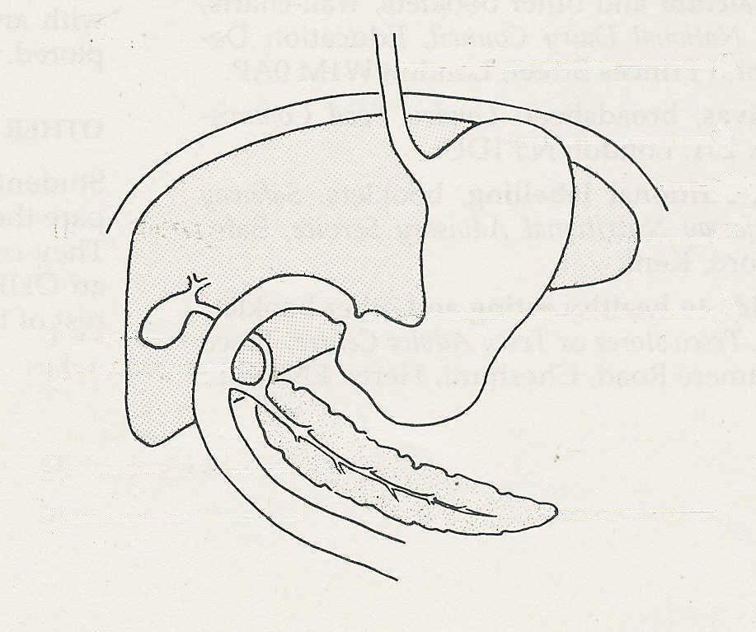
17 What does the liver do to (a) hormones,
diaphragm
(b) alcohol, (c) vitamin A?
B
18 Name the structures labelled A to I.
F
C

E
D

G
I
H

