EXCRETION AND HOMEOSTASIS
PAST K.C.S.E QUESTIONS ON THE TOPIC
- In an investigation the pancreatic duct of a mammal was blocked. It was found that the blood sugar regulation remained normal while food digestion was impaired. Explain these observations. ( 2 marks)
- (a) Explain why the body temperature of a healthy human being must rise up
to 39⁰c on a humid day. (2 marks)
(b) In an experiment a piece of brain was removed from rat. It was found that
the rat had large fluctuations of body temperatures suggest the part of the brain that had been removed. ( 1 mark)
- (a) Explain why sweat accumulates on a person’s skin in a hot humid
Environment. (2 marks)
(b) Name the specific part of the brain that triggers sweating.
( 1 marks)
- Explain why some desert animals excrete uric acid rather than ammonia.
(2 marks)
- State the role of the following hormones in the body
  - Insulin (3 marks)
  - Antidiuretic Hormone (3 marks)
- What osmoregulatory changes would take place in a marine amoeba if it was transferred to a fresh water environment?
- Name two components of blood that are not present in glomerular filtrate.
( 2 marks)
- How would one find out from a sample of urine whether a person is suffering from diabetes mellitus? (2 marks)
- When is glycogen, which is stored in the liver, converted into glucose and released into the blood? ( 2 marks)
- A person was found to pass out large volumes of dilute urine frequently. Name the
(a) Diseases the person was suffering from (1 marks)
(b) Hormone that was deficient (1 mark)
- State the importance of osmoregulation in organisms ( 2 marks)

- What happens to excess fatty acids and glycerol in the body? (2 marks)
- Give reasons for each of the following
(a) Constant body temperature is maintained in mammals ( 1 mark)
(b) Low blood sugar level is harmful to the body ( 2 marks)
- The temperature of a person taken before during and after taking a cold bath. The results are shown in the graph

(a) Explain why the temperature fell during the bath ( 2 marks)
(b) What changes appeared in the skin that enabled the body temperature to return to
normal. (2 marks)
- (a) Name the fluid that is produced by sebaceous glands (1 mark)
(b) What is the role of sweat on the human skin? ( 2 marks)
- State the role of insulin in the human body? ( 1 mark)

- Describe how the human kidney functions. ( 20 marks)
- (a) What is the meaning of the following terms:
(i) Homeostasis ( 1 mark)
(ii) Osmoregulation ( 1 mark)
- (a) Explain what happens to excess amino acids in the liver of humans.
( 3 marks)
- Which portions of the human nephrons are only found in the cortex?
( 3 marks)
- (i) What would happen if a person produced less antidiuretic hormone?
( 1 mark)
(ii) What term is given to the condition described in (c) (i) above?
( 1 mark)
- Define the following terms
  - Excretion
  - Secretion
  - Egestion ( 3 marks)

- Name the components of blood that do not enter the renal tubule in mammals
(2 marks)
- The table below shows the approximate percent concentration of various components in blood plasma entering the kidney glomerular filtrate and urine of a healthy human being.

Component | Plasma | Glomerular | Urine Filtrate
Water  Glucose  Amino Acids  Plasma proteins  Urea  In organic ions | 90  0.1  0.05  8.0  0.03  0.72 | 90  0.1  0.05  0  0.03  0.72 | 94  0  0  0  2.0  1.5

- Name the process responsible for the formation of glomerular filtrate.
- What process is responsible for the absence of glucose and amino acids in urine?
- Explain why there are no plasma proteins in the glomerular filtrate
- Besides plasma proteins what other major component of blood is absent in the glomerular filtrate.
- Why is the concentration of urea in urine much higher than its concentration in the glomerular filtrate?

- When the environmental temperature is very high, some animals urinate on their legs or lick the sides of their body. How does this help in temperature regulation?
- Fish are able to use more of their food intake for growth than mammals. Suggest an explanation for this.
- Explain the term negative feedback
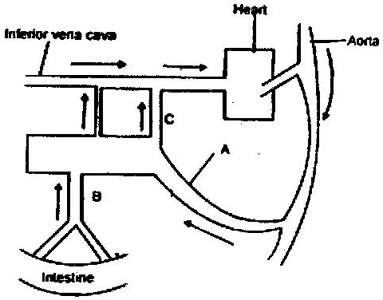
- Study the diagram below and answer the questions that follow.

(a) Name the blood vessels labeled A, B and C.
(b) If the animals has recently fed on a diet which is rich in proteins and
carbohydrates in which of the vessels labeled A, B, and C would you expect to find the highest concentration of:
(i) Glucose
(ii) Amino acids
(iii) Carbon (IV) oxide
(iv) Oxygen
(v) Urea
(c) During fasting, the level of blood glucose in vessels C may be higher than the level in vessel B explain
FORM 3 WORK

