RESPIRATION
PAST KCSE QUESTIONS ON THE TOPIC
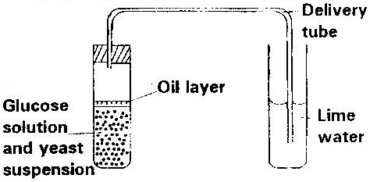
1. The diagram below shows a set up that was used to demonstrate fermentation.

Glucose solution was boiled and oil added on top of it. The glucose solution was then allowed to cool before adding the yeast suspension.
a) Why was the glucose solution boiled before adding the yeast
suspension? (1mk)
b) What was the importance of cooling the glucose solution before
adding the yeast suspension? (1mk)
c) What was the use of the oil in the experiment? (1mk)
d) What observation would be made in test tube B at the end of the
experiment (1mk)
e) Suggest a control for this experiment (1mk)
2. Give two reasons why accumulation of lactic acid during vigorous exercise lead to an increase in heart beat. (2mks)
3. A process that occurs in plants is represented by the equation below.
C₆H₁₂O₆ 2C₂ H₅OH) + (2CO₂) + Energy
Glucose Ethanol Carbon Dioxide
a) Name the process (1mk)
b) State the economic importance of process name in (a) above.
(1mk)
4. Other than carbon dioxide, name the other products of anaerobic respiration in plants. (2mks)
5. Name the substance which accumulates in muscles when respiration occurs with insufficient oxygen. (1mk)
6. a) In what form is energy stored in muscles? (1mk)
b) State the economic importance of anaerobic respiration in plants.
(2mks)
7. State four ways in which respiratory surfaces are suited to their function. (4mks)
8. a) A dog weighing 15.2kg requires 216kJ while a mouse weighing
50g requires 2736KJ per day. Explain. (2mks)
b) What is the end product of respiration in animals when there is
insufficient oxygen supply? (1mk)
9 a) Name the products of anaerobic respiration in:
i) Plants (1mk)
ii) Animals (1mk)
b) What is oxygen debt? (1mk)
10. 5C₅₁H₉₈O₆ ₊ 145O₂ 1 O₂CO₂ + 98 H₂O + energy
The above equation shows an oxidation reaction of food substances.
a) What do you understand by the term respiratory quotient? (1mk)
b) Determine respiratory quotient of the oxidation of food substance.
(2mks)
c) Identify the food substances. (1mk)
11 Write differences between aerobic respiration and photosynthesis. (4mks)
12. Below is a diagram of an organelle that is involved in aerobic respiration.
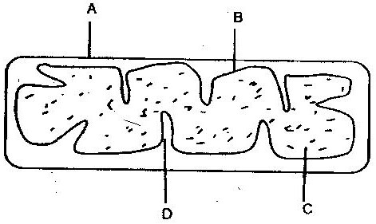

a) Name the organelle (1mk)
b) Name the parts labeled A, B, and C. (3mks)
c) What is the purpose of the folding labeled D? (1mk)
d) Give the chemical compound which is formed in the organelle and
forms the immediate source of energy.

