GASEOUS EXCHANGE
PAST KCSE QUESTIONS ON THE TOPIC
1. Discuss how gaseous exchange occurs in
a) Terrestrial Insects (9mks)
b) Bony fish (11mks)
2. a) Explain how mammalian lungs are adapted for gaseous exchange.
(8mks)
b) Describe how carbon dioxide is produced by
i) Respiring muscle cells reaches the alveolar cavities in
mammalian lungs.
ii) Respiring mesophyll cells of flowering plants reaches the
atmosphere. (12 mks)
3. a) Describe the path taken by carbon dioxide released from the tissues
of an insect to the atmosphere.
b) Name two structures used for gaseous exchange in plants. (2mks)
4. Why are gills in fish highly vascularized? (1mk)
5. Describe the
a) Process of inhalation in mammals. (10 mks)
b) Mechanism of opening and closing of stomata (10 mks)
- Name three sites where gaseous exchange takes place in terrestrial plants. (3mks)
7. How is aerenchyma tissue adapted to its function? (2mks)
8. The diagram below represents a part of the rib cage.
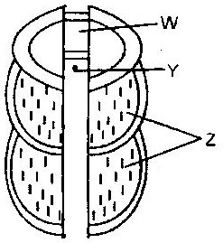

a) Name parts labeled W, Y and Z.
b) How does the part labeled Z facilitates breathing in? (1mk)
9. State two ways in which floating leaves of aquatic plants are adapted to gaseous exchange. (2mks)
10. a) Name two structures for gaseous exchange in aquatic plants.
(2mks)
b) What is the effect of contraction of the diaphragm muscles during
breathing in mammals? (3mks)
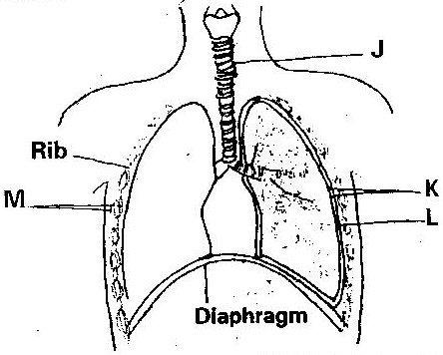
11. The diagram below represents some gaseous exchange structures in humans.

a) Name the structure labeled K, L and M (3mks)
b) How is the structure labeled J suited to its functions? (3mks)
c) Name the process by which inhaled air moves from the structure
labeled L into blood capillaries. (1mk)
d) Give the scientific name of the organism that causes tuberculosis in
humans. (1mk)
12 State three factors that make alveolus adapted to its function. (3mks)
13. Explain how the alveoli are ventilated.
14. Explain why water logging of the soil may lead to death in plants. (2mks)
15. Write three advantages of breathing through nose than through mouth.
(3mks)
16. State and explain ways the leaves are adapted for gaseous exchange (4mks)
17. Name three gaseous constituents involved in gaseous exchange in plants.
(3mks)
18. Name three sites of gaseous exchange in frogs. (3mks)
19. Name the main site of gaseous exchange in
a) Mammals
b) Fish
c) Leaves
d) Amoeba (4mks)
20. Name the physiological process by which gas exchange takes place at the respiratory surface in animals and plants (1mk)

