TRANSPORT IN ANIMALS
PAST KCSE QUESTIONS ON THE TOPIC
1. People can die when they inhale gases from burning charcoal in poorly ventilated rooms. What compound is formed in the human body that leads to such deaths? (1mk)

2. Explain why blood from a donor whose blood group is A cannot be transfused into a recipient whose blood group is B. (2mks)
3. State one difference between closed and open circulatory systems. (1mk)
4. a) Give an example of a phylum where all members have
i) Open circulatory system
ii) Closed circulatory system (2mks)
b) What are the advantages of the closed circulatory system over the
open circulatory system? (5mks)
5. Explain two ways in which mammalian erythrocytes (red blood cells) are adapted to their function (2mks)
6. a) i) Name the blood vessels that link arterioles with venules.
(1mk)
ii) Explain four ways in which the vessels you named in (a)
above are suited to carrying out their functions. (4mks)
b) State two ways in which the composition of blood in the
pulmonary arterioles differ from that in the pulmonary venules. (2mks)
7. Why would carboxyhaemoglobin lead to death? (2mks)
8. Explain how the red blood cells of mammals are adapted for efficient transport of oxygen. (2mks)
9. The chart below is a summary of the blood clotting mechanism in man.
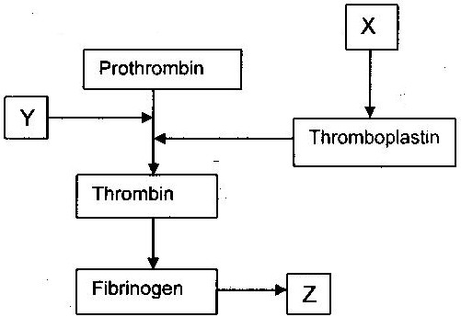

Name
i) The blood cells represented by X
ii) Metal ion represented by Y
iii) The end product of the mechanism represented Z
10. a) How can excess bleeding result in death? (2mks)
b) Name the process by which the human body naturally stops
bleeding. (1mk)
c) How can low blood volume be brought back to normal? (2mks)
11. a) Name one defect of the circulatory system in humans. (1mk)
b) State three functions of blood other than transport. (3mks)
12. a) What prevents blood in veins from flowing backwards? (1mk)
b) State two ways in which the red blood cells are adapted to their
function. (2mks)
- State one way by which HIV/AIDS is transmitted from mother to child.
(1mk)
14. Explain how the various components of blood are adapted for their function. (20mks)
15. Distinguish between blood, plasma, serum, tissue fluid and lymph. (10mks)
16. a) A patient whose blood group is A died shortly after receiving
blood from a person of blood group B. Explain the possible cause of death of the patient. (2mks)
b) A person of blood group AB requires a transfusion.
i) Name the blood groups of the possible donors (2mks)
ii) Give reasons for your answer in (i) above. (2mks)
17. Differentiate between active immunity and passive immunity. (2mks)
18. Explain why a person can catch a cold several times in a year but only catches measles once in his or her lifetime. (2mks)
19. Most carbon dioxide is transported from tissues to the lungs within the red blood cells and not in the blood plasma. Give two advantages of this mode of transport. (2mks)
20. What is the importance of tissue fluid? (2mks)

