TRANSPORT IN PLANTS
PAST KCSE QUESTIONS ON THE TOPIC
1. In an experiment, a leafy shoot was set up in a photometer and kept in a dark room for 2 hours. The set up was then transferred to a well-lit room for 2 hours.
a) What was the aim of this experiment? (1mk)
b) Explain the results which would be expected in each of the two
experiments conditions. (3mks)
2. Explain how drooping of leaves on a hot sunny day is advantageous to plant. (2mks)
3. Explain how environmental factors affect the rate of transpiration in flowering plants. (20mks)

4. The diagram below represents a transverse section of a young stem.
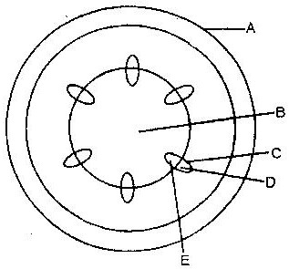

a) Name the parts labeled A and B (2mks)
A___________________
B____________________
b) State the functions of the parts labeled C, D and E
C________________
D_______________
E_______________
c) List three differences between the section shown above and one
that would be obtained from the root of the same plant (3mks)

5. The diagram below represents the pathway of water from soil into the plant.
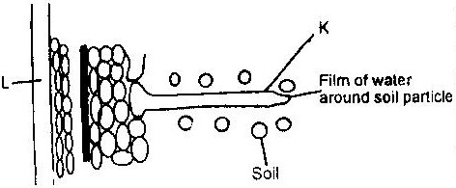

a) Name the structures labeled K and L
K_______________
L_______________ (2mks)
b) Explain how water from the soil reaches the structure labeled L.
(5mks)
c) Name the process by which mineral salts enter into the plant. (1mk)
6. State two ways in which xylem are adapted to their function. (2mks)
7. What makes young herbaceous plant remain upright? (2mks)

8. The diagram below represents part of phloem tissue
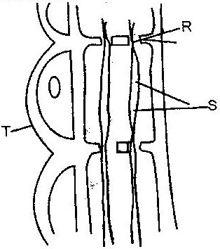

a) Name the structures labeled R and S and a cell labeled T.
R ___________________
S ___________________
Cell T ___________________ (3mks)
b) State the function of the structure labeled S. (1mk)
c) Explain why xylem is a mechanical tissue (2mks)
9. Name the
a) Material that strengthens xylem tissue. (1mk)
b) Tissue that is removed when the bark of a dicotyledonous plant is ringed. (1mk)
10. How are xylem vessels adapted for support? (1mk)

11. What is the role of vascular bundles in plant nutrition? (3mks)

12. a) Name two tissues which are thickened with lignin. (2mks)
b) How is support attained in herbaceous plant? (1mk)
13. The diagram below represents a transverse section through a plant organ.
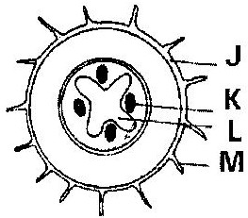

a) From which plant organ was the section obtained? (1mk)
b) Give two reasons for your answer in (a) above. (2mks)
c) Name the parts labeled J, K and L (3mks)
J__________________________________
K_________________________________
L_________________________________
d) State two functions of the part labeled M. (2mks)
14. Describe how water moves from the soil to the leaves in a tree. (20mks)

15. State two ways in which the root hairs are adapted to their function.
(2mks)
16. The diagram below represents a plant tissue.
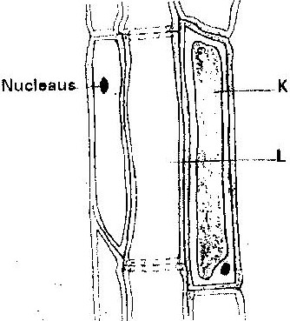

17. In an experiment to determine the effect of ringing on the concentration of sugar in phloem, a ring of bark from the stem of a tree was cut and removed. The amount of sugar in grammes per 16cm³ piece of bark above the ring was measured over a 24 hour period. Sugar was also measure in the bark of a similar stem of a tree which was not ringed. The results are shown in the table below

Time of the day | Among of sugar in grammes per 16 cm³ piece of bark
 | Normal stem | Ringed stem
06 45 | 0.78 | 0.78
09 45 | 0.80 | 0.91
12 45 | 0.81 | 1.01
15 45 | 0.80 | 1.04
18 45 | 0.77 | 1.00
21 45 | 0.73 | 0.95
00 45 | 0.65 | 0.88
.
a) Using the same axes, plot a graph of the amount of sugar against time (6mks)
b) At what time was the amount of sugar highest in the;
i) Ringed stem (1mk)
ii) Normal stem (1mk)
c) How much sugar would be in the rigged stem if it was measured at 03 45 hours. (2mks)
d) Give reasons why there was sugar in the stems of both trees at 06 45 hours. (2mks)
e) Account for the shape of the graph for the tree with ringed stem between:
i) 06 45 hours and 15 45 hours (3mks)
ii) 15 45 hours and 00 45 hours (2mks)
f) Other than sugars name two compounds that are translocated in phloem. (2mks)
18. Explain why plants shed off their leaves. (2mks)
19. a) What is the importance of transpiration to plants?
b) Give adaptive features which enable a plant to reduce the loss of
water.

