TRANSPORT IN PLANTS
1. a) To investigate the effect of light on the rate of transpiration.
b) More water was lost in the light than in the dark. Rate of transpiration was greater in light than in the dark. This is because the stomata are fully open in light but less open or closed in the dark. In light, photosynthesis takes place hence no water used.
2. The leaves exposed a smaller surface area to the sun thus reducing transpiration. Excessive water loss.
3.
- Temperature- high temperature increase transportation. Low temperature lower transpiration.
- Light intensity-more light increase transpiration, dim light lower transpiration.
- Wind – strong wind increase transpiration, calm weather lower transpiration.
- Humidity – High humidity lower transpiration, low humidity increase transpiration.
- Atmospheric pressure- High atmospheric pressure increase transpiration.
- Water availability-more water increase transpiration due to opening of stomata while little water lowers transpiration.
4. a) A - Epidermis
B - Pith
b) C - Transport manufactured food/translocation
D - Produce new cells/divide giving new cells
E - Transport mineral salts and water.
c) -Xylem in centre/star shaped.
-Phloem in arm of xylem
-No pith in root
-Roots hairs present in root
5 a) K - Root hair
L - Xylem vessel
b) Water moves from the soil into the root hair by osmosis. Because concentration of cell sap is higher than water in the soil; the cell sap of the root hair is diluted thus making it less concentrated than neighbouring cells; therefore water moves into the neighbouring cell. It is then actively secreted into L.
c) Active transport/diffusion.
6.
- Lignified/thickened to prevent collapsing.
- Narrow to facilitate capillarity
- No cross wall for continuous flow of water.
- Side walls pitted to allow lateral movement of water and mineral salts.
7.
- Turgidity
- Presence of xylem vessels
- Presence of collenchyma
8. a) R- sieve pore/plate
S-Cytoplasm strand
T- Companion cell
b) Translocation
c) Thickened, - Lignified
9. a) Lignin,
b) Phloem
10. They are strengthened by lignin hence supporting the stem.
11. - Xylem - Transports water and mineral salts to photosynthesizing cells
- Phloem - Transports manufactured foods from the leaves creating high
concentration gradient.
- Veins - Supports the leaf to be upright for maximum absorption of
light for photosynthesis.
12. a) Ovule
b) Ovary
13 a) -Xylem vessels
-Sclerenchyma
b) -Turgidity of parenchyma cells
-Presence of collenchyma cells
14.
a) Dicot root
b) i) Presence of root hairs
ii) Phloem between rays of xylem (star shaped xylem).
c) J - Epidermis
K - Phloem
L - Xylem
d) Absorbs water and mineral salts from soil.
15. - Adhesion- force of attraction between unlike molecules
- Due to the force of adhesion water tends to stick to the walls of vessels containing it.
- Cohesion- forces of attraction between like molecules
- Cohesion between water molecules prevents the water column from breaking.
- Root pressure- due to pressure generated by the root’s endodermis
- Capillary due to narrowness of xylem.
- Transpiration pull- as water evaporates from the leaf’s surface more is absorbed
- After the water reaches the leaves cells, it passes the cells by osmosis from the xylem. Water vapour diffuses out through stomata.
16. - Absence of cuticle to allow diffusion of water.
- Thin walled to reduce distance of diffusion.
- Elongated to increase surface area for absorption of water and mineral salts.
- Presence of large vacuole to increase concentration gradient between cell sap and soil water.
17.
a) Phloem tissues
b) K- Companion cell
c) Supply nutrients and energy to the sieve tubes.
18. a) Graph
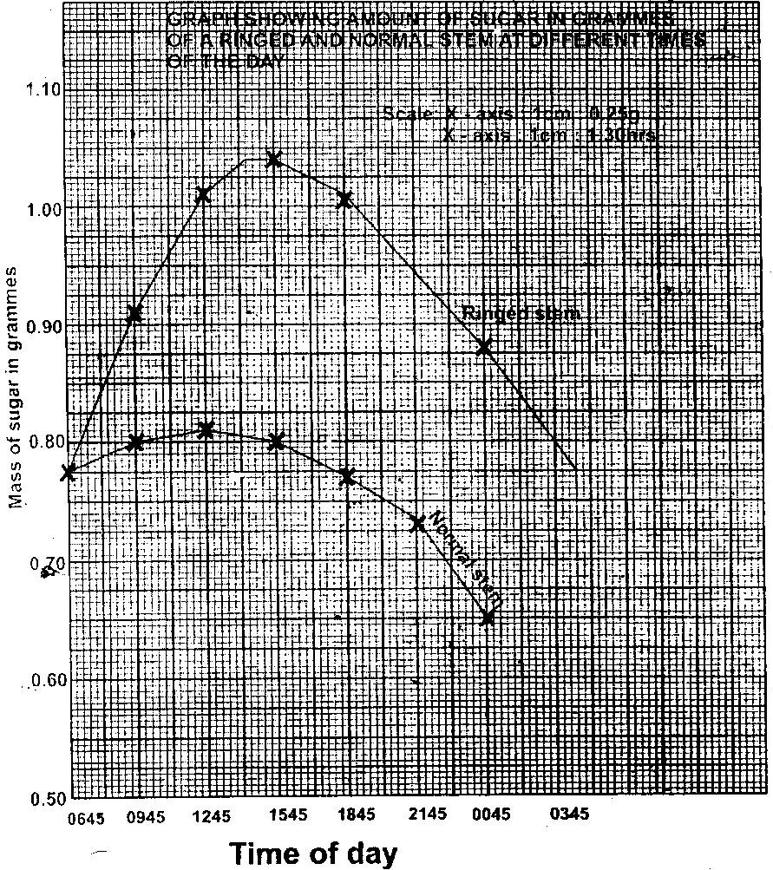

b) i) 15:45
ii) 12:45
c) 0.79 ± 0.02 grammes
d) The food that had been manufactured the previous day had been converted to soluble sugars and was being translocated to other parts of the plant.
e) i) 06 45 hours and 15 45 hours.
- There was low concentration of sugar early in the morning as there
was little translocation.
- As day progresses the light intensity increases and more food is
manufactured thus more translocation increasing concentration of sugars.
ii) 15 45 and 00 45
- The light intensity is decreasing reducing rate of photosynthesis. Less food is manufactured, hence less is translocated.
- As it turns dark there is no photosynthesis reducing concentration of sugar translocated.
iii) Sieve plates
- Cytoplasmic strands
f) - Amino acids
- Soluble fats/lipids.
19. i) Reduce transpiration
ii) Eliminate excretory wastes on the leaf
20. a) - Maintain transpiration stream
- Cool the plant
- Remove excess water
- Enhance absorption and distribution of water and mineral salts.
b) - Few and small leaves
- Reduced leaf size
- Sunken stomata
- Thick cuticle.

