4 How substances get in and out of cells - answers
Self-assessment questions 4.03

1 (a) The gas will diffuse from Y to X (i.e. from the region of higher concentration to the region
of lower concentration).
(b) Eventually, the gas will be evenly distributed between the two containers so each one will
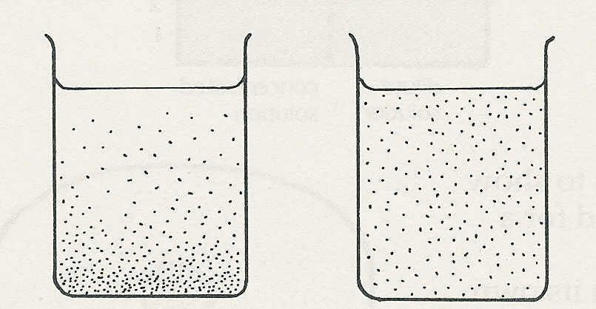
contain 0.5g per litre.

2 The salt molecules will move by diffusion
till they are evenly distributed.

(b)
(a)

3 When a cell is respiring aerobically, oxygen will be diffusing into the cell and carbon dioxide will be diffusing out.

4 (a) (i) Inside the cell the substance will diffuse from B to C (i.e. down the concentration
gradient).
(ii) If the cell membrane were freely permeable, the substance would diffuse out of the cell,
from B to A, because its concentration inside is greater than that outside.
(b) If there is no change in the concentration, you might assume that the substance was not free
to diffuse across the cell membrane and was being taken up by active transport and
diffusing across the cytoplasm by passive diffusion.

5 (a) The best definition of osmosis is (iii) ‘The movement of water from a dilute solution to a
concentrated solution across a partially permeable membrane'.
(b) An acceptable description of diffusion (at least in solutions) is (ii) ‘The movement of a
substance from a concentrated solution to a dilute solution'. (The partially permeable
membrane is not essential for diffusion to occur.)
8
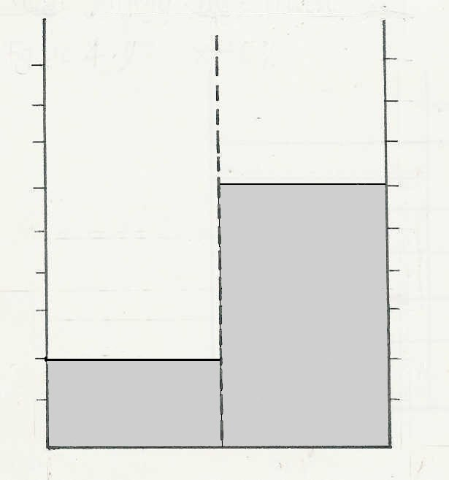
6 There will be a rise in level on the right and
a corresponding fall on the left as water passes
from the dilute to the concentrated solution by
6
osmosis. (The figures need not be the same as
shown here.)
4

2

7 (b) A concentrated solution has a low osmotic potential (because it contains effectively fewer
free water molecules than a dilute solution).

Self-assessment questions 4.04
How substances get in and out of cells - answers (continued)
(b) Higher osmotic potential
(water potential)
(a) Lower osmotic potential
(water potential)
8
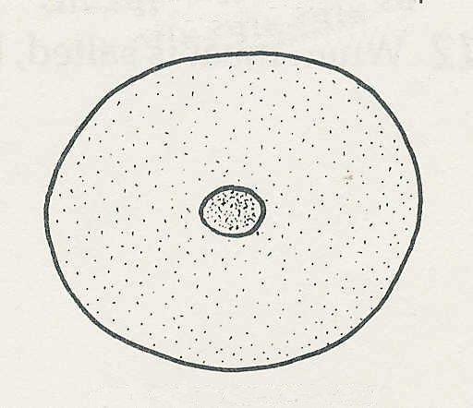
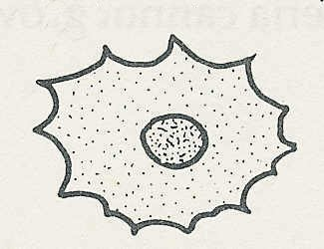

(cell loses water to more concentrated solution)

(cell gains water from more dilute solution)

9 If the cell membrane were freely permeable, harmful substances could diffuse in and useful
substances could diffuse out.

10 If the tissue fluid became more dilute, the cells would absorb water by osmosis and swell up. If the tissue fluid became more concentrated, the cells would lose water by osmosis, shrink and become dehydrated, possibly to a point where metabolism was no longer possible.

11 The salt lowers the meat's osmotic potential so that water is withdrawn, by osmosis, from bacterial cytoplasm and so kills the bacteria.

