Self assessment questions 1.01
1 Cells and tissues
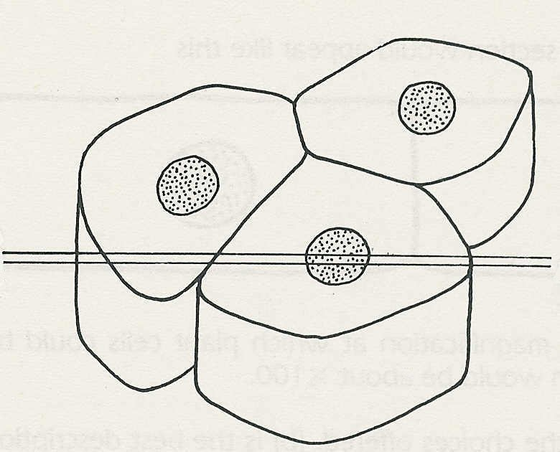

1 The drawing shows a group of three cells.
Make an outline drawing to show how the
cells would appear under the microscope if a
thin section A-A was cut and mounted on
a slide.
A
A

2 Which one of the following is most likely to be true: To see plant cells with a microscope
you usually need a magnification of about
(a) x5, (b) xl0, (c) xl00, (d) xl000?

3 Which one of the following best describes the function of a cell membrane?
(a) It keeps the cell in shape.
(b) It controls the substances entering and leaving the cell.
(c) It controls the substances entering the cell.
(d) It supports the cell structures.

4 Which of the following structures are (a) in plant and animal cells, (b) in plant cells but not in animal cells?
cell wall, cytoplasm, cell membrane, mitochondria, nucleus, central vacuole,
chromosomes, cell sap

5 The drawings below show stages in cell division but in the wrong order. What is the most
likely sequence of events?
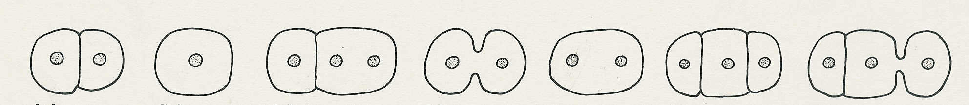

a b c d e f g

6 Select the most appropriate words from the list below to complete the following
paragraph:
If a cell develops in such a way that it does one particular job very efficiently, it is said to
be …….. . Such a cell is also said to be …… to its function. A nerve cell is ….. for conducting impulses. It can do this efficiently because of its ……and the chemical reactions in its …..

shape, vacuole, adapted, cytoplasm, size, specialised, mature, mitochondria

7 Classify the following under the headings 'Cell structure', 'Tissue', 'Organ' or 'System'.

bone, nucleus, skeleton, brain, nerve, mitochondrion, muscle, cytoplasm, epithelium,
heart and blood vessels, stomach, alimentary canal, lung, lungs and windpipe

