1 Cells and tissues - answers
Self-assessment questions 1.02
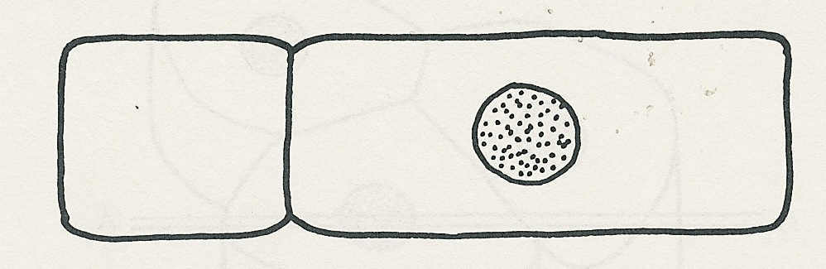
1 The section would appear like this

2 The magnification at which plant cells could be
seen would be about x 100.

3 Of the choices offered, (b) is the best description of a cell membrane's function: it controls the substances entering and leaving the cell.

4 (a) Plant and animal cells have cytoplasm, cell membrane, mitochondria, nucleus and
chromosomes.
(b) Only plant cells have a cell wall, central vacuole and cell sap.

5 The most likely sequence is as shown below.
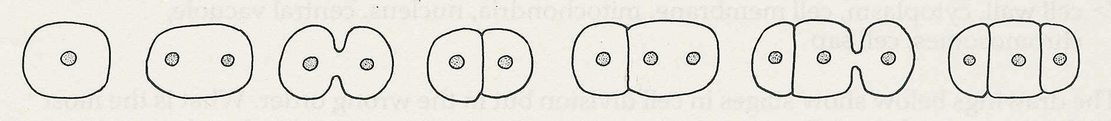

b e d a c g f

6 If a cell develops in such a way that it does one particular job very efficiently, it is said to be specialised. Such a cell is also said to be adapted to its function. A nerve cell is specialised for conducting impulses. It can do this efficiently because of its shape and the chemical reactions in its cytoplasm.

7 Cell structure: nucleus, mitochondrion, cytoplasm.
Tissue: bone, nerve, muscle, epithelium.
Organ: brain, stomach, lung.
System: skeleton, heart and blood vessels, alimentary canal, lungs and windpipe.

Note: You could reasonably argue that the digestive system includes salivary glands, pancreas and liver, and therefore the alimentary canal is an organ, not a system.

