2 The Chemicals of living cells - answers
Self-assessment questions 2.03

1 Cells need to take in water and salts, in addition to food.

2 (a) A high thermal capacity means that any temperature rise is small in comparison with the amount of heat absorbed. This helps to protect the cell against extremes of temperature.

3 (a) Cytoplasm, the cell membrane, membrane systems in the cell, the nucleus and
mitochondria all contain structural proteins.
(b) Enzymes are the other type of cell proteins.

4 Proteins contain the elements carbon, hydrogen, oxygen, nitrogen and sulphur.

5 All proteins are composed of sub-units called amino acids.

6 (b) A protein which is denatured has changed its shape.

7 A lipid is a fat or oil. It may be combined with other substances, e.g. phospho-lipid or lipo-protein.

8 Lipids are found in cell membranes and other membrane systems in the cell. Some cells may have food reserves in the form of lipid droplets.

9 (a) lipids are formed from the combination of fatty acids with glycerol.
(b) lipids contain the elements carbon, hydrogen and oxygen.

10 (a) Sugars (glucose, fructose, maltose, sucrose), starch, glycogen and cellulose are examples
of carbohydrates.
(b) Carbohydrates contain the elements carbon, hydrogen and oxygen.

11 The formula for glucose is C₆H₁₂O₆

12 (a) Maltose
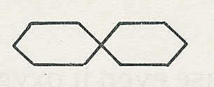

(b) Part of a starch molecule
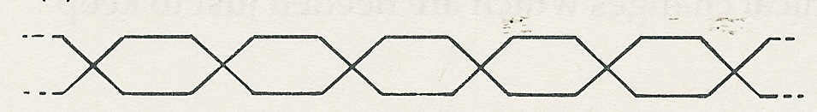

13 All cells contain enzymes which are proteins and act as catalysts which speed up chemical reactions. The reaction does not use up the enzymes, which can take part in further reactions.

14 Using the lock and key model, enzyme A is most likely to react with substance R.
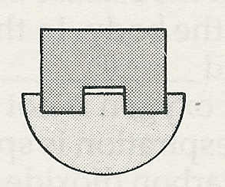

R

15 If an enzyme normally works at 10°C, then
(a) a fall in temperature to 2°C will slow down the reaction
(b) a rise in temperature to 20°C will speed up the reaction (by x2)
(c) a rise in temperature to 65°C will denature the enzyme and stop it working (though the
reaction may speed up at first).

The chemicals of living cells - answers (continued)
Self-assessment questions 2.04

16 An enzyme which has been denatured has changed its shape and will no longer combine with its substrate (the substance it acts on).

17 (b) The optimum pH is 7 because the rate of reaction is greatest at this pH.

18 (a) A protein-digesting enzyme would have no effect on starch.

19 All enzymes are produced inside cells. Enzymes which do their work outside cells are called extra-cellular. Enzymes which do their work inside cells are called intra-cellular Most of our digestive enzymes are examples of extra-cellular enzymes.

20 In the course of brewing, enzymes in the grain catalyse the conversion of starch to maltose; enzymes in yeast catalyse the conversion of maltose to alcohol.

21 Catalase speeds up the breakdown of hydrogen peroxide to water and oxygen.

22 (a) Boiling denatures enzymes. If a substance still works after boiling, it cannot be an
enzyme.
(b) If the reaction still worked after A had been boiled, either A is not an enzyme or, if it
is, it is not necessary for the reaction.

23 (a) The test for starch is iodine solution, which goes blue.
(b) When no blue colour appears after adding iodine, all the starch has gone and the
reaction is complete.

