NUTRITION IN PLANTS
PAST KCSE QUESTIONS ON THE TOPIC
1. An experiment was carried out to investigate the rate of reaction shown below.
Sucrose → Fructose + Glucose
For the products; fructose and glucose to be formed, it was found that substance K was to be added and the temperature maintained at 37⁰C. When another substance L was added, the reaction slowed down and eventually stopped.
a) Suggest the identity of substances K and L. (2mks)
K ________________________
L ________________________
b) Other than temperature state three ways by which the rate of reaction could be increased. (3mks)
c) Explain how substance L slowed down the reaction. (1mk)
2. State the role of light in the process of photosynthesis. (2mks)
Name one product of dark reaction in Photosynthesis (1mk)
3. State one effect of magnesium deficiency in green plants.
4. The graph below shows the effect of substrate concentration on the rate of enzyme reaction.
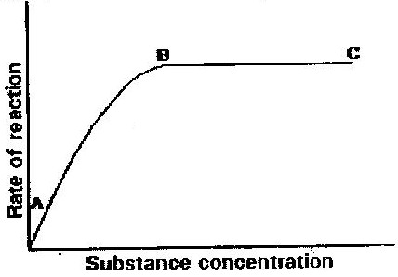

a) Account for the shape of the graph between
i) A and B (3mks)
ii) B and C (2mks)
b) How can the rate of reaction be increased after point B? (1mk)
c) State two factors that affect the rate of enzyme reaction. (2mks)
5. a) State the function of co-factors in cell metabolism. (1 mk)
b) Give one example of a metallic co-factor. (1 mk)
6. Name two mineral elements that are necessary in the synthesis of chlorophyll.
(2mks)
7. What is the role of the vascular bundles in plants nutrition? (3mks)
8. Describe what happens during the light stage of photosynthesis. (3mks)
9. Photosynthesis takes place in two stages. Name the part of the chloroplast where
i) Light stage occurs
ii) Dark stage occurs (2mks)
b) How is dark stage dependant on the light stage of photosynthesis? (2mks)
10. A solution of sugarcane was boiled with hydrochloric acid; sodium carbonate was heated with Benedict’s solution. An orange precipitate was formed.
a) Why was the solution boiled with hydrochloric acid? (1mk)
b) To which class of carbohydrates does sugarcane belong?
c) Name the type of reaction that takes place when:
i) Simple sugars combine to form complex sugar. (1mk)
ii) A complex sugar is broken into simple sugar. (1mk)
d) State the form in which carbohydrates are stored in:
i) Plants
ii) Animals (2mks)

11. i) Name structural units of lipids (1mk)
ii) State three important functions of lipids in living organisms. (3mks)
12. The diagram below shows an experiment carried out to investigate photosynthesis in a potted plant which has been kept in the dark for 48 hours.
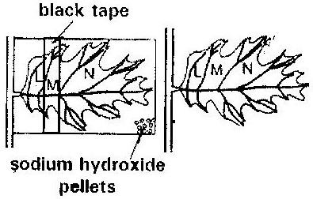

The setup was left in the sunshine for 6 hours. The leaf was tested for starch using iodine solution at the end of the experiment.
a) What would be the colours of the regions of the leaf marked L. M and N?
(3mks)
b) What is the function of the sodium hydroxide pellets? (1mk)

