CELL PHYSIOLOGY
PAST KCSE QUESTIONS ON THE TOPIC
1. The table below shows the concentration of some ions in pond water and in the cells sap of an aquatic plant growing in the pond.
Ions | Concentration in pond water (parts per million) | Concentration in cell sap (parts per million)
Sodium  Potassium  Calcium  Chloride | 50  2  1.5  180 | 30  150  1  200

a) Name the processes by which the following ions could have been taken up by this plant. (2mks)
i) Sodium ions
ii) Potassium ions
b) For each processes named in (a) (i) and (ii) above, state one condition necessary for the process to take place. (2mks)
2. Explain how water in the soil enters the root hairs of a plant. (4mks)
3. Explain how drooping of leaves on a hot sunny day is advantageous to a plant.
(2mks)

4. a) What is diffusion? (2mks)
b) How do the following factors affect the rate of diffusion?
i) Diffusion gradient (1mk)
ii) Surface area to volume ratio (1mk)
iii) Temperature (1mk)
c) Outline 3 roles of active transport in the human body (2mks)
5. State the importance of osmosis in plants (3mks)

6. An experiment was set up as shown in the diagram below.

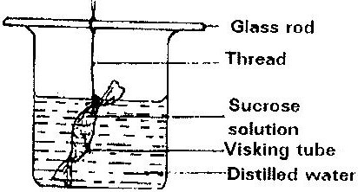

The set up was left for 30 minutes.
a) State the expected results. (1mk)
b) Explain your answer in (a) above. (3mks)
7. Explain why plant cells do not burst when immersed in distilled water. (2mks)
8. Distinguish between diffusion and osmosis. (2mks)
9. Define the following terms in relation to a cell
a) Isotonic solution
b) Hypotonic solution
c) Hypertonic solution (3mks)
10. Addition of large amounts of salt to soil in which plants are growing kills the plants. Explain (6mks)
11. Explain why
a) Red blood cells burst when placed in distilled water while plant cells remain intact.
b) Fresh water protozoa like amoeba do not burst when placed in distilled water. (2mks)

