THE CELL
PAST KCSE QUESTION ON THE TOPIC
1. Which organelle would be abundant in?
Skeletal muscle cell __________________
Palisade cell __________________
2. State the functions of the following organelles.
Lysosomes __________________
Golgi apparatus __________________
3. State the functions of the following organelles;
Goigi apparatus _______________
Ribosomes cell _______________
4. Name the organelles that perform each of the following functions in a cell.
Protein synthesis __________________
Transport cell secretions __________________
5. The diagram below represents a cell.

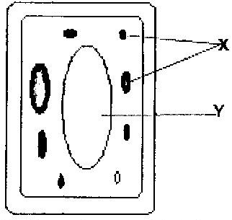

a) Name the parts labeled x and y
X _______________
Y _______________
b) Suggest why the structures labeled x would be more on one side than the other side.
6.
a) State the function of cristae in mitochondria (1mk)
b) The diagram below represents a cell organelle
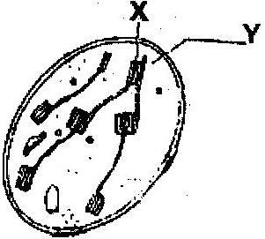

(i) Name the part labeled Y (1mk)
(ii) State the function of the part labeled X (2 mks)
7.
a) What is the formula for calculating linear magnification of a specimen when using a hand lens? (1mk)
b) Give a reason why staining is necessary when preparing specimens for observation under the microscope. (1mk)
8.
State three functions of Golgi apparatus. (3mks)
9. Name two structures found in plant cell but are absent in animals cell.
10. Write the role of the following parts of a microscope
i) Nerve cell
ii) Palisade cell
iii) Root hair cell
iv) Red blood cell
11. The diameter field of view of a light microscopic is 3.5mm. Plant cells lying of the diameter are 10. Determine the size of one cell microns (1mm = 1000µm)
12. Define the following
i) Tissue
ii) Organ
iii) Organ system

