17. FISHING
The topic entails:
- Definition of fishing and fisheries.
- Explaining the factors influencing fishing
- Accounting for the location of the major fishing grounds of the world.
- Describing type sand methods of fishing
- Discussing fresh water and marine fisheries in East Africa
- Assessing the significance of the fishing industry in Kenya
- Discussing problems facing fishing in Kenya and their possible solutions
- Comparing and contrasting fishing activities in Keya and Japan
- Explaining ways and means of managing and conserving fresh water and marine fisheries.

The map below shows some major fishing grounds n the world. Use it to answer questions below:

1. (a (i) Name the countries marked P and Q
(ii) Explain four conditions that favour fishing in the shaded coastal water

2. (a) The diagrams below represent some fishing methods

(a) (i) Name methods R and S
(b) Describe how each of the two methods are used in fishing
(c) Explain three measures used to conserve fish in Kenya

3. (a) (i) What is fish farming?
(ii) Explain three measures that have been undertaken by the government of Kenya
to encourage fish farming.
(b) Explain four problems which face marine fishing in Kenya.
(c) (i) Name three fishing grounds in the Northern Hemisphere.
(ii) Explain three physical factors that favour fishing in Japan.

4. (a) Differentiate between veins and lodes.
(b) State the effects of dereliction

5. (a) (i) Name two methods of fishing.
(ii) Name two types of fish caught along the Eastern Coast of Canada.
(b) Explain how the following factors favour fishing:-
(i) Indented Coastline
(ii) Ocean Currents
(c) Explain four ways in which fisheries in Kenya can be conserved.

6. (i) Give three methods used to preserve fish.
(ii) Explain three problems experienced by fishermen in Lake Victoria.

7. State four reasons why marine fisheries in Kenya are under-developed

8. (a) (i) Name three types of nets used in modern fishing
(ii) Identify the two main fishing grounds of the Pacific Ocean
(b) Explain any four problems facing fishing in East Africa
(c) Explain any four ways in which fishing is significant to Kenya
(d) Name four areas where fish farmers in Kenya can obtain fingerlings

9. a) i)State the three categories of fish communities
ii) Explain four reasons why North East Atlantic is one of the most extends
iii) State four measures taken by the Kenyan government in the management and
conservation of fisheries

10. (a) A part from trawling, name two other modern methods of fishing
(b) State two reasons why the Western Coast of Africa has high concentration of fish than
the Eastern Coast.

11. (a) Name two commercial fishing methods commonly used in Atlantic fishing ground
(b) State three problems Kenyan fishermen face while fishing in Lake Victoria

12. (a) State two measures that have been taken to conserve fish in Kenya
(b) Give three reasons why Norway is a great fishing nation

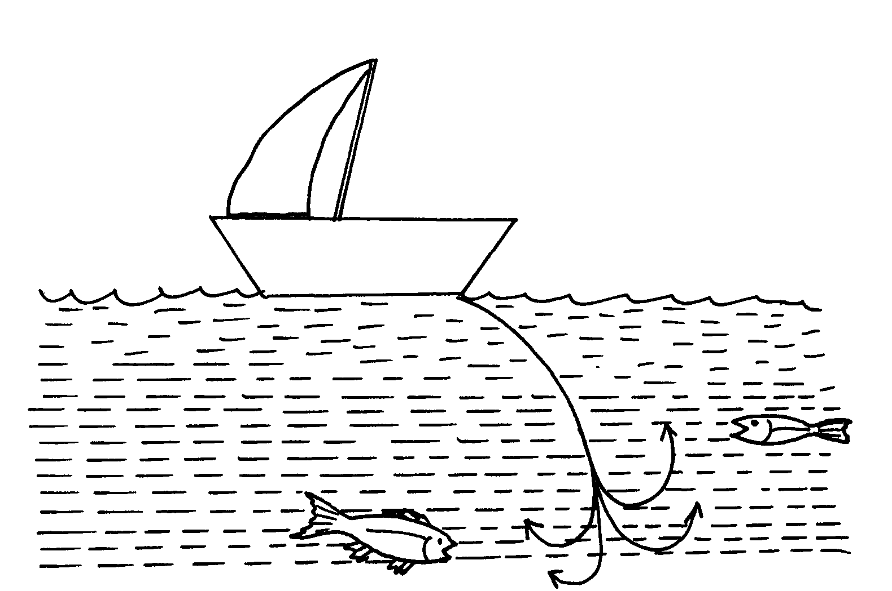
13. (a) Name commercial methods of fishing shown in the diagrams below:

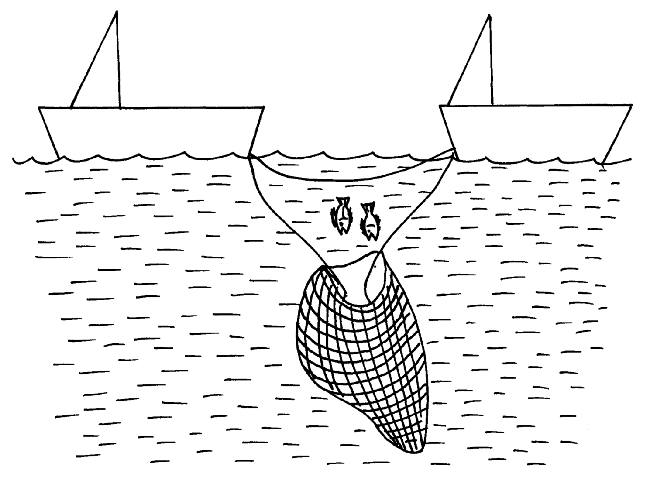

(b) State three reasons why marine fisheries in Kenya are underdeveloped

14. (a) Differentiate between pelagic fish and demersal fish?
(b) Identify two problems facing the fishing industry in Kenya.

