FACTORS WHICH INFLUENCE AGRICULTURE
In this topic, the following factors influence agriculture.
-Human factors e.g. -level of education, -Health HIV/AIDS, -Economic status of the farmer e.t.c
- Biotic factors e.g. pests, parasites, decomposers, pathogens, pollinators, predators e.t.c.
- Climatic factors e.g. rainfall, temperature, wind and relative humidity, light
- Edaplus factors e.g. type of soils, soil profile, soil structure, soil texture, soil chemical properties.
The following relevant questions and their answers in this topic will greatly help and
motivate the user to comprehend and understand the required concepts:

1. State two roles of humus in the soil that are beneficial to crops
2. a) outline five activities that may be undertaken in organic farming
3. List four effects of temperature on crop growth
4. State four ways by which wind affects the growth of crops
5. Name two factors related to light that affect crop production and distribution in Kenya
6. Describe the environmental conditions that may lead to low crop yields
7. List three environmental factors that affect crop distribution in Kenya
8. State one physical characteristic used in classifying soil
9. Outline four advantages of organic farming
10. The diagrams below show an experiment carried out by a form 1 class. Study them carefully and
answer questions that follow:
E
D
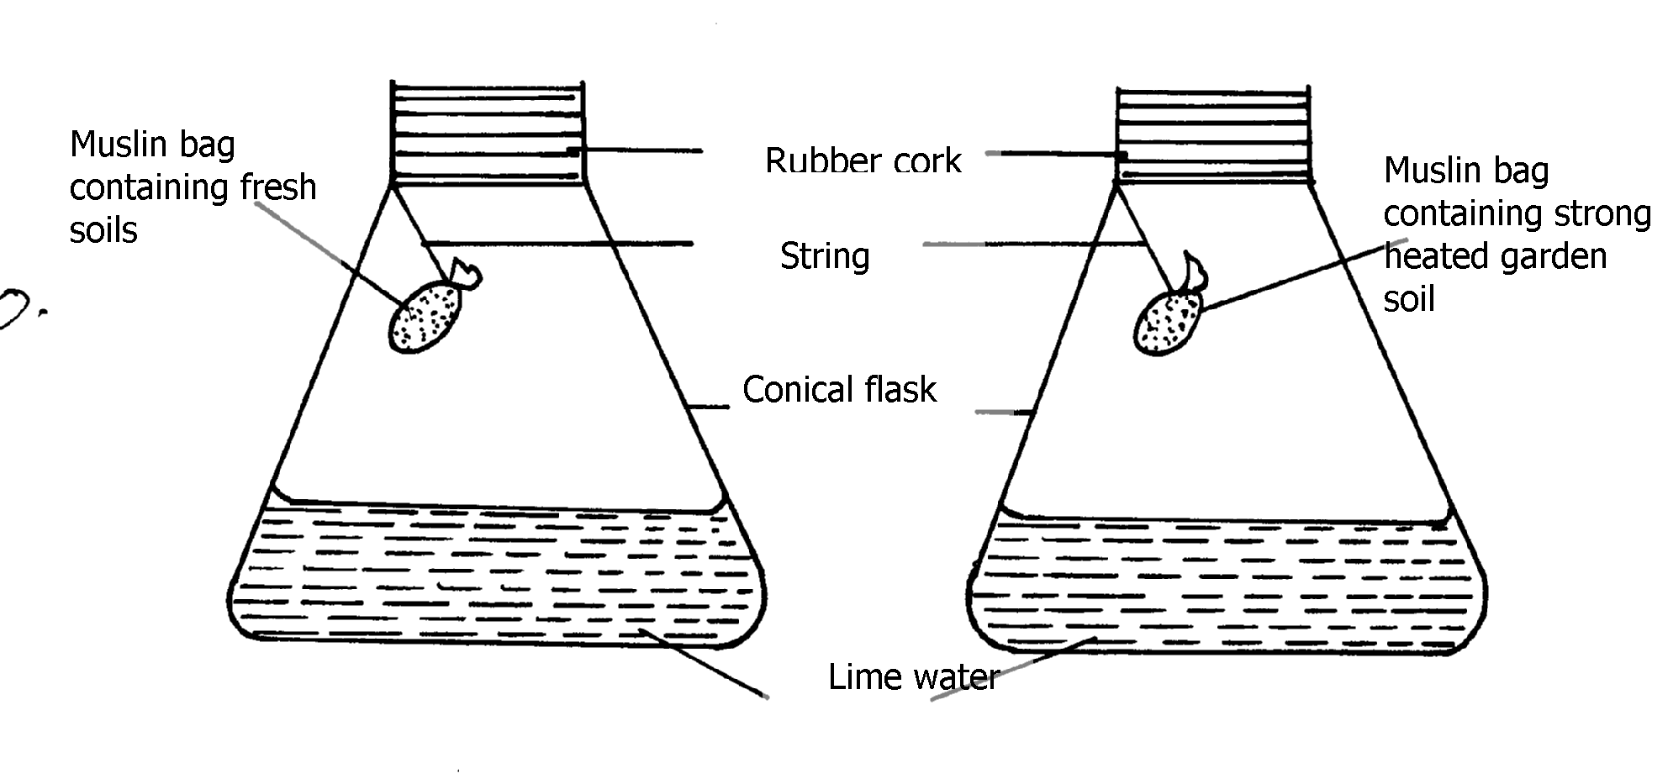

(a) What was the aim of the experiment?
(b) What was the observation that form 1 students made at the end of the experiment in
flasks D and E?
(c) Give the reason for the observation made in flask D

12. Briefly explain how sub-soil as a horizon in a soil profile can affect soil productivity
13. (a) What are the three aspects of light that are important to a farmer?
(b) Mention three ways through which relative humidity affect crop production
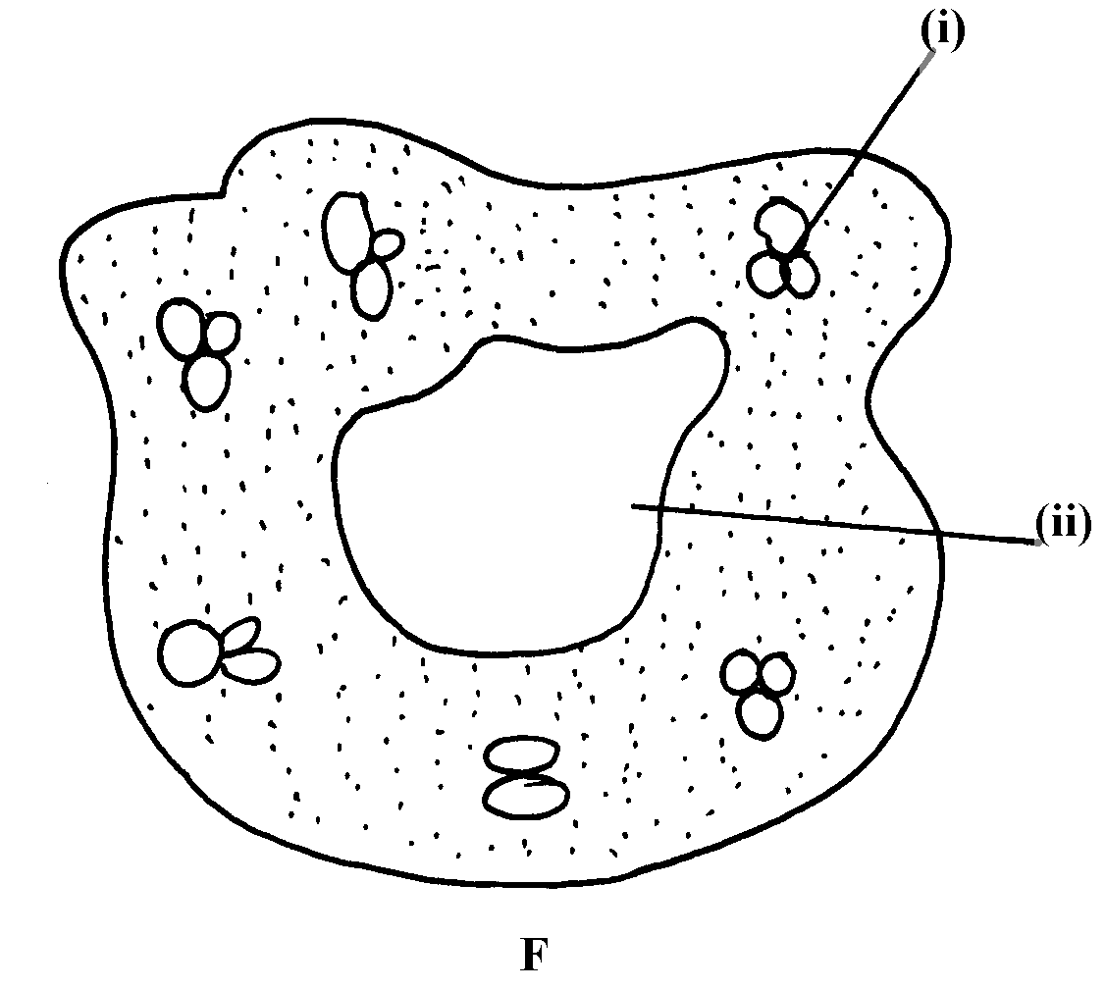
14. The diagram labeled E and F below illustrates some type of soil structure. Study the diagrams
carefully and answer the questions that follow:
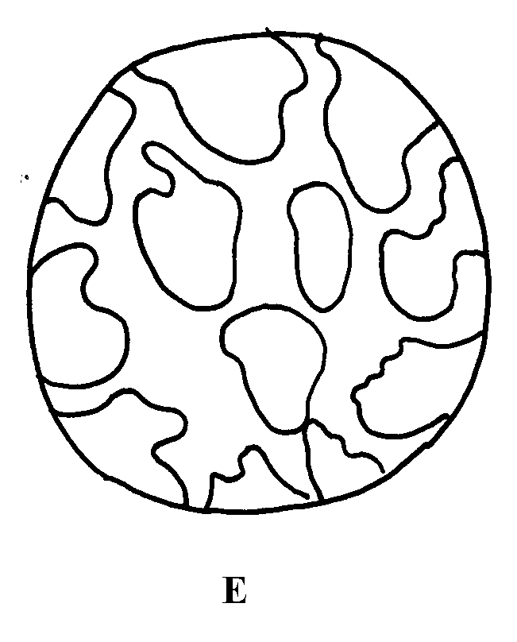

(a) Identify the types of soil structure illustrated in diagrams E and F
(b) Identify the parts labeled (i) and (ii) in diagram F
(c) Outline the influence of physical characteristics of soil on its properties
15. State three physical characteristics of soil
16. Study the diagram below and answer the questions that follow

a) State merits of horizon A
b) State distinct features of horizon B
c) What does the term transition zone refer to in soil profile
i) Name horizon C and state its importance
17. Outline two ways temperature affects crop production
18. List four ways by which biological agents can enhance the process of soil formation
19. List four environmental factors that affect crop production in Kenya
20. Explain the role played by topography in soil formation
22. Mention two importance of parent’s material in soil profile
23. Mention four ways of modifying soil temperature in crop production
24. a) Mention two factors that affect selectivity of herbicides
b) Name two farming practice that cause water pollution
25. Give four factors that influence soil formation
26. State three properties of soil that is influenced by soil texture
27. Name any three agents of biological weathering

FACTORS WHICH INFLUENCE AGRICULTURE
1. two roles of humus in the soil that are beneficial to crops
- Provide nutrients
- Increase water holding capacity
- Increase soil temperature
Neutral soil PH
2. a) five activities that may be undertaken in organic farming
- Mulching
- Apply manure
- Use medicinal plants to control parasites and diseases
- Crop rotation
- Rear livestock on natural organically grown pasture
- Physical/ cultural/ biological/ pests, weeds and disease control
3. four effects of temperature on crop growth
Low temp-slow growth rate
-increase incidence of negative infection e.g. CBD
-improve quality of some crop
High temp-cause wilting
-increase growth rate
-improve quality of some crops
-increase pest and disease incidences (1/2x4=2mks)
4. four ways by which wind affects the growth of crops.
- Causes physical damage to crops.
- Cause rapid spread of diseases/ pests/ weeds.
- Can cause water stress as a result of evaporation.
- Causes stress of crops due to chilling caused cold winds.
- Encourage transpiration hence water and mineral uptake.
5. Two factors related to light that affect crop production and distribution in Kenya:-
- Light intensity
- Light duration
- Light wavelength
6. The environmental conditions that may lead to low crop yields
- Poor soil fertility /infertile soil
- Damage by hailstorms
- Less rainfall/unreliable/drought
- Poor soil type resulting into leaching or water logging
- Inappropriate soil PH
- Inappropriate temperature (too low or high)
- Excessive wind leading to increase in water loss from the soil
- Extreme relative humidity
- Extreme of light intensity
- Topography / some attitudes e.g. very high may limit crop growth ( 1mk x any 7pts = 7mks)
7. - Rainfall
- Soil
- Topography
- Light
- Wind
8. One physical characteristic used in classifying soil is:
- Colour,
- Texture,
- Structure

9. Four advantages of organic farming
- Environmental friendly
- Products do not have organic farming
- Products do not have organic chemical residue
- Improve soil structure
- Replenishes nutrients in the soil as it uses organic manure
- Enhances soil water retention
- Provides food for soil microbes
- Enhances soil water infiltration ( 4x ½ = 2mks)
10. (a) The aim of the experiment was:- to show presence of living organisms in the soil
(b) observations were:
- Flask D - Limewater turns milky/turbid (1mk)
- Flask E – Lime water remains clear (1mk)
(c) The reason for the observation in flask D is:-
Carbon dioxide which turns water milky in flask D would have been produced only during the respiration of living organisms present in fresh soil
11. - It may have hard pan which interfere with water infiltration
12. a) - Light duration
- Light intensity
- Light wave length ( ½ x3=1 ½ mks)
b) Evapotranspiration
- Presence of pest
13. a) - E – Single grained structure
- F – Granular structure (1x1=1 mk)
b) i) Humus with clay (1x1=1 mk)
ii) Air space (1x1=1 mk)
c)- Colour affects soil texture and hence micro- organisms in the soil √
- Texture – affects drainage, aeration and capillary
- Structure – affects aeration and root penetration
14. three physical characteristics of soil (1 1/2mks)
- Soil structure
- Soil texture
- Soil colour
15. a) State merits of horizon A
- source of plant nutrients
- support/anchor the crops
- store of water for the crops
- sources of soil micro organism
b) State distinct features of horizon B
- deficient of humus(nutrients)
- contain leached nutrients
- contains more compact soil particles
- presence of hard pans in some soils
c) Transitional zone-this is a zone bordering two adjacent layer of soil profile
i)Weathered rock
Importance
- Give rise to sub soil
- Source of minerals
- Determine mineral content of soil and type of soil
16
- Low temperatures encourages crop diseases such as leaf rust
- Low temperatures may increase or lower the quality of farm produce
- High temperatures hastens maturity/ improves the quality/ lower the quality
- Increases the rate of evapo transpiration which may result loss plant moisture/ leading to wilting of crops
17.
- Movement of animals in large numbers
- Decomposition of plant and animal remains by soil micro- organisms
- Physical breaking of rocks by roots of higher plants
- Man’s activities e.g. cultivation, mining and road construction
- Mixing up of soil by animals e.g. earth worms and
18. - Temperature/ Altitude
- Soil type;
- Prevailing winds;
- Rainfall; (4x ½ =2mks)
19. - It influences the movement of the weathered materials hence affecting the depth of soil development;
22. two importance of parent’s material in soil profile
- Determine soil characteristics
- Determine soil depth
Determine soil nutrients
23. four ways of modifying soil temperature in crop production
- Mulching
- Pruning
- Shading of crops
- Irrigation (4x ½ mks)
24. a) two factors that affect selectivity of herbicides
- Stage of plants growth
- Plants morphology and anatomy
- Mode of action
- Environmental factors (2x1=2mks)
b) Name two farming practice that cause water pollution
25. four factors that influence soil formation
- Parents rock material
- Climate
- Topography
- Biotic/organic/living organism
26. - Drainage
-Aeration
-Water-holding capacity
-capillary
27. -large animals e.g. Buffaloes
-Man activities e.g. farming
-Root pressure of plants
-Burrowing animals e.g moles, termites

