NAME ----------------------------------------------------------------------- INDEX NO------------------------------------
DATE_________________________ CANDIATES SIGNATURE ___________

232/2
PHYSICS
PAPER 2
(THEORY)
TIME; 2 HOUR

INSTRUCTIONS TO CANDIDATES
- Write your name and index number in the spaces provided
- This paper consist of two section A and B
- Answer all questions in section A and B in the spaces provided
- All working must be clearly shown in the spaces provided in this booklet.
- Non- Programmable silent electronic calculators and KNEC mathematical tables may be used
SECTION | QUESTION | MAXIMUM SCORE | CANDITATES SCORE
A | 1-12 | 25
B | 13 | 13
 | 14 | 10
 | 15 | 3
 | 16 | 13
 | 17 | 6
TOTAL SCORE |  | 80

This paper consist of 9 printed pages candidates should check the questions paper to ascertain that all the pages are printed as indicated and that no questions are missing
SECTION A 25MARKS
- The block of wood on the balance in the figure below is a cube of side 20cm Determine its density in kgm⁻³ (3mks)
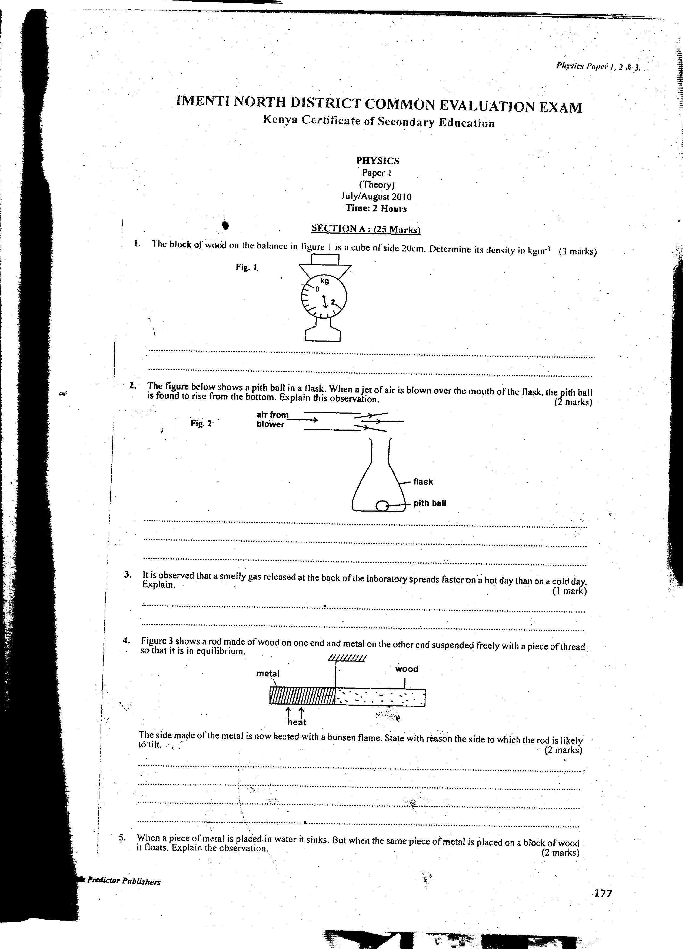

- The diagram below shows a pith ball in a flask. When a jet of air is blown over the mouth of the flask, the pith ball is found to rise from the bottom. Explain this observation (2mks)

- It is observed that a smelly gas released at the back of the laboratory spreads faster on a hot day than on a cold day. Explain (1mk)

- The diagram below shows a rod made of wood on one end and metal on the other end suspended freely with a piece of thread so that it is in equilibrium

The side mad of the metal is now heated with a Bunsen flame. State with reason the side to which the rod is likely to fit (2mks)

- When a piece of metal is place in water it sinks. But when the same piece of metal is placed on a block of wood it floats explain the observation (2mks)

- A bullet traveling at a speed of 100ms⁻¹ strikes a wall and penetrates 2cm. How long does the bullet take to stop after striking the wall? (3mks)

- A balloon of volume 1.5cm³ containing helium gas at a pressure of 3.0 x 106pa is released from the ground when the temperature is 20°C. What will be the pressure when it reaches a point where the volume becomes 3.0m and the temperature 5°C (3mks)

- Explain why mercury forms a convex meniscus and water a concave meniscus in a tube (2mks)

- A force of 3500N acts on a stationary body of mass 20kg for 0.02 seconds. Calculate the velocity attained by the body (2mks)

- The diagram below shows two identical iron rods, one is placed on a wooden block and the other on a metal block. The ends of the rods are heated as shown.
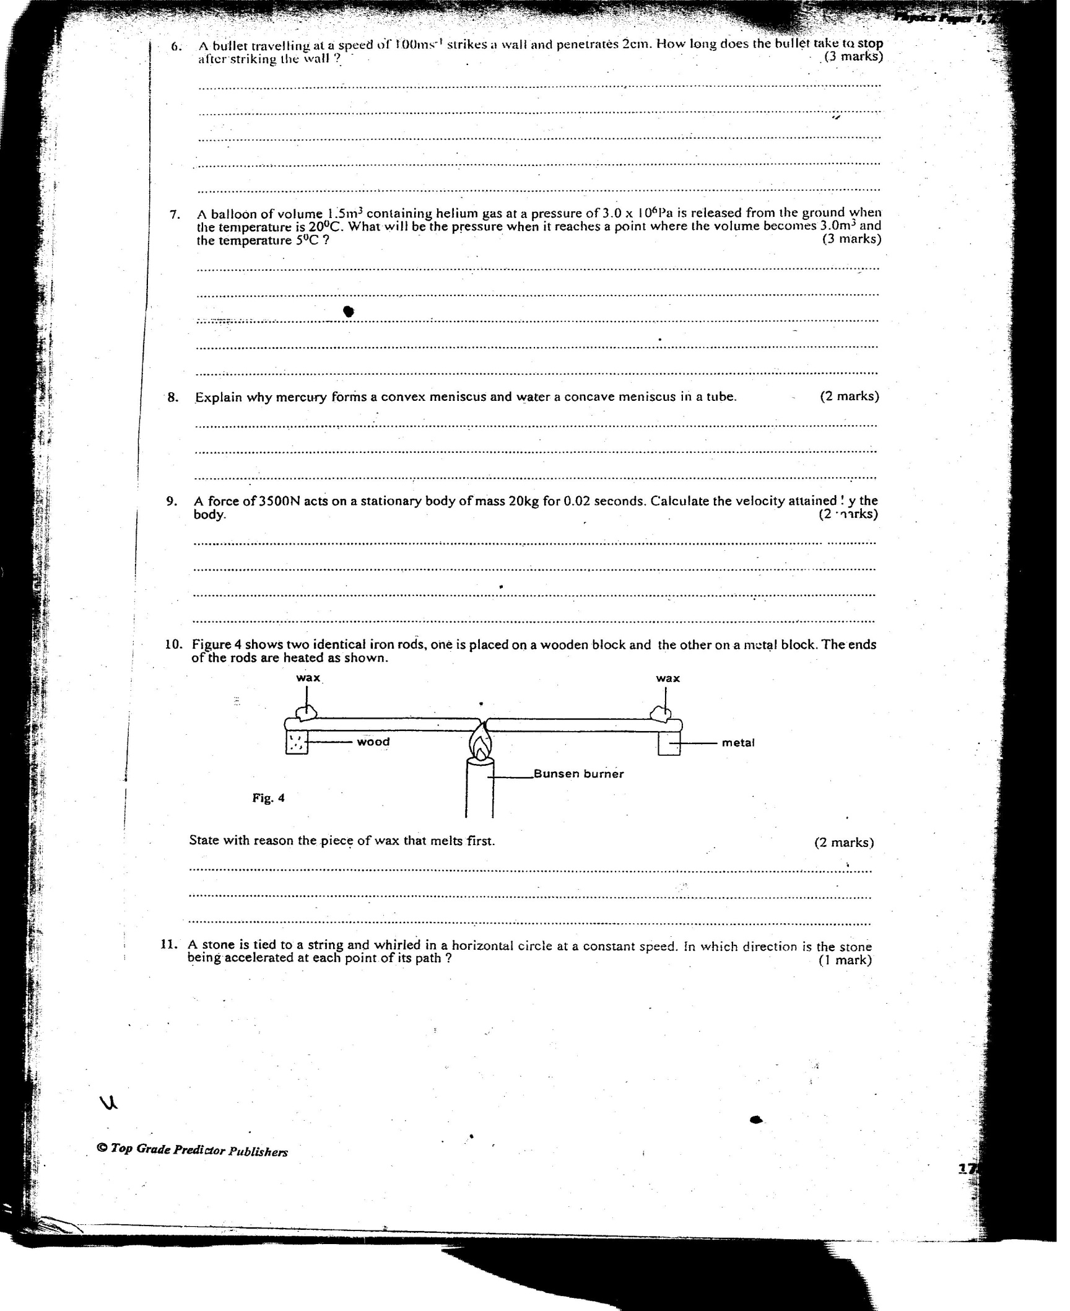
State with reason the piece of wax that melts first (2mks)

- A stone is tied to a string and whirled in a horizontal circle at a constant speed. In which direction is the stone being accelerated at each point of its path? (1mk)

- A force of 2.0N compresses a spring by 1.0mm. Determine the energy stored in the spring

SECTION B 55MKS
- a) Define the term ‘velocity’. (1mk)
b) The following figure shows velocity –time graph for the journey of a car in 100minutes.

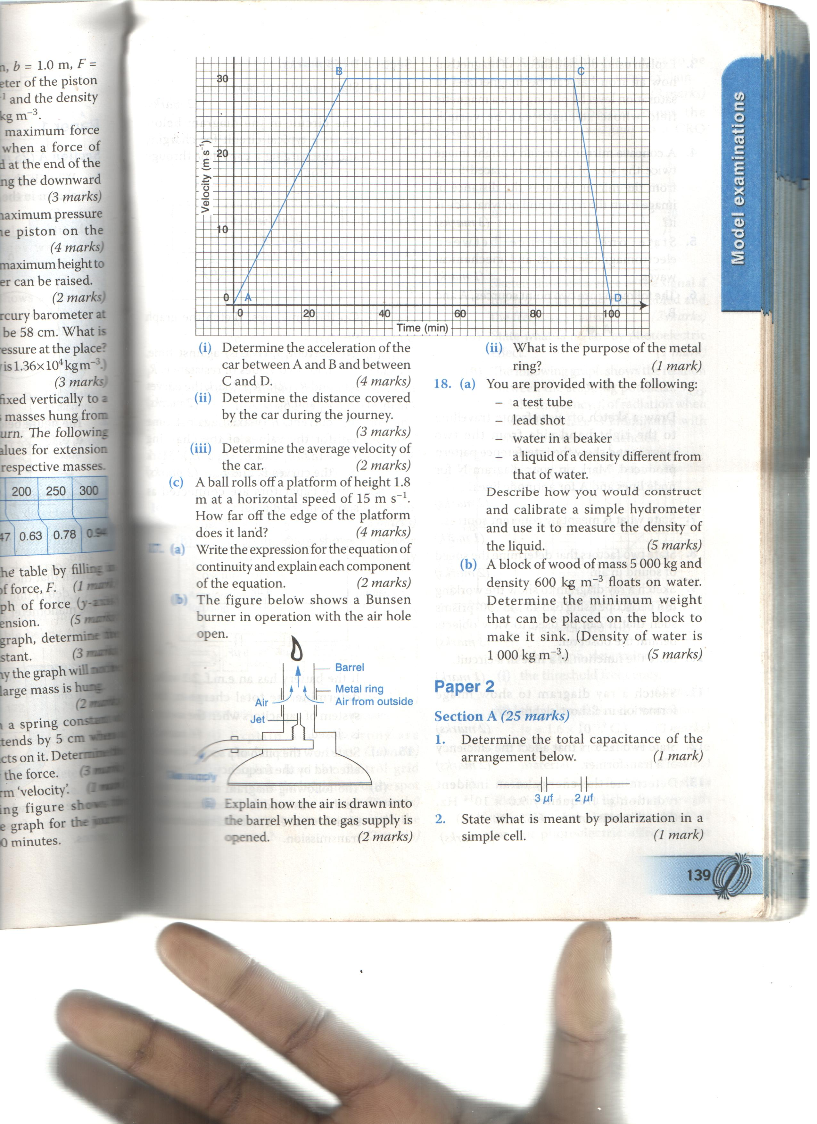

- Determine the acceleration of the car between A and B and between C and D (4mks)

- Determine the distance covered by the car during the journey (3mks)

- Determine the average velocity of the car (2mks)

c) A ball rolls off a platform of height 1.8m at a horizontal speed of 15 ms⁻¹. How far off the edge of the platform does it land? (4mks)

- A car of mass 2000kg travelling at 5ms⁻¹ collides with a minibus of mass 5000kg travelling in the opposite direction at 7ms⁻¹. The vehicles stick and move together after collision. If the collision lasts for 0.1seconds;

- Determine the velocity of the system after collision of 3 decimal places. (3mks)

- Calculate the impulsive force on the minibus (3mks)

- Calculate the change in kinetic energy of the system (3mks)

- Explain the change in kinetic energy of the system (1mk)

- a) What is the difference between longitudinal and transverse waves? (2mks)

b) The following figure shows a transverse wave travelling along the x-axis.
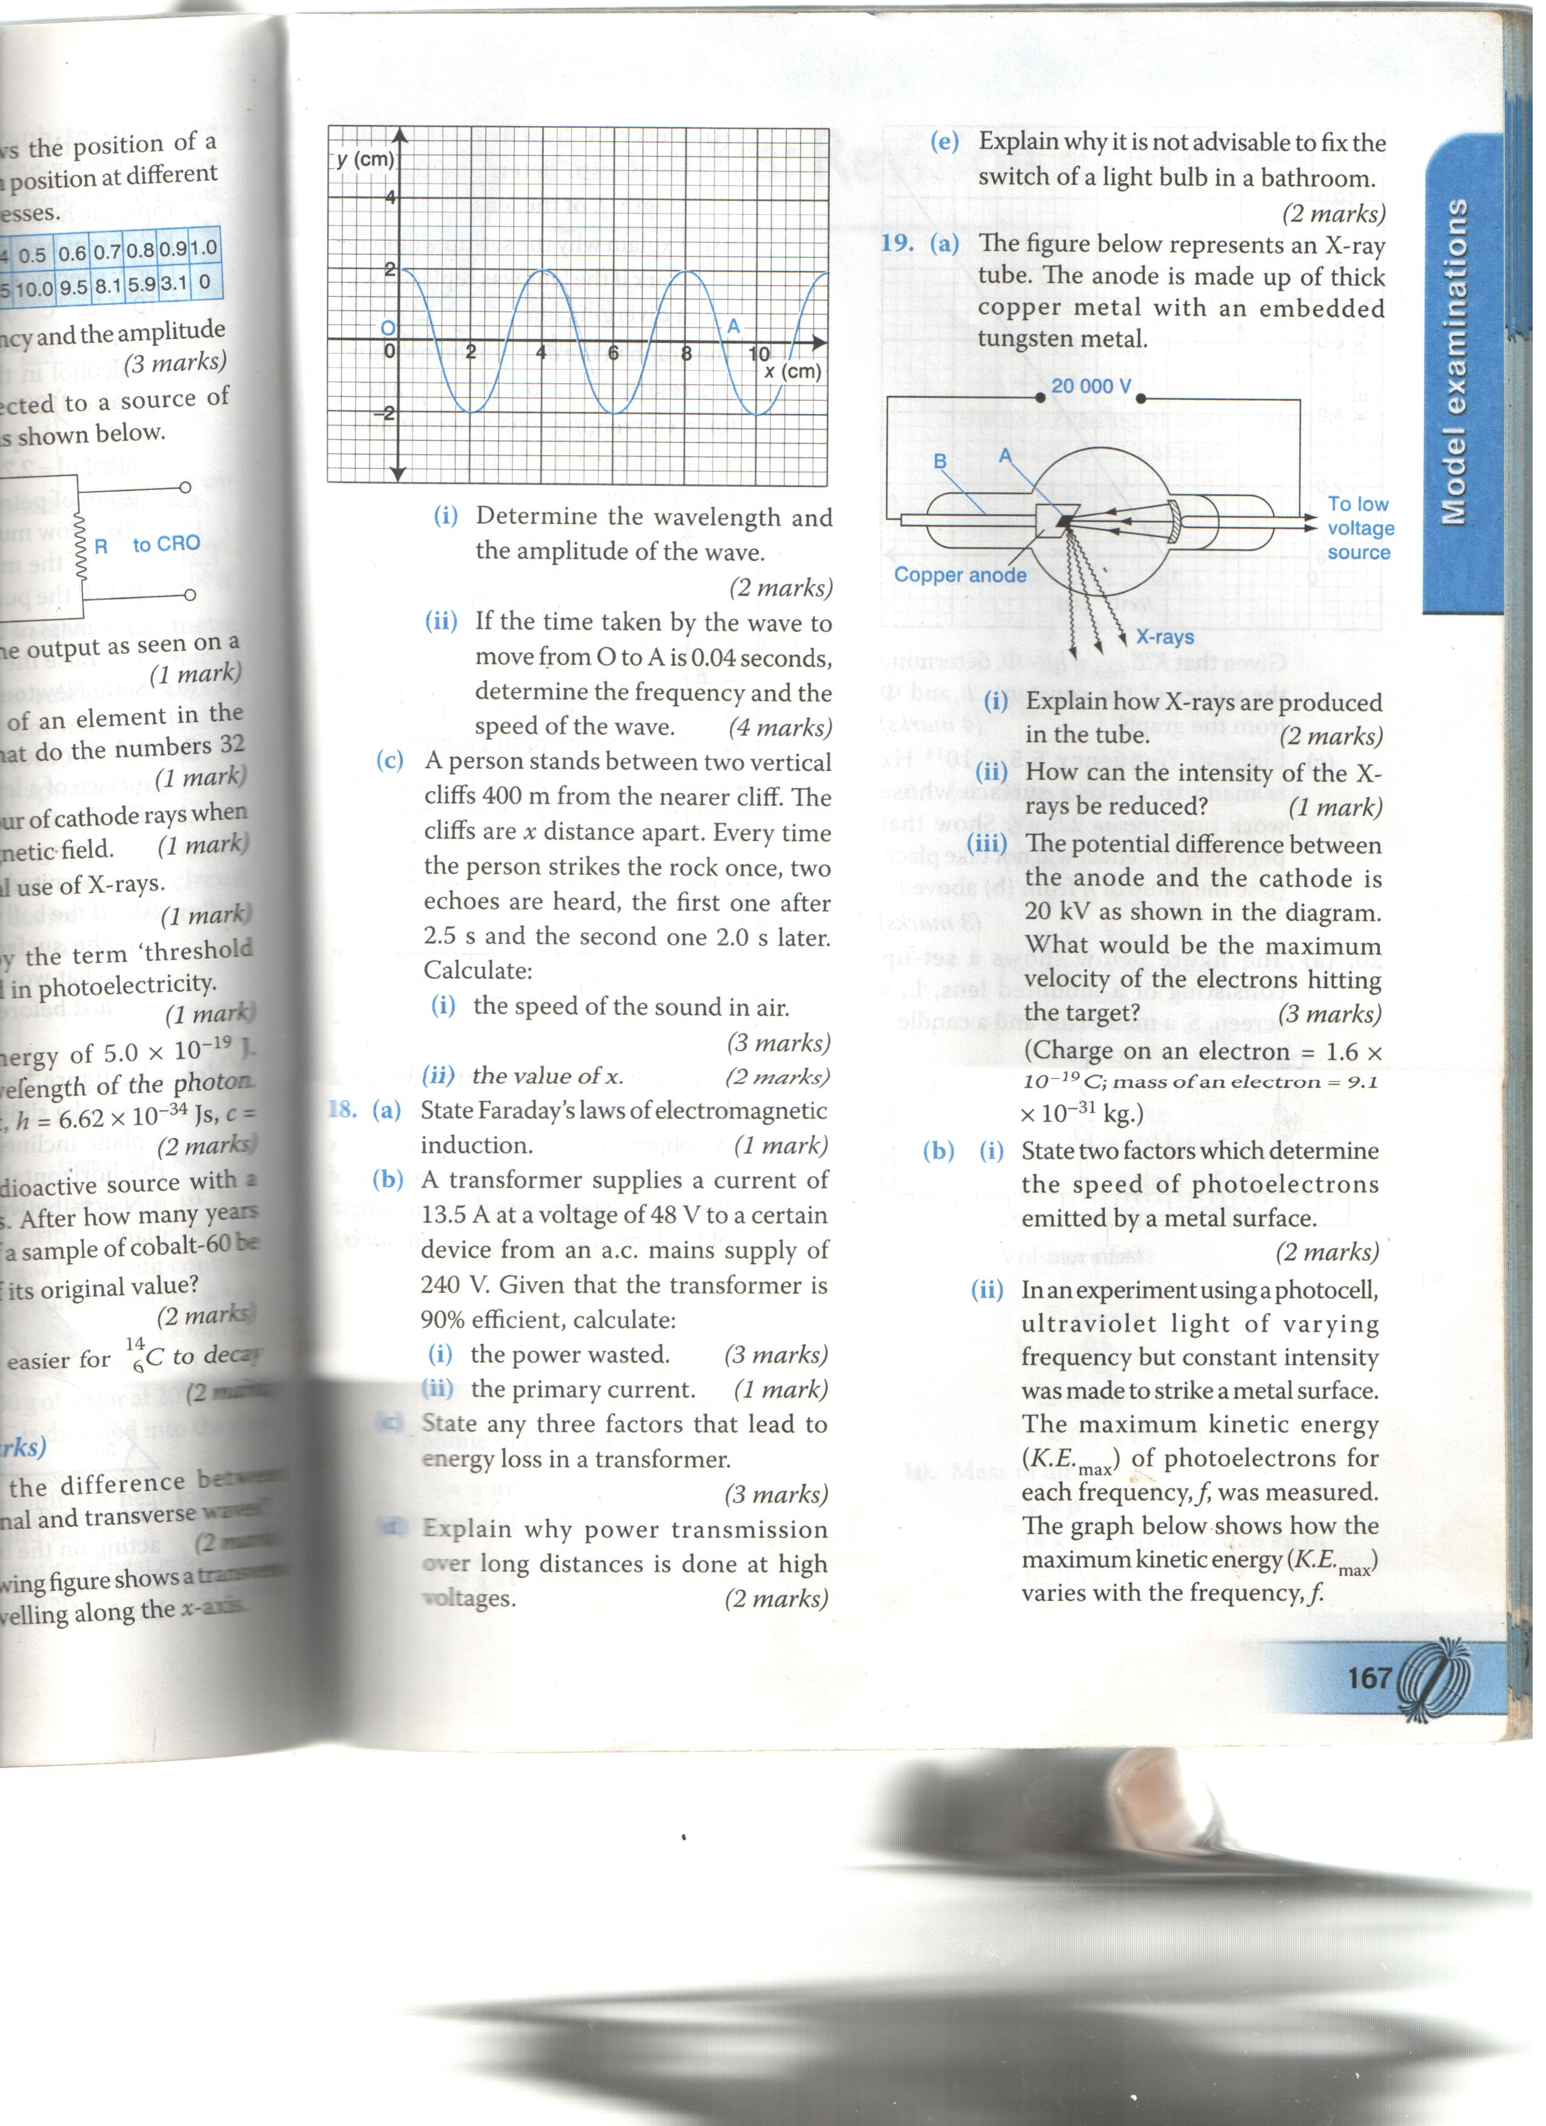
- Determine the wave length and the amplitude of the wave. (2mks)

- If the time taken by the wave to move from O to A is 0.04 seconds, determine the frequency and the speed of the wav (4mks)

c) A person stands between two vertical cliffs 400m from the nearer cliff. The cliffs are x distance apart.
Every time the person strikes the rock once, two echoes are heard, the first one after 2.5s and the second one 2.0 s later. Calculate
- the speed of the sound in air (3mks)

- the value of x (2mks)

- a) The following figue shows an object, O, 3cm high placed in front of a concave mirror. C is the centre of curvature mirror. C is the centre of curvature of the mirror.
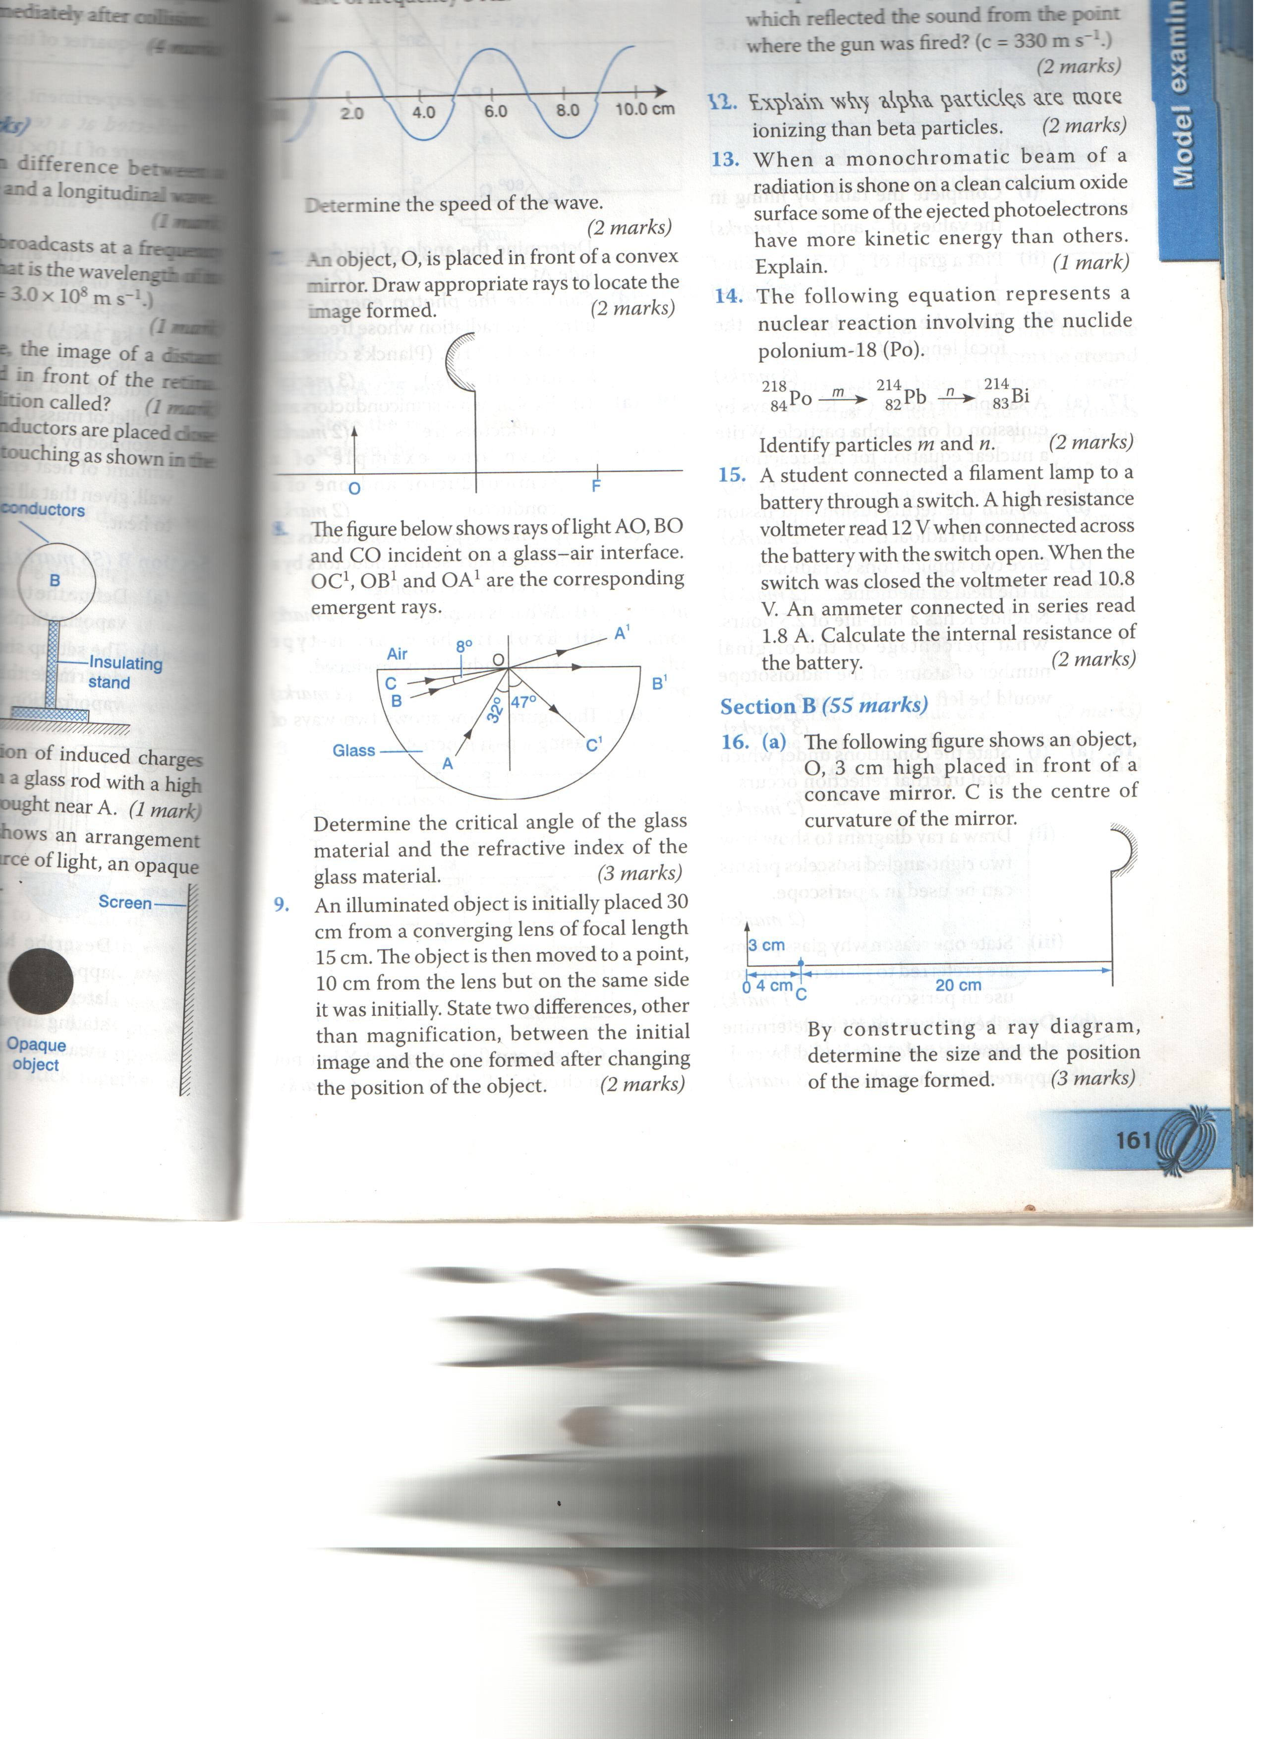

By constructing a ray diagram, determine the size and the position of the image formed. (3mks)

b) The table shws the object distance, u, and the corresponding image distance v, for an object placed in front of a concave mirror.
u (cm) | 20 | 25 | 30 | 40 | 50 | 70
v(cm) | 20 | 16.7 | 15 | 13.3 | 12.5 | 11.6
(cm⁻¹)
(cm⁻¹)

- Complete the table by filling in the values of and (2mks
- plot a graph of (y-axis) against (5mks)
- From the graph, determine the focal length of the mirror. (3mks)

- The figure 6 shows a transverse wave travelling along the horizontal axis
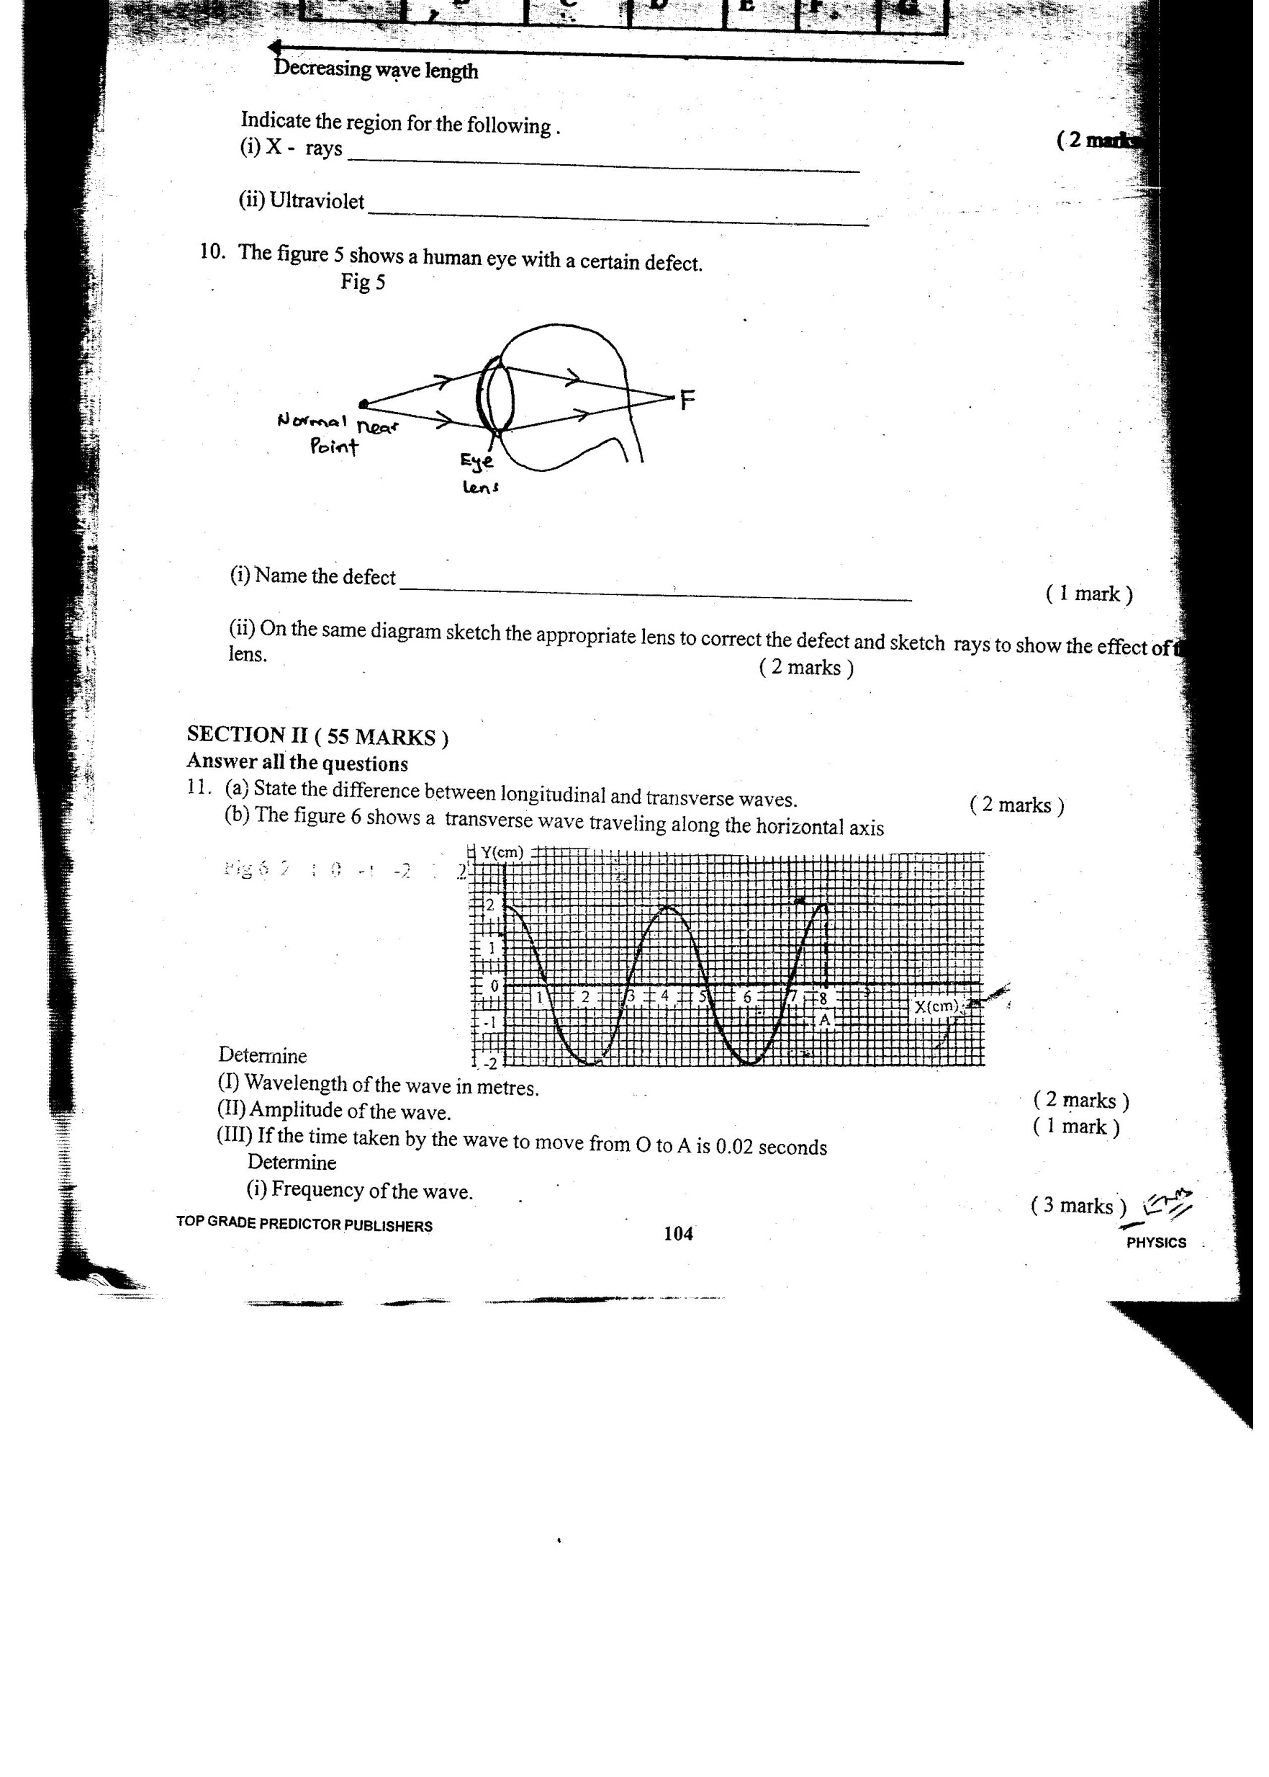

determine
- Wave length of the wave in metres (2mks)

- Amplitude of the wave (1mk)

- If the time take by the wave to move from O to A IS 0.02seconds Determine frequency of the wave (3mks)

