13. EXTERNAL LAND FORMING PROCESSES
The topic entails ;-
- Definitions of :
- Weathering
- Mass weathering
- Hydrological cycle and action of rivers
- Oceans, Seas and their Costs
- Action of wind and water in Arid areas
- Action of water in Limestone areas
- Glaciation
- Lakes
- Distinguishing between oceans and seas
- Description of water movements in oceans and seas
- Explaining the external land forming processes and the resultant features
- Identifying the sources of under ground water
- Discussing the significance of the resultant physical features to the environment
- Carrying out field work of land forms within the local environment

1. (a) Name two rivers in Kenya West of the Rift Valley that cause frequent flooding
(b) State three factors that lead to frequent flooding in the Lake region of Kenya

2. (a) i) Other than seif dunes, name two other types of sand dunes
ii) Give five characteristics of seif dunes
iii) State four factors that facilitate the formation of the sand dunes
b) Describe how a desert rock pedestal is formed
c) Explain four positive effects of desert features to human activities

3. a) i)Give three reasons why there are no ice sheets in Kenya
ii) Explain three factors that influence the movement of ice from the place of accumulation
b) Describe the process through which the following features are formed.
i)an arête
ii) A crag and tail
c) Explain four positive effects of glaciation in lowland areas

4. a)i) Give the dates in a year during which the number of hours of darkness is equal in
both the north and the south poles
ii) Why do the lengths of days and nights vary from one part of the earth to another?
b) State two effects of the rotation of the earth on its axis

5. a)What is a lake ?
b) State three ways through which lakes are formed

6. a) i) What is desertification
ii) Differentiate between wind deflation and wind abrasion
iii) Describe how wind transports its materials through the following processes:
I) Saltation
II) Suspension
III) Surface creep
b) Describe how the following features are formed
i) Zeugens
ii) Oasis
7. a) State two ways in which glacier moves
b) State three differences between a young river valley and a glaciated valley

8. The diagram below represents the action of waves on the coastline. Use it to answer
questions (a) and (b)
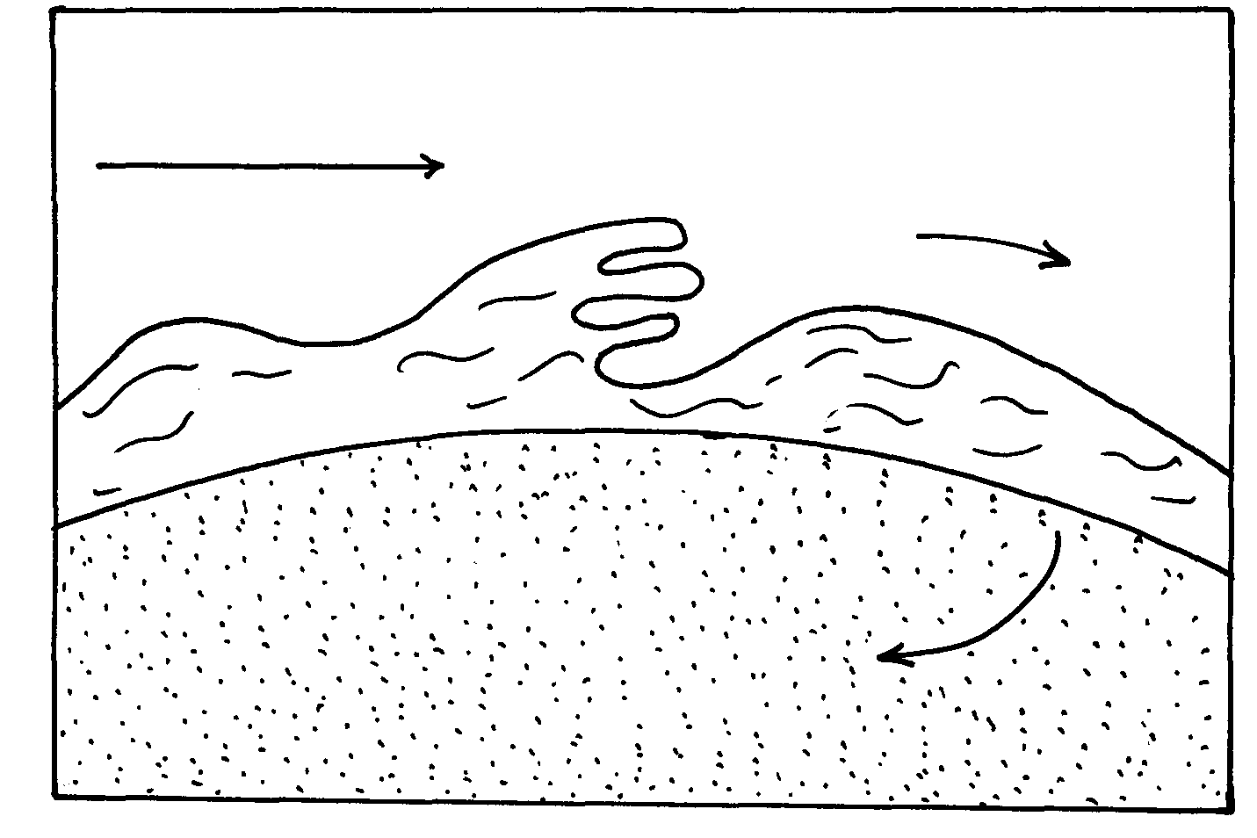

a) Name the features marked X and Y.
b) List three ways in which waves erode the coastline.

9. Name two sources of underground water.

10. a)i) What is chemical weathering
ii) State five factors that affect the rate of chemical weathering in equatorial regions
b) Explain the following chemical weathering process
i) Carbonation
ii) Hydrolysis
c) Explain four economic importance of weathering to physical and human environments

11. a) Name two types of tides
b) Give three ways in which the shape of the landmasses may influence movement of ocean
waters
(c) State four sources of underground of water
(d) State five ways in which springs occur
(e) Account for four ways in which desert vegetation adopt to the climate of their environment

12. (a) Hamada and Erg
(b) Explain three processes of wind erosion
(c) With the aid of well labeled diagrams, describe the formation of:
i) A Barchan
(ii) Rock pedestal
(iii) An oasis
(d) Name three features resulting from water deposition in desert
13. State three reasons why wind erosion is predominant in desert areas.
(b) Describe three processes by which wind erodes.
(c) With aid of well labeled diagrams, describe the formation of the following desert features;
(i) Rock pedestal.
(ii) Zeugen.
(d) State four ways in which desert land forms influence man’s activities.
14. (a) Differentiate between oceans and seas.
(b) Explain three sources of salinity in the oceans .
(c) State three features on the ocean floor.

15. (a)(i) What is the difference between a sea and an ocean?
(ii) Explain any three ways in which islands are formed.
(b) (i) Describe how Lake Victoria was formed.
(ii) Explain any three ways in which Lake Victoria has influenced the climate of
surrounding areas
(c) (i) Distinguish between aridity and desertification
(ii) Explain any three physical causes of aridity and desertification

16. (a) (i) What is chemical weathering?
(ii) Name any three surface features that result from carbonation.
(b) The diagram below shows a feature resulting from weathering. Use it to answer the
questions that follow:-
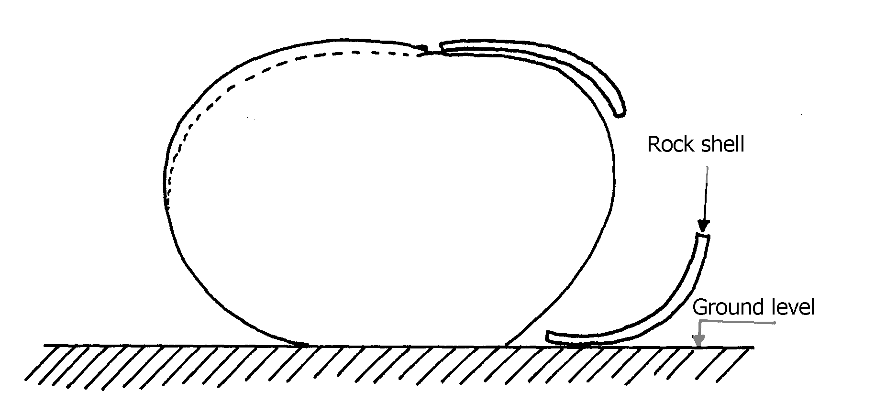

(i) What is the name of the feature?
(ii) Describe how the feature is formed.
17. (a) Differentiate between a river system and a river regime.
(b) The diagram below shows a drainage pattern. Use it to answer the questions that follow:-

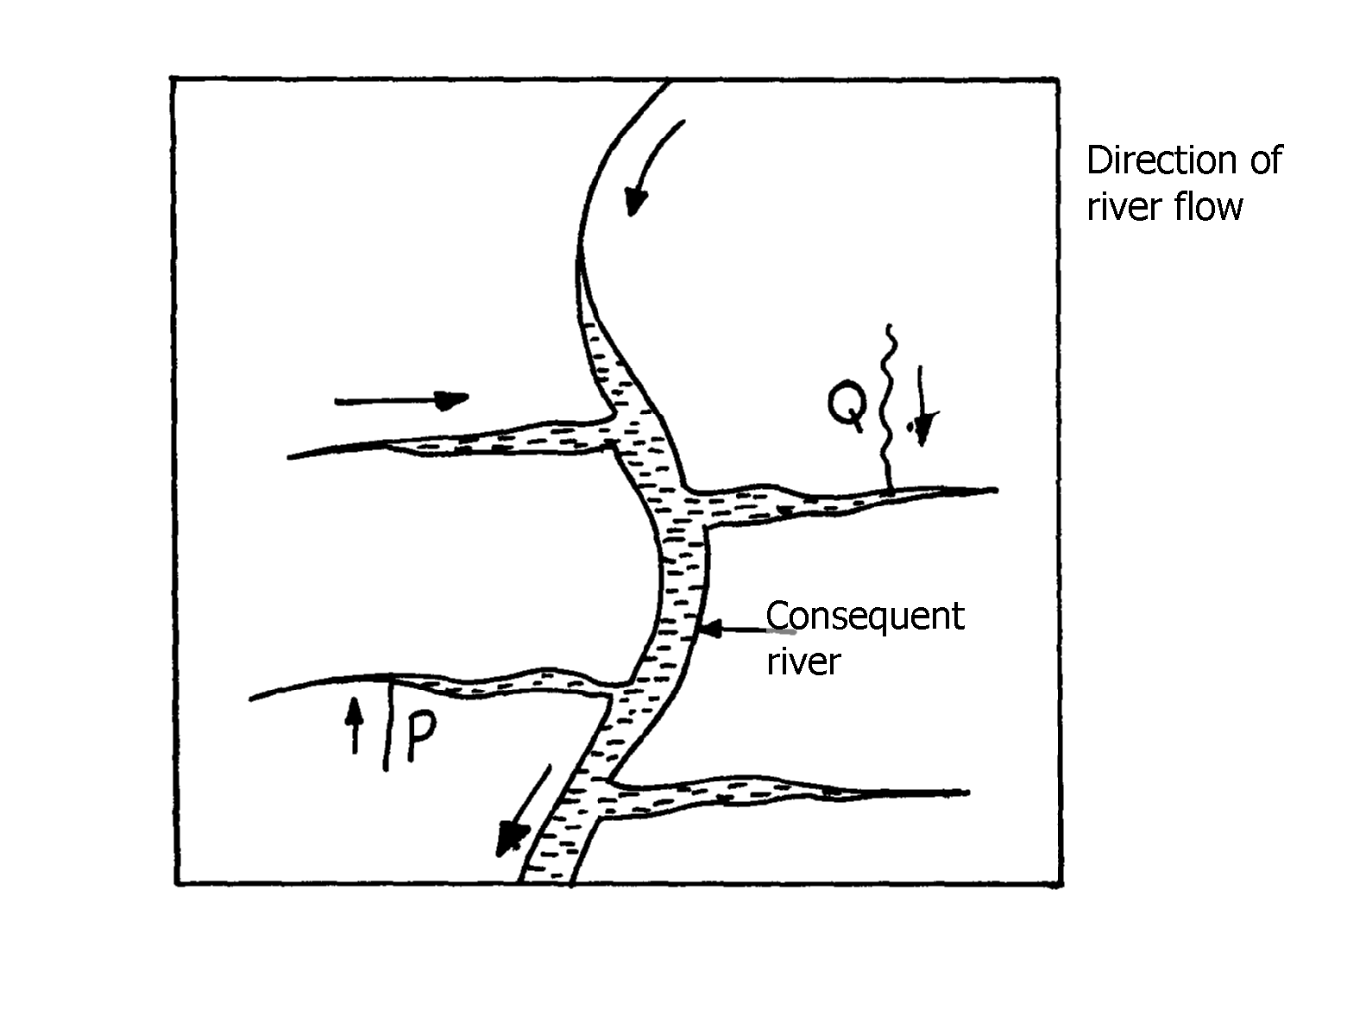

(i) Name the drainage pattern.
(ii) Name the parts labelled P and Q

18. (a) Name any two features deposited by glacier in lowland areas.
(b) Describe how a roche moutonee is formed.

19. (a) The diagram below shows zones of underground water. Use it to answer the questions
that follow:-

(i) Name the parts labelled U and V.
(ii) Name the surface water feature likely to form at the part labelled W.
(b) Explain how the nature of underground rocks influences the existence of underground water

20. (a) (i) State two ways in which wind erodes the surface of the earth
(ii) Explain three ways thorough which wind transports its load
(b) Using well labeled diagrams, describe how the following desert features re formed:-
(i) Zeugen
(ii) Rock pedestal
(c)(i) Give the name given to rocky desert in the Sahara
(ii) Explain three positive effects of desert features to both human and physical environment

21. (a) What is a lake?
(b) (i) Name two types of lakes formed due to vulcanicity
ii) explaining how lake Victoria has influence the climate of the surrounding area
(c) (i) State four main reasons why lakes within the Rift valley are salty
(ii) Name any three fresh water lakes in Kenya which are within the rift valley
(d) Explain any four economic significance of lakes to Human activities

22. (a) Name three types of tides
(b) Differentiate between oceans and seas

23. (a) (i) Differentiate between aridity and desertification
(ii) Describe three ways through which wind erodes the desert areas
(b) Using well labelled diagrams describe how the following desert features are formed:
(i) Rock pedestals
(ii) Yardangs
(c) State five uses of desert features

24. (a) State four factors which may cause a waterfall to form
(b) (i) Describe how river braids are formed
(ii) Name three features resulting form river rejuvenation
(c) Describe how a river capture occurs
(d) Give two reasons as to why Lake Naivasha is a fresh water lake

25 . Give three ways through which rocks may be metamorphosed

26. (a) (i)State two processes though which the wind erodes the surface.
(ii) Explain three ways though which wind transport its load
(b) Describe how the following desert features are formed :
(i) Oasis
(ii) Zeugen
(c) Explain four ways in which desert land forms are of significance to human activities

27. (a) (i)Name two ways in which ice moves
(ii) State two factors which facilitate the movement of ice
(b) Identify two erosional features in glaciated lowlands
(c) Describe how the following features are formed:
(i) Outwash plain
(ii) Moraine-dammed lake
(d) Explain four ways in which a glaciated landscape is of significance to human activities

28. (a) Differentiate between mechanical and chemical weathering
(b) State three factors which influence weathering

29. a) Differentiate between a spring and well.
b) With aid of a well labeled diagram, show the three Zones of ground water.
c) List four candidates necessary for the formation of an artesian well.
d) Explain three ways in which ground water is of significant to human activities.
e) i) Define the term Karet scenery
ii) Give two conditions for the development of Karet landscape
iii) Outline the significance of Karet landscape to human activities.

30. (a) Use the diagram below to answer the following questions
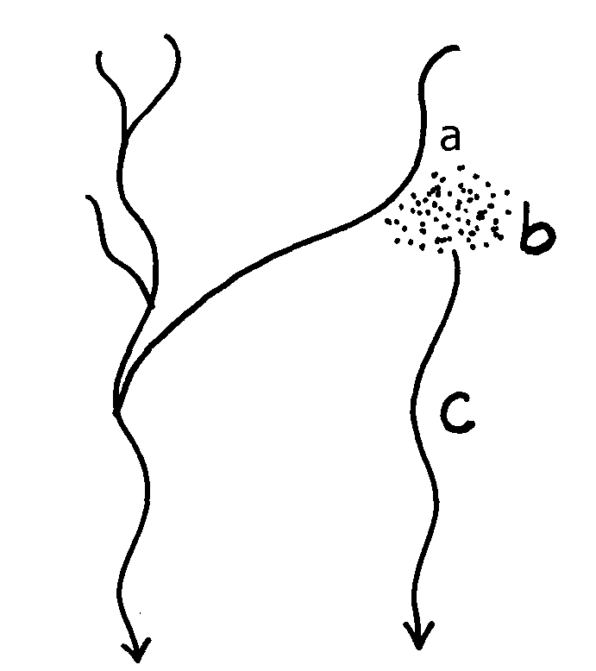

(i) Name the parts labelled :-
(ii) State four causes of river rejuvenation

31. a i) Differentiate between denudation and mass wasting.
ii) Explain two reasons why chemical weathering is dominant in humid tropics.
b) Explain three factors that influence mass wasting.
c) With aid of a diagram, explain the process of solfluxion.
d) i) State four negative effects of mass wasting.

Name the:
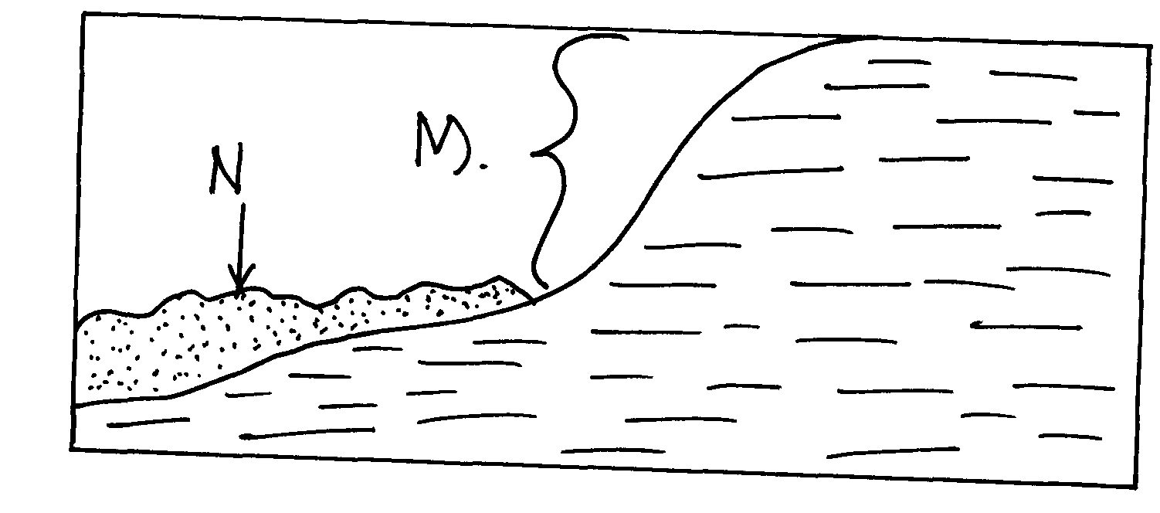
i) Type of mass movement shown

iii) Features M and N
iv) State the factor that influenced the process above

32 a) State three reasons why wind is a major agent of land sculpture in the desert.
b) Explain any two processes of wind erosion in deserts.
c) With and of well labeled diagram, explain how a deflation hollow is formed.
d) State four characteristics of a seif dune.

33. a) State two causes of coastal submergence.
b) Name three conditions necessary for the growth of coral polyps.

34 a) State two ways in which wind transport it’s load
b) Highlight the factors that influence the formation of a desert sand dune

35. a) Name three sources of lake water.
b) State three factors that determine the size of a lake.

36. a) i) What is a river?
ii) Distinguish between a river confluence and a river tributary
b) Describe how a river erodes its channel by the following processes
i) Hydraulic action
ii) Abrasion
37. a) Describe the process of a river capture
b)State five characteristics of a flood plain

38. a) i) Name four features resulting from water action in deserts
ii) State three factors which contribute to the development of deserts
iii) Name three types of deserts according to the nature of their surfaces
b) i)Explain three factors which influence wind transportation in deserts
ii) How is an oasis formed?

39. (a) What is the difference between swash and backwash
(b) Why is wave cut platform and cliff line in Mombasa found above the sea level?

40. (a) Define the term river capture
(b) The diagram below shows a river capture, name the features marked X, Y, Z

41. (a) Differentiate between accordant and discordant drainage systems
(b) State three factors that facilitate formation of deltas

42. a) i) What is a desert
ii) Name three types of desert landscapes
b) i) Name two processes of wind erosion responsible for sculpturing desert landscapes
ii) Using well labeled diagrams describe how a zeugen may be formed
c) i) Name four desert landforms found in deserts associated with the action of water
ii) What is the significance of desert landforms

43. (a) (i)Name three processes of wind erosion in desert
(ii) State three factors which influence the rate of wind transportation
(b) With the help of a well labeled diagram describe the formation of the following features:-
(i) Rock pedestal
(ii) Oasis
(c) (i)List three external land forming processes which lead to the formation of lakes
(ii) Explain three ways in which lakes influence the natural environment
(d (i) With the aid of a well labelled diagram, Describe how limestone pillars are formed
in Karst scenery
(ii) Explain three significance of resultant feature in limestone areas to human activities

