CROP PRODUCTION III
NURSERY MANAGEMENT PRACTICES

This topic entails the following:
- A nursery bed
- A nursery bed and a seed bed
- Reasons of establishing nursery bed
- Suitable site for nursery bed
- Nursery bed preparation
- Nursery bed management practices
- Transplanting seedling crops from nursery bed
- Budding a seedling
- Grafting a seedling
- Reasons for budding, grafting and layering
- Tissue culture
- Damage caused by animals to a seedling and prevention.

The following relevant questions and their answers in this topic will greatly help and motivate the user to comprehend and understand the required concepts and practices.

1. Name three methods of grafting that are used in propagation of plants
2. State two practices done during hardening-off of seedlings in a nursery bed.
3. List two methods of budding used in crop propagation
4. List four management practices carried out on a nursery bed
5. Outline two importance of tissue culture in crop propagation
6. Differentiate between a nursery bed and a seedling bed
7. Give four advantages of under sowing in pasture production
8. Give four advantages of under sowing in pasture production
9. The diagram below shows a structure used in crop production:
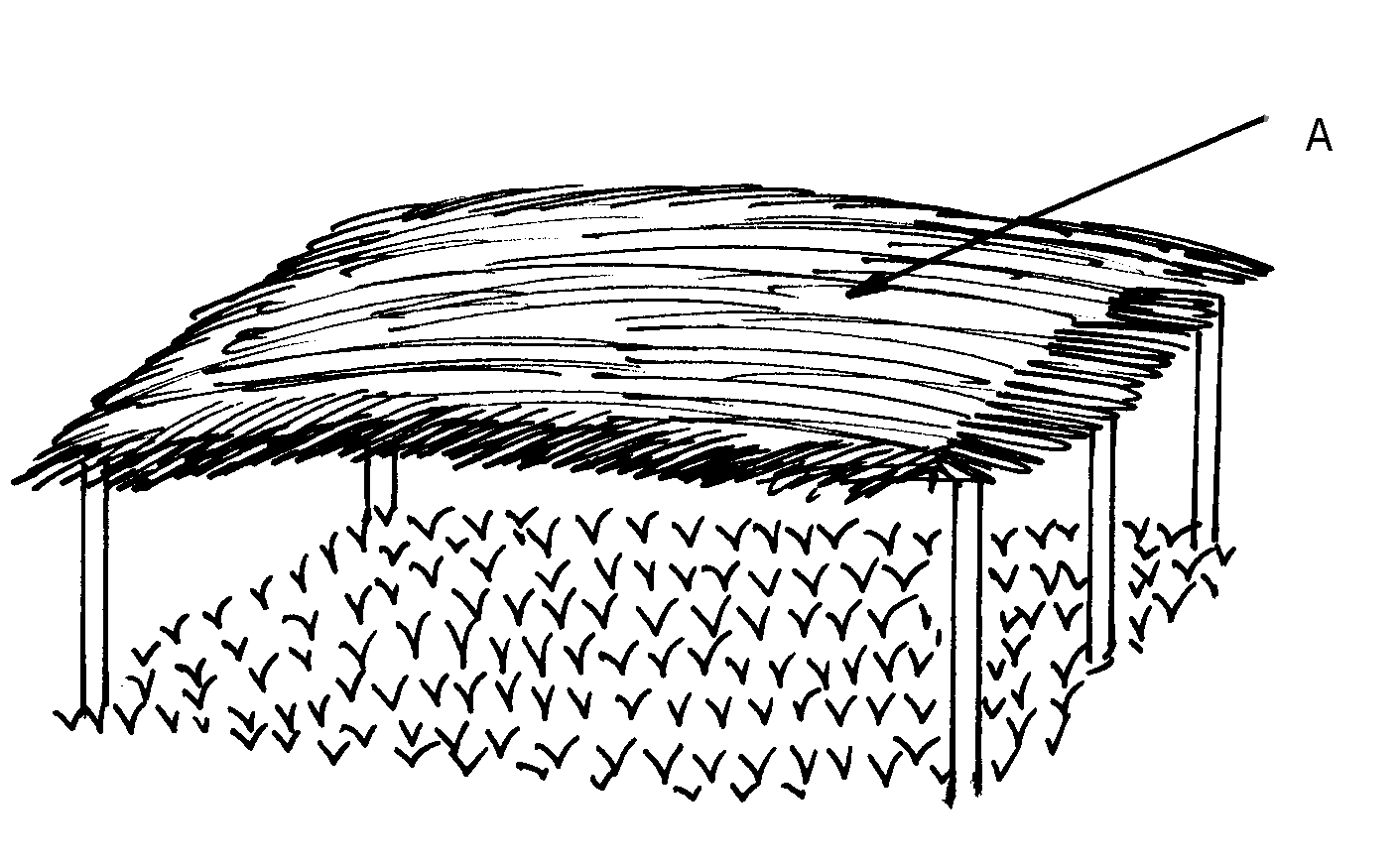

(a) Identify the structure above
(b) Give a reason for carrying out each of the following practices in the structure shown above
(i) Pricking out
(ii) Hardening off
(c) State three importance of the part labeled A in the above structure
10. (a) Describe the siting and establishment of a crop nursery
(b) Explain management practices in a crop nursery
11. State four importance of thinning seedlings in the nursery bed
12. State the difference between a seedling bed and a seedbed.
13. Below is a diagram of a nursery for raising the seedlings
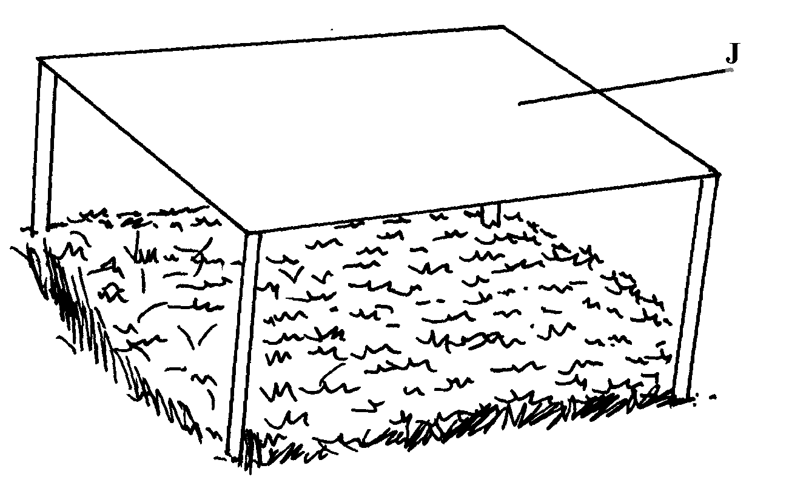

(a) State two advantages of having the part labeled J
(b) State any three management practices that should be carried out on the nursery from the time
seedlings emerge to the stage of transplanting

