CHEMISTRY FORM 1
END OF TERM 1
Answer All the questions in the spaces.
- a) What is a drug? (2 mks)

b) What is drug abuse? ( 2mks)

c) One of the effects of drug abuse is hallucination. What does this term mean. ( 2mks)

d) Name three frequently abused drugs? ( 3mks)

- Distinguish between a conductor and a non-conductor and give and example in each. ( 3mks)

- The diagram below shows the relationship between the physical states of matter.Study it and answer the questions that follows.
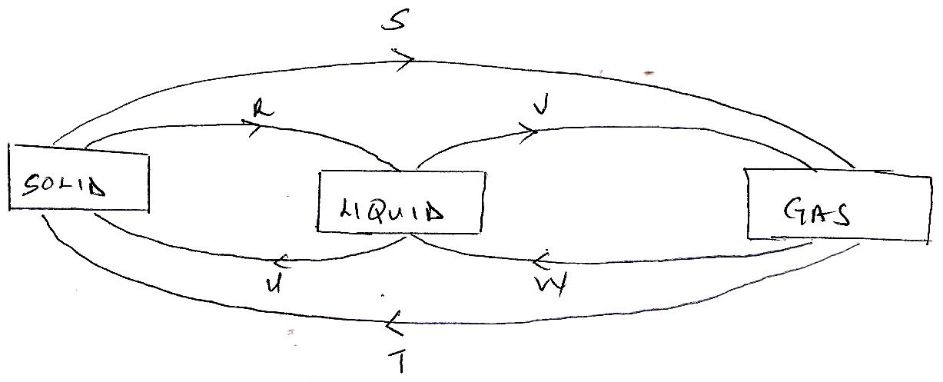

- Identify the process R,V,W and U ( 4 mks)

- Name three substances which can undergo the process represented by process S and T.( 3mks)

- The table below shows liquids that are miscible and those that are immiscible
Liquid L3 L4
L1 Miscible Miscible
L2 Miscible immiscible

Use the information given to answer the questions that follow.
- Name the method that can be used to separate L1 and L3 from a mixture of the two. ( 1mk)

- Draw and name an apparatus that can be used to separate a mixture of L2 and L4.( 3mks)

- Give two reasons why most Laboratory apparatus are made of glass.( 2mks)

- Name three sources of heat beside Bunsen burner in the laboratory.( 3mks)

- a) Draw a labeled diagram of a non-luminous flame produced by the Bunsen burner.( 4mks)

- State two reasons why a non-luminous flame is preferred for heating.( 2mks)

- After use a non-luminous flame should be put off or adjusted to a luminous flame. Explain. (2mks)

- Name three apparatus that are used to measure accurate volume of liquids. ( 3mks)

- Distinguish between an element and a compound and give an example of each. ( 3mks)

- By use of a diagram between a residue and a filtrate. ( 2mks)

- Name the method you would use to separate the following mixtures.
- Sand and ammonium chloride.( 1mk)

- Oil and Water. ( 1mk)

- Kerosene and crude oil ( 1mk)

- Salt and water.( 1mk)

- Describe how you would separate a mixture of salt,sand and iodine into different components.( 3mks)

- State the functions of the following apparatus as used in the laboratory.
- Spatula (1mk)
- Pine-clay triangle ( 1mk)

- Wire gauze ( 1mk)

b Draw and state the use of a deflagrating spoon.( 3mks)

- State the two causes of accidents in a Chemistry laboratory.( 2mks)

- Define the following terms
- Solvent extraction ( 2mks)

- Hydrated salt ( 2mks)

- Saturated Solution 2mks)

- State two functions of a fume cupboard as found in a chemistry laboratory. ( 2mks)

- Explain the differences between solid and gaseous states using the theoretical model of matter in terms of the Kinetic theory. ( 3mks)

- The diagram below represents a paper chromatogram for three brands of juices suspected to contain banned food colourings.
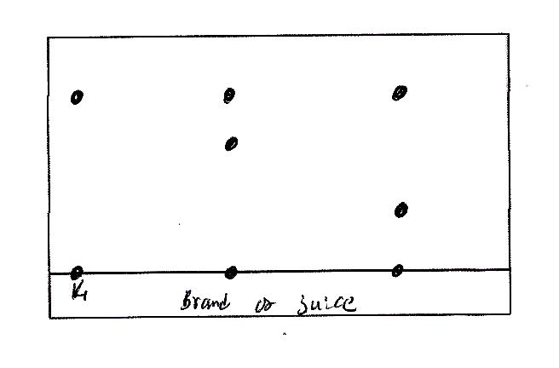

The results showed the presence or banned food colourings in L and M only.
- On the same diagram
- Circle the spots which show the banned food colourings. ( 2mks)

- Show the solvent front. ( 2mks)

- State two factors that determine the position where the pigments are deposited in the paper chromatogram from the point of origin. ( 2 mks)

- Classify the following processes as either chemical or Physical process type of change ( 3mks)
- Heating copper(ii) sulphate crystals

- obtaining Kerosene from crude oil

- Souring of milk.

- The figure below shows a heating curve of a certain pure solid.
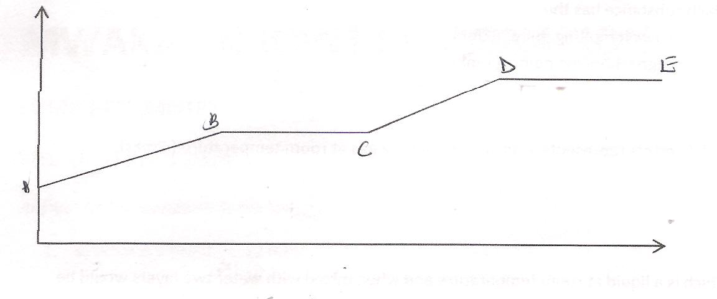

- What is happening at the stages represented by BC and CD ( 4mks)

- On the diagram draw a heating curve of an improve substance. ( 2 mks)

- Common table salt is contaminated with copper (ii)oxide. Explain how Pure sodium Chloride can be obtained from the mixture. ( 3mks)

- The table bellows gives information on some substances. Use it to answer the question that follows.
Substances Melting Point ºC Boliling point ºC Solubility in water
A - 177 78.5 Very Soluble
B -23 77 Insoluble
C -219 -183 slightly soluble
D -78 -33 Soluble

- Which substance has the
- Lowest melting point ( 1mk)
- Highest boiling point (1 mk)

- Which letters represents a substance that is a gas at room temperature.( 2mks)

- Which is a liquid at room temperature and when mixed with water two layers would be formed.( 1 mk)

- Which substance dissolves in water and could be separated from the solution by fractional distillation.( 2mks)

- a) Give the symbols of the following elements ( 3mks)
- Sodium

- Calcium

- Potassium

- Name the elements presents in the following compounds ( 2mks)
- Zinc sulphide

- Sodium oxide.

