CHEMISTRY PAPER 1 FORM FOUR.
ANSWER ALL THE QUESTIONS.
- State two reasons why we use the non-luminous flame for leading in a laboratory instead of using the luminous flame. (1mk)

- Chlorine has two isotopes with atomic mass 35 and x occurring in the ratio 3:1 respectively. The relative atomic (R.M.A) OF CHROLINE IS 35.5. Determine the value of x. (3mks)

- The use of cfc₅ has been linked to the depletion of the ozone layer.
- What does CFC stand for? (1mk)

- Explain the problem associated with the depletion or the ozone layer. (1mk)

c) State another environmental problem caused by CFC₅.

- In an experiment to prepare Nitrogen C1) oxide, ammonium nitrate was gently heated in a flask.
- Write the equation for the reaction that took place in the flask. (1mk)

- State and explain how the gas was collected. (1mk)

- A sample of the gas was tested with damp blue and red litmus paper what observations were made. (1mk)

- During an experiment sulphure (IV) oxide gas was formed to diffuse through a certain pore at a rate of 25cm3 per minute. When the experiment was repeated under the same conditions with another gas G, gas G was found to diffuse through the same pore at a rate of 26.26cm³ per minute. Work out the molecular mass of Gas G. (0=16, 5=32) (3mks)

- Element Y whose atomic number11 react with chlorine gas to form a compound.
- Name the group and period to which Y belongs. (1mk)

- Write an equation for the reaction. (1mk)

- Draw all structural formulas for all the isomers with molecular formula C₂H₃CL_{3.} (2MKS)

- Calculate the volume of 0.6M sulphuric (VI) acid solution needed to neutralize 30cm³ of 0.2M potassium hydroxide. (2mks)

- Use dot (.) and crosses (x) to show the bonding of the following compounds.
- NH₃ (1MK)

- NH₄⁺ (1MK)

- Analysis of a compound showed that it had the following composition: 69.42%carbon, 4.13% hydrogen and the rest oxygen. If the molecular formula of the compound (C=12, O=16, H=1) (3MKS)

- A reference book states that the solubility of CuSO₄ in water at 15ºc is 19g/100g of water. What is meant is meant by this statement. (1mk)

- State two uses of hydrogen gas. (2mks)

- Explain how a solid mixture of sulphure and potassium Chloride can be separated into solid sulphur and potassium chloride. (3mks)

- Aqueous ammonia was added to a solution copper (ii) sulphate dropwise until in excess. State the observations made when
- A few drop of aqueous ammonia were added.(1mk)

- Excess aqueous ammonia was added. (1mk)

- By use of chemical equations distinguish the reaction of magnesium with water and magnesium with steam. (2mks)

- The table below gives the number of electrons, protons and neutrons in substances X, Y, and Z.

Substance | Electrons | Protons | Neutrons
X | 10 | 10 | 10
Y | 10 | 8 | 10
Z | 8 | 8 | 8
- Which letter represents an ion? (1mk)

- Which of the substances are isotopes? Give a reason. (2mks)

- a) What is meant by the terms.
- Element (1mk)

- Atomic number (1mk)

- The formula for a chloride of titanium is Ticl₃. What is the formula of its sulphate? (1mk)
- The chart below shows a scheme or reactions involving a sample of solution N. Study it and answer the questions that follow.
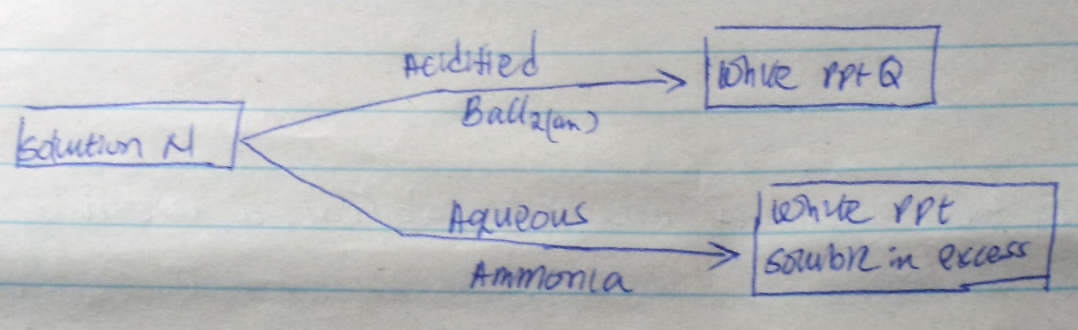
- Identify the cation and the anion in solution N, (2mks)

- Write an ionic equation to show how Q is formed. (1mk)

- Name the process
Solid carbon (IV) oxide (dry ice) changes directly into gas. (1mk)

- When carbon (IV) oxide gas was passed through aqueous calcium hydrogen a white precipate was formed.
- Write an equation for the reaction that took place. (1mk)

- State and explain the changes that would occur when excess carbon (iv) oxide gas is bubbled through the white precipitate. (2mks)

- Give the names of the following compounds
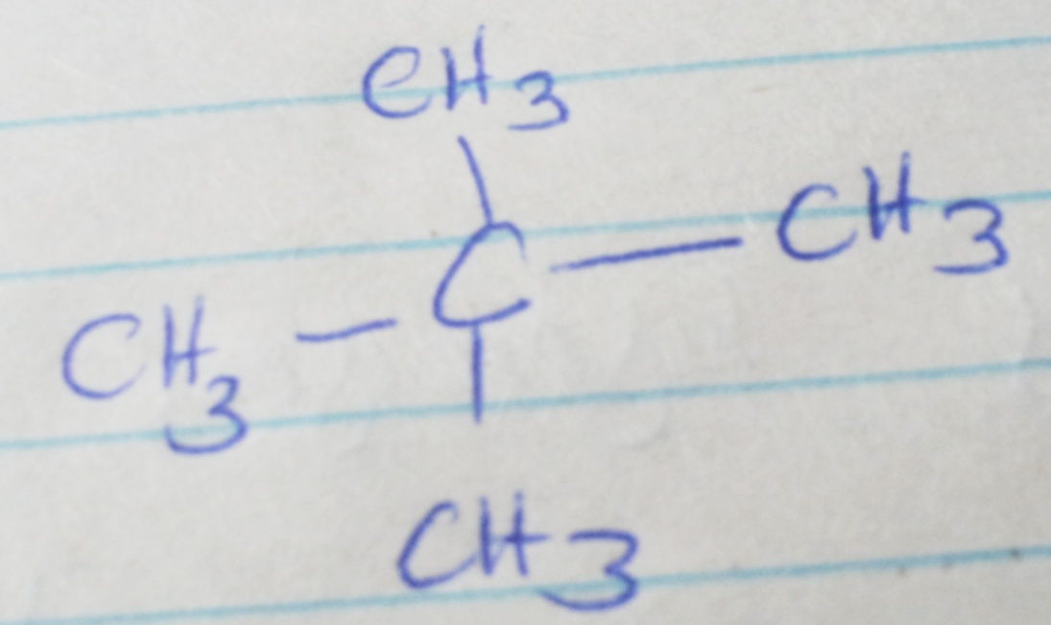

- Explain why burning magnesium continue to burn in a gas jar full of sulphure (iv) oxide while humming splint would be extinguished. (3mks)

- When hydrogen sulphide gas was bubbled into aqueous solution of iron (iii) chloride a yellow precipitate was formed.
- State another observation that was made. (1mk)

- Write an equation for the reaction that took place. (1mk)

- What type of reaction was undergone by hydrogen sulphade gas in this reaction? (1mk)

- A. What is allotropy (1mk)

.
- Name two allotropes of carbon. (2mk)

- Ammonium sulphate is a fertilizer produced by passing ammonia gas into concentrated sulphure (VI) acid. Calculate the mass in kg of sulphure (VI) acid required to produce 25kg or the fertilizer. (s=32, 0=16, N=14,H=1) (3mks)

- The reaction between hot concentrated Sodium hydrogen and chlorine gas produces sodium chloride (v), sodium chloride and water.
- Write the equation for the reaction. (1mk)

- Give one use of sodium chlorate (v). (1mk)

- Explain why a solution of hydrogen chloride gas in methylbenzene does not conduct electricity but solution of a gas in water conduct electricity. (2mks)

- Below is a sketch of a reaction profile. Study it and then answer the question that follows.
State and explain the type of reaction represented by the profile. (2mks)

Reactants

Reaction path

- I) what are amphoteric oxides? (1mk)

ii) Give a chemical formula example of an amphoric oxide. (1mk)

- Calcium oxide can be used to dry ammonium gas.
- Explain why Calcium oxide is not used to dry hydrogen Chloride gas. (2mks)

- Name one drying agent of hydrogen chloride. (1mk)

- When an organic compound Y is reacted aqueous Sodium carbonate it produces carbon (iv) Oxide. Y reacts within propanal to form a pleasant smelling compound whose formula is.

O

CH3 CH2 C O CH₂ CH₂ CH₃

- Name and draw the structure formula of compound Y. (2mks)

- What is the name given to the group of compound to which Z
belongs? (1mk)

- Element X and Y have atomic numbers 20 and 8 respectively.
- Write the electron arrangement of their ions. (2mks)

- Write the formula of the compound formed between X and Y. (1mk)

