NAME…………………………………………CLASS……………………….ADM……………
233/2
FORM 3 CHEMISTRY PAPER 2 THEORY
TIME 2HRS
TERM 1
Instructions to candidates.
- Write your name and index number in spaces provided in the question paper.
- Answer all the questions in the spaces provided in question paper.
- Mathematical tables and silent calculators may be used.
- All working must be clearly shown where necessary.
QUESTIONS | MAXIMUM SCORE | STUDENT SCORE
1 | 12
2 | 10
3 | 5
4 | 8
5 | 12
6 | 10
7 | 11
8 | 12

- The grid below show part of the periodic table.(the letter do not represent the actual symbols). Use it to answer the questions that follow.
T |  |  |  |  |  |  |  | Q
 |  |  |  | S |  | R | K
A | J |  | Y |  | U |  | L
W |  |  |  |  |  |  | M | B
 | C |  |  |  |  |  | N
P
- Select the most reactive non-metal(1mk)

- Select an element that forms a divalent cation. 1mk

- Element Z has atomic number 14. Show its position in the grid. 1mk

- How do the atomic radii of U and J compare. 2mks

- How does the boiling point of element K, L and M vary? Explain. 2mks

- How do electrical conductivity of A and Y compare?(2mks)

(b) the table below gives information on four elements by letter K,L,M and N . Study it and answer the questions that follow. The letters do not represent the actual symbols of the element.
ELEMENT | ELECTRON ARRANGEMENT | ATOMIC RADIUS | IONIC RADIUS
K | 2.8.2 | 0.136 | 0.065
L | 2.8.7 | 0.099 | 0.181
M | 2.8.8.1 | 0.203 | 0.133
N | 2.8.8.2 | 0.174 | 0.099

- Which two element have similar properties.explain .2mks

- Which element is a non-metal? Explain. 1mk

- Define charle’s law. 2mks.

- Rates of diffusion of two gases A and B are in the ratio 2:1. If the molecular mass of gas A is 16g. find the molecular mass of gas B. 3mks

bi) if the volume of a gas at s.t.p is 100cm³ what is its volume at 30⁰ c and a pressure of 800mmHg?(3mks)

c) Define Gays Lussac’s law. 2mks.

- What is a PH scale 1mk.

b. the following data gives the PH value of solution P,Q and R.
SOLUTION | PH VALUE
P | 13.6
Q | 6.9
R | 1.3

Which solution would produce carbon (iv) oxide when reacted with copper (II) carbonate.(1mk)

ii) What would be the colour of solution “p” after adding few drops of phenolphthalein indicator.(1mk)

iii) what is the basicity of an acid? 1mk

iv)Which solution reacts vigorously with magnesium. 1mk

- Study the set up below and answer the questions that follow.
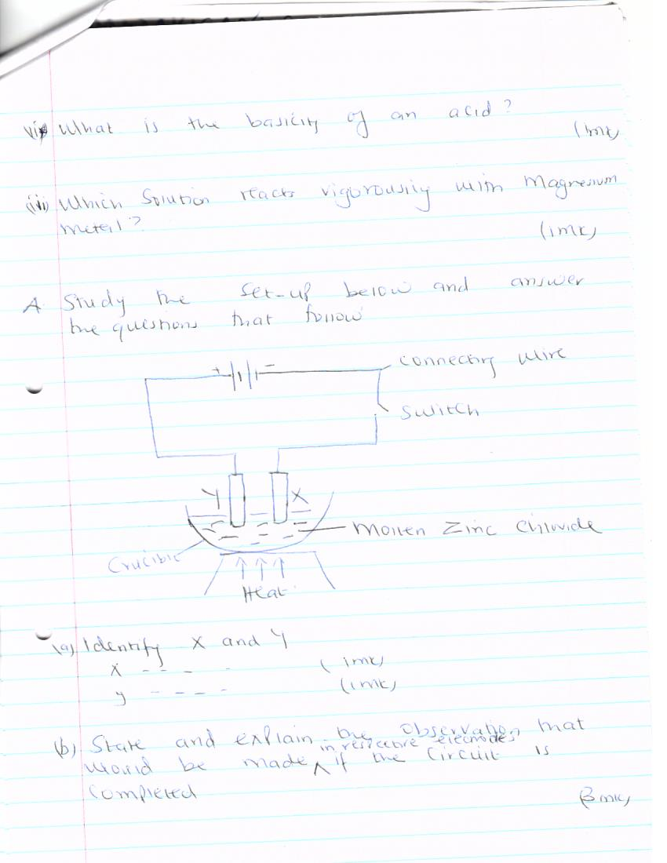

- Identify x and y
x……………………………………..1mk

y………………………………………1mk

- State and explain the observation that would be made in respective electrodes if the circuit is completed.(3mks)

- Write an ionic equation for the reaction that takes place at x and y.
X ……………………………………………….1_{1/2mks}

y…………………………………………………..1 _{1/2mks}

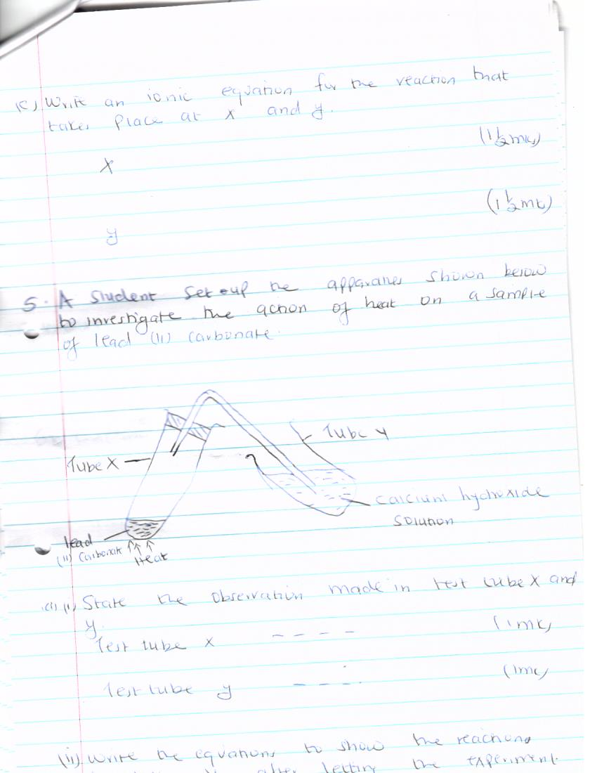
- A student set-up the apparatus shown below to investigate the action of heat on a sample of lead (II) carbonate.

- I) state the observation made in test tube x and y.
Test tube x……………………………………………………………..1mk.

Test tube y………………………………………………………………1mk.

(ii) Write the equation to show the reaction in tube Y after letting the experiment proceed for a long time. 3mks.

Bi) What is meant by the term allotrophy. 1mk.

ii) Name the allotropes of carbon. 1mk.

C. Explain why graphite is a better lubricant than oil.2mks.

D. Describe a simple chemical test that can be used to distinguish between carbon (II) oxide and carbon (IV) oxide. 2mks.

- State one use of carbon (iv) oxide. 2mks.

- a)explain which of the following fertilizers urea (NH₂)₂ CO, or ammonium nitrate NH₄NO₃ is a better source OF Nitrogen? Show your working (N=14, C=12, O=16, H=1) (3mks).

- An oxide of silicon was found to contain 47% by mass of silicon. What is the empirical formula of the oxide? (SI=28,O=16) 3mks.

- Suppose 71g of sodium sulphate are dissolved in enough water then made to one litre of solution. Determine the molarity of the solution formed (Na=23, S=32, O=16) 2mks

- One atom of a certain metal X has a mass 2.2 x 10⁻²² , calculate the relative atomic mass of x.(l=6.023 x 10²³ .(2mks)

7.i) using dots(.) and cross (x) to represent electrons draw structures to represent the following.
i) Hydrozonium ion H₃o⁺ 2mks

II) Ammonia NH₃ (1mk)

ii) State why ammonia molecule combine with hydrogen ion to form NH₄⁺ ⁽1mk)

b) Name types of chemical bond formed in each of the following compounds.
i) Carbon (II) oxide (1mk)

ii) Within water molecules (1mk)

iii) Between water molecules. 1mk.

ci) explain how the structure of diamond make it appropriate for use in drilling.(2mks)

(ii) Sketch a labeled diagram showing the structure of diamond.(2mks)

8. The diagram represents an incomplete set-up of apparatus used by a student in an attempt to prepare and collect dry hydrogen.
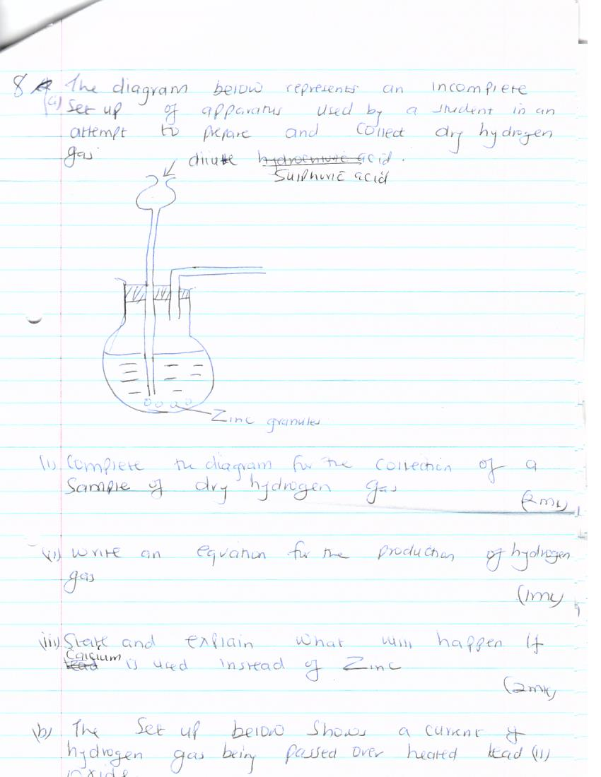

- Complete the diagram for the collection of a sample of dry hydrogen gas.(2mks)

- Write an equation for the production of hydrogen gas. (1mks)

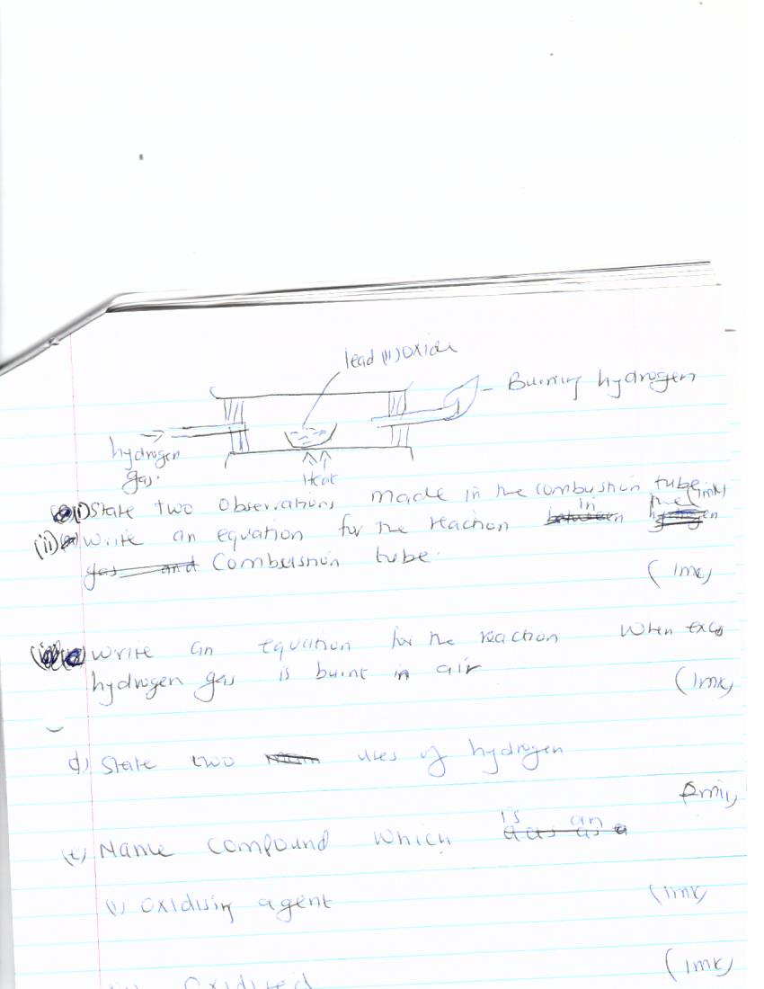
b) The set-up below shows a current of hydrogen gas being passed over heated lead (II) oxide.

- State two observation made in combustion tube. 1mk.

- Write an equation for the reaction in the combustion tube. 1mk.

c) Write an equation for the reaction when excess hydrogen gas is burnt in air. 1mk

d) State two uses of hydrogen. (2mks)

- Name compound which is an
- Oxidizing agent (1mk)

- Oxidized (1mk)

