MARKING SCHEME FORM 3 CHEMISTRY PAPER 2

1ai) k (1mk)

ii) J or C (1mk)

iii) Group (IV), period 3 below s in the grid (1mk)

iv) I and U are in the same period and across the period the nuclear charge (1mk) increase hence nuclear chare of U is greater than that of I hence it pulls the outermost electron more strongly reducing the radius. Therefore the radius of U is shorter than the radius of J. (1mk)

v) The B.P of the elements increases down the group. (1mk).This is because the intermolecular group forces of attraction increases down the group with increase in size of the molecules. (1mk)

vi) Y is a better conductor of electricity than J. (1 mks)
This is because Y has more delocalized electrons than J (1mk)

bi)K and N (1mk)
This is because they are in the same group or loses 2 electrons or same number of electrons in the outer energy levels. (1mk)

ii) L( _{1/2mk)}
This is because its ionic radius is bigger than atomic radius.
It will gain electrons to be stable. (1/2mk)

2. i) the volume of a fixed mass of a gas is directly proportional its absolute temperature provided the pressure remains constant.(2mks)

ii) Formula rate of diffusion of A = molecular mass of B
Rate of diffusion of B molecular mass of A 1MK

2= M of B
1 16

M of B = 2x 16 = 8 (1mk)

Hence M = 8² = 64

Molecular mass of B = 64(1mk)

©When gases react they do so in the volume which bear a simple ration to one another and to the volume of the products of the gaseous provided all the volume are measured at the same temperature
3(a) PHscale- It is a scale which shows the degree of acidity or alkalinity of a solution
(b)R
(C)(I)PINK /Red
(ii)Basicity –number of replaceable hydrogen atom in an acid
(iii)R
4(a)x-cathode
Y-Anode
(b) Pale –green gas bubbles are formed at the anode
The gases are chlorine (cl2) chloride ion move to the anode and give up electrons
Chlorine atoms are formed and then the atoms combine to make chlorine gas molecules
Grey beads of zinc begin to collect at the cathode
The zinc ions move to the cathode.They accepts two electones and become zinc atoms ( (c) Equation at X zn_{l}²⁺ +2e=Zn _{(l}
Ionic equation at Y Cl_{l}⁻ Cl_{g} +e⁻
Cl _{g} +Cl _{g} Cl₂ _{g}

2Cl _{l}⁻ Cl_{2(g)}+2 e⁻

5(a)(i)In a test tube X-a residue which is red-brown when hot and yellow when cold is observed
In a test tube Y-a white precipitate is formed eventually the precipitate dissolves forming a colorless solution
Ca(OH) _{2(aq)}+CO_{2(g)} CaCO_{3(s)}+H₂O_{(l)}
CaCO_{3(g)}+H₂O_{l}+CO_{2g} Ca(HCO₃)_{2(aq)}

b(i)Allotropy is the existence of an element in more than one form without change of state
(ii)Graphite
Diamond
(c )Graphite is a better lubricant for hot moving parts of machine because oil might evaporate but graphite has a high melting point
(d)Take two gas separately bubble them each a time into a solution of calcium hydroxide. Carbon iv oxide will form white precipitate while carbon iv oxide will not form a white precipitate
(e)Uses of carbon iv oxide
-It is used in the manufacture of sodium carbonate
-Used in carbonated drinks e.g. coca-cola
-Used as refrigerant
-Used in fire extinguishers
6(a) (NH₂)₂CO (2X14) + (1X4) +12+16=60
Nitrogen in x 100= 46.66% =46.7%
₊Urea
NH₄NO₃ 14+(1+4)+14+(3X16)=80
Nitrogen in (Ammonium Nitrate) x100 =30%
Urea is better than ammonium Nitrate because it has the highest percentage of Nitrogen 46.7%
(b) Element silicon Oxygen
Composition by % 47 100-47=53
Molar mass 24 16
No. of moles =1.68 =33.31
Mole ratio =1 =1.94
Simplest whole no. ratio 1:2
Therefore empirical formular of silcon is SiO₂
(c) Mass of Na₂SO₄ dissolved= 71.0g
Mass of 1 mole of Na₂SO₄ =(2x23)+32+(4x16) = 142g
Number of moles in 1 litre = =0.5 mol/dm³
Therefore molarity is 0.5M Na₂SO₄ (2mks)
(d) 1 mole of x =6.023x10²³ atoms
R.A.M x 6.23x10²³x2.28x10⁻²² =13.73x10²³⁻²² R.A.M 137
7(i) Hydrozonium ion H₃O⁺
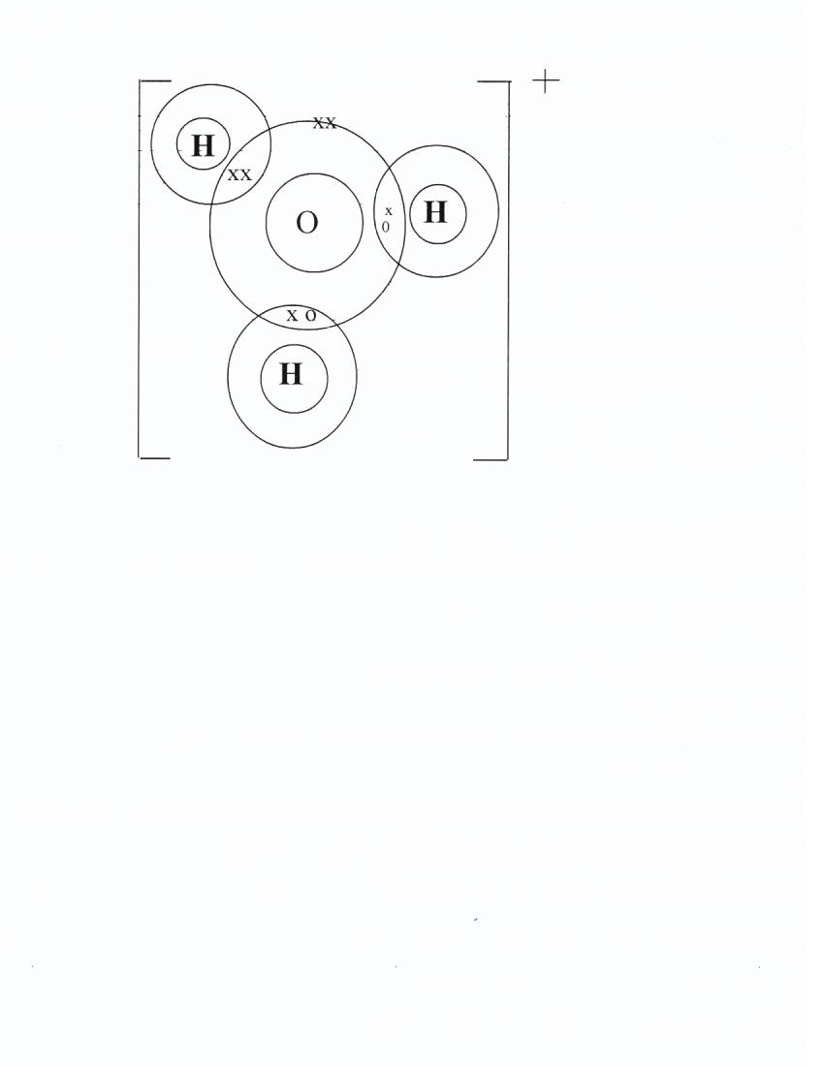

(b) Ammonia NH₃
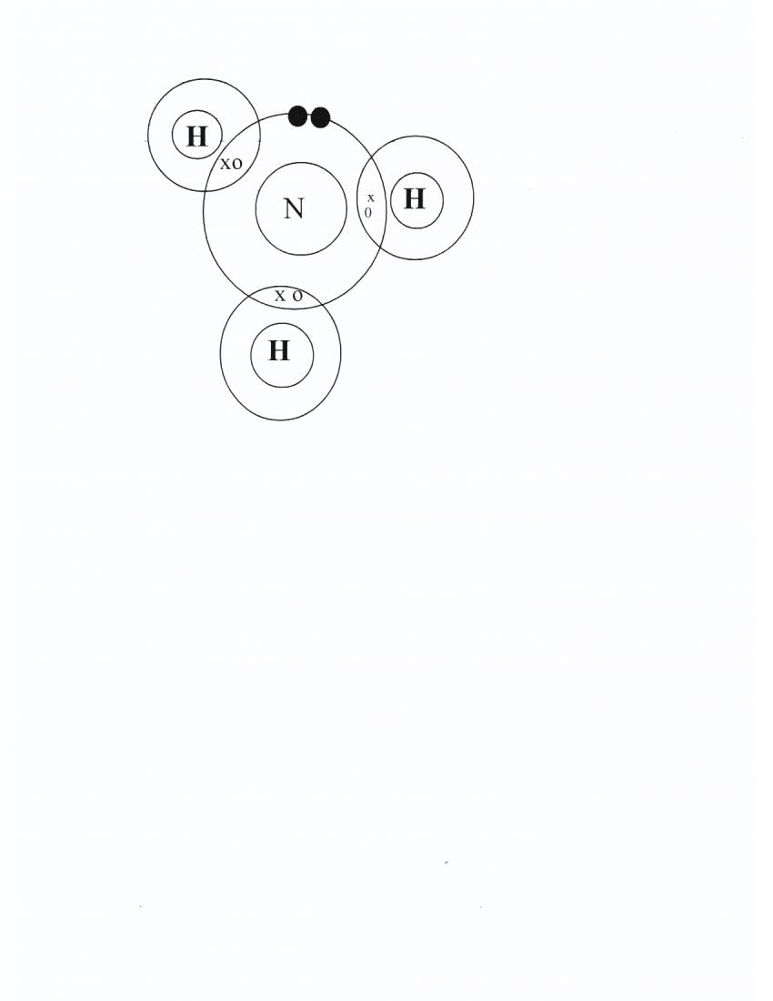

(ii) This is because of the presence of lone pair of electron on the nitrogen atom
B(i) covalentt bond & co-ordinate bond
(ii) Covalent bond
(iii) Hydrogen bond
C(i) Diamond has a giant atomic structure. The structure is very strong because it has covalent bonds between the carbon atoms.
The network of covalent bond extends throughout the structure making it very hard and suitable for making drilling bits
(ii)

(c ) in chlorine molecules the atoms are joined together by strong covalent bond but between the molecules there are weak van der Waal’s forces of attraction.
Chlorine forms a simple molecular structure that is why it exists as gas. In silicon (IV) oxide, between silicon and oxygen atoms there are covalent bonds giving a giant atomic structure which makes it to exist as solid at a room temperature.
8i) dg.

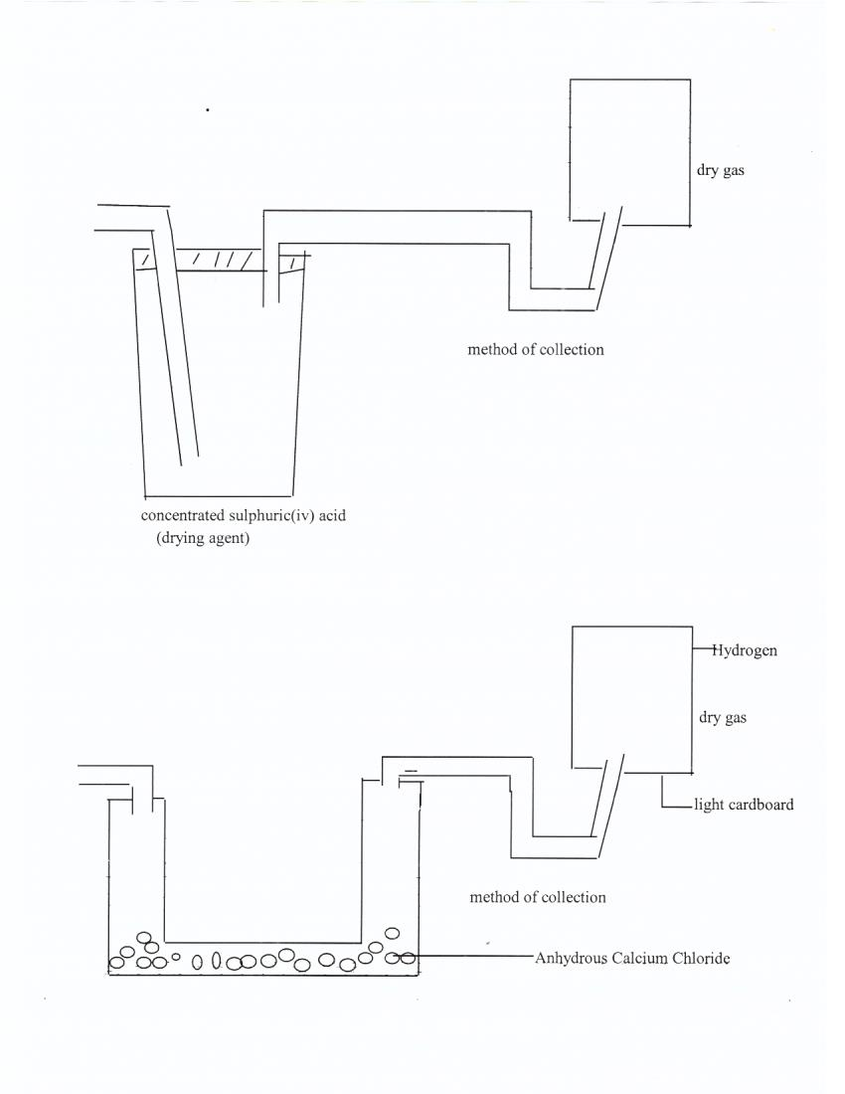

(ii) ZN(S) + H₂SO₄ ____________ZnSO₄ (aq) + H₂(g)
(iii) the reaction will start and stop.
This is due to formation of Calcium Sulphate will coat lead metal preventing any further reaction with the acid.
B) Brown Lead (II) oxide changed to grey lead metal. There is formation of colourless liquid.

bi) PbO(s) + H₂ (g) _______________Pb(s) + H₂ O(l)
c) 2H₂(g) + 2 0₂(g)________________2H₂O(l)
d) used to manufacture ammonia in haber process.
-used in hydrogenation –hardening of oils to form fat.
-used in welding and cutting metals.
-used in manufacture of hydrochloric acid.
e.i) lead (ii) oxide.
(ii) hydrogen gas.

