233/2
CHEMISTRY
Paper 2
MARCH/APRIL
Time: 2 hours

M A R K I N G S C H E M E

1. A. In an experiment to determine the percentage of oxygen in air, the apparatus below were set up. Study the set up and the information provided to answer the
questions that follow.
K
Copper turnings
100

200

300

400

500
J

Water

I

Heat

Flask H (500cm³)

A 500cm³ measuring cylinder K was filled with water and assembled for gas collection. Copper turnings were heated red hot and water was slowly passed into 500cm³ flask H until it reached the 500cm³ mark. A colourless gas was collected in K.

(i) What was the purpose of passing water into flask H? (1 mark)
To displace air in flask H over the hot copper turnings.
(ii) What observations were made in the tube I? (1 mark)
The brown solid changes to black
(iii) Name one of the gases that is likely to be found in J. (1 mark)
Nitrogen, carbon (IV) oxide, argon, (Xeron, neon) (Any one)
(iv) What was the volume of the gas collected in the measuring cylinder at the end of the experiment? (1 mark)

410cm³

(v) Calculate the percentage of oxygen in air using the above results. (2 marks)
1
1

B. Study the diagram below and answer the questions that follow.

Ice cold water
Copper (II) oxide

Colourless liquid Y
Heat

(a) Give one observation made in the combustion tube after some time. (1 mark)
Black CuO turns to red-brown Cu.

(b) Write an equation for the formation of the colourless liquid Y. (1 mark)

(c) What was the aim of the above experiment as demonstrated in the combustion
tube? Explain. (2 marks)

To determine the reducing property of hydrogen. 1 Hydrogen is above Cu 1 in the reactivity series, thus it reduces the oxygen from CuO.
2. Use the information below to answer the questions that follow. The letters are not the actual symbols of the elements.

Element | Atomic No. | M.P⁰C | B.P⁰C | Ionic radius (nm)
P | 11 | 98 | 890 | 0.095
Q | 12 | 650 | 1110 | 0.065
R | 13 | 660 | 2470 | 0.050
S | 14 | 1410 | 2360 | 0.041
T | 15 | 44.2 & 590 | 280 | 0.034
U | 16 | 113 & 119 | 445 | 0.184
V | 17 | -101 | -35 | 0.181
W | 18 | -189 | -186 | -

(a) (i) Write the electronic configuration of the atoms represented by letters T and W. (1 mark)

T - 2.8.5  ½
W - 2.8.8  ½

(ii) State the nature of the oxides of the elements represented by Q and U. (2 marks)
Q - Basic Oxide 1
U - Acidic oxide 1

(b) Why does the elements represented by the letters T and U have two values of melting points? (1 mark)

The two elements exhibit allotropy.

(c) Explain the following observations in terms of structure and bonding.

(i) There is an increase in boiling point from P to R. (2 marks)
There is gradual increase in the strength of the metallic bonds 1 due to the increase in the number of delocalized (valence) electrons in the element 1

(ii) Element S has a high boiling point. (2 marks)
The atomic radius of V is smaller than that of U. 1 V has more protons therefore has a stronger nuclear attraction hence the smaller atomic radius. 1

(iii) There is a decrease in boiling points from U to W. (2 marks)
Elements U, V and W have simple molecular structures 1 in which the molecules are held by weak Van der waals forces. The Van der waals 1 forces weaken from U to W.

(d) (i) Compare the atomic radius of U and V. (1 mark)
The atomic radius of V is smaller than that of U. 1

(ii) Why is there no ionic for W reported in the table? (1 mark)

It has a stable electron configuration hence does not ionize.

3. (a) The solubilities of potassium nitrate and potassium bromide at different temperatures was determined. The following data was obtained.

Temperature ⁰C |  | 0 | 10 | 20 | 30 | 40 | 50 | 60 | 70 | 80
Solubility g/100g H₂O | KNO₃ | 5 | 15 | 26 | 43 | 61 | 83 | 105 | 135 | 165
 | KB_{r} | 50 | 55 | 60 | 65 | 70 | 77 | 85 | 90 | 95

(i) Draw solubility curves for both salts on the same axis. (3 marks)
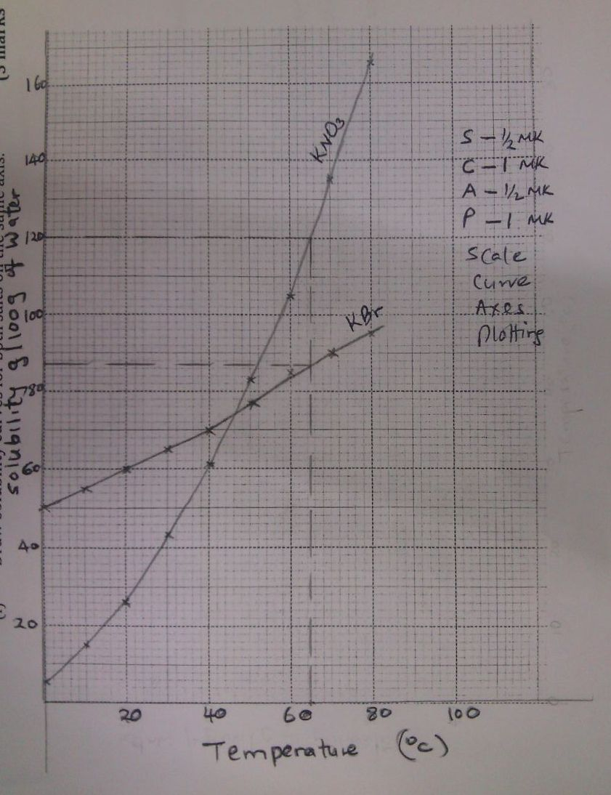

(ii) What was the solubility of each salt at 65⁰C? (1 mark)

of water  ½

KBr 87g/100g of water 1  ½

(iii) 100g of a saturated solution of potassium nitrate at 70⁰C was cooled to 20⁰C. What mass of the crystals will be crystallized? (2 marks)

At 70⁰C solubility = 135g/100g of water
If 235g contain 135g of salt
100g contain 135g
 ½

At 20⁰C solubility = 26g/100g of water
If 126g contain 26g of salt
100g contain ?
 ½
Mass which will crystallized
57.4468 – 20.6349
= 36.8119g

(b) Study the flow chart below and answer the questions that follow.

Solution
C
Dil. HCl
Solid A
+
Gas B
Heat
Metal carbonate

A few drops of NH_{3(aq)}

Deep blue solution E
Excess of
NH_{3(aq)}
Solid D

(i) Write an equation for the formation of solid A and gas B. (1 mark)

(ii) Name;
Solution C - Copper (II) chloride (1 mark)
Solid D - Copper (II) hydroxide (1 mark)

(c) Write the formula of the complex ion in solution E. (1 mark)
2+

4. Study the flow chart below and answer the questions that follow.
II
III
NaOH
Heat

Na₂CO₃
W
NaOH

I

NaOH
IV
Na

Q

V
Z
X

HI
R

VI

H H

C C

H H

Y

n

(a) Name substance. (3 marks) X - Sodium ethonoate  1
Q - Sodium ethoxide  1
R - Iodoethane  1
(b) Write down an equation for the reaction represented by step III. (1 mark)

(c) What are the conditions and reagent required for steps?

- I (2 marks)
Reagent - Propan-l-ol  1
Condition - Conc. H₂SO₄  1

- IV (2 marks)
Reagent - Conc. H₂SO₄  1
Condition - Temp 160 – 180⁰C  1
(b) Name the process represented by: (4 marks)
I - Esterification
II - Substitution
IV - Oxidation
V - Dehydration

5. I. Study the scheme below and answer the questions that follow.
Water
Colourless
gas D
Brown gas
Nitric (V) acid
Ammonia gas
Substance B
Substance A

Step I
Oxygen
Catalyst F

Step II
Oxygen

(a) Identify substances. (3 marks)
A - Hydrogen
B - Nitrogen
D - NO

(b) State the catalyst necessary for; (2 marks)
Step I - Iron finely divided / iron
Step II - Platinum – rhodium catalyst

(c) Write a balanced chemical equation for taking place in step II. (1 mark)
4NH₍₃₎ + SO₂ 2NO_{(g)} + 6H₂O
(d) Write two balanced chemical equations for the reaction between chlorine
Gas and;
(i) Hot and concentrated sodium hydroxide. (1 mark)
6NaOH_{(aq)} + 3Cl_{2(g)} NaClO_{3(aq)} + 5NaCl_{(aq)} + H₂O_{(l)}
(ii) Dilute and cold sodium hydroxide. (1 mark)
2NaOH_{(aq)} + Cl₂ NaOCl + NaCl + H₂O
II. The diagram below shows an experiment in which the Lead (II) nitrate crystals are heated.
Powdered Pb(NO₃)₂

Gas Y

Ice
Liquid P

- Name; (2 marks)

- Liquid P - dinitrogen tetra oxide
- Gas Y - oxygen

- Write a balanced chemical equation for the decomposition of Lead (II) nitrate. (1 mark)

- Explain how you can distinguish between nitrogen (II) oxide and nitrogen (I) oxide.
(2 marks)
- Nitrogen (V) oxide relights a glowing splint while nitrogen (II) oxide does not.
- N₂O has xtic sweet smell, while. NO₂ is odourless.

6. I. Study the standard electrode potentials given below and answer the questions that
follow.

- Identify the strongest:
- Reducing agent D (1 mark)
- Oxidizing agent R²⁺ (1 mark)
(b) Calculate the e.m.f of a cell made of G and M. (2 marks)

e.m.f =
=
= +2.70V

(c) Write the cell representation for the above cell in (b). (1 mark)

Penalize for lack of states and E
value

- Draw a cell diagram for the cell in (b) above. (2 marks)

Workability 1
Labelling 1

M_{(s)}

Salt bridge
- Write the cell reaction for the drawn cell diagram in (d) above. (1 mark)

II. Electrolysis of aqueous solution of metal M resulted in the deposition of 1.07g of metal upon passage of a current of 1.32 amperes for 75 minutes.
(M = 52, 1F = 96500C)

- Calculate the quantity of electricity passed through the cell. (1 mark)

 ½
 ½

- Calculate the charge on the metal ion. (3 marks)

If 1.07g is departed by 5940C
52g “ “
1

If 1F is 96500C
? “ 288672.8972C

1

3
+3  1

7. Extraction of iron involves two main processes, smelting and refining. Below is the blast furnace which is used to smelt iron from its ore.
CO₂, CO
as waste

300⁰C

500⁰C

600⁰C

800⁰C

1600⁰C

C
Carbon (IV) oxide recycled

B

A
Fire brick lining
Hot air blast from stove

Slag tap
Slag
Iron
Molten iron from tap

(a) (i) What does the word smelt mean? (1 mark)
Extraction of a metal from its ore using a reducing agent and heat.

(ii) Name the reducing agent in the process. (1 mark)
Carbon ( in form of coke)
- What is the role of the hot air blast in the process? (2 marks)
Hot air reacts with coke to form carbon (IV) oxide producing a lot of heat which melts the iron formed in the blast furnace.

(b) Write equations for the reactions that take place at the region marked A, B and C. (3 marks)
A
B
C
(c) What is the purpose of limestone in the extraction process? (1 mark)

To remove silica impurities in the ore.

- Write equations to show how impurities are removed from the ore.
(3 marks)
heat

slag

