**CHEMISTRY 2ND TERM END OF TERM FORM ONE**

**MARKING SCHEME.**

1. A- Deflagrating spoon – (1mk) used for holding substances being burned.(2mks)

B-Liebig condenser- used to condense vapour into liquid (2mks)

C-separating funnel-(1mk)- used for separating immiscible liquids(2mks)

1. i) Proper use of all medicinal drugs

ii) never starting to use any illegal drug.

iii) Keeping away from those who use or sell drugs

iv) using all our time productively by doing school works, games and sports.(4mks)

1. a)i)When air hole is closed.

ii) When air hole is opened (2mks)

b)At end of glass tubing they was a flame. Reason is because, the tube was placed in region containing unburnt gases (almost colourless region)2mks

1. a)Filtration: obtaining clean water for use in homes (1mk)

Fractional distillation: Crude oil to obtain fraction such as diesel, petroleum, cooking gas.

Recycling of used oil

Liquid air in the manufacture of nitrogen and oxygen (any 1mk)

c) Solvent extraction- extraction of

1. oil form nuts and seeds
2. natural dyes from plants
3. some herbal medicine from plants
4. caffeine from tea and coffee
5. in dry cleaning to remove dirt. (any 1mk)
6. a.By determining i)boiling point

ii)melting point they should be constant (constant must be there)2mks

b.i)YZ and AB(1mk)- the temperature is constant(1mk)

ii)XY-solid(1mk)

ZA-liquid(1mk)

1. a. Solution-uniform mixture of solvent and solute(1mk)

B.saturated solution-solution that cannot dissolve any more solute at a given temperature (1mk)

1. a.The delivery tube is dipped in sodium peroxide .

no gas can be collected(1mk)

b.Note the gas is passed either through (3mks)

I.concentrated sulphuric (vi) acid

ii) Anhydrous calcium (ii) chloride

c.Water(1mk)

d.sodium peroxide + water sodium hydroxide + oxygen(2mks)

e.i)it is colourless

ii)Has no effect on moist litmus paper

iii)It relights glowing splint

iv)it is slightly soluble in water(any 1mk)2mks

1. a. Downward delivery-denser than air

Over water- not insoluble in water

Upward delivery – less denser than air(3mks)

1. a. Universal indicator shows strength of an acid or alkali, while acid-base indicator only shows the colour change.(1mk)

b.i) C ii) E iii)D iv) B v) 7 (5mks)

c.i) Zinc + Hydrochloric acid Zinc chloride + hydrogen gas(2mks)

ii) Magnesium oxide + hydrochloric acidcalcium chloride + water + carbon (iv) oxide (2mks)

iii) Magnesium oxide + Hydrochloric acidmagnesium chloride = water (2mks)

iv) Sodium hydroxide + hydrochloric acid sodium chloride + water (2mks)

c.Stung by wasp is slightly acidic .sodium hydrogen carbonate is weak base, hence neutralize the acidic.(2mks)

e.Sodium hydroxide is a strong base(1mk)

f.i) calcium carbonate + dilute hydrochloric acid calcium chloride + water + carbon (iv) oxide (2mks)

ii)white ppt is observed(1mk)

g.(i) manufacture of anti- acid tablets.

ii)Neutralizing acidity of soil

iii) Manufacture of soaps

iv) Manufacture of fertilizes(2mks)

b.(i) carbonic acid is used in aerated drinks to enhance taste.

ii) Hydrochloric acid is used to clean metal surfaces

iii) Sulphuric acid is used in car batteries, manufacture of fertilizers. any 2mks)

1. Anhydrous copper(ii) sulphate (1/2mk ) when water is added it from white to blue

Anhydrous calcium chloride –it forms colourless solution when water is added.(2mks)

1. **Permanent change temporary change**
2. Not reversible reversible
3. New substance is formed no new substance is formed
4. Heat is released or absorbed heat is not released or absorbed
5. Mass change no change in mass(**4mks)**
6. Reaction I= temporary physical change

II) Permanent chemical change

III) Temporary chemical change(3mks)

1. a.

b. solvent

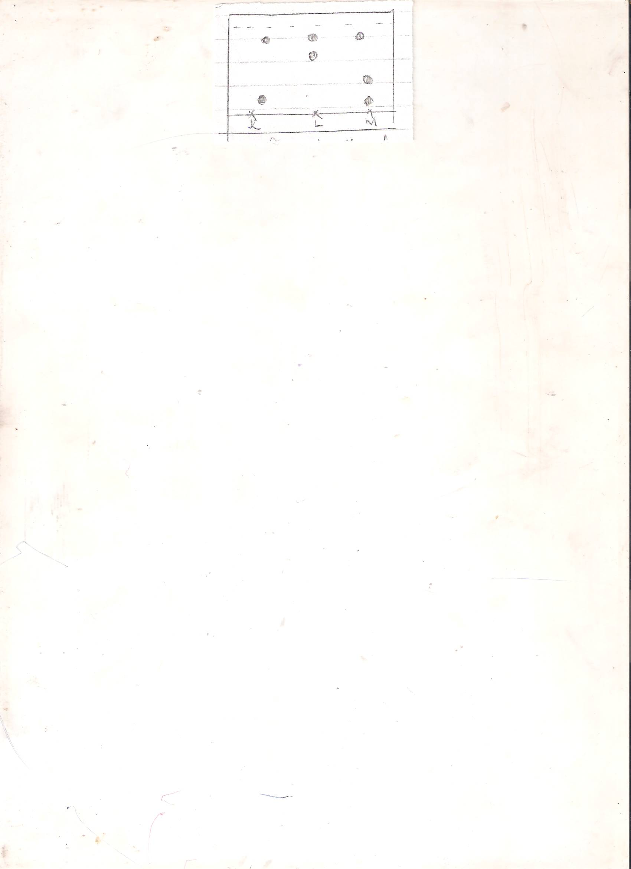 banned food colourings

c.1. in spots chromatography ,is used to identify banned substances.

2.in pharmaceutical industry, to test purity drugs

3.In food industry, to identify contaminants from foods and drinks

4.In cosmetic industry, to identify harmful substances (any 2mks)

1. a. x 100Nu

40 x 100

200

= 20% A1 2mks)

b. Copper + Oxygen copper (ii) oxide(1mk)

c.i)The air initially present in the tube is not accounted for.

ii) Not all the oxygen may be used up.

iii) There might be leakage of air.(2mks)

d.Passed slowly – to allow enough time constant repeatedly – ensure that all oxygen is used up..(1mk)