PAPER 231/3

PRACTICAL.

QUESTIONS.

MAX.40 MKS.

ANSWER ALL THE QUESTION IN THE SPACES PROVIDED.

Answer all the questions in the spaces provided.
- You are provided with substance L.Carry out food tests on the substance using the reagents provided .Record your procedure , observations and conclusions in the table below.(9mks)
Food substance | Procedure | Observation | Conclusions

- a

During a visit to a museum, students were shown ten specimens of organisms on display.The teacher provided a dichotomous key (shown in a separate page) to enable them to place each species on display into its taxonomic group. Five of the specimens that were on display are shown in the diagrams provided.

Dichotomous Key.
1.(a) Animal with a flattened body….. …………………………………..go to 9.
(b)Animal without a flattened body……………………………………. go to 2.
2.(a)Animal with body in a shell ………………………………………….Mollusca.
(b)Animal with body in shell………………………………………….. go to 3.
3.(a)Animal with segmented body….. …………………………………….go to 4.
(b)Animal with body not segmented…………………………………….Nematoda.
4.(a)Animal with jointed appendages go to 6.
(b) Animal without jointed appendages to 5.
5.(a)Animal with long and cyndrical body…………………………………..annelida.
(b)Animal with short stout body………………………………………….. Trenada.
6.(a) Animal with antennae…………………………………………………...go to7.
(b) Animal without antennae ….. ………………………………………….go to 8.
7.(a)Animal with one pair of antennae……………………………………… Insecta.
(b) Animal with more than one pair of antennae………………………….. crustacean.
8.(a)Animal with pincer –like mouthparts………………………………….. Arachida.
(b) Animal with sucking mouth parts………………………………….….Acarina.
9.(a)Animal with long ribbon-like body ……………………….…………….cestoda.
(b) Animal with circular body………………………………………….. rinoidea).
Use the dichotomous key to identify the taxonomic group of each of the five specimens shown in the drawings.
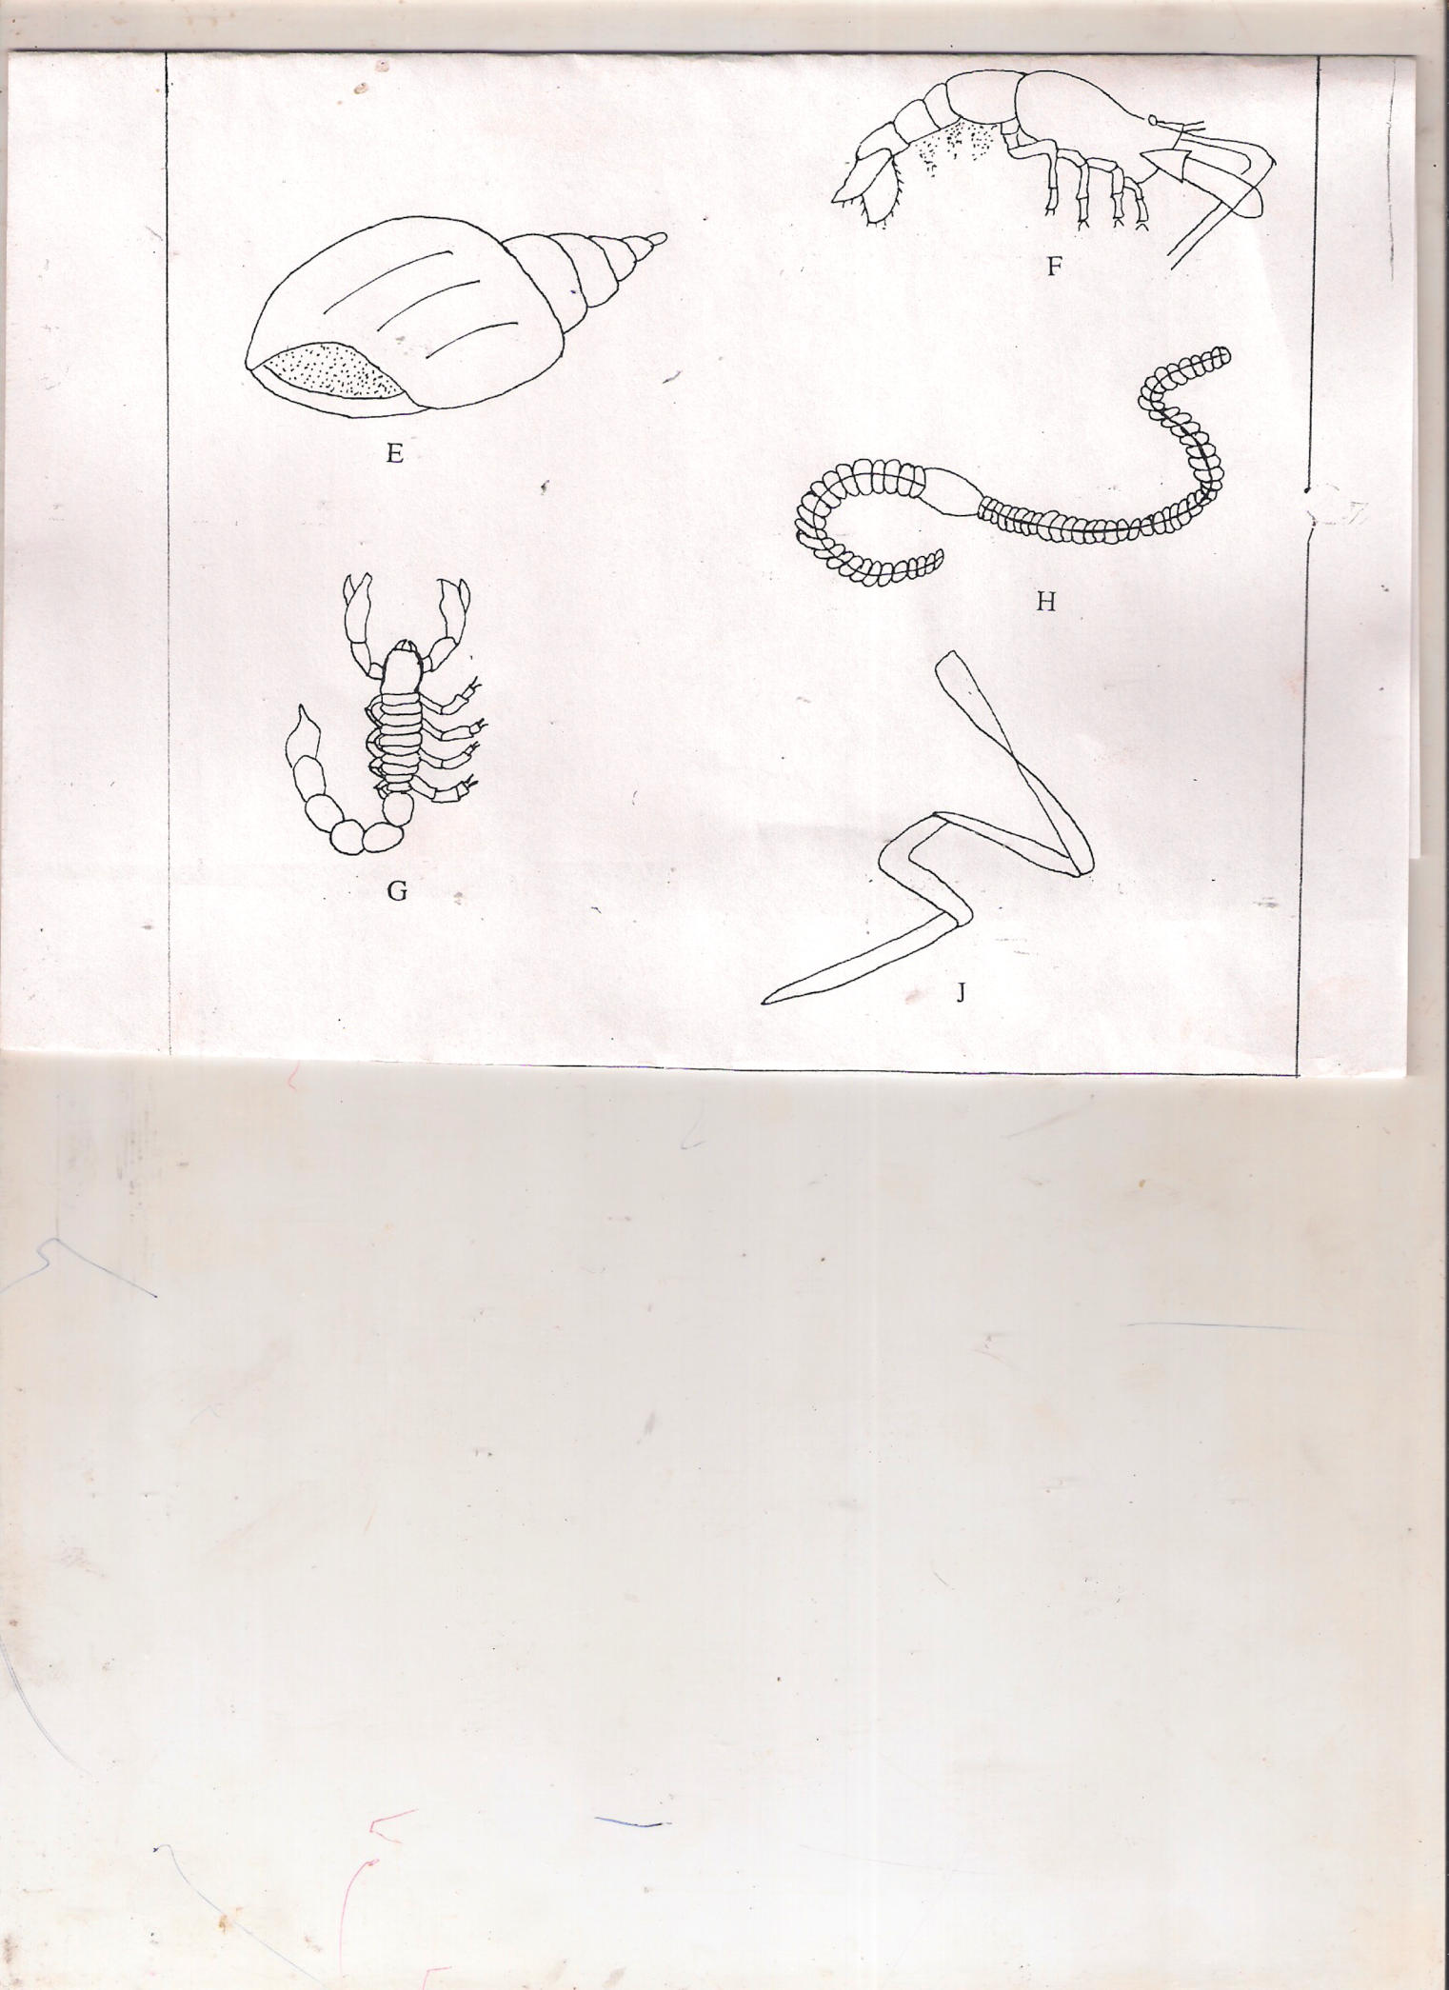

In each case, show in sequence the steps (ef 1a,2a,5a, 7b) in the key that you followed to arrive at the identify of each specimen.(5mks)
Animal Steps followed Identity
E ……………………………………….. ……………………………………………………..
F ………………………………….….. ……………………………………………………..
G ……………………………………. ……………………………………………………..
H ……………………………………. ………………………………………………………
J ……………………………………… …………………………………………………….
b)i)Nam the phylum and the class to which specimen M belongs(2mks)
Phylum:

Class:

ii) Name the observation features that enabled you to place it in the class above.(3mks)

(c)With the help of a hand lens, examine the body of specimen M.

i)State with a reason in each case he observable features that enable the specimen to be a disease vector.(2mks

(ii) Name one disease transmitted by specimen M.(1mk)

iii) State two methods that can be used to prevent specimen M from spreading diseases.(2mks)

- You are provided with specimens labeled S₁ S₂ and S₃
- Using a scarpel blade split S₁ longitudinally and draw a well labeled diagram to show the internal structures.
State your magnification (4mks)

- With a reason ,state the class to which the plant from specimen S₁ belongs to.
Class(1mk)

Reason(1mk)

- Specimen S₂ is a germinated seedling of S₁.In the table below, name three structures and say which structure in S₁developed into the structure in S₂.
Structure in S₁ | Structure in S₂

d.(i) Using specimens S₁ and S₃ ,name the type of germination in :-
S₁

S₃ (1mk)

ii. Give the difference between the this type of germination in (d) (i) above (2mks)

iii.Account for the type of germination in :-
S₁ 2mks

S₃(2mks)

