PRE-MOCKS
BIOLOGY FORM 4 PAPER 2
TIME 2 Hrs
NAME: …………………………………………………………… ADM NO: ……………….. CLASS: …….
Instructions to candidates: Answer All Questions in the Spaces Provided
- The diagram shows two types of cells placed in a certain solution. Study them and answer questions that follow
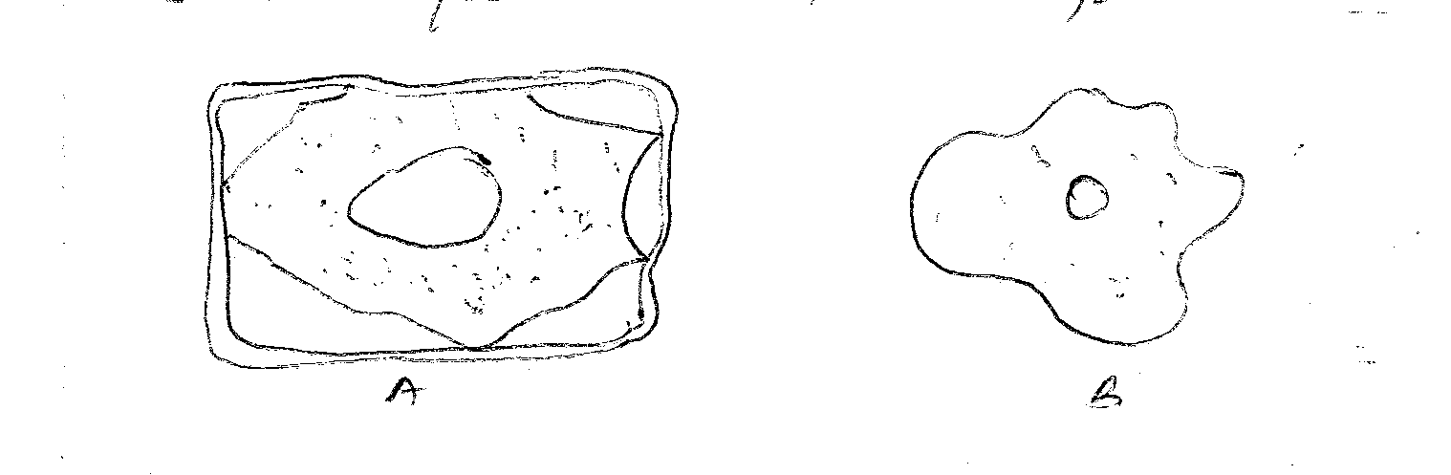
  - Name the physiological process responsible for the observed results. [1 Mark]

  - Give the correct biological term used to describe cells A & B. [2 Marks]
A –

B –

- The equation below shows a chemical reaction that takes place in plants.

Carbon (iv) oxide + water A + water
  - Identify substance A. [1 Mark]

  - Name the process represented by the equation. [1 Mark]

  - Other than the reactants state two conditions necessary for this reaction. [2 Marks]

- The diagram below illustrates an experiment used to determine rate of respiration in a small insect.
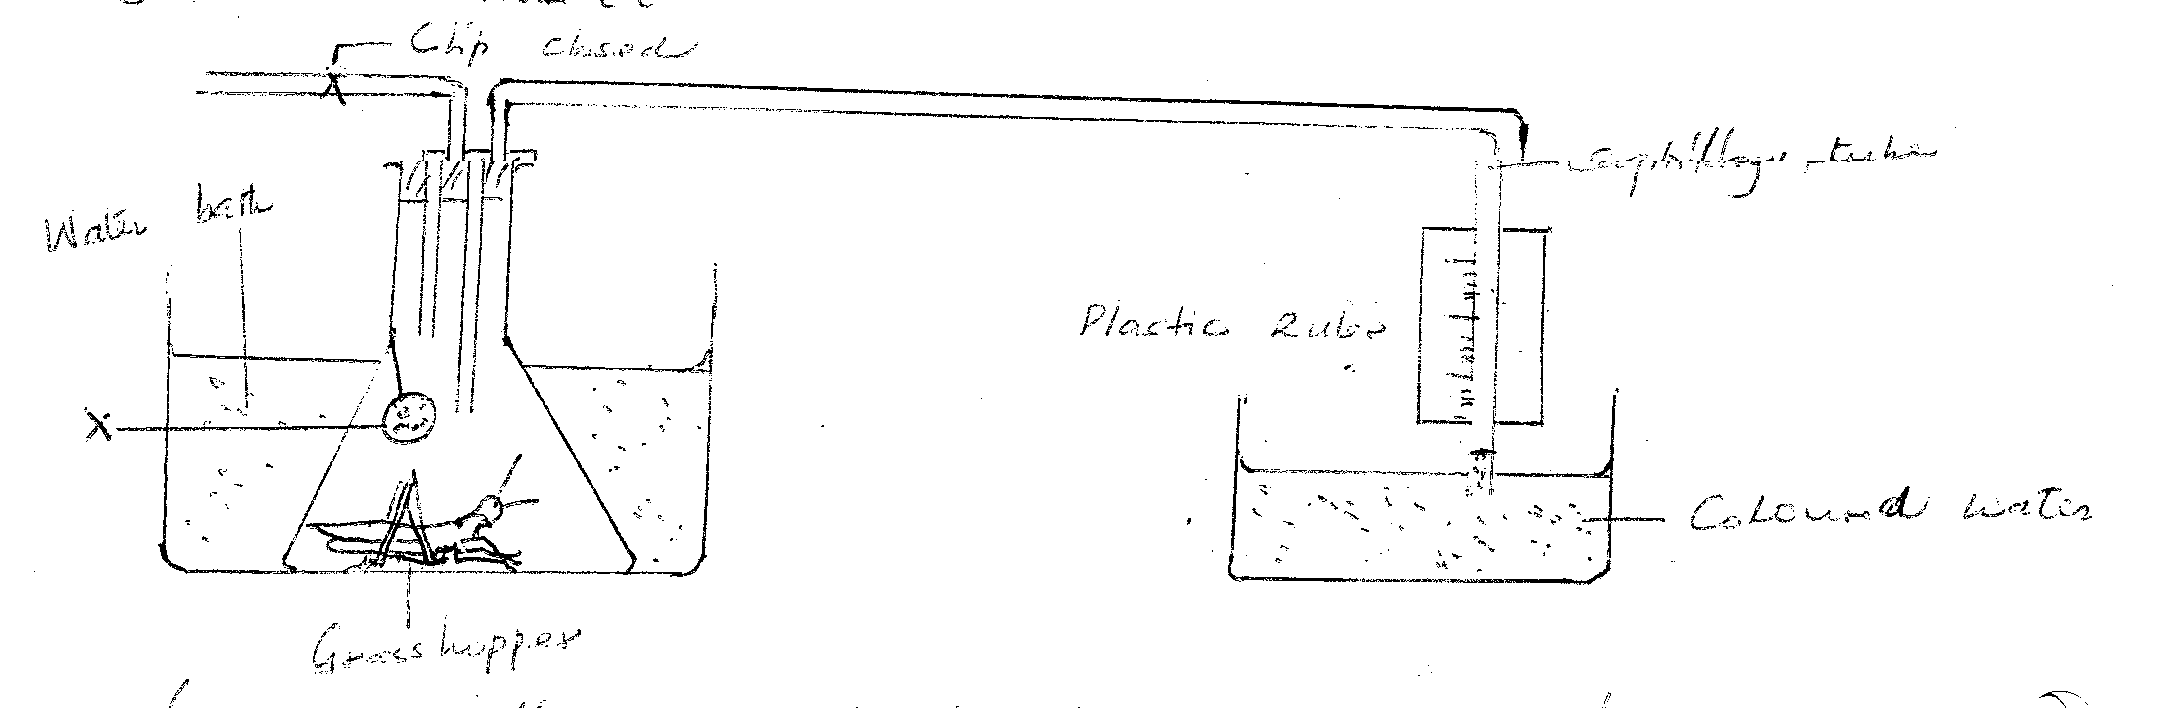
  - Name the chemical compound labeled X and state its function. [2 Marks]
Compound –

Function –

  - Why is the conical flask placed in a water bath? [1 Mark]

  - What would happen to the level of coloured water after 5 minutes? Explain: [2 Marks]

  - How can a control experiment be set? [1 Mark]

- In a biology lesson a student collected the animal in the diagram below.
Use it to answer questions that follow;
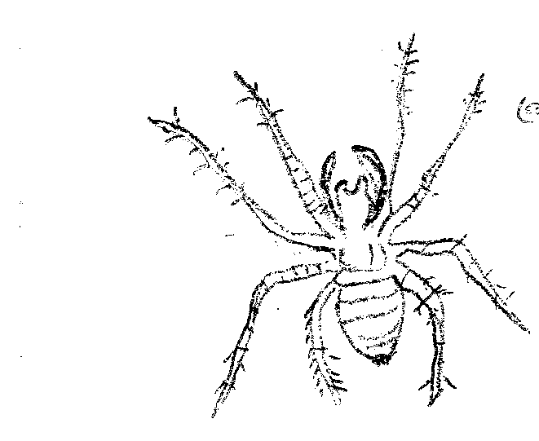
  - Name the phylum and class to which the organism belongs
    - Phylum ______________________________________ [1 Mark]

    - Class________________________________________ [1 Mark]

  - Give two reasons for your answer in 1 (i), (ii) above [4 Marks]
    - __________________________________
__________________________________
    - __________________________________
__________________________________
- The diagram below represents a plant in the division Byrophyta:
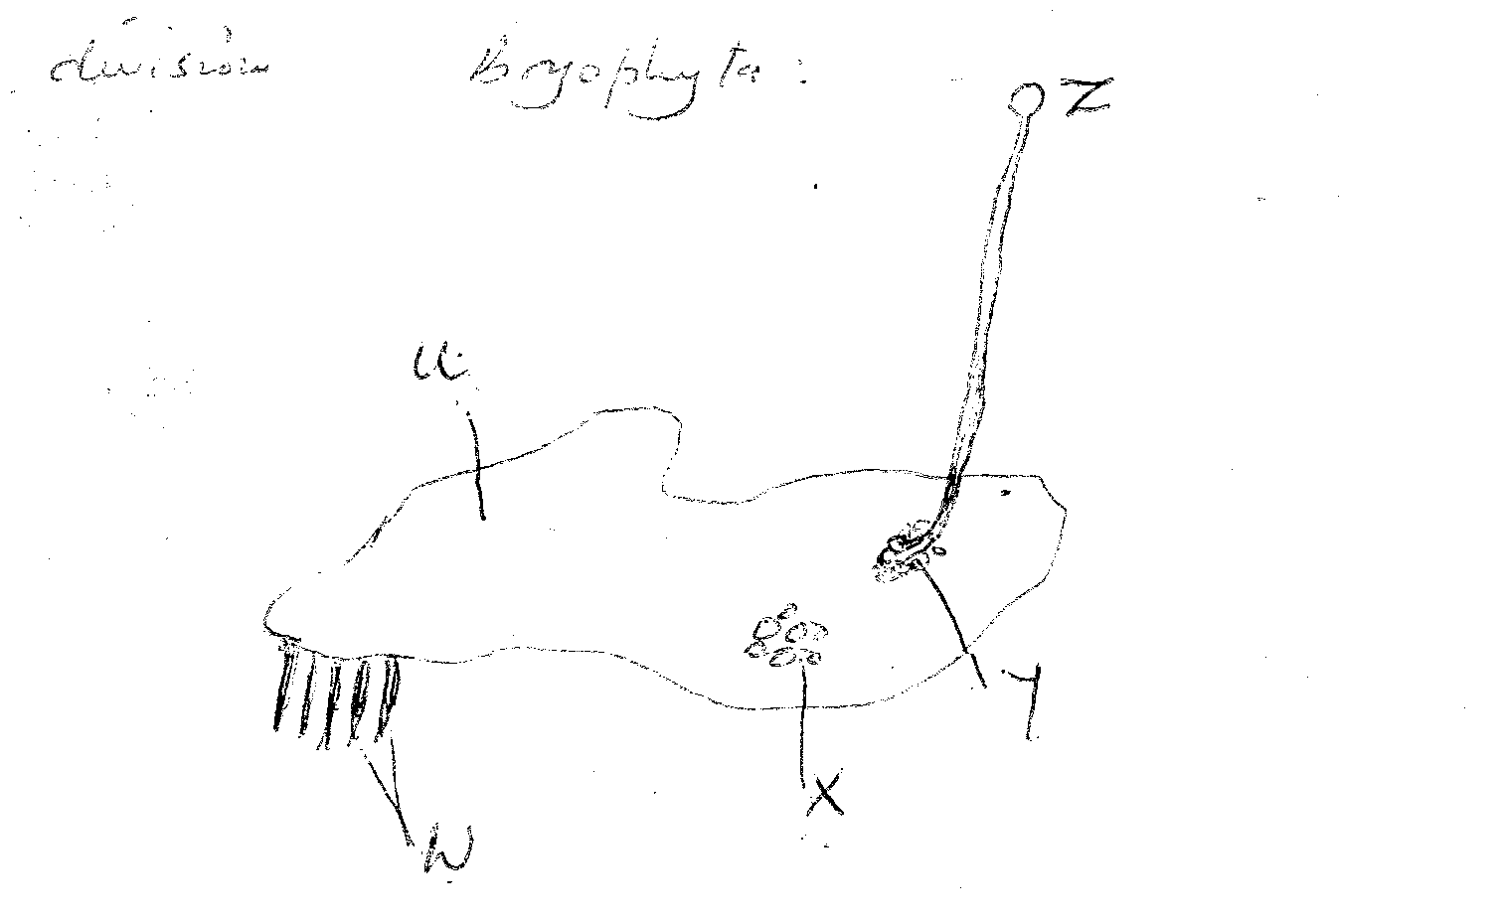

  - Name the parts labeled [5 Marks]
U

W

X

Y

Z

  - Name one function of part labeled. [3 Marks]

X

Y

Z

  - It is observed that when apical bud of a plant is removed, lateral buds sprouts, where as they do not sprout in presence of the apical bud;
    - What is the biological term used to describe this? [1 Mark]

    - Give one application of this phenomena in agriculture. [1 Mark]

  - State four roles of IAA in plant growth and development: [4 Marks]

  - In epigeal germination the cotyledon is brought above the soil surfaces; Explain
[2 Marks]

  - State 2 structural modifications of nephrons in desert mammals. [2 Marks]

  - State a kidney disease whose symptom is coloured and turbid urine [1 Mark]

- In a biological experiment; a cross was made between a tall pea plant & dwarfs plants; their progeny was selfed and the resulting plants were in a mixture in the ratio of 3:1. Make a biological cross to show these outcomes. [4 Marks]

- Explain geographical distribution as evidence of organic evolution. [2 Marks]

SECTION B
Answer Questions 10 (Compulsory) and either question 11 or 12 in the Spaces Provided

- The table below shows the changes observed in the dry weight in milligrams of a barley seedling, its embryo and Endosperm during the first ten days after the onset of germination.
 | Dry weight in milligrams
Time (days) | Embryo | Endosperm | Whole seedling
0 | 2 | 41 | 45
2 | 2 | 39 | 43
4 | 7 | 32 | 41
6 | 15 | 21 | 38
8 | 22 | 11 | 35
10 | 35 | 6 | 43
  - Using a suitable scale and on the same axis, plot a graph of dry weight of embryo, endosperm and whole seedling against time. [8 Marks]
  - State and account for the changes in dry weight shown by:-
    - Endosperm [4 Marks]
    - Embryo [4 Marks]
  - Explain the role of water during germination [4 Marks]

  - Describe how the mammalian heart is adapted to its function [10 Marks]
  - How does gaseous exchange take place in terrestrial plants? [10 Marks]

  - How is the Epidermis of a green plant adapted to its function? [6 Marks]
  - Describe how structural factors affect rate of transpiration in plants [8 Marks]
  - Describe how xerophytes adapted to minimize water loss in their habitat. [6 Marks]

