NAME _______________________________________________________ AD NO ______________
DATE ________________________________ Class ___________________________

MWAKICAN EXAMS FORM 4 TERM ONE

BIO PP1

TIME:
INSTRUCTIONS:
Answer all the questions in the spaces provided

1. Name the part of a flower that develops into:
[i] Seed [1mk]

[ii] Fruit [1mk]

2. State two ways in which floating leaves of aquatic plants are adapted to gaseous exchange. [2mk]

3. The diagram below represents a stage during cell division

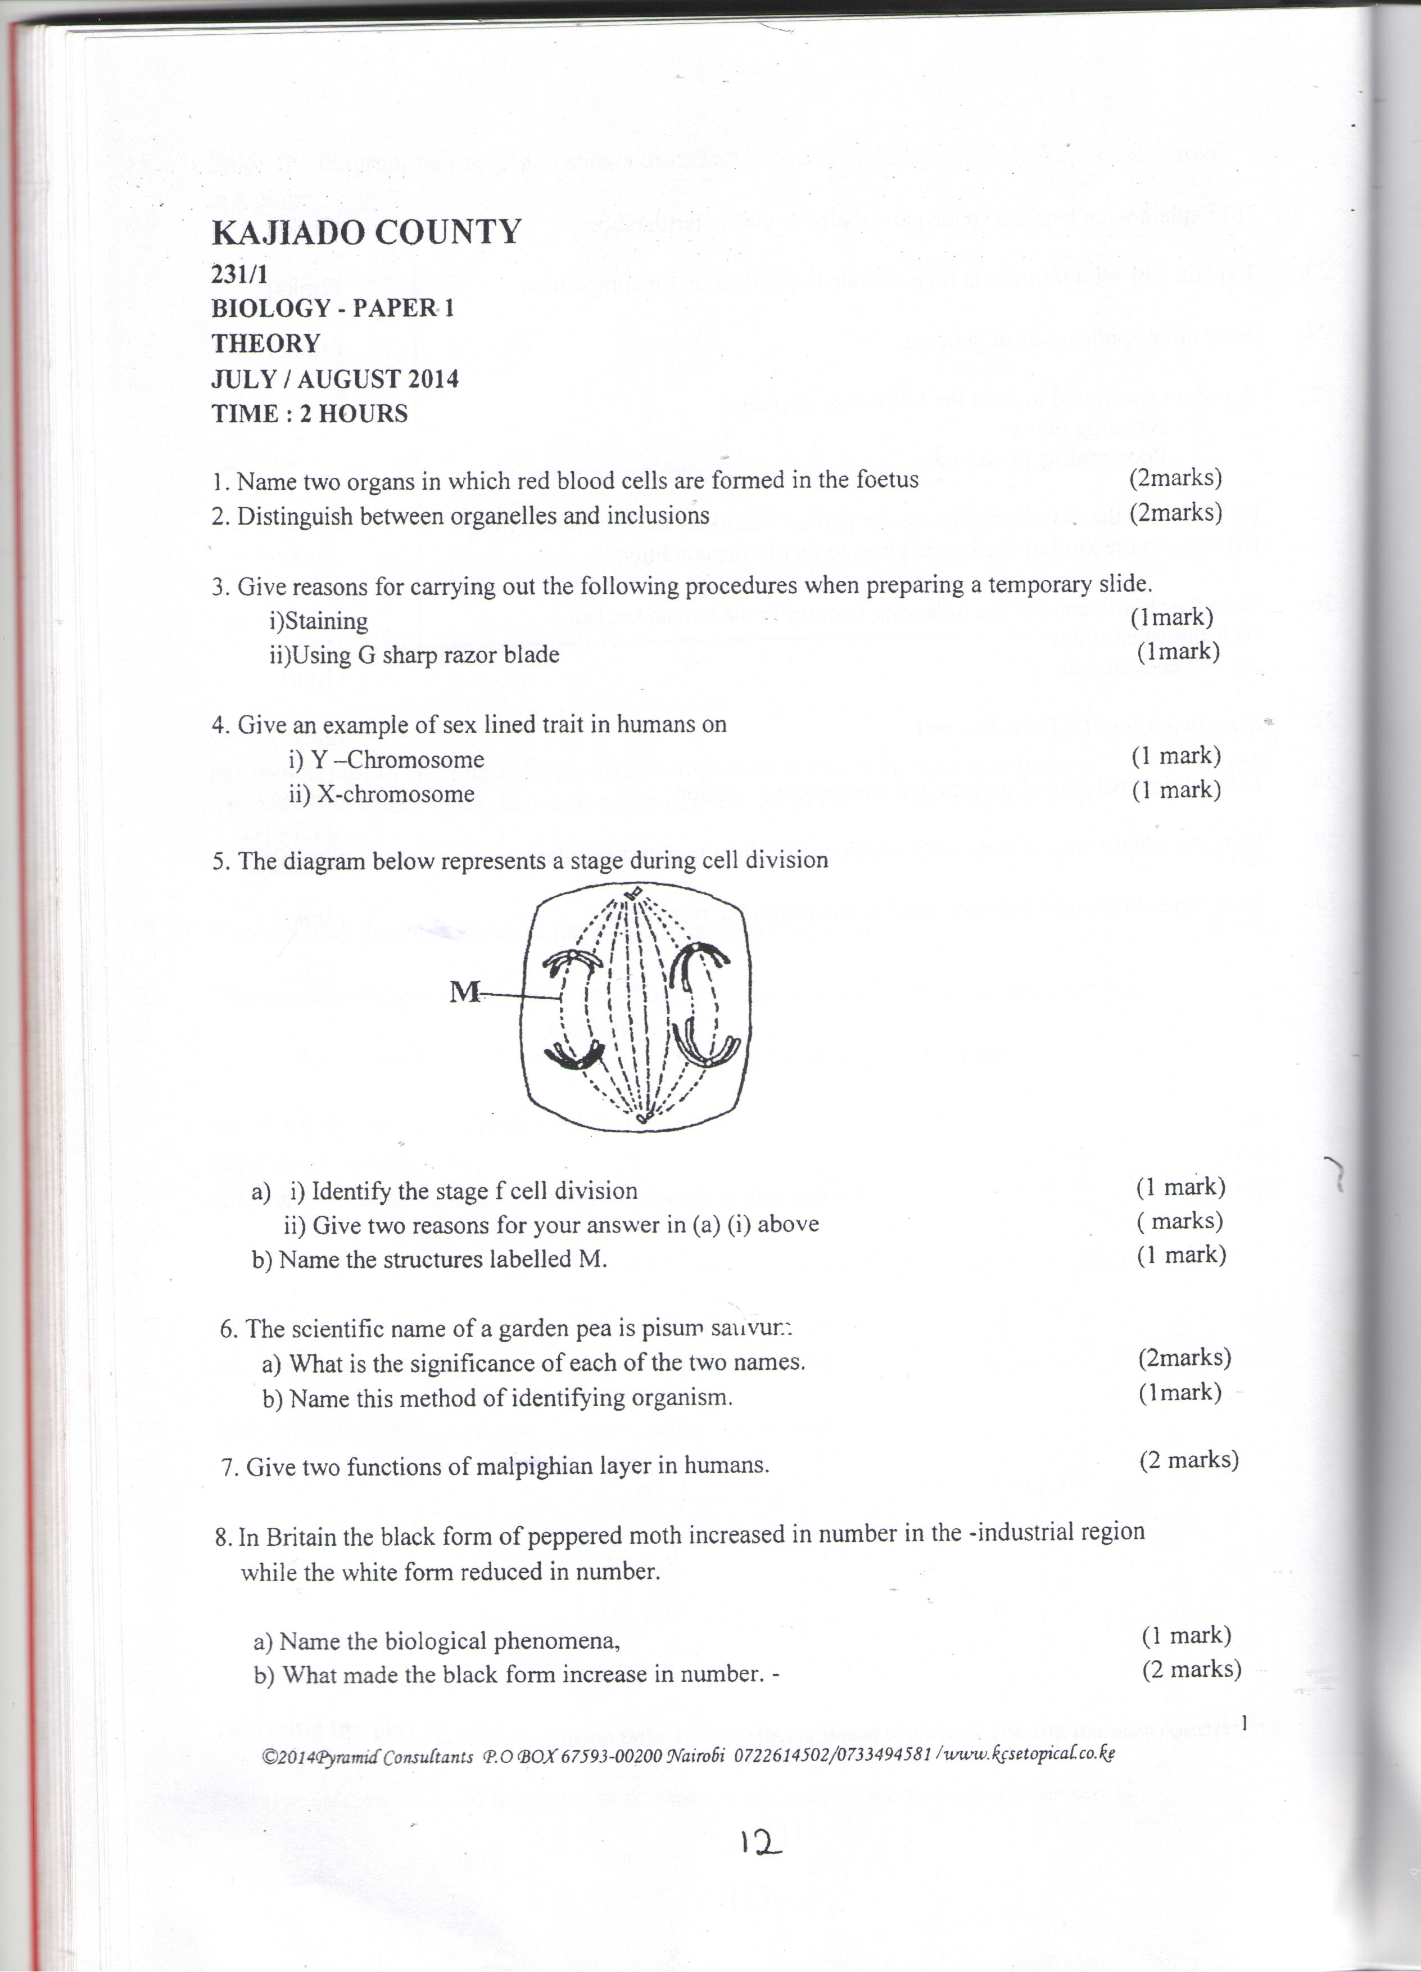

[ a] [i] Identify the stage of cell division [1mk]

[ii]Give two reasons for your answer in [a] [i] above [2mk]

[b] Name the structures labeled M [1mk]

[b] Name the class to which millipede belongs [1mk]

4[a] Distinguish between the terms [2mk]
Homodont and heterodont

[b]what is the function of the carnassial teeth [2mk]

5.An A blood group patient involved in a road accident required an urgent blood transfusion. His relatives were invited to donate blood.
[a]Name the possible relative who would not donate blood to him [2mk]

[b]State why the others would not be in a position to donate blood to him [2mk]

6. The flow chart shows a part of a food relationship in an ecosystem
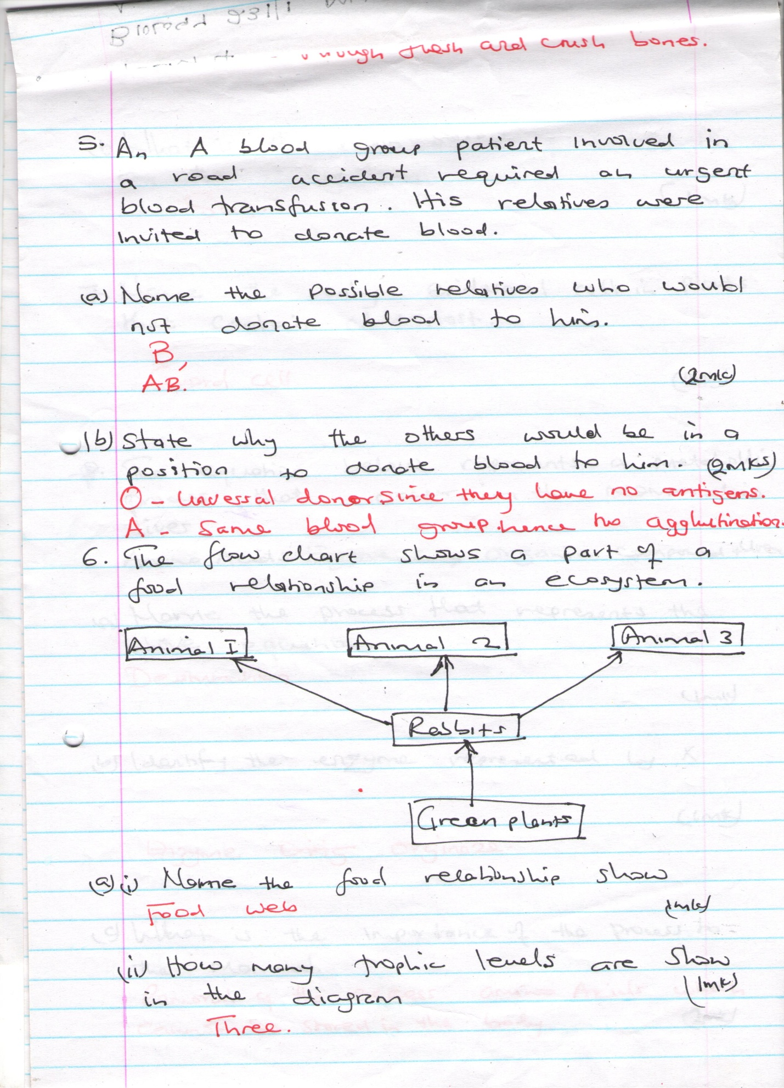
[a]_{[i]}Name the food relationship shown [1mk]

_{[ii]} How many trophic levels are shown in the diagram [1mk]

[b]What is the main source of energy in the ecosystem [1mk]

7. Name the only epidermal cell in plants that contain chloroplast [1mk]

8. The equation below represents a metabolic process that occurs in the mammalian lives
Amino Acids Enzyme x organic compound
[a]Name the process that represents the above equation [1mk]

[b]Identify the enzyme represented by x [1mk]

[c] What is the importance of the process to the mammal [1mk]
9. [a] Name the carbohydrate that is stored in mammalian muscle [1mk]

[b]What name is used to describe removal of indigestible and undigested food material from the alimentary canal [1mk]

10.[a]Carl Linnaeus developed the taxonomic units of classification
[i]What is taxonomy [1mk]

[ii]Why was the system of classification by carl linneaus described as natural system of classification [2mk]

11. Phagocytes also called granulocytes or polymorphs are cells found in the blood whose they ingest pathogens and cell debris
[i]why are they called polymorphs. [1mk]

[ii]Name the cell organelle most abundant in phagocytes to enable them function effectively [1mk]
12. Name the:
[a] Material that strengthens xylem tissue [1mk]

[b]Tissue that is removed when the part of a plant is ringed [1mk]

13. The diagram below represents a cell organelle.
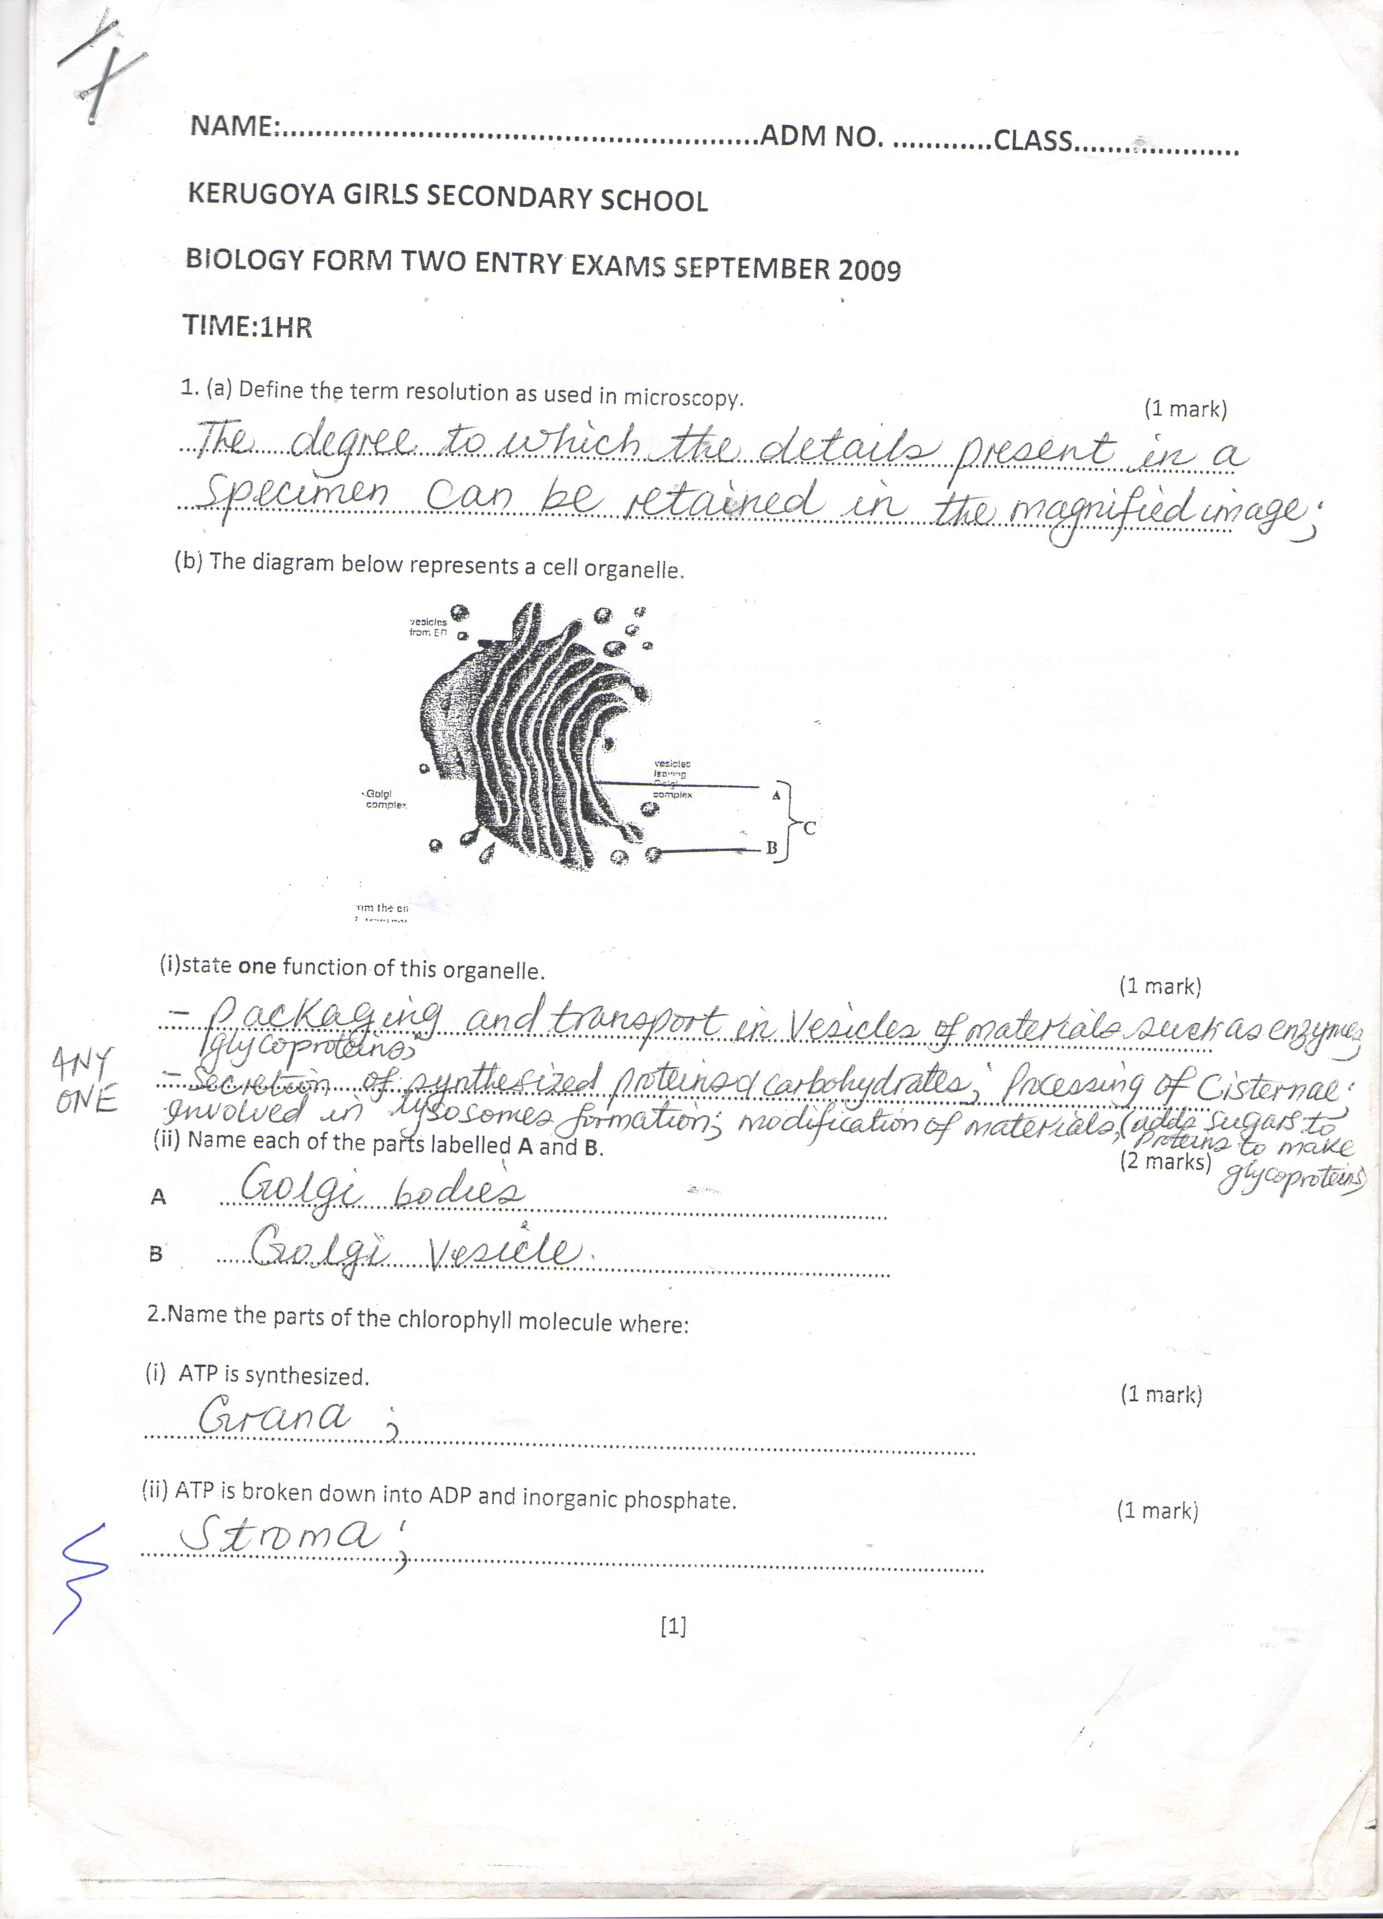

[i]State the function of this organelle [1mk]

[ii]Name each of the parts A and B
A [1mk]

B [1mk]
14. In which two ways do guard cells differ from other epidermal cells [2mk]

15.Through cellular respiration, the chemical energy stored in glucose molecule is converted into which specific molecule [3mk]

[b]Name the substance that speed up chemical reaction without being used up in those reactions
[1mk]

16.During germination and early growth, the dry weight of endosperm decreases while that of embryo increase explain [2mk]

17. The diagrams below show changes in the life cycle of flowering plants
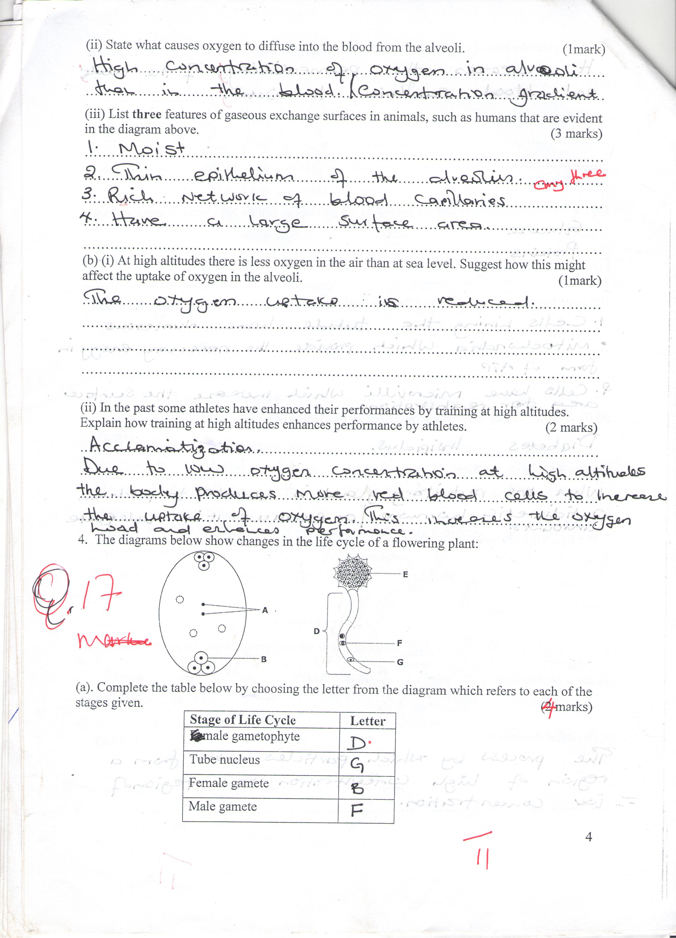
[i]Complete the table below by choosing the letters from the diagram which refers to each of the stages given [4mk]
STAGE OF LIFE CYCLE | LETTER
Male gametophyte
Tube nucleus
Female gamete
Male gamete
[1mk]
3 [a]. State 2 characteristics of kingdom Monera that are not found in other kingdoms [2mk]

19.State three ways by which plants compensate for lack of the ability to move from one place to another [3mk]

20. State three physiological processes that are involved in movements of substances across the cell membrane [3mk]

21. If the human pancrease is not functional:
[a]Name the hormone which will be deficient [1mk]

[b]Name the disease the human is likely to suffer from [1mk]

22. The oxidation state of a certain food is represented below by a chemical equation
2C₃ H ₂O ₂N + 6O₂ (NH₄)₂ CO₂ + 5CO₂ + 5H₂ O

[a] Calculate the respiratory quotients[RQ] of the food substance [2mk]

[b]Identify the food substrate [1mk]

23. The diagram below shows an apparatus used during collection of specimen
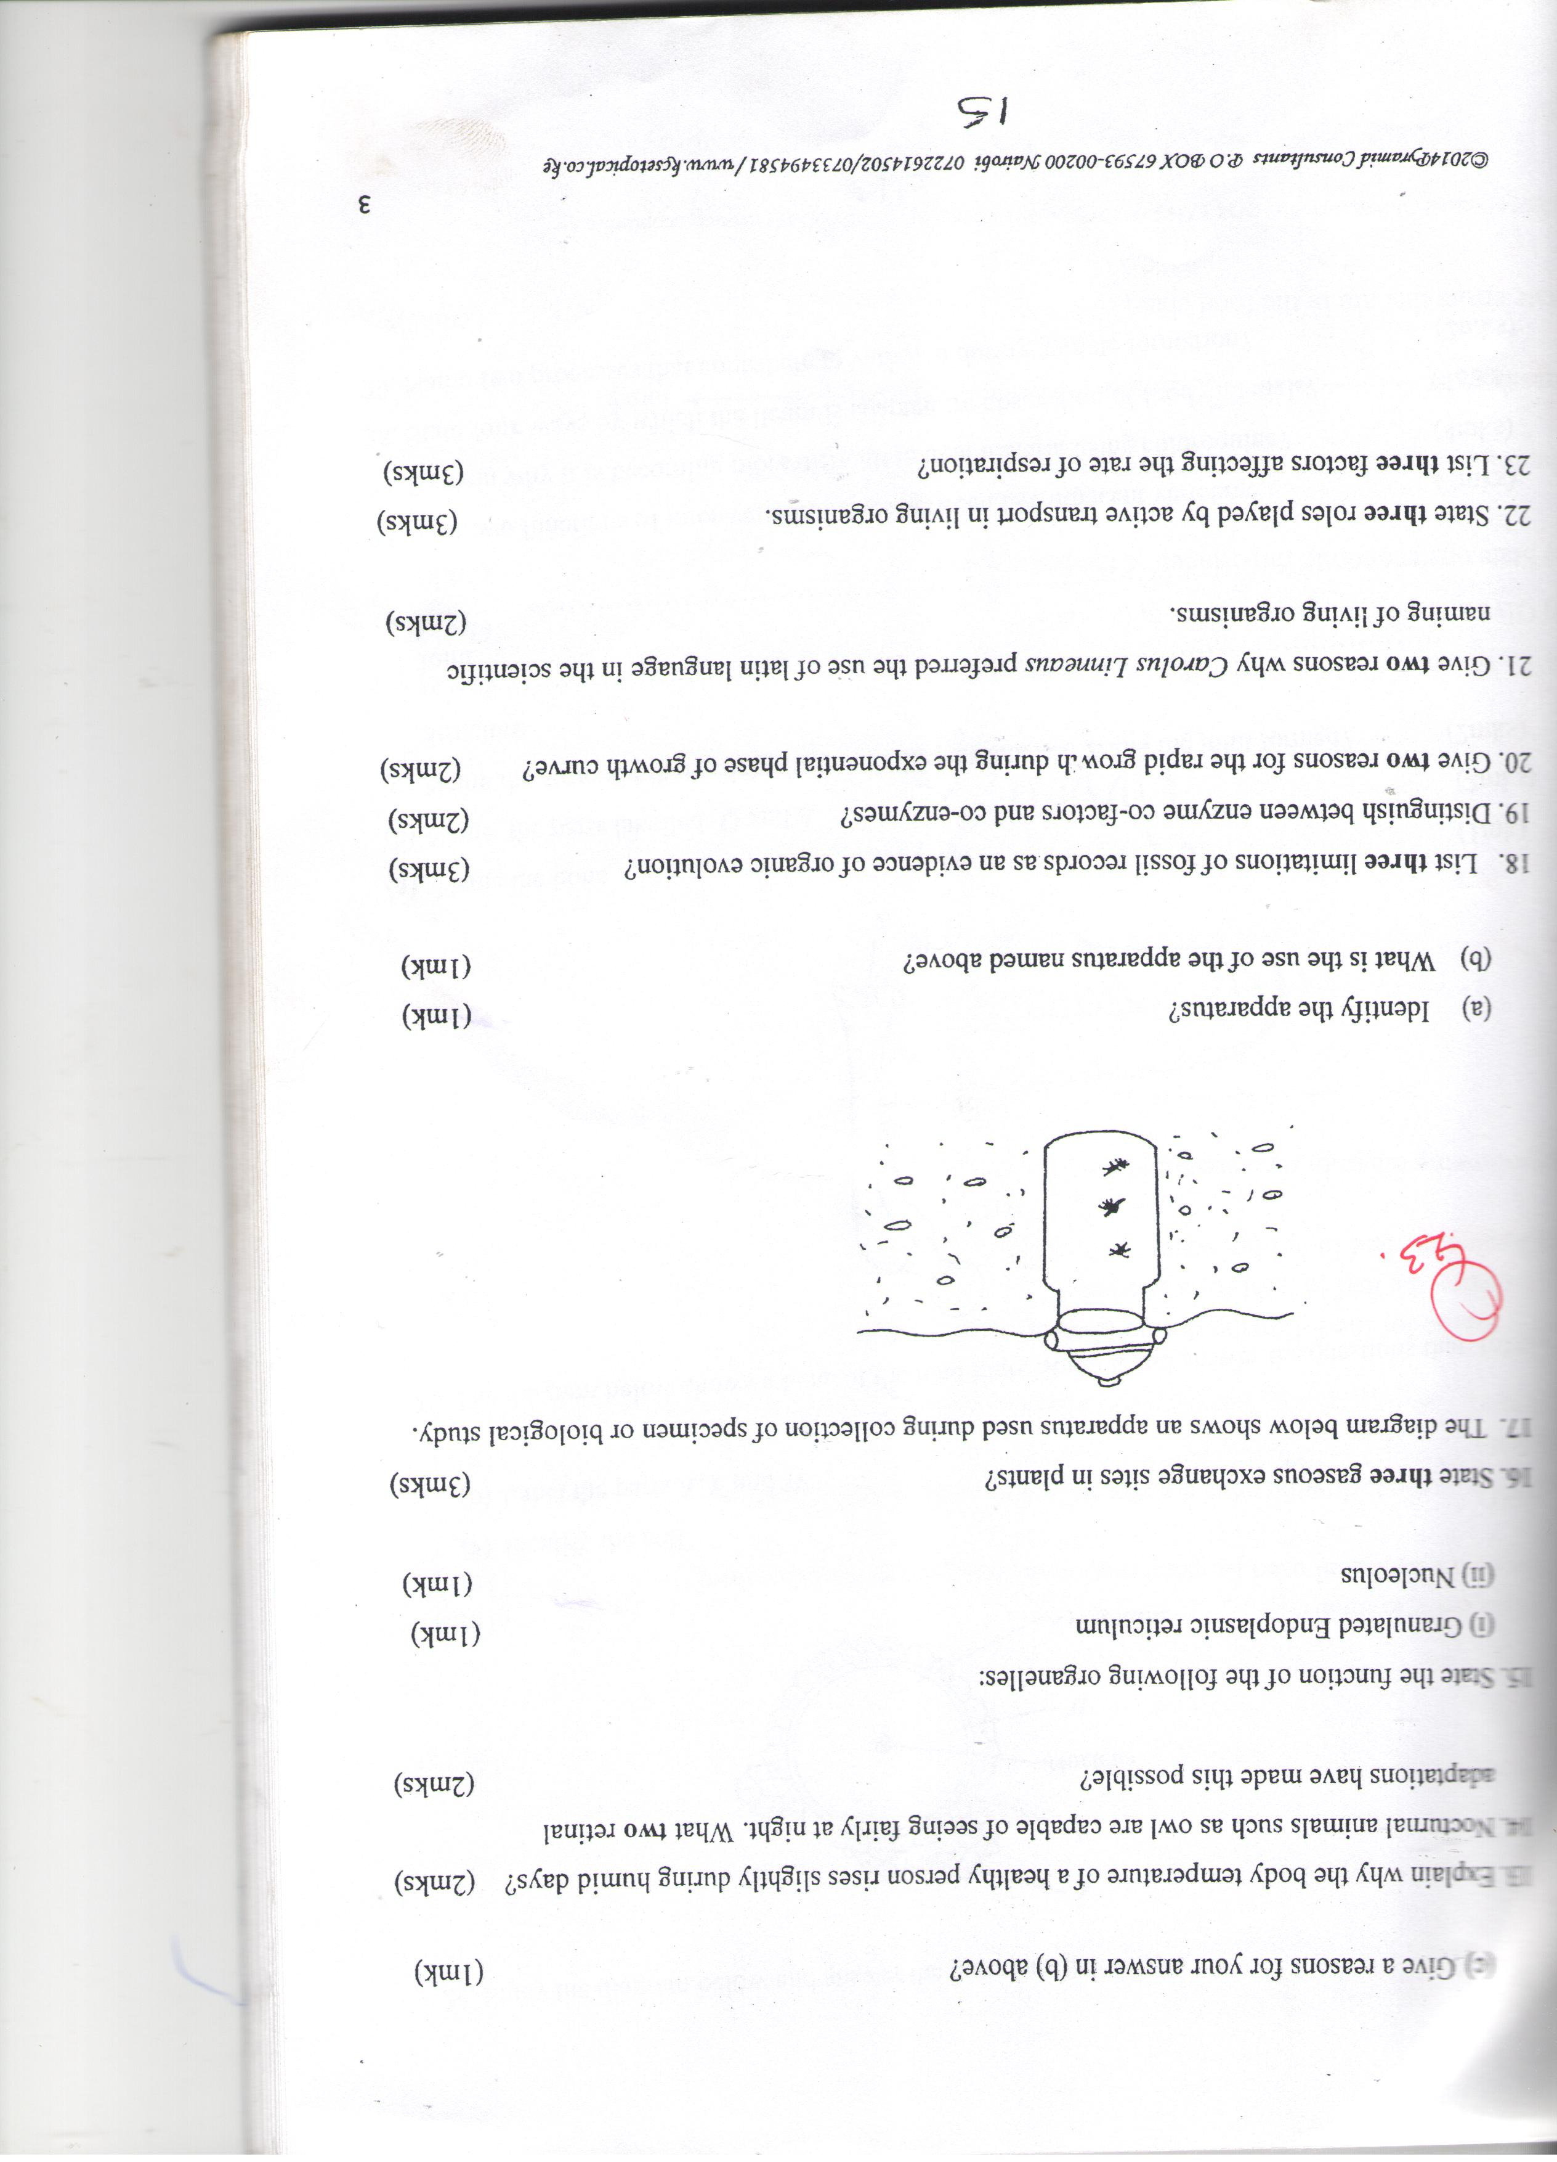

[a]Identify the apparatus [1mk]

[b]What is the use of the apparatus named above [1mk]

24. State two factors in an ecosystem that affect the distribution of organisms [2mks]

25. A DNA strand has the following base sequence G C C T A G A T C A C
What is the sequence of the
[i] Complementary DNA strand [1mk]

[ii] M-RNA strand copied from this DNA strand [1mk]

26. State three limitations of fossil records as evidence of organic evolution [3mk]

27. How does nutrition as a characteristic of living organism differ in plants and animals [2mk]

28.State the function of the following parts of a light microscope .
[ i] Body tube [1mk]

[ii] Diaphragm [1mk]

29. State three characteristics of gaseous exchange surfaces [3mk]

30. State two sources of variations [2mk]

