15. AGRICULTURE
The topic entails:-
- Definition of Agriculture
- Discussion of factors influencing Agriculture
- Explaining types of Agriculture
- Location of major cash crops on the map of Kenya
- Discussing the selected crops in respective countries
- Identifying and explaining similarities and differences between selected crop farming in Kenya and that of other parts of the world.
- Discussing Pastoral farming in Kenya
- Comparing and contrasting:
(a)Dairy farming in Kenya and Denmark
(b) Bee farming in Kenya and Argentina
- Carrying out field work on agricultural activities in the local environment

1 (a) (i) State the difference between land reclamation and land rehabilitation.
(ii) Other than tree planting, give three other methods employed in rehabilitation of land.
(b) (i) State three objectives that led to the establishment of Mwea Irrigation Scheme in Kenya
ii) Explain four human problems that face irrigation farming in Kenya.

2. (a) Describe the stages followed in the reclamation of land from the sea in Netherlands
(b) State four benefits of the delta plan to the Netherlands.

3. (a) (i) Name two districts in Rift valley where maize is grown in plantations.
(ii) Describe maize production from planting to harvesting.
(b) Outline the significance of maize growing in Kenya.

4. Explain three problems facing maize farmers in Kenya.

5. (a) Name two exotic breeds of dairy cattle reared in Kenya.
(b) Give three reasons why the Kenya highlands are suitable for dairy farming.

6. (a) Name two horticultural crops grown in Kenya
(b) State three reasons why horticulture is more developed in the Netherlands than in Kenya.

7. (a) Name two horticultural crops that are produced in Kenya
(b) Explain two reasons why horticultural produce is exported by air

8. (a) (i) What is nomadic pastoralism?
(ii) State three characteristics of nomadic pastoralism

9. a)i) Name three exotic breeds of dairy cattle kept in Kenya
ii) Apart from milk name three other dairy products
b)i) State three factors which favour the rearing of dairy cattle in Kenya highlands
ii) Explain four problems facing dairy farmers in Kenya
c) i) Compare dairy farming in Kenya and Netherlands
ii) Name two dairy plants in Kenya

10. (a) Name two dairy breed found in the lowlands of Kenya
(b) State three problems that have hindered the dairy activities in the Kenya highland

11. a) State three physical factors that favour wheat farming in Kenya
b) Give three problems facing wheat farming in Kenya

12. (a) Name ;
(i) Three provinces in Kenya where wheat is grown on commercial scale
(ii) Three wheat producing provinces in Canada
(b) Explain three conditions that favour wheat farming in Kenya
(c) Explain five factors which enable Canada to produce more wheat than Kenya
(d) State three importance of wheat to the economy of Canada

13. (a) Name three districts in Kenya where wheat is grown on large scale
(b) Account for any four physical conditions needed for the growth of wheat
(c) Describe the cultivation of wheat under the following:-
(i) Processing of wheat
(ii) Marketing of wheat
(d) (i) Explain two problems facing wheat farmers in Kenya
(ii) Give two reasons why Canada produces more wheat than Kenya (2mks)

14. (a) State three physical conditions that favour sugarcane cultivation in Western Kenya
(b) Give two reasons why we need to encourage dairy farming in Kenya

15. (a) (i) Apart from Ghana name two other countries that produces cocoa in Africa
(ii) State three physical conditions that favour large scale cocoa farming in Ghana
(b) Outline the stages cocoa goes through from harvesting to the time it is ready for export
(c) Explain three problems experienced by cocoa farmers in Ghana

16. (a) (i) What is horticulture
(ii) Horticulture is more developed in the Netherlands is more developed in the Netherlands
than in Kenya. Give four reasons for this
(iii) Give three reasons why the growing of flowers in green house is preferred in Kenya

17. Give four physical factors favouring wheat –growing in Kenya
18. (a) State two physical conditions favoring dairy farming in the Kenya highlands
(b) Compare dairy farming in Kenya and Denmark under the following headings:-
(i) Feeding of the animals
(ii) Marketing of the products

19. (a) Name two exotic breeds of beef cattle reared in Kenya
(b) State three physical conditions that favour beef farming in Argentina

20. (a) The figure below shows wheat growing province of Canada
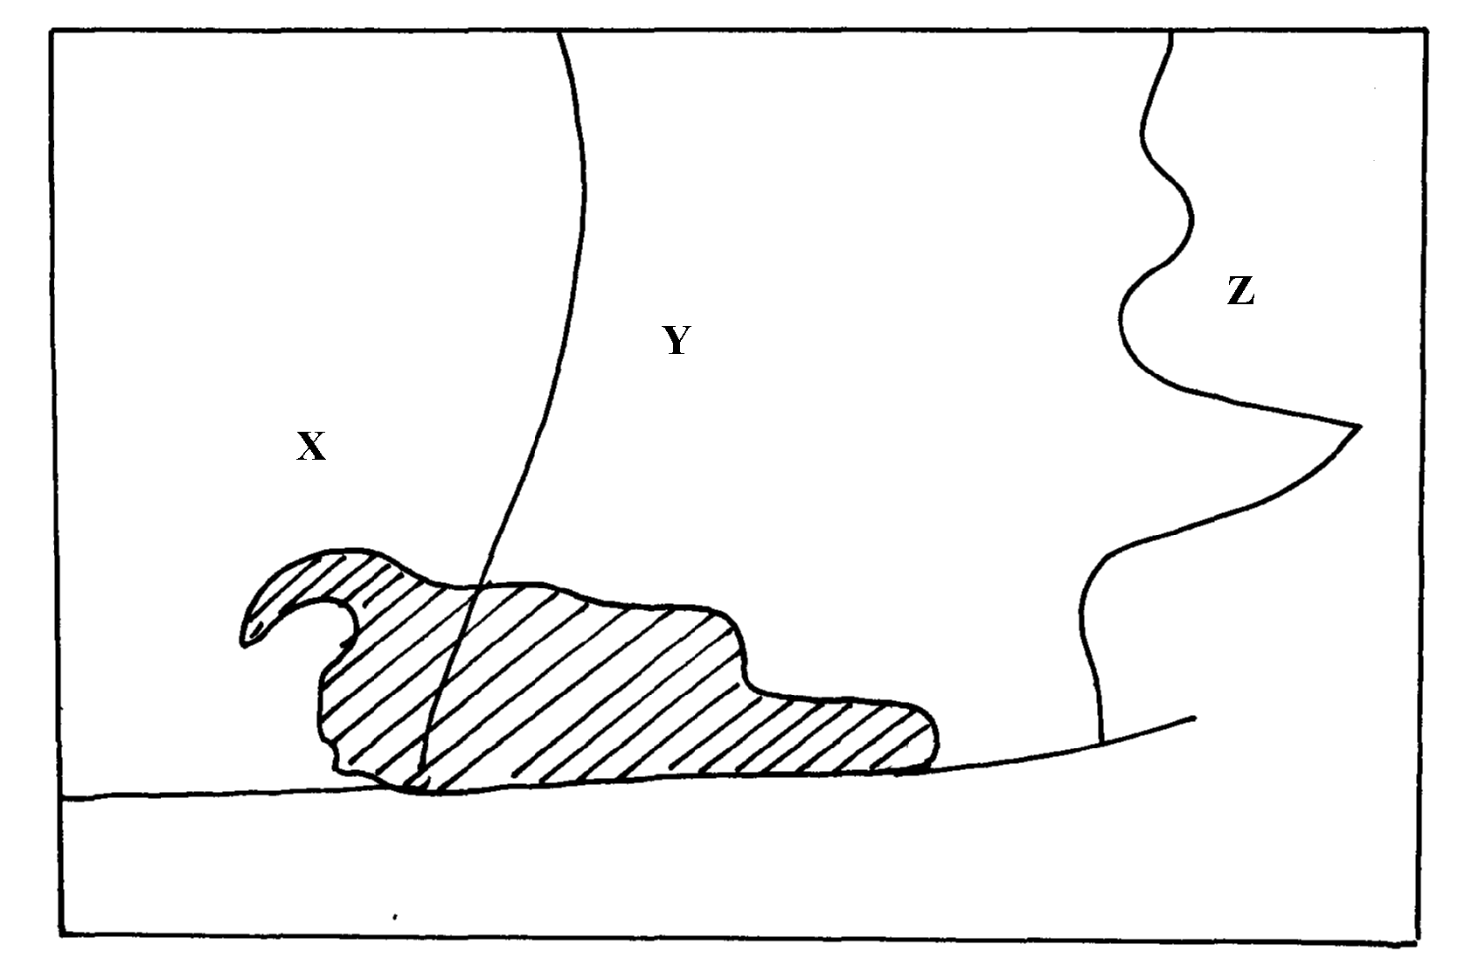

(i) Name the provinces marked X , Y and Z
(ii) State two physical factors favouring wheat farming in the named provinces above
(b) Give one province where coffee is grown on large scale in Kenya

21. a) Differentiate between horticulture and market gardening
b) State three factors that favour horticultural industry in Kenya

22. a) Define nomadic pastoralism
b) Give three characteristics of pastoral farming in Kenya

23. a) Give four reasons why there has been a steady increase of milk production in Kenya in
the recent past
b) Give similarities between dairy farming in Kenya and Denmark
c) Explain three benefits of dairy farming in Kenya

24. The table below shows horticultural crop production in Kenya
Crop | Quantity in tonnes
flowers | 42, 500
oranges | 22, 600
tomatoes | 20, 300
carrots | 15, 400
(a) (i) Draw a divided rectangle 15cm long to represent horticultural crop production in
Kenya in the year 2000 using the data above.
(a) (i) Calculate the range of the above data
(ii) What is the percentage of horticultural crop with the lowest tonnage?
(b) (i) State two advantages of using divided rectangle to represent geographical information.
(ii) State two climatic conditions that favour horticultural crops in Kenya
(c) Explain four problems facing horticultural farming in Kenya

25. (a) Name three main breeds of dairy cattle reared in Kenya
(b) State three benefits of dairy farming in Kenya

26. (a) Name two leading export commodities from Kenya
(b) State three problems facing trade in Kenya

27. (a) State any three roles played by livestock in the economy
(b) Identify any two solutions to problems facing pastoralists in the Northern part of Kenya

28. (a) List two economic factors that influence Agriculture
(b) (i) List two uses of cocoa
(ii) State one economic problem experienced in cocoa farming in Ghana

29. (a) Differentiate between horticulture and market gardening
(b) Name two main types of flowers grown in Kenya
(c) What problem do farmers in Kenya face in carrying out this activity?

30. (a) State three ways in which drought affect the agricultural sector in Kenya.
(b) State three reasons why the government of Kenya is encouraging bee keeping in the
country?

31. (a) List three social factors that influence Agriculture.
(b) State two factors that favour mechanization of wheat farming in Canada.

32. (a) State three climatic factors that favour the growing of oil palm in Nigeria.
(b) State any two products obtained from oil palm.

33. (a) Define the term pollution as used in Geography.
(b) Dither their air pollution name three forms of pollution.
(c) State physical conditions required for the growing of tea in Kenya.
(d) Explain four problems experienced in small scale to production in Kenya.

34. (a) Name two exotic beef cattle breeds in Kenya.
(b) State three steps taken by the government to improve beef farming in Kenya.
(c) State three problems facing beef farming in Kenya.
(d) (i) Explain three physical conditions that favour beef farming in Argentina.
(ii) Explain two ways in which beef farming contribute to the economy of Argentina

