IDEAL RELEASE VOLUME 1

REVISION AGRICULTURE PAPER 2
10 Sample Papers + Answers

SAMPLE PAPER 1
AGRICULTURE PAPER 2
443/2
SECTION A (30 MARKS)
Answer ALL questions in this section

1. State two reasons for hoof trimming in goat management. 2mks
2. State two conditions when supplementary feeding of bees is necessary. 2mks
3. State four factors considered when selecting a breeding stock. 2mks
4. Name two hormones that control milk letdown in cattle. 2mk
5. List four factors that determine the amount of food consumed by an animal. 2mks
6. Give the difference between maintenance ration and production ration. 2mk
7. Name any four bacterial diseases affecting livestock. 2mks
8. State two characteristics of an ideal udder of a dairy cow. 2mks
9. Give the meaning of ratio 3:3:3 as commonly used in pig production. 1mk
10. Name the four compartments of a ruminant stomach in an orderly sequence. 1mk
11. Give the breeding system involved in each of the following cases. 2mks
(a) Fresian sire mated with Ayrshire dam.
(b) Freshian sire (father) mated with Freshian dam (daughter)
12. State the causal agent of the following livestock diseases. 2mks
i) Anthrax
ii) East coast fever
iii) Mastitis
iv) Contagious abortion
13. State two dairy goat breeds. 2mks
14. State two disadvantages of natural incubation in poultry production. 2mks
15. (a) What is hybrid vigour? 1mk
(b) Give three ways in which an animal will express hybrid vigour. 3mks

SECTION B ( 20 MARKS)

Answer ALL the questions in this section in the spaces provided
16. Study the diagram of an oviduct of a hen and answer questions that follow:

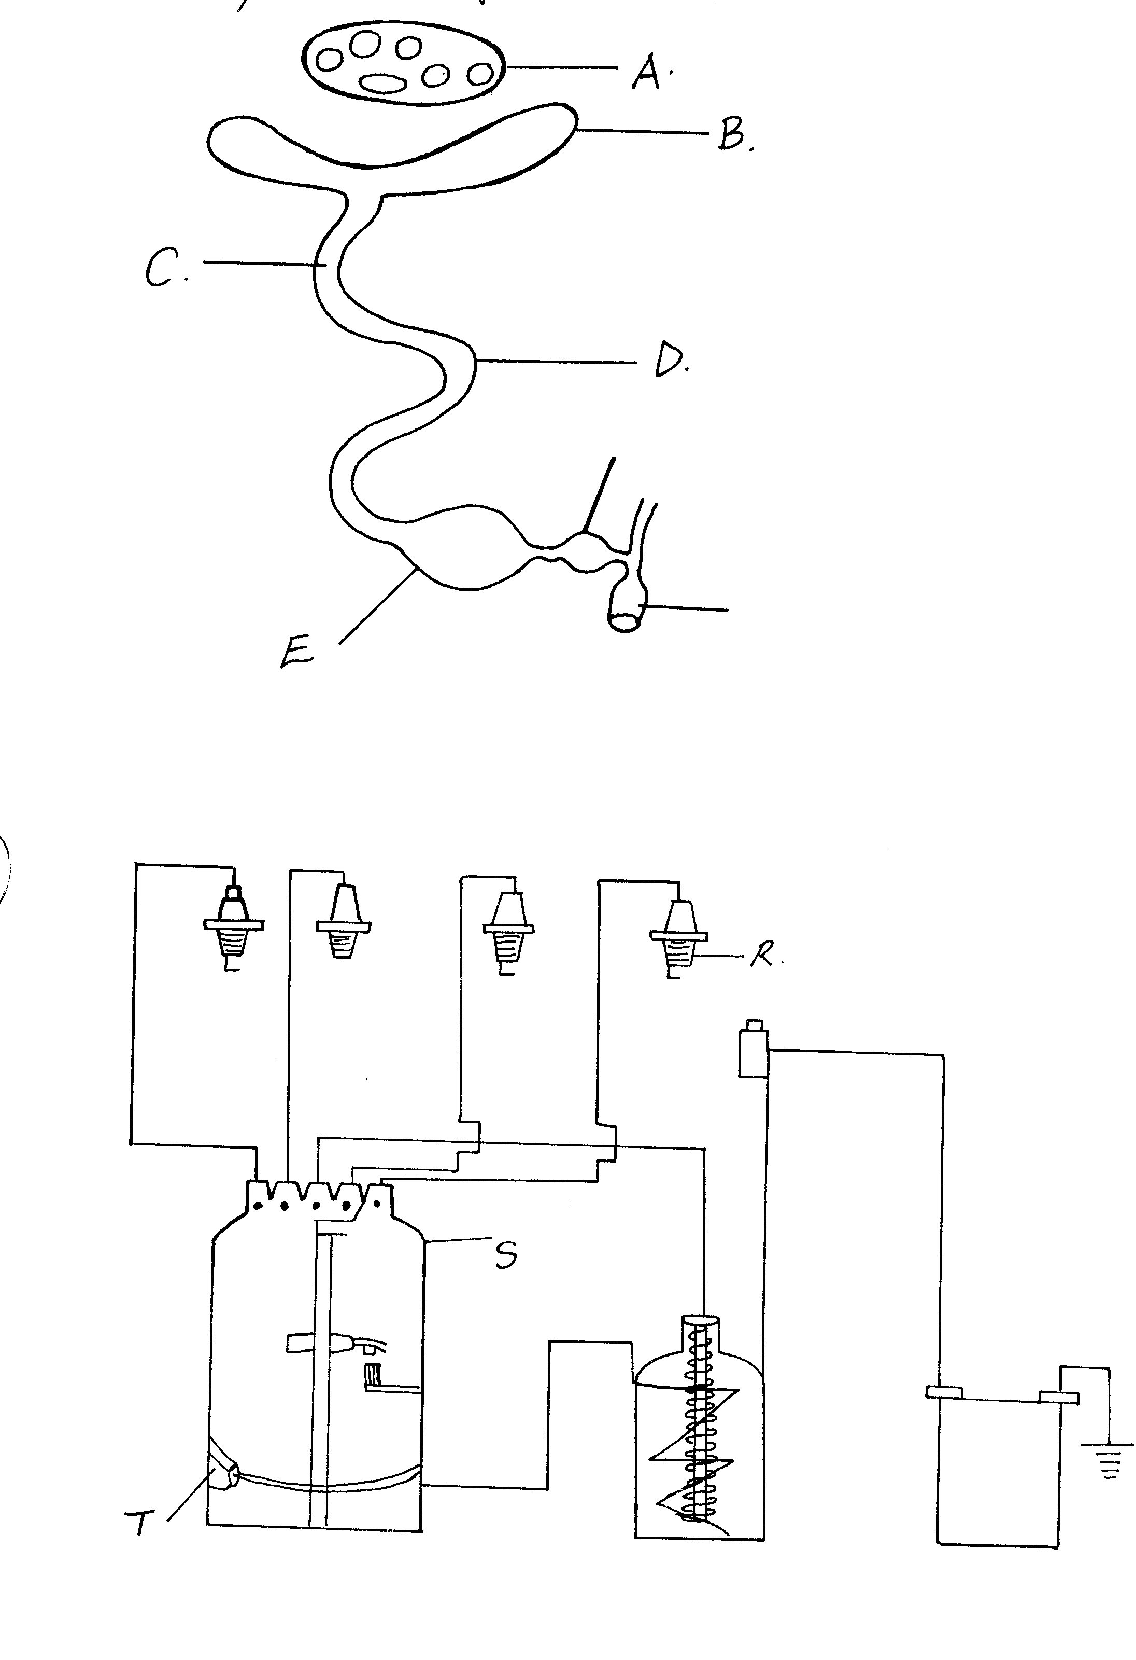
cloaca
Vagina
- Name part A 1mk
- Describe two changes that occur on the yolk at each of the parts B to E. 4mks
17. Study the structure and answer the questions:
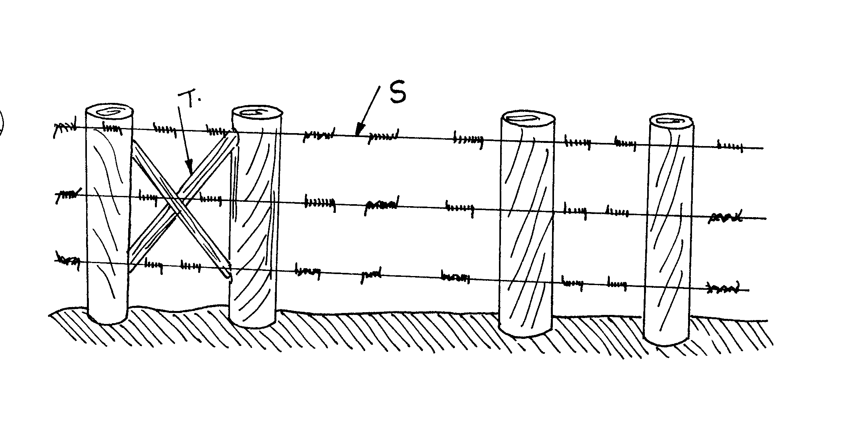
a) Name the structure above. 1mk
b) Name the parts labeled: 2mks
S
T
c) State the functions of parts labeled 2mks
T
S
18. a) Give the functions of each of the following parts of a mould board plough 4mks
i) Mould board
ii) Share
iii) Frog
(iv) Land slide
b) Give one daily maintenance practices that should be carried out on the mouldboard plough. 1mk
19. a) State two advantages of animal power as compared to tractor power. 2mks
b) State three-transmission mechanism in tractor. 3mks
SECTION C
Answer any two Questions
20. (a) The diagram below is about one of the tractor systems. Study it and answer the questions that follow.

Q
i) Identify the system shown above. 1mk

ii) Name the parts Q, R,S and T. 2mks
Q -
R –
S -
T -
iii) Explain two types of current produced in the system above. 9mks
- Use the diagram to answer the question below:

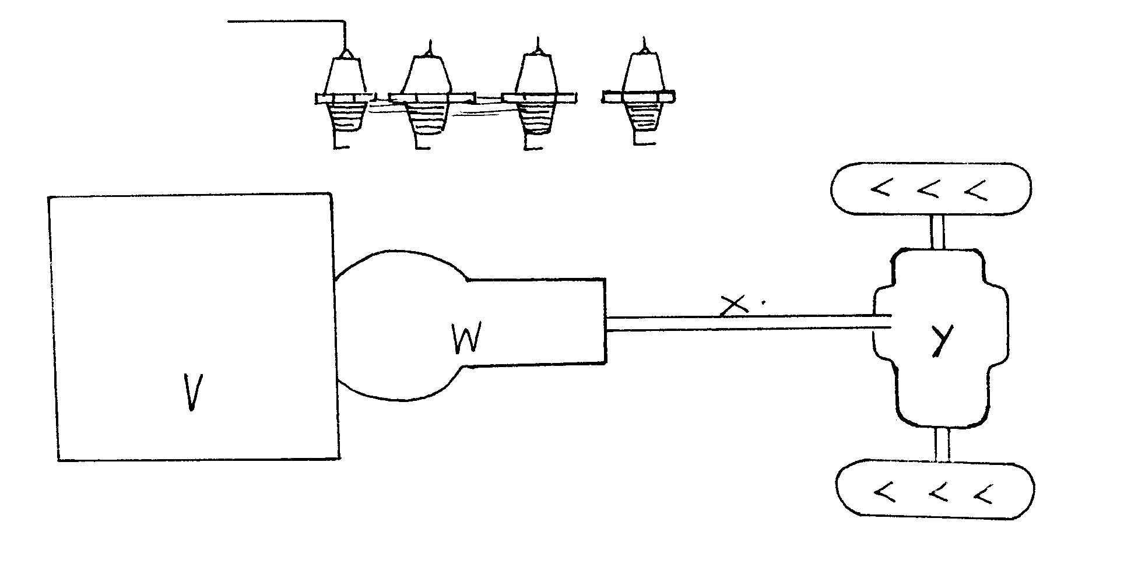

(i) Name the parts labeled V, W, X, and Y in a tractor power transmission system. 2mks
(ii) State two ways of improving the traction force in land wheel. 2mks

(iii) State four major differences between a diesel and petrol engine. 4mks
21. a) State any four management practice carried out in a crush. 4mks
b) State four factors considered in siting a beehive. 4mks
c) Describe the procedure used in establishing the foundation of a permanent farm building.
12mks
22. a) Discuss anthrax disease in cattle under the following subheadings 10mks
(i) Causal organism
(ii) Symptoms
- Control
b) Describe the lifecycle of three host tick. 10mks

MARKING SCHEME
SAMPLE PAPER 1
443/2

- -To control foot rot
-To prevent lameness/ minimize physical injury
- -When the colony is new
-Lack of food near the hive
-lack of water/ dry conditions
-When high multiplication of bees is required
- -Young animals are selected as they have a long productive life
-High level of production
-Healthy animals
-Body conformation –according to their purpose
-Adaptability
- -Oxytocin
-Adrenalin
- -Body size and weight
-Age of animal –Young ones require more
- Animal’s activity.
-Level of production –High producers require more
- -Maintenance ration –Amount of food given to an animal per day
-Production ration –Amount of food given to an animal above and over maintenance ration for the purpose of production
7. - Mastitis Black quarter
- Foot rot Contagious abortion
- Scours Anthrax
8 - Appropriate size of udder
- Well set/ attached udder
- Well spaced teats
- Teats of suitable size
- Have four teats
- 3.3.3 means gestation of a sow of 3 months 3 wks and 3 days
- -Rumen
-Reticulum
-Omasum
-Abomasum
11. a) Cross breeding
b) Inbreeding
12 -Bacillus anthracis
-Theilaria parva
-Streptococcus spp and staphylococcus
-Brucella Abortus
- -Saneen
-Toggenberg
-British alpine
- -Possible only for broody hens
-Suitable only to small scale farms
-A farmer cannot plan when to incubate. Egg production decreases when hens go broody
- Egg production decreases when hens go broody
15. a) -Improved performance resulting from mating two unrelated superior breeds

- -Increase in growth rate
-Increase in production
-Increased fertility
-Improved body conformation
SECTION B
- A-ovary
B-(Infundibulum)
Fertilization occurs here
Addition of chalaza
C-(Magnum)
Addition of albumen
Addition of water and salts
D-(Isthmus)
Addition of Albumen
Addition of water minerals and vitamins
Formation of shell membranes
E-(Shell gland/ uterus)
Addition of water and salts
Shell pigments are added
Formation of egg shell
17. a) Barbed wire fence
b) S Barbed wire
T Dropper
c) T Stops wire from sagging/ reinforce wire/ strain
S Strengthens the fence
18. a) i) Turns/ inverts furrow slices
ii) Cuts furrow slice horizontally
- Holds the frame onto the mould board land slide and share
- Stabilizes/ balance the plough
19. a) -Animal power is cheap
-It does not require much skill
-Low initial capital
-Can work on steep slopes as opposed to the tractor
-Can work on a small and irregular pieces land
- -Propeller shaft
-P.T.O shaft
-Hydraulic system
SECTION C
20.a) (i) -Ignition system
ii) Q -Ignition coil
R -Spark plug
S -Distributor unit
T -Condenser
iii) a) -The primary current from the battery follows through the ignition and back to the battery through earthing of body.
- -The secondary current is produced when the primary current is broken up by circuit breaker. This creates high voltage in ignition coil of up to 600-800 voltage. The high voltage jumps primary coil to secondary coil. The high voltage is passed on to distributor cup and spark pugs to ignite fuel mixture in engine

b) (i) V - Engine block
W -Gear box unit
X -propeller shaft
Y -Differential unit
- -Increase the diameter of wheel
-Add weight i.e. filling the tube with water
-Replace the worn out tyres
iii)
Diesel | Petrol
-Has injection pump  -Fuel and air is mixed in cylinder | -Use carburettors  -Fuel and air is mixed a in carburetor

21. a) -Hand spraying/ dressing to control parasites
-Identification
-Dehorning
-Pregnancy diagnosis
-Castration
-Milking
-Vaccination
-Close examination of animal 1mk
b) -Distance from the farm buildings
-away from grazing land/ paddocks
-Under shade
-Close to flowers/ plants
-Near water source
-away from roads/ paths Any 4x1=4 mk
c) -The foundation is measured and pegged
-The foundation is dug to remove loose and disturbed soil
-Concrete of 1:2:4 or 1:3:6 which is reinforced with steel rods is placed in the trench
-It is compacted and the foundation stone laid up to 15cm above the ground level
-Mortar used for joining the foundation stones should be at the ratio of 1:6
-Damp proof course (PVC) sheet is placed on top of the foundation to reduce termite and moisture rising up the wall 6x2=12 mks
Cause.
22. a) i) Bacillus anthracic/ bacteria 1 mk
- Symptoms
-Absence of rigor mortis
-Watery blood oozes through natural orifices
-Difficulty in breathing
-Extensive bloat after death
-Presence of blood in feaces and milk
- Shivering
-Sudden death and fast decomposition 5x1=5 mks
Control
-Vaccination
-Impose quarantine in infected areas
-Proper disposal of carcass
-Disinfect –animal house e.g. with formalin
-Do not open carcass if suspected of the disease
-Proper inspection of meat. 4x1=4 mks
- -Adult tick lay eggs on the ground
-Eggs hatch into larvae on the ground
-Larvae mount onto the first host
-Larvae on host –one feed to full engorgement and drop down
-larvae moult into nymphs on the ground
-Nymphs mount second host- suck blood until engorges
-Nymphs drop down
-Nymphs moult into adults
-Adults mount third host, suck blood to fully engorgement
-Adults drop down to repeat cycle 10x1=10 mks

SAMPLE PAPER 2
AGRICULTURE PAPER 2
443/2
SECTION A (30mks)
Answer ALL questions in this section
- Give TWO factors a farmer should consider when selecting garden tools for cultivation
(2mks)
- (i) What is milk let down? (1mk)
(ii) State THREE practices which are carried out to control mastitis in lactating cows (3mks)
- Give TWO uses of an ox-drawn tine harrow
- Give TWO advantages of keeping a jersey cow instead of a Friesian cow for milk production (2mks)
- State any FOUR causes of stress in a flock of layers (4mks)
- State TWO reasons for seasoning timber before use (2mks)
- Give TWO conditions that indicate mineral deficiency in livestock (2mks)
- List FOUR qualities of a good grain store (4mks)
- Give FOUR conditions under which a farmer would use instead of a tractor power for seed bed preparation (4mks)
- (a) Give TWO functions of worker bees in the hive (2mks)
(b) Name TWO types of eggs that are laid by a queen bee (2mks)
- Which livestock food is a by-product of pyrethrum? (1mk)
Section B (20mks)
Answer ALL questions in this section
12. Below is the breeding cycle of an ewe in relation to the feeding regime accompanying it. Use it to
answer the following questions

TUPPING

Gestation period Moderate diet

Low quality diet A B
C

Adequate amount of high quality feed

(a) What do A, B and C represent? (3mks)
(b) Which TWO aspects of nutrition are (i) and (ii)? (2mks)
(c) What is the importance of (i) and (ii) (2mks)
(d) How long is the gestation period? (1mk)
(e) How long is C? (1mk)
(f) How long should the resting period? (1mk)
(g) Name ONE breeding disease that affects sheep (1mk)

(a) Study the diagram below and answer the questions that follow
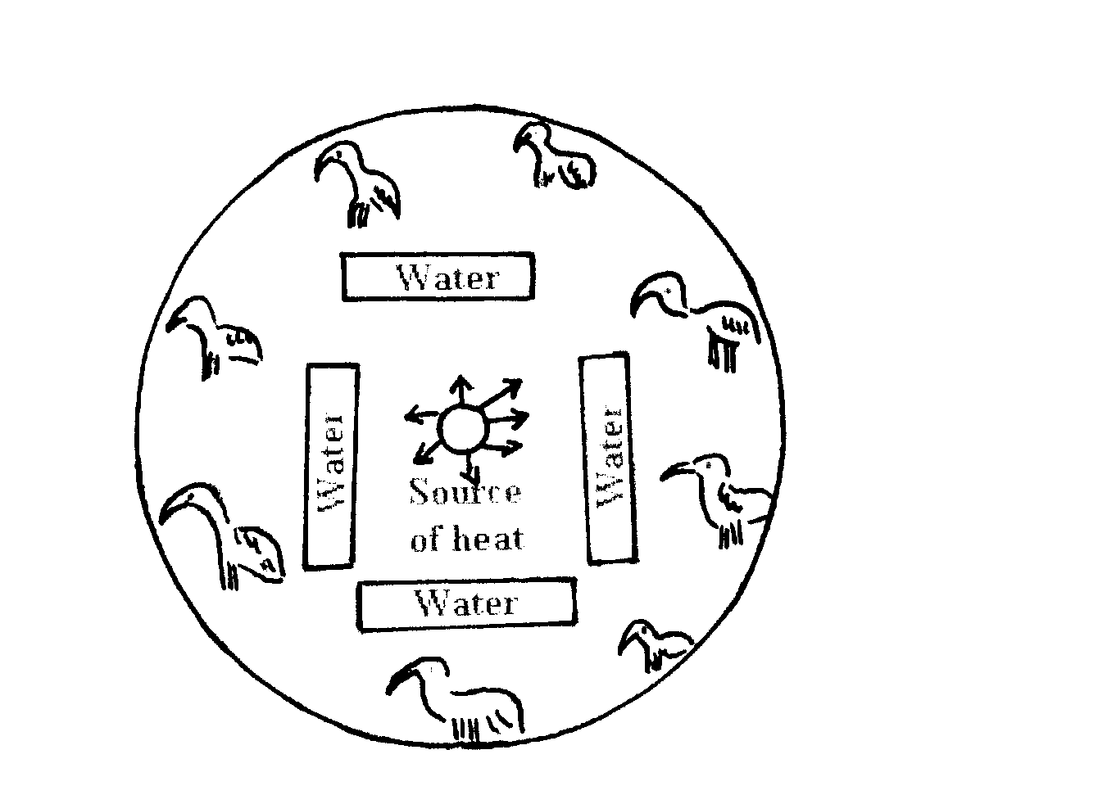
- Name the structure illustrated above (1mk)
- Why should the structure be round and not rectangular or square shaped? (1mk)
- Describe the heat situation in the structure (1mk)
- Give ONE reason to support your answer above (1mk)
- Why is the sawdust not suitable for use as litter in the structure (1mk)
14.
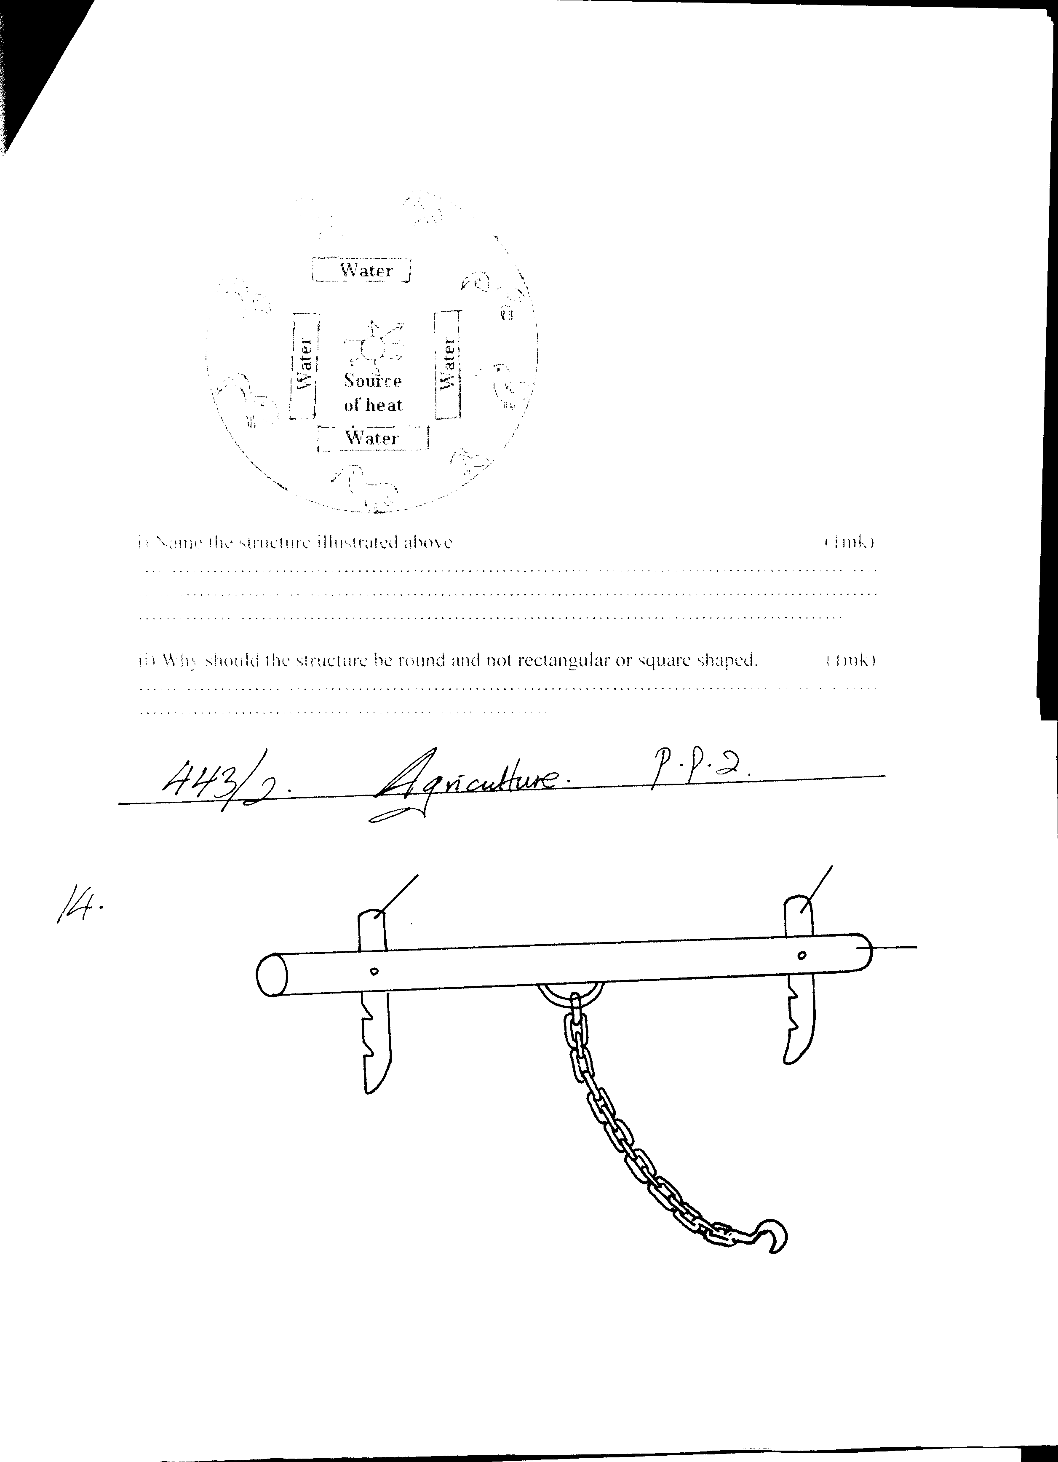
P
N
M
- Identify the illustration drawn above (1mk)
- The illustration above cannot be effectively used as indicated above. Give a reason (1mk)
- The part labeled P is made of wood. State TWO reasons why wood is preferred than the use of metal (2mks)
- For the illustration to be used more effectively one component is missing. State the component missing (1mk)
Section C (40mks)
Answer any TWO questions from this section
15 (a) Describe the signs of internal parasites attack in livestock (10mks)
(b) Describe the life cycle of a liver fluke Fasciola spp (10mks)
16. Describe the management of a dairy heifer calf from birth until it is mature for first service
(20mks)
17. Describe the control measures of disease in livestock, for each control measure give an example of a disease controlled (20mks)

MARKING SCHEME
SAMPLE PAPER 2
443/2

1. - Soil type / hardness of the soil
- Cost of the tool
- Availability of the tool
- Capital
- Desired depth of tillage
- Nature of the field ( 2 x 1 = 2mks)
2. i) Flow of milk from the upper region of the udder (alveolar) to the gland teat cistern

ii) - Practice farm hygiene
- Immediate treatment of infected cows
- Practicing teat dipping after milking
- Appling milking jelly to prevent teat from drying and cracking
(3 x 1 = 3mks)
3. - Leveling seedbed
- Breaking soil clods
- Covering the seeds
- Removal of trash
- Stirring/incorporation of manure / fertilizer into soil (2 x 1 = 2mks)
4 - Ability to tolerate / withstand high temperature
- High butter fat content
- Consumes less food due to small size
- Can survive on low/poor quality pastures (2 x 1 = 2mks)
5. - Overcrowding
- Pests infestation/disease outbreak
- Sudden change of routine e.g. feeds
- Imbalanced diet
- Extreme temperatures (4 x 1 = 4mks)
6. - Prevents timber from decaying / being affected by fungus and moisture
- Prevents timber from warping (bending) due to uneven expansion or contraction
- Prevent timber from cracking (2 x 1 = 2mks)
7. - Anaemia - lack of iron
- Curled toe paralysis in poultry – calcium and phosphate
- Milk fever-lack of calcium is lactating cows
- Goitre in calves-iodine deficiency
- Swayback in lambs due to lack of copper
- Bovine ketosis or acetoanaemia-lack pf carbohydrates (2 x 1 = 2mks)
8. - Roof should not leak/ water proof
- Easy to clean
- Well ventilated
- Vermin proof have rat guards or buffers
- Well built to contain the load / strong
- Allow easy loading & unloading
- Damp produce e.g raised above the ground
- Appropriate for storing the material/grain (4 x 1 = 4mks)
9. - Where land is not accessible by a tractor
- Irregular shaped pieces of land
- Where the cost of hiring a tractor is high
- Where tractors for hiring are not available - very steep slopes (4 x 1 = 4mks)

10. - Caring the larvae/ newly emerged larvae
- Foraging i.e. collection of nectar pollen and propolis
- Comb building
- Hive cleaning
- Receiving food from field home bees
- Control hive temperatures via fanning the wings
- Water collection
- Guards the hive (2 x 1 = 2mks)
b) - Un fertilized eggs
- Fertilized eggs (2mks)
- Pyrethrum marc (1mk)

SECTION B

12.a) A- Weaning
B- Lambing
C-Lactation/milk production (1mk each)
b) i) Steaming up
ii) Flushing (1mk each)
c) i)
- Gives the ewe good condition for parturition
- Facilitate rapid foetal development
- Reduces incidences of twin lamb disease / progeny toxaemia (1mk)
ii)
- Increase conception rate due to higher ovulation rate
- Facilitate implantation of the zygote
- Increases lambing percentage
- Increases chances of multiple births (1mk)
- 5 months (1mk)
- 3 months (1mk)
- 4 months (1mk)
- – pregnancy toxaemia
  - lambing sickness
  - Brucellosis
  - Mastistis (1x 1 = 1mk)
13. i) Brooder (1mk)
ii) Round to avoid chicks from heaping in corners (1mk)
iii) The brooder is hot (1mk)
- Chicks have runs aways from source of heat (1mk)
- Chicks confuse sawdust with food (1mk)

14. i) Ox yoke (1mk)

- - Brack N is wrongly placed
iii) - Easily available / locally available
  - Not expensive / cheap
  - Easy to work with ( 2 x 1 = 2mks)
iv) Neck strap (1mk)

SECTION C
15. a) - Emaciation
- Rough coat
- Scouring /diarrhoea /digestion disorders
- Pot bellies especially in calves
- Oedematous swelling under the jaw
- Blockage / obstruction of intestines
- Proglottis / parasites segments in faeces
- Anaemia
- Excessive appetite (10 x 1 = 10mks)

(b)- Primary host are ruminants of "cattle
- Adult flukes are found in bile ducts of the liver
- Immature worms live in the liver tissue or other organs
- Adults lay eggs which are passed through bile ducts into the intestines via feaeces
- In a favourable environment - presence of water, they hatch into a ciliated larva the miracidium
- Miracidium penetrate the body of water snail/mud snail-snail of limnae spp and develop further into sporocysts.
- Sporocysts develop into rediae
- Rediae develop into cercariae
Cercariae get attached on vegetation becoming encysted (metecerariae)
- The metacercaria can withstand harsh conditions for a long time
- Grazing animals ingest mitacereariae upon the entry into the stomach the walls will be digested to release young flukes.
- Young flukes migrate to the liver of primary host where they grow into adult flukes
which releases eggs and the cycle continues ( 10 x 1 = 10mks)
16. - Clean mucus from calf soon after birth
- Ensure calf is breathing or administer artificial respiration
- Cut and disinfect umbilical cord
- Ensure calf suckles the mother within the first 8 hours to get colostrums
- Feed the call on colostrums for the first 4 hours
- Keep records on performance of the calf
- Introduce feeding of whole milk or milk replacer after the 4th day
- Feed the calf with warm milk at regular intervals
- Feed the calf 2-3 times per day for the first 1 -4 weeks
- Feed the correct amount of milk up to weaning time
- Protect the calf against adverse weather conditions e.g. wind by providing proper
hygiene
- Provide adequate clean water from the 3'^{u} week
- Introduce palatable dry foods e.g. concentrates & good quality grass from 3rd week
- Keep calf in individual pens until it is 3-4 months old
- Spray dip the call against external parasites
- Drench / deworm calf against internal parasites
- Vaccinate¹ the calf against prevalent diseases
- Release the calf occasionally for exercises
- Wean the calf 8 weeks or late weaning at 16 weeks
- Dehorn the calf using appropriate method
- Graze the calf on good quality pasture preferably ahead of mature animals
- Separate heifer calves from bull calves at puberty to avoid inbreeding
- Remove extra teats if necessary
- Any change of feeding should be done gradually to avoid feeding disorders
- Serve at the right age of 15-20 months ( 20 mks)
17. - Use prophylactic drugs-animals are given drugs routinely to control certain diseases
- Use of antiseptics and disinfectants for cleaning poultry houses or calf pens to
- control disease e.g scours
- Quarantine during an outbreak of certain diseases e.g. foot and mouth
- Isolation animals suffering horn infectious diseases e.g. scours are not allowed
to mix with others
- Mass & slaughter / cull animals suffering from certain dangerous diseases e.g.
anthrax
- Vaccination -animals usually vaccinated against certain diseases e.g. black quarter
- Control of vectors-diseases carrying parasites e.g. tsetse flies are controlled by
spraying the bush to control diseases like Nagana
- Use healthy breeding stock/ AI prevent the spread of diseases like brucellosis
- Proper nutrition well balanced diet to be provided to animals to prevent
nutritional diseases e.g. anaemia in piglets
- Drenching/ control of internal parasites e.g. roundworms
- Keep resistant type of livestock e.g. zebu to prevent occurrence of E.C.F
- Proper housing to prevent diseases like pneumonia
- Foot trimming to prevent foot rot/removal of sharp objects
- Feed animals with dry roughages before feeding them succulent roughages to
minimize occurrence of bloat /other nutritional disorders ( 10 x 20 = 20mks)

SAMPLE PAPER 3
AGRICULTURE PAPER 2
443/2

SECTION A ( 30 MARKS)
Answer ALL questions in the spaces provided.

1. Name the dairy goat breed which has the following characteristics: ½ mk
- Large and white body
- Upright ears that point forward.
2. Give TWO reasons for creep feeding in livestock production. 2mks
3. State TWO structural requirements of a deep litter house in poultry rearing. 1mk
4. Give TWO routine management practices in calf rearing. 1mk
5. State TWO characteristics of a beef calf that make it suitable for beef production. 1mk
6. State TWO ways in which digestion of food in pigs differs from that in ruminants.1mk
7. Give TWO ways through which the health of an animal can be restored. 1mk
8. Differentiate between a stir-up pump and a knapsack sprayer. 2mks

9. Give TWO reasons why male animals are castrated when they are still young. 2mks
10. State TWO functional differences between the petrol and diesel engine. 2mks
11. Give TWO features that can differentiate between a good layer and a poor layer. 1mk
12. State TWO main factors that lead to low egg production in a flock of layers. 1mk
13. State TWO uses of proper ventilation in an animal house. 1mk
14. State TWO functions of additives in silage making. 1mk
15. Differentiate between maintenance ration and production ration as used in livestock nutrition.
16. Name an intermediate host for each of the following internal parasites: 1mk
- Tapeworm (Taenia solium)
- Liverfluk (Fasciola hepatica)
17. (a) Name the casual organism for foot rot disease. ½ mk
b) Give TWO symptoms of foot rot in sheep. 1mk
c) State TWO control measures of Foot rot in sheep. 1mk
18. Give TWO disadvantages of natural mating as a breeding method in dairy cattle. 1mk
19. State ONE use of each of the following tools on the farm.
(i) Spoke shave. ½ mk
(ii)Plumb bob. ½ mk
20. (a) State TWO signs of infestation by external parasites in livestock. 1mk
(b) State TWO methods of controlling internal parasites in livestock. 1mk
21. State TWO advantages of farm mechanization. 1mk
22. State FOUR disadvantages of inbreeding. 2mks

SECTION B (20MKS)
Answer ALL the questions in this section in the spaces provided.

  - The diagram below shows farm equipment. Study it carefully and use it to answer the questions that follow.
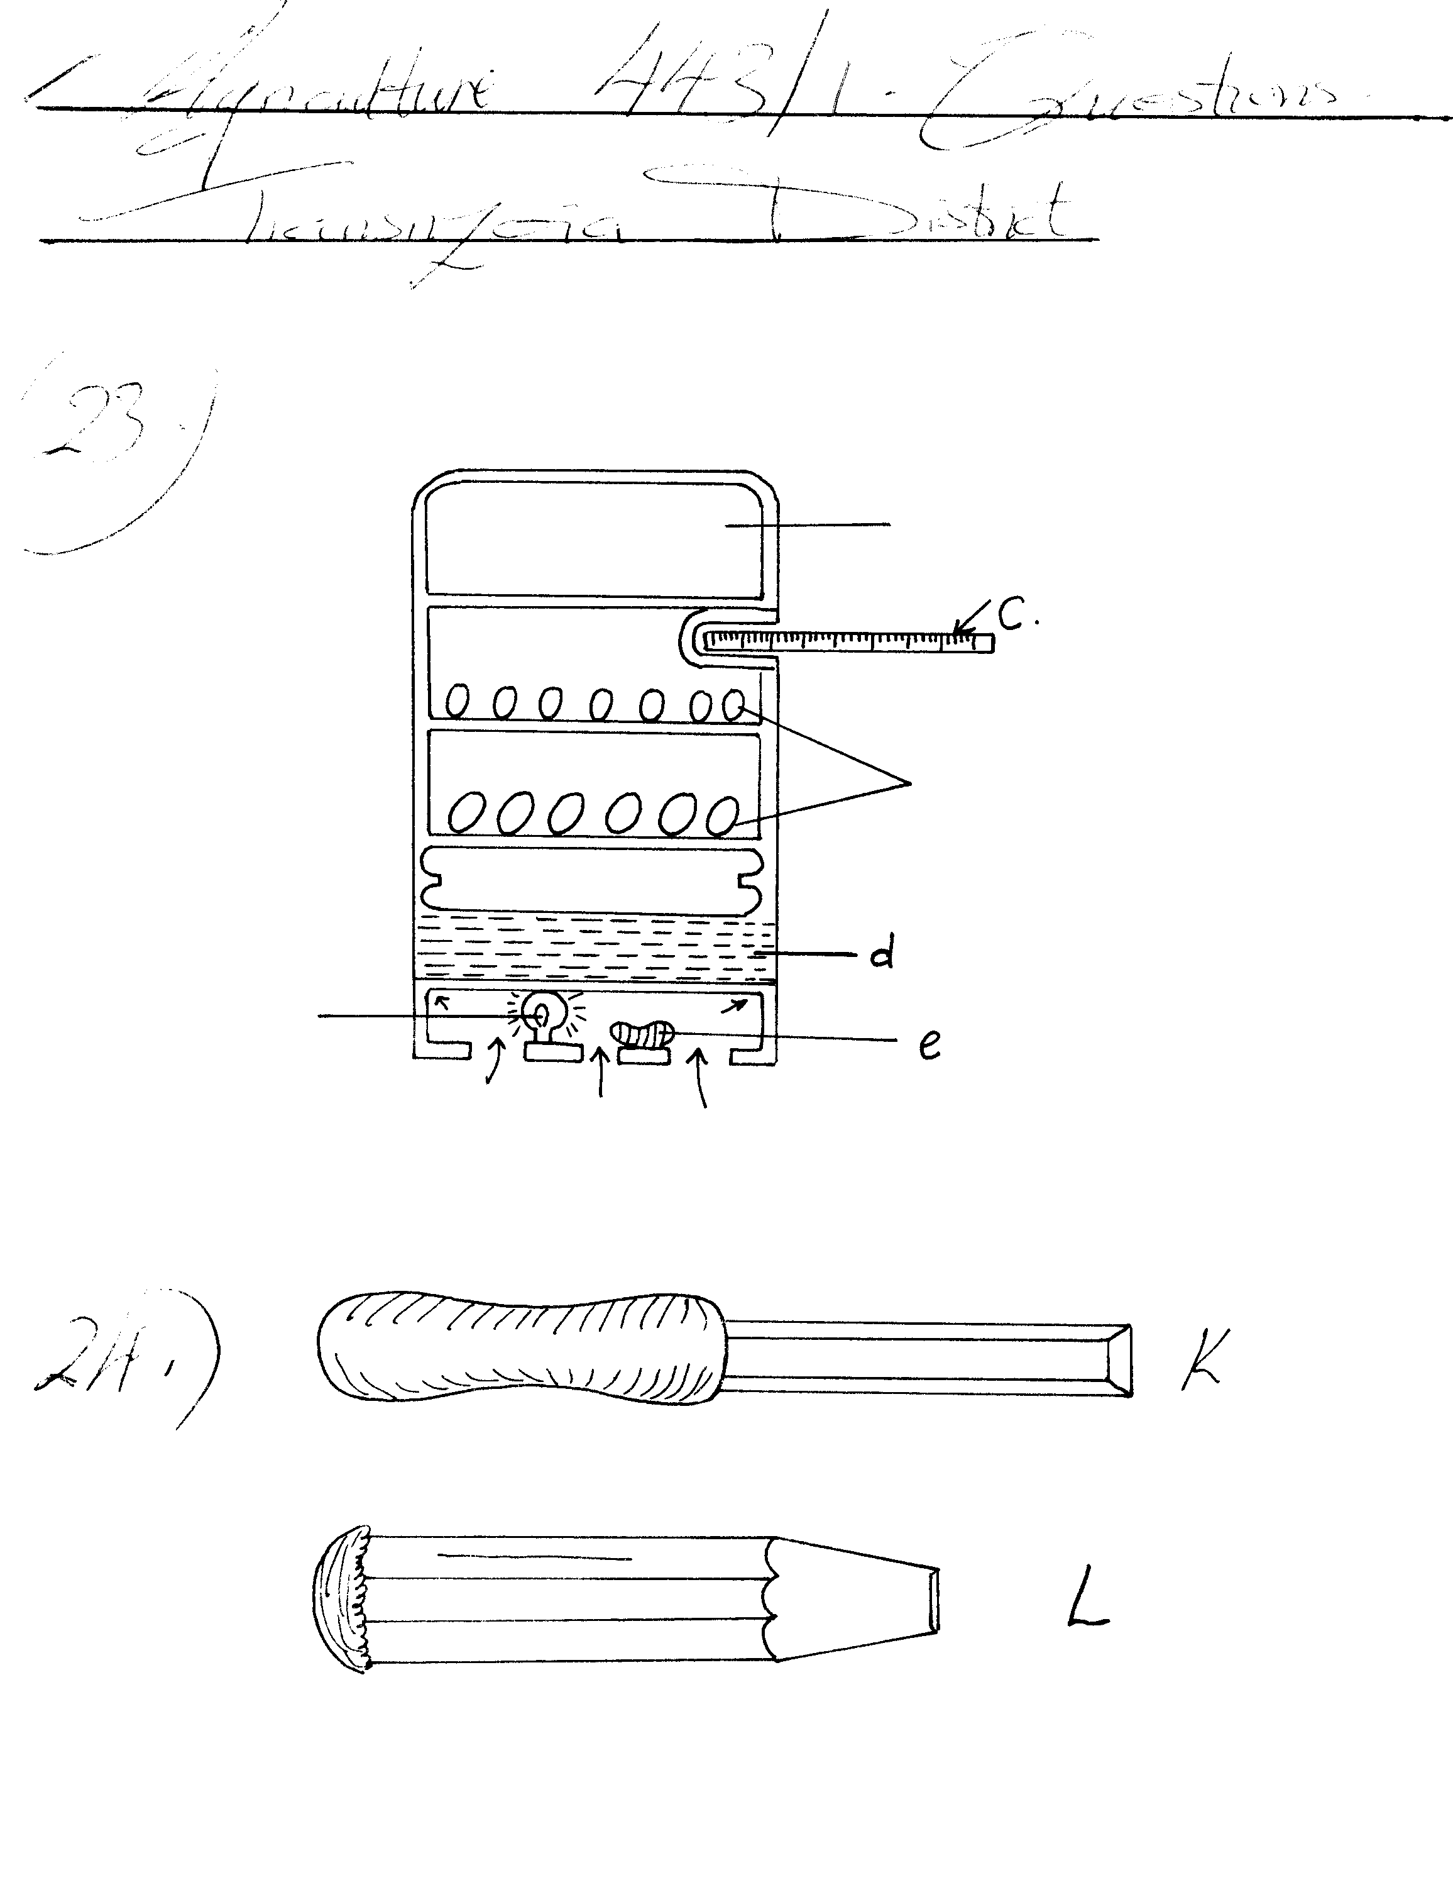
Air
Heat surface
Egg trays

a) Identify the equipment. ( ½ mk)
b) Name the parts labeled C and D. (1mk)
c) Give the use of the part labeled E. ( ½ mk)
d) State THREE conditions that must prevail in the equipment shown to make it suitable for its functions. ( 1 ½ mks)
e) Give THREE disadvantages of using the above equipment by small scale farmers.(1 ½ mks)
24. Below are diagrams of farm tools. Use them to answer the questions that follow.
a) Identify the tools. (1mk)
b) State ONE functional difference between the tools K and L. (1mk)
c) State TWO maintenance practices carried out on these tools to make them efficient.(1mk)
25. The diagram below represents a calf pen. Study the diagram and use it to answer the questions that follow.
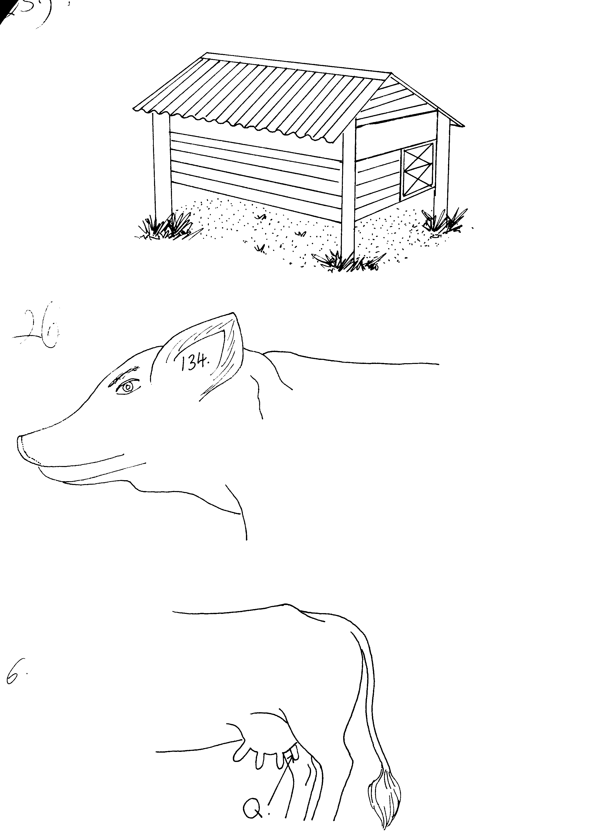
(a) Give a reason why the floor of the calf pen is raised above the ground. 1mk

(b) State TWO reasons why the calf pen is constructed to house only one calf . 2mks
(c) List FOUR structural requirements of the calf pen. 2mks
26. (a) The diagram below illustrates an activity carried out on a pig. Study the diagram and answer the questions that follows:

(i) Identify the activity carried out. ½ mk

(ii) Give TWO disadvantages of the activity above. 1mk
(b) Use the diagram below and answer the questions that follow:
(i) Identify the operation that should have been carried out on the teat labeled Q.½ mk
(ii) Name TWO tools used in the above operation. 1mk
(iii) State TWO advantages of the above operation. 1mk
27. Study the diagram of a tractor air cleaner shown below and answer the questions that follow:
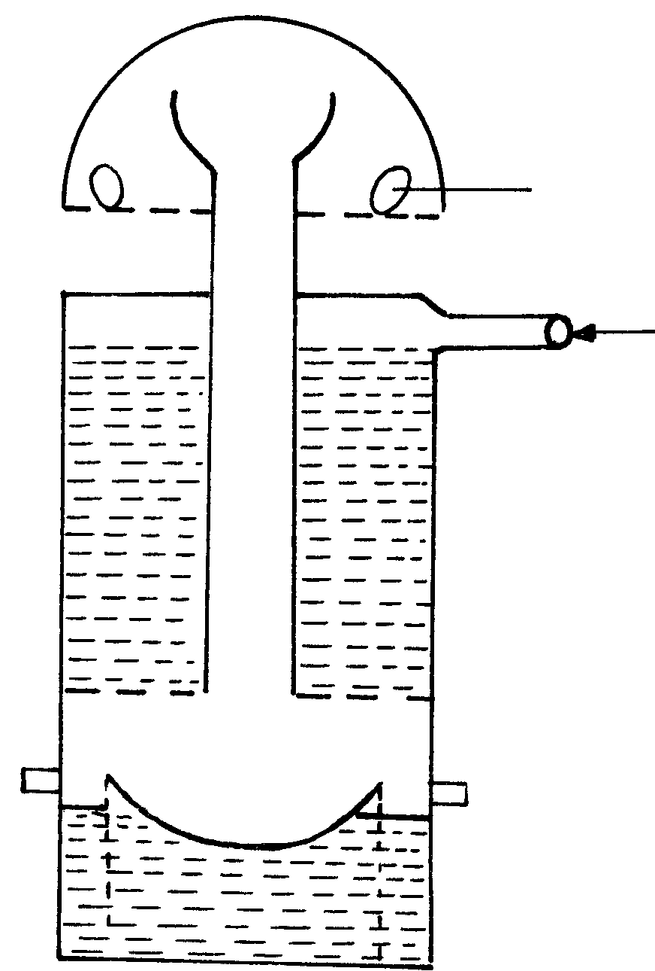
B
A
(a) Identify the parts labeled A and B. 1mk
(b) Draw arrows on the diagram to indicate the movement of air through the air cleaner. 1mk
(c) State TWO maintenance practices carried out on this type of air cleaner. 1mk
SECTION C (40 MARKS)
Answer only TWO questions on the separate answer sheets provided
28. (a) Explain the factors to consider when sitting farm structures. 5mks
(b) Explain the uses of fences on the farm. 8mks
(c) Give the advantages of live fences. 7mks
29. Describe mastitis disease in dairy cattle under the following sub headings:
  - Causal organism. 1mk
  - Predisposing factors. 7mks
  - Symptoms. 4mks
  - Control measures. 8mks
30. a) Describe the four stroke cycle of a petrol engine. 10mks
b) State advantages of the four stroke engine over two stroke cycle engine. 5mks
c) Give the disadvantages of using animal power on the farm. 5mks

MARKING SCHEME
SAMPLE PAPER 3
443/2

1. - Saanen
2. - To replace the mothers milk at weaning
- To maintain health and growth if the mother doesen’t produce enough milk
- To introduce young animals to solid feeds
- Gives the necessary nutrients for high growth rate

3. - Properly ventilated
- Leak proof to avoid dampness
- Must have litter on the floor
- Must be draught free
- Spacious
- Properly drained
- Well lit

4. - Feeding
- Deworming/ drenching
- Castration
- Disbudding/ Dehorning
- Removal of extra teats

5. - Blocky and deep body that is well flashed
- Fast growth rate / effiecient converter of feed to meat
- Good forager

6. - In pigs, digestion starts in the mouth, WHILE in ruminants, it starts in the rumen
- There is no microbial digestion of food in pigs as it is in ruminants
- No chewing of cud in pigs contrary to ruminants

7. - Good feeding
- Provision of a clean environment
- Treating the disease
- Inducing repair of damaged tissues
- Relieving discomfort or injury to animal
- Preventing further spread of the disease

8. - A stir- up pump is used with a separate chemical container WHILE a knapsack sprayer
has its own chemical tank
- A stir- up pump is used for the control of ectoparasites in livestock/ acaricide while a knapsack sprays chemicals in crops

9. - Animal tissues are delicate and hence less pain is inflicted
- Young animals have a fast growth rate leading to easy healing
- Young animals still feeding on milk heal faster because of the proteins in the milk
- They would cause unwanted breeding if castrated when mature

10. - The petrol engine has a carburetor WHILE a diesel engine has an injection pump
- Fuel and air are mixed in the carburetor while in a diesel engine they are mixed in the cylinder
- Fuel is ignited by an electric plug in a petrol engine but by compression of air and fuel in the diesel engine
- Diesel engines produce more power than petrol engines / diesel engines have higher compression ratios than petrol engines

11. - A good layer has warm, waxy, red and large combs and wattles while in a poor layer, they
are small or shrunken, dry, scaly, pale and cold
- A good layer has bright, orange and alert eyes while a poor layer has dull and pale yellow eyes
- A good layer has a pale beak while a poor layer has a yellowish beak
- A good layer has rugged feathers / plumage while a poor layer is smooth / well preened

12. - Stress
- Vices
- Breed
- Poor feeding / low quality feeds

13. - For efficient air circulation in the house
- Prevents high humidity inside the house
- Controls temperature in the house

14. - To have adequate carbohydrates for proper fermentation
- To improve the quality / palatability of silage

15. - Maintenance ratio is a daily allowance of food given to an animal to provide minimum energy required for body functioning when in resting state while a production ration is the
daily amount of feed given to an animal over and above the maintenance ration to keep it in production (OWTTE.)

16. i) Tapeworm (Taenia Solium) – Pig (reject cattle)
ii) Liver fluke (Fasciola hepatica) – Mud/ water snail (reject snail alone)

17. a) Fusiformis spp/ Fusiformis necrophorous/ Fusiformis nodosus

b) - Swollen foot
- Lameness
- Pus and a rotten smell from the hoof
- A sheep kneels while grazing if the front feet are affected
- Sheep spends most of the time lying down if the hind feet are affected
- Emaciation due to lack of feeding

c) - Trimming overgrown hooves regularly ( reject cutting hooves)
- Treating affected sheep to avoid spread
- Isolating sick animals from healthy animals
- Keep grazing land free from sharp objects
- Use disinfectant in footbath e.g. copper sulphate solution / formalin
- Keep animal house dry
- avoid grazing sheep on swampy areas

18. - Difficult to control in breeding
- It is expensive to keep a bull on the farm
- Risk of transmission of breeding diseases
- A bull may cause physical injury to a cow
- Few cows can be mated by one bull within a given time
- Semen is wasted
- Risky to keep aggressive bulls

19. i) Spoke shave-Planing curved/ round edges

- Plumb bob –To check if the wall is vertical
- To determine a point directly above or below a point as in surveying

20. a) - Anaemia/paleness of mucous membranes
- Irritation/ scratching/ rubbing against objects
- Loss of hair
- Wounds on the skin
- Presence of parasites on body of animal

b) - Regular drenching/ Deworming
- Rotational grazing
- Draining swampy areas / fencing off swampy areas
- Proper sanitation in livestock houses
- Clean feeds and water
- Proper disposal of faeces/ use of latrines by humans
- Use of prophylactic drugs
- Burning pastures to kill eggs, larvae, adults
- spraying swampy areas with appropriate drugs e.g. CUSO₄
- Ploughing infested pastures to bury eggs
- Peripheral/ perimeter/ double fencing to keep away other animals
- Control water snails( reject control of snails)

21. - Saves time
- Work is done efficiently
- Reduces cost of labour/ saves labour
- Reduces druggery by farm labourers

22. - Leads to loss of hybrid vigour/ heterosis
- Leads to decline in fertility of animals
- Leads to reduction in performance
- Leads to high rate of prenatal mortality

SECTION B (20 MKS)
23. a) Incubator

b) C –Thermometer
D – Water source/ water bath
c) A damp cloth for maintaining relative humidity / maintains relative humidity

d) - Temperature is maintained at 37.0°C -39.4°C
- Should be enough fresh air circulating
- Should have correct relative humidity (60% RH)

e) - It is expensive
- Labour demanding
- Requires more skill than natural method
(Reject requires skill alone)

24. a) - K – Wood chisel
L – Cold chisel

b) - K is for cutting wood/ working on wood while L is for cutting metal sheets

c) - Keep cutting edges sharp ( reject sharpening alone)
- Store safely in their tool racks
- Use each tool for its proper use
- Apply old engine oil to prevent rusting

25. a) - To avoid dampness in the pen
- For easy drainage/ disposal of urine & dung

b) - To avoid calves licking each other leading to formation of hairballs in the rumen
- To control infection by worms

c) - Properly ventilated
- Properly drained
- Leak proof
- Spacious
- Free from cold draughts
26. a) i) Ear tattooing

ii) - The number cannot be read from far
- Difficult to read the number when the ear is dirty

b) i) Deteating/ Removal of extra teats

ii) - Scalpel/ sharp knife
- Pair of scissors

iii) - Minimises chances of disease infection of udder
- To make the milking process easy

27. a) A) - Air inlet sources
B) - Air outlet
- MOVEMENT OF AIR (ARROW)
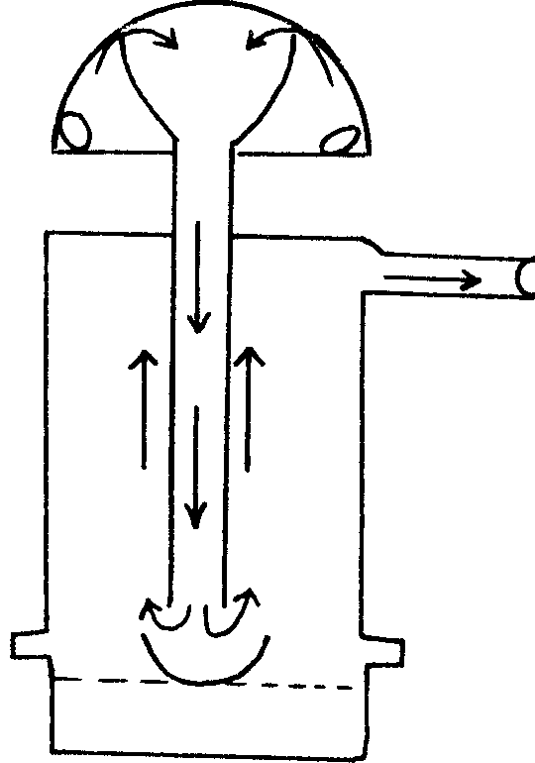

c) - Weekly inspection
- Maintaining the level of oil at the marked point
- Refill with fresh oil/ replace the old oil
- Check oil frequently if the machine is working in a dirty environment
and replace accordingly
- Clean the wire mesh in kerosene periodically
- The dry wire mesh should be dipped in fresh oil

SECTION C (40 MKS) Two out of three questions
28. a) - Location of the homestead
- Accessibility
- Security
- Drainage
- Direction of prevailing wind
- Relationship between the structures
- Farmers tastes and preferences
- Topography
- Proximity of amenities like water and electricity
- Government regulations

b) - Perimeter fence marks boundaries
- Keep off wild animals and intruders
- Separate crop fields from pastures
- Divide pastures in paddocks
- Control movement of animals or people (Trespass)
- Control spread of parasites and diseases
- For isolation of sick animals
- Control breeding
- Provide security to homesteads and farm animals

c) - Cheap and easy to establish
- Tall varieties are wind breaks e.g. kei apple
- Have aesthetic value (Beauty)
- Roots hold soil firmly controlling soil erosion
- Livestock feeds e.g. Tithonia spp
- Provide shade to livestock
- Source of organic matter
- Source of wood fuel
- Some had medicinal value
- Thorny species keep off intruders

Mastitis disease
29. i) Casual organism
- Streptococcus agalactiae
- Staphyloccus urens
ii) Predisposing factors
- Sex
- Age- Older animals that are lactating are affected
- Stage of lactation period- Affects during early or late lactation
- Udder attachment- Large and pendulous udders are at risk
- Incomplete milking- Retained milk leads to infection
- Mechanical injury- Leads to bacterial infection
- Poor sanitation- Poor hygiene leads to infection
- Poor milking technique- Pulling teats makes the sphincter muscles of the udder weak and loose
- Hereditary factors

iii) Symptoms
- Milk contains pus, blood, thick clots and turns watery
- Swollen udder and teats/ cow kicks when udder is touched
- Death of infected quarter
- Milk has a salty taste
- Small clots/ flakes in milk

iv) Control measures
- Treat affected teats with antibiotics
- Use a teat dip on every quarter after milking
- Use correct milking technique
- Strict cleanliness
- Use a strip cup to detect infections
- Treat open wounds immediately
- Use separate udder clothes when cleaning the udder
- Remove sharp objects from grazing land to avoid udder infection

30. a) - One revolution by the crankshaft is complete when each piston has made
four strokes
There are 4 strokes
- The induction stroke:
- The piston moves downwards while air and fuel are sucked into the cylinder through the inlet valve
- The exhaust valve is closed
- The partial vacuum in the cylinder and the high pressure outside the cylinder force the fuel mixture to be sucked in
- The inlet and outlet valves close when the piston reaches the BDC (Bottom Dead Centre), trapping the fuel mixture in the cylinder

- Compression stroke
- The piston moves upwards
- The inlet and outlet valves are still closed
- The mixture is compressed at the top of the cylinder
- The stroke ends when the piston reaches the TDC

- Power stroke
- A spark ignites/ burns the compressed fuel- air mixture
- The mixture expands and explodes producing power which pushes the piston downwards
- The valves are still closed (inlet &outlet)
- The descending piston and connecting rod (con –rod) turn the crankshaft

- Exhaust stroke
- The piston moves upwards
- Inlet valve is closed while exhaust valve opens
- Exhaust gases are expelled through the exhaust valve
- The cycle begins again with the induction stroke
NB – Name of stroke 4 x ½ = 2mks
- Explanation for each stroke 2 x 4 = 8mks

b) Advantages of four- stoke engine over two- stroke.
- The engine produces more power and can do heavier work
- Have efficient fuel and oil utilization
- Perform a wide range of farm operations
- The engine is efficiently cooled by water
- Exhaust gases are effectively expelled from the cylinder
- They have heavy crankcase enabling them to withstand vibrations
- Make less noise than 2 –stroke engines

c) Disadvantages of using animal power on the farm
- Extra land is required for grazing draught animals
- Require extra cost incase of sickness
- Animals can only work on small scale farms
- Animals can damage crops
- Animal power is affected by weather and seasons reducing their efficiency
- Animals are fully maintained even when not in use

SAMPLE PAPER 4
AGRICULTURE PAPER 2
443/2

SECTION A (30MARKS)

ANSWER ALL QUESTIONS IN SPACES PROVIDED
- (a) Name a breed of dairy animal having the following characteristics: red coat with white markings on the legs; face tail; switch and girth (1mk)
(b) Name a breed of pig with the following characteristics: Black coat with white feet face and tail switch (1mk)
- Differentiate between an ectoparasite and endoparasite (2mks)
- List two uses of fences in the farm (2mk)
- If a broiler consumes 4kg of feed from hatching to slaughter, calculate its FCR if by slaughter it weighs 2kg (1mk)
- List two qualities of clean milk (2mks)
- State three maintenance practices done on a water cooling system of a tractor (3mks)
- (a) Name the causative organism of Pneumonia in calves (1mk)
(b) Give two predisposing factors to Pneumonia in calves (2mk)
(c) State two symptoms of Pneumonia in calves (2mks)
- Give two conditions under which a farmer would use animal power instead of tractor power for seedbed preparation (2mks)
- Give two reasons for maintaining farm tools properly (2mks)
- Outline two characteristics of livestock that are used in mass selection (2mks)
- List two factors associated to the animal that determine the amount of feed that an animal consumers (2mks)
- Enumerate two advantage of Kenya Top Bar Hive (2mks)
- State two adaptation of a camel to its environment (2mks)
- State one negative effect of pulling teats as a method of milking in cows (1mk)
SECTION B (20 MARKS)
ANSWER ALL QUESTIONS IN SPACES PROVIDED
- The diagrams below shows farm tools. Use them to answer the questions that follow
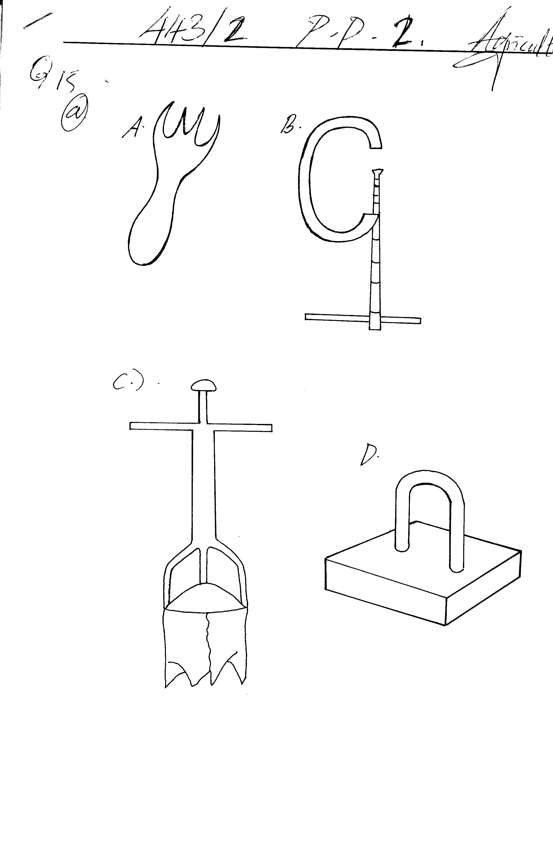
(i) Name the tools labeled (2mks)

(ii) State the functions of the following tools (2mks)
(c )

(iii) State one maintenance practice done on tool labeled B (1mk)
- The diagram below illustrates a livestock handling structure

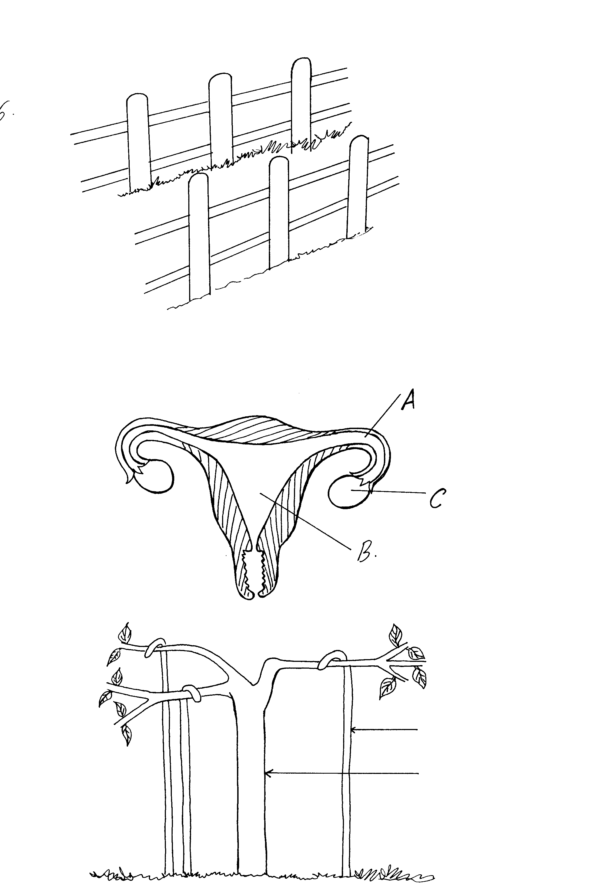

(a) Identify the structure (1mk)
(b) Name four practices that a farmer can carry out in the above structure (4mks)
- (a) What is embryo transplant (1mk)
(b) Describe the procedure of embryo transplant using Mon-surgical method (4mks)
- The diagram below shows the reproductive system of a cow
(i) Name the parts labeled A, B, C (3mks)
(ii) State the functions of parts labeled A and C (2mks)
SECTION C (40 MARKS)
ANSWER ANY TWO QUESTIONS
- (a) Discuss the procedure of obtaining clean milk from a cow (10mks)
(b) Name five sources of power in the farm and describe the uses of each (10mks)
- (a) Discuss the factors considered when selecting a site for a farm structure (10mks)
(b) State the management practices one should carry out to ensure effective dipping(10mks)
- (a) Discuss characteristics of ideal dairy cow (8mks)
(b) Giving examples, describe measures taken to control diseases in the farm (12mks)
MARKING SCHEME
SAMPLE PAPER 4
443 / 2
AGRICULTURE
- (a) Guernsey
(b) Berkshire
- Ecto-parasite-Live on animals body either partially like tsetse flies which bite and escape or wholly like ticks, mites ,lice, keds e.t.c O.W.T.E
Endoparasites – Live in an animals body e.g.Tapeworm, roundworms, liverfluke OWTE
- Two uses of fences in the farm
- To mark boundaries
- Keep away intruders and thieves from the farm
- To control grazing e.g. by paddocking
- To prevent damage of crops by livestock
- To control breeding and mating in the farm
- Control diseases and parasites through vocational grazing and isolation of sick animals
- Act as windbreak
- Increases beauty of the farm
- FCR= weight of food consumed = 4
Live weight gained = 2
= 2:1
- Qualities of clean milk
- Free from disease causing organisms
- Free from hair
- Free from dirt and dust
- Must have a good flavour
- Must have a high keeping quality
- Must have the right chemical composition
- Three maintenance practices done on a water cooling system of a tractor
- Lubricate the moving parts of the water pump regularly
- Use clean water in the radiator
- Remove trash from the fins
- Fix all pipes tightly to avoid leakage
- Adjust the fan belt tension
- (a) Cansal organism of pneumonia:
Bacterium/mycoplasma mycoides
(b) Predisposing factors of pneumonia
- Poor ventilation
- Over crowding
- Age of the animal
- Dampness/chilliness in the animal house
(c) Two symptoms of pneumonia
- Severe respiratory problems
- Abundant mucoid nasal discharge
- Difficulty in breathing
- Dullness
- Loss of appetite/anorexia
- Abnormal lung sound/bubbling sound/hissing sound/ gurgling sound.
- Coughing due to congestion of bronchioles
- Where land is not accessible by a tractor
- Irregular shaped pieces of land
- Where the cost of hiring a tractor is high
- Where tractor for hiring one not available/very steep slopes

- Two reasons for maintaining farm tools
- Make them last longer
- Avoid injuries to users
- To make them more efficient
- Reduce replacement costs
- Two characteristics used in mass selection
- Observable characteristics e.g. coat colour, size, shape
- Measurable characteristics e.g. body weight, milk yield
- Two factors associated to the animal determining amount of feed an animal consumer
- Age of the animal
- Size/weight of an animal
- Physiological condition of an animal
- Production level of the animal
- Two advantages of K.T.B.H
- Top bars can be easily removed and replaced during inspection of the combs
- Honey combs are removed without disturbing the brood
- Easy to construct and repair
- A queen excluder can be used to separate the honey from the brood
13. Adaptation to staying in hot areas
- Ability to vary its body temperature
- Thin hair reduces heat absorption
- Ability to produce concentrated urine
- Large drinking capacity
- One negative effects of pulling teats as a method of milking in a cow
- Cause friction between the teat canal and epithelial lining predisposing teats to mastitis
- Lead to development of scar making milking painful to a cow
- Weakness udder suspension ligaments causing the udder to become pendulous

SECTION B
- (i) Name of tools
    - Garden fork
    - G-clamp
(ii) Uses of tools
Tool c- (a) Level/smoothen concrete or mortar .
(b) Hold mortar before it is placed in position
Tool d- (a) Soil sampling
(b) Digging holes for fixing fence posts
(iii) Maintenance practices done on tool b
(a) Store properly in a tool rack
(b) Apply grease on the threads
(c) Replace the thumb heavy metal head
- (a) Crush
(b) Four practices carried out by the farmer on the structure
- Milking
- Vaccination
- Spraying
- Dehorning
- Identification/branding/ear notching
- Hoof trimming
- Artificial insemination
- Drenching
- Examination
- Taking blood samples
- Embryo transplant
(a) Transporting of fertilized egg, resulting from mating a superior female by a
superior male, into the uterus of an inferior female
(b) Procedure of Embryo transplant using Non- Surgical method
- Remove embryo by flooding the uterus with a liquid media
- Massage the uterus to dislodge the embryo the uterine lumen to flow out with the solution
- Withdraw solution containing the uterus using a tube to a syringe
- Syringe taken to the lab where the fertilized ova are selected and separated under high powered microscope
- Recipient cow is then restrained anaesthesized and shaved on the area of operation
- Incision made in the left flank to allow horn of uterus to be pulled out
- Fertilized ovum inserted into the uterus using a pipette or syringe, through the tiny hole in the uterine wall
- Pipette checked under microscope to ensure that the transplant is complete
- Uterine horn retracted to its position
NB: Award for the first four points systematically written
- (a)

Parts Name
A Oviduct/fallopian tube
B Uterus
C Ovary
(b)

Parts Functions
A (i) A passage through which ova pass from ovary to the uterus
(ii) Where fertilization takes place as the ovum passes to uterus
C (i) Production of ovum
(ii) Production of progesterone/oestrogen/sex hormones

SECTION C
19. (a) Procedure of obtaining clean milk from a cow
- Healthy milking herd
- Clean milking cows
- Healthy and clean milkman
- Clean milking utensils
- Milk filtration, cooling and storage
- Avoid flavours in milk
- Clean milking materials and equipment
- Correct milking procedure
NB: Stating 1mk, Explanation 1mk
(b) Sources of power in the farm
- Tractor power: Pulling and pushing implements, rotation of mowers, lowering of implements, transport.
- Electricity: Heat provision for livestock, lighting, operating machines e.g. milking machines.
- Solar: Produce electric energy using panels, drying of crops.
- Charcoal/wood: Provision of heat energy
- Oil: Running engines e.g. tractors, generators, lighting, heating
- Water: Driving turbines and grinding mills
- Biogas: Cooking and lighting
NB: Stating 1mk, Explanation 1mk
- (a) Factors considered when selecting a site for a farm structure
- Topography
- Prevailing winds and rainfall
- Soil type
- Nearness to utility
- Sewage disposal
- Security
- Accessibility to roads
- Easy access to water supply
NB: Stating 1mk, Explanation 1mk
(b) Management practices to ensure effective dipping
- Clean plunge tanks regularly
- Prevent any leakage from the roof to avoid dilution of the acaricides and loss through evaporation
- Check the concentration of the acaricides as often as possible
- Maintain the solution at the top level
- Dip the livestock at fixed intervals i.e. once a week
- Dip the animals when weather is cool and after watering them to prevent them from drinking the solution
- Dip the animals in a single file
- All animals in the farm should be dipped
- Keep pens and footbaths clean
- Repair the collecting yard and draining race when broken
21. (a) Characteristics of an ideal dairy cow.
- Triangular in shape/wedge shaped
- Big udders
- Have large stomach
- Have well set hindquarters
- They have a straight top line
- They have prominent milk veins
- Their lean bodies carry little flesh
- They are docile with mild temperament
(b) Measures taken to control diseases in the farm
- Farm hygiene: Cleanliness of house, clean equipment/proper carcass disposal to destroy pathogens
- Isolation of sick animals: Sick animals to be separated from healthy ones
- Deworming: To control internal parasites
- Treatment of the sick animals to prevent the spread of diseases
- Vaccination: To create resistance to disease transmission
- Control of vectors: To avoid disease transmission
- Prophylactic approach/use of drugs to avoid infections
- Proper feeding/balanced rations to prevent nutritional disorders e.g. milk fever, anaemia
- Killing/slaughtering to prevent spread of contagious diseases e.g. anthrax
- Proper breeding to control breeding diseases e.g. brucellosis
- Quarantine:To avoid exposing animals to predisposing factors for diseases

SAMPLE PAPER 5
AGRICULTURE PAPER 2
443/2
SECTION A
Answer ALL the questions in this section
1. What is zero grazing? 1mk
2. List any four farm structures that are necessary for handling dairy animals. 2mks
3. Apart from a tractor and electricity, name four other sources of power that may be used for doing work on the farm. 2mks
4. Which tool would be required for each of the following farm operations?
(i) Cutting wool from sheep. 1mk
(ii) Castrating piglets 1mk
5. Give three conditions under which a farmer may prefer to use an ox-cart instead of a tractor drawn trailer? 3mks
6. Give four factors that should be considered when siting a beehive in a farm. 2mks
7. State four management practices that would ensure maximum harvest of fish from fishpond. 2mks
8. Give two predisposing factors to foot-rot disease in sheep. 2mks
9. What is the intermediate host for liver fluke? 1mk
10. Give two causes of soft shell in eggs. 1mk
11. List four factors associated to the animal that determine the amount of feed that an animal consumes. 2mks
12. Give four reasons why the feeding of colostrum is important in the rearing of piglets. 2mks
13. Give four reasons why young rams should be docked. 2mks
14. List four cattle diseases caused by viruses. 2mks
15. State any two disadvantages that may arise from inbreeding in livestock production.
2mks
16. Give two signs that would show that a doe is just about to give birth. 2mks
SECTION B ( 20 MARKS)
Answer ALL the questions in this section in the spaces provided.
17. a) The diagram below is a tractor-drawn farm implement hitched at the rear of the tractor.
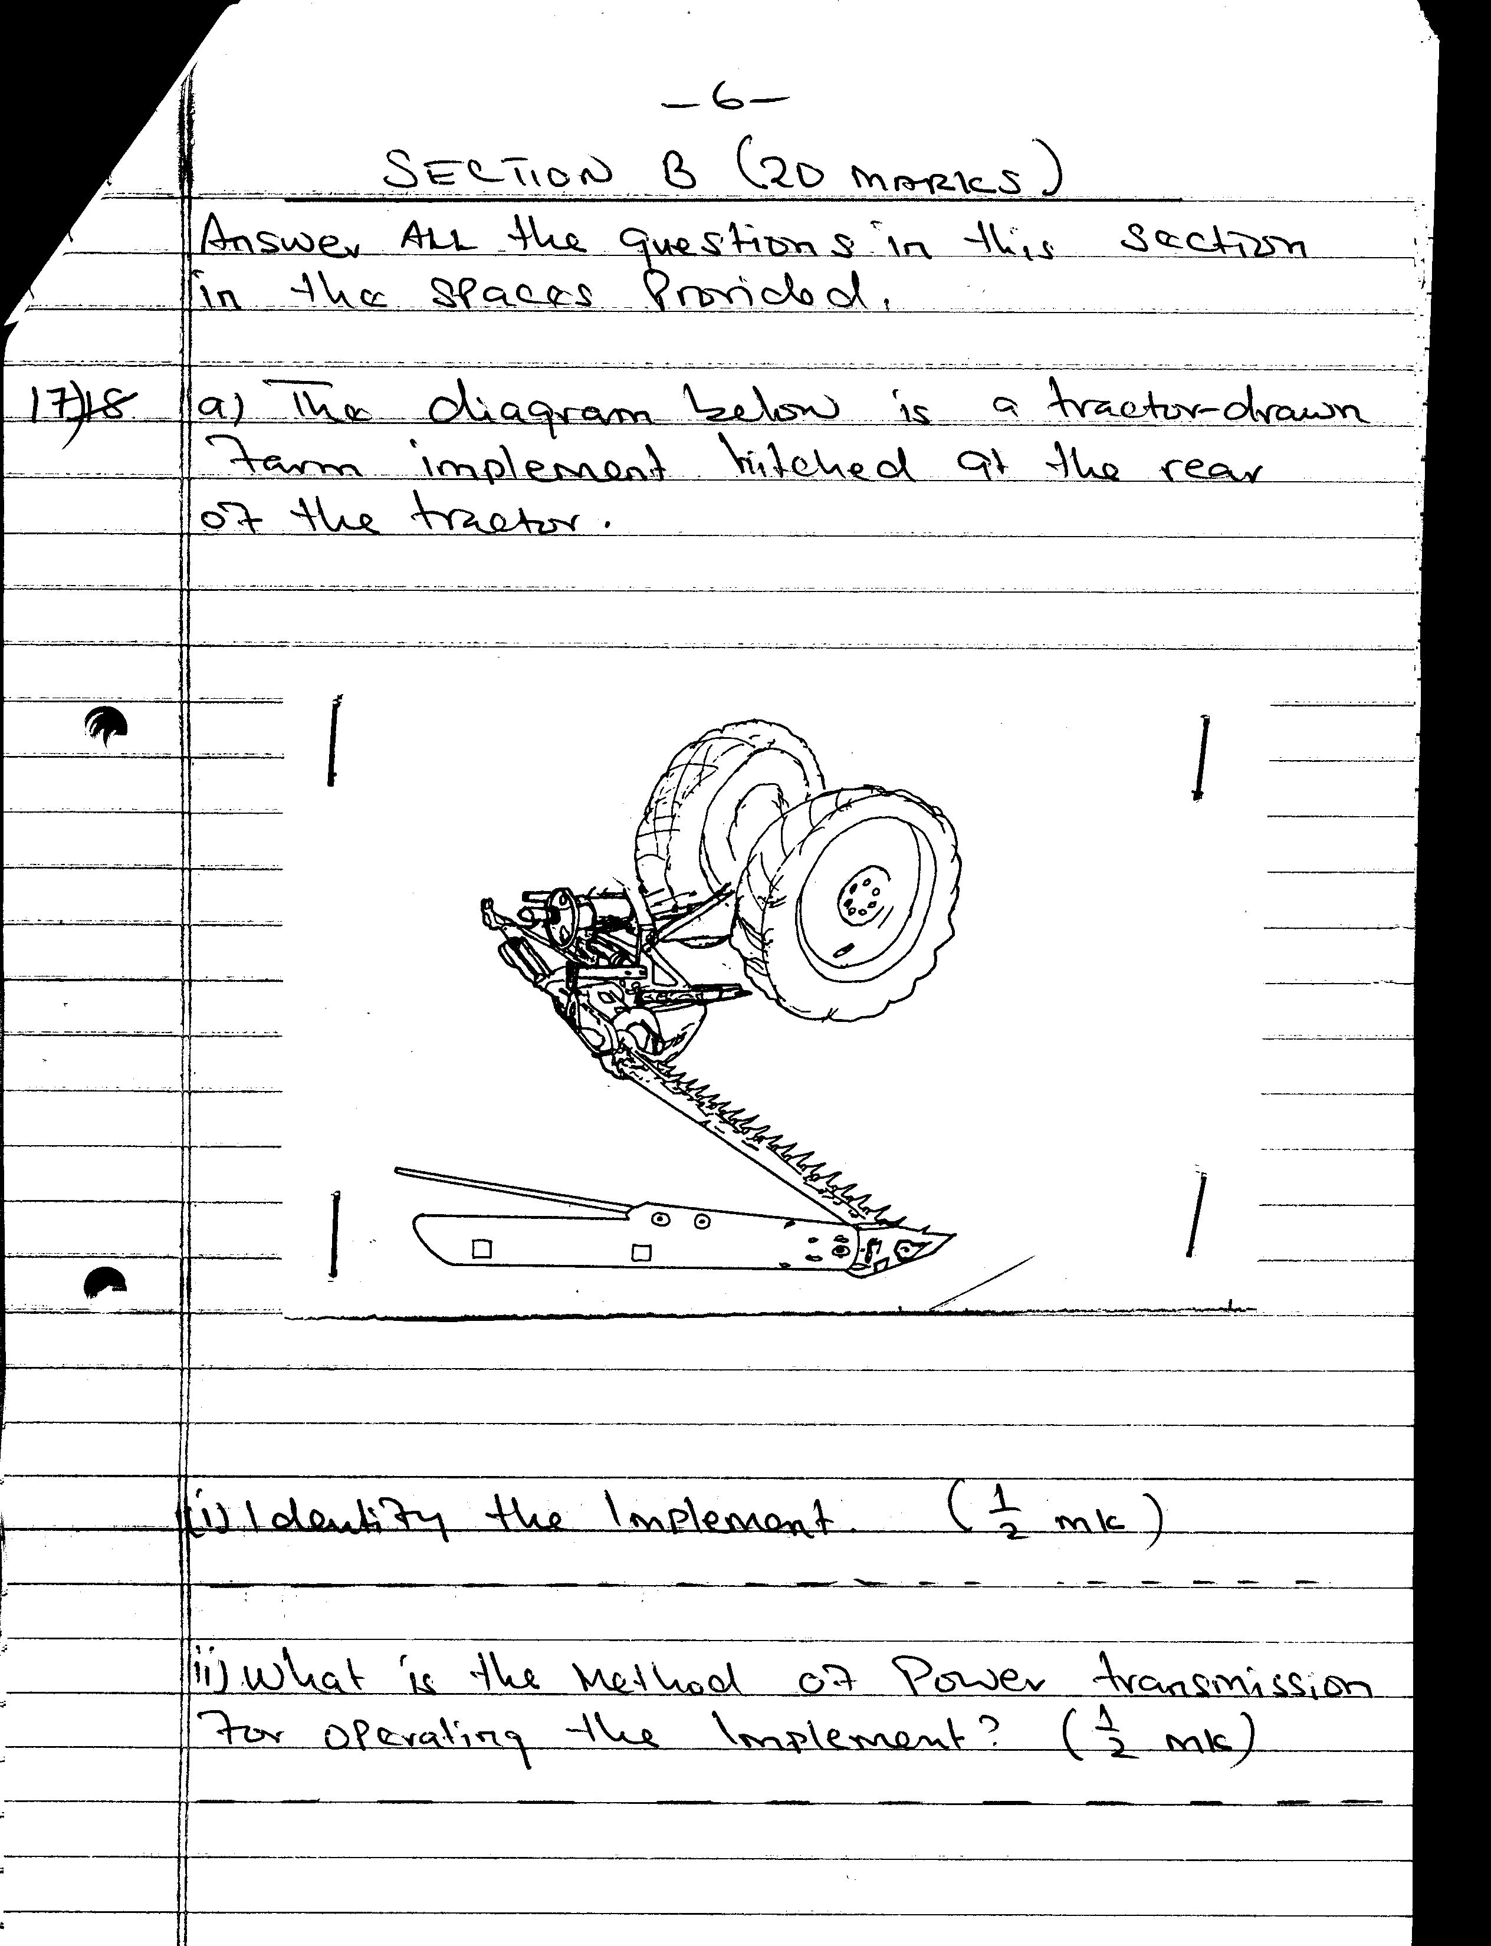

(i) Identify the implement. ½ mk
(ii) What is the method of power transmission for operating the implement? ½ mk
(iii) State three maintenance practices that should be carried out on the implement. 1 ½ mks
- Below is a diagram of a piece of farm equipment.
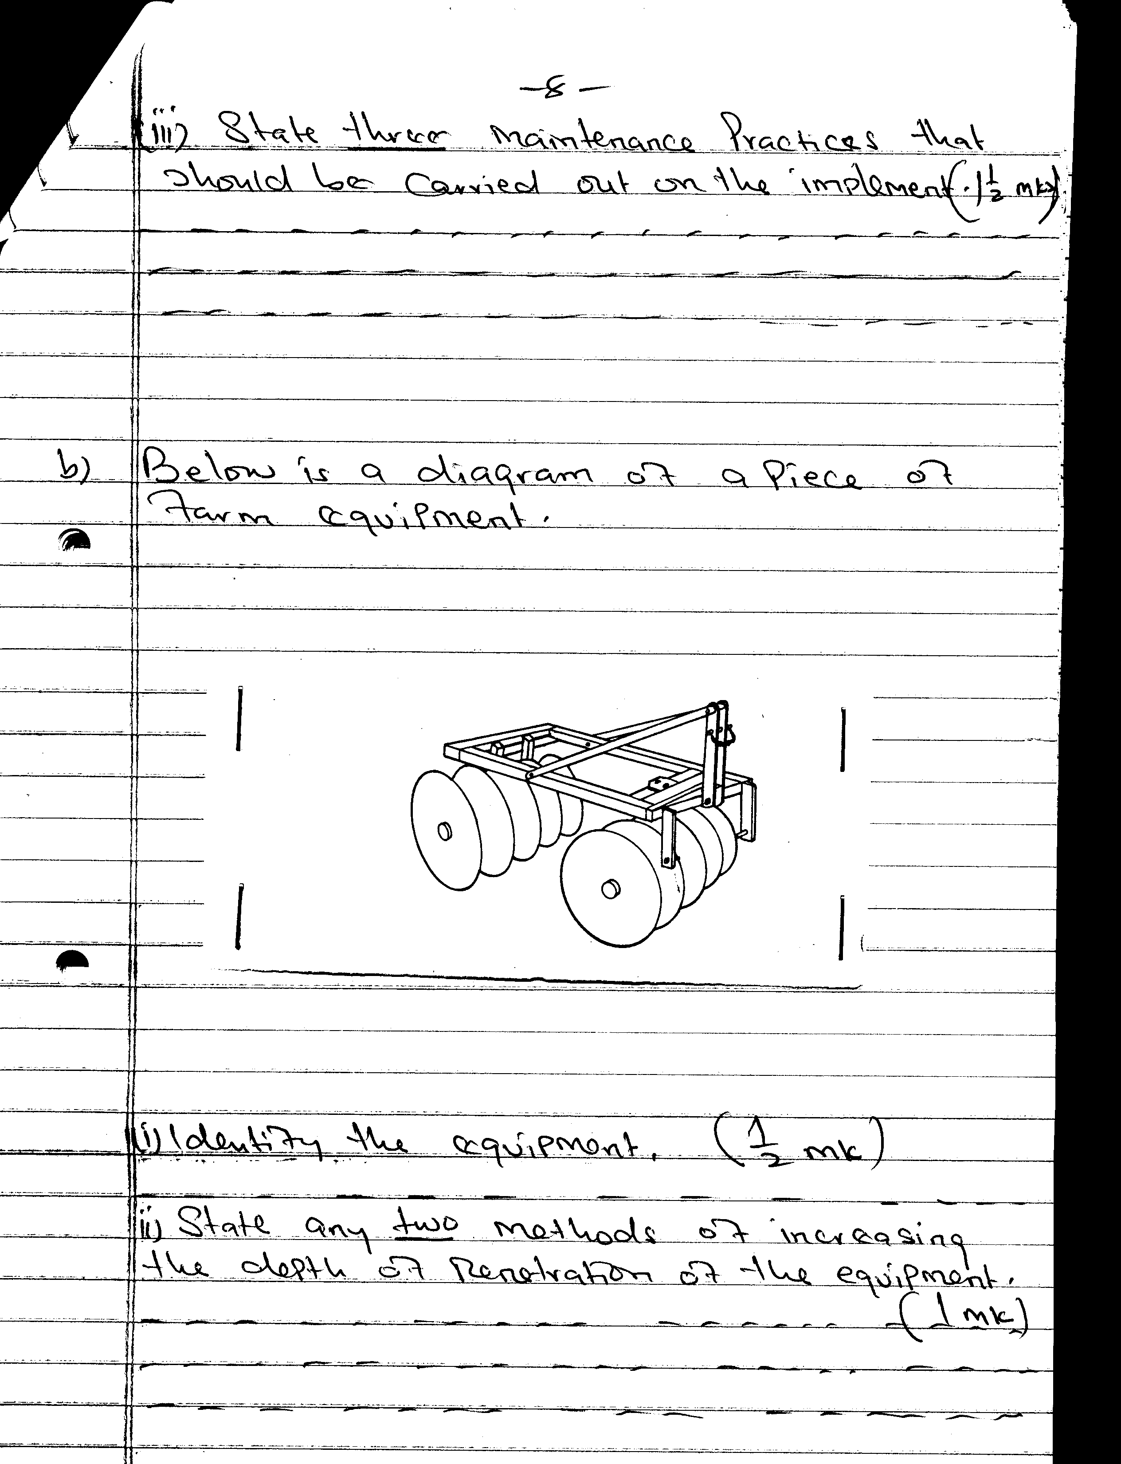
(i) Identify the equipment ½ mk
(ii) State any two methods of increasing the depth of penetration of the equipment.1mk
18. Study the diagrams below labeled P,Q,R and S representing some workshop tools and then answer the questions that follow.
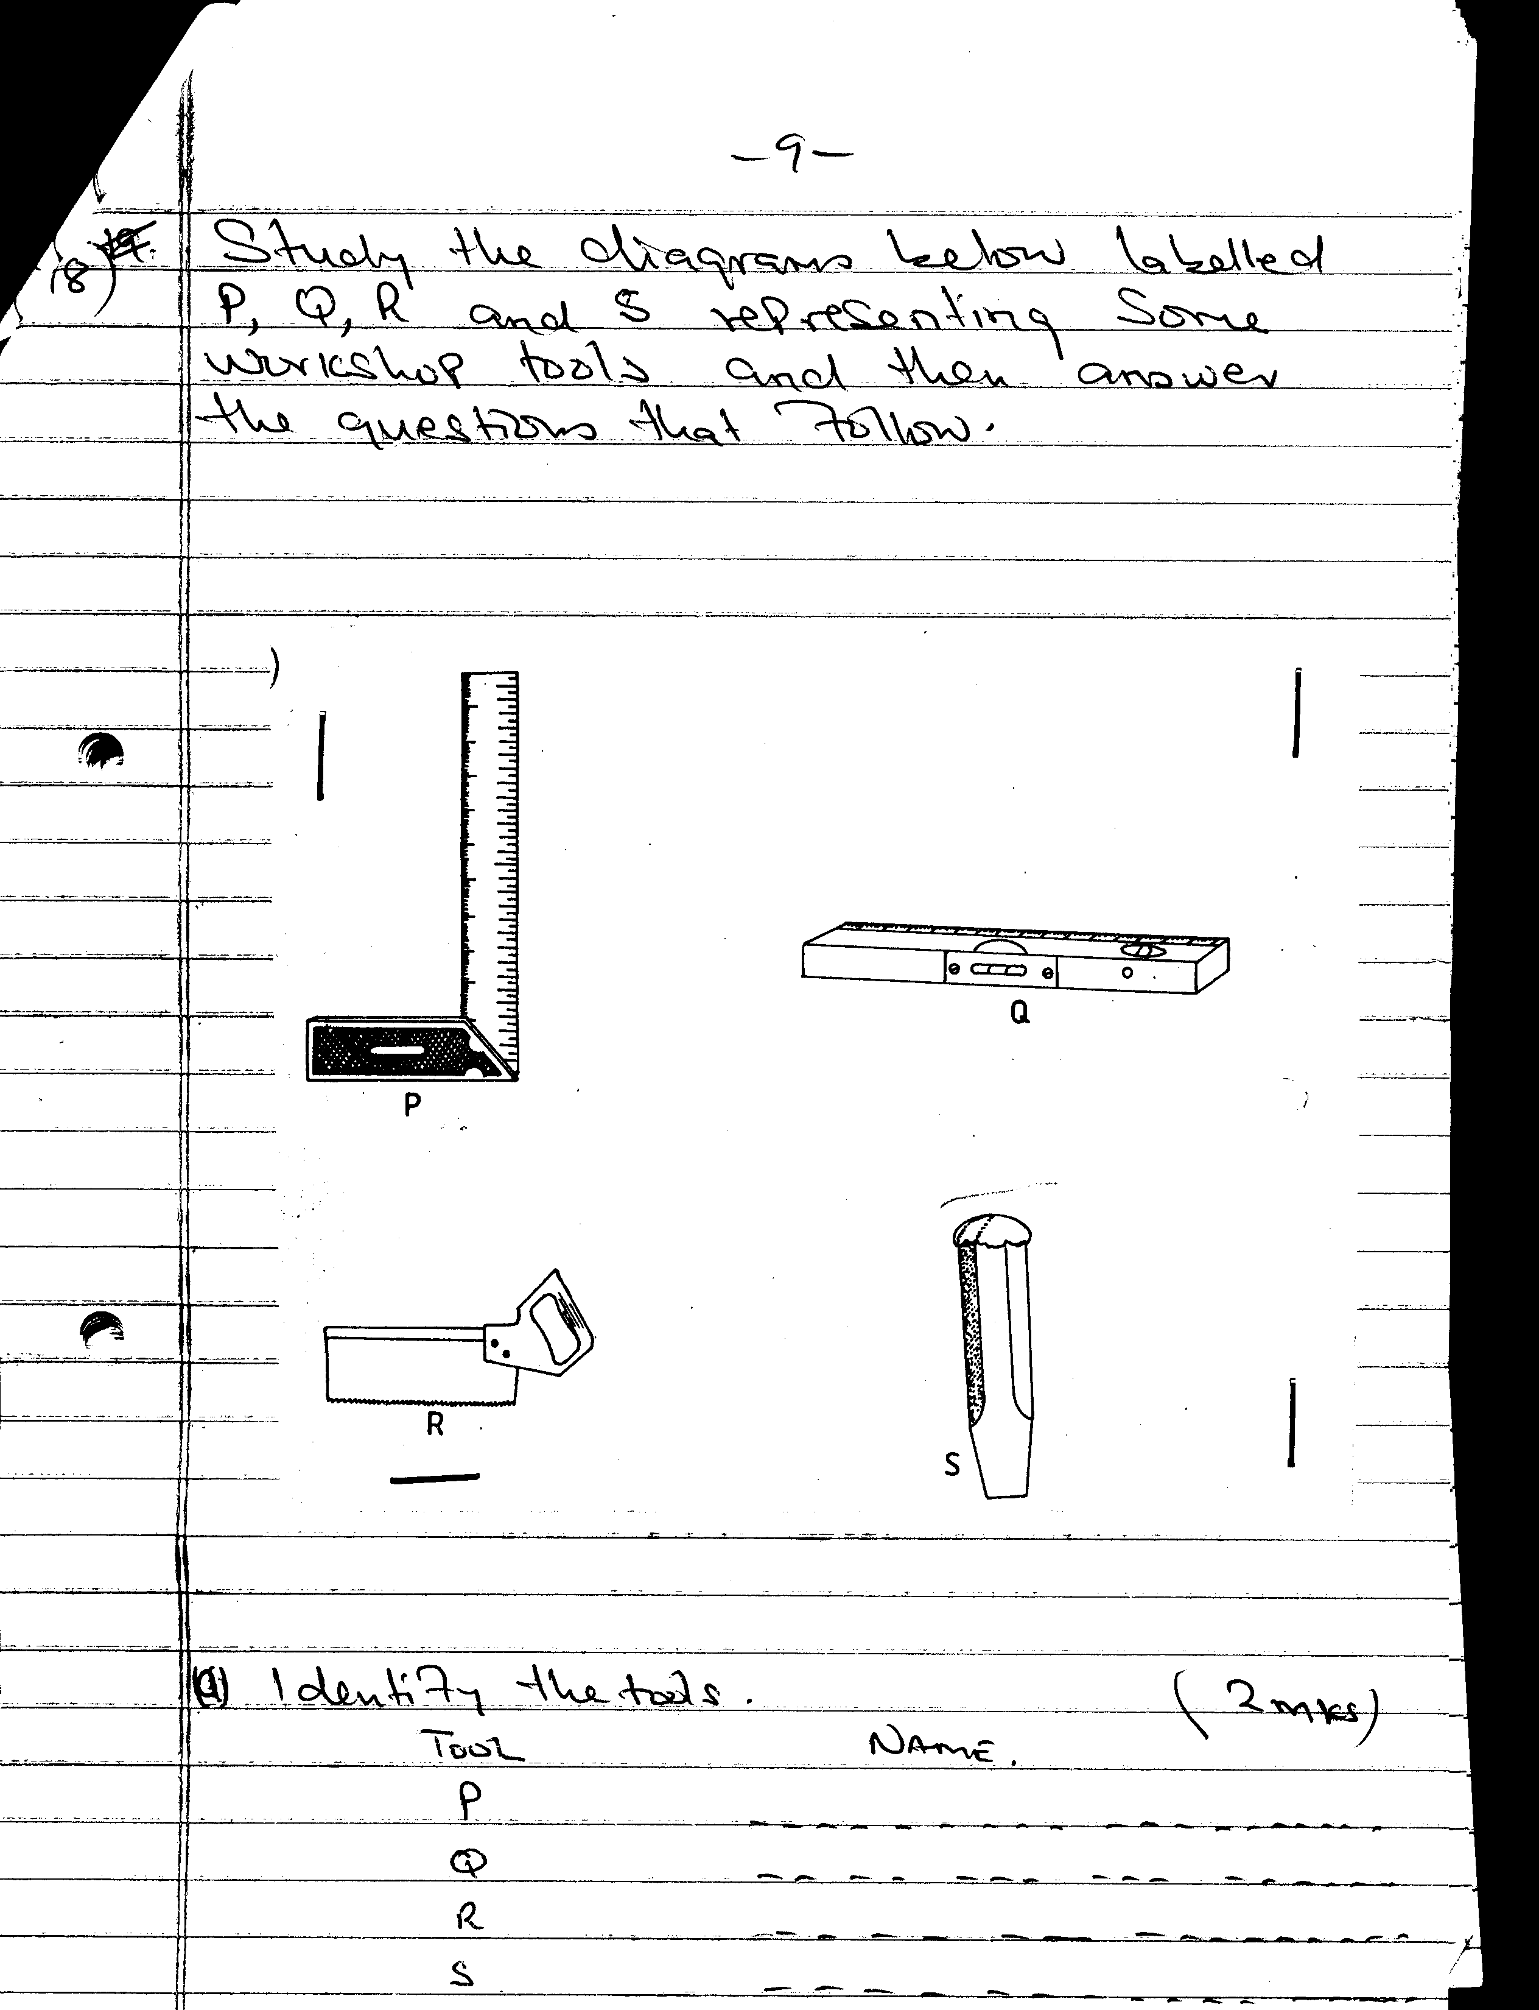

a) identify the tools 2mks
Tool Name
P ………………………………………….
Q …………………………………………
R …………………………………………
S …………………………………………
b) Give one use of tools P and R in the construction of a wooden feed trough.1mk
P ………………………………………
R ……………………………………….
c) How would the tool labelled Q be used in the construction of a calf pen? ½ mk
d) Give two maintenance practices carried out on tool S. 1mk
19. Study the illustration of a farm structure below and answer the questions that follow.
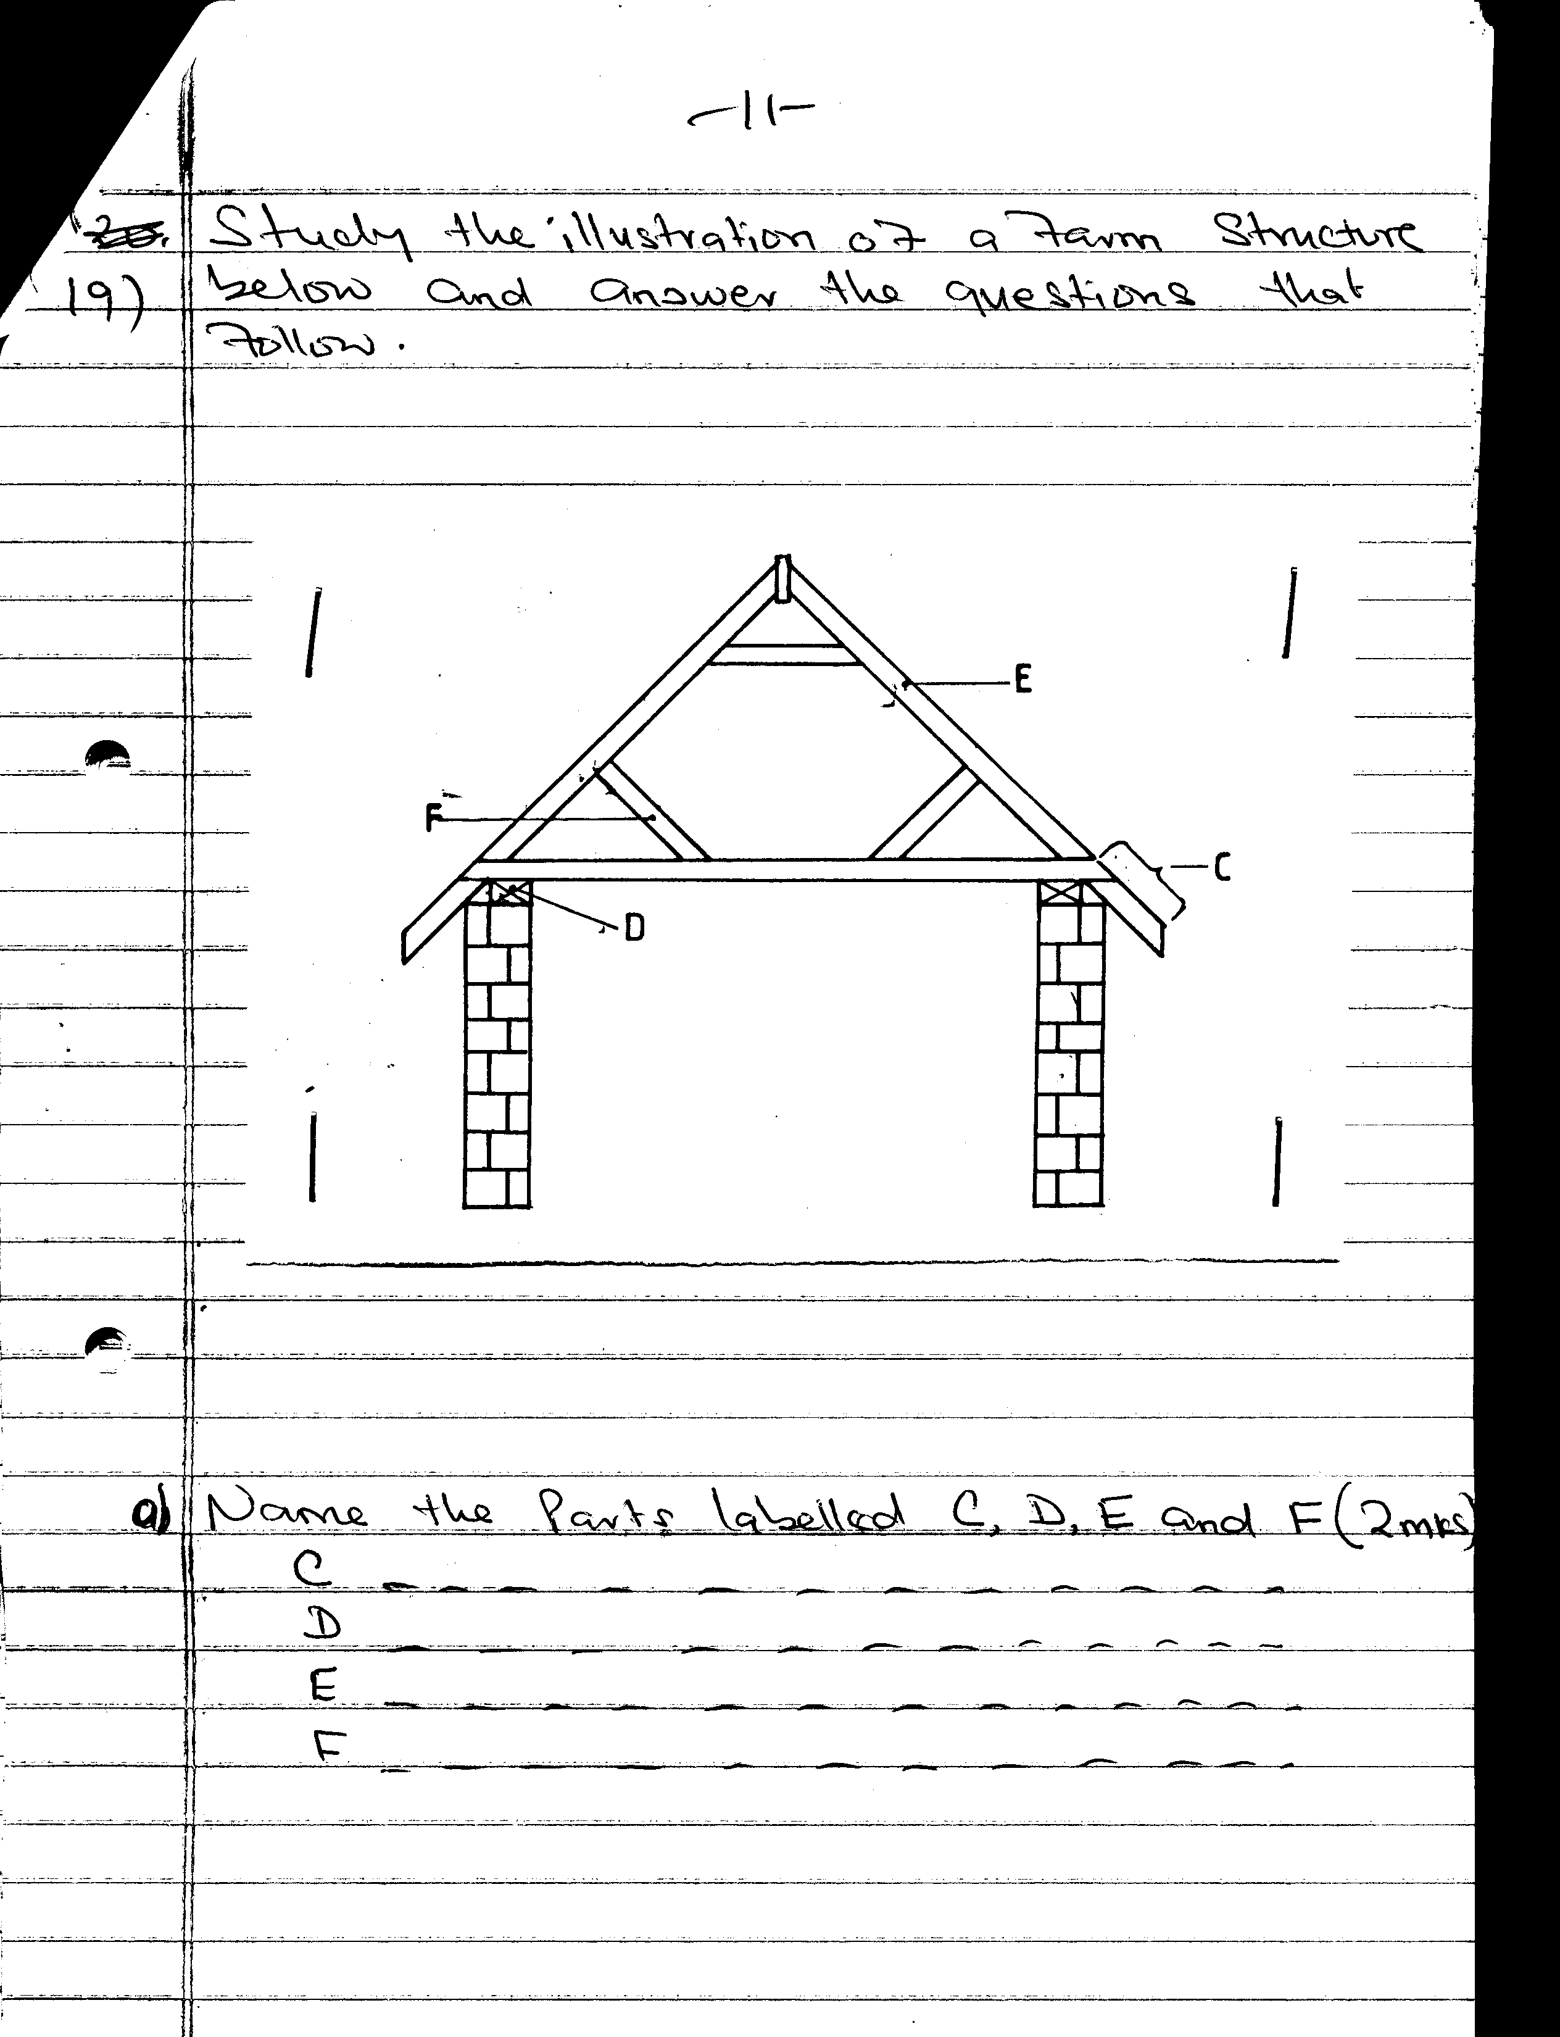
a) Name the parts labelled C, D, E and F. 2mks
b) State the functions of the parts labelled C,D,E and F. 2mks
c) Name two chemical preservatives used to treat the wooden parts of the structure against insects and fungal damage. 1mk
20. The diagrams below represent livestock parasites.
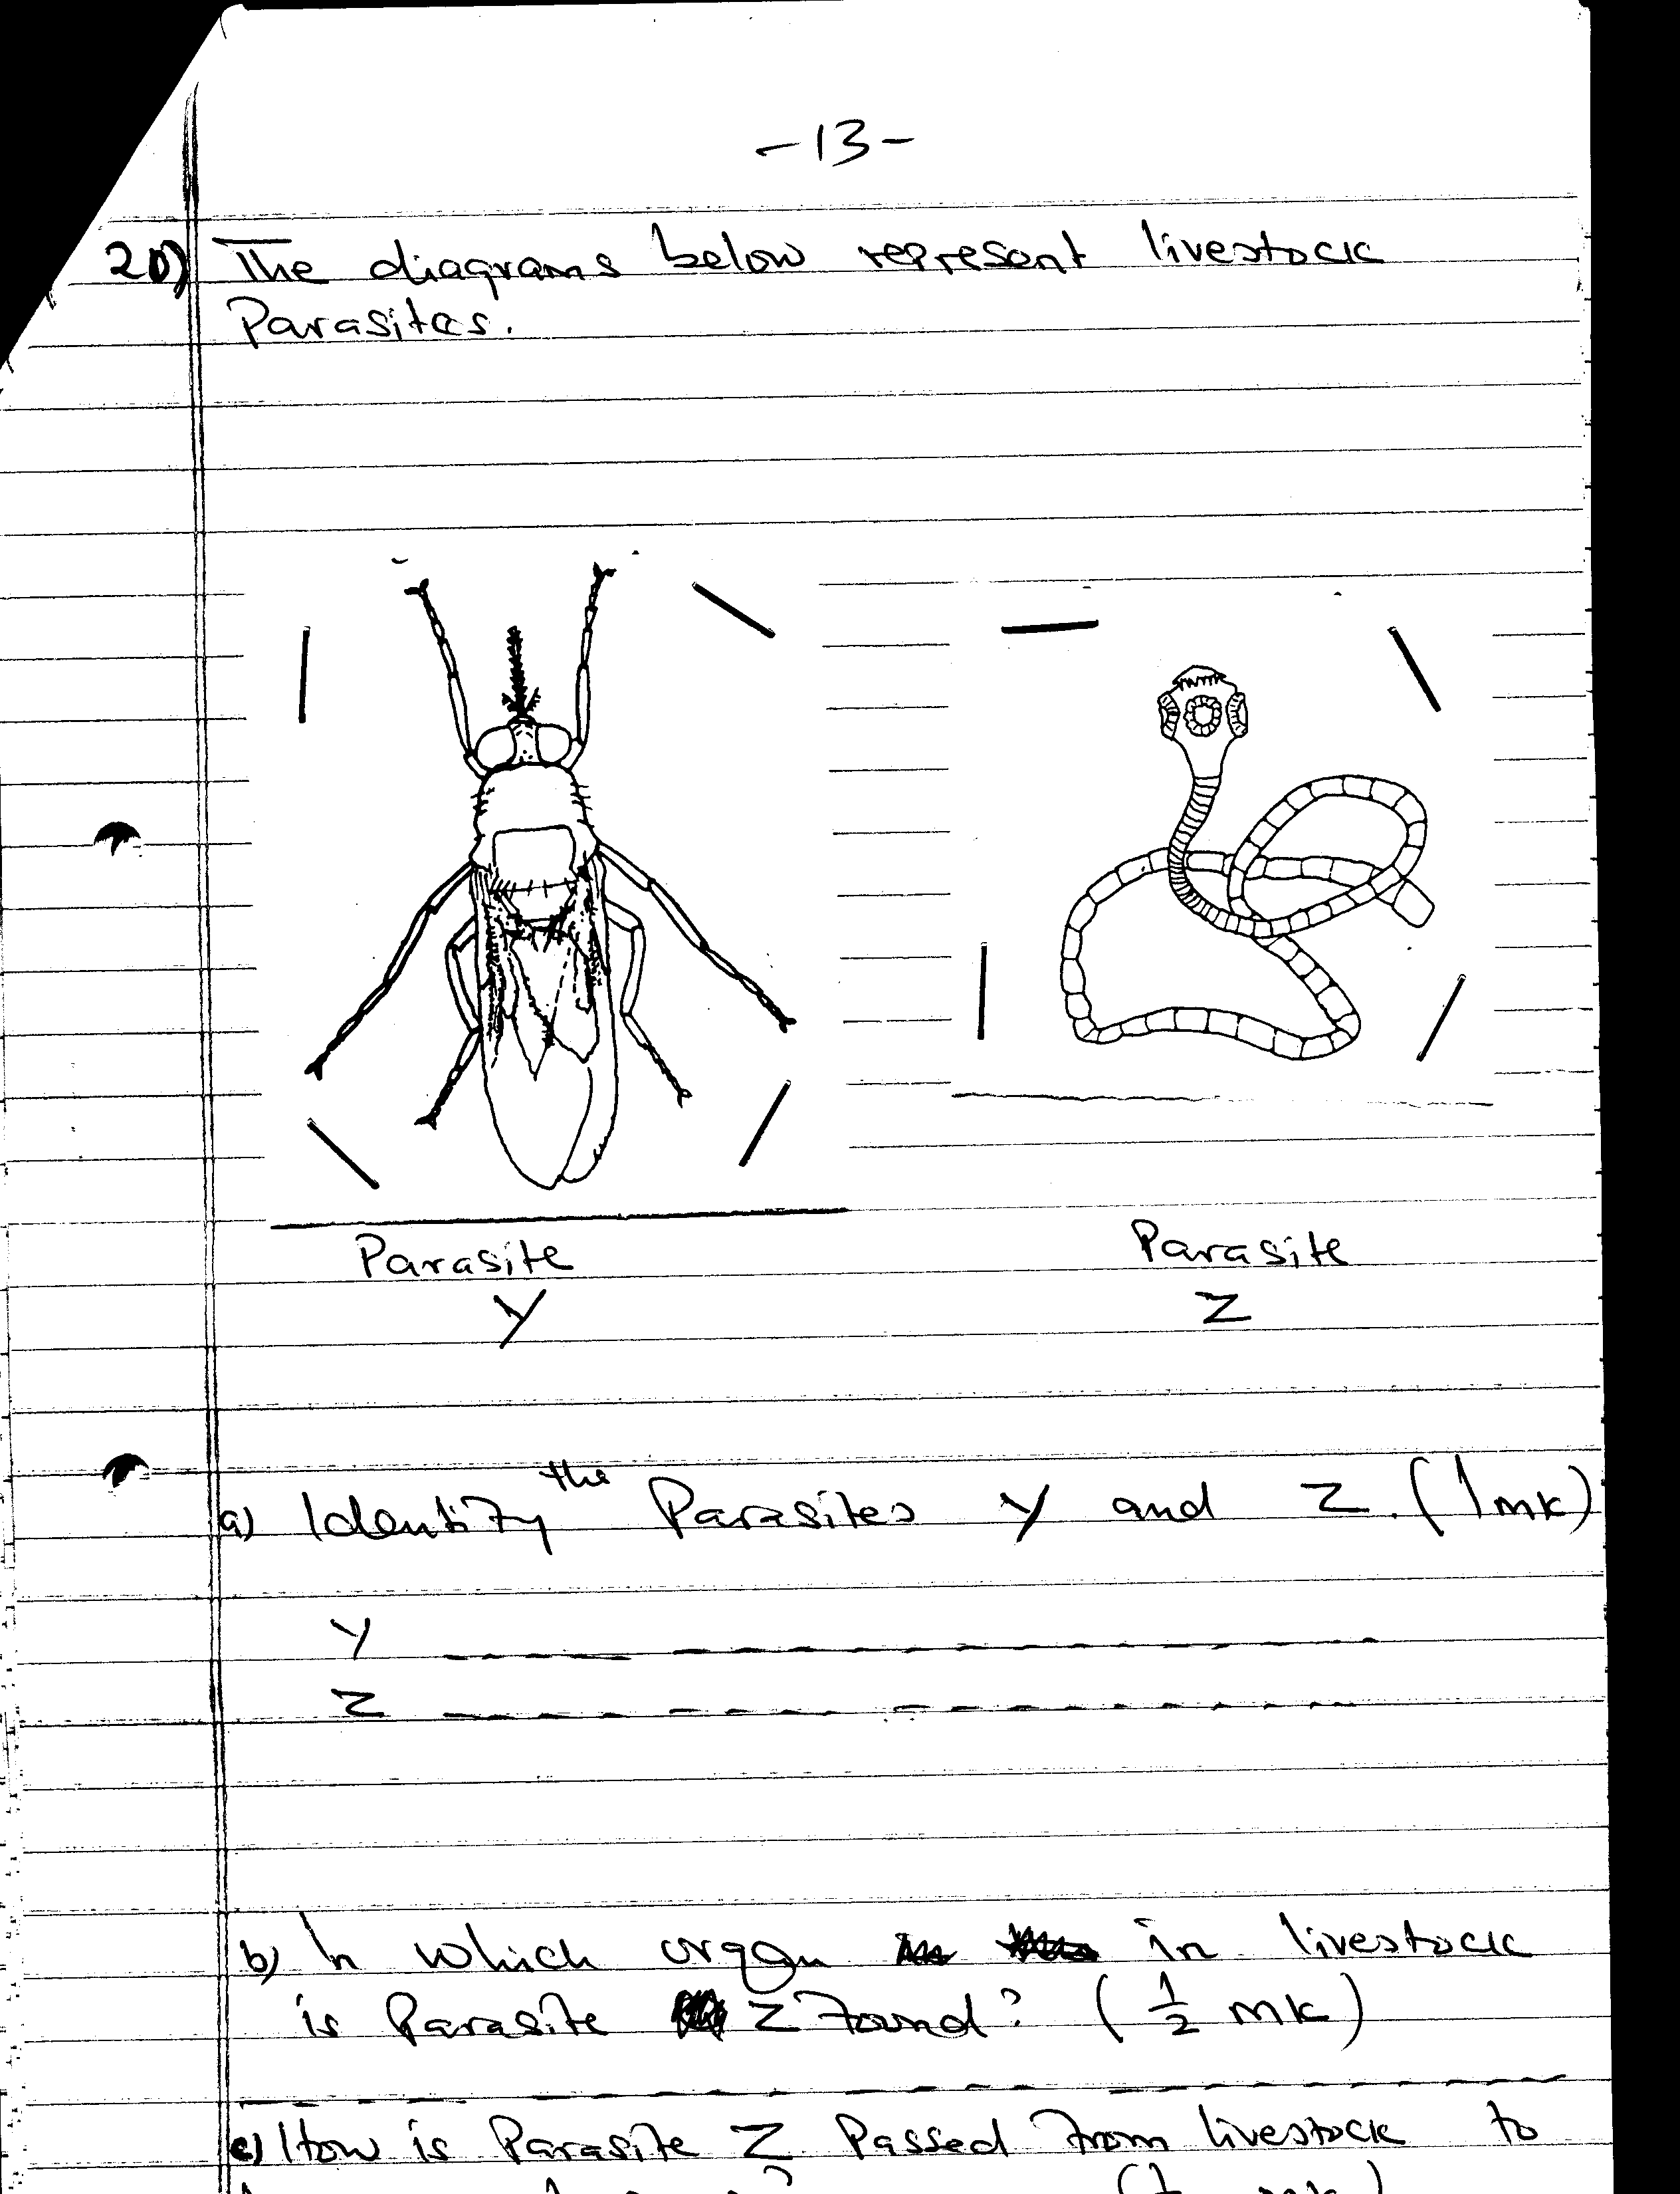
Parasite Z
Parasite Y
a) Identify the parasites Y and Z. 1mk

b) In which organ in livestock is parasite Z found? ½ mk
c) How is parasite Z passed from livestock to human beings? ½ mk
d) Give two control measures of each parasite. 2mks
Y……………………………
Z……………………………
21. Below is a diagram showing a cross section of a house and a brooder set up for brooding chicks
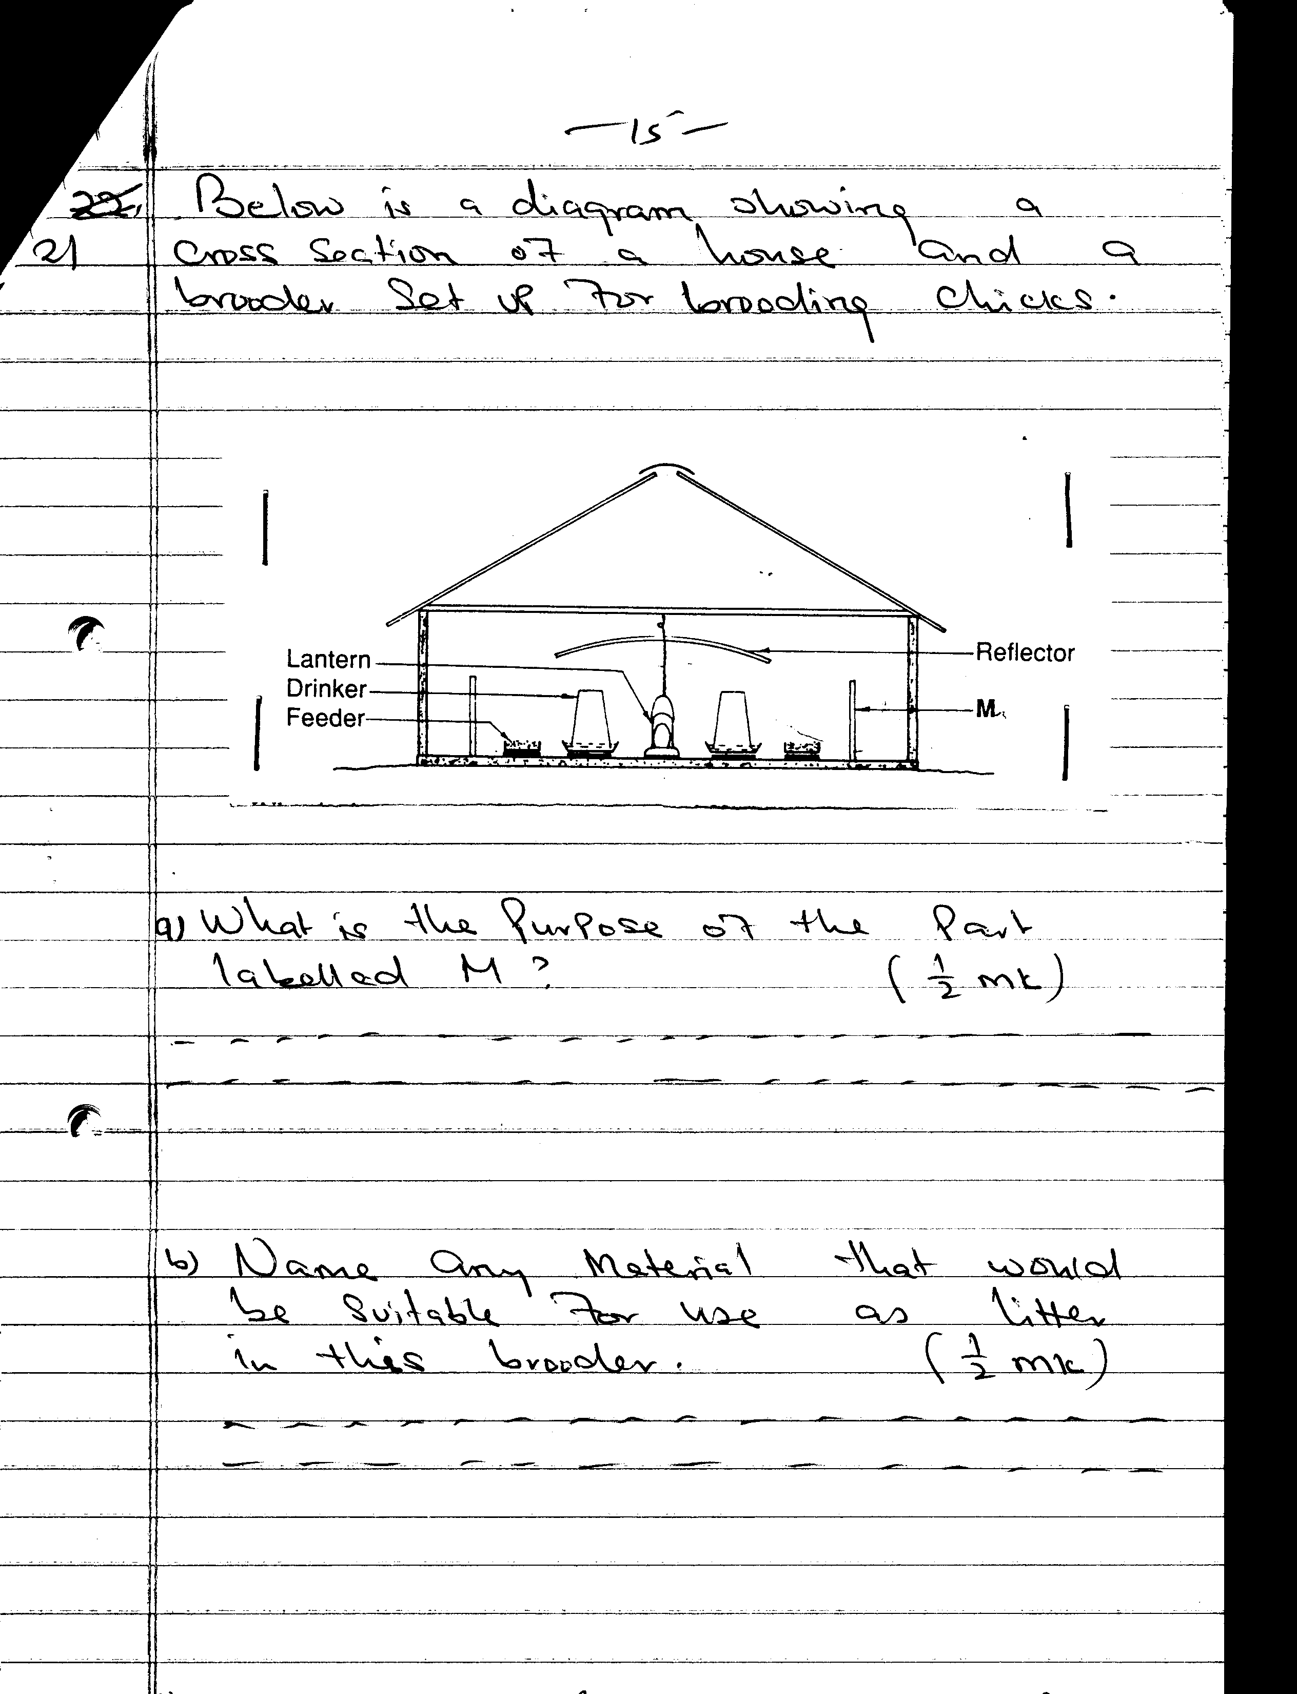
Reflector
a) What is the purpose of the part labelled M? ½ mk
b) Name any material that would be suitable for use as litter in this brooder. ½ mk
c) State two observations that would be made on the behaviour of chicks to determine when the temperature in the brooder is too high for chicks. 1mk
d) State one way by which the temperature in this brooder may be raised. ½ mk
SECTION C ( 40 MARKS)
Answer ANY TWO questions in this section in the spaces provided after this section.
22. Describe the management practices that should be carried out to raise beef cattle, using natural rearing methods, starting from birth to market stage of steers 20mks
23. a) What causes milk fever in dairy cows? 2mks
b) State five symptoms that would show that a cow is suffering from milk fever. 10mks
c) How would the disease be controlled? 6mks
d) Name two other animals that may suffer milk fever. 2mks
24. a) Compare the use of Ox-drawn mould board plough with that of tractor drawn mould board plough. 10mks
b) Describe the maintenance practices that should be carried out on an ox-drawn mould board plough. 6mks
c) What are the advantages and disadvantages of using tractor hire services in farming over owning and using your own tractor. 4mks

MARKING SCHEME
SAMPLE PAPER 5
443/2
AGRICULTURE

SECTION A
- Zero grazing:
Zero grazing is the practice of rearing animals under confinement stalls whereby food and water are brought to the animals.
- Farm structures for handling dairy animals:
-Crush
-Fence
-Milking shed
-Calf pen
-Stall/kraal/night bomas/ handling yards/cattle shed
- Other sources of farm power
-wind power
-water power
-human power/animal
-biogas
-wood fuel/charcoal
-Gas/paraffin

4. i) Cutting wool
- A pair of shears
ii) Castrating piglets
- scalpel/sharp razor/sharp knife
5. When ox chart may be preferred to tractor drawn trailer.
- If the farmer has little capital
- If the land is very steep
- If the farmer has little load to carry
- Factors considered when sitting a beehive
-Nearness to nectar producing flowers
-In shady/cool/bushy place
-Safe distance from livestock/living houses
-Away from disturbance
-Protect them from predators
- Practices to ensure maximum harvest of fish from fish pond
- Control of stocking rate
- Control of water pollution
- Supply of fish food/nutrient for aquatic life
- Aerating water/flowing water
- Maintaining appropriate depth of water in the pond.

- Predisposing factors to foot-rot diseases
- Wet ground/muddy soils
- Injuries on hooves/wounds

- Intermediate host for liver fluke
-Fresh water snail/limneas species/ water snail/mud snail

- Causes of soft shell in eggs
- Lack of calcium
- Some diseases such as Newcastle disease
- Animal factors determining amount of feed an animal consumes
- Age of animal
- Size/weight of animal
- Physiological condition of an animal
- Production level of an animal

- Importance of feeding colostrums to piglets
- Colostrum is highly nutritious/rich in proteins, vitamins, fats and minerals e.t.c.
- Contains antibodies which provide immunity to piglets
- Acts as laxative and helps to clear digestive tract
- Highly digestible

- Why young rams should be docked
- To allow for even fat distribution in the body
- To prevent accumulation of dirt which would encourage blowfly infestation
- Minimize fouling of the wool with faeces
- Facilitate easy mating later in adult life

- Cattle diseases caused by viruses
- Foot and mouth
- Rinderpest
- Rabies
- Pneumonia
- Devine malignant catarrh
- Blue tongue
- Lumpy skin disease
- Rift Valley fever
Emphemeral fever/ three day sickness
- Disadvantages of inbreeding
- Increase embryonic mortality/abortion
- Reduces disease resistance ability
- Reduces the vigor of the animal/ weak/ causes abnormalities
- Reduce yield

- Signs to show that a doe is about to give birth
- plucking off fur to line up the nest
- Making nest

SECTION B

17. a) i) -Reciprocating knife mower/reciprocating mower/cutter bar mower

ii) Method of power transmission
Powers take off (PTO)
iii) Maintenance practices carried out on the implement
  - Blades of the cutting knives should be sharpened
  - Worn out blades should be replaced
  - Bolts and nuts should be checked regularly and tightened when loose
  - Moving parts should be lubricated
  - The knife register should be checked and adjusted if necessary
  - Clean the implement when necessary

- i) –disc harrow/ two gang disc harrow

    - Methods of increasing the depth of penetration of the equipment
  - add weight on to the arrow
  - Exert more hydraulic forces
  - Sharpen the disk blades
  - Use fewer disc / increase the space between discs
  - Lessen the area of disc contact with soil/ increase the cutting angle of the discs

18.a)
Tool | Name
P | Try square
Q | Spirit level
R | Tenon saw/back saw
S | Cold chisel

- Use of tools P and R in the construction of a wooden feed trough
P-Measuring angles/ layout of angles/ measuring lengths

R- Cutting timber to make joints/ used for joinery work
-Fine cutting/ sawing

- Use of Q in the construction of a calf pen
To determine if the floor level/ the walls are vertical.

- Maintenance practices on tool S
-Sharpening the cutting edge
-Removing the mushroom head

19. a) Names of parts C, D,E and F
C-Eases
D-Wall plate
E-Rafter
F-Strut
- Functions of parts C, D, E AND f
C- Prevent rainfall falling on the walls
D- Support the roof
E-hold the roof material
F-Hold the weight on the roof
- Chemical preservatives to treat wooden parts
-Sodium dichromate
-Arsenic pent oxide
-Old engine oil
20 . a) Identity of parasites
Y-Tsetse fly/Glossina spp
Z-Tapeworm/moniezia expansa/taenia spp.
b) Organ where Z is found
Small intestine/ileum / intestine
How parasite Z is passed from livestock to human beings
By eating infected raw meat/eating infected undercooked meat

- Control measures for parasites Y&Z
Y-Bush clearing
-Spraying bushes with appropriate insecticides
-Trapping and killing tsetse flies
-Sterilizing males with sterilizing agents and releasing them.

Z-Proper sewage disposal/farm hygiene
-use of antihelminthic drugs
-Eat well cooked meat
-Buy inspected meat
21. a) Purposes of part M
-Confine chicks around the source of heat (Lantern)

- material suitable for use as litter in the brooder
-Wood shavings
-Crushed maize cobs
-Dry chopped grass
-Saw dust
- Behaviors of chicks- when temperature is too high in the brooder
-Panting/ open beaks
-Drooping wings/ wings away from body
-Chicks make a lot of noise
-Chicks far away from source of heat/ chicks do not crowd together
- Ways of increasing temperature in the brooder
-Raising the wick of lantern
-Lowering the reflector

SECTION C
22. Raising beef cattle up to market stage
- As soon as the calf ensure it is breathing
- Check for any foreign bodies in the mouth and nostrils and then induce breathing by applying artificial respiration
- Disinfect the naval cord to avoid infection
- Ensure the calf is licked dry by its mother/wipe the calf dry
- Ensure the calf suckles colostrums/ help the calf to suckle colostrum within 12 hrs of birth
- Leave the calf to stay with its dam to suck milk at will
- Wean calf at 6-8 months
- Separate weaners to graze in good quality pasture after weaning
- Spray calves up to weaning time after which they can be dipped to control external parasites
- Dehorn calves
- Calves should be dehorned within the first 4 months
- Castrate bull calves not intended for breeding at 6-8 months
- Castration should be done at weaning time
- Identify calves as early as possible after birth
- Separate uncastrated bulls from heifers at weaning time
- Give mineral supplements when necessary
- Deworm weaners regularly to control internal parasites
- Give supplementary feeds during dry seasons
- Clean water should be provided adlib at all times
- Vaccinate the calves/ weaners against prevalent diseases
- Observe and treat sick animals
- Separate sick calves/weaners from healthy ones
- Animals should be ready for marketing depending on breed, from 12-30 months
- Keep proper records
- Cull defective animals.
23. a) Cause of milk fever
- Low calcium level in the blood/ high milk yield without calcium replenishment

- Symptoms of milk fever
- Paralysis/ inability to more or arise
- Muscular twitching (not shivering)
- Stiffening of the whole body
- Head turned back
- Unconsciousness
- Walking in staggering manner
- Control of milk fever
-Feed enough mineral salts before and after parturition
-Inject calcium and phosphorus
-Partial milking on known cases

- Other animals that suffer milk fever
-goats
-Pigs
-Sheep

24. a) Comparison between ox-drawn and mould board plough and tractor drawn mould board plough.
- Ox-drawn mould board plough is light equipment hence does not compact soil as much as tractor drawn mould board
- Ox-plough can be used for more operations e.g. ploughing, weeding, harvesting root crops like groundnuts e.t.c. than tractor-drawn mould board plough
- Less skill is required to operate ox-plough than tractor drawn mould board plough
- Tractor plough can be used to plough harder soils than ox-plough
- Tractor plough is faster than ox-plough so it can plough a larger area within a shorter time
- The source of power for tractor plough since the use of ox-plough depends on the health of oxen
- Tractor plough can plough deeper than ox-plough
- Ox-plough can plough steeper lands where tractor plough cannot plough
- Ox-plough requires more people to operate than tractor plough
- Ox-plough is cheaper to maintain
- Ox-plough is cheaper to buy

- Maintenance practices on an ox-drawn mould board plough
-Grease the moving parts
-Oil before long storage to avoid rusting/ paint shiny parts if long storage
-Tighten loose bolts and nuts
-Always clean the plough after work
-Store the plough in a sheltered place e.g. machinery shed
-Repair damaged parts
-Replace worn out parts
c) i) Advantages of using tractor hire services
-It is cheaper for a farmer to use a tractor without buying one
-The farmer does not incur maintenance costs
-The farmer does not incur risks of owning a tractor e.g. theft, accident, burning e.t.c.
-farm operations are carried out faster
  - Disadvantages
-Tractor hire service may not be available at the time when required
-Some tractor hire service operators may charge very high fees for services rendered
-Some operators can produce very poor quality work

SAMPLE PAPER 6
AGRICULTURE PAPER 2
443 / 2

SECTION A ( 30 MARKS)
Answer ALL questions in the spaces provided.
1. State three importance of keeping livestock healthy. 3mks
2. State two conditions, which would make it necessary to feed bees. 2mks
3. What is pica as used in livestock production? 1mk
4. Name a pig breed with white colour on feet, nose and tail. 1mk
5. Name three methods of livestock selection. 3mks
6. List three disadvantages of embryo transplant. 3mks
7. Distinguish between crutching and ringing as used in livestock production. 2mks
8. Name two faults of ignition system of a tractor. 2mks
9. Name three importance of lubricating system in tractor. 3mks
10. Give a reason for packing eggs with the broadside upwards in an egg tray. 1mk
11. Name a tool one can use to join two pieces of barbed wire during fencing. 1mk
12. a) Name three mechanical methods of controlling ticks. 3mks
b) Name the intermediate host of liver fluke 1mk
13. a) Name the cause of fowl typhoid. 1mk

SECTION B ( 20 MARKS)

Answer ALL questions in the spaces provided

14. Below is a diagram of a farm implement
No diagram
a) Identify the implement 1mk
b) State the use of the implement 1mk
15. The following diagram illustrates a method of milking a cow.
(i) Identify the method of milking. 1mk
(ii) How long should it take to milk a cow from the start to the end of milking? 1mk
(iii) How would a milk man ensure that no milk remains in the udder at the end of milking.
(iv) State three practices done before start of milking to ensure clean milk production
3mks
16. The following diagrams illustrates farm tools.
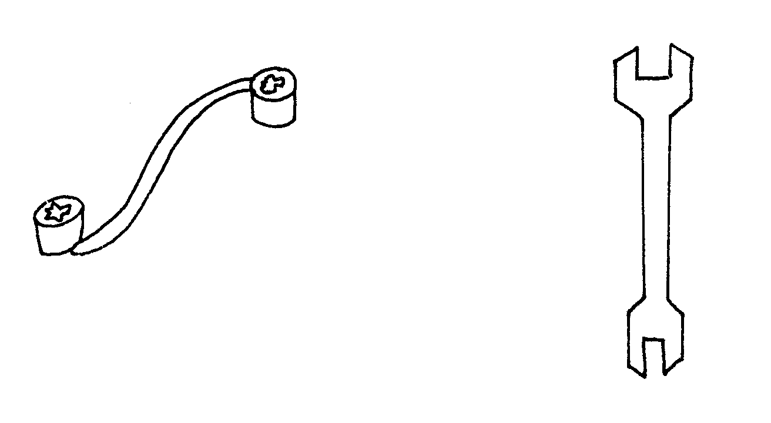
N
M
(i) Identify the tools M N 2mks
(ii) State the advantage of tool M over tool N. 1mk

17. The following is an illustration of wooden post wire fence. Study it and answer the
A
questions that follow.
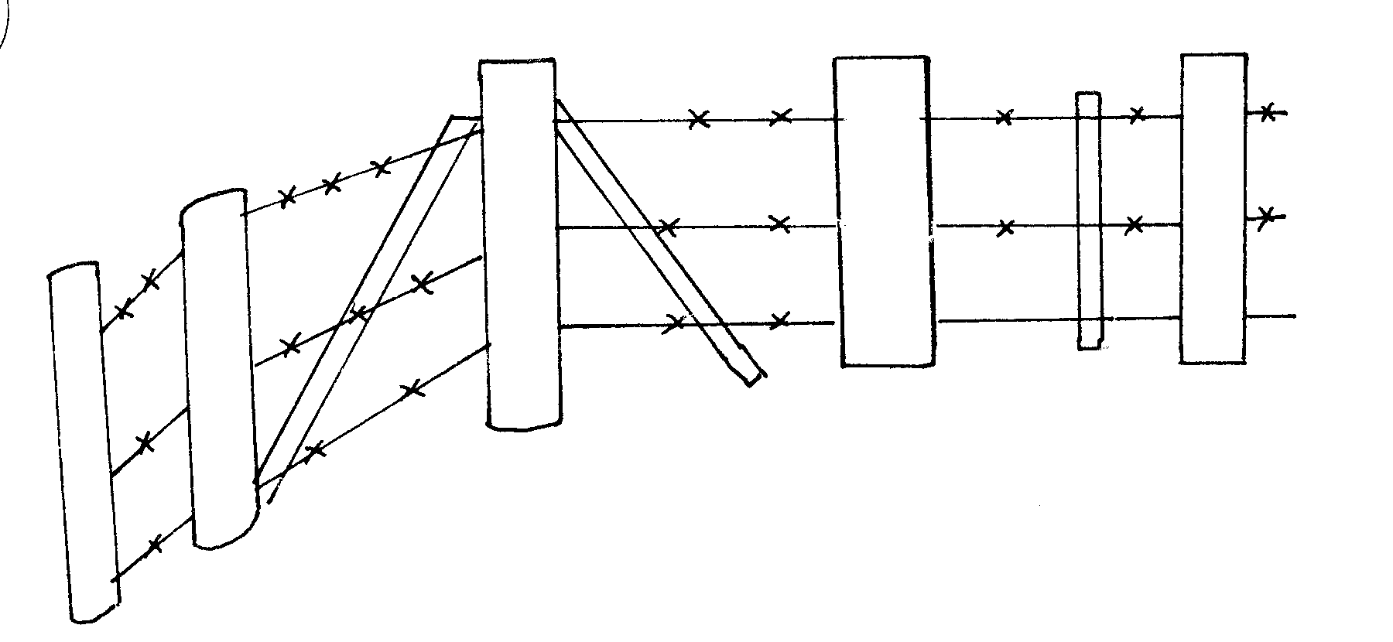
B
(i) Identify the type of wire in the illustration. 1mk
(ii) Label the parts A and B on the diagram. 2mks
(iii) Name three ways of making wooden post to last long. 3mks
iv) Name a tool used to tighten the wire during construction. 1mk
Section C ( 40 Marks)
Answer any two questions
18. Describe the management of growers in a deep litter system from 8 weeks old to the point of lay. 20mks
19. a) Describe the procedure used in establishing the foundation of a permanent farm building. 8mks
b) Describe the uses of various hand tools used in the establishment of the foundation in (a) above. 12mks
20. a) State five microbial activities that takes place in a rumen. 5mks
b) How are various methods used to control livestock diseases control disease 15mks

MARKING SCHEME
SAMPLE PAPER 6
443/2
AGRICULTURE.
- To increase quantity of livestock products/ work output /regular breeding.
  - Increase quality of livestock products
  - Reduce cost of production
  - Prevent spread of diseases
  - Increase productive life of livestock
- During drought when no flowers*NDI*
  - When a new colony is small and faster reproduction is required
  - When a new colony has just entered the hive and no food reserves
- Depraved where animal feed or nonfood materials (1mk)
- Berkshire
- - mass selection
  - Progeny testing
  - Contemporary comparison
- - Expensive
  - Requires highly skilled labour
  - Require special equipment for fertilization & storage
  - If the uterus of the animals to receive the embryo is not ready implantation will not occur

- Crutching = cutting wool around reproductive organ of ewe
Ringing = cutting wool around sheath
- - Sudden stopping
- Continuous engine running
- - Increase efficiency of machine
  - Reduces heat created by rubbing surface
  - Acts as cleaning agent.
- Oil used prevent rusting of stationery machines
- Gaseous exchange
- Splicing fool
12.a) - Burning infested pastures
- Fencing off the pasture land and farm
- Starving the ticks by keeping animals away from infested pastures.
- Handpicking ticks from animals & killing them
- Change ticks environment e.g. by ploughing pasture laser etc.
b) Mud snail / fresh water snail
13a) Bacterium / Salmonella gallinarum
b) - Extensive bloating
- Tar-like waterly blood oores off from openings on office e.g. nose
- Waterly blood does not clot quickly
- Lack of rigor mortis
SECTION B (20Mks)
14. a). a subsoiler
b). breaking hard pans
c) - Clean after use
- Replace / repair worn out parts
- Store it properly / under a shed
- Oil the unpainted parts before long storage.
15. (i) Machine milking
(ii) 8 minutes or less
(iii) Massaging the udder & stripping out milk from the teat(OWTTE)
- Maintain healthy milking herd
  - clean milking cow
  - Milk man should be clean and healthy
  - Milking shed should be clean
  - Use clean milking utensils
  - Avoid flavour in milk by not using feed stuffs e.g. silage etc
16. (i) M – Ring spanner
N - Open – ended spanner
(ii) - Used to loosen or tighten hidden nuts
17. (i) barbed wire
(ii) (A) brace
(B) Dropper
(iii) - Charrying the post
  - Covering the tops with metal (plastic)
  - Reinforcement of bottom with concrete
  - Cutting the top at a slope
(iv) Wire strainer / morkey strainer
SECTION C
- - Space in the house should be adequate to the number of growers
  - Litter should be kept dry and from dampeness / dust
  - Provide adequate perches / roosters
  - Provide enough clean water in the waterers
  - Control external parasites by dusting
  - Vaccinate against prevalent diseases
  - Hung green vegetables in the house to make them busy
  - Provide grit / oyster shell to help in digestion towards end of growing period.
  - Introduce layers mash in the 10th week
  - Give adequate growers mash
  - Keep proper records
  - Keep the wateres and all other equipment clean
  - Debeak the birds to prevent cannibalism / egg eating
  - Provide appropriate prophylactic drugs
  - Treat sick birds
  - Avoid stress factores e.g. noise etc
  - Provide adequate waterers
  - Provide adequate feed trough
  - Scatter grains on the utter to make birds busy
  - Isolate sick birds
  - Dispose off dead birds properly
  - Cull frequently sick birds
19. (a) - Clear vegetation from the site
- level the site
- Measure and peg it
- Dig a trench 30cm wide and at least 60cm deep to remove all loose and disturbed soil
- Pour in concrete of correct mixture /1:2:4 /1:3:6
- Compact the concrete
- lay foundation stone / block /bricks to 50cm above the ground level
- Place a damp proof course /PVC sheet.
b) Slasher / panga - clearing vegetative / making pegs
Jembe - Levelling the site / digging the trench
Spade - Removing soil from site / trench
Spirit level - Checking horizontalness of the laying the building materials
Rammer - for firming concrete
Mason’s square - Measuring corners
Mason’s trowel - applying mortar between building material
Mallet - for hitting the pegs into the ground
Tape measure - Measuring distance
Plumb bob - for checking verticalness
Naming the tool

20.a) - Fermentation of food
- Synthesis if vitamin B complex / VHB₁ B₂, B₆ & VA.K
- Synthesis of amino acides from ammonia gas.
- Breaking down of proteins into peptides, amino acids and ammonia
- Breaking down carbohydrates & cellutose to carbon dioxide , volatile fatty acides /
Accept specific.
b) - General farm hygiene / cleanliness of houses, equipment proper carcass disposal :-
to destroy pathogens
  - Isolation of sick animals- avoids spread of diseases
  - Drenching / deworming – controls internal parasites
  - Vaccination – creates resistance to diseases in animals
  - Control of vectors – avoids disease transmission
  - Prophylactic approach / use of drugs avoids prevents infection
  - Proper feeding / balanced ration-prevents nutritional disorders slaughtering frequently sick animals prevents spread of contagious diseases
  - Proper breeding – controls breeding diseases
  - Quarantine- avoids introduction of disease / prevents spread of disease
  - Foot trimming – minimizes occurrence of foot rot.
  - Proper housing – avoids predisposing animals to diseases.

SAMPLE PAPER 7
AGRICULTURE PAPER 2
443/2
SECTION A ( 30 Marks)
Answer all the questions in this section in the spaces provided
1. Name TWO pre-disposing factors for mastitis. 2mks
2. State TWO safety precautions considered when planing. 2mks
3. a) Name TWO products obtained from milk after processing. 1mk
b) Give TWO essentials of clean milk production 2mks
4. a) What is a feed ration 1mk
b) Give TWO advantages of proper feeding of livestock. 2mks
5. Name TWO methods of harvesting fish. 2mks
6. a) Give ONE functional difference between petrol and diesel engines. 1mk
b) Give TWO maintenance practices of a diesel fuel system. 2mks
7. Give ONE advantage of using Kenya Top Bar Hive over log hive in honey production
1mk
8. List TWO factors that lead to cannibalism in poultry management. 2mks
9. State ONE reason why Blackhead Persian sheep is suitable for drier areas. 1mk
10. a) Give TWO harmful effects of keds in sheep 2mks
11. State TWO reasons for breeding livestock. 2mks
12. State TWO signs of farrowing in pigs. 2mks
13. State ONE condition under which the spike tooth harrow is used. 1mk
14. a) Name TWO livestock handling techniques during feeding. 2mks
b) Give ONE advantage of correct handling of livestock during feeding. 1mk
15. Distinguish between pipe wrench and pipe cutter. 1mk
SECTION B ( 20 MARKS)
Answer ALL questions in this section in the spaces provided
16. The following illustrations show the behaviour of chicks in different brooders.
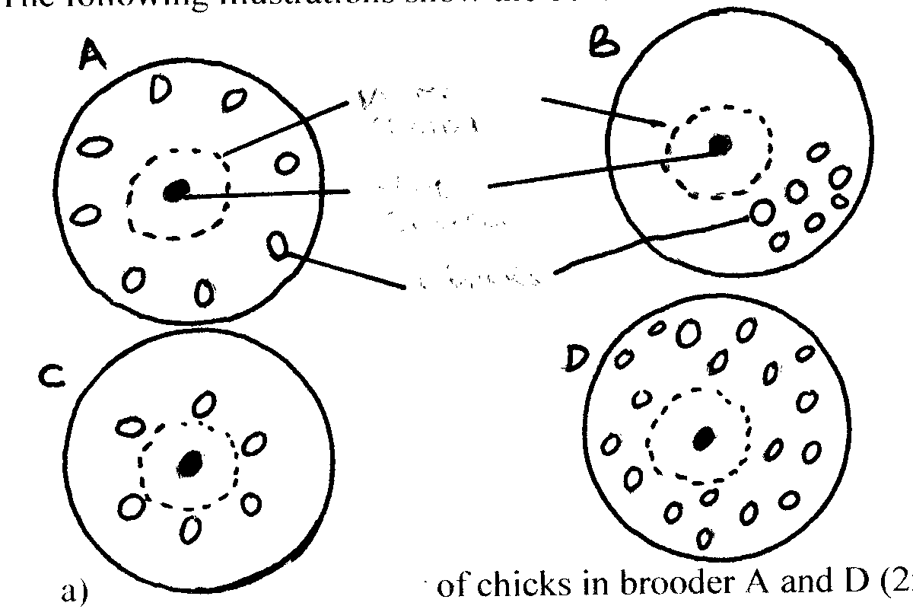
Chicks
Heat source
Wire guard

a) Explain the behaviour of chicks in brooder A and D. 2mks
b) What adjustments should be made on brooders B and C 2mks
17. Study the diagram below and answer the questions that follow.
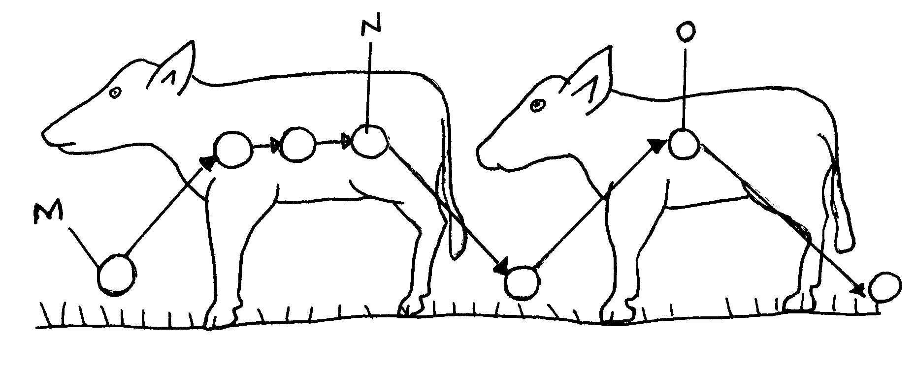
a) What does the illustration represent. 1mk
b) Name the stages labeled M,N, O 3mks
c) Give TWO ways of controlling the stages named in (b) above. 2mks
18. The diagram below represents parts of a roof. Study the diagram carefully and answer questions that follow.
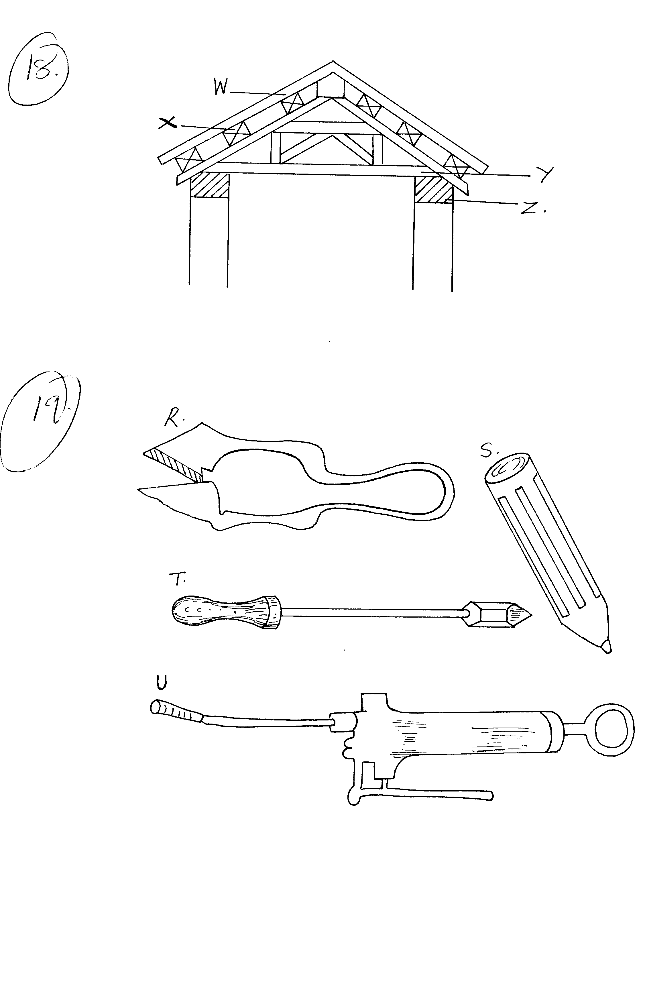
a) Name the parts labelled WXY and Z. 4mks
b) State ONE factor which determine the pitch of the roof. 1mk
c) Give a reason for your answer in (b) above 1mk
19. Study the farm tools labelled R,S,T and U and answer the question that follow.
a) State the functions of tools R and S. 2mks
b) Give the importance of the metal used to make tool T 1mk
c) State ONE maintenance practice of tool U. 1mk
SECTION C ( 40 MARKS)
Answer ANY TWO questions in this section in the spaces provided
20 a) Describe the procedure followed during preparation of silage as livestock feed.
16mks
b) Explain four qualities of good silage 4mks
21. a) By use of suitable illustrations, describe digestion of food in ruminant animals18mks
b) Explain TWO advantage of digestion of food in ruminants over that of non-ruminants.
22. a) Describe FIVE sources of power on the farm. 15mks
- Describe FIVE maintenance practices carried out on a named farm implement.
5mks

MARKING SCHEME
SAMPLE PAPER 7
443/2 –

1. Predisposing factors for mastitis
i) Age
ii) Stage of 1actation
iii) Udder attachment
iv) Incomplete milking
v) Mechanical injuries
vi) Poor sanitation
vii) Poor milking techniques
2. Safety precautions when planning
i) Plane blade should be as sharp as recommended
ii) Plane blade should be properly adjusted
iii) Plane along grains
iv) Wood being planed should be held firmly on the bench by clamps or bench
v ices
v) Start planing from the end nearest to you.
vi) Push plane with long uniform strokes
vii) Wood should not have nails or metals sticking on it.
3. a) Milk products
- Cream ,
- Ghee
- Butter
- Homogenized and pasteurized milk
- Ultra heat treated milk (UHT)
- Curd Cheese
- Powdered milk
- Ice cream, yoghurt & Condensed milk
b) Essentials of clean milk production
- Healthy milking herd
- Clean milking cows
- Clean milking utensils
- Avoid flavours in milk
- Healthy and clean milk man
- Milk filtration, cooling & storage
- Clean milking shed
4. a) Feed ration - Daily amount of feed given to an animal
b) Advantages of proper feeding of livestock
- Produce high quality products
- Give higher yields
- Grow faster and mature early
- Increases resistance to diseases
- Economical to keep
5. Cropping fish -Removal offish of marketable size from the fish pond Methods
- Use of nets
- Use of hook and line
6. Functional difference between petrol & diesel engines
Petrol engine Diesel engine
Produces little smoke - produces a lot of smoke
- Completely burnt - Diesel is not completely burnt - Light in weight and suitable for light duties. - Heavy and suited for heavy duties
b) - Fillters should be replaced as recommended by the manufacturers
- The sediment bowl should be cleaned regularly
- Bleaching should be done incase air is entrapped in the system.
7. Kenya top Bar Hive
- Easy lo harvest honey by removing Bars
- Higher yields
- Avoid destruction of larval bees during harvesting
- High quality honey not mixed with brood
- Bars can be removed for examination of combs
8. Cannibalism in poultry
- external parasites
- prolapse
- mineral deficiency
- bright light
- overcrowding
- introduction of new bird.
9. Black Persian sheep is prone to foot-rot infections
10. a) Harmful effects of Keds
- Suck blood causing anemia
- Cause retardation of growth in lambs
- Cause irritation
- Sheep scratches and bites itself hence damaging its wool.
b) Control
- Dipping sheep
- Shearing infested sheep and applying appropriate chemicals either by hand, spraying or washing.
1 1 . Reasons for breeding
- Introduces new genes increasing productivity
- To overcome environmental problems
- Such as diseases, pests and adverse climatic conditions
- For economic reasons; livestock with high growth rates mature faster thus cheap to produce.
- Expands inherited potential of the animal.
12. Signs of farrowing
- Enlargement of vulva
- Loss of appetite
- Restlessness
- Slackening of muscles on each side of the tail
- Udder and teats become enlarged
- Presence of milk in teats
- Sow collects litter at one corner to build a nest.
13. Condition for using spike tooth harrow
- removal of trash in farms with plant residues
- Leveling soil surface to plant - small seeds
- Used in ploughed farms with large soil clods
- Used when incorporating fertilizes into the soil
14. a) Livestock handling techniques
- Free range
- Zero grazing
- Morant system
- Artificial bucket feeding
- Tethering
- Paddocking
- Strip grazing
b) Advantages of correct handling
- Underfeeding is prevented
- Overfeeding is avoided
- Adequate quantity of feed is given
- Injuries to animals is avoided
15. Pipe wrench - for holding, tightening and loosening metallic pipes
Pipe cutter - used for cutting PVC pipes
SECTION B (20MKS)
16. a) Behavior of chicks in brooders
A - chicks have moved away from the heat source due to high temperature
D - chicks are evenly spread all over the broods due to optimum temperature.
b) Adjustments on brooders
B - prevent drought coming from one direction of the brooder
C - Increase temperature in the heat source to avoiding over crowing around the heat source
17. a) The life cycle of a two host tick
b) M - Larva
N - Nymph
O - adult
c) - Dipping or spraying
- Hand dressing animals
- Hand picking of ticks
- Rotational grazing
- Burning
- Ploughing
- Fencing
18. a) Parts of a roof
A - Rafter
B - Purlin
C - Cross tie
D - wall plat
b) Roofing materials
c) The pitch/rise of the roof is high if the roofing materials used retain water such as grass and tiles pitch low if materials allow easy flow of water such as corrugated iron sheets.
19. a) R — shearing wool in sheep
S – punching holes in metals
b) Advantages of correct handlingUnderfeeding is prevented Overfeeding is avoided Adequate quantity of feed is given Injuries to animals
SECTION C
20a) Silo should be prepared before harvesting crop.
- The shape and size of silo depends on the amount of forage to be ensiled
- Cut the crop at an appropriate stage (8 weeks for re growth and wilt for 6
- 12 hours to about 65-75% moisture content.
- Chop up the crop and put into the silo compacting it at every 10-23cm layers
- Fill silo as rapidly as possible (Preferably in less than two days) ensuring the ensiled material
has a "ridge" appearance when ensiling is completed
- Temperature in the silo should be checked regularly during ensiling period. If temperature
is higher than 32°C water should be added and compaction reduced. If temperature is
below 32.2°C, compaction should be increased and dry materials or molasses added
- Ensilled material should be covered with a polythene sheet or a layer of dry grass to protect it from water and air.
- Cover silo with a thick layer of soil maintaining the ridge appearance.
- Dig a trench round the silo to drain of rain water.

b) Factors affecting quality of silage
- Colour should be greenish to yellow but not brown or black
- Obtained from high quality forage cut at proper stage of growth
- Free of moulds and bad odours such as ammonia and butanic acid
- Have a pH of 4.2 or below
- Have a fine texture with no sliminess

21.
Liver
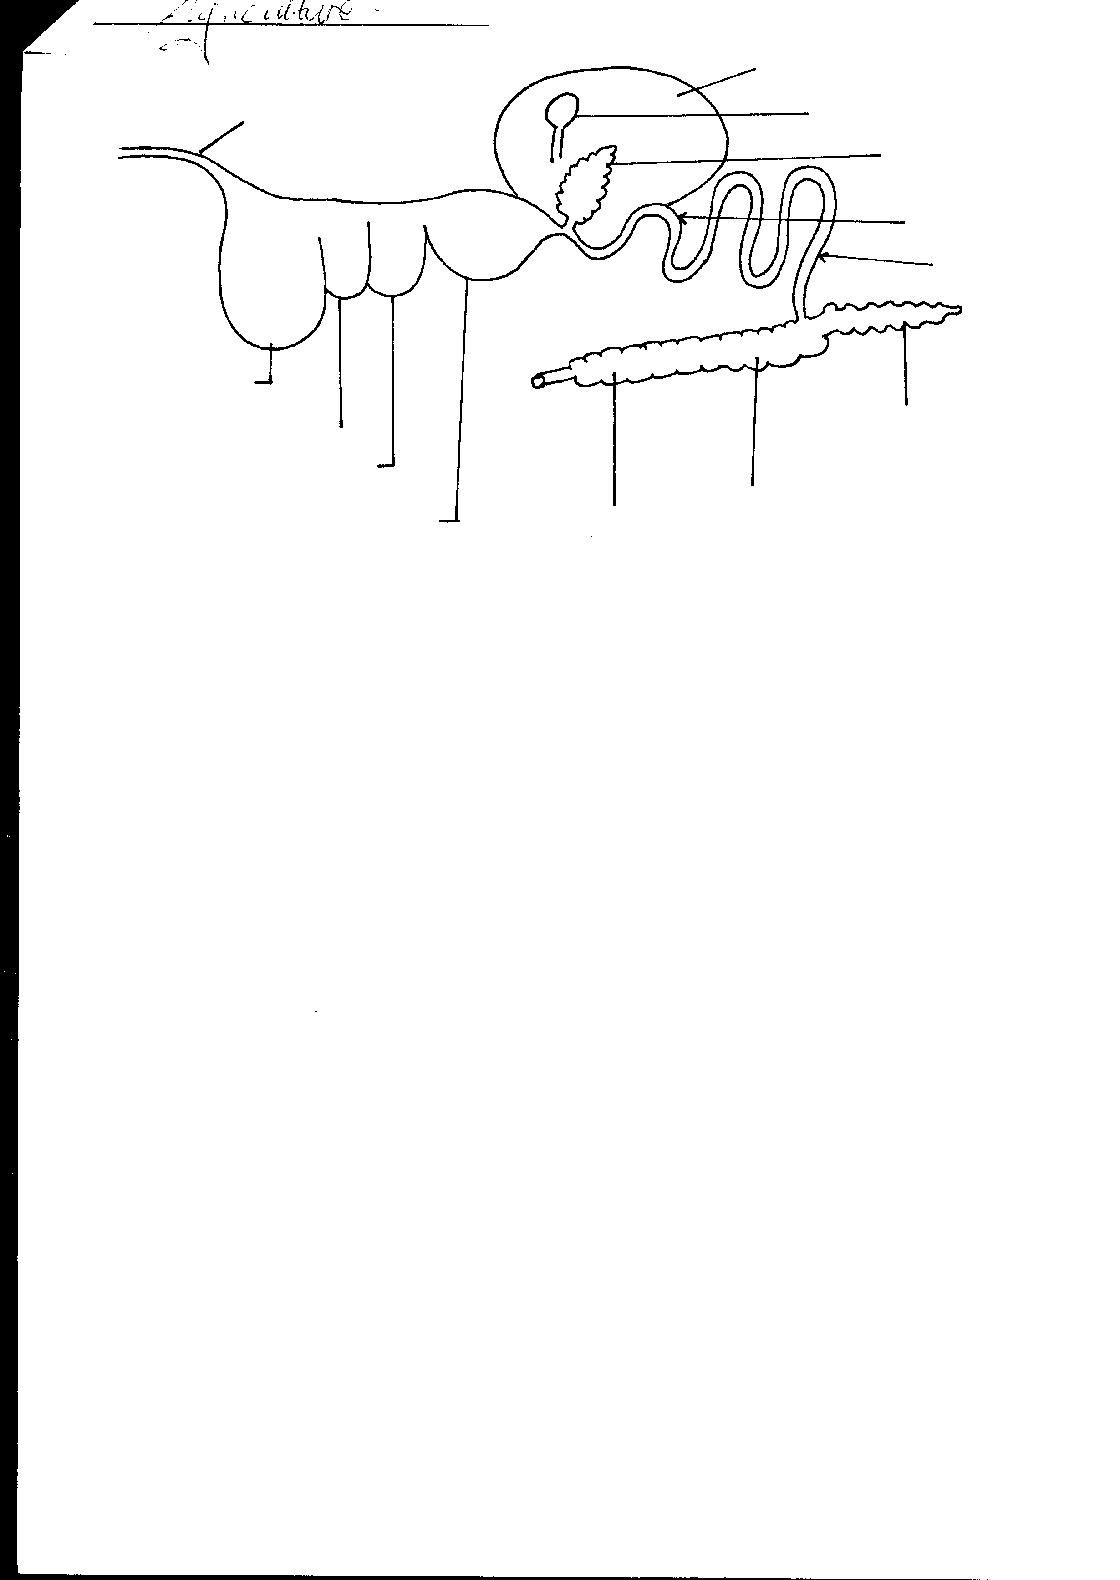
Labelled
Correctly drawn diagram ( 4mks)
Mouth
Rectum
Anus
Rumen
Abomasum

Reticulum
Omasum
Gall bladder
Duodenum
Ileum
Pancrease
Colon
Caecum
Oesophagus

- Ruminants are animals which chew cud
- They have a stomach which is divided into four chambers namely rumen, reticulum, omasum and abomasum
- Their digestive system is mainly with vegetation
- Food is chewed in the mouth with teeth, mixed with saliva and swallowed to rumen through the oesophagus
- No enzymatic digestion takes place in the mouth since ruminants lack ptyalin in their saliva
- The rumen acts as a temporary store for food before regurgitation to the mouth for further chewing
- Digestion in rumen is microbial i.e. acted on by micro- organisms such as bacteria after fermentation
- Microbial activity results in synthesis of vitamin B complex, vitamin B2, vitamin B6 and vitamin K. It also causes synthesis of amino acids, breakdown of proteins to peptides, amino acids and ammonia. Breakdown of carbohydrates and cellulose leads to production of carbon dioxide and hydrogen released through belching
- Reticulum receives food from the mouth after regurgitation where food is sieved and separated into fine material from course materials
- Reticulum also retains foreign and indigestible materials such as polythene papers, wires and pieces of strings eaten with food accidentally
- Omasum (the book) receives food from reticulum and absorbs water, grinds and sieves food particles by means of its folds
- Abomasum (true stomach) is concerned with digestion of proteins
- Final digestion of proteins takes place in the small intestines
- Absorption of water also takes place in the colon

b) i) Presence of micro- organisms in the digestive system of ruminants assists in the
breakdown of tough plant materials such as cellulose and lignin
- The four stomach chambers provides a large surface area for digestion and absorption of food in ruminants unlike the short digestive system of non-ruminants

22. a) i) Human power
- provided by human beings who is healthy, fully grown and well fed
- Man provides between 0.07 Kw to 1.0 kw
- Human power can be used to perform various tasks in the farm
- Animal power
- Provided by animals such as donkeys’ oxen, camels
- Provide power mainly for cultivation and transportation
- Work output is higher than human power and can work in various places
- Wind power
- Wind can be used to perform light jobs like winnowing of crops
- It is also used to pump water using the wind mill
- Wind power is rarely used in farms due to its unreliability in terms of strength, direction and availability
- Water power
- Running water can provide energy for the generation of HEP, driving, grinding milk and hydraulic pumps for pumping water
- Its use is limited due to unreliability of water, cost of harnessing the power and accessibility to moving water
- Biomass
- This is energy produced from biogas and wood or charcoal, coffee husks or sawdust
- Trees provide firewood and charcoal which on combustion produces energy for heating and cooking
- Biogas is produced when organic wastes such as animal dung are fermented in a digester to produce methane gas which is flammable
- Solar energy
- Employs radiant energy from the sun
- Heat of the sun is used to dry most crops before storage or processing
- Solar energy can be stored by using photovoltaic dense or module that produces electricity directly from the sun
- Electric power
- It’s obtained from geothermal power station, hydropower station and nuclear station or a storage battery
- Electric power is used for lighting and driving several machines
- Fossil fuel
- Includes fossil fuels such as petroleum oils, cola and natural gases
- Petroleum oils are refined to produce kerosene, petrol, diesel e.t.c. used to provide light and/ or drive machines
- Coal can be used in running industrial plants

b) Maintenance production on named farm implement
- oiling movable parts
- Replacing and repairing worn out parts
- Cleaning and proper storage after use
- Painting to prevent rust
- Sharpening cutting edges
- Tightening loose bolts and nuts

SAMPLE PAPER 8
AGRICULTURE PAPER 2
443/2
SECTION A ( 30 MARKS)

Answer ALL questions in this section in the spaces provided

1. State the use of each of the following tools in bee production. 2mks
- Swam net
b) Catcher box
2. List TWO dairy goat breeds. 2mks
3. a) State one chemical used in relieving a ruminant animal of bloat. 1mk
b) State Two reasons why drenching alone is not an effective method of controlling internal parasites in livestock 2mks
4. a) State the class of each of the following feedstuffs. 2mks
- Molasses
- Mac lick
- Name the type of breeding system represented below 1mk
Ayrshire sire x Boran Dam F₁ heifer x Hereford
5. Give the importance of flushing in sheep management. 2mks
6. a) Name the causative organism of the Gumboro disease. 1mk
b) State two symptoms of coccidiosis infection in poultry. 2mks
7. State two differences between the dromedary and bactrian breeds of camels. 2mks
8. State one way by which each of the following practices help in disease control. 2mks
a) Proper feeding
b) Proper housing
9. a) State one effect of tse tse fly infestation on livestock. 1mk
b) State one way of controlling tse tse flies 1mk
- Give one reason why tsetse fly control is considered as land reclamation method.
1mk
10. State two ways in which a production ration may be utilized by cattle. 2mks
11. Name two diseases in cattle that may be spread through breeding. 2mks
12. a) Under what conditions would a farmer prefer to use an ox-cart instead of a tractor – drawn trailer. 2mks
b) Name Two implements that may be connected to power take over shaft of a tractor.
2mks

SECTION B ( 20 MARKS)
Answer all the questions in this section in the spaces provided.
13. Below is a layout of an animal housing study it and answer the questions that follow.
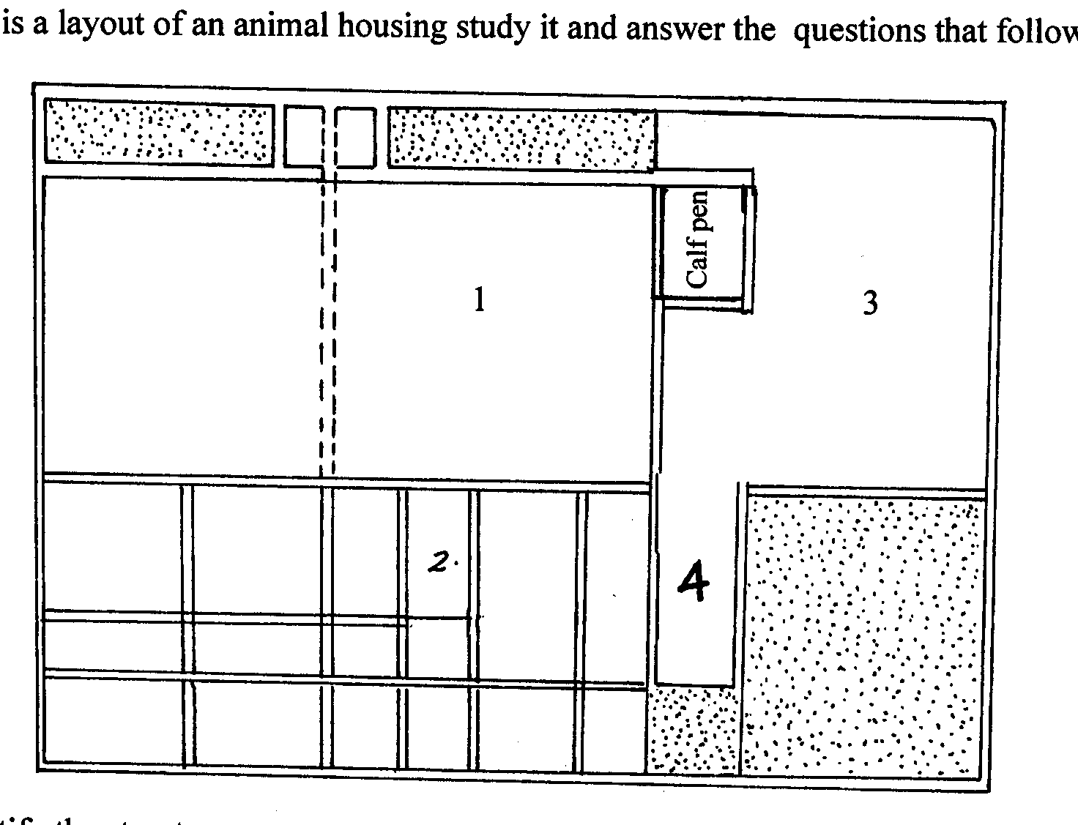

i) Identify the structure 1mk
(ii) Name the parts labeled 2,3,4. 3mks
(iii) What is the role of the part labeled 3. 1mk
14. Study the diagram of an egg below and answer the questions that follow.
A
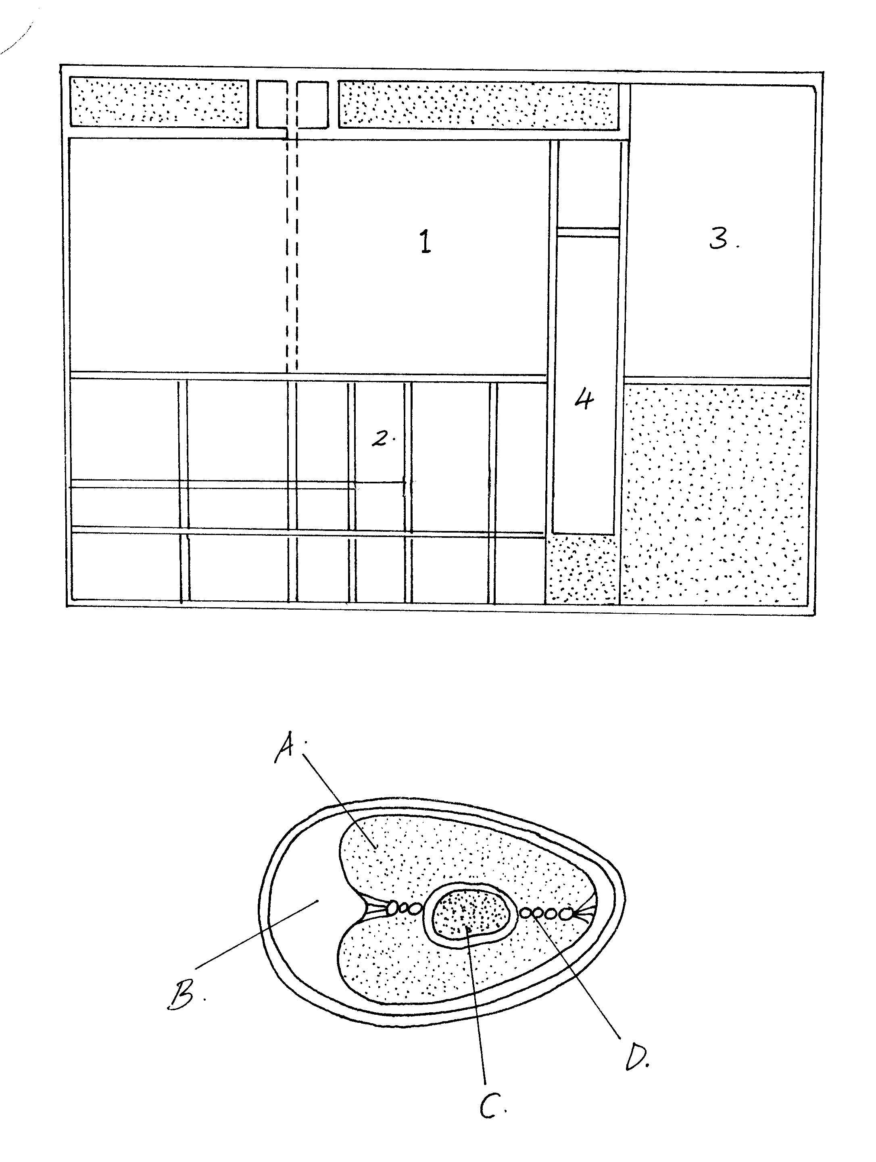
D
C
B

- Name the parts labeled A,B C and D. 4mks
- State the roles of parts labeled A and D during incubation. 2mks
15. Drawn below is a diagram of a fishpond.
X
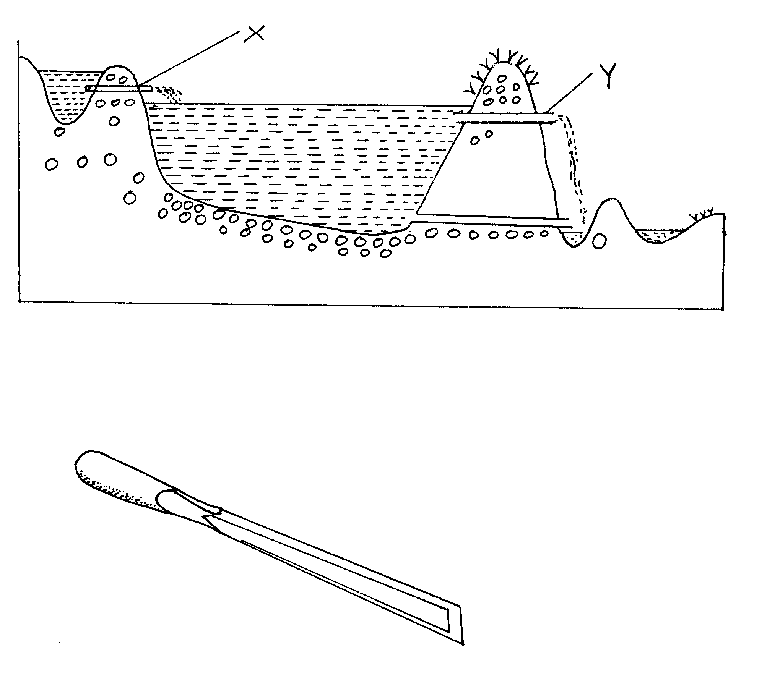
Y
a) Name the parts labeled X and Y. 2mks
b) State three management practices carried on a fish pond. 3mks
16. Below is a diagram of a farm tool.
a) Identify the tool 1mk
b) State the use of the tool. 1mk
c) List two maintenance practices carried out on the equipment. 2mks

SECTION C 40 MKS
ANSWER ANY TWO QUESTIONS
17. a) Discuss the essentials of clean milk production. 14mks
b) Name the common poultry vices and outline their control. 6mks
18. a) State six advantages of farm mechanization. 6mks
b) Discuss the management practices carried out on a tractor. 10mks
c) List the four strokes in a 4 – stroke cycle engine. 4mks
19. Explain the measures used to control
a) Livestock diseases 14mks
b) Livestock parasites. 6mks

MARKING SCHEME
SAMPLE PAPER 8
443/2
1. a) Catching/trapping of swarm of bees from up a tree, pole e.t.c.
b) Small hive for attracting bees
2. - Saaren
- Toggenburg
- British Alpire
- Anglo Nubian
- Jamnapari
3. a) - Epson Salt
- Methyl silicon
- Mixture of turbentine and vegetable oil
b) - Drenching does not destroy intermediate host
  - Drenching does not destroy parasite in pasture, water forage e.t.c
  - Drenching does not destroy some / other stages of parasites
4. a) molasses – Energy concentrate Rej. Concentrate alone
(ii) Maclick – supplement
b) Upgrading/ grading up
5. Increase conception rate due to higher rate of ovulation
- Facilitates implantation of the Zygot
- Increases the chances of multiple births
6 a) Birna virus
b) - diarrhoea
- Dysentry /blood in faeces
- Emaciation
- Ruffled feathers
- dullness with drooping wings
- sudden death

7.
Dromedary | Bactrian
- single humped  - larger  - less hairy | Double humped  Smaller  More hairy
8. a. Prevents deficiency diseases
- imparts resistance to diseases
- Prevents draughts/ colds wind
Prevents dampress due to proper drainage and ease of cleaning
9 a) Transmit disease trypanosomiasis
- Sucks large quantities of blood/ causes anaemia
- Damage skin and hides
-causes wounds which are routes for secondary infection
- causes irritation to livestock
- - Bush clearing / destroy breeding places
  - spray with chemicals
  - Sterilising
  - Use fly traps
- Human settlement made possible
Livestock rearing is made possible
10. - For production of products e.g. milk, meat
- for reproduction i.e. foetal development
- for growth in young animals
- for work
11. - Brucellosis /contagious abortion/ bang’s diseases
- Trichinomiasis
- Virginitis
12. a) If a farmer has little capital
- If the land is very steep
- If the farmer has a little load to carry
- Mower
Planters
Retavators
Sprayers
Fertilisers Spreaders

SECTION B
13 (1) Zero grazing unit
(ii) 2 – Cubicle
3 – Place for chaff cutter/feed preparation area /fodder chopping area
4 – milking palour
- Cutting livestock feeds
14. a) A – Albumen
B – Air space
C - Yolk
D - Chalaza
b) A – is a food reserve to the developing chicks
D - Hold yolk on both ends allowing yolk to move germinal disc always to the top. This encourages
heat transfer to the developing embryo
15 a) X - inlet pipe
Y - Spillway
b) - Repairing of the dykes
- cleaning/removing foreign materials
- planting grass on banks
- cutting/clearing vegetation surrounding the pond
- removing silt
16. a) Wood chisel
b) Making holes on wood
c) - Store well after use /in a tool rack
- sharpen the cutting blade
- Coat the blade with oil to prevent rusting
- Repair/replace the handle when damaged

SECTION C 40 MARKS
17. a) Essential of clean milk production
(i) Healthy milking head
- Test animals (annual), for milk borne disease e.g. brucellosis
- Separate the sick and treat
- Carry mastitis test using strip cup
(ii) Clean milking cows
  - Before milking the following parts be washed thoroughly: flanks, underline and whole udder
  - Dry the udder using a clean towel
  - Long hair on the udder and flanks be clipped regularly
- Healthy and clean milkman
  - Milkman should not conduct duties when affected by contagious disease
  - Be physically clean/ wear white overalls when handling milk
  - Fingernails be kept short and the hair covered.

(iv) Clean milking shed
  - Milking shed/parlour be kept clear free from dust or odours
  - Cleaning be done after every milking
  - Should be built on a well drained area
  - Construction should allow for easy cleaning
(v) clean milking utensils
  - Milking utensils should be washed with hot water/detergent and rinsed after milking
  - They should be sterilized by drying in the sun
  - The equipments should be seemless, smooth and joint well filled to facilitate easy and through cleaning
(vi) Milk filtration cooling and storage
  - after milking, milk be filtered
  - and cooled immediately to 5 C( to slow bacteria multiplication)
  - then be stored in a cool dry and dust free room
- Avoid flavours in milk
  - Feeds that cause flavous e.g. some silage should not be fed to livestock before or during milking
  - Protects milk from sunlight to reduce oxidation
  - Use utensils that are free from traces of copper and iron or the surface

- Cannibalism
Control
  - Avoid bright light in the brooder
  - Avoid overcrowding / give enough space
  - Supply balanced diet
  - Kept birds according to age groups
  - Control external parasites
  - Keep birds busy by hanging green leaves
  - Debeak hens which peek at others
  - Cull perpetual cannibals
Egg Eating
Control
  - Collect eggs regularly
  - Make nests dark
  - feed balanced diet
  - debeak perpetual eaters of eggs
  - supply green leaves
18. a) More work done in a short time
    - Faster operations
    - Efficient operations/ process quality work
    - Economises on labour where labour costs are high
    - Increases production by benefiting from economies of large scale production
    - Makes the work easier and enjoyable
b) - Check for fuel in the tank / add if necessary
- Check oil level and state /adjust if necessary
- Check tyre pressure and adjust accordingly
- Tighten wheel axles
- Check for water in the radiator / add if necessary
- Keep under shed when not in operation
- Lubricate/ grease moving parts
- Replace /repair worn out part
- Clear of trash/soil after use
c) - Induction stroke
- Compression stroke
- Power stroke
- Exhaust stroke
19. a) - Isolation of sick animals to avoid spread of disease
- General farm hygiene – to destroy pathogens
- Drenching / deworming to control internal parasites
- Treatment of sick animals to prevent spread of disease
- Vaccination to create resistance against diseases
- Control of vectors – to avoid transmission
- Proper feeding to prevent nutritional disorder and impart resistance
- Culling – to prevent spread of contagious) disease
- Proper breeding to control breeding diseases
- Observe quarantine – to prevent spread of infectious diseases
- Proper housing to avoid predisposing factors
- Fencing – prevents mixing of animals that may spread diseases

- - Regular Drenching / deworming/ prophylactic drugs
  - Draining of swampy area to destroy breeding sites or intermediate root/snails
  - Fencing to keep away other animals
  - Proper sanitation in livestock housing
  - Burning pastures to destroy eggs
  - Ploughing pastures to burry eggs
  - Spray breeding places
  - Spray / dip livestock against external parasites
  - In rotationa grazing young animals graze a head of order animal any 6 @ 1mk = 6mks

SAMPLE PAPER 9
AGRICULTURE PAPER 2
443/2

SECTION A ( 30 MARKS)
Answer ALL questions in the spaces provided.
1. Name the intermediate host for the following parasites.
i)Tape-worm
- Liver fluke 2mks
2. State two factors one would consider when choosing feedstuff for preparing a livestock
ration 2mks
3. State how the quality of hides may be lowered during each of the following stages4mks
- Rearing period
- Flaying
- Curing
- Storage
4. Differentiate between tactical and strategic treatment. 1mk
5. State three harmful effects of ticks to livestock. 3mks
6. Why is it necessary to supplement domestic poultry diet with grit. 1mk
7. Define the following terms:-
- Dry matter 1mk
- Starch Equivalent. 1mk
8. List two factors that affect the digestibility of roughages in livestock. 2mks
9. State two disadvantages of early debeaking 2mks
10. List two advantages of strip grazing. 2mks
11. Mention two factors that determine the quality of hay. 2mks
12. Name the casual organism of Black quarter in livestock. 1mk
13. List two symptoms of bloat attack in cattle. 2mks
14. State the functions of each of the following parts of a tractor engine.
i) Carburettor
ii) Spark plugs
iii) Lift pump
iv) Ignition coil 4mks
SECTION B ( 20 MARKS)

Answer ALL the questions in this section in the spaces provided
15. Fig. 2 shows a series of cylinders of a four stroke cycle engine of international 574 tractor. The firing order in the cylinders is 1-3-4-2 in this tractor model. Look at the positions of the pistons.
(i) Indicate by drawing the positions of the valves in each cylinder (A=inlet valve
and B=exhaust valve). 2mks
(ii) Fill in the blanks the stroke on for each cylinder. 2mks
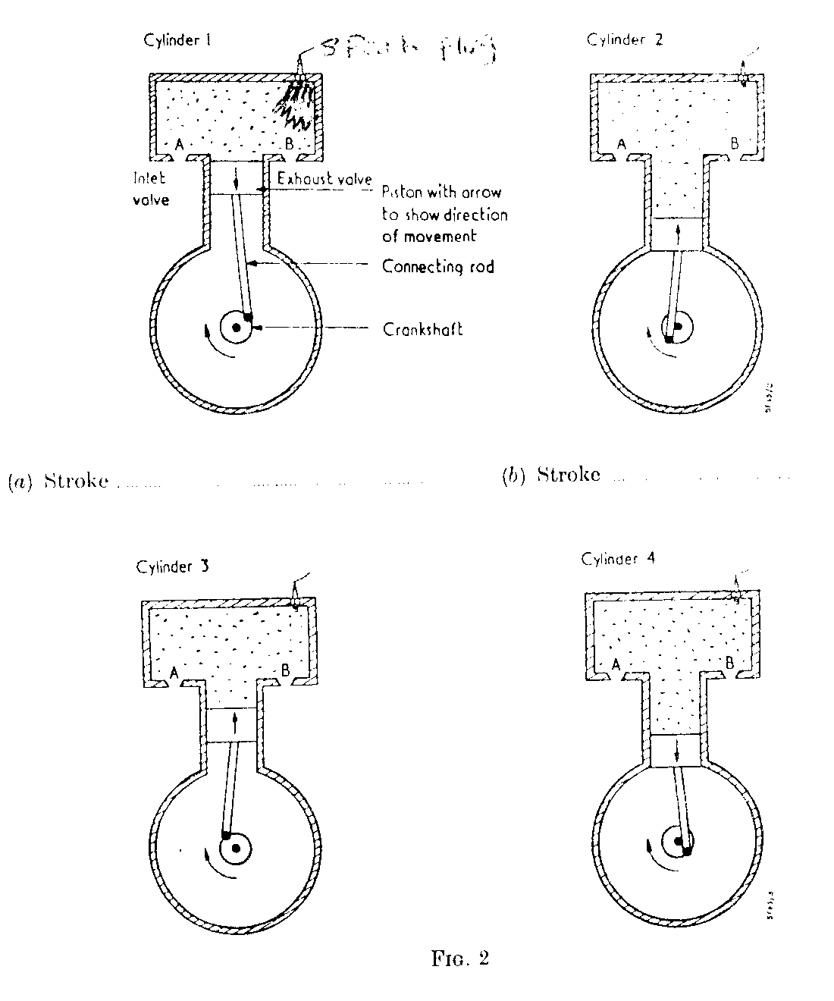
Spark plug
Cylinder 2
Cylinder 1
(a) Stroke …………………………………. (b) Stroke ………………………………
Inlet valve
Crankshaft
Connecting rod
Exhaust valve
Piston with arrow to show direction of movement
Cylinder 4
Cylinder 3

(a) Stroke …………………………………. (b) Stroke ………………………………

16. Diagrams A and B below illustrate livestock production tools
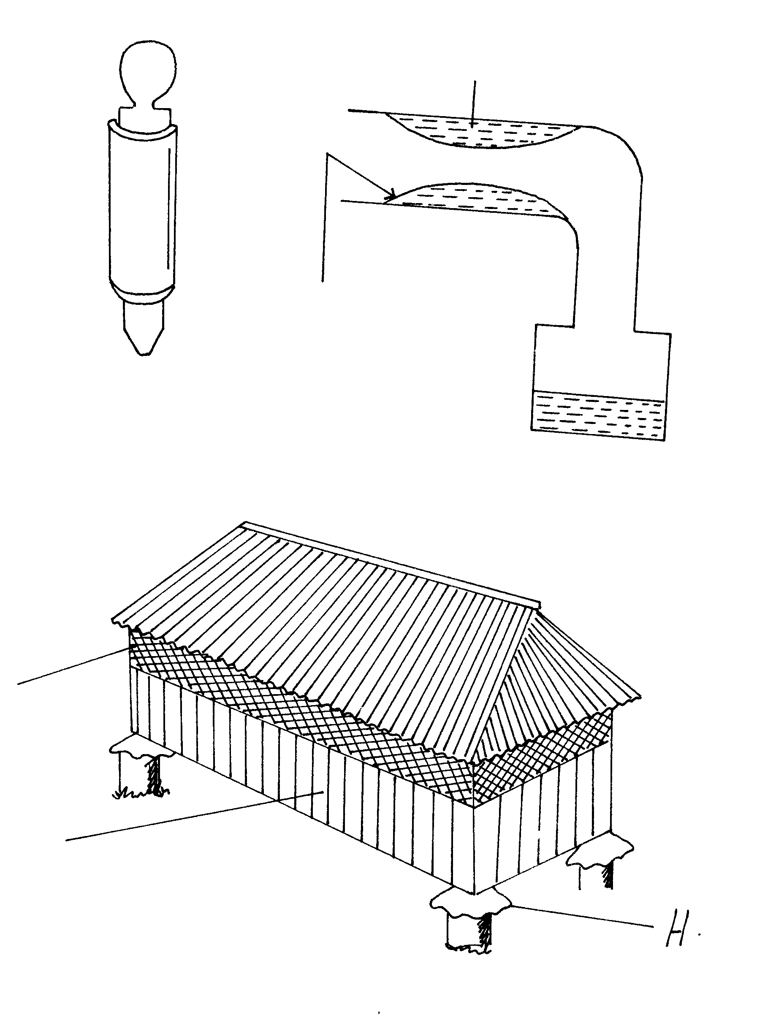
B
A
Rubber casing
Warm water
a) State one function of each tool 2mks
b) State three advantages derived from the use of tool B. 3mks
17. The diagram below represents a structure of a modern grain store. Study it and answer the questions that follow.
H
Wall made
of timber
Wire mesh
a) State the advantage of the store fitted with wire mesh. 1mk
b) Name the parts labeled H. 1mk
c) State two maintenance practices that should be carried out on the store before a crop 2mks
18. The diagram labeled K,L,M and N below show four possible ways of drawing milk from
the teat of a cow during milking.
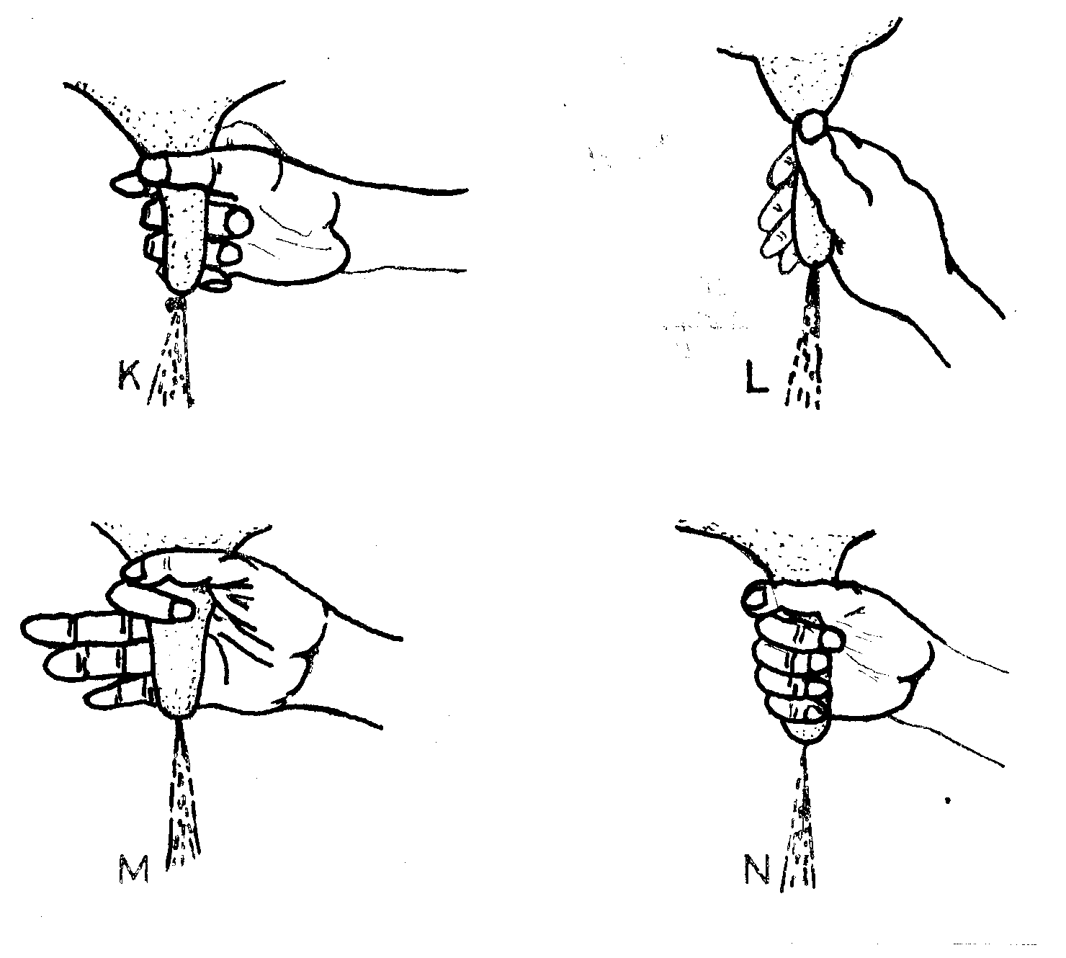
a) Which diagram shows the proper way of drawing milk. 1mk
b) How long should it take to milk a cow from the start to the end of milking. 1mk
c) How would a milkman ensure no milk remains in the udder at the end of milk. 1mk
d) Give any one practice carried out on milk immediately after milking. 1mk
19. The diagram below shows a reproductive system of a hen. Study it and answer the questions that follow.
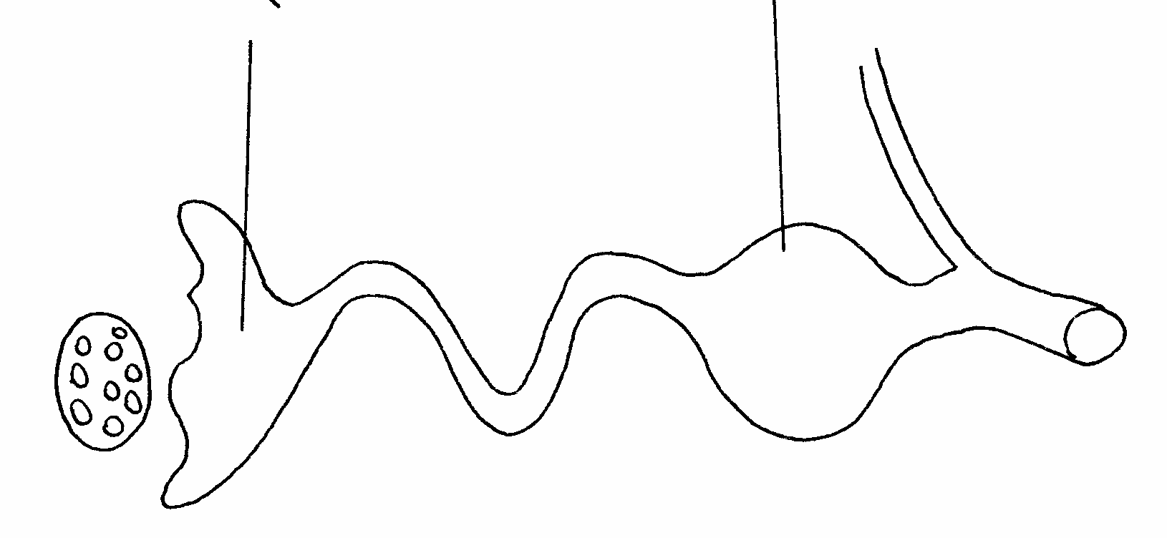
B
A
a) State one component added to the egg during formation at regions A and B. 2mks
b) What happens if blood spot drops at the part labeled A. 1mk
SECTION C (40 MARKS)
Answer any two Questions from this section in the blank spaces provided
20. Describe the management of layers in a deep litter system from the point of lay. 20mks
21. a) Explain the checks and procedures you should perform before taking the tractor to the field. 10mks
b) Outline the conditions for which you would advise.
(i) Ploughing by oxen 5mks
(ii) Ploughing by tractor. 5mks
22. a) Describe the procedure for constructing a secure barbed wire fence. 10mks
b) Explain the uses of fences on the farm. 10mks

MARKING SCHEME
SAMPLE PAPER 9
443/ 2
AGRICULTURE
1. i) Pigs / cattle
ii) Water snails
2. i) Availability of the feed
ii) Cost
- Nutrient composition
- Type of livestock
- Age of the animal
3. i) Poor branding/ parasites / body injury / diseases
ii) Cut’s made carelessly
iii) Contamination during handling / bacterial attack
iv) Rodents / fungal attack
4. Strategic treatment refers to periodic regular treatment administered to livestock mainly to avoid contamination and infection during the period of risk while Tactical treatment refers to treatment given to the susceptible group to avoid outbreak (1mk)
5. i) Cause or transmit diseases to livestock
ii) Cause anaemic condtions in livestock
- Cause irritation through bites
- Lower the quality and value of the hides.
- Their bites cause wounds which act as entry points for the pathogens

6. Grit helps in grinding food(Physical digestion
7. i) This is the actual percentage of protein, carbohydrates and minerals in a feed.
ii) This is the energy value of a feed that is equivalent to the net energy value of a certain amount of pure starch.
8. i) The chemical composition of the feed
ii) The form in which the feed is offered to the animal e.g crushed maize is more digestible than whole maize.
- The species of the animal- e.g. sheep is able to digest grass better than pigs
- The quantity of feed already present in the digestive system of the animal
- The ration of energy to proteins will affect digestibility
9. i) Chicks will lose weight
ii) Growth rate is reduced for a period after debeaking
- Sexual maturity is delayed
- The beak will regenerate
10. i) Minimises bloat attack
ii) The pasture is utilized more efficiently
- Cheaper than constructing paddocks
- Livestock give more production per unit area.
11. i) The species / type of forage used
ii) Degree of damage during handling and curing
- The speed / time within which hay is made
- Stage of growth at which the fodder is cut
- Method and efficiency of storage
12. Clostridium chauvei.
13. i) Distended belly especially the left side
ii) Constipation
- Immobility
- Digestive complications
14. i) Carburreter :- Mixes air and petrol and supplies the mixture to the inlet manifold
ii) Spark plugs:- Provides sparks and introduces it into the combustion chamber
iii) Lift pump;- Maintains constant supply of fuels in the carburreter

- Ignition coil- Stepping up low battery voltage to high voltage

SECTION B
15. CYLINDER 1 CYLINDER 2 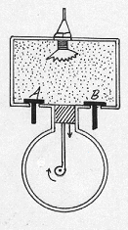 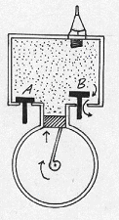
a) stroke 3 /POWER b) stroke 4 / EXHAUST
CYLINDER 3 CYLINDER 4

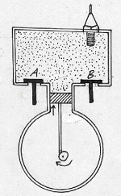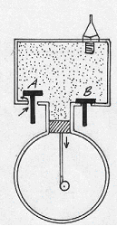

c) stroke 2 / COMPRESSION d) Stroke 1/INDUCTION/ INLET
a) If drawing are correct ½ x 4 – 2mks
b) 2 mrks (Mark as a whole if the sequence is correct)
16. a) A- for controlling bloat by piercing the left side of the rumen
B- for collecting semen from a teaser bull for artificial insemination
b) i) Enhances easy transfer of semens to remote areas
ii) Control breeding diseases e.g. brucellosis
iii) To avoid injury to small dams by large bulls
iv) Semen of one superior bull can be used to serve many cows
v) Reduces expenses of keeping the bull
vi) Semen can be stored for a long time
vii) Easy to control breeding
- Eliminate dangerous bulls on the farm
17. a) Allow proper ventilation
b) Rat guards / baffer
c) i) It should be cleaned
ii) Repair any broken parts
iii) Dust/spray with recommended insecticide
18. a) N
b) 5-8 minutes
c) Stripping each teat
d) i) Weighing the milk
ii) Recording the quantity of the milk
iii) Straining the milk
iv) Store the milk in a cool place
19.a) i) A- Chalazae are added to the yolk
ii) B – Shell is added around the egg
b) The blood spot will be added to the egg contents during egg formation
Management of layers from the point of lay
20 .i) Ensure enough space in the house
ii) The space should be between 0.3 – 0.5m² per bird
- The litter should be kept dry by regularly raking
- Provide enough perches which should be well spaced in the house
- Provide adequate waterers / feeders and well- distributed
- Provide clean and adequate water.
- Keep waterers and all equipment clean
- Replace soft litter in the nest to prevent egg eating
- Ensure the nest is dark enough to avoid cannibalism
- Collect eggs at least twice a day
- Provide adequate layer marsh
- Supply some grit to help in digestion
- Ensure adequate supply of greens for vitamins
- Hang the greens to help them exercise
- Cull poor layers or diseased birds
- Debeak birds to prevent cannibalism and egg- eating
- Vaccinate against prevailing diseases
- Check birds for disease symptom
- Check for pests occurrence and apply appropriate pesticides
- Avoid stress factors like noise
- Discourage broodiness among layers
- Provide grains on the litter to avoid cannibalism
- Isolate and treat sick birds
- Dispose farm records
- Maintain concentration of footbath
21. a) 1. Check the level of oil in the sump using a dipstick
2. Check to see whether the fuel tank contain enough fuel. If not enough, clean fuel should be added .
3. Check the level of the electrolyte in the battery. If it is below the required level distilled water should be added
4. Moving parts should be greased by forcing grease through nipples using a grease gun
5. Check the tension and condition of the fan belt. Loose fan belts should be tightened
6. Check the level of water in the radiator/ add water to the radiator when necessary
7. Check air filters / cleaners for excessive dust and carry out recommend practices
8. Check tyre pressure / inflate tyres to recommend tyre pressure
9. Tighten loose bolts / nuts / pins
10. While working under dusty conditions sediment bowls get clogged with dust. It is advisable to open them and remove the dirt before running the tractor.
11. Ensure the brake fluid level is maintained at the recommend level
21.a) i) Ploughning by oxen
1. When the farmer has little capital / not enough capital to use services of a tractor
2. When the land is very steep for the tractor
3. When the size of the land is too small for a tractor
4. When the farmer has no skills/ little skills to operate a tractor.
5. When the profit margin of the crop is low
6. When ploughing soft soil
b) Ploughing by tractor
i) When the farmer has enough capital
ii) When the size of the land is large
- When the farmer have enough skills/ skilled labour to operate and maintain the tractor
- Where land is fairly flat
- When ploughing hard soils / dry soil / virgin land
- When the profit margin of the crop is high
22. a) i) Clear the fence line
ii) Align the fence line
- mark the position of posts
- Locate the corners of the area
- Dig holes 60-90cm deep
- Fix corners posts
- Put fencing posts in holes
- Fill holes and ram / reinforce with concrete
- Mound soil around post
- Nail wires onto the post/ pass wires through drilled holes in posts
- Brace all corner posts / put strut / tie wires
- Tighten / strain the wire
- Treat posts with appropriate chemicals
- Fix droppers
b)i) Marking the boundary
ii) Privacy
- Provide security
- Facilitate rotations grazing / night paddocking
- Live fence serve as windbreaks
- Used in mixed farming to protect crops from animal damage
- Control spread of parasites and diseases
- To beautify the farm / Aesthetic purpose
- Provide firewood
- Provide forage / mulching / fruits
- Control soil erosion
- It adds value to the farm

SAMPLE PAPER 10
AGRICULTURE PAPER 2
443/2

SECTION A ( 30 MARKS)
Answer ALL the questions in this section in the spaces provided.
1. State four safety measures which could be taken when using workshop tools in order to prevent injury. (2mks)
2. After restraining a cow and supplying it with feed, outline the procedure to be followed in preparing a cow before milking. (2mks)
3. State four functions of vitamins in livestock. (2mks)
4. State four signs of kidding in Nannies. (2mks)
5. State four signs of broodiness in poultry. (2mks)
6. Differentiate between milklet down and milk secretion in dairy cattle management. (1mk)
7. State four uses of solar energy in the farm. (2mks)
8. Give four characteristics of dairy cattle (2mks)
9. State four functions of minerals in an animals body. (2mks)
10. State four factors that influence the choice of tools for cultivation. (2mks)
11. Give the four strokes of a four stroke cycle engine. (2mks)
12. State four qualities of a good feed store. (2mks)
13. List four characters of a good creep feed. (2mks)
14. Give four effects of livestock disease in agriculture production (2mks)
15. Give two limitations of coal as a source of farm power. (1mk)
16. List four precautions that should be followed when handling bees. (2mks)

SECTION B ( 20 MARKS)
Answer ALL questions in this section in the spaces provided
17. Below is an illustration of a farm implement.
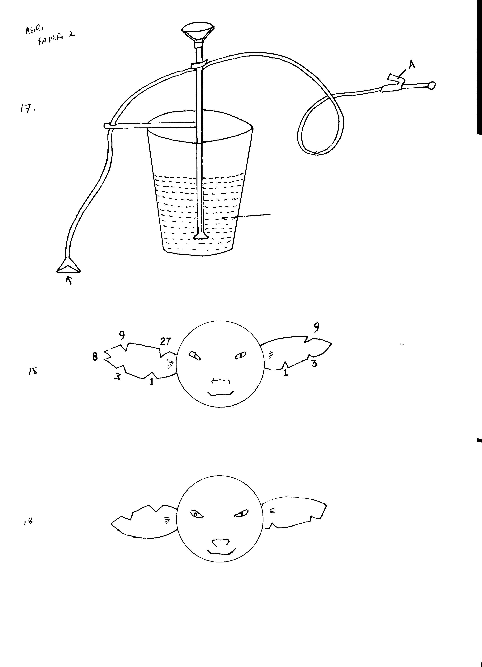
B
C

Identify the above implement…………………………………………………….... (½ mk)
Name the parts labelled ( 1 ½ mks)
A ………………………………………………………
B ………………………………………………………
C ………………………………………………………
Give three maintenance practices for the above implement. (3mks)
- …………………………………………………………………………………………………………………………………………………………………………………………
- …………………………………………………………………………………………………………………………………………………………………………………………
- …………………………………………………………………………………………………………………………………………………………………………………………

18. Study the diagram below and answer the questions that follow. The number on the right ear represents the litter number while the left ear number represents the individual number.
Name the livestock routine practice shown above. (1mk)
State three reasons why farmers carry out the livestock routine practice shown in the diagram above. (3mks)
Study the diagram below and then an interpretation of the individual number and litter number of the piglet.
19. a) Differentiate artificial insemination from embryo transplant. (2mks)
b) Give two advantage of embryo transplant. (2mks)
c) Give one disadvantages of embryo transplant. (1mk)
20. Below is a diagram showing a cross-section of a house and a brooder set up for brooding chicks.
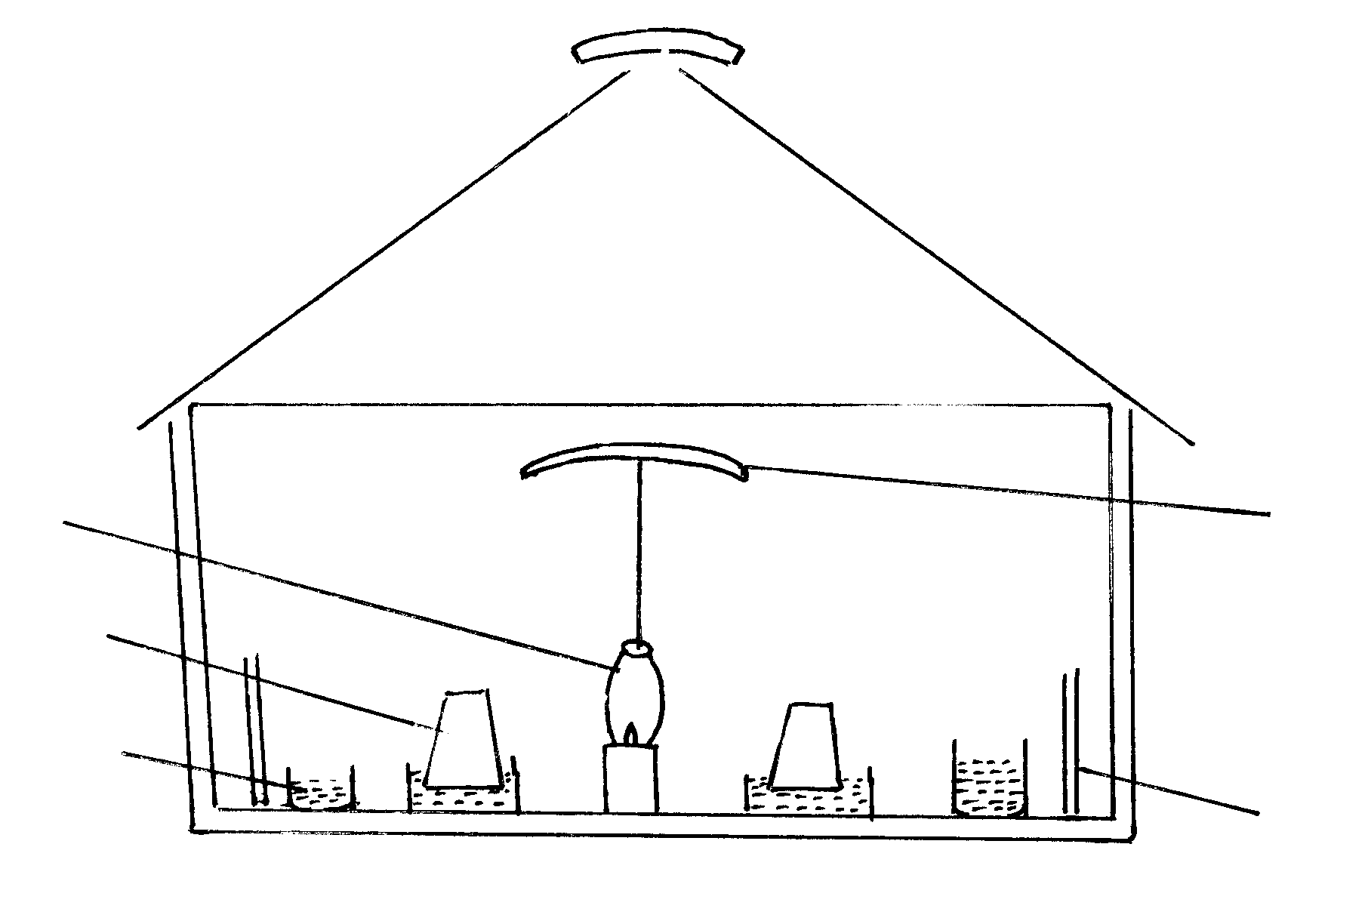
Lantern

Drinker

Feeder
Reflector

M
- What is the purpose of the part marked M ……………………………………… (1mk)
Name any material that would be suitable for use as a litter in the brooder. (1mk)
State two observations that would be made on the behaviour of chicks to determine when the temperature in the brooder is too high for chicks. (2mks)
State one way in which the temperature in the brooder may be raised. (1mk)
SECTION C ( 40 MARKS)
Answer any TWO questions from this section on the spaces provided at
the end of the section

20. Describe the management practices that should be carried out to raise beef cattle using natural rearing method starting from calving to market stage of steer. (20mks)
21. a) Describe the difference between diesel and petrol engines. (10mks)
b) Explain the factors one would consider to ensure fast and effective cultivation by oxen. (10mks)
22. Discuss bloat disease under the following sub-headings.
a) Species of the animals affected by the disease. (3mks)
b) Causes of the disease. (4mks)
c) Symptoms of the disease. (6mks)
d) Control measures of the disease (2mks)
e) Treatment of the disease. (5 mks)

MARKING SCHEME
SAMPLE PAPER 10
443/2

SECTION A(30MKS)

1.- Use each tool for the correct job
- Work with well maintained /repaired tools
- Handle the tools correctly /take care when using the tools
- Have enough working space
- Put on protective clothes
- Avoid slippery floors
- Keep tools in a tool box /rack

2. - Wash / clean the udder with warm water
- Dry the udder with a clean towel /cloth
- Test for mastitis

3. - Promote growth
- Help in blood clotting
- Help in bone formation
- Help in muscular activities
- Prevent diseases in livestock
- Acts as organic catalysts

4. - Udder becomes firm and teats enlarge
- The muscles at either sides of the tail slacken
- Restlessness
- Separating itself from the rest of the flock
- Clear discharge from the vulva

5. - Making an incubation nest
- Plucks off her feathers to line up the nest
- Aggressiveness
- Continuous stay in the nest especially overnight
- The hen stops laying eggs

6. Milk secretion is the synthesis / manufacture of milk while milk let down is the flow of milk from
the upper regions of the udder (alveolar region ) to the lower region of the udder (gland asten & teat cistern)

- Drying farm produce
  - Heating water
  - Distillation of clean drinking water
  - Cooking
  - For generating electricity

- - Lean body
  - Wedge / Triangular shape
  - Large stomach
  - Straight top line
  - Well set hind quarters
  - Docile
  - Large well developed udder & teats
  - Large milk wells

- - Constituents of bones and teeth
  - Constituents of body fluids
  - Used in formation of products e.g milk
  - Components of vitamins & hormones
  - Maintenance of correct acid – base balance
  - Constituents of certain enzymes

- - Initial condition of the land
  - Topography
  - Obstacles in the land
  - Soil type and condition
  - Perennial weeds present
  - Source of power
  - Skill of the operator
  - Capital available
  - Availability of tools
  - Crop type

- - Intake stroke
  - Compression stroke
  - Power stroke
  - Exhaust stroke

- - Spacious
  - Easy to clean
  - Damp proof
  - Rodent free
  - Easy to load and offload
  - Proper ventilation

- - Highly digestible
  - High in energy content
  - High in digestible crude protein
  - High palatable
  - Rich in vitamins and minerals

- - High death / morality rate
  - Unproductively /Reduced yields
  - Reduced quality /market value
  - Infection to man
  - Higher cost of production
- - It has a low energy value
  - It is dirty and produce a lot of smoke and soot when burnt /cause air pollution
  - It is expensive to extract
  - It is bulky hence high transportation cost
- - Do not frighten the bees
  - Bee hive should not be approached from the front
  - Bees should not be crushed during handling
  - More quietly towards the bee hives
  - If stung, the bee keeper should not run or through the combs down
  - Scrap off a bee string with a nail or a razor blade
  - Always wear protective clothing

SECTION B 20 MARKS
- a) - Stir up pump / bucket pump
b) A- Strigger
B- Foot support
C- A caricide solution
c) - Replace worn out parts
- Grease the moving part
- Check and repair any leakages
- After spraying clean /flush the pump
- Proper storage after use

- a) - ear notching

b) – To facilitate culling
- To ease record keeping
- To ease feeding
- To facilitate disease control and treatment
- To facilitate selection & breeding
c) Litter no.- Right ear 3 + 1 = 4
Individual no.- left ear 27 + 9 = 36

- a) - A.I is the introduction of semen into the female reproductive tract by hand using syringes
or tubes
- Embryo transplant is where ova (eggs) are harvested from a female animal (donor)
- Fertilized in test tubes and then embryo’s that develop are transplanted into foster mothers(recipient) OWTTE
b) - Improves performance / production
- Stimulates milk / production
- Highly productive female can benefit many farmers
- It is easier to transport embryo’s than the whole animal
- Embryo can be stored for a long time awaiting a recipient female
c) - The technology is expensive
- It requires trained personnel /skill
- Requires special equipments

- a) - Confirm the chicks around the source of heat
- Conserve / maintain heat within the brooder

b) - Saw dust /wood shavings / cereal husks/ dry chipped grass

c) - Chicks moving away from the source of heat
- Chicks drink water frequently
- Chicks make abnormal noise
- Chicks lying flat on their fellies
- Opening /spreading wings
- Opening of beaks / panting

d) - Raising the wick
- Adding another lantern in the brooder
- Lower the reflector
- Preventing draught /cold winds

SECTION C 40 MARKS

- - As soon as the calf is born, ensure that it is breathing
  - If the calf is not breathing, check for foreign bodies in the mouth, and nostrils and remove if any
  - Then induce breathing by applying artificial respiration
  - Cut and disinfect the umbilical cord to avoid infection
  - Ensure the calf is leaked dry by its mother wipe the calf dry
  - Ensure the calf suckles colostrums within 12 hours of birth
  - Leave the calf to stay with its mother to suck milk at will
  - Feed calf 2 – 3 times a day for the first four days
  - Wean calf at 6 – 8 months
  - Separate the weavers to graze on good quality pasture after weaning
  - Protect the calf against adverse weather conditions /proper housing
  - Provide adequate clean water from the third week
  - Spray the calf upto weaning time after which, they can be dipped to control external parasites
  - Drench / dewarm weaners regularly to control internal parasites
  - Dehorn the calf within four months
  - Castrate bull calf not intended for breeding within four months
  - Identify calf as early as possible
  - Separate uncastrated full from heifer at weaning time
  - Give mineral supplements where necessary
  - Give supplementary feedstuffs during dry periods
  - Vaccinate the calf against prevalent diseases
  - Treat sick animals
  - Cull defective animals
  - Keep proper records
  - Animals should be ready for market depending on the breed from 12 – 30 months

- a) Diesel engine Petrol engine
- Use diesel as fuel  - Does not have a carturator  - Fuel is ignited by compression  - Operates at a higher compression ratio(16:1)  - Has infectors  - Uses less fuel per unit distance  - Produces a lot of smoke  - Air and fuel first mikes in the cylinder before  ignition  - Air is taken in during induction stroke thus  the ratio of air; fuel is not constant  - Has sediment bowl  - Operation costs lower / low fuel consumption  - Relatively heiry in weight /suited for heavy duties | - Use of petrol as fuel  - Has a carburetor  - Fuel ignited by electric spark  - It operates at a lower compression ratio  - No infectors  - Uses more fuel per unit distance  - Produces less smoke  - Air and fuel first mixes in the carburator before igniting  - No extra addition of air or fuel during induction stroke thus the air : fuel ration is constant (15 : 1)  - Has no sediment bowl  - Operation costs are high / high fuel consumption  - Relatively light in weight / suited for light duties

b) - Use of properly trained animals
- Ensure proper feeding of oxen
- Ensure proper health of the oxen
- Ensure proper handling of the oxen / avoid overworking / feating
- Use skilled operator
- The draw bar should be adjusted properly
- Harmless oxen properly
- Replace worn out parts of the plough
- Adjust land wheel properly
- Ensure nuts and bolts are tight
- Use correct number of oxen
- Ensure the operators are motivated well fed
- Oxen / operators should be rested when tired

- Animals affected
a) - Cattle
- Sheep
- Goats
b) - Obstruction of the oesophagus due to bulky food particles such as potatoes, carrot, mangoes
- Abnormal pressure exterted on the oesophagus by swelling in the wall of the chest
- Indigestion – caused by an accumulation of gases due to paralysis of the rumen and the value at the entrance
- Feeding animals on feeds containing a lot of pasture legumes cabbage leaves and lush pasture

c) - Symptoms are
- Distension of the left side of the abdomen due to gas accumulation
- Difficulty in breathing
- Profuse salivation
- Animal lies down and is unable to rise up
- Grunting and kicking at the belly
- Death within hours due to pressure on blood vessels, heart and lungs

- Control
- Provide dry roughages just before feeding the animals on green and succulent
or wet pasture
- Feed animals on wilted grasses and pasture legumes

e) - Treatment measures
- Exercise the sick animal by walking it around & up-hill
- Use medicinal oils as defrothing agents such as liquid paraffin
- Epsom salt can be used to empty the stomach
- A stomach pump can be inserted into the rumen through the esophagus
- In extreme cases trocar and canula or sterilized sharp knife is used to
pierce through the skin of the rumen
- Methy / silicone injection

