AGRICULTURE PAPER 2
FORM 3
NAME ……………………………………………… ADM …………………………
CLASS …………………………..
SECTION A (30MKS) ANSWER ALL THE QUESTIONS.
- State two disadvantages of artificial incubation of eggs. (2mks)

- List four desirable of a good ewe for breeding should have. (2mks)

- What is progeny testing as used in the selection of livestock? (1mk)

- State two reasons for docking sheep. (1mk)

- Name any four dual purpose breeds of cattle. (2mks)

- Give 2 reasons for culling in cattle production (1mk)

- Give two types of ticks that attack livestock. (2mks)

- Give three causes of nutritional diseases. (3mks)

- State two characteristics of the bacteria in camel. (1mk)

- Name two types of dead fences. (1mk)

- A) Give three factors to be considered when siting poultry house. (1 ½ mks)

b) Define the term breeding. (1mk)

c) Name two brooding methods in poultry. (2mks)

- Define pre-disposing factors. (1mk)

B. State four pre-disposing factors of scours in calves. (2mks)

- Give four symptoms of internal parasites in livestock. (2mks)

- State two uses of footbath in a cattle dip. (1mk)

- State five signs of fawowing in sows. (2 ½ mks)

- Differentiate between terms apiculture and aquaculture as used in Agriculture. (1mk)

SECTION B (Answer all the questions.) 20mks)
- Study the illustration below and use it to answer the questions that follow.
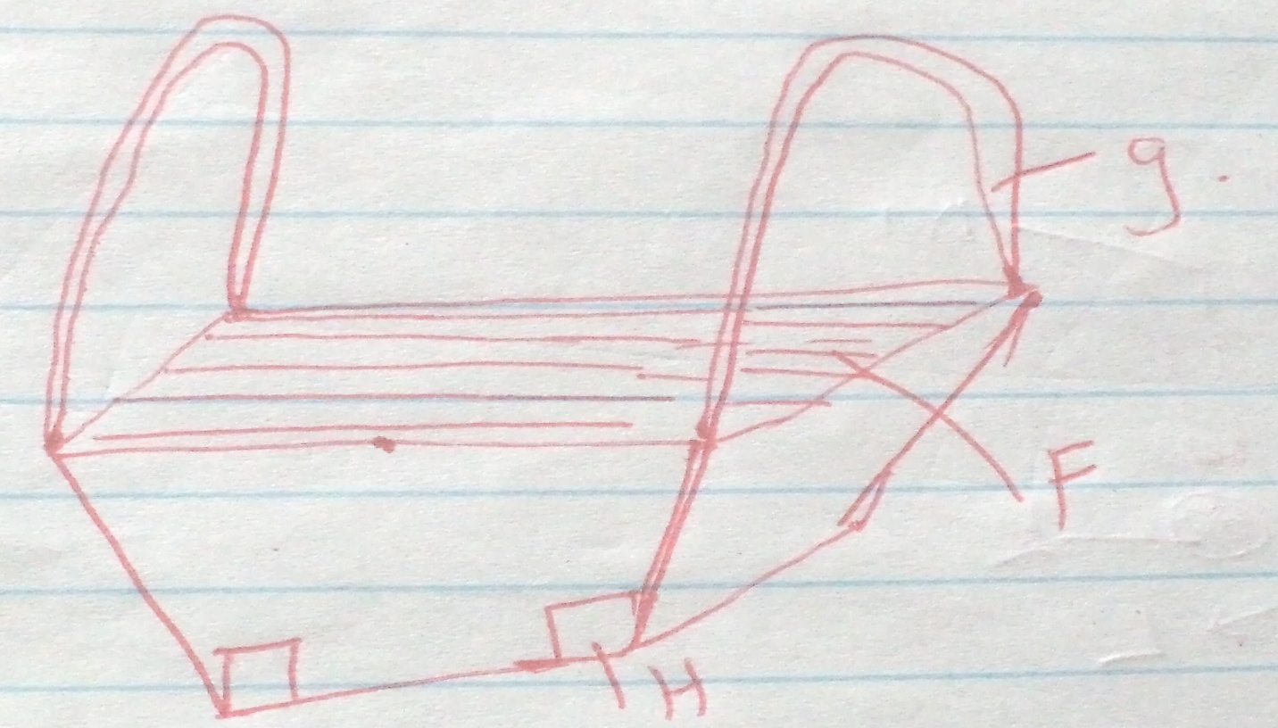

- Name the type of beehive shown. (1mk)

- Give names of other two types of hives. (1mk)

- Name the parts labeled F,G AND H. (3mks)

- Define the term digestibility. (1mk)

b. Using the person’s square method compute how much maize meal (8%cp) and soyabean meal 43%cp would be required to prepare 100kg of the mixture containing 15% cp. (4mks)

- Study the diagram below of a reproductive system of a cow.
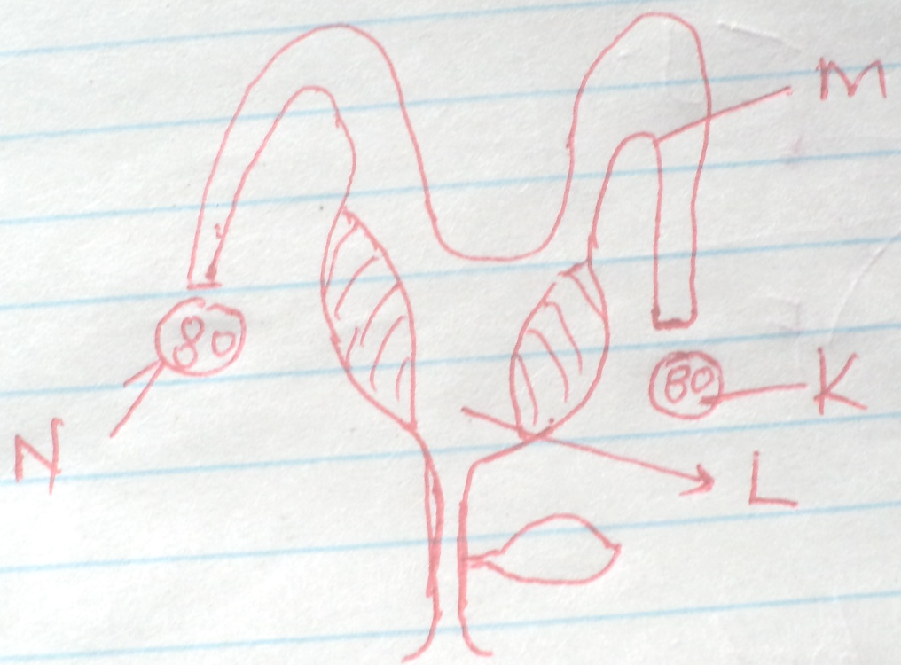

- Name the parts labeled k and l. (1mk)

- Give the use of the parts M and N. (2mks)

- State any four cultural methods of controlling ticks. (2mks)

- Diagrams F, G, H and J illustrate farm tools.
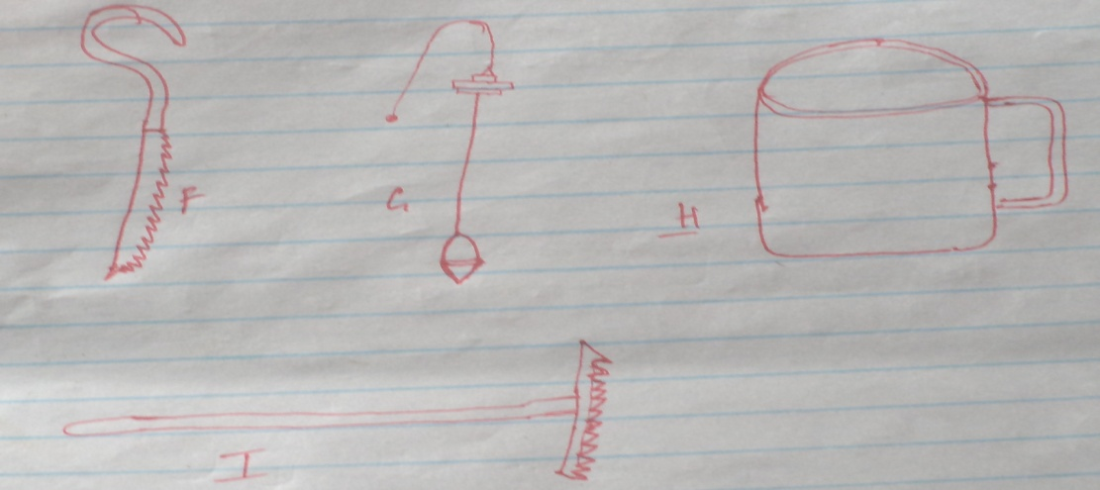

- Identify the tools F, G, H and I. (2mks)

- Give the function of each of the above tools. (2)

- Indicate two maintenance practices on tool H. (1mk)

SECTION C (Answer any two questions) 40mks.

- Outline six advantages of artificial insemination in dairy cattle management. (6mks)

b. Explain seven factors to consider when selecting materials for constructing a calf pen. (14mks)

- Describe the importance of livestock in the farm. (10mks)

b. Outline five signs of ill health in livestock. (5mks)

c. List any five desirable features of rabbit hatch. (5mks)

24.a) Describe the management practices that should be carried out during rearing of a dairy calf from birth to weaning. (12mks)

- State eight causes of calving internal. (8mks)

