AGRICULTURE F3
MARKING SCHEME PP2
1
- Jack plane ½ x 1 = ½ mark
- Stock and die ½ x 1 = ½ mark
- Sledge hammer ½ x1 = ½ mark
- Rip saw ½ x 1 = ½ mark

2 Helps building up energy reserve for parturition
  - Provides nutrients necessary for foetal growth
  - Ensures birth of healthy off springs
  - Increases milk product ion after culling
½ x 4 = 2mks
3 It pulls fur from her belly
- I t makes a nest using bedding and its fur
- It becomes restless
- It losses appetite
½ x4 = 2 marks
4 To make the fatten growth
- Control breeding
- To control breeding diseases
- To make them docile for ease of handling
- To improve the quality of meat / avoid shell in the meat ½ mk
5 Its expensive
- Requires highly trained personnel
- Requires special equipment for fertilization and storage of embryo.
6 (a) Prevent destruction of farm structures
Enables easy transportation and feeding / occupy less space
Makes the animals docile and easy to handle
Prevents cattle from injuring each other and injuring human beings
½ x4 = (2mks)
b)= Use of causitic potash stick (potassium hydroxide)
Use of dehorning collochion
7. Hormones
- Antibiotics
- Medicants
½ x 3 = 11/2 marks

8.Has powerful/thick muscles
- Has a thick inner layer al/grit
- Has folded or ridged inner layer
½ x 2 = 1 mrk
9.Transmit disease
Deprive the host of nutrition
Produce toxins
Increase cost of production
Blockage of internal organ
May c cause disease erg anemia
10.Malpresentation /breach presentation
Prolonged labour
A long delay in appearance of calf or the watering breaks
Discharge of smelly fluid, including death of a calf
Only one unit appearing
Retained placenta beyond 48 hr after calving
½ x 4 = 2,ks
11. a.zoonotic disease
- A disease that can be transmitted from live stock to man
(b) A notifiable disease
A disease whose outbreak is notified to a government office.
(c) The government instruction of movement of animals in an area from an outbreak of a notified disease to prevent the spread

12.a)Calf
b)Piglet
c)Heifer
d)Pullet
e)Boer
f)Cock
g)Cow
h)Sow
½ x 8 = 4 mrks
13.(a) pigs -3 months 3wks 3 days(11days)
(b) cattle 270 -285 days aprox.9 months
c) rabbits 30 days 1month
½ x 3 = 1 ½ mks

14.A vector carves diseases causing organism from a sick animal to a healthy animal through feeding eg tick, tsetse fly
While a intermediate host causes a parasite in its body doing the parasites life cycle. Eg water snail and the live r fluke
(both correct) 2 mks
15.I) Source of energy respiration
Raw materials to synthesize animal products eg milk,meat,wool
Excess carbohydrates stored as fat under the skin hence act as insulation to loss 1x1=1mk

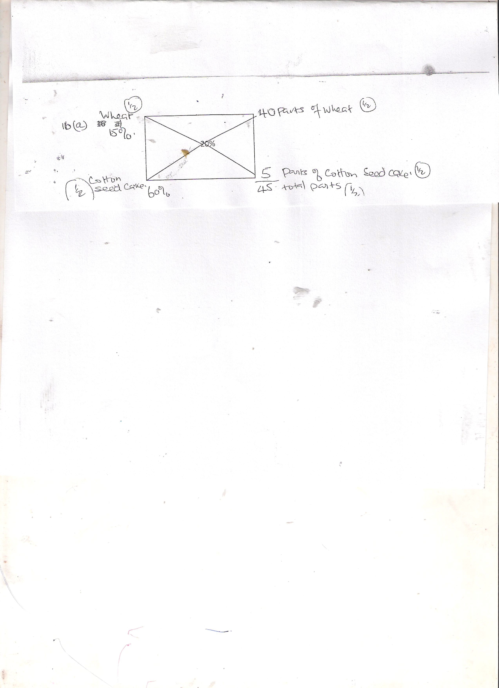
- a)

Quantity of wheat required=5/45 x 400 = 44.4kg ½ mk
Quantity of cotton seed cake required 40/45 x 400 = 355.6kg ½ mk
(4mks)
b)Trial and error method(1mk)

- Part of the digestive system
  - A-Crop(1mk)
  - B-Proventiculus(1mk)
  - C-Gizzard(1mk)
  - D-Caecum(1mk)
(b) The function of D
- Absorption of water and mineral salts
- Digestion of cellulose due to presence of micro-organisms
( c) Presence of grit
The organ has a very muscular wall
1x1 =1
18
(a)Ear notching 1x1=1mk
(b) 48

- a)Adjustable spanner –used to tighten and loosen nuts and bolts with different diameters
Rasp –used to smoothen rough surfaces of wood
1x1 = 1 mrk
(b) Rasp - used to smoothen rough surfaces of wood.
c) Claw hammer – used to drive in and remove nails into from wood.
1x1 = 1mrk
- plumb bob - used to check whether a tall wall is vertical
1x1=1 mark

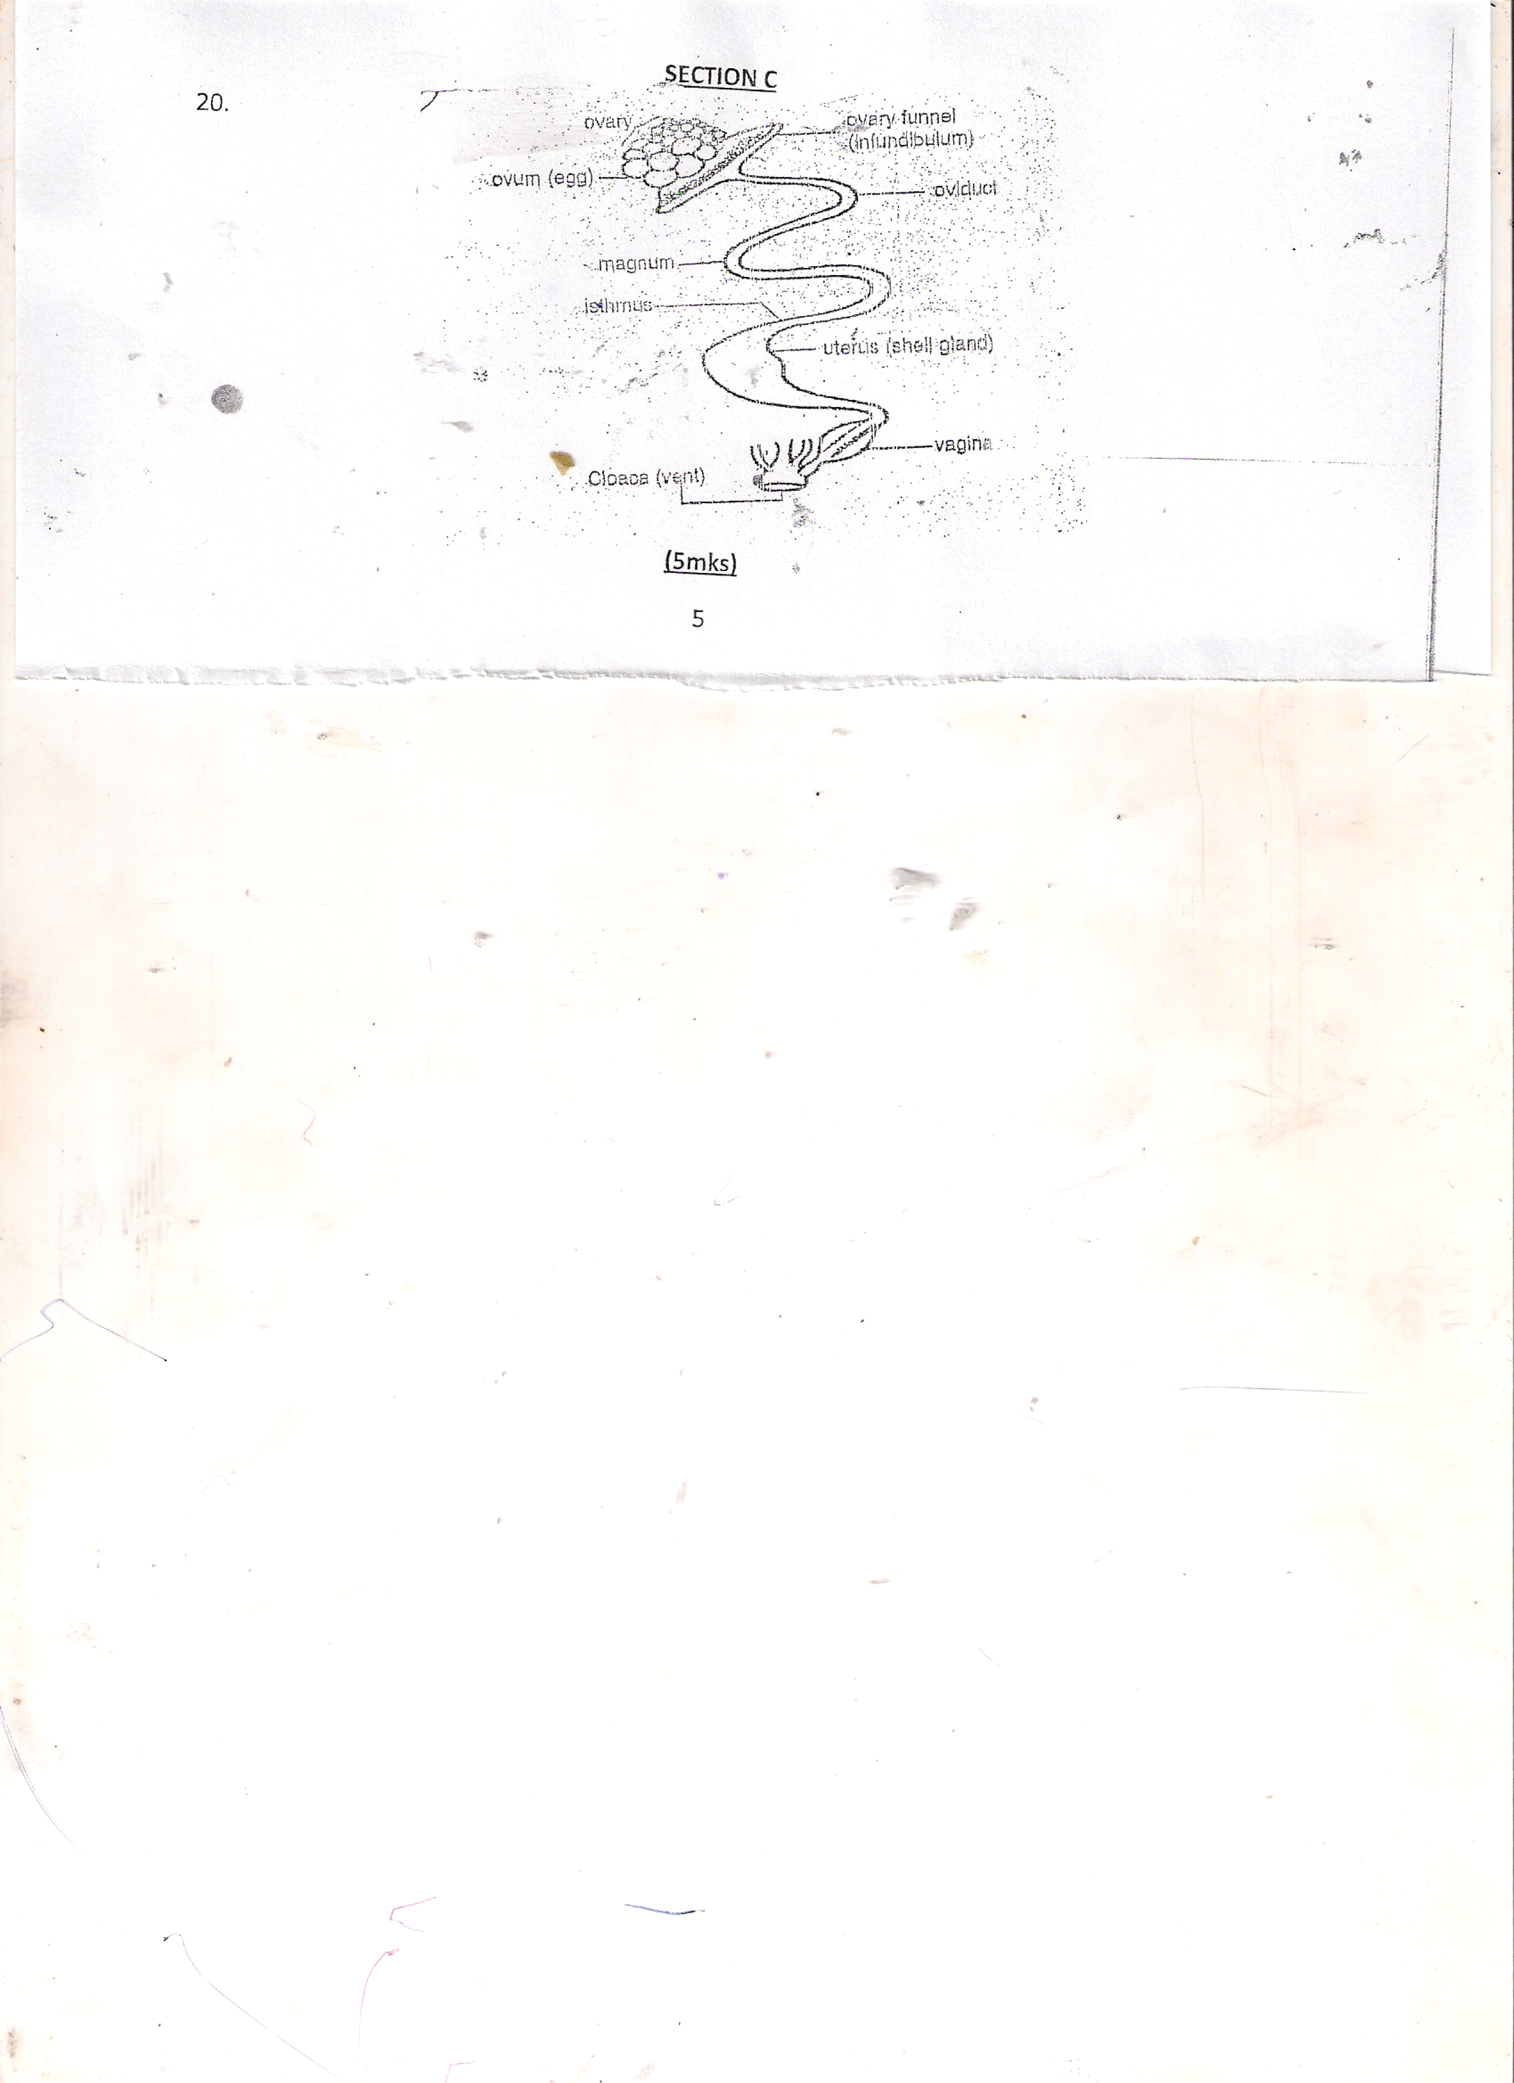
SECTION C

(5mks)

  - Ovum York is released by ovary upon maturity and rabbits follicle
  - Ovum received by the funnel(infudibulum)
  - Ovum meets sperm in the funnel;fertilisation takes place in the infudibulum
  - Chalazae added hold the yolk in infudubulum.egg stays here for 15 minutes ,funnel is 11 cm long
  - Yolk moves to the magnesium
  - The magnesium is 33.6cm long egg stays here for 3 hrs
  - The yolk moves to the isthmus .It is 10,6cm long.
  - Shell membrane are added to the egg minerals ,water, vitamins are added in the isthmus
  - Egg moves to the shell gland
  - A shell is added
  - Egg stays here for 18-22 hrs
  - The egg moves to the vagina 6.9 cm egg is temporarily stored
  - Egg moves out through the clock
(Egg is laid down)
15x1 = 15 marks

    - (a) Lyfe cycle of a host tick
  - Egg hatch on the ground/grass
  - Larva clutch on the its host when feeding larvae sucks blood gets engorged
  - Larvae moves into lymph on the sane host
  - Nymph sucks blood and gets engorged
  - Nymph falls to the ground and moults into adults
  - Adults climb on the second host
  - Adults feed and get engorged adults male on the 2nd host.
  - The female drops off to lay egg and the cycle continues
7 x 1 = 7 marks
(b)Measures to control external parasites
- Burning infected parasites
- Spraying animals in appropriate
- Hand picking and killing them
- Fencing to keep off other animals and hold animals
- Double fencing to control ticks
- Biological control eg allowing birds to pick ticks
- Rotational grazing
- Ploughing pastures
1x8 =8 mrks
c)Factors that affect digestibility in livestock
- The species of an animal
- Form on which the food is offered to the animals
- Amount of food already present in the digestive system the animal .
- The chemical composition of the feed
The ratio of enrgy to protein of the feed.(1x5=5mks)
22. a.Measures of controlling livestock diseases
Proper feeding and nutrition –which avoids nutrition diseases and makes animals healthy to resist diseases.
Proper breeding and selection-healthy animals should be selected to prevent disease weak and animals known to be susceptible to some diseases should be called.
Proper housing –all requirement of housing should be neat;eg proper ventilation,leak proof,easy clean,free from draught etc.
Proper hygen-high levels of hygen should be maintained e.g avoid muddy and filthy surroundings.
Imposition of quarantine-restrictionb of movementof animals and their products from and to the affected areas in the event of an outbreak of notifiable disease.
Use of prohylatic drugs e.g coccidiostats to control coccidiosis.
Drenching /deworlming of animals to control internal parasites.
Regular vaccinations to imrove resistance to diseases and boost immnunity.
Slaughtering of affected animals
Isolation of sick animals-in separate pens to ominous spreading of disease
Use of antiseptic and disinfections. They contain germicidal chemicals
Treatment of sick animals to prevent spread to healthy animals and restore them back to health. ½ mk ;stating ½ -explaining ; 1x13=13mks)

b) Disease predisposing factors
- Herding
- Age of the animal
- Breed of the animal
- Colour of the animal
- Species of the animal
- Change of health condition-external temperature
- Environment of the animal eg parasites and sharp objects
- Physiological condition of the animal eg weakness pregnancy
- Overcrowding 1x7=7mks

