443/1
AGRICULTURE
FORM 2
TIME: 2 HRS

INSTRUCTIONS TO CANDIDATES
- Write your name and index number in the spaces provided
- This paper consist of three sections A, B and C

SECTION | MAXIMUM SCORE | CANDIDATE’S SCORE
A | 30
B | 30
C | 40
TOTAL | 100

This paper consist of 9 printed pages candidates should check the questions paper to ascertain that all the pages are printed as indicated and that no questions are missing

SECTION A (30MKS)

- Define the following terms (2mks)
- Entomology

- pomology

- Apiculture

- olericulture

- Outline four aspects of rainfall important in Agriculture (2mks)

- State the four physical agents of weathering (2mks)

- Give four effects of biotic factors in the soil (2mks)

- Distinguish between rip saw and cross-cut saw (1mks)

- For each of the following tools give two examples (2mks)
- file

- scrappers

- chisels

- gauged marking tools

- Describe four conditions necessary for land clearing to take place (2mks)

- State four reasons why burning as a method of land clearing is discouraged. (2mks)

- a) What is minimum tillage? (1mk)

- Distinguish between a weir and a dam (1mk)

- Give two types of each of the following pipes (1mks)
- Hose pipes

- Metal pipes

- Identify two dairy goats (1mk)

- Give four benefits derived from a camel (2mks)

- Differentiate between macro nutrients and micro-nutrients (1mks)

- Highlight the functions of phosphorus in plants (2mks )

- Give four fertilizers that can be used during planting in crops (2mks)

- List any four methods of harvesting crops (2mks)

- Highlight any two diseases that attack cabbages (1mk)

- List any two insect-pests that attack tomatoes (1mk)

SECTION B (30MKS)
- Study the diagram below and answer the questions that follow
- Identify what is being tested in the above set-up (1mk)
- Identify the most ideal soil for most crops (1mk)
- Give two ways of improving the clay soil to be used for cultivation (2mks)
- Describe four characteristics of clay soils (4mks)

- The diagram below represents a hand saw study it and answer the questions that follow
- Name the parts marked P,Q,R,S and T (2 ½ mks)
P
Q
R
S
T
- Give four maintenance practices for the above saw (4mks)

- Study the diagram below and answer the questions that follow

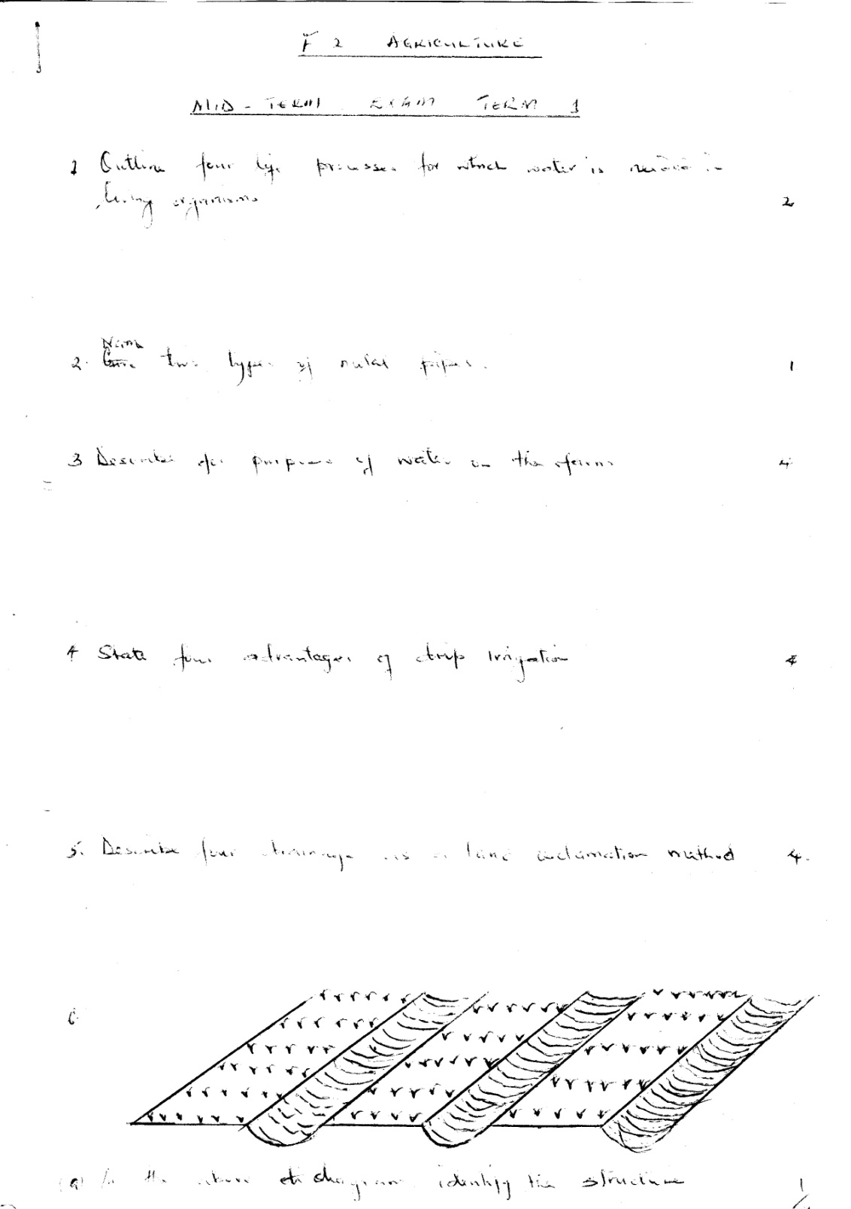
- identify the structure above (1mks)

- State the function of the structure in (a) above (1mks)

- State the importance of activity carried by the structure in (a) above (4mks)

- Study the diagrams below and answer the questions that follow
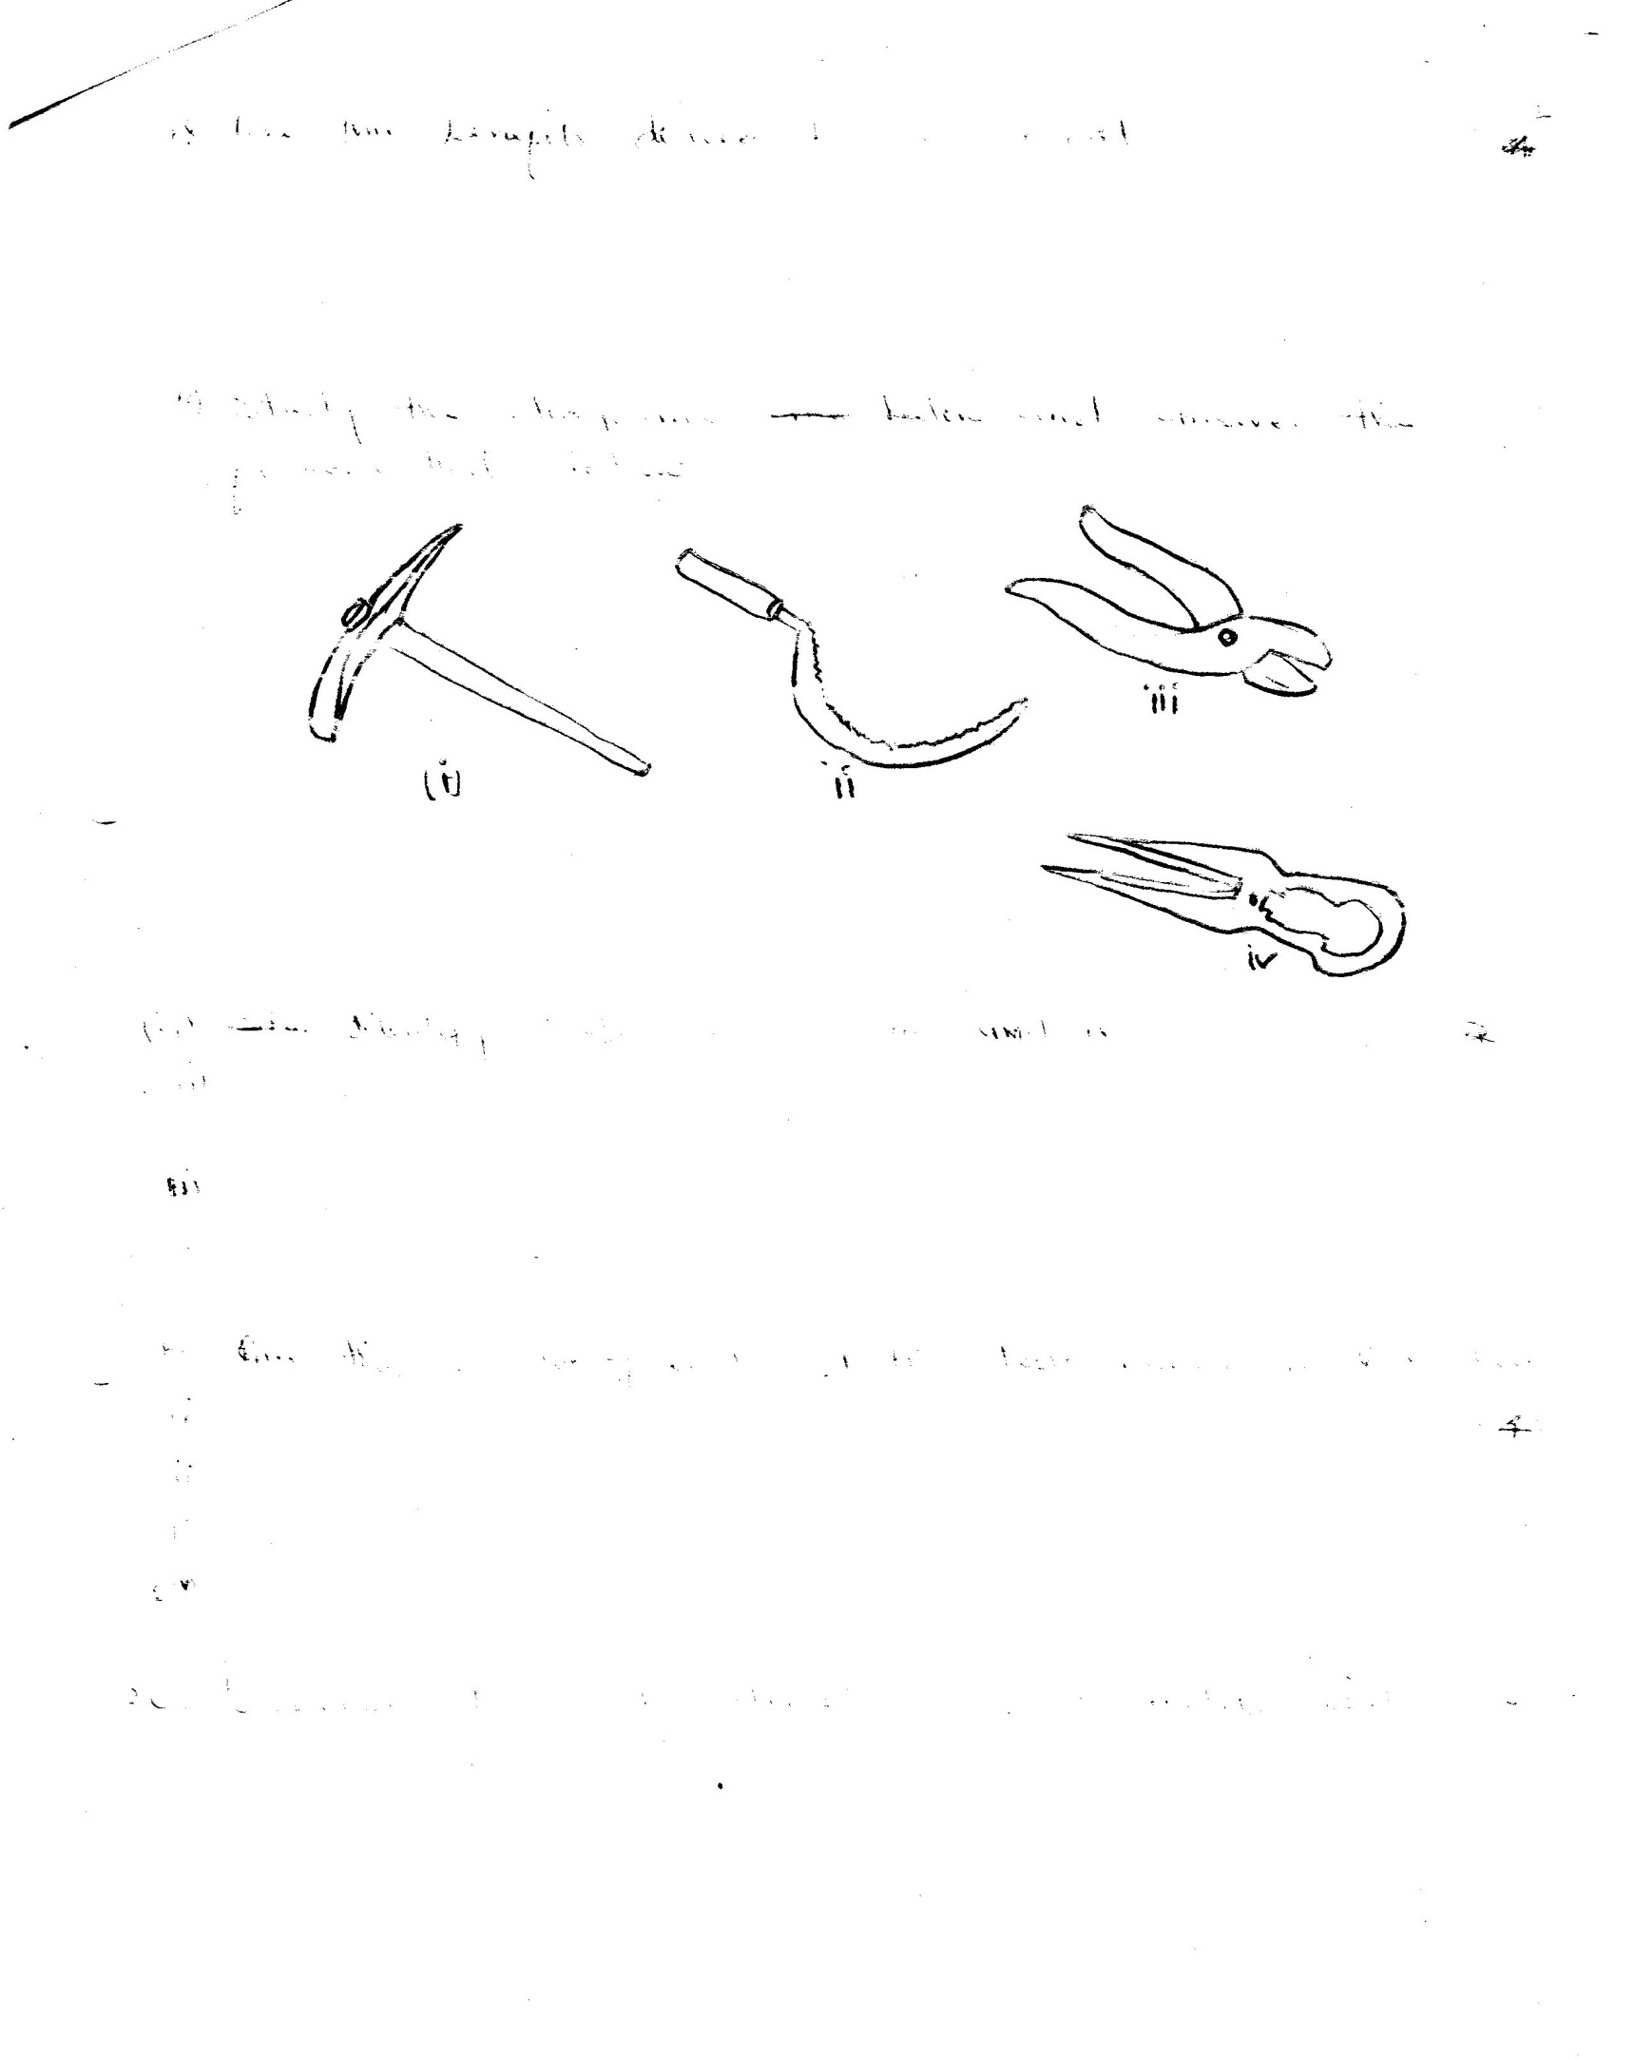
- Identify tools (i), (ii), (iii), (iv) (4mks)

- Give the use of each of the tools named in (a) above (4mks)

SECTION C(40MKS)
- a)Name and explain the importance of Agriculture in the economy of Kenya (6mks)

b) Give practices carried out in minimum tillage (7mks)

c) Describe the benefits of minimum tillage ( 7mks)

- a) Highlight the importance of water treatment (4mks)

b) Describe four characteristics of a fertile soil (6mks)

c) State any four characteristics of nitrogenous fertilizers (6mks)

d) Describe four characteristics of a good storage structure (4mks)

