TOPICS COVERED

SECTION I QUESTIONS

- INTRODUCTION TO AGRICULTURE………………………………………………………..3
- CROP PRODUCTION I (LAND PREPARATION) ……………………………………………5
- FACTORS WHICH INFLUENCE AGRICULTURE………………………………………......5
- WATER SUPPLY, IRRIGATION AND DRAINAGE…………………………………..………....
- SOIL FERTILITY 1 (ORGANIC MANURE) ………………………………………………..…..8
- AGRICULTURE ECONOMICS (BASIC CONCEPTS AND FARM RECORDS) ……………9
- SOIL FERTILITY II (IN ORGANIC FERTILIZERS) ……………………………….………..10
- CROP PRODUCTION II (PLANTING) ………………………………………………..……….12
- CROP PRODUCTION III (NURSERY MANAGEMENT PRACTICES) …………………….14
- CROP PRODUCTION IV (FIELD MANAGEMENT PRACTICES) …………………………15
- CROP PRODUCTION V (VEGETABLES) …………………………………………………..16
- LIVESTOCK HEALTH (INTRODUCTION TO LIVESTOCK HEALTH) ……………………17
- AGRICULTURAL ECONOMICS II (LAND TENURE AND LAND REFORM) …………….18
- SOIL AND WATER CONSERVATION………………………………………………………...18
- WEEDS AND WEED CONTROL………………………………………………………………19
- CROP PESTS AND DISEASES………………………………………………………………….21
- (pp1): CROP PRODUCTION VI ( FIELD PRACTICES FOR MAIZE, MILLET, SORGHUM,
- BEANS AND RICE: HARVESTING OF COTTON PYRETHRUM, SUGAR CANE COFFEE
- AND TEA CROP PRODUCTION III(NURSERY MANAGEMENT PRACTICES) …………23
- FORAGE CROPS………………………………………………………………………………...24
- AGRICULTURAL ECONOMICS III (PRODUCTION ECONOMICS)………………………..25
- CROP PRODUCTION IV (FIELD MANAGEMENT PRACTICES) ……………………………
- CROP PRODUCTION V (VEGETABLES)……………………………………………………….
- AGRICULTURAL ECONOMICS IV………………………………………………………….29
- LIVESTOCK HEALTH (INTRODUCTION TO LIVESTOCK HEALTH) ……………………
- AGRICULTURAL ECONOMICS II (AND TENURE AND LAND REFORM) …………….…
- SOIL AND WATER CONSERVATION……………………………………………………..…..
- WEEDS AND WEED CONTROL………………………………………………………………..
- CROP PESTS AND DISEASES………………………………………………………………..
- CROP PRODUCTION VI (FIELD PRACTICES FOR MAIZE, MILLET,
- SORGHUM, BEANS AND RICE:
- HARVESTING OF COTTON, PYRETHRUM, SUGAR CANE COFFEE & TEA………………
- AGRICULTURE ECONOMICS (V) …………………………………………………….……..32
- AGRO FORESTRY…………………………………………………………………………....32
SECTION I ANSWERS………………………………………………………………..……..34
- SECTION II QUESTIONS
- FARM TOOLS AND EQUIPMENT………………………………………………………...….92
- LIVESTOCK PRODUCTION I (COMMON LIVESTOCK BREEDS) ………………………96
- LIVESTOCK HEALTH II (LIVESTOCK PARASITES) ……………………………………97
- LIVESTOCK PRODUCTION II (NUTRITION) ………………………………………………..98
- LIVESTOCK PRODUCTION III (SELECTION AND BREEDING) …………………….. 99
- LIVESTOCK PRODUCTION IV (LIVESTOCK MANAGEMENT PRACTICES)…………..100
- FARM STRUCTURES ………………………………………………………………………103
- LIVESTOCK HEALTH III (LIVESTOCK DISEASES) ……………………………………108
- LIVESTOCK PRODUCTION V (POULTRY) ………………………………………………110
- LIVESTOCK PRODUCTION III (LIVESTOCK REARING PRACTICES) …………………112
- FARM POWER AND MACHINERY…………………………………………………………..113
SECTION II Answers ………………………………………………………………………..117

SECTION I : QUESTIONS

INTRODUCTION TO AGRICULTURE
This topic entails the following:-
- Definition of agriculture
- Main branches of agriculture
- Farming systems
- Farming methods
- Role of agriculture to Kenya’s economy
- Varied opportunities in agriculture.

The following relevant questions and their answers in this topic will help and motivate the user to comprehend and understand the required concepts and practices:

1. Give two factors which characterize intensive farming
2. State three reasons why organic farming is encouraged in farming
3. State two ways in which agriculture contributes to industrial development
4. State four ways by which wind affects the growth of crops
5. State one physical characteristic used in classifying soil
6. Outline four advantages of organic farming
7. State two conditions under which shifting cultivation is practiced
8. Differentiate between the following terms as used in Agriculture:-
(a) Oleculture and floriculture
(b) Apiculture and aquaculture

FACTORS WHICH INFLUENCE AGRICULTURE
In this topic, the following factors influence agriculture.
-Human factors e.g. -level of education, -Health HIV/AIDS, -Economic status of the farmer e.t.c
- Biotic factors e.g. pests, parasites, decomposers, pathogens, pollinators, predators e.t.c.
- Climatic factors e.g. rainfall, temperature, wind and relative humidity, light
- Edaplus factors e.g. type of soils, soil profile, soil structure, soil texture, soil chemical properties.
The following relevant questions and their answers in this topic will greatly help and
motivate the user to comprehend and understand the required concepts:

1. State two roles of humus in the soil that are beneficial to crops
2. a) outline five activities that may be undertaken in organic farming
3. List four effects of temperature on crop growth
4. State four ways by which wind affects the growth of crops
5. Name two factors related to light that affect crop production and distribution in Kenya
6. Describe the environmental conditions that may lead to low crop yields
7. List three environmental factors that affect crop distribution in Kenya
8. State one physical characteristic used in classifying soil
9. Outline four advantages of organic farming
10. The diagrams below show an experiment carried out by a form 1 class. Study them carefully and
answer questions that follow:
E
D
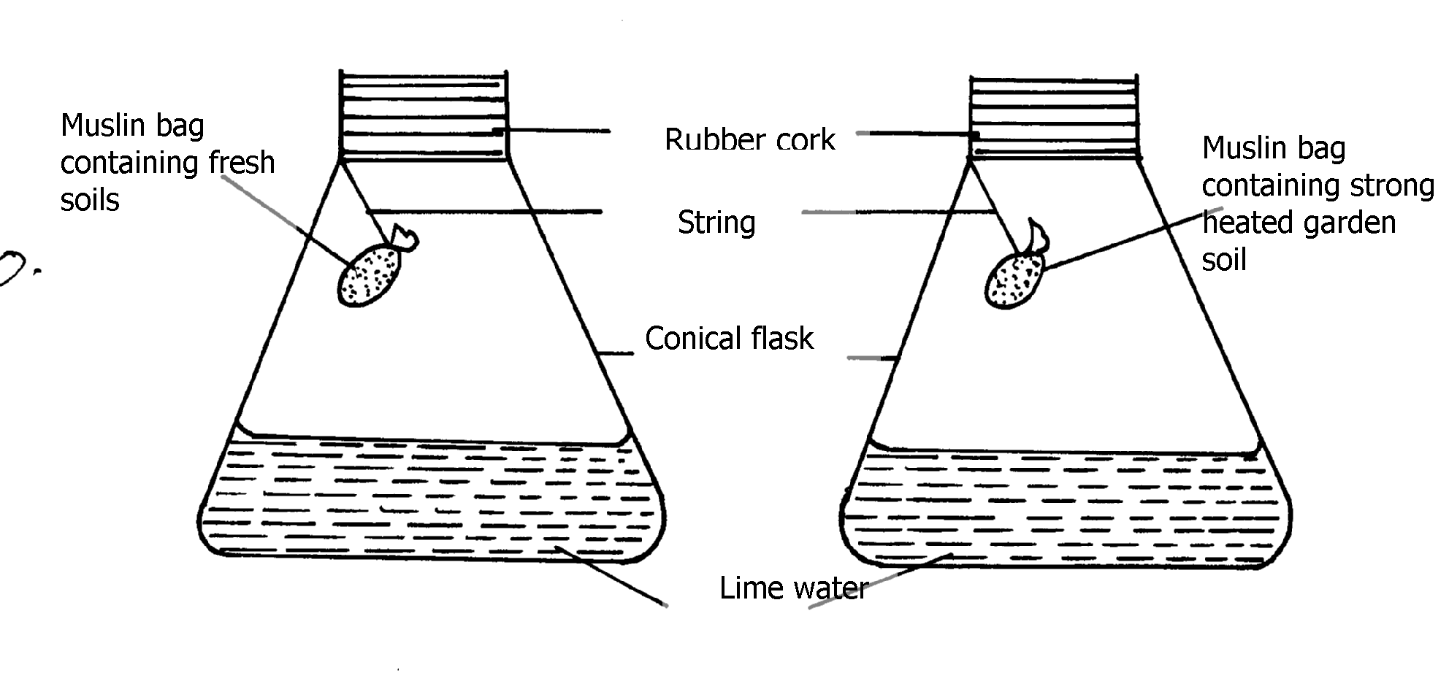

(a) What was the aim of the experiment?
(b) What was the observation that form 1 students made at the end of the experiment in
flasks D and E?
(c) Give the reason for the observation made in flask D

12. Briefly explain how sub-soil as a horizon in a soil profile can affect soil productivity
13. (a) What are the three aspects of light that are important to a farmer?
(b) Mention three ways through which relative humidity affect crop production
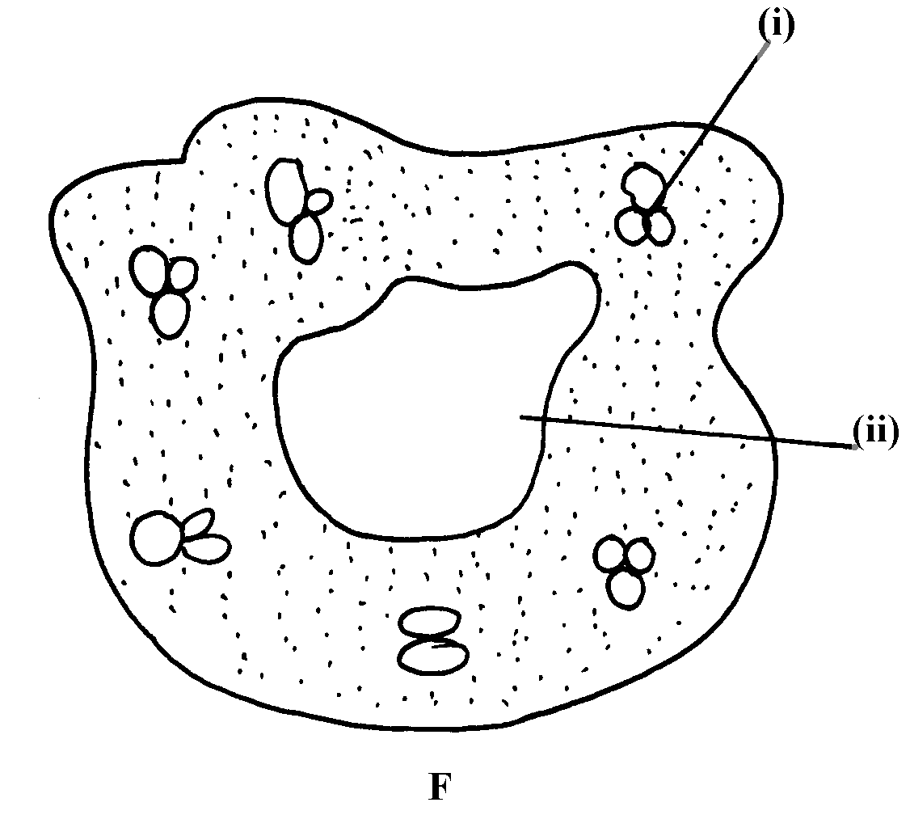
14. The diagram labeled E and F below illustrates some type of soil structure. Study the diagrams
carefully and answer the questions that follow:

(a) Identify the types of soil structure illustrated in diagrams E and F
(b) Identify the parts labeled (i) and (ii) in diagram F
(c) Outline the influence of physical characteristics of soil on its properties
15. State three physical characteristics of soil
16. Study the diagram below and answer the questions that follow

a) State merits of horizon A
b) State distinct features of horizon B
c) What does the term transition zone refer to in soil profile
i) Name horizon C and state its importance
17. Outline two ways temperature affects crop production
18. List four ways by which biological agents can enhance the process of soil formation
19. List four environmental factors that affect crop production in Kenya
20. Explain the role played by topography in soil formation
22. Mention two importance of parent’s material in soil profile
23. Mention four ways of modifying soil temperature in crop production
24. a) Mention two factors that affect selectivity of herbicides
b) Name two farming practice that cause water pollution
25. Give four factors that influence soil formation
26. State three properties of soil that is influenced by soil texture
27. Name any three agents of biological weathering

CROP PRODUCTION I (LAND PREPARATION)
- Land preparation entails the following farming practices.
- Land clearing or bush clearing tools, chemicals and equipment used.
- Primary cultivation, tools and equipment as machines used.
- Primary cultivation, tools and equipment as machines used.
- Secondary cultivation, tools and equipment used.
- Tertiary operations e.g. ridging, rolling and leveling.
- Sub-soiling, tools used and reasons for the same.
- Minimum tillage and reasons for the secure.

The following relevant questions and their answers in this topic will greatly help and motivate
the user to comprehend and understand the required concepts and farming practices:

1. Give three factors that determine depth of ploughing during land preparation
2. List four reasons for cultivating land before planting
3. (a) What is minimum tillage?
(b) Give four farming practices that help in achieving minimum tillage.
4. (a) Describe the establishment of grass pasture from the time the land is ploughed using a mould
board plough to the time the pasture is ready for grazing
(b) Explain five practices that a farmer should carry out to ensure uniform germination of seeds (c) Describe five factors that determine the number of cultivations when preparing a seedbed
5. State four physical conditions of the seedbed that need to be changed to facilitate germination
6. State four importance of sub soiling as a tertiary operation
7. Outline four advantages of rolling in seedbed preparation
8. State four disadvantages of minimum tillage
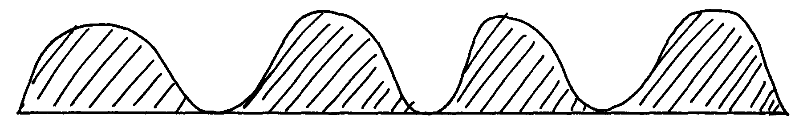
9. The diagram below illustrate a tertiary operation carried out in the farm

a) Identify the tertiary operation
b) (i) State the importance of the tertiary operation identified in 20(a) above
(ii) Give two other tertiary operations carried out in the field besides the one identified above
10. Give two reasons why it is advisable to cultivate the field during the dry season
11. How are hard pans caused by cultivation?
12. Give four factors that determine the number of secondary cultivation operations
13. Define the term minimum tillage
14. List four advantages of timely planting
15. State any two factors that determine the number of cultivation on a field before it is ready for
planting
17. Give three benefits of timely planting of annual crops
18. State four factors determining the depth of ploughing land

WATER SUPPLY, IRRIGATION AND DRAINAGE

This topic entails the following:
- Hydrological cycle
- Sources of water on the farm
- Water collection and storage
- Pumps and pumping of water
- Types water pipes
- Water treatment
- Uses of eater of the farm.
- Types of irrigation advantages and disadvantages.
- Importance and methods of drainages
- Water pollution causes and prevention.

The following relevant questions and their answers in this topic will greatly help and motivate the user to comprehend and understand the required concepts and practices:

1. State two reasons for treating water for us on the farm
2. State three reasons for draining swampy land before growing crops
3. Use the diagram below of irrigation method to answer the questions that follow.

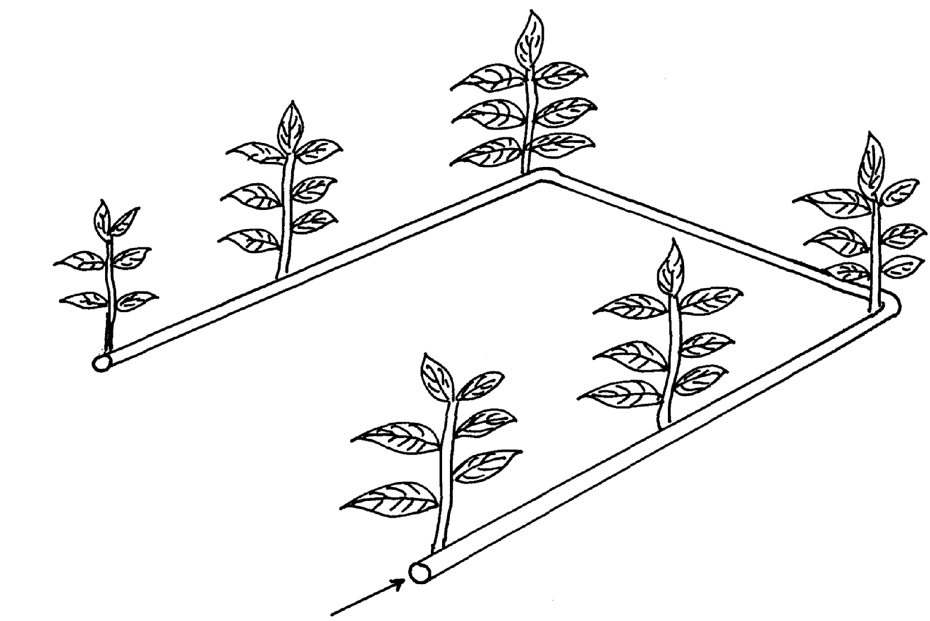

a) Identify the method of irrigation
b) State four advantages of the above irrigation system
c) State three factors that determine the type of irrigation on the farm
d) State two disadvantages o f the above system of irrigation
4. a) What is irrigation
b) Outline three methods of irrigation
5. a) List four use of water on the farm
b) Give four methods of harvesting water on the farm
c) Outline the stages involved in water treatment process
6. List any four uses of water in the farm
7. State two types of irrigation used in Kenya
8. Outline four disadvantages of cambered beds
Describe the process of water treatment
9. Give four roles of drainage as a method of land reclamation
10. Name two types of water pumps which can be used in the farm
11. Name any four examples of working capital in maize production
12. List four types of water pumps which can be used in the farm
13. State four methods of drainage
14. Distinguish between a dam and a weir
15. How do the government control prices of essential farm produce
16. What is the difference between pumping and piping of water in the farm?
17. List four reasons of draining water logged soils before planting.
18. Give three Agricultural practices which lead to water pollution
19. The diagrams below illustrate some methods of irrigating crops in the field. Study the diagrams
and answer the questions that follow:

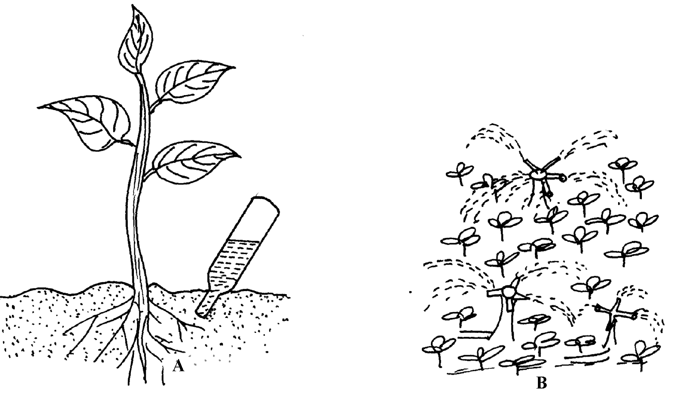

(a) Identify the methods used ; (i) A (ii) B
(b) State two advantages of method A over method B
(c) What material should be inserted at point T
b) Name two farming practice that cause water pollution
20. Give four reasons for practicing irrigation
22. a) State four importance of water to plants
b) State four reasons for treating water before use c) Describe water treatment system in a chemical treatment plant
23. Name four diseases caused to man by drinking untreated water
24. State the functions of the following chemicals as used in water treatment;
(a) Chlorine.
(b) Aluminum sulphate (AIlum)
21. The diagrams labeled S and T illustrate some methods of draining waterlogged fields; use it to
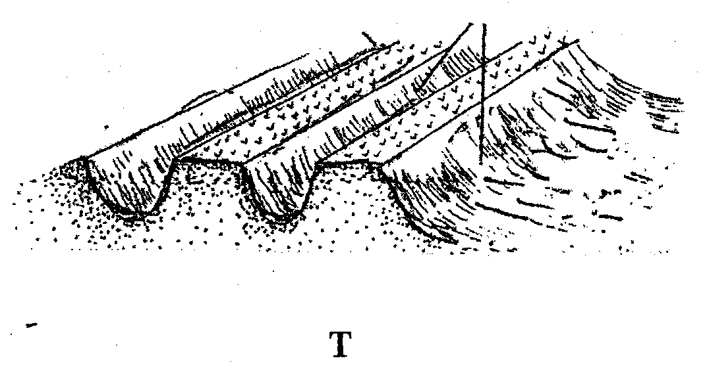
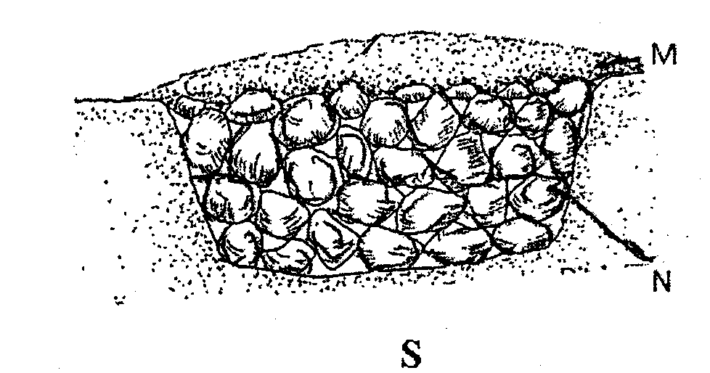
answer the questions that follow:

(a) Identify the methods illustrated
(b) What are the materials in S labeled M and N
(c) Name two types of crops that can be planted in the field instead of carrying out the practice
illustrated in S and T
(d) What is the importance of carrying out land reclamation?

SOIL FERTILITY 1 (ORGANIC MANURE)
This topic entails the following:
- Characteristics of a fertile soil
- How soil loses soil fertility
- Soil fertility maintenance
- Reasons of adding organic matter to soil
- Disadvantages of organic manure
- Types of organic manure i.e green manure, farm yard manure and compost measure.

The following relevant questions and their answers in this topic will greatly help the user to comprehend and understand the required concepts and practices:

1. State two roles of humus in the soil that are beneficial to crops
2. List four characteristic of fertile soil
3. The diagram below illustrates a compost heap. Study it and answer the questions that follow

a) Name the part labeled Q and state its function
b) What is the function of each of the following components in preparation of compost manure
i) Top soil
ii) Wood ash
iii) Rotten manure

4. The illustration below shows a four heap system of making compost manure. Study it and answer
the questions that follow.

(a) By use of arrows indicate on the diagram above how the following material should be
transferred from one heap to another till the manure is applied in the field
(b) How long does the material take to be ready for application in the field as manure?
(c) Give a reason for turning the material in the heap regularly
(d) Give two reasons why it is necessary to sprinkle water on the heap
5. Name four indicators of well-decomposed manure
6. (a) State two factors that should be considered when siting a compost manure heap
(b) When preparing compost manure, explain the importance of each of the following:-
(i) Addition of ash
(ii) Regular turning of the compost manure
7. What is leaching?
8. State four advantages of adding organic matter to a sandy soil
9. (a) Describe the preparation of the following farm materials:-
(i) Farm yard manure
(ii) Hay
(b) Explain the factors considered in timely planting of annual crops
10. A ration containing 18% protein is to be made from maize and sunflower cake. Given
that maize contains 7% protein, and sunflower seed cake 34% protein. Use Pearson square
method to calculate the value of feedstuffs to be used to prepare 100kgs of the feed
ii) A part from Pearson square method, name two other methods that can be used to formulate
feed ration

AGRICULTURE ECONOMICS
(BASIC CONCEPTS AND FARM RECORDS)
This topic entails the following
- Definition of scarcity, preference and classic, opportunity cot as used in agriculture production.
- Uses of farm records
- Types of farm records i.e production records, filed operation records, breeding records, feeding records, health, labour records and master roll.

The following relevant questions and their answers in this topic will greatly help and motivate
the user comprehend and understand the concepts and practices.

1. (a) What are the uses of farm records to a farmer?

2. Identify the farm record below and the questions that follow:
Date | Disease symptoms | Animals affected | Drug used | Cost of treatment | Remarks
(a)Identity of the record
(b) State two different information that should be entered in the remarks column
(c) Give two importance of keeping the farm record illustrated above
3. State four uses of farm records
4. State four uses of farm records
5. Outline two ways the level of education and technology influence the efficiency of agricultural
production
6. Study the illustration below of farm records:- Use it to answer the questions that follow:
Enterprise
Month
Name of cow | DAYS IN MONTH
 | 1 |  | 2 |  | 3 |  | 4 |  | 5 |  | 6
 | AM | PM | AM | PM | AM | PM | AM | PM | AM | PM | AM | PM

(a) Name the type of the farm record illustrated above
(b) Give three reasons for keeping health records in a livestock production
(c) Give three pieces of information a dairy farm manager should collect for planning purposes
7. List down four pieces of information recorded in a field operation record.
8. List two events occur during induction stroke in a four stroke engine
9. Give two conditions under which a farmer may prefer the use of donkey trailed cart instead of
a tractor drawn trailer in his farm

SOIL FERTILITY II (IN ORGANIC FERTILIZERS)

This topic entails the following;
- Essentials elements required by cops
- Classification of essential elements
- Role o micro-nutrients
- Deficiency symptoms of macro-nutrients and micro-nutrients.
- Identification and classification of fertilizers.
- Soil sampling and testing methods of fertilizer application.
- Effect of soil acidity/alkalinity air crops
- Fertilizer rate calculations

The following relevant questions and their answers in this topic will greatly help and motivate the user to comprehend and understand the required concepts and practices:

1. State four advantages of applying lime in clay soil
2. a) Give the form in which the following elements are absorbed by crops
i) Sulphur
ii) Nitrogen
iii) Carbon
iv) Magnesium
b) List three effects of nitrogen to plants
3. Mr. Malombe of Shinyalu village prepared to top dress 10 hectares of nappier grass using
sulphate of ammonia (21%N). Sulphate of ammonia is applied at rate of 150kg per hectare.
Calculate
a) The quantity of sulphate ammonia fertilizer the farmer will need for 10 hectares
b) The number of 50kg bags of fertilizer he will purchase
4. Give two disadvantages of using farmyard manure
5. State four factors which influence the stage at which the crops are harvested
6. A form four student was given a sample of a fertilizer with the following characteristics:
(i) Grey in colour
(ii) It is granular
(iii) Causes no corrosion
(iv) It is highly hygroscopic
(v) It is neutral
(a) Identify the fertilizer
(b) At what stage of growth of maize should it be applied?
(c) Calculate the amount of K₂O contained in 400kg of a compound fertilizer 25:10:5
7. State two pieces of information that soil sample should have before being taken to the laboratory
for testing
8. A compound fertilizer bag has the labels 20-20-0. What do the figures stand for?
9. Give four functions of sulphur in crops
10. State four advantages of lining as a measure of soil improvement
11. State two methods of increasing soil PH
12. (a) State three factors that determine the amount of inorganic fertilizers needed to be applied
to crops
(b) What are the necessary precautions observed when carrying out soil sampling?
13. List three functions of nitrogen in crops
14. (a) Distinguish between fertilizer grade and fertilizer ratio
(b) List four elements whose deficiency results into chlorosis in plants
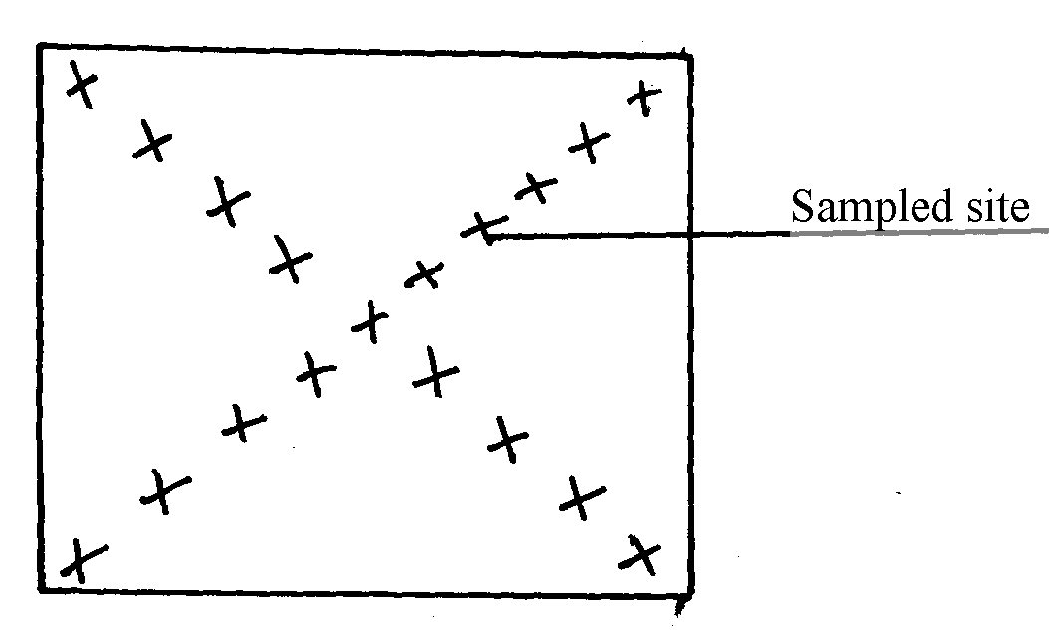
15. The diagram below shows a method of soil sampling

(a) Name the method illustrated in the diagram
(b) State three precautions taken when collecting the soil for testing using the above method
(c) Give four reasons why soil from the farm is tested
16. A farmer was advised to apply compound fertilizer 20-20-10 on an orchard measuring
20m X 10m at the rate of 80kg/ha. Calculate the amount of fertilizer the farmer would require
for the orchard. (Show your working)
17. a) A compound of fertilizer has a fertilizer grade of 25:10:5.calculate the a mount
of phosphorus fore sent in 400kg of this fertilizer
b) The diagram below illustrate methods of collecting soil sample from a field

i) Identify the methods illustrated 1-
ii) xx
iii) State three importance of carrying out soil sampling and testing
18. (a) What is an incomplete compound fertilizer?
(b) State four reasons why a maize crop continued showing deficiency of potassium despite
applications recommended amount of potassic fertilizer
19. The diagram below shows a soil sampling method.
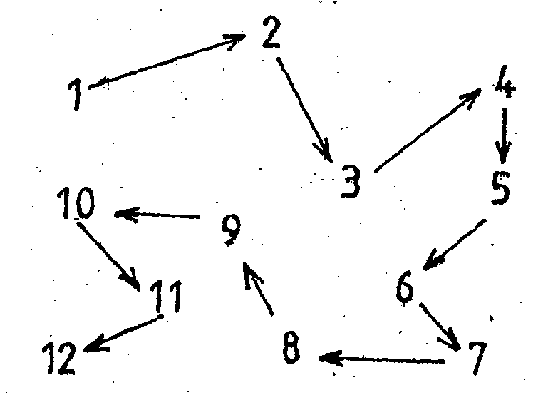

(a) Identify the method illustrated above
(b) Name any two spots in a farm that should be avoided during sampling
(c) Describe the steps followed while carrying out the exercise in (a) above

CROP PRODUCTION II (PLANTING)
This topic entails the following:
- Correct planting materials for various crops
- Selection and preparation of planting materials
- Determination of optimum time of planting
- Factors which determine planting depth
- Planting procedure for different crops
- Factors which determine seed rate, spacing and plant population.
- Calculation of plant population
- Economic value of land.
The following relevant questions and their answers in this topic will greatly help and motivate
the user to comprehend and understand the required concepts and practices:

1. State two reasons for seed treatment of tree species before planting
2. Give three factors that determine spacing of beans
3. State four reasons for using certified seeds for planting
4. Below are diagrams showing vegetative material used for propagation.

a) Name the propagation materials A, B, C, D
b) What is the term used for inducing B to start germinating?
c) State four advantages of vegetative propagation on crop production
5. Differentiate between hybrid and composite
6. a) A farmer planted 100 maize seeds and 90 seeds germinated.
Calculate the germination percentage
b) Given that maize is planted at a spacing of 75cm by 25cm, calculate the plant population in a
plot measuring 4m by 3m
7. Give four qualities of a mother plant which should be considered when selecting vegetative
material for propagation
8. Explain five practices that a farmer should carry out to ensure uniform germination of seeds
9. State two factors which determine the depth of planting
10. State two advantages of adding organic matter to sandy soil

11. Calculate the number of tea plants in two hectares (2ha) given that the spacing is 150cm x 75cm
and one seedling is planted per hole
12. Outline four reasons why training is important in some crops
13. Give four factors that influence the depth of planting
14. Two precautions taken when harvesting cotton
15. Outline four reasons why training is important in some crops
16. Give four factors that influence the depth of planting
17. Two precautions taken when harvesting cotton
18. State four factors that determine the spacing of annual crops
19. Outline four advantages of rolling in seedbed preparation
20. List two factors that effect rooting of cuttings in crop production
21. Outline three ways of preparing materials before sowing
22. Outline three ways of preparing materials before sowing
23. Distinguish between over sowing and under sowing

24. Study the illustration below of a tea vegetative material and answer the questions that follow
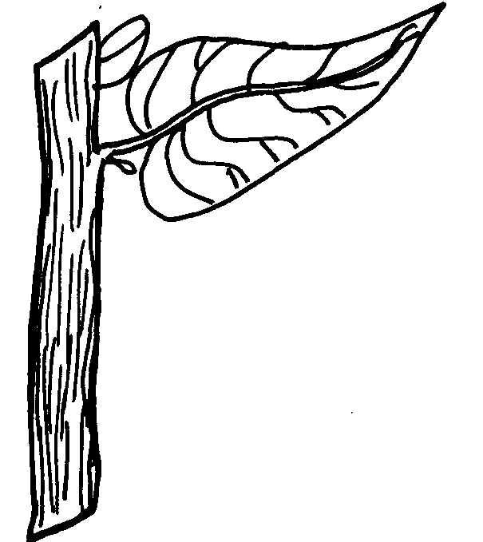

a) What name is given to the vegetative material drawn above for tea propagation
b) State two devisable characteristics of the selected plants used to develop the plant shown
c) Give two precautions observed during the preparation of the material above before planting
25. The diagram below illustrates the spacing which is used when planting beans. Study the diagram
and answer the questions that follow:

a) State the spacing illustrated above
b) Suppose the student is asked to use the illustrated spacing to plant in a plot 4m by 3m leaving
30cm distance from the edge; calculate;
i) The number of rows on the wider side of the plot
ii) Calculate the plant population
26. Using planting material whose diagram is shown below, list four factors that would influence the
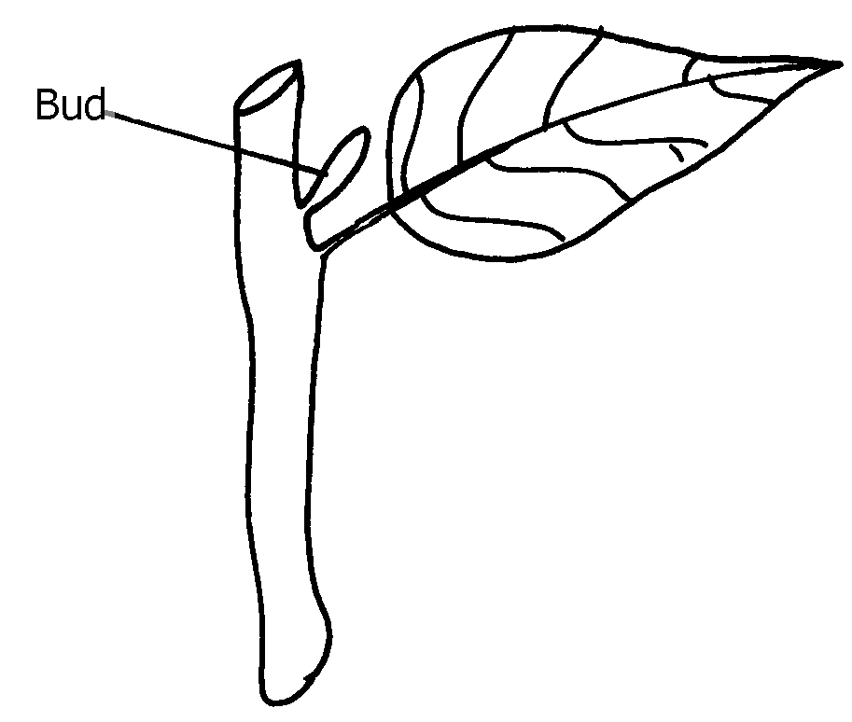
rooting of the structure

27. Describe the selection, preparation and raising of vegetative tea seedlings in the nursery
28. Explain the factors considered in timely planting of annual crops
29. Give four disadvantages of broadcasting as a method of planting.
30. Define the following terminologies as used in Agriculture
31. Give two advantages of producing crops by use of seeds over vegetative propaganda
32. State four ways of preparing planting materials before planting

CROP PRODUCTION III
NURSERY MANAGEMENT PRACTICES

This topic entails the following:
- A nursery bed
- A nursery bed and a seed bed
- Reasons of establishing nursery bed
- Suitable site for nursery bed
- Nursery bed preparation
- Nursery bed management practices
- Transplanting seedling crops from nursery bed
- Budding a seedling
- Grafting a seedling
- Reasons for budding, grafting and layering
- Tissue culture
- Damage caused by animals to a seedling and prevention.

The following relevant questions and their answers in this topic will greatly help and motivate the user to comprehend and understand the required concepts and practices.

1. Name three methods of grafting that are used in propagation of plants
2. State two practices done during hardening-off of seedlings in a nursery bed.
3. List two methods of budding used in crop propagation
4. List four management practices carried out on a nursery bed
5. Outline two importance of tissue culture in crop propagation
6. Differentiate between a nursery bed and a seedling bed
7. Give four advantages of under sowing in pasture production
8. Give four advantages of under sowing in pasture production
9. The diagram below shows a structure used in crop production:
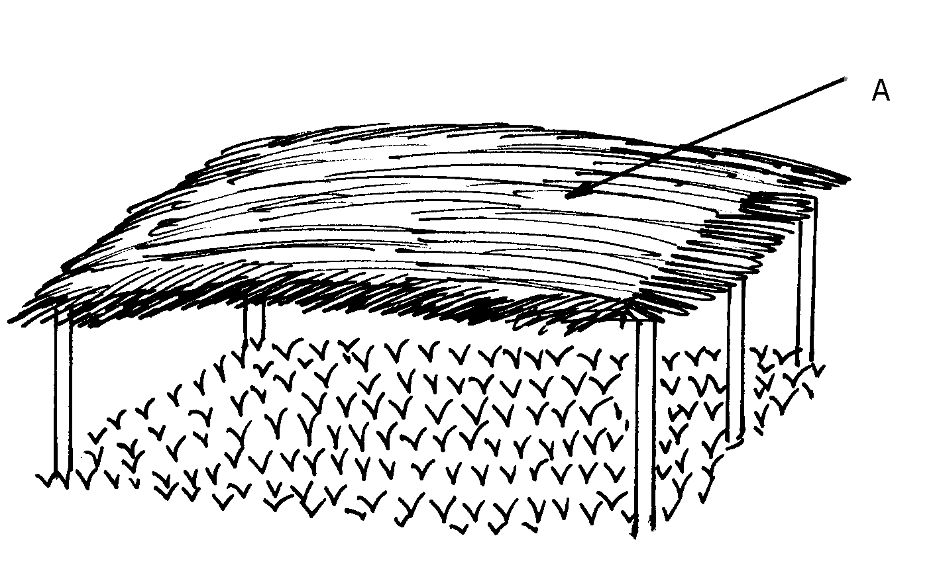

(a) Identify the structure above
(b) Give a reason for carrying out each of the following practices in the structure shown above
(i) Pricking out
(ii) Hardening off
(c) State three importance of the part labeled A in the above structure
10. (a) Describe the siting and establishment of a crop nursery
(b) Explain management practices in a crop nursery
11. State four importance of thinning seedlings in the nursery bed
12. State the difference between a seedling bed and a seedbed.
13. Below is a diagram of a nursery for raising the seedlings
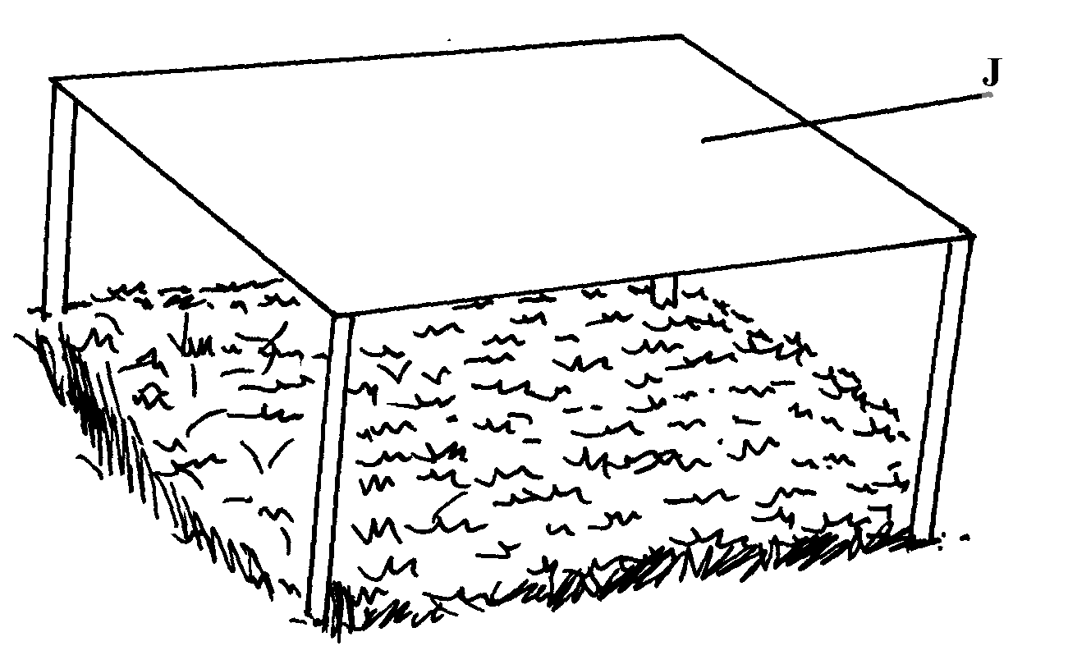

(a) State two advantages of having the part labeled J
(b) State any three management practices that should be carried out on the nursery from the time
seedlings emerge to the stage of transplanting

CROP PRODUCTION IV (FIELD MANAGEMENT PRACTICES)
This topic entails the following:
- Crop rotation
- Reasons for crop rotations
- Crop rotation programme
- Terms used in crop farming
- Mulching
- Reasons for various field management practices
- Correct stage for harvesting crops
- Harvesting practices of various crops.

The following relevant questions and their answers in this topic will greatly motivate and help the user to comprehend and understand the required concepts and practices:

1. Distinguish between staking and propping as a field management practice on crops
2. Explain five advantages of crop rotation
3. State four factors which influence the stage at which the crops are harvested
4. The diagrams labelled B and C below are illustrations of coffee plants established using two
different formative pruning systems.
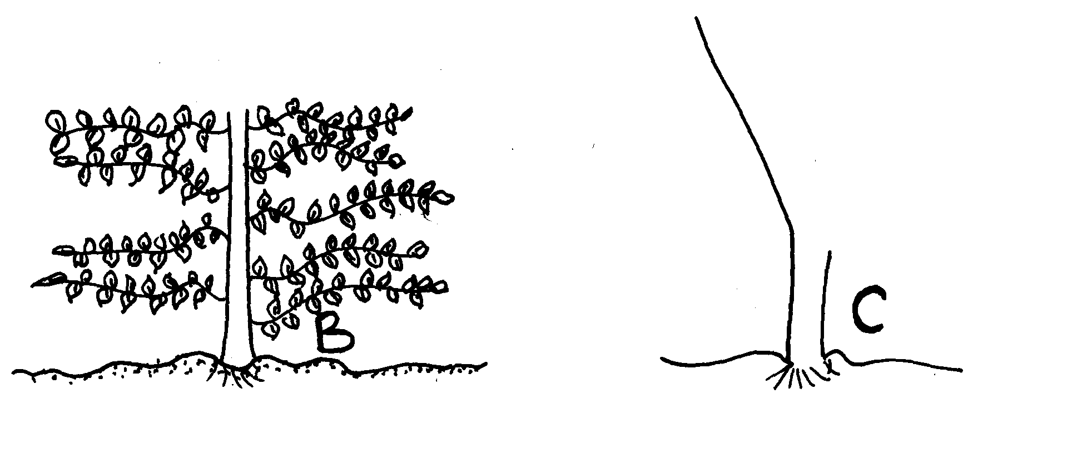
Examine the diagrams and answer the questions that follow:-

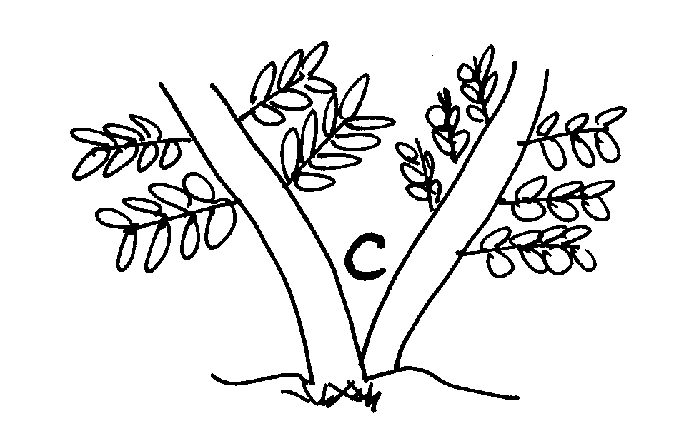

(a) Identify the system of pruning illustrated in B
(b) Identify the system of pruning in C
(c) Outline the procedure of how pruning in diagram C is carried out
5. Give two functions of earthing up in crop production
6. Describe the factors which determine the stage of harvesting of crops
7. Give two ways in which inorganic much helps to conserve water
8. State four factors that determine the spacing of annual crops
9. Explain the importance of each of the following practices: (i) Hardening off
(ii) Pricking out
(iii) Gapping
10. Outline two factors that determine the stage of harvesting crops
11. (a) List four factors that determine harvesting sage of a crop
(b) Give four practices that can be used to control storage pests
12. List four benefits of pruning in crop production
13. (a) What is winnowing?
(b) Give one importance of the following practices: (i) Mulching (ii) Threshing
(c) Which factors are considered when carrying out a crop rotation program?
14. What is frelishing?
15. Briefly explain how each of the factors listed below will determine the stage at which a crop is harvested
(a) Intended use of the crop
(b) Market demand
16. What is roguering in crop production?
17. What is meant by the term “changing the cycle” in coffee growing?
18. The diagram below shows a practice carried out on various crops on the farm. Study them
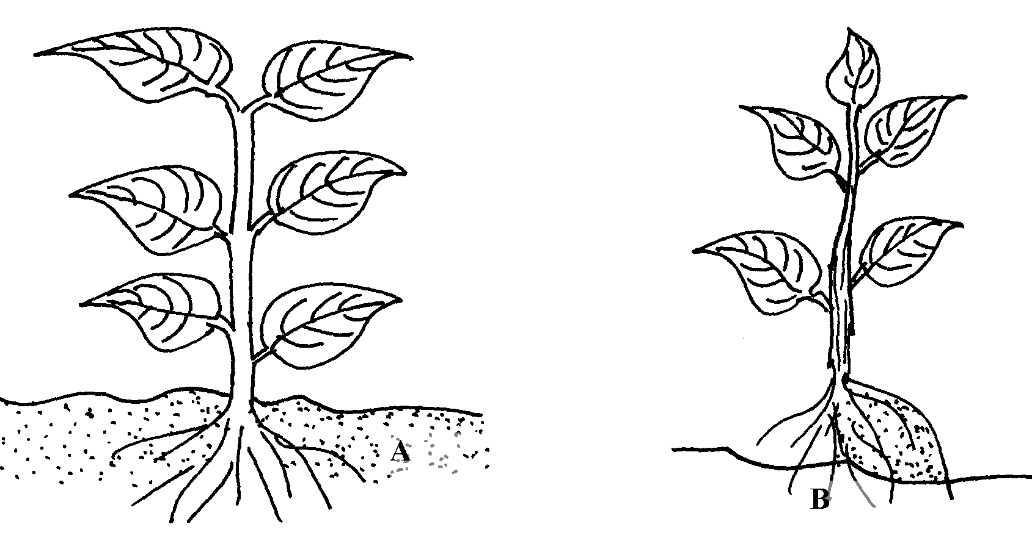
carefully and answer the questions that follow;

(a) Identify the farm practice represented by B
(b) State the importance of the above practice in the following crops;
(i) Maize
(ii) Irish potatoes
(c) At what stage of growth should the above practice be carried out in maize?
19. Mention four factors which determine the stage at which crops are harvested
20. State two limitation of using polythene sheets as mulching materials in a field of tomatoes
21. Give two management practices carried in a banana stool
23. State two functions of polythene sheet when used as mulch material
24. Give four crops requiring training

CROP PRODUCTION V (VEGETABLES)
This topic entails the following:
- Growing or production of a vegetable crop form nursery establishment to harvesting
- Keep records of crop production.
- Market vegetable crop produce
- Give reasons or importance of growing vegetable crops.
- The vegetable crops include the following: Tomatoes, cabbages, onions, carots, kales.

The following relevant questions and their answers in this topic will greatly motivate and help the user to comprehend and understand the required concepts and practices:

1. The diagram below is of a tomato plant. Study it and answer the questions that follow:-
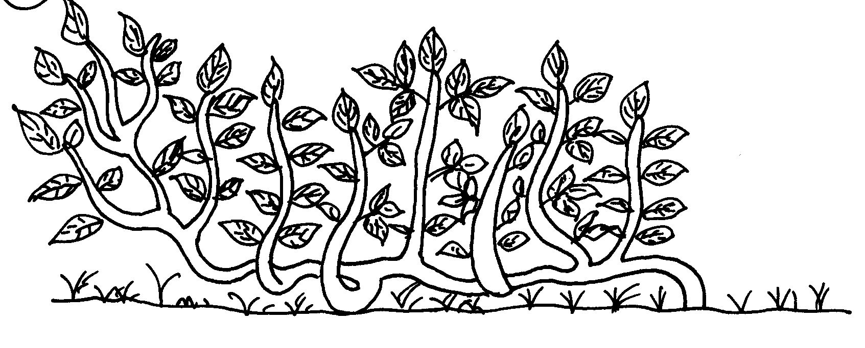

a) State three management practices that have not been carried on the plant above b) For each management practice state one reason why it should be carried out
c) Name two diseases that attack the crop above in the field
2. Describe the production of tomatoes (lycopersicon esculentum) under the following subheadings
a) Varieties
b) Nursery establishment
c) Field management practices
3. List four symptoms of late blight in tomatoes
4. State any four factors considered when grading tomatoes for fresh market
5. State two ways of controlling purple blotch in onions
6. The following is an illustration of an infected tomato plant. Study it carefully and answer the
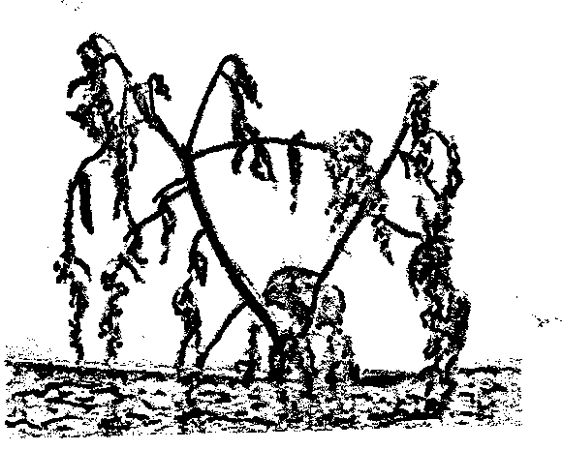
questions below:-

(a) Identify the disease which may have caused the condition shown in the illustration
(b) Name any other crop which may be affected by the disease identified in (a) above (c) Mention two other factors which can lead to the same condition as shown by the illustration
(d) State two measures that can be sued to control the disease named in (a) above
7. Give two ways in which pruning helps to control diseases in tomatoes
8. Outline four ecological requirements for cabbages
9. a) Mention two pests which attack tomatoes
b) Give two causes blossom end rot disease in tomatoes
10. List three ecological requirements of tomatoes.

LIVESTOCK HEALTH
(INTRODUCTION TO LIVESTOCK HEALTH)

This topic entails the following:
- Definition of Health and disease.
- Signs of sickness in animals livestock diseases
- Categories of livestock diseases
- Reasons for keeping livestock in good health
- Disease control practices
- Appropriate methods of handling livestock.
The following relevant questions and their answers in this topic will greatly motivate and help the user to comprehend and understand the required concepts and practices.
1. Identify four physical appearances to be observed in a sick animal
2. State two reasons why tsetse fly control is considered to be a land reclamation method
3. a) Explain five factors to consider when siting a fish pond
b) Explain the measures used to control livestock diseases
4. a) Name four notifiable diseases in livestock
b) Discuss four ways in which livestock disease are spread in the farm
c) Describe the methods of controlling livestock disease giving an example of different disease
in each case

AGRICULTURAL ECONOMICS II
(LAND TENURE AND LAND REFORM)
- Definition of land tenure.
- Description of tenure systems.
- Descriptions of land reforms.
The following relevant questions and their answers in this topic will greatly motivate and help the user to comprehend and understand the required concepts and practices.

1. State four ways by which Re-afforestation help in land reclamation
2. State three objectives of land reforms that are taking place in Kenya
3. State two causes of land fragmentation in Kenya since independence
4. Outline the process followed in land adjudication
5. State four benefits of a farmer having land title deed
6. State four reasons for practicing land consolidation
7. Give four advantages of communal land tenure system
8. State four advantages of landlordism and tenancy
9. Outline four objects of land tenure reform
10. State three advantages of communal land tenure system
11. List down four important details in a land title deed.

SOIL AND WATER CONSERVATION
This topic entails the following:
- Definition of soil erosion
- Explanation of various factors which influence erosion.
- Agents of erosion
- Description various methods of erosion
- Description of various methods of erosion control
- Description of micro-catchments and then uses.

The following relevant questions and their answers in this topic will greatly motivate and help the user to comprehend and understand the required concepts and practices:

1. Name three human activities that may influence soil erosion
2. Below is a diagram showing soil erosion control method
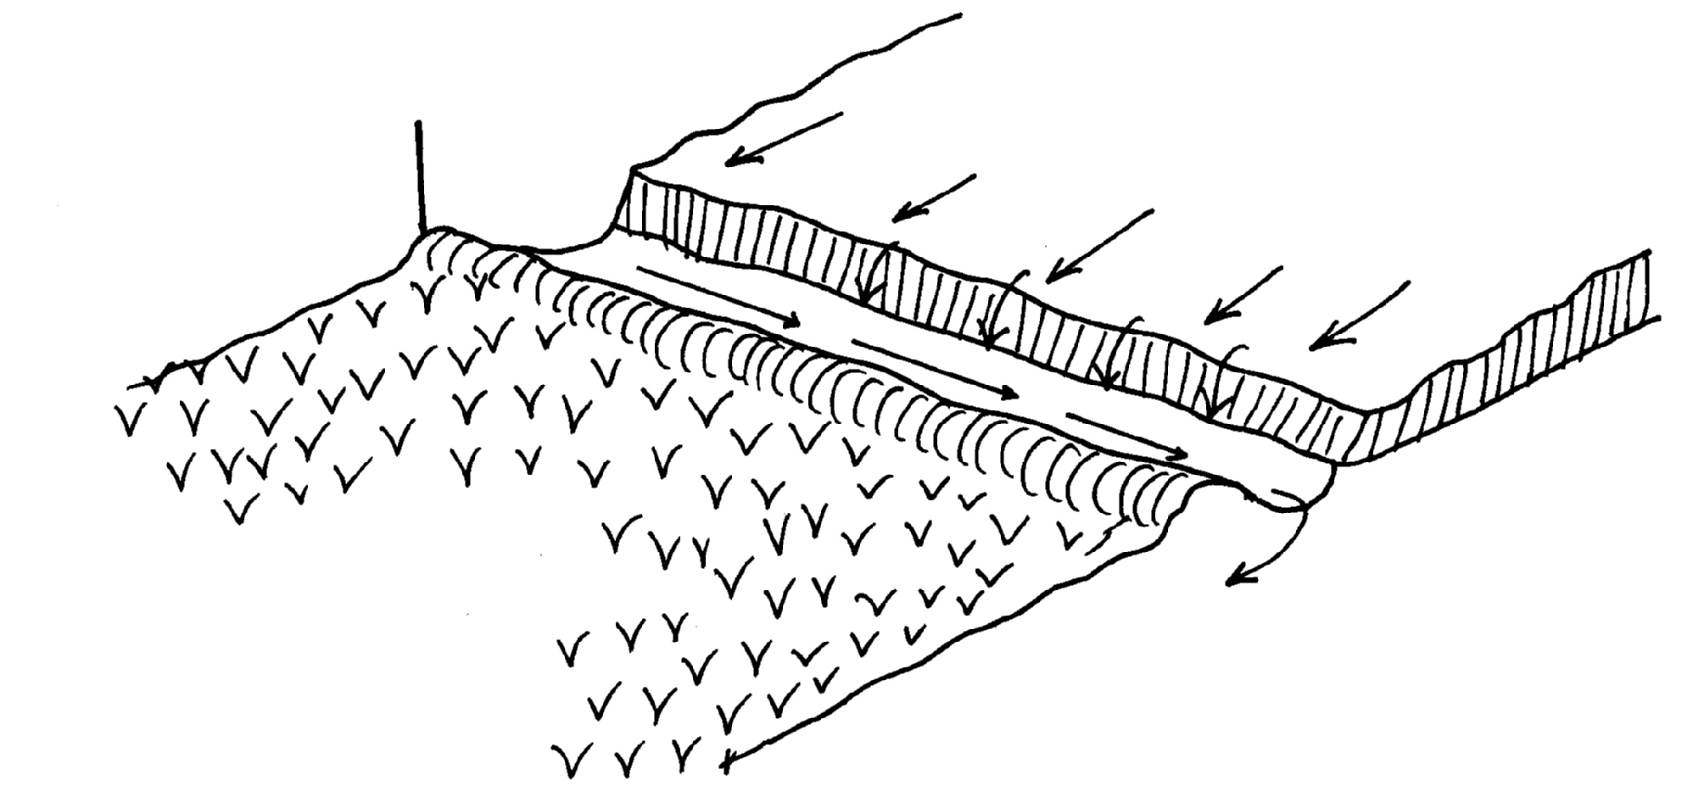
Soil
Uncultivated land
Water movement

Cultivated land with crops

a) Identify the structure used to control soil erosion
b) What is the function of the structure made
c) Why was soil not put on the upper side of the trench made
d) State four effects if water was allowed into the cultivated land
3. Give two roles played by Grassley in soil erosion control
4. List three materials that may be used for constructing a gabion
5. State one factor that would determine the width and depth of a cut off drain
6. Explain five ways by which grass helps to conserve soil
7. Give four farming practices that help in reducing the effects of water shortage in crop production
8. Name two types of terraces
9. Name two forms of gully erosion
9 -V- shaped
-U – shaped
10. Explain the cultural methods of soil erosion control
11. Mention four control measures of river bank erosion
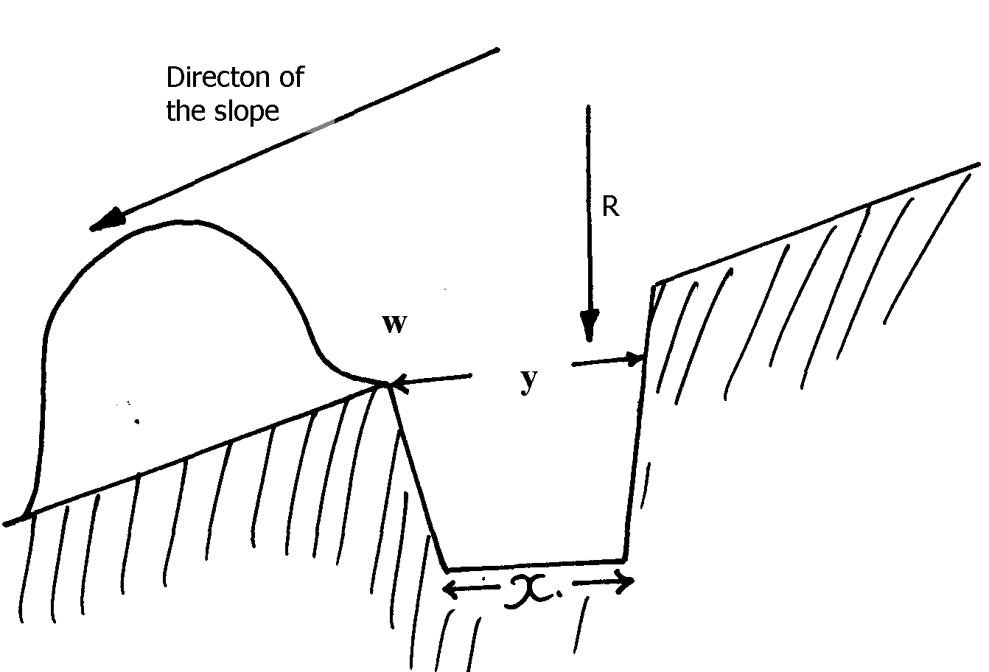
13. The figure below represents a physical soil and water conservation measure used on various slopes

a) Identify the measure represented above
b) Describe the construction of the identified measure above
15. a) What is soil erosion
b) Give four types of water erosion
c) Explain factors which influence soil erosion
d) State any seven cultural ways of controlling weeds
16. Give two ways through which gabions control soil erosion

WEEDS AND WEED CONTROL
This topic entails the following:
- Definition of a weed
- Identification of weeds
- Classification o weeds
- Competitive ability of weeds
- Description of weed control methods
- Harmful effects of weeds
The following relevant questions and their answers in this topic will greatly motivate and help the user to comprehend and understand the required concepts and practices:

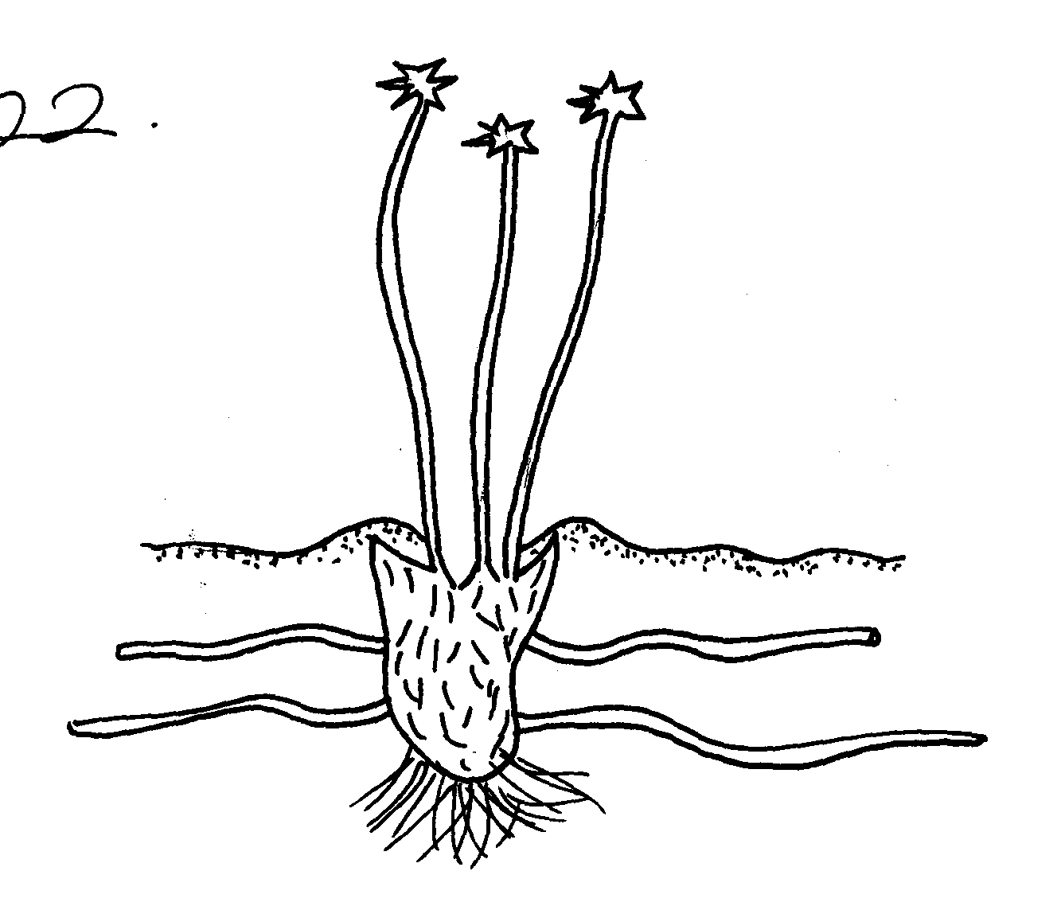
1. Study the diagram below and answer the questions that follow:

(a) Identify the weed
(b) Why is it difficult to control the weed?
(c) State the economic importance of the weed shown above

2. The following is an illustration of a common weed of arable land

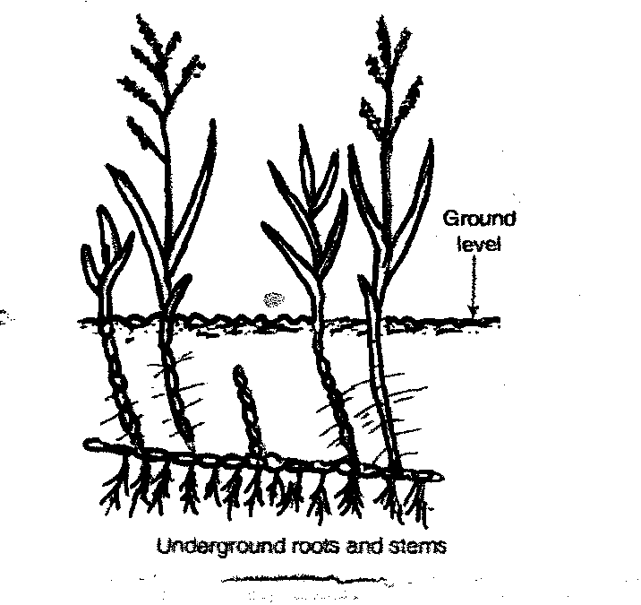

(a) Identify the weed (b) Why is it difficult to control the weed?
(c) State one harmful effect of the weed on crop production
(d) Give two measures used to control the weed
3. Below is a diagram of some common weeds. Study then and answer the questions that follow:-

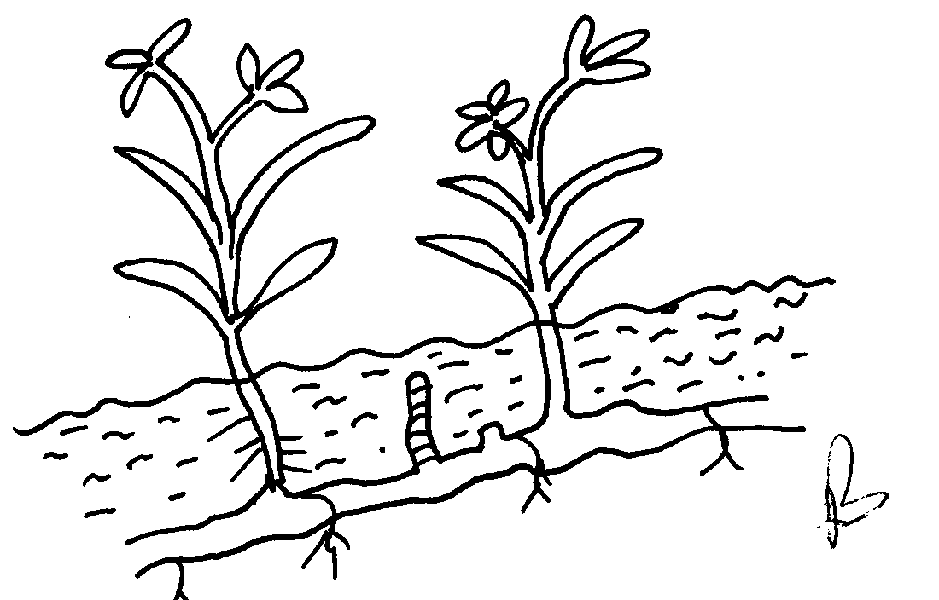

(i) Identify weed A and B (ii) State two effects of weed B on crop production
(iii) Give a reason why weed B is difficult to control
(iv) State the effective method of controlling weed B
4. Give four methods of propagation which make weeds have a high competitive ability
over crops
5. The diagrams below show weeds:-
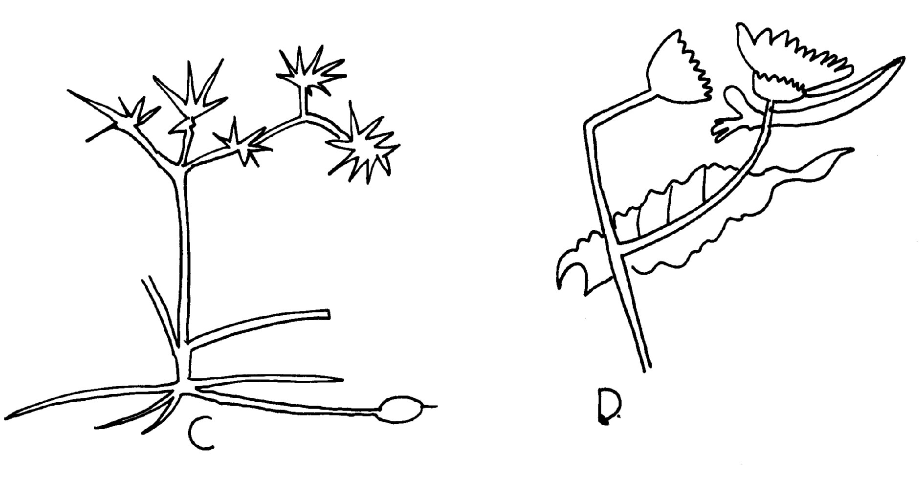

C

D

Identify the weeds C and D

(b) State why it is difficult to control weed C
(c) State two economic importance of weed D
6. (a) List any four types of weeds known to be poisonous to livestock
(b) At what stage of life cycle is best recommended to control weeds?
7. State two disadvantages of using herbicides
8. a) Name four herbicides that can be used to control weeds in a field of maize
b) At what stage of growth of maize should the weeds be controlled by use of a post
emergence herbicides
9. (b) Give an account of economic importance of weeds
10. a) mention two factors that affect selectivity of herbicides
11. Listing specific examples of weeds describe their harmful effects in agricultural production

CROP PESTS AND DISEASES
This topic entails the following:
- Definition of a pest and a disease
- Main cause of crop diseases
- Description of harmful effects of crop pests and diseases
- Identification of crop pests and diseases
- Control measures of crops pests and diseases

The following relevant questions and their answers in this topic will greatly motivate and help the user to comprehend and understand the required concepts and practices:

1. State two possible causes of swelling on the roots of legume crops
2. Discuss the various cultural methods of controlling pests in crops
3. What does the term ‘close season’ mean in crop production?
4. Explain five cultural methods of pest control in stored grains
5. Name four symptoms of viral infections in plants
6. Study the illustrations given below and then answer the questions that follow:-

C
D

(a) Identify the pests shown by the illustrations B, C and D
(b) State one effective method of controlling the pest labelled
(c) Name the type of crop commonly attacked by the pest labelled ‘C’
7. State the various practices carried out in the field to help control crop diseases
8. State two ways in which pesticides kill crop pests

9. The diagram below shows kale seedling attacked by a pest

(a) Identify the pest
(b) What damage does the pest cause to the crop
(c) State two methods of controlling the pest
11. Define the term ‘economic injury level of a pest and integrated pest control management
12. List four harmful effects of crop pests
13. The diagram below shows a fungal disease in a section of potato crop leaf
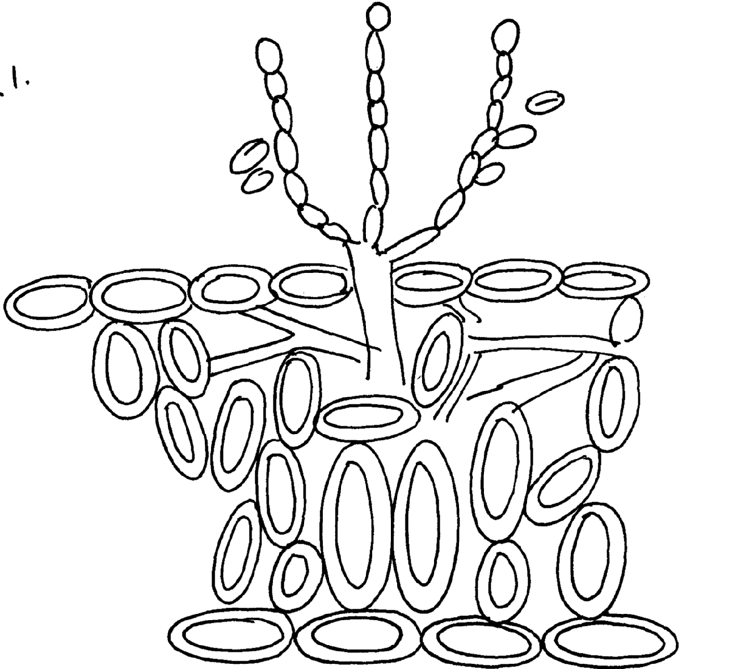

a) Identify the fungal disease
b) (i) State the causal organism of the disease identified above
ii) Give two symptoms of the above disease
c) Give two control measures of the disease
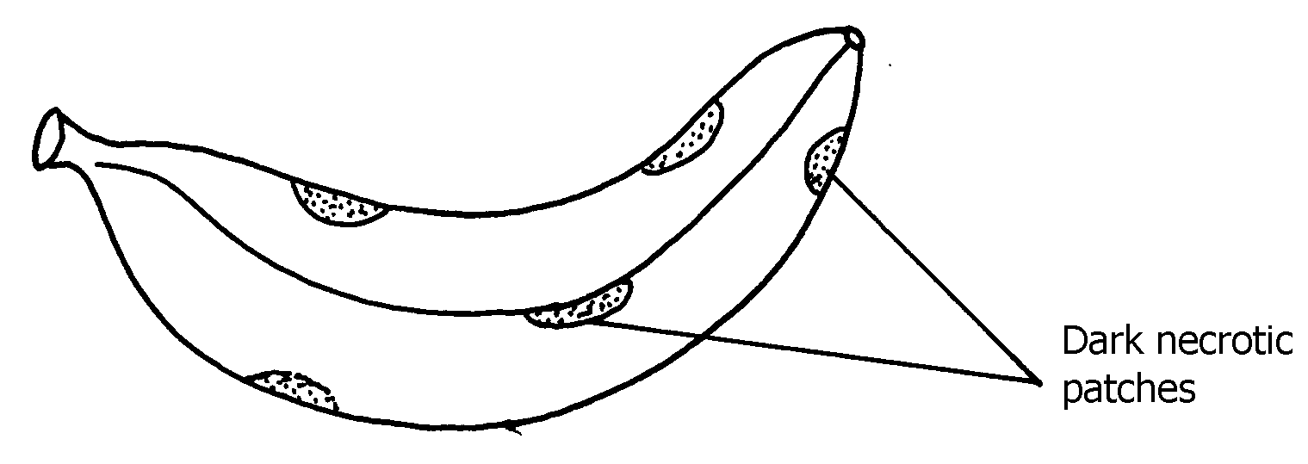
14. The diagram below shows a banana fruit infected by a certain disease.

- Identify the disease
- Suggest any one control measure for the disease you have named in (a)
15. The diagram below shows a crop pest;

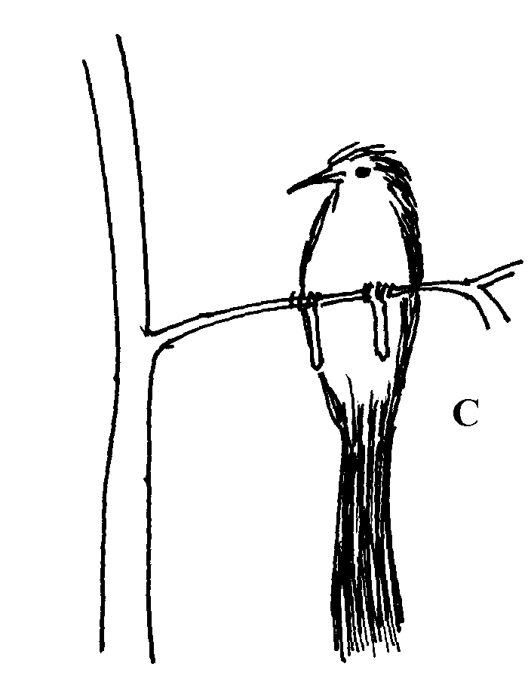

(a) Identify the crop pest
(b) State two damages the pest would cause to crops

16. Give two symptoms of nematode attack on bananas.
17. Give four cultural practices used in controlling crop pests
18. State three symptoms of coffee berry disease.

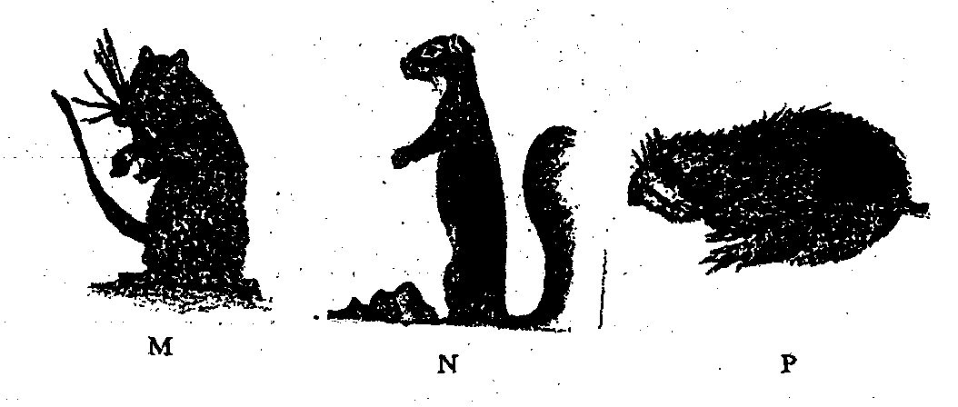
19 (i) Use the diagrams below to answer the question that follow.

(a) Identify the crop pests labeled M, N and P
(b) State one control measures of crop pests labeled M
(c) State the damage caused to crops by crop pest labeled N
20. State and explain the cultural methods of pest control

CROP PRODUCTION VI
FIELD PRACTICES FOR MAIZE, MILLET, SORGHUM, BEANS AND RICE: HARVESTING OF COTTON PYRETHRUM, SUGAR CANE COFFE AND TEA

This topic entails the following:
- Description of management practices of the food crops from planting to harvesting and marketing.
- Economic value of food crops and industrial crops
The following relevant questions and their answers in this topic will greatly motivate and help the user to comprehend and understand the required concepts and practices:

1. List four management practices carried out in maize field at 45cm high
2. Why is it not recommended to use sisal bags in handling cotton
3. Describe the production of rice under the following sub-headings:-
(a) Land preparation
(b) Water control
(c) Fertilizer application
(d) Weed control
(ii) Describe the environmental conditions that may lead to low crop yields
4. Describe the production of maize for dry grain production under the following sub-headings:-
(a) Seedbed preparation (b) Planting
(c) Weed control
(d) Pest control
(e) Disease control
(f) Harvesting
5. Two precautions taken when harvesting cotton
6. Describe production of maize under the following sub-headings ;
(a) Varieties
(b) planting
(c) pest and pest control
(d) harvesting and storage
7. Describe the field production of maize under the following sub headings
a) Ecological requirement
b) Varieties
c) Seedbed preparation
d) Pests and diseases
e) Harvesting
8. a) Discuss harvesting of cotton b) Explain the roles of Agricultural co-operatives in Kenya
9. Describe the production of maize under the following sub-headings:
(a) Ecological requirements
(b) Land preparation (c) Planting and field management
(d) Pests and disease control
(e) Harvesting and marketing
10. Give two precautions measures a farmer should put into consideration when harvesting cotton
11. Describe the production of beans under the following sub headings:
(a) Ecological requirements
(b) Seedbed preparation (c) Planting (d) Pest and pest control

FORAGE CROPS
This topic entails the following:
- Definition and classification of pasture crops.
- Identification of pasture corps
- Description of ecological requirements of forage crops
- Description of the establishment of pasture and fodder crops
- Description of forage utilization and conservation.
The following relevant questions and their answers in this topic will greatly motivate and help the user to comprehend and understand the required concepts and practices.

1. State three factors which affects the quality of standing forage given to livestock
2. Explain Napier grass production under the following sub-headings
i) Seedbed preparation
ii) Planting
iii) Fertilizer application
iv) Weed control
v) Utilization
3. Why is it necessary to allow freshly cut nappier grass to wilt before ensiling
4. Describe the establishment of grass pasture from the time the land is ploughed using a mould
board plough to the time the pasture is ready for grazing
5. State two causes of failure in pasture establishment
6. State two advantages of grass-legume mixture
7. List four factors that determine the quality of hay
8. i) Discuss the production of Guatemala grass (Trypsacum Laxum) under the following headings
a) Ecological required
b) Land preparation
c) Planting
d) (i) Utilization and defoliation
ii) Discuss six effects of late defoliation of fodder
9. Give four factors that determine the nutrient content in hay
10. (a) Describe the preparation of the following farm materials:-
(i) Farm yard manure
(ii) Hay
(b) Explain the factors considered in timely planting of annual crops
11. (a) What is topping in pasture management
(b)State two methods used in topping in pasture management
12. Give two advantages of grass-legume pasture over pure grass pasture
13. Why are farmers encouraged to conserve excess forage in the farm?
14. Give two factors affecting the quality of hay

AGRICULTURAL ECONOMICS III
(PRODUCTION ECONOMICS)

This topic entails the following:
- Parameter of national development
- Factors of production
- Law of diminishing returns
- Farm planning and budgeting
- Agricultural services
- Risks and uncertainities
- How to adjust to risks and uncertainities.

The following relevant questions and their answers in this topic will greatly motivate and help the user to comprehend and understand the required concepts and practices:

1. State four ways of increasing labour efficiency on the farm
2. The table shows egg production from individual birds with varying mounts of layers mash

100 layers  (Fixed number) | Layers mash  Kgs/week | Total egg production per week | Marginal production per week
100 | 0 | 140 | 0
100 | 10 | 155 | 15
100 | 20 | 180 | 25
100 | 30 | 240 | 60
100 | 40 | 340 | 100
100 | 50 | 470 | 130
(a) Sketch a graph representing the total egg production per week against amount of feed given
(b) Identify the type of production function represented by the graph in (a) above

3. (a) What are the uses of farm records to a farmer? (b) Explain four ways in which a farmer may improve Labour productivity in the farm
(c) Outline the process followed in land adjudication
4. Name any three types of agricultural services available to the farmer
5. Outline four management guideline questions which assist a farm manager in making accurate
farm decisions
6. Give four ways of improving labour productivity
7. List four variable inputs in sorghum production
8. List four agricultural support services available to a crop farmer in Kenya
9. Define the following as used in Agricultural economics:-
(a) Gross domestic product (GDP)
(b) Per capita income
10. Explain the various ways in which farmers may adjust to risks and uncertainties
11. (a) The table below represents the yield of maize in 90kg bags in response to application of
different quantities of planting fertilizer
(i) Fill in the blank spaces

Input 50kg bag fertilizer | Out put 90kg bag maize | Average product (AP) | Marginal product (MP)
0  1  2  3  4  5  6  7  8 | 6  10  24  31  36  40  43  43  40 | -  -  -  -  -  -  -  -  - | -  -  -  -  -  -  -  -  -

(ii) Suggest the best level of production in relation to the inputs and output
(b) A farmer is considering undertaking the production of either maize or beans. Study the
following information about the two crops then answer the questions that follow:

(i) Maize
Yield per hectare 5,500 kg
Price 15 per kg
Cost of cultivation / ha Kshs. 3000
Amount of seeds/ha 25kgs
Cost of DAP fertilizer/bag Kshs.1,500
Amount of DAP fertilizer/ha 3bags
Cost of seeds/kg Kshs.100
Labour requirements/ha 50 man days
Cost of labour Kshs.150 per man day
Amount of CAN fertilizer/bag 3 bags
Cost of CAN fertilizer/bag Kshs.1000

(ii) Beans
Yield per hectare 5000kg
Price 50per kg
Cost of cultivation / ha KShs.3600
Labour requirements/ha 75 man days
Cost of labour Kshs. 200 per man day
Cost of DAP fertilizer/bag Kshs. 1500
Amount of DAP fertilizer/ha 2bags
Cost of seeds/kg Kshs.800
Amount of seed/ha 20kg
Amount of CAN fertilizer/bag 1bag
Cost of CAN fertilizer/bag Kshs.1,000
Cost of sprays Kshs.3,000
(i) Calculate the gross margins for each crop (14mks)
(ii) From your calculation, which crop is profitable to grow?
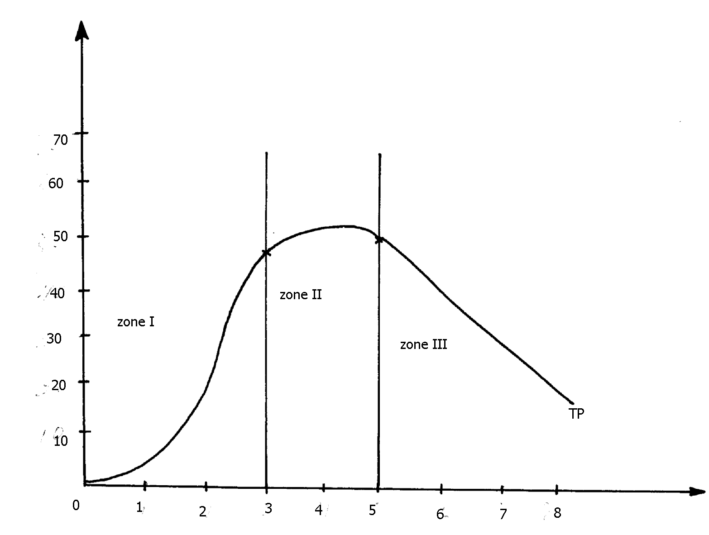
12. Below is a graphical representation of the law of diminishing returns.

Maize output (in 90kg bags)

NPK fertilizer input (in 50kg bags)

(a) Explain what happens in each of the three zones marked I and III in relation to the output
of maize and the NPK fertilizer input
(b) Which of the three is a rational zone of production
13. Give four variable costs in maize production
14. A farmer has the following yield from a two hectare millet crop enterprise at Oluch irrigation schemes.
Study it and prepare his gross margin. is it profitable to grow millet? He spent the following in
his operations
Weed 800/=
Seeds 20kg/ha
Irrigation 600/=/ha
Ploughing 500/=/ha
Clearing the land 1200/=
Cost of seeds 300/= /10kg bag
Planting 400/= /ha
Harvesting 1200/= /ha
Yield 32bags
DAP fertilizer 2 bags at 10 000/= /50kg bags
CAN fertilizer 2 bags at 700/= /50kg bags
Gunny bags 40/= /bag
Transport to market 2000/=
14. A farmer has the following yield from a two hectare millet crop enterprise at Oluch irrigation schemes. Study it and prepare his gross margin. is it profitable to grow millet? He spent the following in his operations
Weed 800/=
Seeds 20kg/ha
Irrigation 600/=/ha
Ploughing 500/=/ha
Clearing the land 1200/=
Cost of seeds 300/= /10kg bag
Planting 400/= /ha
Harvesting 1200/= /ha
Yield 32bags
DAP fertilizer 2 bags at 10 000/= /50kg bags
CAN fertilizer 2 bags at 700/= /50kg bags
Gunny bags 40/= /bag
Transport to market 2000/= (20mks)

15. What is profit maximization in Agricultural Economics
16. a) A farmer is considering undertaking the production of either maize or beans. Study the
following information about the two crops and then answer the questions that follow:

Maize
Yield per hectare | 5500kg
Price | Kshs.15 per kg
Cost of cultivation/ ha | Kshs. 3000/=
Amount of DAP fertilizer/ bag | Kshs.1500/=
Amount of DAP fertilizer/ ha | 3 bags
Cost of seed/ Kg | Kshs.100
Labour requirements / ha | 50 man days
Cost of labour | Kshs.150 per man day
Amount of CAN fertilizer | 3 bags
Cost of CAN fertilizer/ bag | Kshs.1000

Beans
Yield per hectare | Kshs.5000
Price | Kshs.50 per kg
Cost of cultivation/ ha | Kshs.3600
Labour requirements/ ha | 75 man- days
Cost of labour | Kshs.200 per man day
Cost of DAP fertilizer/ bag | Kshs.1500
Amount of DAP fertilizer/ ha | 2 bags
Cost of seed/ kg | Kshs.80
Amount of seed/ ha | 20kg
Amount of CAN fertilizer/ | 1 bag
Cost of CAN fertilizer/ bag | Kshs.1000
Cost of sprays | Kshs.3000

i) Calculate the gross margin for each crop
ii) From your calculation which crop is profitable to grow
b) Discuss five factors considered when planning a farm
17. Using the data provided in the table below, make an interpretation and advice the farmer on which
crop to grow ;
Type of crop | Gross margin (Ksh)
Cotton | 18,400
Ground nuts | 20,050
18. Outline three advantages of budgeting in farm business
19. A farmer has 1 Ha piece of land on which he grows maize. His farm record on maize
production for nine years is as shown in the table below:
Year | Fertilizer applied (bags) | Total output of maize (bags)
1995 | 0 | 4
1996 | 2 | 10
1997 | 4 | 28
1998 | 6 | 42
1999 | 8 | 52
2000 | 10 | 60
2001 | 12 | 66
2002 | 14 | 66
2003 | 16 | 64

(a) i) Using an appropriate scale, with input on the X-axis draw a graph to show the relationship
between inputs and total output
(ii) From the graph you have drawn, how many bags of maize would the farmer produce if
he applied 9bags of fertilizer?
Calculate the farmers marginal products and average products for the years (i) From the data given, what rate of fertilizer application would the farmer choose if he
wanted to grow maize in 2004?
(ii) Give an explanation for your choice in (c) (i) above
(b) Assuming that the average price of fertilizer over the years recorded was shs. 1,200/= per bag
and the price of maize was ksh.1000/= per bag :
Calculate the gross income for the years 2002 and 2003
Calculate the net income for the year 1999. (Assume no other costs were incurred)
20. Name five types of costs incurred in a farming business
22. List any four sources of credit to farmers.
23. List three ways in which labour peaks can be overcome in the farm (1½ mks)
24. State four ways of improving farm labour productivity
25. A farmer had a plot of land measuring 5 hectares in which be intended to plant maize.
He was advised to apply 150 kg of P₂0 per hectare at planting and 200kg N per hectare during
top dressing. The fertilizer available in the market was Calcium Ammonium Nitrate containing
20% N and Di-ammonium phosphate 46% P₂0₅. Calculate.
(a) (i) The amount of Di—ammonium phosphate required
(ii) The amount of calcium ammonium nitrate required
(b) Baraka farm manager plans to grow Irish potatoes or maize for grains. Study the information
below and answer the questions that follow:

Irish potatoes
Cost of fertilizers/ha____________________________ Ksbs 10,000.
Labour requirements/ha ______________________ Kshs 50 man - days
Yield /ha ___________________________________ 10,000kg
Seed potato/ha ________________________________Kshs20, 000
Cost of labour ___________________________ Kshs 200 per man day
Cost of fungicides___________________________ Kshs 5000
Cost of ploughing____________________________ Kshs 4000
Selling price of potatoes per kg __________________ Kshs 30.

Maize
Yield per hectare ______________Kshs.7,500kg
Selling price of maize per kg _____________Kshs 20.
Cost of ploughing /ha ________________Kshs.4000
Seed maize/ha _____________________Kshs.3000
Labour requirement /ha _________________________ 200 man days.
Cost of fertilizers /ha ____________________Kshs 10,000
Cost of top dressing fertilizers __________________Kshs 4,800
Cost of labour _____________Kshs 150 per man - day

(i) What is gross margin?
(ii) Calculate the gross margin of each of the crops
(iii) From the calculation above which crop should the farm grow?
(d) Describe the environmental factors that may lead to poor yields in crop production

AGRICULTURAL ECONOMICS IV

This topic entails the following:
- Importance of farm accounts
- Financial documents and their uses
- Analysis of financial statements
- Books of accounts and their uses.

The following relevant questions and their answers in this topic will greatly motivate and help the user to comprehend and understand the required concepts and practices:

1. Name three methods of grafting that are used in propagation of plants
2 a) The following transactions were extracted from Mr. Tembo’s financial books for the year
ending 31st Dec 2003.study and answer the questions that follow:
Particulars cost (ksh)
Milk sale 8 000
Goat sale 500
Purchase of farm tools 1 000
Construction of zero grazing unit 10 000
Depreciation of machinery 800
Closing stock 16 000
Veterinary bills 400
Interest payable 750
Wages 4 800
Sales of cabbages 750
Sales of tea 4 700
Opening stock 12 000
Sales of heifers 9 400
Purchase of pesticides 300

(a) i) Prepare a profit and loss account for Mr. Tembo’s farm for the year ending 31st Dec. 2003
ii) Calculate the percentage profit or loss made by the farm
b) i) Give five functions of farmer’s cooperative societies
ii) Outline five common risks and uncertainties in farming

3. State four reasons for using certified seeds for planting
4. List any two financial statements which may be prepared on a farm
5. The following information was obtained from Lang’at’s farm records for the year ending
December, 2004. Study it and answer the questions that follow:-
Goats 4,000
Poultry 15,000
Causal workers 12,000
Opening valuation 150,000

His sales and receipts are as follows:
Mohair 75,000
Rabbits 3,600
Eggs to hotel 15,000
Closing valuation 200,000
(a) Prepare the profit and loss A/C of Lang’at’s farm
(b) State the benefit of a profit and loss A/C to Mr. Lang’at

6. (a) List any four financial documents used in the farm
(b) Prepare a profit and loss account for Mr. Rob’s farm for the year ending 31st Dec. 2009, given
the following information:-
Sale of milk Kshs.10,000
Sold two heifers kshs.10,000
Cabbage sold Kshs. 20,000
Debts payable Ksh.4,200
Sold tomatoes Kshs. 3,000
Veterinary bills Kshs.2,500
Bought livestock feeds Kshs.2,500
Purchase fertilizers Kshs.5,000
Bought seeds Kshs. 4,000
Debts receivable Kshs.20,000
Opening valuation Kshs.150,000
Closing valuation Kshs.200,000
(c) Did the farm make a profit or a loss? Calculate the percentage profit or loss made by the Farm
(d) Explain the various ways in which farmers may adjust to risks and uncertainties
7. a) The following transactions were extracted from Mr. Tembo’s financial books for the year
ending 31st Dec 2003.study and answer the questions that follow:
Particulars cost (ksh)
Milk sale 8 000
Goat sale 500
Purchase of farm tools 1 000
Construction of zero grazing unit 10 000
Depreciation of machinery 800
Closing stock 16 000
Veterinary bills 400
Interest payable 750
Wages 4 800
Sales of cabbages 750
Sales of tea 4 700
Opening stock 12 000
Sales of heifers 9 400
Purchase of pesticides 300

i) Prepare a profit and loss account for Mr. Tembo’s farm for the year ending 31st Dec 2003
ii) Calculate the percentage profit or loss made by the farm
b) i) Give five functions of farmer’s cooperative societies
ii) Outline five common risks and uncertainties in farming

8. At the end year ended 31/12/2005 Bidii farm recorded the following:
Perennial crops 250,000
Bank loans 30,000
Cash at hand 5,000
Bank overdrafts 15,000
Land 350,000
Unpaid wages 3,000
Debts receivable 20,000
Stocks in store 25,000
Livestock 200,000
Bank balances 100,000
(a) Prepare a balance sheet as at 31/12/2005
(b) Did Bidii farm qualify for a loan and why?

9. State one condition in which each of the following documents is used.
i) Invoice
ii) Delivery note
iii) Receipt
10. Below is a transaction showing Mrs.Okello’s financial position in her business for the year 2009
-Purchase of pesticides 3,000 00
-Milk sales 8,000 00
-Sales of goats 5,000 00
-Construction of store 10,000 00
-Closing valuation 16,000 00
-Depreciation of machinery 3,000 00
-Interest payable 1,750 00
-Purchase of farm tools 800 00
-Veterinary bills 1,400 00
-Sales of tomatoes 1,750 00
-Wages 10,000 00
-Sales of heifer 10,000 00
-Opening valuation 12,000 00
-Sales of coffee 5,000 00
i) Prepare a profit and loss account for Mrs. Okello’s farm
ii) Calculate the percentage profit or loss that Mrs. Okello made during the year 2009
iii) Explain six ways in which farmers adjust to risk and uncertainties in farming
11. Name two examples of liabilities in a balance sheet

AGRICULTURE ECONOMICS (V)
This topic entails the following:
- Market and marketing
- Types of markets
- Supply and demand
- Marketing functions
- Problems of marketing
- Agricultural organizations

The following relevant questions and their answers in this topic will greatly motivate and help the user to comprehend and understand the required concepts and practices.

1. a) Explain the principle that govern the operations of farmers’ co-operative societies
b) Explain the role of agricultural cooperatives in Kenya
c) Explain various functions of agricultural marketing
2. a) Give four marketing functions
b) Outline four problems associated with marketing of agricultural products
3. State two roles of agricultural society of Kenya
4. (a) What is elasticity of demand for a commodity
(b) Given that at a price of shs.1000 per bag, 20 bags of maize are demanded but when the price
changes to shs.800 per bag, 22 bags are demanded. Calculate the elasticity of demand. Show
your working
(c)Outline six problems of marketing maize as an agricultural product
(d) Determine nine principles governing cooperatives in Kenya
5. Outline four reasons why training is important in some crops
6. (a) Explain marketing activities in Agriculture
(b) Discuss problems experienced in marketing of Agricultural products
7. What is elasticity of supply

8. How do the governments control prices of essential farm produce
b) Explain the roles of Agricultural co-operatives in Kenya
9. State the law of demand and supply.
10. What do the following initials stand for?
(i) K.N.F.U – Kenya National Farmers Union
(ii) H.C.D.A – Horticultural Crops Development Authority
11. (a) What is a co-operative society
(b) List two functions of co-operatives
(c) State and explain the nine principles of governing co-operatives
12. Give four factors which influenced the demand of tomatoes in the market

AGROFORESTRY

This topic entails the following:
- Definition of agro forestry
- Importance of agro forestry
- Forms of agro forestry
- Importance of trees
- Selection f trees to plant
- Routine management practices on trees
- Methods of tree harvesting.

The following relevant questions and their answers in this topic will greatly motivate and help the user to comprehend and understand the required concepts and practices.

1. State two reasons for seed treatment of tree species before planting
2. State four ways by which Re-afforestation help in land reclamation
3. List four advantages of agro-forestry
4. The illustrations below are techniques of harvesting agroforestry trees. Study them carefully and
then answer the questions below:-

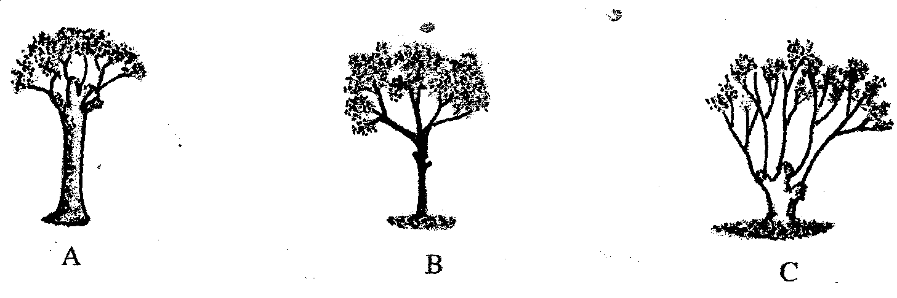

(a) Identify the harvesting techniques represented by techniques A and B
(b) Give an example of a tree species suitable for technique B and C as a method of harvesting
5. State four factors considered when choosing trees for Agroforestry
6. (a) Five characteristics of trees used in agroforestry are;
(b) The benefits of agroforestry are:
7. Name four forms of agro- forestry
8. Give four characteristics that good agro-forestry tree should posses

ANSWERS SECTION 1

INTRODUCTION TO AGRICULTURE

1. two factors which characterize intensive farming
- Small farms
- Huge capital
- Skilled labour
- Produce for sale
Mechanization done
2. three reasons why organic farming is encouraged in farming
- Cheap
- Environmental friendly
No chemical residues in produce
3. two ways in which Agriculture contributes to industrial development.
- Provide raw materials for industries.
- Provide market for industrial goods.
- Is a source of capital for starting industries.
4. four ways by which wind affects the growth of crops.
- Causes physical damage to crops.
- Cause rapid spread of diseases/ pests/ weeds.
- Can cause water stress as a result of evaporation.
- Causes stress of crops due to chilling caused cold winds.
- Encourage transpiration hence water and mineral uptake.
- Agriculture – rearing of fish in fish ponds
5. One physical characteristic used in classifying soil is:
- Colour,
- Texture,
- Structure
6. Four advantages of organic farming
- Environmental friendly
- Products do not have organic farming
- Products do not have organic chemical residue
- Improve soil structure
- Replenishes nutrients in the soil as it uses organic manure
- Enhances soil water retention
- Provides food for soil microbes
- Enhances soil water infiltration
7. Two conditions under which shifting cultivation is practiced are:
- Can only be practiced where land is abundant
- Practiced where population is sparse
- Practiced where number of livestock per units low (2 ½mks)
8. Four factors that determine the time of planting a crop
(a) Olericulture – production of vegetables
- Floriculture – production of flowers
(b) Apiculture – bee keeping
- Agriculture – rearing of fish in fish ponds

FACTORS WHICH INFLUENCE AGRICULTURE
1. two roles of humus in the soil that are beneficial to crops
- Provide nutrients
- Increase water holding capacity
- Increase soil temperature
Neutral soil PH
2. a) five activities that may be undertaken in organic farming
- Mulching
- Apply manure
- Use medicinal plants to control parasites and diseases
- Crop rotation
- Rear livestock on natural organically grown pasture
- Physical/ cultural/ biological/ pests, weeds and disease control
3. four effects of temperature on crop growth
Low temp-slow growth rate
-increase incidence of negative infection e.g. CBD
-improve quality of some crop
High temp-cause wilting
-increase growth rate
-improve quality of some crops
-increase pest and disease incidences (1/2x4=2mks)
4. four ways by which wind affects the growth of crops.
- Causes physical damage to crops.
- Cause rapid spread of diseases/ pests/ weeds.
- Can cause water stress as a result of evaporation.
- Causes stress of crops due to chilling caused cold winds.
- Encourage transpiration hence water and mineral uptake.
5. Two factors related to light that affect crop production and distribution in Kenya:-
- Light intensity
- Light duration
- Light wavelength
6. The environmental conditions that may lead to low crop yields
- Poor soil fertility /infertile soil
- Damage by hailstorms
- Less rainfall/unreliable/drought
- Poor soil type resulting into leaching or water logging
- Inappropriate soil PH
- Inappropriate temperature (too low or high)
- Excessive wind leading to increase in water loss from the soil
- Extreme relative humidity
- Extreme of light intensity
- Topography / some attitudes e.g. very high may limit crop growth ( 1mk x any 7pts = 7mks)
7. - Rainfall
- Soil
- Topography
- Light
- Wind
8. One physical characteristic used in classifying soil is:
- Colour,
- Texture,
- Structure

9. Four advantages of organic farming
- Environmental friendly
- Products do not have organic farming
- Products do not have organic chemical residue
- Improve soil structure
- Replenishes nutrients in the soil as it uses organic manure
- Enhances soil water retention
- Provides food for soil microbes
- Enhances soil water infiltration ( 4x ½ = 2mks)
10. (a) The aim of the experiment was:- to show presence of living organisms in the soil
(b) observations were:
- Flask D - Limewater turns milky/turbid (1mk)
- Flask E – Lime water remains clear (1mk)
(c) The reason for the observation in flask D is:-
Carbon dioxide which turns water milky in flask D would have been produced only during the respiration of living organisms present in fresh soil
11. - It may have hard pan which interfere with water infiltration
12. a) - Light duration
- Light intensity
- Light wave length ( ½ x3=1 ½ mks)
b) Evapotranspiration
- Presence of pest
13. a) - E – Single grained structure
- F – Granular structure (1x1=1 mk)
b) i) Humus with clay (1x1=1 mk)
ii) Air space (1x1=1 mk)
c)- Colour affects soil texture and hence micro- organisms in the soil √
- Texture – affects drainage, aeration and capillary
- Structure – affects aeration and root penetration
14. three physical characteristics of soil (1 1/2mks)
- Soil structure
- Soil texture
- Soil colour
15. a) State merits of horizon A
- source of plant nutrients
- support/anchor the crops
- store of water for the crops
- sources of soil micro organism
b) State distinct features of horizon B
- deficient of humus(nutrients)
- contain leached nutrients
- contains more compact soil particles
- presence of hard pans in some soils
c) Transitional zone-this is a zone bordering two adjacent layer of soil profile
i)Weathered rock
Importance
- Give rise to sub soil
- Source of minerals
- Determine mineral content of soil and type of soil
16
- Low temperatures encourages crop diseases such as leaf rust
- Low temperatures may increase or lower the quality of farm produce
- High temperatures hastens maturity/ improves the quality/ lower the quality
- Increases the rate of evapo transpiration which may result loss plant moisture/ leading to wilting of crops
17.
- Movement of animals in large numbers
- Decomposition of plant and animal remains by soil micro- organisms
- Physical breaking of rocks by roots of higher plants
- Man’s activities e.g. cultivation, mining and road construction
- Mixing up of soil by animals e.g. earth worms and
18. - Temperature/ Altitude
- Soil type;
- Prevailing winds;
- Rainfall; (4x ½ =2mks)
19. - It influences the movement of the weathered materials hence affecting the depth of soil development;
22. two importance of parent’s material in soil profile
- Determine soil characteristics
- Determine soil depth
Determine soil nutrients
23. four ways of modifying soil temperature in crop production
- Mulching
- Pruning
- Shading of crops
- Irrigation (4x ½ mks)
24. a) two factors that affect selectivity of herbicides
- Stage of plants growth
- Plants morphology and anatomy
- Mode of action
- Environmental factors (2x1=2mks)
b) Name two farming practice that cause water pollution
25. four factors that influence soil formation
- Parents rock material
- Climate
- Topography
- Biotic/organic/living organism
26. - Drainage
-Aeration
-Water-holding capacity
-capillary
27. -large animals e.g. Buffaloes
-Man activities e.g. farming
-Root pressure of plants
-Burrowing animals e.g moles, termites

CROP PRODUCTION I (LAND PREPARATION)

1. three factors that determine depth of ploughing during land preparation
- Crop to be planted
- Implement available
Type of soil
2. Four reasons for cultivating land before planting.
- To improve soil aeration.
- To improve germination.
- Destroy weeds.
- Destroy weeds.
- Incorporate organic matter in the soil.
- Increase water infiltration.
3. (a)Is a situation in which least possible cultivation operations are carried out in crop
production.
(b) - Clearing the land / bush clearing.
- Using appropriate chemicals to kill the existing vegetation.
- Weeding using herbicides.
- Planting / drilling seeds directly into the stubble of previous crop.
4. (a) - Harrow the land to a fine filth;
- Harrow during the dry or before the rains;
- Make the seed be weed – free / ensure clean seed bed;
- Firm the seed bed using rollers after sowing;
- Select a desirable variety of seed for the ecological zone,;
- Sow seeds at the onset rains/ early planting;
- Apply phosphatic fertilizers at appropriate rate of 200 – 300 kgs/ ha at planting time;
- Drill or broadcast the seeds evenly;
- Use a recommended seed rate for the variety / seed rate of 1.5 – 2.0 kh/ha pure seeds;
- Bury seeds at 2 ½ times their diameter;
- Control weeds by uprooting/ apply a suitable herbicide;
- Apply nitrogenous fertilizers about 6 weeks after germination in split application.
- Avoid grazing when the pasture is too young.
- Practice light grazing in the field phase of pasture establishment. (10 x 1 = 10 mk)
(b) - Select seeds of the same size, variety, age and free from pests and diseases.
- Plant seeds at the same time.
- Prepare the whole field to required uniform tilth.
- Plant at the right moisture content of the soil / irrigation uniformly.
- Treat seeds before planting i.e. break dormancy.
- Plant at the correct depth. (5 x 1 = 5 mks)
(c) - Soil moisture content.
- Type of soil.
- Cost of operation.
- Size of seed/ type of planting material/ type of crop.
- Type of machinery available / use of tractors.
- Topography / gradient of the land/ liability of soil erosion.
- Skills of the operator.
- Initial conditions of the land/ the cropping history of the land.
- Time available to carry out the operation before planting.
5. Four physical conditions of the seedbed that need to be changed to facilitate
Germination
- Size of soil clods (clods (made small or medium size
- Appropriate soil depth
- Soil looseness
- Should be weed free
- Soil moisture content improved

6. Four importance of sub soiling as a tertiary operation
- Brings leached nutrients to the surface
- Breaks hard pans
- Promotes aeration of the soil
- Promotes water infiltration
- Ensures better root penetration

7. Four advantages of rolling in seedbed preparation are:
- Press the seeds against the soil moisture
- Controls soil erosion
- Ensure uniform germination
- Controls removal of small seeds by wind
- Breaks large soil cods
8. four disadvantages of minimum tillage
- The less porous surface increased soil erosion especially in heavily sols
- Difficulty in weed control
- Speed of planting to reduce due to large amount of residues in the soil and big clods
Leads to accumulating of soil borne pests and diseases
9. a) - ridging
b) (i) Encourage tuber expansion
- Allow easy harvesting of crop roots
(ii) Rolling
  - Leveling
10.
- Leads to timely planting
- Weeds are appropriately controlled especially the perennial such as couch grass
- Farmers take advantage of availability of labour reducing the cost of labour
- Control of soil borne pests
Gives time for better organic decomposition
11. - By repeated cultivation at the same depth;
- Cultivating the soil when wet using heavy machinery;
12. - Type and size of planting material;
- Topography/slope f land;
- Soil moisture content;
- (Initial) condition of land/amount of vegetation on the land;
-Capital available
- Type of implement used;
13. It is the least number of cultivation operations either during preparation of the seed bed or
during the management of the crops.
14.
- Market demand
- Type of crop to be planted
- Moisture condition of the soil and rainfall pattern
- Prevalence of pests and diseases
- Prevalence of weeds
15. two factors that determine the number of cultivation on a field before it is ready for planting
- purpose of crop
- moisture content
- concentration of desired chemical
- weather
- market demand
16. - Enables crop to benefit maximumly from available moisture
-Crops make use of nitrogen flush available at that time
-Crops fetch high market prices
-Crops escape from pests and diseases
-There is high vigour in crops that resist diseases
-Ensures timely harvesting
17. - type of crop to be planted
-Implements available
-Type of soil
-Climatic conditions
WATER SUPPLY, IRRIGATION AND DRAINAGE
1. State two reasons for treating water for us on the farm
- Remove chemical impurities
- Remove foreign material
- Remove disease earning organisms
Remove bad smell & taste
2. State three reasons for draining swampy land before growing crops
- Increase soil volume
- Improve aeration
- Increases activities of micro organisms
- Control erosion
Reduce toxic substance in soil
3 . a )Sprinkle irrigation
b) four advantages of the above irrigation system
- Little water required
- Done on nay topography
- Control weeds between rows
- Water under low pressure
- Prevent fungal diseases
c) three factors that determine the type of irrigation on the farm
- Where tree crops are planted
- Little water supply
- Enough capital for the method is available
- Slope land 3x ½ = 1 ½ mks
d) two disadvantages o f the above system of irrigation
- Difficult to carry field mechanization
- Require a lot of capital
- Require clean water
- Regular repair of broken pipes and blocked pipes
Applicable where tree plants are grown
4. a) Artificial√ application of water to the soil surface for purpose of supplying enough
moisture√ for plants growth(mark whole)
b) Surface,
overhead,
subsurface,
drip/trickle
5. a) four use of water on the farm
- Irrigation
- Domestic use
- Diluting chemicals
- Construction work
- Watering livestock and washing buildings
- Processing farm produce(1/2x4=2mks)
b) four methods of harvesting water on the farm (2mks)
- roof cantonment
- weirs
- rock cantonment
- dams
- ponds

c) the stages involved in water treatment process
- filtration of water intake
- softening
- coagulation and sedimentation
- filtration in tanks
- chlorination storage (1/2x6=3mks)
6. four uses of water in the farm.
- For diluting chemicals used to control pests.
- For watering livestock.
- For watering plants e.g. irrigation.
- For washing utensils, calf pen bully sheds.
- For domestic use e.g. drinking, cooking.
- For rearing fish.
- For recreation
- Processing of farm produce.
- In construction of buildings.
7. two types of irrigation used in Kenya.
- Overhead / sprinkler.
- Surface / Flood / furrow/ basin.
- Drip/ trickle.
8. Four disadvantages cambered beds
- High cost of maintenance
- Provides breeding ground for vectors of malaria
- Prevents proper mechanization of the farm
- Labour intensive
(c) Stage I: Filtration of water intake.
- Water from source river is made to pass through a series of sieves.
- Large particles of impurities are trapped by the sieves.
- Water then enters into the large pipe to be directed to the mixing chamber.
Stage II: Softening of the water.
- Water circulates in the mixing chamber and doses of soda ash to soften the water.
Stage III: Coagulation and sedimentation
- Water is passed through coagulation tank where fresh air enters to remove bad smell/ chloride of lime used.

- Water stays for 36 hours thus solid particles settle and bilharzias causing organisms killed.
- Alum added to coagulated solid particles which settle at the bottom.
Stage IV: Filtration
- Water is passed through filtration tank with layers of sand and gravel to filter it.
- Water leaving the filtration tank is clean.
Stage V: Chlorination
- Water is passed through chlorination tank where chlorine is added.
- Micro-organisms in the water are killed by chlorine.
Stage VI: Storage
- The treated water is stored in large overhead tanks before distribution and use.
9. - Improves soil aeration
- Raises soil temperature
- Increases activities of micro- organisms
- Increases soil volume
- Prevent accumulation of poisonous substances in the soil
10. - Semi-rotary
- Hydram
- Piston/ reciprocating
- Centrifugal
- Rotary
11. Four examples of working capital in maize production are;
- Seeds
- fertilizer
- Herbicides
- Pesticides
- Fuel fragticides
- Casual labour (4x ½ = 2mks)
12. four types of water pumps which can be used in the farm
- Centrifugal/rotadynathic pumps
- Piston/reciprocating pump
- Semi-Rotan pump
- Hydram pump
13. four methods of drainage
Open ditches
- Under ground drain pipes
- French drains
- Cambered beds
- Pumping
- Planting of trees/planting of trees such as Eucalyptus
14. A dam is a barrier constructed a cross a river or a dry valley to hold water and raise its level
to form a reservoir or lake
- A weir is a barrier constructed across a river to raise the level of water and still allow water to flow over it
15. - Giving subsidies by reducing the cost of production inputs
Fixes prices of the related products
16. – Piping is the conveyance of water through pipes from one place to the other while pumping is the lifting of water from one point to another by use of mechanical force;
17.
- To facilitate the action of soil living organisms
- To check or reduce leaching
- To moderate or increase soil temperature
- To reduce accumulation of dissolved soil salts
- To reduce erosion rate of top soil
- To improve soil structure
- To increase effectiveness of phosphorous fertilizer and conserve soil nitrogen
- As a way of reclaiming areas such as coastal plains and the river belts which may have high water tables
- In rice fields, water should be controlled by draining the water for a different crop cycle.
18.
- Allowing livestock to graze near water sources often results in organic waste products being washed into the water ways.
- Fertilizer application
- Pesticides
- Over grazing
- Irrigation
- Over cultivation
- Use of farm machinery
19. a) i) A – Drop/ trickle irrigation
ii) B – Sprinkler/ overhead irrigation
b) Two advantages of method A over method B
- Conserves water
- Does not damage flowers, leaves
- Does not cause splash/ splatter irrigation
- Does not encourage spread of fungal diseases from crop to crop
- Does not encourage the growth of weeds all over the field
- Agro- chemical can be dissolved in the water and directly applied to the crop
c) i) Cotton wool
ii) Rough sand
21. four reasons for practicing irrigation
- Increase crop production by applying adequate moisture
- To reclaim dry areas
- To meet moisture requirement of crops
- To produce and benefit from off season crops
- Growing of paddy vice
23. - to prevent rotting
-For processing
- For long storage
- Prevent pest and disease attack
24. (a) Kill germs
(b) For sedimentation
21. S- French drainage T- Vambedred peds M – soil- stones

SOIL FERTILITY 1 (ORGANIC MANURE)
1. two roles of humus in the soil that are beneficial to crops
- Provide nutrients
- Increase water holding capacity
- Increase soil temperature
Neutral soil PH
2. four characteristic of fertile soil (2mks)
- Well drained
- Correct PH
- Good water holding capacity
- Adequate plant nutrients
- Free from pest and diseases
- Correct soil nutrients
3. a) Q-stick√
Function-checking temperature√ and other conditions within the heap
b) i) Top soil-introduces organisms to effect composition√
ii) Wood ash-increases the level of phosphorus and potassium√
iii) Rotten manure-provides food for micro-organism√
4. The illustration below shows a heap system of making compost manure. Study it and answer
the questions that follow.

a) use of arrows indicate how the decomposing material should be transferred from one heap
to another till the manure is applied in the field.
b)- 3 - 6 wks
c) one reason for turning the material in the heap regularly.
- Proper decomposition.
- Facilitate air circulation.
- Microbial activities.
d) two reasons why it is necessary to sprinkle water on the heap.
- To regulate the internal temperatures in the heap.
- Create moist environment for microbial activity.
5. Four indicators of well-decomposed manure
- Absence of bad odour and instead the smell of forest soil
- Light weight
- Brown colour
- Moist but not wet
- - Original nature of material not noticeable (½ x 4pts = 2mks)
6. (a) Two factors that should be considered when siting a compost manure heap are:-
- Accessibility
- Drainage
- Direction of prevailing wind
- Size of the farm/proximity
(b) Five advantages of rotation grazing are: (5mks)
- Livestock with maximum use of pastures
- Reduces build up of parasites and diseases
- Animal waste evenly distributed
- Pasture area given time to regenerate
- Excess pasture conserved
- Possible to apply fertilizer in the parts of the pasture which are not in use (5x1=5mks)
7. It is movement of dissolved nutrients front p soil to lower horizons of soil becoming
Unravel able to crops
8.
- Improves soil structure
- Adds nutrients
- Increases cation exchange capacity
- Increases microbial activity in the soil
- Improves water holding capacity/ reduces leaching
- Buffers soil PH
Moderates soil temperature
9. (a) (i) Preparation of farm yard manure:-
- Collect animal waste/refuse/dung and urine;
- Collect animal bedding/litter and other rotten plant residues;
- Store collected materials under roof/shed to prevent leaching and oxidization of nutrients;
- Turnover the materials regularly;
- Sprinkle water if dry;
- leave the material to rote completely before use; (6x1=6mks)
(ii) Preparation of Hay
- Cut the grass /legume in the field when 50% of it is starting to flower;
- The cut forage is spread in the field for four continuous days (sunny days)
- The cut forage is turned daily for even for four uniform drying;
- Gather the dried material in a central spot;
- Bale the material;
- Properly store the baled hay (6x1=6mks)

(b) Factors to consider in timely planting of annual crops
- Escape from serious weed competition;
- Utilization of early rainfall;
- Exploitation of Nitrogen flush in the soil that has accumulated during dry season;
- Escape from serious pest + disease attack e.g. stalk borer in maize;
- Fetch high market prices when harvested early;
- Reduce competition for labour during labour peak period;
- For harvesting season to coincide with dry period to reduce losses e.g. cotton
Early planting means early farming/calendar for the farmer to enable him /her to finish up other farm activities; (8x1=8mks)

10. i) A ration containing 18% protein is to be made from maize and sunflower cake. Given
that maize contains 7% protein, and sunflower seed cake 34% protein. Use Pearson square
methods to calculate the value of feedstuffs to be used to prepare 100kgs of the feed (3mks)
ii) two other methods that can be used to formulate feed ration (2mks)
- Linear programming
- Trial and error
Graphical method.

AGRICULTURE ECONOMICS
(BASIC CONCEPTS AND FARM RECORDS)
1. (a) - Help to determine the value of the farm/ determine assets and liabilities.
- Provide history of the farm.
- Assist in planning and budgeting in various fields.
- Helps to detect losses or theft in the farm.
- Assists when sharing losses or profits (dividends)for communal owned farms/ partnership.
- Help to settle disputes in the farm among heirs.
- Help to support insurance claim e.g. against fire and theft.
- Provide labour information like terminal benefits, NSSF due, Sacco dues for all employees.
- Help to compare the performance of different enterprises within a farm or other farms.
- Help in the assessment of income tax to avoid over or under taxation.
- Records, helps to show whether the farm business is making profit or losses. This information
helps in obtaining credit. (10 x 1 = 10 mks)

2. (a)Health record
(b) Next date of treatment /vaccination
- - Occurrence of the disease
- - Response to treatment ( ½ x 2 =1mk)
(c) - Select and cull animals on health ground
- Know the course of action to be taken in the event of a disease and maintenance of good health
- Know the prevalent disease
- Calculate cost of treatment

3 Four uses of farm records are;
- Used to compare the performance of different enterprise
- Shows history of the farm
- Help in planning and budgeting of farm operations
- Assessment of income tax
- Calculation of profits and losses
- Securing loans
- Settling disputes where no will is left
4. four uses of farm records
- Help compare performance of different enterprises within the farm and other farms
- Shows the history of the farm
- Guide a farmer in planning and budgeting of farm operations
- Helps to detect losses or theft on the farm
- Helps to avoid over taxation or under taxation
- Helps to determine the value of the farm in terms of assets and liabilities
- Helps in sharing of profits and losses in partnership
- Helps in setting disputes among heirs in absents of a will
- Shows whether the farm business is making profit or losses
- Helps in supporting insurance claims of farm assets
- Provide labour information
5.
- Understanding the technical language used in agriculture
- Application of the right amounts of inputs
- Correct/ appropriate measurements in farming
Uses of appropriate technology

6. (a) Milk production record (1x1=1mk)
(b) Determine prevalent diseases;
- Establish treatment of diseases;
- Establish disease control method;
- Determine cost of medication/health care;
- Determine the health status of different animals; (4x1=4mks)

(c) Price trends/market situation
- Production techniques
- Labour trends
- Breeds of dairy cattle
- Production constraints/risks and certainties
7.
- Field
- Area of the land
- Season
- Crop planted
- Crop variety
- Land preparation date
- Type of fertilizer at planting
- Type of fertilizer at top dressing
- Seed rate used
- Type of weed and date of weed control
- Type of pest and date of pest control
- Date of harvesting
- Remarks (Any 4)

8. List two events occur during induction stroke in a four stroke engine. (1mk)
- Piston moves down from TDC
- Exhaust valve is closed
- Inlet valve is open
- Air / fuel mixture get into combustion chamber
- Piston reaches BDC. (4x ½ = 2mks)

9. – Where the resources are free
- where there is no alternative
- where the alternatives are very many.

SOIL FERTILITY II (IN ORGANIC FERTILIZERS)

1. four advantages of applying lime in clay soil
- Lower soil acidity
- Increase calcium content
- Hastens decomposition of organic matter
- Improve soil structure/ improve drainage
- Facilitates availability and absorption of nitrogen and phosphorous
- Improve legume nodulation and nitrogen fixation
Increase multiplication of micro- organisms
2. a) i) Sulphur- SO₄²⁻,SO₂
ii) Nitrogen-NO₃⁻,NH₄
iii) Carbon-CO₂
iv) Magnesium-mg²⁺
b) three effects of nitrogen to plants (1 1/2mks)
- delayed maturity
- excessive succulence
- excessive vegetative growth
- weak stems
- lodging
3. a) The quality of sulphate ammonia fertilizer the farmer will need for 10 hectares (1mk)
100kg SA supplies 21kg N
1ha requires 150kg SA
10ha requires (150x10) kg SA
= 1500kg SA in 10ha
b) The number of 50kg bags of fertilizer he will purchase (1mk)
50kg fill 1 bag
- 1 x 1500=30bags (1)
50
4. two disadvantages of using farm yard manure
- It’s bulky hence difficult to apply by one laborer.
- It may spread weeds.
- It may spread diseases.
- It releases nutrients slowly.
5. four factors which influence the stage at which the crops are harvested.
- Purpose of the crop / maturity.
- Moisture content.
- Concentration of certain chemicals.
- Water condition.
- Market demand.
6. a) - Calcium Ammonium Nitrate CAN.
b)- Knee high
- 30 – 45 cm height.
c) Calculate the amount of K₂O contained in 400 kg of a compound fertilizer 25 : 10 : 5.
5 kg of K₂O is in 100 kg of 25 : 10: 5
∴ 400 kg of compound fertilizer
400 x 5 = 20 kg of K₂O
100
7. Two pieces of information that soil sample should have before being taken to the laboratory
for testing are:-
- Name of the farmer
- Address of the farmer
- The type of test to be carried out
- Date of sampling
8. A compound fertilizer bag has the labels 20-20-10. What do the figures stand for
- 20 – 20% Nitrogen (N)
- 20 – 20% Phosphorous Pentoxide (P₂O₅)
- 0- 0% Potassium Oxide (K₂O)
9. Four functions of sulphur in crops are:-
- Amino acids/protein synthesis
- Formulating enzymes and hormones
- Increase oil content and hormones
- Needed for formation of chlorophyll
Needed in carbohydrate metabolism
10. - Improves soil PH hence microbial activities
- Allows wide production of different crop varieties
- Improves soil aeration
- Improves drainage
Improves soil structure
11. -Liming
- use of alkaline fertilizer (2 ½ = 1mk)

12. a) -Type of crop
- Fertilizer characters
- Type of soil
- Environmental condition ( ½ x3=1 ½ mks)
b) - Avoid unique sites e.g. compost, along fence
- Remove all vegetation parts
- Mix the samples thoroughly
Make as many samples as possible
13. three functions of nitrogen in crops (1 1//2mks)
- Protein synthesis/formation
- Forms part of chlorophyll molecule
- Encourages vegetative growth
- Regulate availability of phosphorus and potassium in plant
- Increase to size of grains and protein content increases
14. Fertilizer ratio is the proportion of various nutrients in a fertilizer grade is the percentage of
nutrients in a fertilizer;
(b)- Nitrogen
- Calcium
- Potassium
- Magnesium
- Sulphur

15. (a) Diagonal/transverse method; (1x1=1mk)
(b) – Avoid contamination/use sterilized container;
- Avoid sampling soil from unusual sites e,g ant hills
- Avoid mixing top soil with sub-soil; (3x1=3mks)
(c) – To determine the nutrient status of te soil;
- To determine the soil PH/type of fertilizer to add to the soil/lime to add to the soil;
- To determine the type of crop to grow;
- May help in diagnosing low crop yield/mineral deficiency;
16. Area – 10x20 =200m² (1mk)
100,000m² require 80kgs of 20-20-10
200m² will require
200 x 80
10,000
═ 1.6kgs (1mk)
17. a) A compound of fertilizer has a fertilizer grade of 25:10:5.calculate the a mount
of phosphorus fore sent in 400kg of this fertilizer
N:P:K
25:10:5
If 10kg P₂O₅√1 = 100kg NPK
? = 400kg NPK√1
= 400 x 10
100
= 40kg P₂O₅√1 (3 steps x 1=3mks)
b) i) - zigzag method
ii) xx –traverse/diagonal
iii) State three importance of carrying out soil sampling and testing
- determine the type of crop to grow
- determine the type of fertilizer to be used
- determine type of nutrients in the soil (3x1=3mks)
18. (a) Lacks one of the major fertilizer NPK elements
(b) – The soils could be very acidic
- Too much rainfall.
19. (a) Random/zigzag soil sampling
(b) – old manure heaps
- Ant hills
-Dead furors
-Fence lines
-Cattle bomas
(c) - Clear vegetation
- Mark points using pegs
Collect top soil and sap soil n different paper bag.
- Dry the soil and mix thoroughly
- Sent dispatch to laboratory for fasting

CROP PRODUCTION II (PLANTING)
1. two reasons for seed treatment of tree species before planting
- Break dormancy
Control pests and diseases
2. three factors that determine spacing of beans
- Type of soil
- Moisture in soil
- Species/ size of bean plant
- Machinery to be used
- Purpose of beans
Stand in the field
3. four reasons for using certified seeds for planting
- High yielding
- Quality produce
- High germination percentage
- Grow faster

4. a) A Banana sucker
B Stem tubes
C Bulb
D Stem cutting
b) Chitting
c) four advantages of vegetative propagation on crop production
- Grow faster
- True copy of mother plant
- Have no dormancy period
- Easy to obtain 4x ½ = 2 mks
5. Differentiate between hybrid and composite
Hybrid | composite
Seeds produced by  crossing inbreedlines  and controlled pollination√ | Seeds produced by growing different  varieties together under uncontrolled  pollination√ 2//

6. a) Germinated seed x100√
Total seeds planted
=90 x100 (2)
100 = 90%√
b) Given that maize is planted at a spacing of 75cm by 25cm, calculate the plant population in a plot measuring 4m by 3m
plant ppl = land area√
Spacing
4mx3m
75x25cm
400cmx300cm
75cmx25cm = 64plants√ (2)
7. four qualities of a mother plant which should be considered when selecting vegetative
material for propagation.
- High quality.
- High yielding.
- Disease resistance / healthy/ disease tree.
Fast growth/ fast maturity.
8. - Select seeds of the same size, variety, age and free from pests and diseases.
- Plant seeds at the same time.
- Prepare the whole field to required uniform tilth.
- Plant at the right moisture content of the soil / irrigation uniformly.
- Treat seeds before planting i.e. break dormancy.
- Plant at the correct depth. (5 x 1 = 5 mks)
9. two factors which determine the depth of planting
- Soil type
- Size of seed
- Soil moisture content
- The type of germination
10. - Reduces leaching
- Improves water holding capacity
- Improves soil structure
- Suffer soil pH
- Moderate soil temperature
- Increases microbial activities
- Increases cation exchange capacity
- Improve fertility of the soil after decomposition

11. Area
Spacing
Tea population (10,000x2
1.5mx 0.75) 1
20,000m²
1.125m² 1
= 17,777 plants
Needed in carbohydrate metabolism
12. Four reasons why training is important in some crops
- Facilitate field practices of spraying and harvesting
- Improves crop quality by preventing solving
- Enable crop grow in the required direction
- Improve yield
- Control pest and diseases

13. Four factors that influence the depth of planting are:
- The size of the seed
- Soil moisture content
- Type of soil /soil texture
- Type of germination
14.
- Avoid mixing with foreign materials
- Harvesting during the dry weather
- During harvesting separate grade A and B
Don’t put in gunny/sisal bags
Needed in carbohydrate metabolism
15. Four reasons why training is important in some crops
- Facilitate field practices of spraying and harvesting
- Improves crop quality by preventing solving
- Enable crop grow in the required direction
- Improve yield
- Control pest and diseases
16. Four factors that influence the depth of planting are:
- The size of the seed
- Soil moisture content
- Type of soil /soil texture
- Type of germination
17
- Avoid mixing with foreign materials
- Harvesting during the dry weather
- During harvesting separate grade A and B
Don’t put in gunny/sisal bags
18. - Moisture content of soil
- Use of which the crop is to be put
- Number of seeds per hole
- Prevalence of certain diseases/ pests
- Machinery to be used in subsequent operations
- Fertility status of the soil
19. Four advantages of rolling in seedbed preparation are:
- Press the seeds against the soil moisture
- Controls soil erosion
- Ensure uniform germination
- Controls removal of small seeds by wind
- Breaks large soil cods
20. two factors that effect rooting of cuttings in crop production
- Temperature
- Relative humidity
- Light intensity
- Oxygen supply
- Chemical treatment
- Leaf area
21.
- Breaking seed dormancy
- Seed dressing
Seed inoculation
22.
- Breaking seed dormancy
- Seed dressing
Seed inoculation
23. Under sowing is the establishment of pasture under a cover crop usually maize while over sowing is the establishment of pasture legume in an existing grains pasture
24. a) Stem cutting
b)
- High yielding
- High quality
- Good rooting ability
- Adaptable to the ecological zone
c)
- Make top cut near the auxiliary bud as close as possible and sloping away from it
- Lower cut must be sloping at an angle and be 2.5 – 4cm below the leaf
- Single leaf internodes cuttings must be kept shaded and wet floating in water from the time of cutting to planting

25 a) (30 X 15) cm² / 30cm X 15cm
b)
4M – 0.6 M + 1
0.3M
3.4 + 1
0.3= 12 raws
c) Plant population
3M – 0.6 +1
0.15
= 2.4 + 1
0.15
= 16 plants X 12 raws = 192 plants
26. – Temperature;
- Relative humidity;
- Light intensity;
- Oxygen supply;
- Leaf area;
- Chemical treatment;
27. Selection of mother plants (tea);
- Select healthy bushes/free of pests and diseases;
- Select high quality bushes;
- Select those which are high yielding;
- Select those with good rooting ability;
- select those which adapt to a wide range of ecological conditions; (4x1=4mks)
Preparation of planting materials
- Prune the selected tea bushes and leave unchecked for six months;
- Select and cut good branches for making cuttings
- Obtain the cuttings form the middle of the branches/discard the brown and the hard bottom part/ the green soft top part
- Make single leaf internodes cutting carefully 2.5-4cm long;
- Make slant cut with the use of scalpel/sharp knife taking away from the node;
- Make top cutting near the auxiliary bud as much as ossible;
- Keep the cuttings wet in the water to avoid dehydration until they are planted;
- Keep the cutting under the nursery;
Raising of tea seedlings in the nursery
- Plant cuttings on rooting medium in polythene sleeves/sleeves measure 25 x 7.5-10cm and sealed cut.
- Rooting medium consists of fertile sub-soil and phosphate fertilizer;
- Plant single leaf internodes per polythene sleeve,
- Place the sleeves in the vegetative propagation units,
- Erect wooden hoops over the sleeves cuttings, then place polythene sheet over it/erect shade over the nursery;
- Water sleeved seedlings every 3weeks/main high humidity;
- Uproot weeds when they appear;
- Hardening off done 4 months after raising (9x1=9mks)
28. Factors to consider in timely planting of annual crops
- Escape from serious weed competition;
- Utilization of early rainfall;
- Exploitation of Nitrogen flush in the soil that has accumulated during dry season;
- Escape from serious pest + disease attack e.g. stalk borer in maize;
- Fetch high market prices when harvested early;
- Reduce competition for labour during labour peak period;
- For harvesting season to coincide with dry period to reduce losses e.g. cotton
Early planting means early farming/calendar for the farmer to enable him /her to finish up other farm activities; (8x1=8mks)
29.
- It is wasteful because a higher seed rate is used.
- It is not possible to use machines.
- It is not possible to establish plant population.
- Lack of uniformity in seed establishment.
30. (i) Seed inoculation;
- It is the treatment of legume seeds with Nitro-culture/artificial bacteria to increase their Nitrogen fixation in the soil ,if grown in Nitrogen deficie soils.
(ii)Chitting;- Breaking of dormancy in Irish potatoes before planting
(iii) Tipping;- Removal of three leaves and a bud from each shoot above the required height of the
table in tea during plucking table formation / formation of a uniform and flat plucking table in tea.
31. two advantages of producing crops by use of seeds over vegetative propaganda
- Seed treatment is easier
- Seeds can be stored for a long time
- Faster and uniform germination
- Mechanization of farm operation is easy/possible
Application of fertilizer/manure is easy and can also be mechanized
32. four ways of preparing planting materials before planting
- Breaking seed dormancy
- Seed dressing
- Chitting
- Seed cleaning
- Seed inoculation
Root trimming as in banana or tree seedlings
CROP PRODUCTION III
NURSERY MANAGEMENT PRACTICES
1. three methods of grafting that are used in propagation of plants
- Whip are tongue grafting
- Side grafting
- Approach grafting
- Bark grafting
Notch grafting
2. two practices done during hardening-off of seedlings in a nursery bed.
- Gradual removal of shade
Gradual reduce of watering
3. two methods of budding used in crop propagation (1mk)
- T-budding
- Top budding
- Paten budding

4. four management practices carried out on a nursery bed (2mks)
- Watering
- Shading
- Pest an disease control
- Weed control
- Mulching
- Hardening off
- Pricking out (1/2x4=2mks)
5. Two importance of tissue culture in crop propagation
- Propagate pathogen free plants
- Appropriate soil depth
- Soil looseness
- Should be weed free
- Soil moisture content improved
6. - A nursery bed is a portion of land specially prepared to raise seedlings before transplanting while a seedling bed is a specially prepared portion of land for receiving pricked out seedlings from the nursery bed Mark as a whole (1 mk)
7. Four advantages of under sowing in pasture production
- Amino acids/protein synthesis
- Formulation of enzymes and hormones
- Increase oil content and hormones
- Needed for formation of chlorophyll
- Aid in nitrogen fixation in legumes
Needed in carbohydrate metabolism
8. Four advantages of under sowing in pasture production
- Amino acids/protein synthesis
- Formulation of enzymes and hormones
- Increase oil content and hormones
- Needed for formation of chlorophyll
- Aid in nitrogen fixation in legumes
Needed in carbohydrate metabolism
9. (a) The structure is a nursery
(b) Reason for carrying out each of the following practices in the structure shown above is:-
- Pricking out – to avoid overcrowding /allow seedling to grow strong and healthy transfer seedlings from one nursery to another
- Hardening off – To prepare seedlings to ecological conditions in the main field/reduce transplanting shock
(c) Three importance of the part labeled A in the above structure (1/2 x 3= 1 ½ mk)
  - To reduce the amount of water through vaporization
  - To modify nursery temperature
  - To reduce the impact of raindrops/hailstones hence minimizing damage on seedlings
  - Reduce splash erosion
  - Reduce the scorching effect in the seedlings
  - Reduce the scorching effect in the seedlings
10. a) - Sitting crop nursery
- Good soil fertility
- Security against destruction
- Accessibility
- Should be near source of water
- Topography should discourage water logging (1x5=5 mks)
b)- Establishment
- Prepare fine filth
- Add manure or fertilizers to the nursery
- Sterilize soil against soil borne pests/ diseases
- Shade the nursery bed
- Ensure nursery is 1m wide
- Plant seeds in drills and cover with light soil layer (1x5=5 mks)
b) Management practices
- Mulch to conserve moisture and suppress weeds
- Water regularly in the morning and afternoon
- Pricking – remove excess seedlings and transfer to another nursery or use polythene sleeves
- Weed control – done by hand uprooting
- Pest and disease control – use clean seeds and apply chemicals as recommended
- Hardening off – Done by removal of shade
- 1 week to transplanting to make seedlings survive after transplanting
11. State four importance of thinning seedlings in the nursery bed
- To control spread of pests and diseases
- To create space far other seedlings
- To avoid competition for light, nutrients
- Allow rapid growth of seedlings/vigorous(1/2x4=2mks)
12. Seedling bed is where overcrowded seedlings from the nursery bed are transferred while
seedbed is the final land where planting materials are raised until they are ready for harvesting.
13. a) two advantages of having the part labeled J
- To reduce the amount of water loss through evapo- transpiration
- To modify the temperature
- To reduce the impact of the raindrops thereby minimize the damage of seedlings/ reduce splash
- Retaining water
b) Management practices carried out on the nursery from the time the seedlings emerge to stage of transplanting
- Proper watering
- Controlling weeds
- Hardening off
- Pricking out

CROP PRODUCTION IV
(FIELD MANAGEMENT PRACTICES)
1. Staking is supporting tall varieties of tomatoes using a stick fixed next to the plant and tied with
sisal string while propping is supporting banana plant with sticks Mark as a whole= 1 mk
2. five advantages of crop rotation
- Improves soil fertility: where legumes are included nitrogen is fixed/ added in the soil
- Control pests and diseases: disrupts the life cycle of certain pests and diseases
- Control weeds: control weeds which are specific to certain crops e.g. striga in cereals/ cover crops in a rotation will smother certain weeds
- Better use of the soil nutrients: different crops (due to differing root systems) draw nutrients from varying soils horizons/ different crops require different nutrients
- Control of soil erosion: cover crops included reduce soil erosion
- Improve soil structure: When grass lays are included which during the period organic matter will accumulate to enrich the soil and improve soil structure
3. four factors which influence the stage at which the crops are harvested.
- Purpose of the crop / maturity.
- Moisture content.
- Concentration of certain chemicals.
- Water condition.
- Market demand.
4. a) B. - Single stem pruning system. (1x1=1mk)
b) Identify the system of pruning in C.
- Multiple stem pruning system. (1x1=1mk)
c) Outline how pruning in diagram C is carries out.
- Main stem of the seedling is capped/ cut stem at 38 – 60 cm high.
- Two or three suckers are selected and allowed to grow while the rest are removed
5. Two functions of earthling up in crop production
- To influence tuber expansion
- To retain water between the ridges which increases water conservation/infiltration
- Reduces soil erosion
- To prevent the greening effect in potatoes
6. (a) The factors which determine the stage of harvesting of crops
- Stage maturity of the crops
- Use of the crop
- Tastes and preferences of consumers
- Weather conditions
- Chemical conditions
- Chemical concentration of the chemical
- Moisture content ( 1mk x any 6pts = 6mks)
7. - Reduces runoff thus increasing amount of water into the soil
Reduces evaporation thus increasing the amount of water retained
8. - Moisture content of soil
- Use of which the crop is to be put
- Number of seeds per hole
- Prevalence of certain diseases/ pests
- Machinery to be used in subsequent operations
- Fertility status of the soil
9. i) To acclimatized the seedlings to direct light/ conditions in the seedbed
ii) To avoid overcrowding and reduce competition for light.
iii) Produce healthy and strong seedling
iv) To obtain correct plant population
10. Two factors that determine the stage of harvesting crops are:-
- Purpose of crop
- concentration of required chemical
11 a) - Weather condition
- Use/ purpose
- Stage of growth
- Concentration of the required chemicals (i.e. tea) ( ½ x4=2 mks)
b) - Proper drying of produce
- Keeping storage facility/ structure clean
- Use of pesticides on storage structure
- Treating produce with pesticides e.g. cereals
Use of rodent guards
12. Enable controlling over bearing by ensuring required leave ratio
- Open up canopy for air and light penetration
- Reduce chemical waste
- Control pests and diseases
- Allow other field operation
Give crop desired shape
(c) Which factors are considered when carrying out a crop rotation program?
13. a) -Removing of chaffs by use of wind
b)i)- Prevent erosion
- Add organic matter
- Conserve soil moisture
- Raise soil temperature ( ½ mk)
ii) - improve quality of grains by separating them from rest of plant (½ x1= ½ mks)
c) - Root systems of crops
- Botanical relation of crops
- Nutrient absorption by plant
Susceptibility to pests, diseases or weeds
14. a)This is support given to crops with weak stem. So as to grow in the desired direction
b) -Makes the plant to get enough sunlight to manufacture food i.e. prevent shading
-leads to more productivity
-reduced infections of diseases from the grounds
15. (a) Some crops are harvested earlier e.g. maize for silage at silking stage while maize for grains when the grains are dry;
(b) A crop can be harvested earlier when the market demand is high;
16. It is a farming practice that involves the removal and destruction of crop plants which are heavily
infested with pests and diseases from the field.
17. It is the replacement of old bearing stems by suckers. The cycle is usually changed
after 4 – 6 years.
18. a)- Earthening up
b) Importance of the above practice
i) Maize - provides support to prevent lodging
ii) Irish potatoes – Improves tuber formation
c) During second weeding
19. Four factors which determine the stage at which crops are harvested
- Original conditions of land
- Soil type
- Cost
- Size of planting materials
- Soil moisture type of implement
20. Two limitation of using polythene sheets as mulching materials in a field of tomatoes Expensive
- Requires skilled labour
- Does not decompose
May overheat soil around crop roots
22. - suckering
-Pruning of leaves
-Propping
-Mulching
-Earthing up
23. - Smothers weeds
-Regulate soil temperature
-Conserve moisture
25. -passion fruits
-Deep rooted
-Nitrogen fixing
-Good by-products
- Friendly too crops / not affent crop

CROP PRODUCTION V
(VEGETABLES)
1. a)three management practices that have not been carried on the plant above
- Pruning
- Staking
- Weed control 3x ½ = 1 ½ mks
b) For each management practice state one reason why it should be carried out
- Pruning
- Staking – prevents lying on ground where fruits are soiled and get diseases
Easy movement in field 1x ½ = ½ mk
- Weeding – reduce competition for nutrients, water and space 1x ½ =1/2 mk

c) Name two diseases that attack the crop above in the field
- Tomato blight
- Bacterial wilt
Blossom – end rot
2. the production of tomatoes (lycopersicon esculentum) under the following subheadings
a) Varieties
- fresh market e.g. money maker, beef eater, marglobe supermande
- processing varieties-cal –j, marzano, Kenya beauty (1/2x4=2mks)
b) Nursery establishment
- select site and clear
- dig to remove weeds and narrow to fine tithe
- mark out nursery beds I wide with convenient length and level it
- make drills 10cm apart and crop seeds singly in furrows
- cover with thin layer of soil, mulching, water (1/2x4=2mks)
c) Field management practices
- gabbing-to reduce dad seeds and maintain optimum plant population
- weed control-remove weeds mechanically to prevent competition avoid during flowering
- top dressing-use fertilizers at 20kg/ha when plants are 25-30cm tall
- staking-train plants to grow in desired shape; to produce clean fruits, control pests and disease
- pruning-to remove unwanted braches to input micro climate facilitate spraying
- pest control-use pesticides and other appropriate methods to control pests e.g. aneucal ball worm, leaf hopper
- disease control-use fungicides, legislative methods ,etc to control early blight, damping off, bacterial wilt (7x2=14mks)

3. two symptoms of late blight in tomatoes.
- Rapid drying of leaves.
- Brownish dry rots of fruits.
- Destruction / drying of the whole plant.

4. four factors to consider when grading tomatoes for fresh market.
- Size i.e. large, medium, small.
- Degree of ripeness of fruit.
- Damage of tomatoes e.g. bruises on skin.
- Shape of the fruit.
5. Two ways of controlling purple blotch in onions
- Crop rotation
- Application of fungicides
6. (a) The disease which may have caused the condition shown in the illustration
.Bacterial with (Pseudomonas solana cerum). ( ½ x 2 = 1mk)
(b) Any other crop which may be affected by the disease identified in (a) above
- Irish potatoes( ½ x 2 = 1mk)
(c) Two other factors which can lead to the same condition as shown by the illustration
- Nematode attack
- Lack of water
- Physical damage on the roots/male attack ( ½ x 2 = 1mk)
(d) Two measures that can be sued to control the disease named in (a) above
- Crop rotation
- Regueing /field hygiene
- Use of certified seeds
7. -Enables efficient coverage of plant with chemicals
- Creates unfavorable micro climate for disease causing organism
- Diseased branches are removed hence reduced incidences of disease spread
Remove branches touching the ground to avoid infection

8. - Altitude – 900-2900 meters above sea level
- Rainfall - well distributed throughout the growing period
- 750mm – 2000 mm per annum
- practice irrigation
- Soils – well drained
- Deep rich
- Slightly acidic PH of 6.5
9. a)
- American boll worm
- Cut worm
- Red spider mite
- Nematodes
b) Lack of calcium
- Irregular watering
- Excessive application of Nitrogen in early stages of the plants growth

10
- Altitude 0 – 2100m above sea level.
- Temperature range 18 - 29º C
- Sunlight is important during ripening to give the tomatoes a bright red or yellow colour depending on the variety
- Rainfall – well distributed during the growing season. (760 - 1300mm pa)
- Soils - warm and well drained soils with a PH of 5.5 - 7.0

LIVESTOCK HEALTH
(INTRODUCTION TO LIVESTOCK HEALTH)
1. four physical appearances to be observed in a sick animal
- Behaviour of animal-over excitement, aggression, abnormal sores
- General appearance-dull eyes, restlessness
- Movement of animals -limping/straining when walking
- Posture (4x ½ =2mks)
2. two reasons why tsetse fly control is considered to be a land reclamation method
- Allows livestock rearing
- Enables human settlement
3. a) Siting a fish pond
i) Soil type- clay soil is the best
ii) Topography – requires gentle slope not Lilly and flat
iii) Source of water – near reliable source
iv) Marketing centre should be close
v) Accessibility from the homestead
vi) Security – protected against predators
vii) far from natural source of fish
b)
- General farm hygiene, cleanliness of houses, equipment proper carcass disposal by burning/ burying/
- Disinfection to destroy pathogens e.g. Anthrax and calf diseases
- Isolation of sick animals – separated from healthy ones to avoid spread of diseases e.g. foot mouth
- Drenching/ deworming to control internal parasites e.g. tapeworms and roundworms
- Treatment of the sick animal – to prevent spread of diseases
- Vaccination to create resistance to diseases on regular basis e.g. foot and mouth, anthrax, new castle
- Control vectors – to avoid disease transmission e.g. ECF, nagana/ specific method
- Prophylactic approach/ use of drugs to avoid injection e.g dry cow therapy against mastitis
- Trypanocidal drugs to control trypanosomiasis
- Proper breeding to control breeding diseases e.g. brucellosis
- Proper feeding to prevent nutritional disorders e.g. milk fever, anaemia
- Slaughtering/ killing – to prevent spread of contagious diseases e.g. anthrax
- Quarantine – to avoid spread of diseases
- - prevent introduction of diseases
- Proper housing to avoid predisposing the animal to diseases e.g. ventilation, spacing
- Foot trimming to minimize occurrence foot rot
4. a) four notifiable diseases in livestock (4mks)
- Lumpy skin disease
- Newcastle
- Anthrax
- African swine fever
- Rinderpest
- Rabbies (4x1 = 4 mks)
b) Discuss four ways in which livestock disease are spread in the farm (4mks)
- Ingestion of contaminated feed and water.
- By carrying agents /vectors
- Through wounds
- Through inhalation of pathogens
- By abrasion in the body
- Through contact with the disease causing organisms. (4x1 = 4mks )
c) the methods of controlling livestock disease giving an example of different disease in each case
- Use of prophylactic drugs e.g.coccidiostat to control coccidiosis
- Use of antiseptics / disinfectants to maintain farm hygiene to control calf scours
- Quarantine to control foot and mouth disease
- Isolation to control infectious diseases e.g. foul pox
- Mass slaughter to control zoonotic diseases e.g. anthrax
- Vaccination to control black quarter
- Control vectors like tsetse flies to control nagana.
- Use of healthy breeding stock / to prevent breeding diseases
- Proper nutrition to control bloat and milk fever.
- Treat sick animals to prevent spread e.g. mastitis
- Drenching /control of internal parasites like flascioliasis , ascariosis
- Keep resistant breeds e.g. zebu to control ECF
- Foot trimming to reduce occurrence of foot rot
- Proper housing to control pneumonia. (12x1 =12mks)

AGRICULTURAL ECONOMICS II
(LAND TENURE AND LAND REFORM)
1. Four ways by which Re-afforestation help in land reclamation
- Add organic matter from falling leaves
- Recycles soil erosion
- Control soil erosion
- Improve drainage of swampy areas
Play part in hydrological cycle

2. three objectives of land reforms that are taking place in Kenya
- Increase output from land
- To meet changing national and market demands
- To achieve increasing productivity of both land and labour
- Proper utilization of national land resources and arid lands
- Increases commercial farming
Increase land conservation and improvement

3. two causes of land fragmentation in Kenya since independence.
- People buying pieces of land elsewhere.
- Compensation when the government takes pat of ones land for public use.
- Inheritance of land.

4 - Establishment of land ownership.
- Measurement of land size.
- Description of the land.
- Recording and mapping of the surveyed land.
- Solving objections if any.
- Submission of the maps and records to the district land office registration
5. Four benefits of a farmer having land title deed
- As security to get a loan
- As security of land ownership
- Minimizes land disputes
- Acts as an encouragement to the farmer to carry out long term investment on the land
6. Four reasons for practicing land consolidation are
- To save time and transport
- Make supervision of land easier and more effective
- To facilitate mechanization of farm
- To make it easy for long term investments in the farm
- To have sound farm planning
7. four advantages of communal land tenure system
- Problems of landlessness does not exist
- Land cannot be easily fragmented
- The system allows free merchant of livestock
- The land is left rest for a while so s to allow pasture regeneration
- No land dispute
8. four advantages of landlordism and tenancy
- Enables landlords who cannot use land to get income from tenants
- Idle land can be put into good agriculture use increasing agricultural production
- The landless c an rent land to earn a living
- Ensure equitable distribution of land as a natural resource
- It reduces land dispute since the land lord or the state control its allocation
9.
- To achieve flexibility in farming patterns to meet changing national and market demands
- Achieve effective utilization of National land and introduction of irrigation schemes
- Encourages measures on the land and general improvement of land
- To achieve increasing productivity of both land and labour
- Encourage commercial instead of subsistence production in order to ensure meaningful self employment in rural areas
- Encourages farmers to invest more through offering security of tenure
10. – Freedom to us eland by all members
- Promotes unity among members
- Promotes use of land according to general requirements of the community
11.
- The number of the title deed
- Size of the land
- The name and identity of the owner
- Date of registration
- Type of land ownership
- Seal of the government
- Issuing officer’s signature

SOIL AND WATER CONSERVATION
1. Three human activities that may influence soil erosion
- Ploughing up and down slope
- Over cultivation
- Planting annual crops on slopes
- Overstocking/ burning vegetation/ clean weeding
Over irrigation
2. a)Cut off drain 1x1=1 mk
b)Collect water from uncultivated land and drain it into a water bay 1x1=1 mk
c)Will be washed by water back to the trench, filling it then to cultivated land
d) four effects if water was allowed into the cultivated land
- Will wash top fertile soil away
- Will uproot planted crops
- Expose unproductive soil
Soil washed will cover crops on the lower end of the farm
3. two roles played by Grassley in soil erosion control (1mk)
- Improves soil structure by holding loose particles together
- Provides ground cover to prevent exposure of soil to agents of soil erosion
- Reduce movement of surface run off
4. three materials that may be used for constructing a gabion.
- Wires.
- Stones.
- Concrete/ sand/ cement/ water/ ballast.
- Wood/ poles/ metal pegs/ rods.
5. one factor that would determine the width and depth of a cut off drain.
- Expected volume of run – off.
- Bed rock / soil type.
6. (a) - Reducing the speed of surface run-off – hence reducing the runoffs water erosive power.
- Trap soil from surface run-off/ filter out soil.
- Reduce the impact of rain drops on the soil thus reducing splash erosion.
- Grass holds soil particles together hence reducing soil erosion.
- Soil structure is improved by organic matter from grass thus rate of water infiltration increases.
- Water stays for 36 hours thus solid particles settle and bilharzias causing organisms killed.
- Alum added to coagulated solid particles which settle at the bottom.
Stage IV: Filtration
- Water is passed through filtration tank with layers of sand and gravel to filter it.
- Water leaving the filtration tank is clean.
Stage V: Chlorination
- Water is passed through chlorination tank where chlorine is added.
- Micro-organisms in the water are killed by chlorine.
Stage VI: Storage
- The treated water is stored in large overhead tanks before distribution and use.
7. Four farming practices that help in reducing the effects of water shortage in crop production are:- -Mulching
- Early planting
- Planting early maturing crops
- Practice land fallowing
- Contour cropping/Contour farming
8. - Fanya juu terraces
- Broad base terraces
- Bench terraces
- Narrow based terraces
- Fanya chini terraces
10. The cultural methods of soil erosion control are:
- Planting cover crops – The more the soil is covered by a crop or grass, the less erosion will occur
- Early planting- Established an early ground cover by crops thus reducing the risk of soil erosion
- Inter-cropping – Increases the ground cover protecting the soil from erosion
- Crop rotation – improves soil structure where the rotation includes a grass
- Strip cropping/contour/field strip cropping – This is the growing of alternate strips of different crops in the same field with the purpose of interrupting the continuous flow of water or wind
- Weed or disease and pest control – This ensures a good crop stand that covers the soil more
- Harvesting procedures that leave crop residues on the field
- Mulching- The covering of the soil with organic or inorganic materials
- Contour farming follows the contours during ploughing, ridging and planting which reduces surface run off
- Grass strips formed by either leaving narrow strips of land un ploughed or planting grass on strips along the contour
- Afforestation and reafforestation
- Fallowing – leave the land uncultivated for same time (any 10x2=20mks)
12. - Construction of dams
- Construction of dykes
- Planting trees along river bank to hold soil together
Observing government regulation on leaving a sizeable strip of an uncultivated land along
the river bank
13. a) Bund
b) It is constructed along the contours
- A channel is dug with the upper width (y) 1.5cm and bottom width (x) 90cm
- Excavated soil is put on the lower part of the channel leaving the part (W) the ledge
- The steeper the slope the closer the bunds
14. a) It is the process by which top soil is detached, removed and carried away from one place to
another place where it is not useful
b) four types of water erosion
- rain drop/splash erosion
- sheet erosion
- rill erosion
- gully erosion
c) factors which influence soil erosion
  - Amount and intensity of the rainfall
  - Excess water run off take with it loose soil articles
  - Slope of the land (topography)
  - Sped of water as it flows to determine by the slope of the land .the steeper
  - The slope the higher the rate of erosion
  - Type of soil
  - Some soils drain water faster than the other as sandy soil is easily eroded than sandy soil
  - Soil depth
  - Shallow soil become saturated with water quickly than deep soils
  - Vegetation cover
  - Forests protect soil against erosion than bare soil
  - Overstocking
  - Overstocking increase soil erosion
  - Deforestation
  - Cutting down of trees expose soil to agents of erosion leading tom soil erosion
  - Planting annual crops in steep slope
  - It leads to frequent cultivation hence exposure soil to erosion
  - Indiscriminate burning of vegetation before cultivation
  - The land is exposed to erosive forest of rain and wind
  - Clear weeding
  - This leaves the soil less protected against water erosion
  - Pruning up and down the slope
  - Increase soil erosion
d) seven cultural ways of controlling weeds
i)matching-matching smother weeds
ii)cover cropping-cover crop smother weeds
iii) Crop rotation-some weed only grow well when in association with certain crops
e.g. Striga grow only where some cereal crops and sugar cane are growing .when
these crops are rotated with dicots, striga does not germinate
iv) Timely planting-crops establish early before weeds thus smothering them
v) use of clean seed/planting material-prevents the introduction of weeds to the form land
vi) Proper spacing-helps to create little space for weed growth
vii) Clean seedbed-this starts off the crops on a clean bed so that they effectively compete
with weeds
viii) flooding-mainly practiced in rice fields
15. -Slow down surface run – off
-Filter soil particles from surface run off
WEEDS AND WEED CONTROL

1. Oxalis (sorrel)
-(oxalis latifolia)
b)- The weed contain builbs i.e Elaborate & extensive root system that support the plant.
- Because it has rhizomes.
c) State the economic importance of the weed shown.
- Reduces yields of crops.
- Increases cost of production.
- It’s a livestock feed.
- Fixation of nitrogen.
2. (a)Couch grass Digetaria Scalarum ( ½mk)
(b) Why is it difficult to control the weed?
- It has got underground rhizomes which grow deep in the soil ( ½ x 1pt = 1mk)
(c) One harmful effect of the weed on crop production
- Competes with crops for nutrients/soil moisture and space resulting to low yields
- Increases the cost of production when controlling it
(d) Two measures used to control the wed
- Use of appropriate herbicides
- Physical removal of rhizomes
3. i)- A-Double thorn (oxygonium sinuatum)
- B- Coach grass (Digiteria scalarum)
ii) - Lower the quality of produce
- Lower yields
- Compete with intended plants for nutrients and water
iii) Weed B is difficult to control as it has underground rhizomes
iv) Can be effectively controlled by use of chemicals
4. Four methods of propagation which make weeds to have a high competitive ability over crops
- Availability to produce many viable seeds
- Ability to propagate vegetative –with bulbs, rhizomes
- Ability to regenerate woody stems-quickly
- Efficient means of propagation
Ability to remain viable in the soil for a long period of time
5. Weed C – Nutgrass (Cyprus rotundus)
Weed D – Sow thistle (sonchus oleraceous)
6. a) - Thorn apple
- Sodom apple
- Oxalis
- Tick berry ( ½ x4=2 mks)
b) - Before flowering to avoid spread through seeds
- Early stage before spreading underground organs
7.
- Requires skilled labour
- Have long residual effect which interferes with future crops
It is not environmental friendly/ pollutes the environment
8. a)
- MCPA
- 2 - 4 – D
- Bentazon
- Bromoxynil
- Linuron
- Loxyyril
- Atrazine
- Metrubuzin

b) - 10 – 15cm high
- 2 – 4 weeks after emergence
9.
- Complete for nutrients/ light/ space
- ACD as alternate host of insect pests
- Some produce poisonous substances
- Blocks water cords
- Lowers the quality of pasture
- Poisonous to man and livestock
- Parasites of desired crops
- Aquatic weeds affect navigation and water animals
- Increase the cost of production
- Cause irritation to workers
- Some have medicinal value
- Eaten by man and livestock
- Acts as soil cover
- Add organic matter in the soil
- Some are legumes
10. a) two factors that affect selectivity of herbicides
- Stage of plants growth
- Plants morphology and anatomy
- Mode of action
- Environmental factors (2x1=2mks)
11. specific examples of weeds describe their harmful effects in agricultural production
- Compete with crops for nutrients spacing ,light, moisture lowering yield e.g. MacDonald’s eye etc
- Some are parasitic e.g. wihhweed
- Low quality of produce e.g. Mexican marigold lowering quality of milk/pigweed seeds in finger millet
- Poisonous to both man and livestock e.g. Dahira stramonium, Bracken fern
- Allirnate hosts for pests and diseases e.g. mallow weed –for cotton strainer
- Some are allelopallic/hinder germination e.g. Mexican marigold
- Block irrigation channel e.g. salvinia/water hyacinth
- Affect fishing and navigation-salvinia and water hyacinth
- Lower quality of pasture e.g. manyatta grass
- Reduce workers efficiency/irritate e.g. double thorn, shnging nelthe, devil’s horse whip

CROP PESTS AND DISEASES

1. two possible causes of swelling on the roots of legume crops
- Infection by nematodes
Nodulation/ nitrogen fixing bacteria
2. the various cultural methods of controlling pests in crops
- Timely planting-done early e.g. maize escape stalk borer
- proper tillage-to expose soil boring pest i.e. white grubs
- Timely harvesting-enables crops i.e. maize to escape weevil attacks
- close season-avoids growing susceptible crops for some period to control pink worms in cotton
- trap cropping-plant crops together with main crop to trap/attract pests before they attack e.g. sorghum round the maize plantation
- trap rotation-rotate crops preferred by certain pests with those which are not e.g. groundnuts and potatoes rotated with maize and beans to starve pests
- establishing resistance crop varieties-this enables crops to resist pest using natural mechanism e.g. goose neck sorghum against birds ,tiltering sorghum against shoot fly
- field/farm hygiene-keep the field free from any plant material harboring pests by rouging ,removal of crop residues
- Alteration of environmental conditions by creating microclimates that are not conducive to some pests e.g. open pruning, mulching for traps
- Destruction of alternative host especially weeds that host pests e.g. Removal of mallow weeds help control cotton strainers. Use of clean planting material e.g. seeds, suckers, crown bananas weevils are controlled
- Proper spacing-makes it difficult for pests to move from one plant to another through close spacing in ground nuts controls aphids
- Using organic manure which discourages eelworms
- Irrigation-overhead irrigation in cabbages controls aphids(any 10x2 must be discussed)
3. What does the term close season mean in crop production?
- A period during when a particular crop is not supposed to grown in a given areas so as to
control diseases and pests built up.
4. - Use of clean planting materials.
- Timely planting.
- Proper seed bed preparation.
- Use of resistant crop varieties.
- Proper weed control/ destruction of alternate host.
- Observing field hygiene.
- Mulching.
- Use of close season.
- Use of trap crops.
- Proper spacing.
- Timely harvesting.
- Use of crop rotation.
6. Four symptoms of viral infections in plants
- Leaf curling
- Mosaics
- Malformation/distortions
- resetting (short internodes)
- Leaf chlorosis
7. (a) B - American bollworm ½mk

C - Weaver bird ½mk
D – Mongoose bird ½mk
(b)- Flooding with water
- - Fumigation of the soil with furadan
- - Physical killing ( ½ x1 = ½mk)
(c) Fruits ( ½ x 1 = ½mk)
8. (b) The various practices carried out in the field to help control crop diseases
- Crop rotation
- Rugueing/destroy infected plants
- Plant disease-free plant/use certified seeds
- Closed season
- Early planting /timely planting
- Proper spacing
- Timely weed control
- Use of resistant varieties
- Application of appropriate chemicals
- Use of clean equipment
- Quarantine
- Heat treatment to kill pathogens
- Pruning to create unfavorable micro-climate for diseases
- Proper nutrition to prevent deficiency

9. - Some pesticides cause suffocation of pests by blocking respiratory surfaces
- Some pesticides are stomach poisons that kill pests by damaging the cells/ tissues
- Some pesticides damage the pests nervous system
- Some pesticides kill pests by destroying digestive system
10. a) Cutworm
b) - Cuts the stem causing lodging
- Reduce plant population
c) - Use of appropriate insecticides
Removing and killing it
11. i) This is a situation in which pest population caused damage beyond tolerance
ii) This is the use of combination of both chemical and cultural pest control methods
12. four harmful effects of crop pests
- Some e.g. nematodes damage crop roots causing wilting and death of the plant
- Some like squeals unearth planted seeds leading to low plant population some destroy crop leaves lowering photosynthetic area-result to reduced yield
- Sucking pest deprive plants of food by sucking plants sap
- Some pests attack fruits berries and flowers lowering their quality and quantity
- Some pests destroy embryo seeds lowering their germination potential
- Some transmit crop diseases
- Some e.g. stalk borer eat the growing points causing retarded growth
- They lower mansetabills of crops produce by lowing quality
- Where the leaf is the major product pest damage lower the quality and quantity through defoliation
13. a)Potato blight
b) (i) Pythophthora infestants
ii) dry patches i.e. necrotic lessiory on leaves and fruits
- affected fruits appear rotten and fall off prematurely
c) spraying with copper fungicides
- rogueing the affected crop
14. (a) – Anthracnose of Bananas / Banane anthrancnose;(1x1=1mk)
(b) – Spray with (appropriate) fungicide
- Plant resistant varieties
15. a)- Mouse bird
b) - Destroys grains in records
- Destroys fruits e.g. tomatoes
16.
- Cause swellings called galls on the roots.
- Leads to blockage of the vascular vessels which transport materials within plants leading to wilting and stunting growth of the crops.
17. four cultural practices used in controlling crop pests
- Timely planting
- Proper tillage
- Close season
- Trap cropping
- Timely harvesting
- Crop rotation
- Planting resistant varieties
Field hygiene
18. three symptoms of coffee berry disease.
- Fungal disease
- Favoured by high rainfall
- Flowers have dark brown blotch /stred on brown petals
- Green servier have small dark sunken parches/lessions
- Barry (dip in the ground/dry up on the in the black mummified condition and when squeezed they are empty
19. (a) M – hedgehog N- Squirrel P – Rat
(b) M – Use dogs
N- eat germinating maize/bean seedling
21.
- timely planting
- Early planting
- Timely harvesting
- Early harvesting
- Proper tillage
- Close season- period when that crop is not grown anywhere trap cropping
- Crop rotation
- Planting resistant carieties
- Field hygiene
- Alteration of environmental
- Crop nutrition
- Destroying alternative host
- Use of clean planting material
- Proper spacing
- Lose of organic manure
- Irrigation.

CROP PRODUCTION VI
FIELD PRACTICES FOR MAIZE, MILLET, SORGHUM, BEANS AND RICE: HARVESTING OF COTTON PYRETHRUM, SUGAR CANE COFFE AND TEA
1. four management practices carried out in maize field at 45cm high
- Weed control
- Thinning
- Farthing up
- Top dressing
- Pest and disease control
- Rouging (1/2x4=2mks)
2. To prevent contamination of the cotton by the sisal strings
3. (i) (a) Land preparation
- Land is plaughed /dug
- Ploughs/jembes used for primary cultivation
- The land is leveled
- Bunds are constructed around the plots to control water
- The land is flooded up to a depth of 5cm
- The soil-water mixture should be worked on until a fine mud is produced

(b) Water control
- Bunds are constructed around the plots to control the water level
- The land is flooded with water to a depth of 5cm before transplanting
- The level of water is gradually increased to a height of 15cm by the time the rice crop is fully grown
- Water should be allowed to flow slowly through the field
- Old water should be drained and fresh one added where the flow of water is not possible
- Old water should be drained every 2-3weeks
- The field should be drained off 3weeks before harvesting ( 1mk x any 4pts = 4mks)

(c) Fertilizer application
Sulphate of Ammonia is applied in the nursery before sowing
- Sulphate of Ammonia s applied at the rate of 25kg for each nursery unit of 18.5m x 18.5m
- Sulphate of Ammonia is applied in two splits before transplanting and 40days after transplanting
- Sulphate of ammonia is applied at the rate of 125kg/ha before transplanting and 125kg/ha about 40days after transplanting
- Double super phosphate is broadcasted in the field before transplanting
- DSP is applied at the rate of 120kg/ha ( 1mk x any3pts = 3mks)

(d) Weed control
- Flooding
- Uprooting
- Use of herbicides such as propanil against aquatic weeds ( 1 x any 3pts = 3mks)
(ii) The environmental conditions that may lead to low crop yields
- Poor soil fertility /infertile soil
- Damage by hailstorms
- Less rainfall/unreliable/drought
- Poor soil type resulting into leaching or water logging
- Inappropriate soil PH
- Inappropriate temperature (too low or high)
- Excessive wind leading to increase in water loss from the soil
- Extreme relative humidity
- Extreme of light intensity
- Topography / some attitudes e.g. very high may limit crop growth ( 1mk x any 7pts = 7mks)
Seedbed preparation
- Prepare land in dry period/ early/ before onset of rains
- Clear the land
- Remove stumps/ perennial weeds
- Plough/ primary cultivation
- Harrow/ carry out secondary cultivation (1x5=5 mks)
Planting - Early planting/ plant at onset of rains
- Select suitable variety/ certified seed
- Depth of planting 2.5 cm-10 cm
- Plant with 1-2 seeds per hole
- Plant with DAP/ SSP/ DSP at rate of 120kg/ ha DAP/100-150kg/ha/DSP
- Plant 1-2 seeds per hole
- Spacing 75-90cmx23-30 cm
Weeding- Uproot weeds
- Tillage
- Use herbicides
Pest control
- Use chemicals/ pesticides
- Early planting
- Planting certify seeds
- Rogueing/ field hygiene
Disease control- Uprooting and burning affected crop/rogueing
-Use appropriate chemicals
-Crop rotation
-Field hygiene
Harvesting –Harvested after 4-6 months depending on variety and ecological time
- Harvested when dry 14-20 % moisture content
- Stalk, are cut and stoked in the field
- Cabs are removed by hand

4. Two precautions taken when harvesting cotton
- Avoid mixing with foreign materials
- Harvesting during the dry weather
- During harvesting separate grade A and B
Don’t put in gunny/sisal bags
5. a) - Maize varieties
- Different varieties are developed for different ecological zones
- Example: Hybrids and composites available
- Kitale hybrids e.g. 612, 622 for high and medium altitudes
- Embu hybrids 511, 513 e.t.c. for medium altitudes
- Composites for lower altitudes like katumani composite, coast composite e.t.c. (1x5=5 mks
b) Planting
- Plant early at the onset of rains
- Dry planting is encouraged in low rainfall areas
- Depth of planting 3 – 10 cm
- One – two (1-2) seeds per hole
- Spacing vary with variety (i.e. 20-30cm x 75-90cm)
- Plant either manually or use planters (1x5=5 mks)
c) Pest and pest control
- Maize stalk borer – early planting, rogueing, destroy crop remains, apply appropriate pesticides (placed in cone)
- Army warm – use of recommended pesticides
- Aphid – spray with appropriate pesticides
- Maize weevil – proper drying and dusting with pesticides
- Red flour beetle – good storage
- Rats – use rat proof stores, cats, traps or poison
Pests 5x ½ = 2 ½
Control 5x ½ = 2 ½
d) - Harvesting and storage
- Storing in cool areas can be practiced
- Carry out direct delusking in other warm areas
- Store in bulk (grains)

- Stored on cobs
Can be stored in bags
6. a) Ecological requirement (3mks)
i) Altitude 0-2200m above sea level
ii) SOU- fertile alluvial or loam soil well drained
iii) temperature-moderate
iv) rainfall-moderate
v)PH-neutral or alkaline
b) Varieties (3mks)
- Kenya flat complex
- Double comb variety
- Kitale hybrids
- Embu hybrids
- Coast composites
- Katumani composite
c) Seedbed preparation (5mks)

- early land preparation to allow rotting of vegetation
- clearing of land using appropriate tools
- Ploughing done using appropriate implementing e.g. disc or mould board plough
- harrowing ids done where the seedbed is rough to a medium tilth
- does not require a very fine tilth
- eradicate perennial weeds

d) Pests and diseases (3mks)

PEST | CONTROL
Maize stalk borer | - Early planting  - rogueing  - Burning infected maize crops  - Use of pesticides
Army warm | - Dusting with appropriate chemicals
aphids | - Spraying using suitable insecticides
birds | - Scared away
Maize weevil | - Dusting maize comb or shelled maize with appropriate chemical  - Proper storage hygiene
rats | - Use of rat proof stores, cats, traps  - Bush clearing around stores
(1x4=4mks)
DISEASES | CONTROL
White leaf blight | - Planting resistant variety
Maize streak | - Early planting  - Use of resistant varieties  - rogueing
rust | Planting resistant variety
smut | Crop rotation
(2x1=2mks)

e) Harvesting
- Period varies from one variety to anther
- In some cases stalks are cut and stocked in the field to allow combs to dry
Properly followed by removal of the combs which are stoked in the store
- De-husking directly in the field
- Use of the combined harvesters
7. a) Harvesting of cotton
- Harvesting is the picking of the cotton lint
- Harvesting is done 4 – 5 months after planting
- Cotton picking is done at weekly interval
- Picked lint is placed clean containers/ never use sisal bags whose fibres may mix with the lint
- Never pick wet lint
- Grade lint as it is picked in the field
- Place clean lint AR (safi) in one container and BR(fifi) in another container
- Pick lint which is exposed/ fully opened and the lint dry
- Harvesting is done in dry season
- Avoid picking lint with contamination such as twigs, dry leaves or soil
b) The role of Agricultural Co-operatives in Kenya
- Co-operators pool their resources together to buy expensive machinery e.g. tractor for use by the members
- Provide education/ technical information to members
- Provide loans to members in form of inputs and cash
- Negotiate for higher prices for members
- Reduce overhead costs e.g. transportation, storage and use of machinery
- Bargain with supplier to give discount on seed, fertilizers and other farm inputs/ provide inputs at lower prices
- Provide employment for their members
- Benefit members from lower taxes charged
- Provide strong bargaining power for members on policy issues
- Market farmers produce
- Invest and pay out returns to members in form of dividends
- Help to negotiate for loans for members without security
- Some provide banking services to members
8. Field production of maize under the following sub-headings
a) Ecological requirements
- Altitude (0 – 2200) m above sea level
- Temperatures 23 – 27c
- Rainfall 750mm-1250mm
- Soils, fertile, well drained PH 7 -8
b) Field preparations
- Done during the dry season
- Disc, mold board ploughing to a depth of 20cm
- Disk harrowing to break the soil clods to a medium tilth
- Ridging done at spacing of 75cm apart
c) Planting and field management
- Seeds placed in the ferrous at a spacing of 30cm and covered with soil mixed with DAP
- Gapping, thinning done depending on germination percentage
- Clean weeding done after every 4 weeks interval.
- Top dressing done at interval i.e. 1st done with CAN when the crop is knee high, 2nd when the
crop is tussling
d) Pests and disease control
- Spraying the crop with fungicides (head smut control)
- Uprooting fully infected crops and burning them
- Spraying the crop with insecticides and dusty the base of the leaves (control stalk borer)
- Field hygiene
e) Harvesting and marketing
- Hand harvested by plucking the cobs/ or machine harvested
- Shelled, dusted for storage pests and packed
- Delivered to millers consumers
- Delivered to national cereals and produce board
9. Give two precautions measures a farmer should put into consideration when harvesting *RCH*
- Lint should not e mixed with foreign matter
- Use different containers for different cotton grades
- Avoid picking during wet weather
Avoid using gunning bags
10. (a) - Rainfall that is well distributed
Well drained fertile soils
Neutral soils
Warm temperatures
(b) Clear the land/vegetation plought to appropriate tilth
Levelise for uniform planting
(c) – Make holes 45 x 15cm
- put in 1 teas spoonful of DAP and cover with soils lightly
- Put I seed per hole and cover with soil when soils are moist
(d)pests - Been aphids
Been brachids
American ball worm
Golden ring month
Hens at flowering stage
Control – spray using appropriate pesticide e.g diazinol

FORAGE CROPS
1. three factors which affects the quality of standing forage given to livestock
- Forage species
- Stage of harvesting
Mode of feeding
2. i) Seedbed preparation
- Done during dry period/ done early
- Clear vegetation/ remove stumps
- Carry primary cultivation/ harrowing to
- Make furrows/ holes
- Spacing 90cm x 50cm for cutting and 90cm x 50cm for splits
ii) Planting
- At on set of rains/ early planting/ irrigate if necessary
- Select variety for ecological condition of the area
- Use health planting material
- Place the planting material in holes/ furrows
- Cover the planting material with soil to an appropriate depth
- Use cuttings or splits
- Select cutting from mature cane/ stems
- Cutting should have 3-5 nodes
iii) Fertilizer application
- Apply phosphatic fertilizer at planting 200kg/ha
- Apply manure before planting, 7-10 tonnes/ha
- Top dress phosphorous fertilizer after 8 weeks after planting
- Apply manure after harvesting and dig it
iv) Weed control
- Cultivation/ tillage/ mechanical
- Uprooting
- Slashing
- Suitable herbicide application
- Interplanting legumes as cover crops e.g. Desmodium,
v) Utilization
- Cut and take to animals when proportion of leaf is higher than the stem/ 3-5 months after planting/ frequency 8 weeks
- Cut down excess foliage to conserve as silage or hay
- Cut and sold
- Cut when mature to get stem cuttings for planting
- Cut stems at 2.5 – 5cm above the ground surface
- Use a sharp panga for harvesting
- Chop forage into small pieces before feeding
- Na[pier grass is cut, dried and used as mulching material
3. to reduce moisture content √ which can lead to rotting instead of formation during ensiling
4. (a) - Harrow the land to a fine filth;
- Harrow during the dry or before the rains;
- Make the seed be weed – free / ensure clean seed bed;
- Firm the seed bed using rollers after sowing;
- Select a desirable variety of seed for the ecological zone,;
- Sow seeds at the onset rains/ early planting;
- Apply phosphatic fertilizers at appropriate rate of 200 – 300 kgs/ ha at planting time;
- Drill or broadcast the seeds evenly;
- Use a recommended seed rate for the variety / seed rate of 1.5 – 2.0 kh/ha pure seeds;
- Bury seeds at 2 ½ times their diameter;
- Control weeds by uprooting/ apply a suitable herbicide;
- Apply nitrogenous fertilizers about 6 weeks after germination in split application.
- Avoid grazing when the pasture is too young.
- Practice light grazing in the field phase of pasture establishment. (10 x 1 = 10 mk)
5. Two causes of failure in pasture establishment
- Poor seed germination due to wrong placement of seeds
- Poor inoculation of legume seeds
- Lack f nutrients in the soil
- Unfavourable chemical conditions in the soil
- Poor drainage
- Pest and disease attacks
14. - High nutritive value
- relieve bloat
- Higher yields of forage per unit area
- Improve soil fertility due to nitrogen fixation
Economy in use of nitrogen fertilizers
6. four factors that determine the quality of hay
- Forage species used
- Stage of harvesting i.e. leaf-stem ratio
- Length of drying period
- Weather condition during process
- Conditions of storage structure
7. a) Altitude - High altitude
- 2000 m above sea level
Soils - well drained
- deep fertile
Rainfall High rainfall above 900mm per annum
Well distributed throughout the growing period
b)
- Prepare land early enough/ during dry season/ before onset of rains
- Carry out primary cultivation appropriately
- Harrow to a medium tilth
- Remove all perennial weeds

- - Establishment from stem cutting or splits or seeds makes furrows at a spacing 1m apart. Plant the grass 0.5m apart within the rows. Holes may also be used
Planting is done on the onset of long rains
Phosphate fertilizers are used as planting fertilizers
DAP fertilizer is applied at the rate of 100 – 150kg/ ha
Organic manure is applied at the rate 10 tones/ ha

d)
Utilization – chopped and fed to livestock as green fodder
Detoliation – can be harvested when it is over 8 – 12 weeks

ii)
- Forage has high DM content hence high DM yield
- High cellulose content hence it is woody and fibrous
- High lignin cuten lannin and silia content which are all indigestible
- It has low crude protein content
- It has low leaf stem – ratio
- It has low dry matter digestibility
8. – Weather conditions during dry process;
-Length of the drying period
- Stage of growth at harvesting time/leaf-stem ratio of the plant species;
- Species of the hay crop;
- Storage facilities/method of storage;
- Period of storage
- Disease and pest attack on the crop;
- Fertility of the soil;
9. (a) (i) Preparation of farm yard manure:-
- Collect animal waste/refuse/dung and urine;
- Collect animal bedding/litter and other rotten plant residues;
- Store collected materials under roof/shed to prevent leaching and oxidization of nutrients;
- Turnover the materials regularly;
- Sprinkle water if dry;
- leave the material to rote completely before use; (6x1=6mks)
(ii) Preparation of Hay
- Cut the grass /legume in the field when 50% of it is starting to flower;
- The cut forage is spread in the field for four continuous days (sunny days)
- The cut forage is turned daily for even for four uniform drying;
- Gather the dried material in a central spot;
- Bale the material;
- Properly store the baled hay (6x1=6mks)
(b) Factors to consider in timely planting of annual crops
- Escape from serious weed competition;
- Utilization of early rainfall;
- Exploitation of Nitrogen flush in the soil that has accumulated during dry season;
- Escape from serious pest + disease attack e.g. stalk borer in maize;
- Fetch high market prices when harvested early;
- Reduce competition for labour during labour peak period;
- For harvesting season to coincide with dry period to reduce losses e.g. cotton
Early planting means early farming/calendar for the farmer to enable him /her to finish up other farm activities; (8x1=8mks)
10. (a)It is the constant removal of the steruny fibrous material left behind after continuous grazing
(b) -Done by slashing the whole pasture to the base, leaving only the maintenance forage.
- Burning is also done.
11. two advantages of grass-legume pasture over pure grass pasture
- More nutritious to livestock
- Improves soil fertility through nitrogen fixation
- More total yield per unit area
- Security against total pasture lose (2x1=2mks)
-to feed animals during the dry seasons
- forage species used
-Stage of harvesting / leaf to stem ratio
-Length of drying period
-Weather conditions
-Storage conditions

AGRICULTURAL ECONOMICS III
(PRODUCTION ECONOMICS)
1. four ways of increasing labour efficiency on the farm
- Training them
- Giving incentives
- Supervision
- Good operator – worker relationship
- Farm mechanization
- Assigning tasks according to skills & specialization
- Proper remuneration : Attractive salaries

2. a) graph representing the total egg production per week.

b) - Increasing returns production function.
3. (a) - Help to determine the value of the farm/ determine assets and liabilities.
- Provide history of the farm.
- Assist in planning and budgeting in various fields.
- Helps to detect losses or theft in the farm.
- Assists when sharing losses or profits (dividends)for communal owned farms/ partnership.
- Help to settle disputes in the farm among heirs.
- Help to support insurance claim e.g. against fire and theft.
- Provide labour information like terminal benefits, NSSF due, Sacco dues for all employees.
- Help to compare the performance of different enterprises within a farm or other farms.
- Help in the assessment of income tax to avoid over or under taxation.
- Records, helps to show whether the farm business is making profit or losses. This information
helps in obtaining credit. (10 x 1 = 10 mks)
(b) - Training worker e.g. in F.T.C’s, during field days, Agricultural shows, through
demonstrations and workshops.
- Measuring farm operations to supplement the labour force.
- Providing incentives to workers such as attractive wages, free protective wear, housing, medical facilities, proper feeding, rewarding good workers. Et.c
- Supervising and counseling workers.
- Creating good operator - worker relationships.
- Assigning specific tasks to the labor force.
(c) - Establishment of land ownership.
- Measurement of land size.
- Description of the land.
- Recording and mapping of the surveyed land.
- Solving objections if any.
- Submission of the maps and records to the district land office registration
4. Three types of agricultural services available to the farmer
- Credit
- Extension and training
- Agricultural research
- Banking
- Artificial insemination
- Veterinary
5. Four management guideline questions which assist a farm manager in making accurate
farm decisions
- What product to produce?
- How much to produce?
- What to produce?
- For whom to produce?
6. - Training
- Farm mechanization
- Labor supervision
- Giving incentives and improving terms and conditions of service
Assign specific tasks
7. - Fertilizers - Seeds
- Pesticides -Casual labor
8. - Banking
- Extension and training
- Credit facility
- Agricultural research
- Marketing
- Farm input supplies
Tractor hire service
9. (a) Is the sum total of goods and services produced by a country within a period of one year (b) -Per capital income: Is the gross national income divided by the number of people living
in a country
10. -Diversification- Setting up several and different enterprises on the farm. If one fails the
farmer cannot incur total loss.
- Contracting- farmers can enter into contract with consumers. It guarantees a constant fixed market for goods/services
- Insurance- Taking an insurance cover to compensate them incase of loss
- Input rationing- Farmers can control the quantities of inputs used in various enterprises to reduce losses
- Flexibility in production methods- Ability to change from one enterprise to another in response to demand changes
- Adopting modern methods of production e.g. disease control, irrigation, mechanization e.t.c.
11. Application of fertilizer
Input 50kg bag fertilizer | Out put 90kg bag maize | Average product (AP) | Marginal product (MP)
0  1  2  3  4  5  6  7  8 | 6  10  24  31  36  40  43  43  40 | -  10  12  10.33  9  8  7.18  6.14  5 | 0  4  14  7  5  4  3  0  -3
(ii) The best level of production in relation to the inputs and out put is level 3
(b) (i) Gross margins for the crops
(i) Maize
Value of maize/incomve | 5,500 x 15 = 82,500/= (1mk)
Cost of labour | 50x 150 = 7,500/= (1mk)
Cost of cultivation /ha | 1 x 3,000 = 3,000/= (1mk)
Cost of seed | 25 x 100 = 2,500/= (1mk)
Cost of DAP fertilizer | 3 x 1,500 = 4,500/= (1mk)
Cost of C.AN fertilizer | 3 x 1000 = 3,000/= (1mk)
Total variable costs | 20,500/= (1mk)
GM for maize | 82,500 – 20,500 = 62,000 (1mk)
(ii) Beans
Value of beans/income | 5,000 x 500 = 250,000/= (1mk)
Cost of labour | 75 x 200 = 15,000/= (1mk)
Cost of cultivation /ha | 1 x 3,600 = 3,600/= (1mk)
Cost of seed | 20 x 80 = 1,600/= (1mk)
Cost of DAP fertilizer | 2 x 1,500 = 3,000/= (1mk)
Cost of C.AN fertilizer | 1 x 1000 = 1,000/= (1mk)
Total variable costs | 27,200/= (1mk)
GM for beans | 250,000 – 27,200 = 222,800 (1mk)

(b) (ii) The crop which is profitable from the calculation is that : (1mk)
- It is more profitable to grow beans than maize
12. a) ZONE I
- For each additional unit of input applied the output of maize increased at an increasing
rate because the fertilizer resources are underutilized √1 (1x2=2 mks)
ZONE II
- For each additional unit of input applied the output of maize increased at a decreasing
rate because the resources are used to the maximum√1 (1x2=2 mks)
ZONE III
- For each additional unit of input applied the output of maize decreases because
the fertilizer/ resources are excessively applied√1 (1x2=2 mks)
b) ZONE II
13. Give four variable costs in maize production
- Cost of fertilizer
- Cost of seeds
- Cost of pesticide
- Cost of weeding
- Cost of harvesting
- Cost of casual labour
- Cost of fuel
14.

ITEM | QUANTITY | NO. OF UNITS | COST PER UNIT | TOTAL VARIABLES  COST
Weeding  Seeds  Irrigation  Ploughing  Clearing land  Planting  Harvesting  DAP fertilizer  DAN fertilizer  Gunning bags  transport | -  20kg  -  -  -  -  -  2bags  2bags  32  - | -  2  2ha  2ha  -  2ha  2ha  2  2  32  - | -  300  600  500  -  400  1 200  10 000  700  40  - | 800 00  600 00  1200 00  1000 00  1200 00  800 00  2400 00  20 000 00  1400 00  1280 00  2000 00
Total variable cost |  |  |  | 32 680 00
income |  | 32bags | 1200 | 38 400 00

Gross margin=total revenue-total variable cost
= 38400-32680 = 5720.00
15.
- Profit maximization is the profit in a production process where the highest net returns (Net revenue) on invested capital is realized/ when the difference between total revenue (TR) and total cost (TC) is the highest point in a production process/ where profit is highest
- Is where marginal revenue (MR) is equal to or almost equal to marginal costs

16. a) i) Gross margins for the crops

Value of maize/ income | 55000 X 15 = 82500 | 1 mark
Cost of labour | 50 X 150 = 7500 | 1 mark
Cost of cultivation/ ha | 1 X 3000 = 3000 | 1 mark
Cost of seed | 25 X 100 = 2500 | 1 mark
Cost of DAP fertilizer | 3 X 1500 = 4500 | 1 mark
Cost of CAN fertilizer | 3 X 1000 = 3000 | 1 mark
Total variable costs | 20500 | 1 mark
GM for maize | 82500- 20500 = 62000 | 1 mark

ii) Beans
Value of beans/ income | 5000 X 500 = 250000 | 1 mark
Cost of labour | 75 X 200 = 15000 | 1 mark
Cost of cultivation/ ha | 1 X 3600 = 3600 | 1 mark
Cost of seed | 20 X 80 = 1600 | 1 mark
Cost of DAP fertilizer | 2 X 1500 = 3000 | 1 mark
Cost of CAN fertilizer | 1 X 1000 = 1000 | 1 mark
Cost of sprays | 3000 | 1 mark
Total variable costs | 27200 | 1 mark
GM for beans | 250000 – 27200 = 222800 | 1 mark
iii) It is more profitable to grow beans than maize 1 mark
b)
- Size of the farm
- Climatic conditions
- Fairness objectives and preferences
- Existing market conditions
- Available resources
- Expected returns
17. - The farmer should grow groundnuts;
- The crop has a higher gross margin than cotton;
18. – The farmer may be able to estimate the required production resource e.g labour capital e.t.c
- Assists farmer when e.g. labour capital etc
- Assists farmer in making management decisions;
- Helps to reduce uncertainties in the production process;
- Shows progress or lock of progress in farm business;
19. (a) (i) See the graph paper
(ii) 56 bags; (1x1=1mk)
(b) Table – ( 16x ½ =8mks)
Year | Fertilizer applied (bags) | Maize output (bgs) | Marginal product | Average product
1995  1996  1997  1998  1999  2000  2001  202  2003 | 0  2  4  6  8  10  12  14  16 | 4  10  28  42  52  60  66  66  64 | -  6  18  14  10  8  6  0  -2 | -  5  7  7  6.5  6  5.5  4.7  4
(c) (i) 4 bags (1x1=1mk)
(ii) MP is maximum; AP is maximum; (2x1=2mks)
(d) Gross income = Total output x price per unit
in 2002 66 x 1000 = 66000/= (1x1=1mk
in 2003: 64 x 1000 = 64000/= (1x1=1mk)
(ii) Net income = Total income – Total cost
in 1999: Total income was 52 x 1000 = 52000/=
total cost was 8 x 1200 = 9,600/=
Hence 5200/= - 9600; (1mk)
= Shs. 42,400/= (1mk)

21.
- Flood costs (F.C)
- Variable costs (V.C)
- Total costs (T.C)
- Average costs (A.C)
- Marginal costs (M.C)

22.
- Co-operative societies
- Crop boards
- Commercial banks
- Agricultural finance corporation (A.F.C)
- Settlement fund trustees
- Hire purchase companies
- Insurance companies. (Any 4 )
23. three ways in which labour peaks can be overcome in the farm
- Overtime working for casual labourers
- Greater use of casual workers
- Mechanization
- Use of contractors who may be engaged to do some work at a fee
- Cropping system devised such that ripening of crops could be at different times
Work study to devise new techniques of doing work more quickly and efficient
24 . - training
-giving incentives/motivation
-farm mechanization
-labour
25. (a) 1000kg of NAP con 46kg P₂O₅S
150 x 100 – 150
50
300kg of DAP per hectar
1ha = 300kg of DAP
5ha x 300
1 = 1500g of DAP
1 bag = 50kg
1500 x 1 = 1500kg
50 = 30bags pf DAP
N/B Approximation = 3obags

CAN
100kg contain 20kg of price N
200x 100 = 200kg
30 = 1000kg
I ha = 1000kg
5ha = 1000 x 5 = 5000kg
1bag = 50kg
5000 x 1 = 5000kg
50
= 100bags of CAN

(b) (i) – cross margin is variable cost – total revenue
Gross margin of irish potatoes
Cost of fert = shs 10000 x 5 = 50000
Cost labour requirement = 50 x 200 x 5 = 50,000
Cost of seed potatoes 20,000 x 5 = 100000
Cost of fungicides 5000 x 5 = 25000
Cost of ploughing 400 x 5 = 50,000
Total variable cost shs.145,000
Total revenue = shs.50,000 x 50 = shs.1,500,00
Gross margin shs. 1,500,000 – shs.145,000 =shs.1,255,100

(i) Maize
Cost of fert. shs 10000 x 5 = shs.50000
Cost of fert. shs. 4800 x 5 = shs.24000
Cost of maize seed shs.3000 x 5 = shs.15000
Cost f labour shs.200 x 150x 5 = shs.150000
Cost of ploughing shs.4000 x 5 = shs.20000
Total cost = shs.259000
Revenue 750000 X 5 X 20= Shs.750000
Gross margin = 750000
- 259000
Shs.481000
(ii)He should grow potatoes
- pests
Diseases
Unreliable rainfall
Change in temperature
Strong wind
Light aspect
Infertile soils

AGRICULTURAL ECONOMICS IV
1. three methods of grafting that are used in propagation of plants
- Whip are tongue grafting
- Side grafting
- Approach grafting
- Bark grafting
Notch grafting
2. a) i) Prepare a profit and loss account for Mr. Tembo’s farm for the year ending
31st December 2003 (9mks)
PROFIT AND LOSS ACCOUNT FOR MR. TEMBO√
FARM FOR THE YEAR ENDING 31ST DEC 2003
 |  | Sales and receipts
sh cts
Opening stock√  Purchase of farm tools√  Zero grazing unit construction√  Machinery depreciation√  Interest payable √  Pesticide purchase√  Veterinary bills √  wages √  TOTAL  net profits √ | 12000 00  - 00  10000 00  - 00  - 00  - 00  - 00  - 00  30050 00  9300 00 | Milk sale√  Sale of goats√  Cabbage sale√  Sale of heifers√  Sale of tea√  Closing valuation√ | - 00  - 00  - 00  - 00  - 00  16000 00  39350 00
 | 39 350 00 |  | 39 350√ 00

ii) Calculate the percentage profit or loss made by the farm (1mk)
%profit=profit x 100
Total income
=9300 x 100
39350 = 23.6%
b) five functions of farmer’s cooperative societies
- function of farmers cooperative societies
- marketing farmers produce
- negotiating fair prices for produce and input
- keeping records of the cooperative activities and in forming the members accordingly
- paying dividends to members
- giving loans in kind to members
- educating members on matters relevant to cooperative(5x1=5mks)
ii) Outline five common risks and uncertainties in farming
- risks and uncertainties
- pest and diseases outbreak
- price fluctuation
- sickness and injury
- natural catastrophes e.g. floods, earth quakes ,storm ,strong wind
- new technologies of production
- ownership uncertainty
- physical yield on what is expected
3. four reasons for using certified seeds for planting
- High yielding
- Quality produce
- High germination percentage
- Grow faster
4. two financial statements which may be prepared on a farm.
- Balance sheet.
- Cash analysis.
- Profit and Loss Account.
5. (a) Profit and loss A/C for Langat’s farm for the year ending 31st December, 2004

Purchases & Expenses | Shs. | Cts | Sales & receipts | Shs. | Cts
Opening valuation  Goats  Poultry  Casual worker  Subtotal  Net profit | 150000  4000  15000  12000  181000  112600 | 00  00  00  00  00  00 | Mohair  Rabbits  Eggs to hotel  Closing valuation | 75000  3600  15000  200000 | 00  00  00  00
Total | 293,600 |  |  | 293,600
Awarding:-
- Title (½mk)
- (Purchases & expenses and sales & receipts) ½mk
- Entries each ½ x 10 (5mks)

(b) State the benefit of a profit and loss A/C to Mr. Lang’at
- Helps the farmer to detect whether he has loss or profit
- Helps in tax assessment to avoid over taxation
- Acts as evidence when a farmer requires a loan
6. a) - Invoice
- Receipt
- Delivery note
- Purchase order
- Statement of account (4x1=4 mks)

b) MR. ROBS,
PROFIT AND LOSS ACCOUNT
AS AT 31ST DEC, 2009
Purchases and expenses√ ½ mk | Sales and receipt√ ½ mk
Opening stock 150,000  Vetenary bills 2500  Livestock feeds 2500  Fertilizer 5000  Seeds 4000  Debts payable 4200  TOTAL √ ½ mk 168000 Profit √ 1 mk 94,800  263000 | Sale of milk 10,000  Sale of cabbages 20,000  Sale of two heifers 10,000  Sale of tomatoes 3000  Debts available 20,000  Closing valuation 200,000  √ ½ mk 263,000  √ 1 mk 263,000  ( ½ mk each entry 6 mks)  Total 10 mks
.
c) It made profit
Profit ksh. 94,800√ 1 mk
% profit= profit x 100
Opening Valuation
94,800x100
150,000
= 63.2%√ 1 mk

d) -Diversification- Setting up several and different enterprises on the farm. If one fails the
farmer cannot incur total loss.
- Contracting- farmers can enter into contract with consumers. It guarantees a constant fixed market for goods/services
- Insurance- Taking an insurance cover to compensate them incase of loss
- Input rationing- Farmers can control the quantities of inputs used in various enterprises to reduce losses
- Flexibility in production methods- Ability to change from one enterprise to another in response to demand changes
- Adopting modern methods of production e.g. disease control, irrigation, mechanization e.t.c.

7. a) i) profit and loss account for Mr. Tembo’s farm for the year ending 31st Dec. 2003
PROFIT AND LOSS ACCOUNT FOR MR. TEMBO√
FARM FOR THE YEAR ENDING 31ST DEC 2003

Purchases and expenses |  | Sales and receipts
sh cts
Opening stock√  Purchase of farm tools√  Zero grazing unit construction√  Machinery depreciation√  Interest payable √  Pesticide purchase√  Veterinary bills √  wages √  TOTAL net profits √ | 12000 00  - 00  10000 00  - 00  - 00  - 00  - 00  - 00  30050 00  9300 00 | Milk sale√  Sale of goats√  Cabbage sale√  Sale of heifers√  Sale of tea√  Closing valuation√ | - 00  - 00  - 00  - 00  - 00  16000 00  39350 00
 | 39 350 00 |  | 39 350√ 00
ii) Calculate the percentage profit or loss made by the farm (1mk)
%profit=profit x 100
Total income
=9300 x 100
39350
= 23.6%

b) five functions of farmer’s cooperative societies
    - Function of farmers cooperative societies
    - marketing farmers produce
    - negotiating fair prices for produce and input
    - keeping records of the cooperative activities and in forming the members accordingly
    - paying dividends to members
    - giving loans in kind to members
    - educating members on matters relevant to cooperative(5x1=5mks)
ii) five common risks and uncertainties in farming
  - Risks and uncertainties
  - pest and diseases outbreak
  - price fluctuation
  - sickness and injury
  - natural catastrophes e.g. Floods, earth quakes ,storm ,strong wind
  - new technologies of production
  - ownership uncertainty
  - physical yield on what is expected

8. a) Prepare a balance sheet s at 31.12.2005
BIDII FARM BALANCE SHEET AS AT 31.12.2005
LIABILITIES SHS CTS  Current liabilities  Overdraft 15000 00  Unpaid wage 3000 00  Long term liabilities  Bank l 30000 00  Net worth 897000 00  945000 00 | ASSETS SHS CTS  Current assets  Debt receivable 20000 0  Stocks 25000 00  Bank balance 100000 00  Fixed assets  Perennial crops 250000 00  Land 350000 00  Livestock 200000 00  945000 00

b) Yes it qualified for a loan because it was solvent i.e. has more assets than liabilities
9. one condition in which each of the following documents is used.
i) Invoice –when goods //services are sold /bought on credit
ii) Delivery note-when goods are physically delivered to the buyer
iii) Receipt-when goods/services are bought or rendered on cash
10. i) Prepare a profit and loss account for Mrs. Okello’s farm
profit and loss A/C for Mrs.Okello’s farm for the year ending 31/12/2009
Purchase and expenses | Sales and receipts
Opening valuation 12000 00  Pesticides 3000 00  Construction of store 10000 00  Depreciation of machines 3000 00  Interest payable 1750 00  Purchase of tools 800 00  Veterinary bills 1 400  Wages 10,000  Net profit 3800 | Milk sales 8000  Sales of goats 5000  Sales of tomatoes 1750  Sales of heifer 10 000  Sales of coffee 5000  Closing valuation 16000
45750 | 45750

Award of marks Title -1mk
Purchases and expenses side -1mk
Sales and receipt sales-1mk
Net profit – 1mk
Both totals-1mk (5x1=5mks)
Each of the correct entries in purchase and expenses and sales and receipt sides (14x ½ =7mks)
ii) Calculate the percentage profit or loss that Mrs. Okello made during the year 2009
3800 x100√1
45750
= 8.3%√1
iii) six ways in which farmers adjust to risk and uncertainties in farming
- diversification-production of services products at the same time to avoid risks due to weather, fluctuation in price and disease
- contracting-make contracts with dealers to supply or buy certain commodities at fixed prices thus transfer the risk of drop in demand and supply
- insurance-purchase security by payment of small sum of money for compensation in case of failure
- input rationing-use of inputs sparingly to avoid wastage
- flexibility in production-combination and substitution of inputs and techniques of products for each other use the cheapest
- use of government price stabilization policies
- adapting modern methods of farming-use of researched varieties, breeds better adapted to local conditions
selecting more certain enterprises-engage in enterprises with more surerity of success i.e. artificial insemination as opposed to natural insernimation (any 6x1=6mks)
11. - Bank overdraft
-Bank loans
-Debts payable
-Tax payable
-rent

AGRICULTURE ECONOMICS (V)
1. a) the principle that govern the operations of farmers’ co-operative societies
- Open membership
- Equal rights
- Share limit
- Neutrality
- Non- profit motive
- Loyalty
- Withdrawal of membership
b) the role of agricultural cooperatives in Kenya
- Provide education/ technical information to members
- Negotiate for higher prices for members products
- Market farmers produce
- Help to negotiate for loans for members without security
- Provide inputs to members at lower prices
- Invest and pay out returns to members in form of dividends
- Provide transportation, storage and use of machinery to farmers
c) various functions of agricultural marketing
- Advertising: They advertise farm products in order to increase demand
- Financing: Provide capital to carry out agricultural activities
- Transportation: Provide transport to farm produce to the areas of consumption
- Storage: store farm produce after harvest in order to minimize losses
- Selling: Sell on behalf of the farmer
- Packing: pack the farm produce to reduce storage space and make transportation easy
- Processing: process the farm produce in order to provide a variety, increase value and prolongs shelf life
- Grading: putting into grades to provide uniform standards
- Assembling: gathering the farm produce for bulking and transportation
- Insurance: Bearing risks by protecting farm damage
d) Explain five problems farmers face in marketing agricultural products
- Perishability: detoxation of quality
- Seasonability: affect price and storage problems
- Bulkiness: occupy large space hence problems of handling and storage
- Storage: lack of storage facilities on farms
- Poor transport system: Lead to spoilage of farm produce
- Change in market demand: time between planning and actual production create lack of market
- Lack of market information: concerning prices, how much to produce, where to sell goods; farmers end up disposing of the surplus at throw away prices
- Fluctuation in market price due to seasonality in nature of agricultural products
- Poor marketing systems for some produce: Result in lack of market
2. a) four marketing functions (4mks)
- Buying and assembling
- Transportation and distributing
- Storage
- Packing
- Processing
- Grading
- Marketing research
- Selling
- Financing
- Bearing risk (4x1=4mks)
b) Outline four problems associated with marketing of agricultural products. (4mks)
- perishability
- seasoning
- bulkiness
- poor storage facilities
- poor transport system
- lack of market information
- limited elasticity of demand
3. Two roles of agricultural society of Kenya
- Promotes the agricultural industry
- Organizes national ploughing competitions
- Publish the Kenya farmer magazine
- Improve useful indigenous animals
- Publish a ‘stud’ book
- Hold competitive shows
- Hold trade fairs on livestock
- Demonstration on how to use agricultural machinery
- Encourage breeding and importation of pure breed stock
4. (a) Elasticity of demand for a commodity is the degree of responsiveness of demand to price
OR - The sensitivity of demand to change in price (1mk) (mark as a whole)
(b) Calculation of the elasticity of demand:- (4mks)
Pmk
Elasticity of demand = % Δ Quantity
% Δ price
% ΔQuantity = Change in quantity x 100
Quantity
Pmk
= (1000 – 800 ) x 100 = 25%
800
% ΔPrice= Change in price x 100
price
Pmk
= (20- 22) x 100 = 9%
22
Pmk
Ed = 25 = 2.8
9
(c) Six problems of marketing maize as an agricultural product
- Bulkiness
- Poor storage
- Seasonality of crops hence demand
- Perishability of farm produce
- Poor transport system
- Delayed payments
- Competition from cheap imports ( 1mk x any6pts = 6mks)

(d) Nine principles governing cooperatives in Kenya
- Open membership- voluntarily joining on payment of membership fees
- Equal rights – One man one vote run democratically
- Share limit – A member buys shares up to a specific maximum limit.
- Interest on shares – Any money distributed according to shares
- Withdrawal form ownership – voluntarily
- Loyalty – Members to be faithful and loyal
- Education – continuously educating its members
- Co-operative principle- cooperative members joint cooperative movement
- Non-profit motive – cooperatives are non-profit making organizations
5. Four reasons why training is important in some crops
- Facilitate field practices of spraying and harvesting
- Improves crop quality by preventing solving
- Enable crop grow in the required direction
- Improve yield
- Control pest and diseases
6 . a) - Buying and assembling – acquisitions from small scale farmers and accumulate
- Transporting and distribution – from area of production to areas of consumption and retailers
- Storage – kept to accumulate in amount before selling off or to wait for time of scarcity
- Packing- to protect agent damage, theft
- Processing – involve preparation of produce for consumption e.g. pasteurizing milk
- Grading and sorting – placing in groups according to size, colour e.t.c.
- Each group attracts different prices
- Packaging – presentation of produce in a way to attract consumers e.g. labeling, good packing materials
- Collecting marketing information – through media, on prices and demands of goods on markets
- Selling – Final presentation of produce to consumer’s e.g. advertising, display e.t.c.
- Financing – availing capital for marketing activities
- Bearing risks – at each stage of marketing, apart is to bear the cost of uncertainties
b) - Marketing problems of agri products
- Perishability – short life cycle
- Seasonality – supply depends on the season/ vary with season
- Bulkiness – demand for more space Vs value
- Storage – need costly storage e,g. cold rooms, refrigeration
- Poor transport system especially in rural areas
- Changes in market demand – take long to produce hence cannot meet changes in market
- Limited elasticity of demand – restrict supply
- Lack of market information
7. Is the degree of responsiveness of supply to change in price
8. - Giving subsidies by reducing the cost of production inputs
Fixes prices of the related products
b) The role of Agricultural Co-operatives in Kenya
- Co-operators pool their resources together to buy expensive machinery e.g. tractor for use by the members
- Provide education/ technical information to members
- Provide loans to members in form of inputs and cash
- Negotiate for higher prices for members
- Reduce overhead costs e.g. transportation, storage and use of machinery
- Bargain with supplier to give discount on seed, fertilizers and other farm inputs/ provide inputs at lower prices
- Provide employment for their members
- Benefit members from lower taxes charged
- Provide strong bargaining power for members on policy issues
- Market farmers produce
- Invest and pay out returns to members in form of dividends
- Help to negotiate for loans for members without security
- Some provide banking services to members
9. Law of demand – when the price of a good or service is low, many consumers are able and willing to
buy it and vice versa
- Law of supply – when the price of commodity is high, many sellers are able to provide the commodity in market for sale. (mark as a whole )
10. (i) K.N.F.U – Kenya National Farmers Union
(ii) H.C.D.A – Horticultural Crops Development Authority
11. a)- It is an organization of people who have joined together voluntarily with a common purpose
for a mutual economic benefit
b) Two functions of co-operatives
- Marketing farmers produce
- Negotiating for fair prices for farmers produce and also for Inputs
- Keeping records of the co-operative activities and informing the members accordingly
- Paying dividends to the members
- Giving loans in hand to the members
- Educating the members on matters relevant to their co-operative through field days,
seminars, workshops and demonstrations
c) - Open and voluntary membership: Rights of anybody who fulfills the conditions set out by the
laws of co-operative society
- Democratic control: All members have equal rights to say on the affairs of the co-operative
- Each member is only allowed one vote regardless of shares possessed
- Share limit: All members should have equal chances of buying shares
- Distribution of dividends: Any profits should be distributed to members as dividends depending on their share contributions
- Withdrawal of membership: Should be voluntary
- Selling of produce: Only members can sell their produce through the co-operatives
- Loyalty: members are bound to be loyal to their co-operative society
- Non- profit motive: Co-operatives are not supposed to be profit motivated. They should sell their products to members at seasonable prices
- Co-operative organization: The co-operative should join the co-operative movement from primary level to national or international level
- Co-operative should sell on cash – goods sold on credit are sometimes not paid for
- Continuous expansion: Co-operatives should aim at continuous expansion in terms of membership and physical facilities
- Neutrality: Co-operatives should be neutral in terms of religion, politics or language
12. four factors which influenced the demand of tomatoes in the market
- Quality of tomatoes
- Price of tomatoes
- Presence of other substitutes
- Price of the substitute

AGROFORESTRY
1. two reasons for seed treatment of tree species before planting
- Break dormancy
Control pests and diseases
2. four ways by which Re-afforestation help in land reclamation
- Add organic matter from falling leaves
- Recycles soil erosion
- Control soil erosion
- Improve drainage of swampy areas
Play part in hydrological cycle
3. four advantages of agro forestry
- Source of wood fuel (energy)
- Source of income
- Conserve environment/reduce soil erosion/improve water catmint
- Source of food /fruits
- Medicine/value
- Aesthetic value
- Feed for livestock
- Labour saving
5. (a) A – Pollarding technique (½mk)
B – Coppicing (½mk)
(b) An example of a tree species suitable for technique B and C as a method of harvesting B
(i) Calliandra calothyrus
(ii) Markahmia lutea
(iii) Psidum guajava
(iv) Croton macrostachyus ( ½ x 1 = ½mk)
C (i) - Grevillea robusta
- Calliandra calothyrsus
- Croton cacrostachyus ( ½ x 1= ½mk)
6. -Deep rooted
- Nitrogen fixing/ leguminous
- Fast growing
Good in by product production
7. (a) Five characteristics of trees used in agroforestry are;
- Fast growth rate
- Nitrogen fixing/leguminous
- Good in by product use timber, fruits etc
- Deep rooted
- Nutritious and palatable
- easily coppiced
- Non-competitive ability with main crop (5x1=5mks)
(b) The benefits of agroforestry are:
- Provides food
- Source of energy/fuel
- Fodder for livestock
- Aesthetic value
- Provides shelter
- Income generation
- Soil and water conservation
- Balancing of atmospheric gases (8x1=8mks)
8. four forms of agro- forestry
- Alley cropping
- Woodlots
- Multi-storey
- Source of wood fuel
- Source of income
- Labour saving
- Aesthetic value
- Reduces the carbon dioxide reducing the depletion of Ozone layer
Used as a method of soil and water conservation
9. - Border//edge grow
- Source of wood fuel
- Source of income
- Labour saving
- Aesthetic value
- Reduces the carbon dioxide reducing the depletion of Ozone layer
- Used as a method of soil and water conservation
10. - fast growth
-Deep rooted
-Nitrogen fixing
-Good by-products
- Friendly to crops/not affent crop

PAPER ONE AND TWO
SECTION II QUESTIONS

FARM TOOLS AND EQUIPMENT

There are five categories of farm tools and equipment namely:
- Garden tools and equipment e.g. pangas, jembe, pick axe, spade e.t.c.
- Workshop tools and equipment e.g. saws, hammers, planes, chisels e.t.c
- Livestock production tools and equipment e.g. milking stool, strip cup, milk churn etc.
- Masonry tools and equipment e.g. wood float, spirit level, plumb bob e.t.c
- Plumbing tools e.g. pipe wrench spanner, stock and die e.t.c

It is very important to identify the farm tools and equipment, give the correct users and maintenance practices.

The following relevant questions and their answers in this topic will greatly help and motivate the user to comprehend and understand the require concepts and practices:

1. List four maintenance practice carried out on a cross-cut saw
2. Identify the following tools and state their functions

Identify A, B, C, D
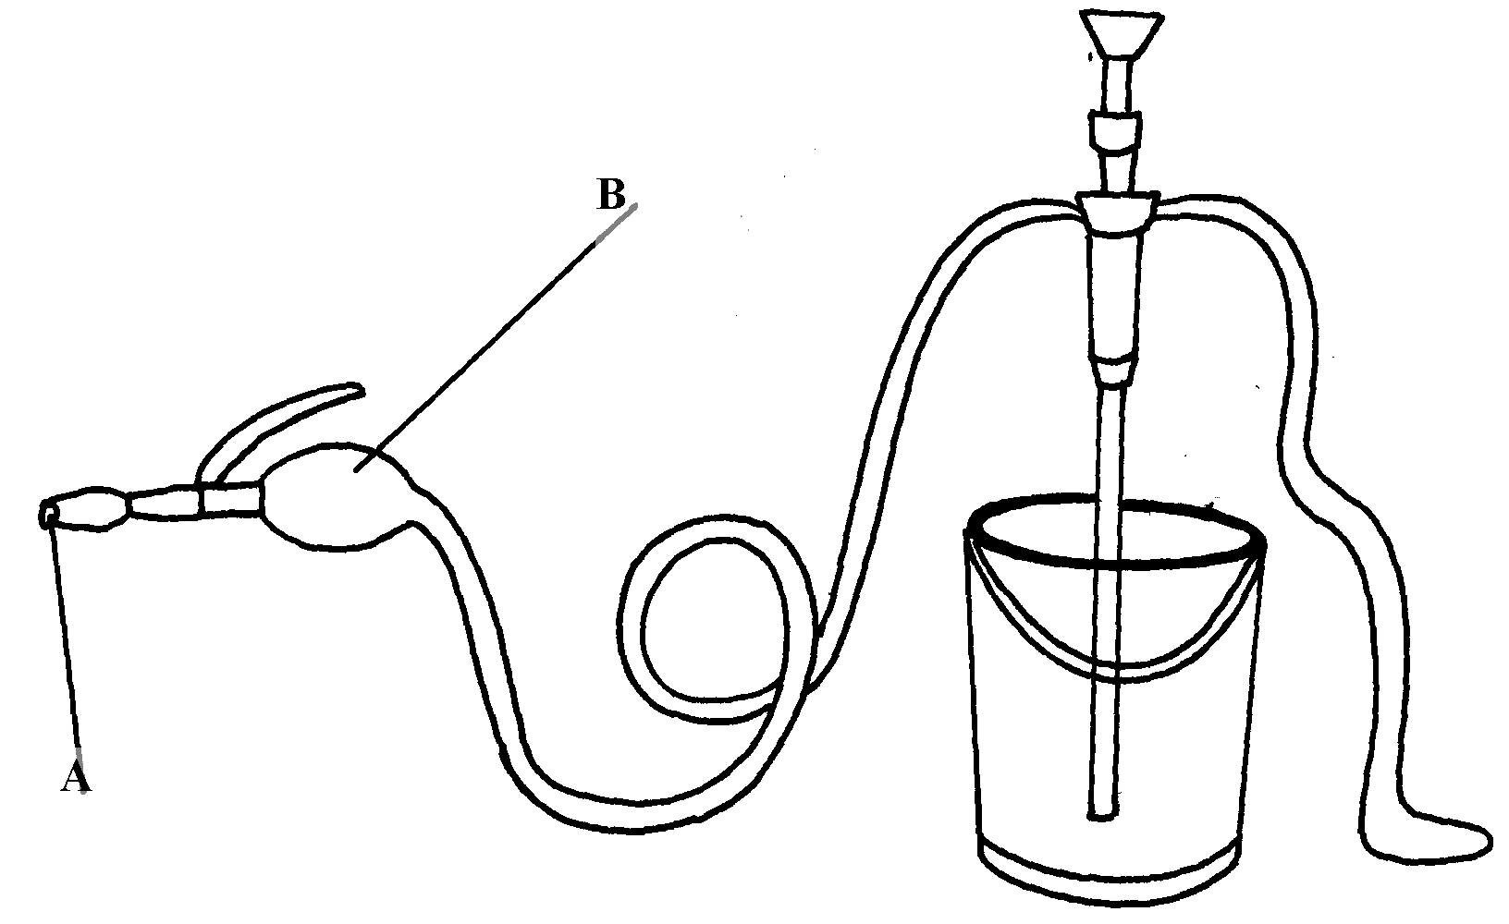
3. Study the illustration below and answer the questions that follow.

i) Identify the equipment represented by the illustration
ii) What is the use of the equipment?
iii) Name the parts labeled A and B
iv) What is the function of the part labeled A and B
4. What is the use of a garden fork?
5. Name the tool that a builder would use to check the vertical straightness of a wall during
construction
6. Name the farm tool that can be used when removing nails from timber
7. Give two examples of equipment that a livestock farmer can use in administering oral
anti helminthes
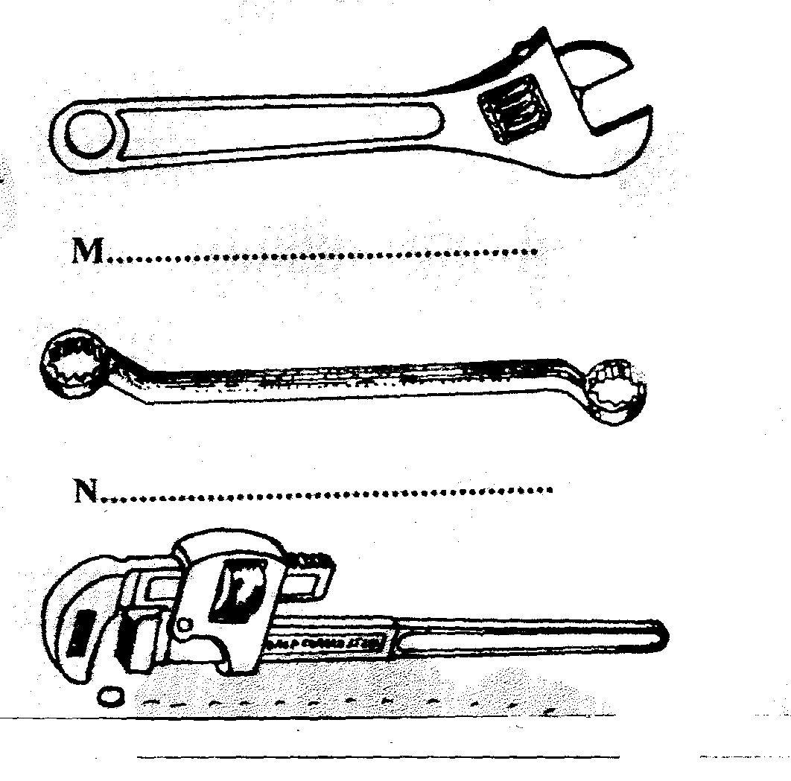
8. Below are farm tools, study them and answer the questions that follow:-
O.............................................
.....................................

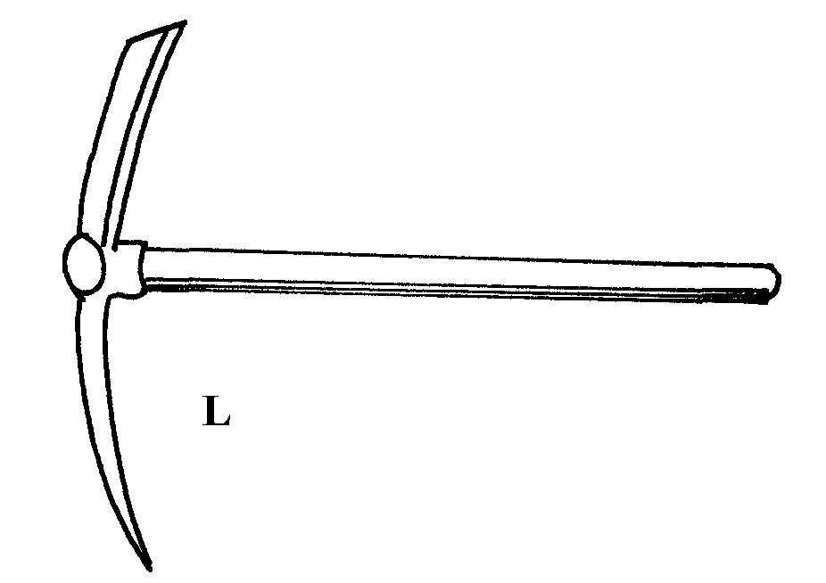

(a) Identify the tools L, M, N, O
(b) Give one functional advantage of tool M over tool N
9. Name a tool used to perform the following functions on the farm;
(i) Drilling of small holes on metal
(ii) Bore holes on wood
10. State the common faults in the operation of Knapsack spray
11. (a) Name the three tools in castration of livestock
12. Name the most appropriate set of animal handling tools that a farmer uses for the following operations:-
(i) Restraining a large bull when taking it around the show ring
(ii) Cutting tail in sheep
13. a) Below are illustrations of farm tools

i) State the use of the tools
ii) Name the type of hammer that may be used for driving tool K during work

b) Given below is an illustration of one of the routine management practices in livestock
Production.
Study the diagram and answer the following questions

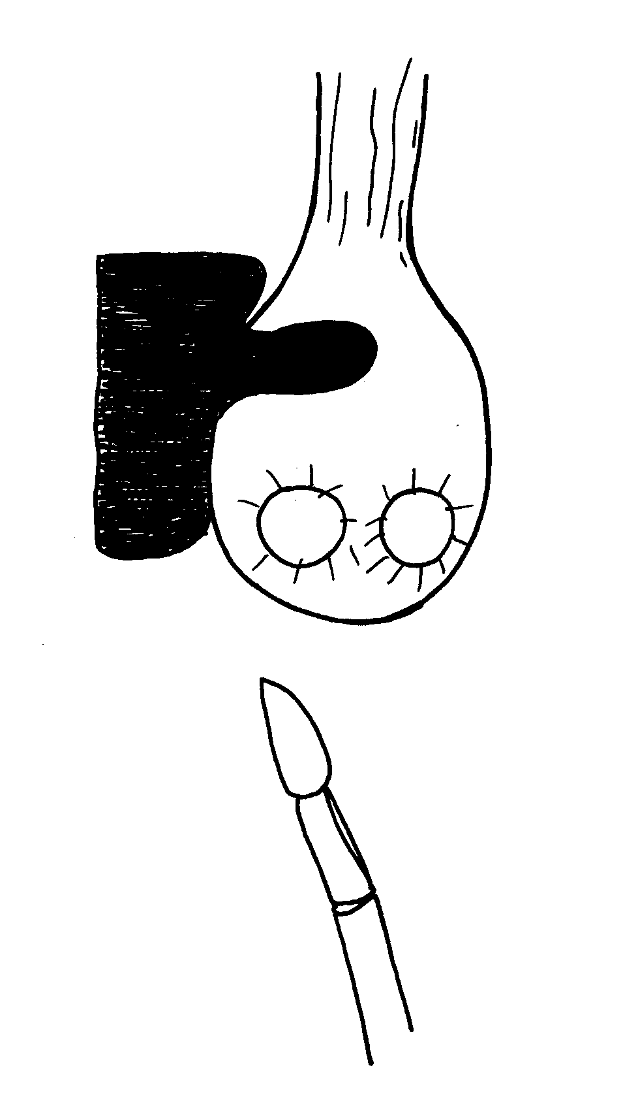

i) Name the practice indicated in the diagram above
ii) Describe the procedure you would follow when carrying out the practice named
in (i) above in piglets

14. Study the diagram below and answer the questions that follow;
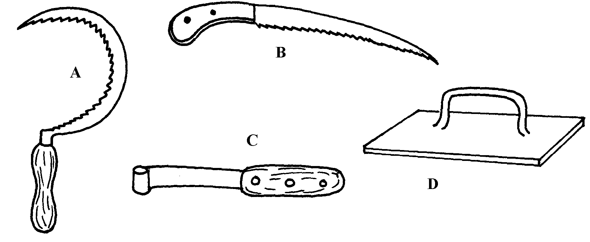

i) Identify the tools
ii) Give the use of each of the tools named above
iii) State two maintenance practices that should be carried out on tool D
15. List two equipments used in handling cattle during an Agricultural exhibition
16. Mention the use of the following tools.
i) Dibber
ii) Spokeshaves
iii) Tinsnips
iv) Burdizzo

17. List four precautions that should be taken when using workshop tools and equipment.
18. i) Below is an illustration of a farm equipment. Study it and answer questions that follow

a) Identify the farm equipment illustrated above b) What is the use of the equipment c) Name the parts labelled W, X and
d) What is the functions of Y on the equipment
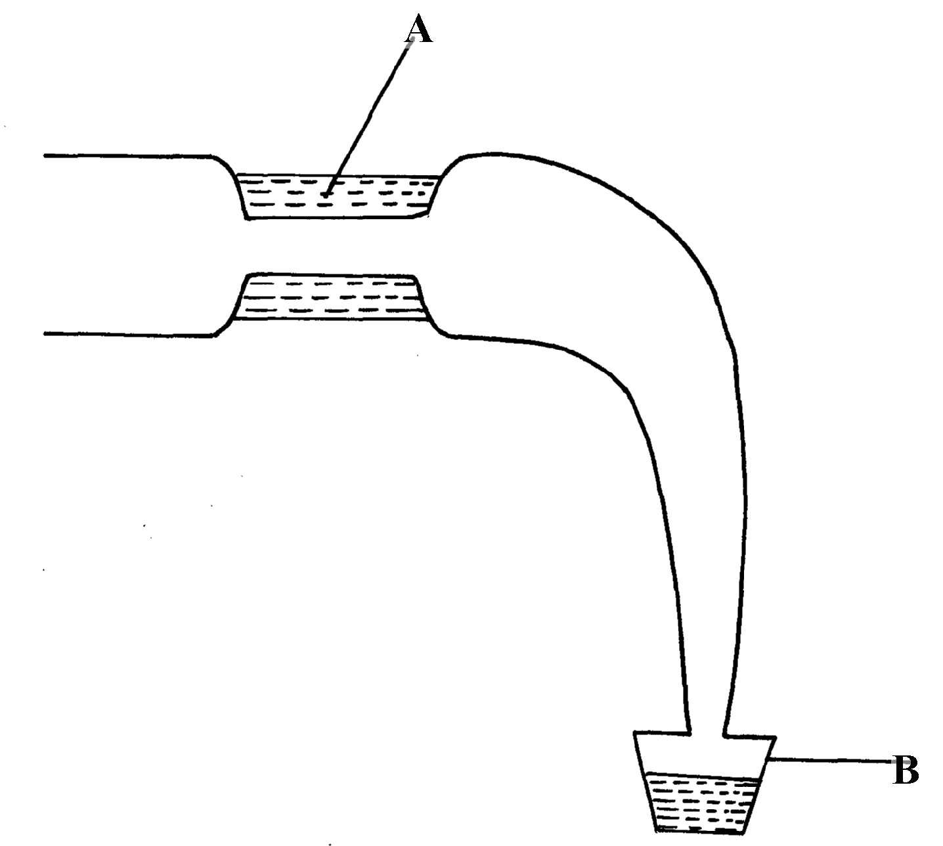
19. Use the diagram below to answer questions which follow

i) Identify the above diagram
ii) Name the parts labelled A and B

LIVESTOCK PRODUCTION I
COMMON LIVESTOCK BREEDS
This topic entails the following:
- Reasons of keeping livestock
- Parts of a cow
- Characteristics of indigenous and exotic cattle breeds
- Dairy cattle breeds
- Beef cattle breeds
- Dual purpose cattle breeds
- Pig breeds
- Sheep breeds
- Goat breeds
- Rabbit breeds
- Camel breeds

The following relevant questions and their answers in this topic will greatly help and motivate the user to comprehend and understand the re1quired concepts and practices:
1. State two reasons for treating water for us on the farm
2. State four advantages of applying lime in clay soil
3. State four ways by which Re-afforestation help in land reclamation
4. Give two distinguishing features between the following breeds of rabbits; Kenya white
and California white
5. Give four reasons why most farmers keep livestock in Kenya
6. Give three ideal conformation features of beef cattle
7. (i) Name a dual purpose cattle breed reared in Kenya
ii) State three uses of a rotavator
8. Name a pig breed with the following features:
White body colour, erect ears, dished snout, big in body size
9. What does the term ‘epistasis’ mean in livestock improvement?
10. (a) Explain the role of livestock industry in Kenya’s economy
(b) Outline the general characteristics of indigenous cattle
11. Below is a diagram of a cattle. Study it an answer the questions that follow:-
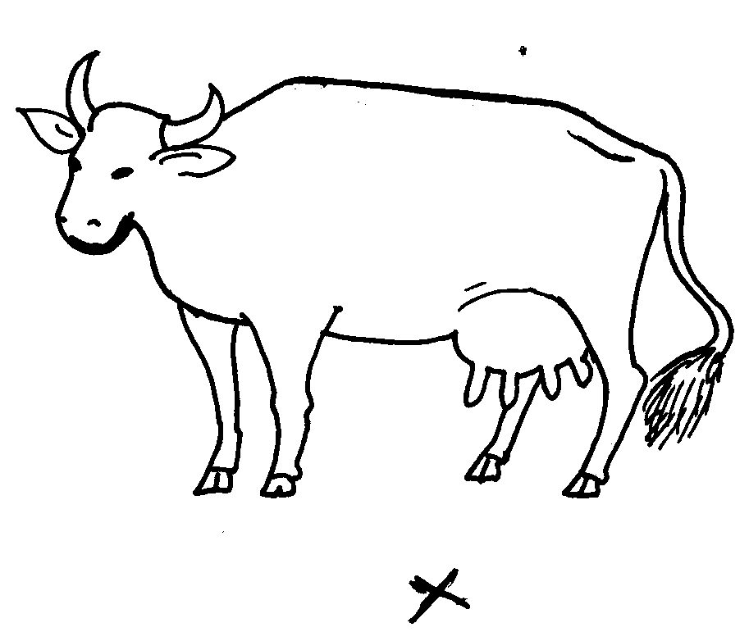

(i) What type of animal is represented above?
(ii) If you stand at a point marked X, state five characteristics that tells you that the animal belong
to type name in (i) above?
(iii) State three areas on the body of a cow where ticks are commonly found
12. Name four breeds of dairy goats
13. List two distinguishing characteristics of Californian breed of rabbit
14. Name the common milk breed of goats reared in Kenya
15. Name four dairy cattle breeds reared in Kenya.
16. Differentiate between ‘breed’ of animal and ‘type’ of animal.
17 Name the camel breed that is adapted to cooler regions and has a woolly body covering
18. State any two channels through which beef is marketed in Kenya.

(LIVESTOCK HEALTH II
(LIVESTOCK PARASITES )

This topic entails the following:
- Host-parasite relationships
- Effects of parasites on livestock
- Life cycle of parasites
- Methods of parasite control in livestock
- Identify different parasites
The following relevant questions and their answers in this topic will greatly motivate and help the user to comprehend and understand the required concepts and practices:
1. Name two chemical methods used in deworming cattle
2. a) state six effects of parasites
b) Describe the life cycle of Taenia solium species of tapeworm
c) State four control measures of the tapeworm
3. Give two functions of calcium in dairy cows
4. Give two control measures of fleas in a flock of sheep
5. Give two measures a poultry farmer can use to control fleas in flock
6. State two reasons why drenching alone is not an effective method of controlling internal parasites
7. Give two forms in which a tape worm is found in livestock
8. Below are diagrams showing different types of internal parasites. Study them carefully and
answer the questions that follow:-
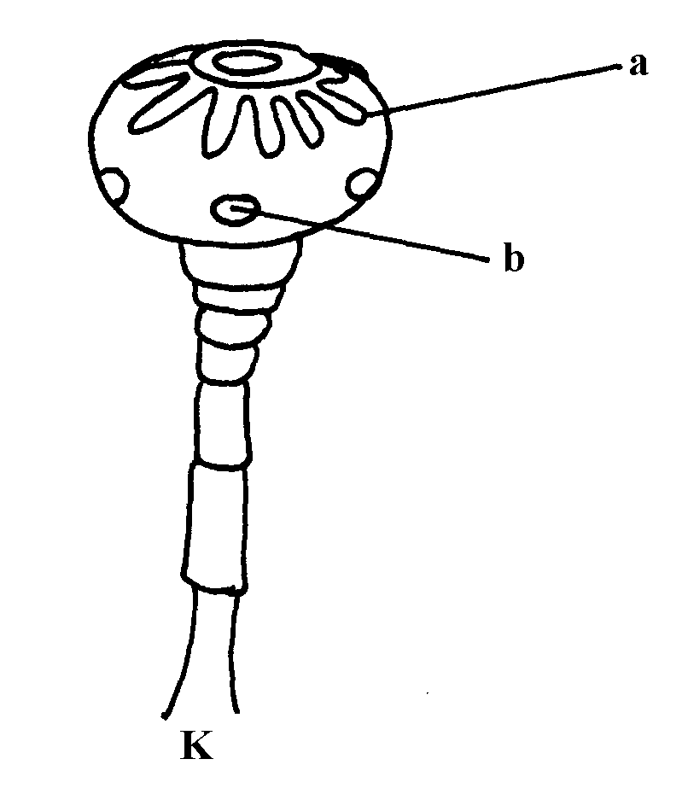
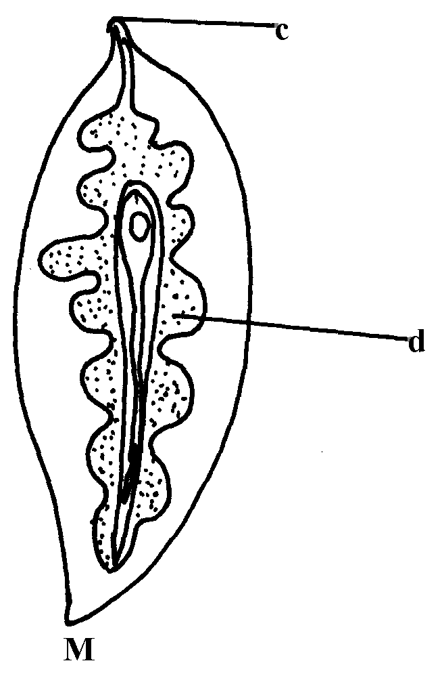

a) Identify the parasites K & M
b) Identify the parts labelled
c) Name the organs where each parasites is found
d) Give the intermediate host of parasite M
9. Give any two effects of external parasites that are harmful to livestock
10. Outline the procedure followed when hand-spraying cattle to ensure effective use of acaricides
to control ticks
11 a) A boar gained 90Kg live weight after eating 360Kg pig finisher meal over a period of
time. Calculate the feed conversion ratio
b) Describe digestion in the four stomachs of the ruminant animal
c) Give the significance of lubrication system
12. State four ways of controlling tsetseflies
13. Name two types of roughages
14. Name the common milk breed of goats reared in Kenya
15. Why are the element calcium and phosphorus important in the diet of young livestock?
16 Give two parasites of cattle which are also disease vectors
17 Give three control measures of fleas in a flock of layers

LIVESTOCK PRODUCTION II (NUTRITION)
This topic entails the following:
- Identification and classification of livestock feeds.
- Digestion and digestive systems of cattle, pigs and poultry
- Definition of terms used to express field values
- Preparation of balanced ration for various livestock
- Functions and deficiency symptoms of various nutritional elements.

The following relevant questions and their answers in this topic will greatly motivate and help the user to comprehend and understand the required concepts and practices;

1. Give two ways by which production ration may be utilized by dairy goats
2. Given that the livestock reared require a ration of 18% DCP and the farmer has maize bran of
10% DCP and sunflower meal of 30% DCP. Use Pearson’s square method to calculate how
much of the feedstuffs a 150kg rations
3. State the importance of the following in livestock nutrition: i) Water ii) Vitamin A
4. Name the compartment of the ruminant stomach where microbial digestion takes place.
5. i) A ration containing 18% protein is to be made from maize and sunflower cake. Given
that maize contains 7% protein, and sunflower seed cake 34% protein. Use Pearson square
method to calculate the value of feedstuffs to be used to prepare 100kgs of the feed
ii) A part from Pearson square method, name two other methods that can be used to formulate
feed ration
6. (a) Define the term ration as used in livestock nutrition
(b) A farmer wanted to prepare a 200kg of pig’s ration containing 16% D.C.P. Using the persons
square method, calculate the amount of maize containing 10% D.C.P and cotton seed
containing 28% D.C.P the farmer would need to prepare the ration (show your work)
7. Give two livestock feed additives
8. State three factors that would determine the amount of concentrate fed to dairy cattle
9. State three factors that would determine the amount of concentrate fed to dairy cattle

LIVESTOCK PRODUCTION III
(SELECTION AND BREEDING)

This topic entails the following:
- Description of reproduction
- Description of reproduction systems
- Selection f breeding stock
- Description of breeding system.
- Identification of livestock on heat
- Description of methods used in serving livestock.

The following relevant questions and their answers in this topic will greatly motivate and help the user to comprehend and understand the required concepts and practices.

1. State four ways of minimizing disowning of lambs by ewes
2. State the gestation period of the following farm animals
i) Pigs
ii) Rabbits
3. i) What is selection in live stock production
ii) State three methods used in selection of livestock
4. Give four signs of heat observed on female rabbit
5. Name four meat breeds of rabbits
6. State four reasons for cutting a breeding boar
7. List the methods of selection in livestock
8. Define the following terms as used in livestock breeding
i) Heterosis
ii) Epistasis
9. State three signs of heat in Does (Female Rabbits)
10. Give the gestation period of the following:
i) Cow
ii) Sow
11. State three disadvantages of natural methods of mating in cattle breeding
12. a) Explain the advantage of battery cage system of rearing layers
b) Outline ten factors considered when selecting dairy cattle for breeding
13. What is upgrading as used in livestock production?
14. Define the word breech of birth as used in livestock production
15. What does the term “drift lambing’ mean in livestock production?

LIVESTOCK PRODUCTION IV
(LIVESTOCK MANAGMENT PRACTICES)

This topic entails the following:
- Description of livestock rearing practices
- Carrying out livestock rearing practices
- Livestock routine management practices i.e. feeding, de-beaking e.t.c.

The following relevant questions and their answers in this topic will greatly motivate and help the user to comprehend and understand the required concepts and practices:

1. Give four reasons of carrying out crutching sheep management
2. Name two ways a farmer can perform closed methods of castration on his male livestock
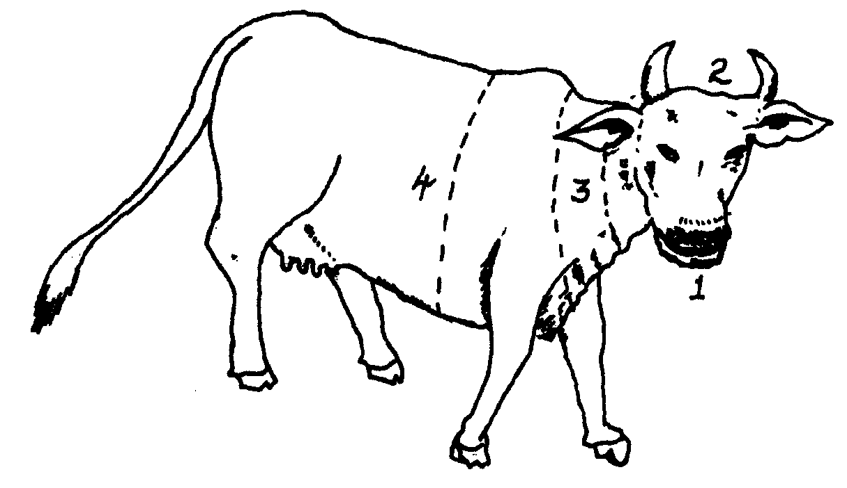
3. Below is a diagram of a farm animal. Study the diagram carefully and then answer the questions
that follow

a) On the drawing, mark the letters indicated in brackets the part of the animal where:
i) Branding should take place (B)
ii) Vaccination should be carried out (V)
iii) Body temperature of the animal should be taken (BT)
iv) Mastitis infection may occur (M)
b) Name three areas of the animal body where ticks are likely to be found
c) Name the parts of the animal numbered 1-4

4. a) What is castration as used in livestock production?
b) State four reasons why castration is done in livestock
5. (a) Describe the management of a gilt from weaning to furrowing
(b) Discuss the preparation a poultry farmer should make before the arrival of day old chicks
6. Outline two reasons for raddling in sheep management
7. State any four reasons for castrating male piglets
8. What are the methods of stocking bees? Give two.
9. State two ways that show how good feeding help to control livestock diseases
6. Name any two recommended methods of docking lambs
7. State three disadvantages of inbreeding
8. State four routine management practices that should be carried out on a lactating ewe
9. (a) Describe the procedure which should be followed to castrate a three weeks old piglet using
surgical method
(b) (i) State five factors that should be considered when sitting a bee hive in a farm
(ii) Describe the management practices that would ensure maximum harvest of fish from a
fish pond
10. Give three types of bees found in a bee colony
11. List three methods of castrating farm
12. Outline the routine management practices of piglets from the 1st day to the 8th week
13. List three types of calf pens
14. State two factors that could lead to failure to conceive in sows after service
15. List three advantages of hoof trimming in sheep production
16. State four factors considered when citing an apiary in the farm
17. Name three methods of stocking a beehive with honey bees
18. List three common methods of extracting honey from the combs
19. a)The illustration below shows a method of identifying pigs, study the diagram and answer the questions that follow:-

i) On the diagram A provided below, draw the mark to indicate a pig number 147,
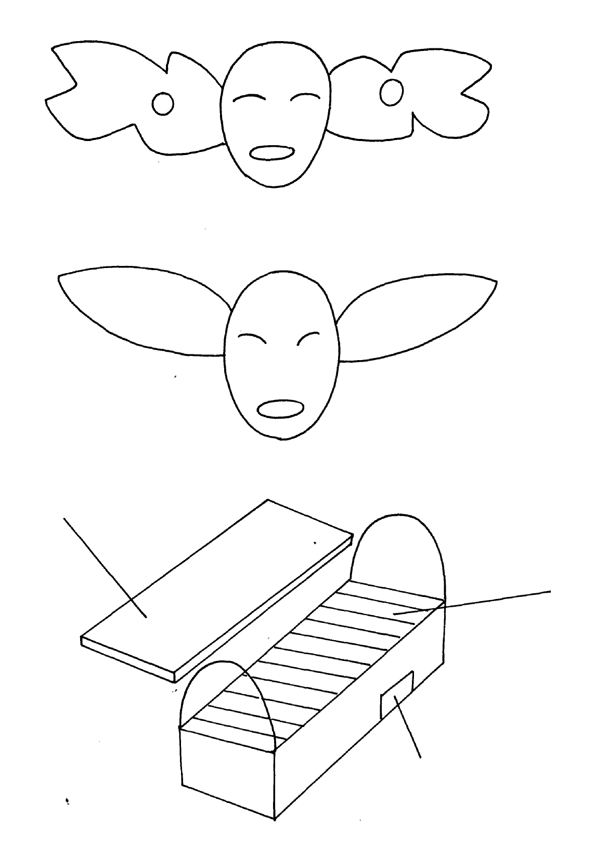
using the procedure of ear-notching in diagram

A

ii) What is the recommended stage of growth in pigs at which the ear-notching should be
carried out?
iii) State any three reasons why weight is an important routine management practice in pig
production
b) Below are illustrations showing the various parts of the Kenya top bar hive. Use the illustration
to answer the question that follow
D

C

B

i) label the parts B ,C and D
ii) How can a farmer attract bees to colonize a new hive?
iii) Outline the procedure of opening the hive to harvest honey
20. a) Below are illustrations of farm tools
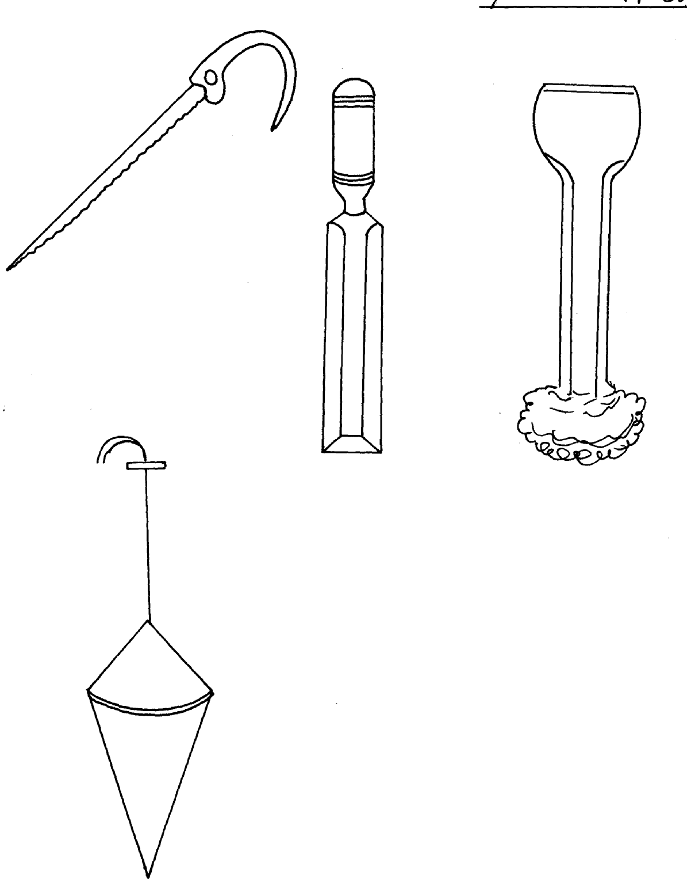

E

F
G

H

ii) State the use of the tools
iii) Name the type of hammer that may be used for driving tool F during work b) Given below is an illustration of one of the routine management practices in livestock
production.
Study the diagram and answer the following questions

i) Name the practice indicated in the diagram above
ii) Describe the procedure you would follow when carrying out the practice named
in (i) above in piglets
21. a) State and explain four advantages of age grouping farm animals as a management practice
b) Explain four major causes of lamb mortality from birth to weaning
c) Describe brucellosis under the following sub headings
i)Cause
ii) Transmission
iii) Symptoms
iv) Control measures
22. a) Explain the advantage of battery cage system of rearing layers
23. Give two reasons why it is important to castrate animals when they are still young
24. (a) Give two reasons why dehorning is carried out in farm animals
(b) State four methods of dehorning livestock
25. (a) What is steaming up in livestock production?
(b) Give two reasons why the practice is important in pig rearing
26. State four management practices that should be carried on a fish pond in order to obtain
maximum fish production.
27. List four factors considered when formulating livestock ration. (2mk)

28. Study the diagram of a cow below and answer the subsequent questions

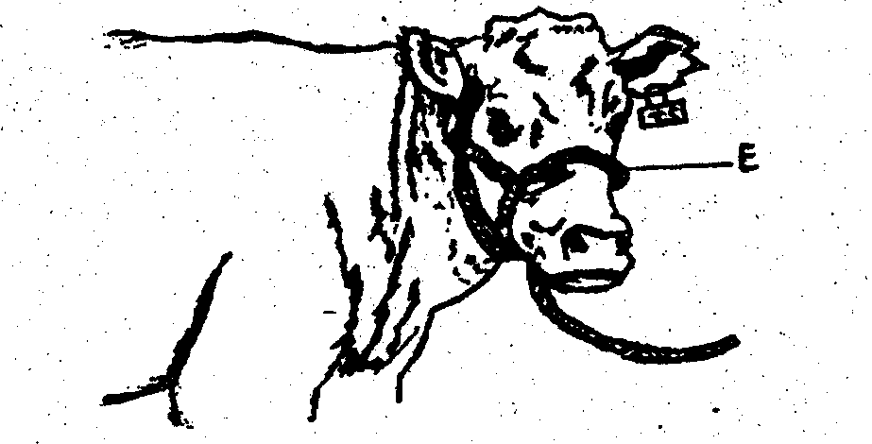

i) Identify the livestock equipment marked E above
ii) State two uses of the equipment in 17(i) above
iii) Name the two types of identification marks applied on the animal above
iv) Show with an arrow and mark with letter P where pye-grease acaricide should be applied
on the anima1
v) Give one disadvantage for each of the identification marks made on the animal

Identification marks | Disadvantage
A
B

29. a) Describe the management practices of a gilt from weaning to the time of farrowing
b) State five factors to consider in selecting a gilt for breeding stock.

28. State four conditions that necessitate the handling of farm animals .
29. Give any two reasons why docking is an important practice in sheep management.
30. Why is crutching a very important management practice in sheep breeding.

31. Study the diagram of a sheep shown below carefully and answer the questions that follow:

(i) What operation is usually carried out on the part labelled A?
(ii) Give two reasons for carrying out the operation in (i) above
(iii) At what age should the above operation be carried out?
(v) Name routine management practice carried out on the part labelked B

FARM STRUCTURES

This topic entails the following:
- Description of parts of a building
- Identification of materials for construction
- Description of various farm structures and their uses
- Construction and maintenance of farm structures.

The following relevant questions and their answers in this topic will greatly motivate and help the user to comprehend and understand the required concepts and practices:

1. Mention four disadvantages of using steel materials for construction of farm structures
2. Give two reasons for placing a polythene sheet on a foundation of farm buildings
3. What is “calf crop” in beef production?
4. a) Outline the procedure in construction of a barbed wire fence
b) List any four wood preservatives
c) Give four factors that will determine the choice of farm building materials
5. i) Give four factors considered when citing a fish pond
ii) Give four features of a good laying nest
6 State two uses of a footbath in cattle dip
7 a) What is a green house
b) Name four materials used in green house construction
c) Give four maintenance practices carried out on a green house
d) Explain the importance of maintaining farm structures
8 Give two disadvantages of a barbed wire fence when used in paddocking
9 The diagram below illustrates a cross-section of a fish pond. Study it carefully and answer the
questions that follow:-

X
Z
Y
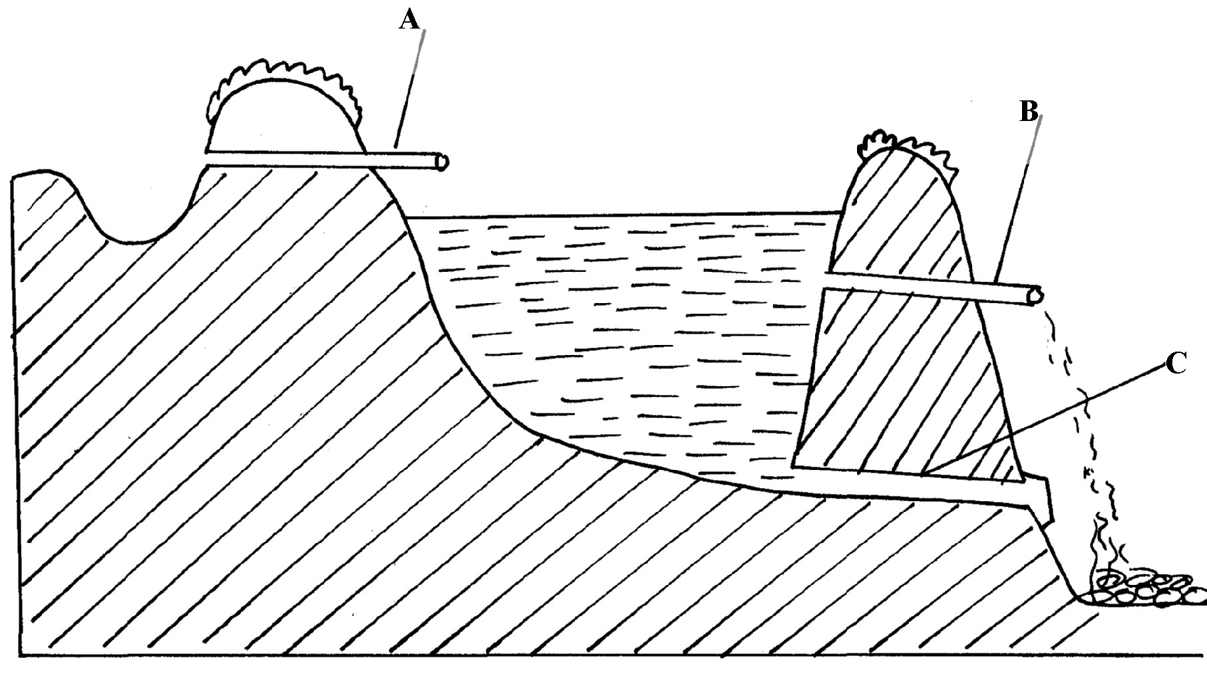

(a) Identify the parts marked A, B, C and C
(b) On the diagram the points marked X, Y and Z are possible sites where fish feeding
can be done. Which is the most appropriate point for feeding?
(c) Give two reasons why the floor of the pond should be covered with lime 14days before
filling it with water (d) Why should part marked B be screened?
(e) State three maintenance practices carried out on the structure

10. Study the farm structure below illustrating a pass:-
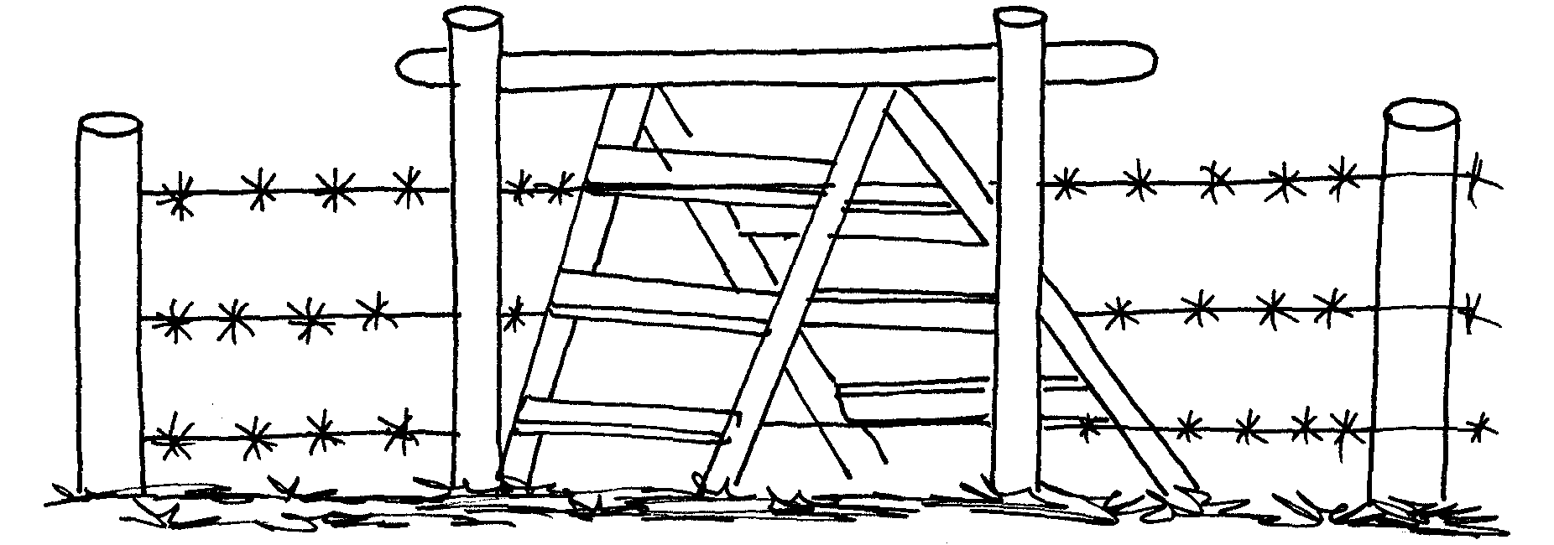

(a) Identify the type of pass illustrated above
(b) Distinguish between a pass and a gate
(c) Name one type of live fence
11 State four requirements of a good maize store
12 State three factors that determine the depth and size of foundation in a farm building
13 (a) Explain the uses of various hand tools in the construction of a poultry house
(b) Describe the procedure of erecting wooden rail fence
(c) Explain various factors considered when choosing the construction materials for farm building
14 State four features of a good calf pen
15 State four uses of a fence

16 Below is a diagram of a cross section of a farm structure. Study it carefully and answer the
following questions.

(i) Identify the labeled parts A, B, and C
(ii) What is the importance of the part labeled B to the structure
(b) (i) When making concrete blocks the ratio 1:3:5 may be used. What do these figures
represent?
(ii) In a concrete mixture 1:3:5, twenty four cubic metres of sand were recommended to be
used in putting up of a foundation of a building. Find the volume of the other two
17 (a) Explain the maintenance practices of a fish pond
(b) Give four ways of controlling fish predators in a fish pond
18 Mention four reasons of treating timber before roofing farm buildings
19 List four uses of crushing in the farm
20 a) Define the term fence
b) List various types of fences
c) Describe advantages of fences
21 Study the illustration of a farm structure below and answer the questions that follow
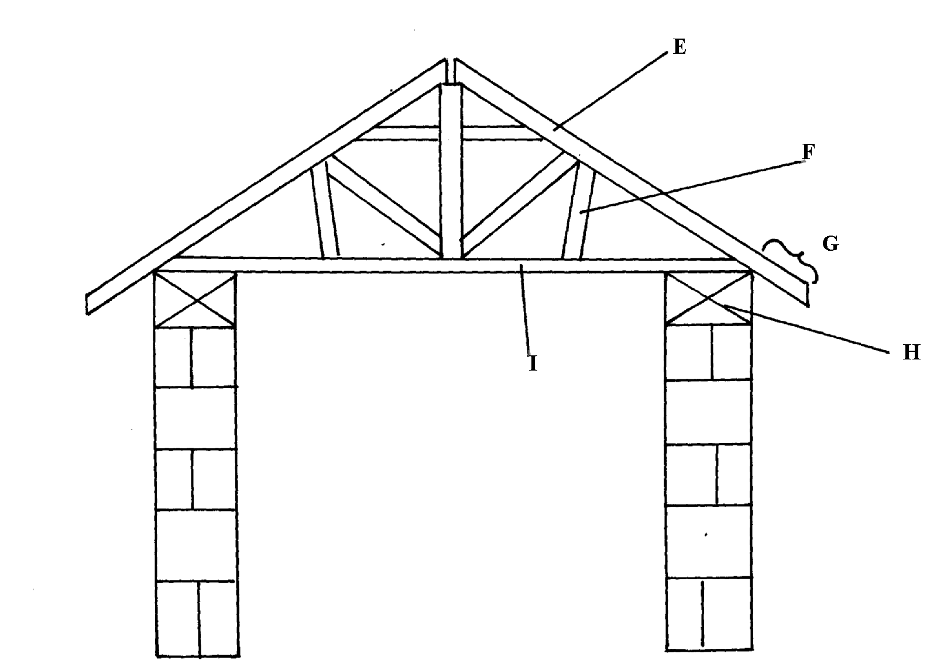

i) Name the parts labeled
ii) State the function of the parts labeled
iii) Name two chemicals preservatives used to treat the wooden parts of the structure against
insects and fungal damage

21. Below is a diagram of a fish pond, study it and answer the questions that follow

i) Label the parts marked K and L
ii) Give a reason why part M is usually deeper than the rest of the pond
iii) State three maintenance practices carried out in the pond
22. a) Explain five factors to consider when siting a fish pond
b) Explain the measures used to control livestock diseases
23. State four factors which influence the selection of materials for constructing a diary shed
24. a) State five maintenance practices of a mould board plough
b) Explain five structural and functional differences between the petrol and diesel engines c) List five uses of farm fences
25. State four uses of farm buildings
26. List four structural requirements for proper housing of farm animal to maintain good health
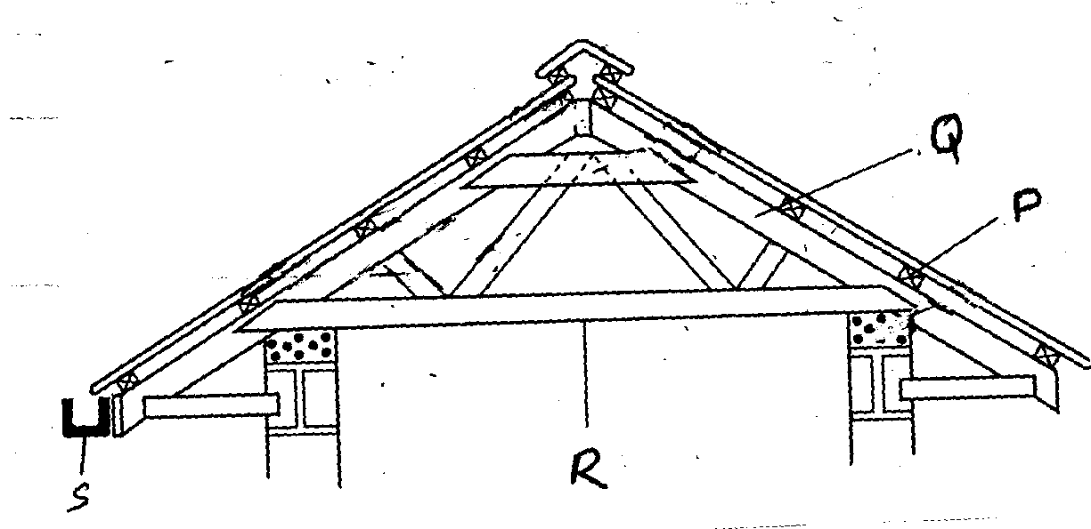
27. The diagram below is part of a farm structure. Study it and then answer the questions that follow:

(a) Name part of structure represented above
(b) Identify parts labeled P, Q, R, and S
(c) Give the functions of the part labeled P and S
28. The diagram below shows an activity of processing a farm product. Study it and answer the
questions that follow:

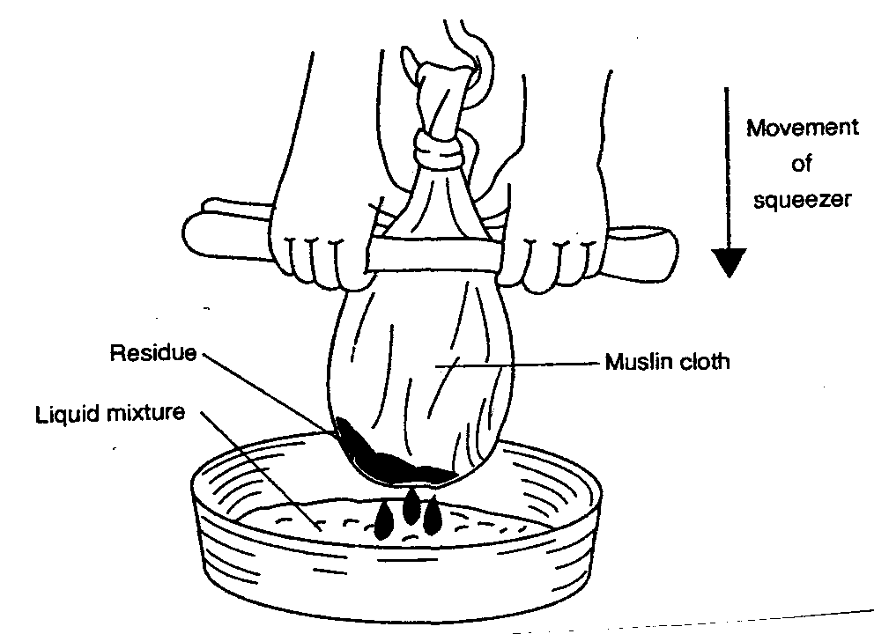

(a) Name the product being processed
(b) Identify the method used in processing the product names in the diagram
(c) Outline the procedure used when harvesting the product named in the diagram
(d) List two factors that affect quality of the product processed in the diagram

31 (a) Describe five parts of a plunge dip
(b) Outline six uses of live fences on the farm
(c) Outline four factors that influence power output of drought animals
32. a) Explain the factors a farmer needs to consider before siting a farm structure on his farm
b) Outline the desirable features of a good grain store
c) Describe the uses of farm fences in promotion of agriculture
33. Name any two pests that attack timber used for construction in the farms
34. State three factors that may lead to dip wash being exhausted or weakened while in the
dip tank

LIVESTOCK HEALTH III
(LIVESTOCK DISEASES)

This topic entails the following:

- Description of causes and vectors of the main livestock diseases.
- Signs of each stated livestock disease
- Stating predisposing factors where applicable
- Control measures of livestock disease

The following relevant questions and their answers in this topic will greatly motivate and help the user to comprehend and understand the required concepts and practices.

1. Name two diseases that affect female animals only
2. Give four pre disposing factors of foot rot disease in sheep
3. i) Name the causative organism of contagious abortion in cattle
ii) Give four symptoms of contagious abortion in cattle
iii) State three methods of controlling contagious abortion in cattle
4. What is a vaccine?
5. (a) Discuss black quarter under the following sub-headings:-
(i) Animal affected
(ii) Casual organism
(iii)Symptoms of disease
(iv) Control measures
(b) (i) Explain four measures used to control liver flukes
(ii) Name an intermediate host of liver fluke
(c) Explain the following terms as used in livestock production
(i) Embryo transfer
(ii) Artificial insemination
(iii) Line breeding
(iv) Cross breeding
(v) Up-grading
6. Give four predisposing factors of foot rot disease in sheep
7. (a) Discuss coccidiosis disease under the following headings:-
(i) Causal organism
(ii) Livestock species attacked
(iii) Symptoms of attack
(iv) Control measures
(b) (i) What are the characteristics of an effective acaricide?
(ii) Explain three methods of acaricide application
8. Name four ways of controlling coccidiosi in the farm
9. State four predisposing factors of scour in calves
10. Name four notifiable diseases of livestock
11. Name two diseases of poultry that are controlled by vaccination
12. State three signs of anthrax injection disease observed in the carcass of a cattle
13. Differentiate between active immunity and acquired passive immunity
14. Name four systems of a tractor engine
15. State two adjustments that should be carried out on a tractor – mounted mould board plough
in preparation for ploughing

16. List three causes of ruminal lympany (Bloat) in ruminant animals
17. (a) Give four symptoms of milk fever
(b) State two methods of controlling milk fever

18. (a) Describe East Coast Fever (E.C.F) under the following sub-topics:
(i) Animal attacked
(ii) Causal organisms
(iii) Symptoms of attack
(iv) Control and treatment
(b) Explain ten measures used to control livestock diseases

29. Name two livestock diseases that are spread through natural mating.
20. a) Give the method used in introducing a vaccine to poultry against fowl typhoid b) State other methods introducing vaccines to livestock

LIVESTOCK PRODUCTION V
(POULTRY)
This topic entails the following:

- Identification of parts of an egg.
- Selection of eggs for incubation
- Identification of suitable sources for chicks.
- Descriptions of broodiness
- Description of condition for incubation
- Description of rearing systems
- Categories of poultry feds according to age-of birds
- Stating causes of stress and vices in poultry and control measures.
- Marketing of eggs and poultry meat.
- Selection, sorting and grading of eggs.

The following relevant questions and their answers in this topic will greatly motivate and help the user to comprehend and understand the required concepts and practices.

1. A deep little poultry house measures 9mx3m. Suppose the amount of space allowed for one
bird is 0.27m².Calculate the number of birds that can be kept comfortably in the house. Show
your working
2. Give two functions of isthmus in female bird
3. Give four features of a good laying nest
4. State four qualities of marketable eggs
5. Study the diagram showing the behaviour of chicks in a brooder and answer the questions that
follow:-
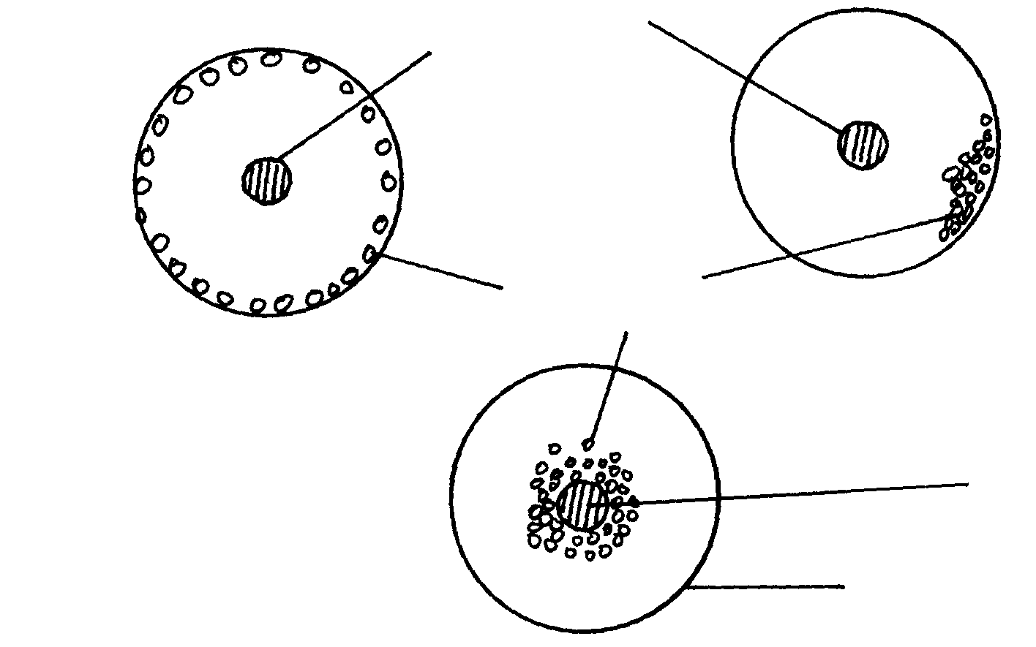
Heat source

B
Chicks

Heat source
A

C
Brooder guard

(a) State the behaviour of chicks in A, B and C
(b) Explain why the brooder guard is rounded as shown in the diagram
6. Mention six characteristics of an egg selected for incubation
7. Describe the management of layers in deep litter system
8. State four reasons for egg breaking and drinking by layers in a deep litter rearing system
9. Below are diagram showing condition of eggs seven days after incubation study them and answer
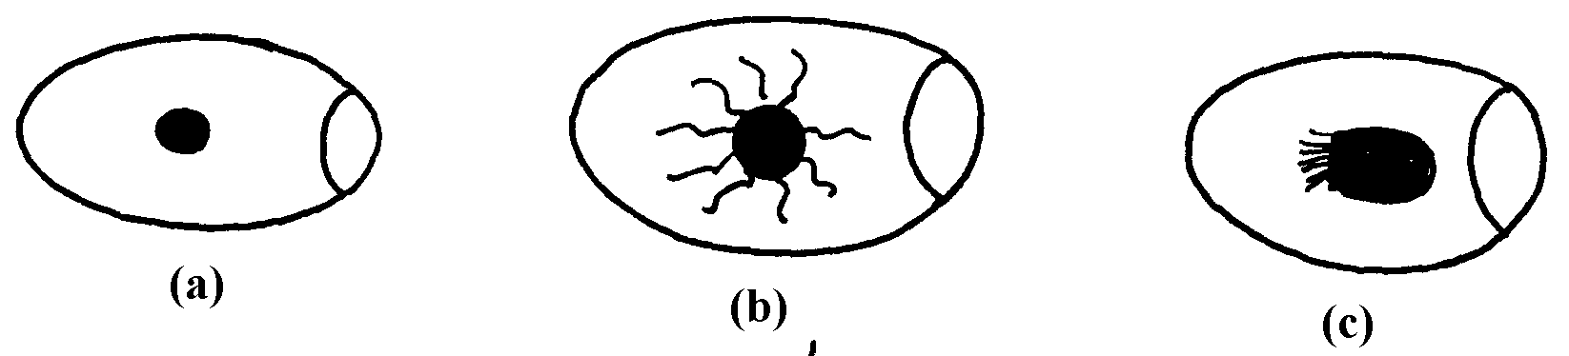
the questions

a) Identify the conditions of eggs
b) Identify the egg which suitable for incubation and give a reasons for your answer
c) Name the practice which used to determine the state of eggs above
10. The diagram U below illustrates an activity carried by a poultry farmer keeping layers. Study the
diagram carefully and answer the questions that follow
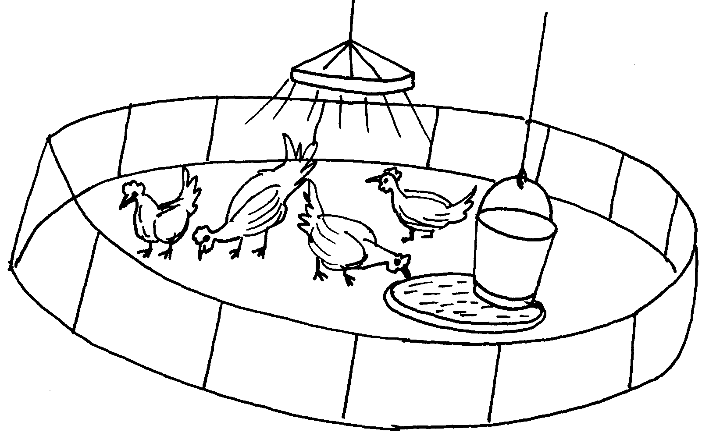

a) Identify the activity carried out using the set up illustrated in diagram U
b) List down four preparations that should be carried out structure U before arrival of
day old chicks
c) List down one behaviouristic activity which would indicate that the chicks are under stress

11. Give two reasons for using litter in a poultry house
12. Give two reasons why it is important to castrate animals when they are still young
13. (a) Give two reasons why dehorning is carried out in farm animals
(b) State four methods of dehorning livestock
14. State four abnormalities of eggs that can be detected during egg candling.
15. Describe the management of day old chicks in a deep litter system from preparation of brooder up
to eight (8)weeks old
16. a) Describe the management practices of a gilt from weaning to the time of furrowing
b) State five factors to consider in selecting a gilt for breeding stock.
17. Study the diagram of an egg be1ow and answer the questions that fol1ow:

i) Name the parts labeled N, O and P
ii) State the functions of the parts M and L
iii) Why should the egg be turned during incubation
18. State three reactions of chicks in a brooder which has higher temperature than normal.
19. Give three types of bedding material a poultry farmer may use in deep litter rearing of layers
20. Give two properties of good eggs for incubation

LIVESTOCK PRODUCTION III
(LIVESTOCK REARING PRACTICES)

This topic entails the following:
- Raising young stock
- Milk and milk components
- Milk secretion and milk let-down
- Correct milking techniques
- Marketing of milk and beef.

The following relevant questions and their answers in this topic will greatly motivate and help
the user to comprehend and understand the required concepts and practices:

1. What is “calf crop” in beef production?
2. a) Describe the procedure of hand milking in a dairy cow
b) Explain the practices observed in clean milk production
3. Give two reasons for washing a cow’s udder with warm water before milking
4. Give two roles of uterus in egg formation process
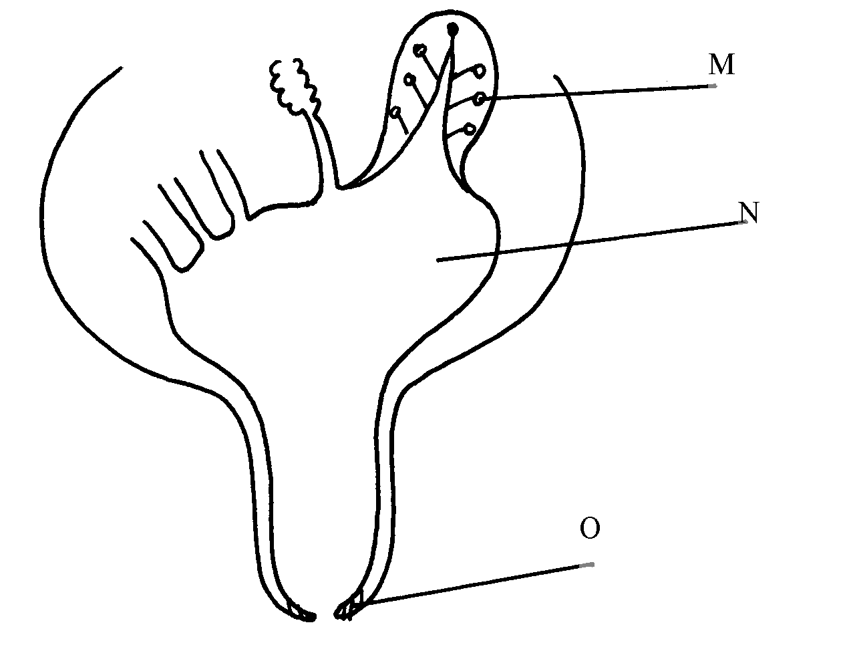
5. The diagram below is a structure of part of a cow’s udder

O

(i) Name the parts labeled M, N, and O on the diagram above
(ii) State the functional difference between the following hormones which influence milk
let-down;
(a) (i) Oxytoxin
(ii) Adrenalin
(b) Mention three qualities of clean milk
6. Give four characteristics of clean milk
7. State three maintenance practices carried out on a milking machine
8. State four reasons for feeding Colostrums to calves immediately after calving
9. Give three ways of stimulating milk let down in a dairy cow
10. a) Describe the operational differences of a disc plough and mould board plough
b) Explain six marketing problems affecting dairy farming in Kenya
c) State four reasons for culling a boar
11. List three advantage of artificial method of calf rearing
12. State three methods that may be used to improve milk production in a breed
of indigenous goats
13. (a) Outline ten physical characteristics between a good layer and a poor layer in a deep
litter house
(b) Describe five factors that influence milk production in a dairy herd
14. a) State two reasons for washing the udder of a cow with warm water before milking.
b) Name the hormone that causes each of the following in dairy cows:.
i) milk letdown.
ii) lactogenesis
15. State four methods of increasing the depth of penetration of a disc harrow.
16. List four farm machines implements that obtain power from P.T.O shaft of a tractor
17. List two tractor drawn implements used for breaking hardpan in a crop field

18. State any three machines which are used for harvesting crops

19. a) describe the daily maintance and servicing of a tractor before use
b) State one function of each of the following parts of a tractor engine.
i) Fly wheel
ii) Ignition coil
iii) Thermostat
iv) Injector
v) Piston

FARM POWER AND MACHINERY

This topic entails the following:
- Sources of farm power
- Systems of a tractor
- Tractor implements, uses and maintenance
- Animal drawn implements uses and maintenance
- Tractor servicing and maintenance practices

The following relevant questions and their answers in this topic will greatly motivate and
help the user to comprehend and understand the required concepts and practices:

1. Give four farm operations powered by engines

2. a) Describe the maintenance practices required on a tractor before it is put to daily use
b) Outline the factors that influence the power output by a draught animal

3. State two uses of gear box in a tractor
4. State two uses for which wind power is harnessed
5. Name three implements that are connected to the power take-off shaft
6. Below is a farm implement, study it keenly and answer the questions that follow:-
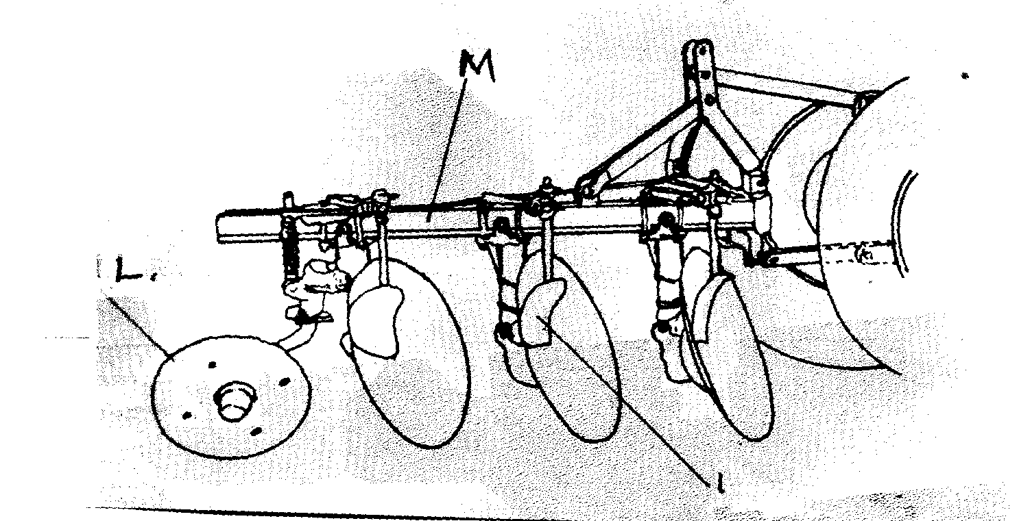

N

(a) Name the farm implement drawn above
(b) Identify the parts labelled L and M above
(c) Give the function of the part labeled M
(d) State the field condition under which the implement can work better than the others (½mk)

7. (a) Explain the factors that a farmer should consider in ensuring fast and efficient cultivation
by oxen
(b) Outline the importance of lubrication system in a tractor
(c) State the daily maintenance and servicing of a tractor

8. State the functions of the following parts of power transmission in a tractor:
(i) Hydraulic system
(ii) Draw bar
(iii) Propeller shaft
(ii) State three sources of tractor hire service

9. (i) What is a tractor hires services (1mk)
(ii) State three sources of tractor hire service (1½mks)

10. The diagram below represents an assembled differential of a tractor. Use it to answer the
questions that follow:-
D
A
B
Wheel

C

(a) Name the parts labeled A, B, C and D
(b) State two functions of differential system of a tractor
(c) Give two reasons why wheel skidding of a tractor is not allowed

11. State four sources of power in the farm

12. Give the four strokes of a four stroke cycle tractor engine

13. State four factors which ensure efficient working by oxen in the farm

14. Mention two sources from which farmers can hire tractors
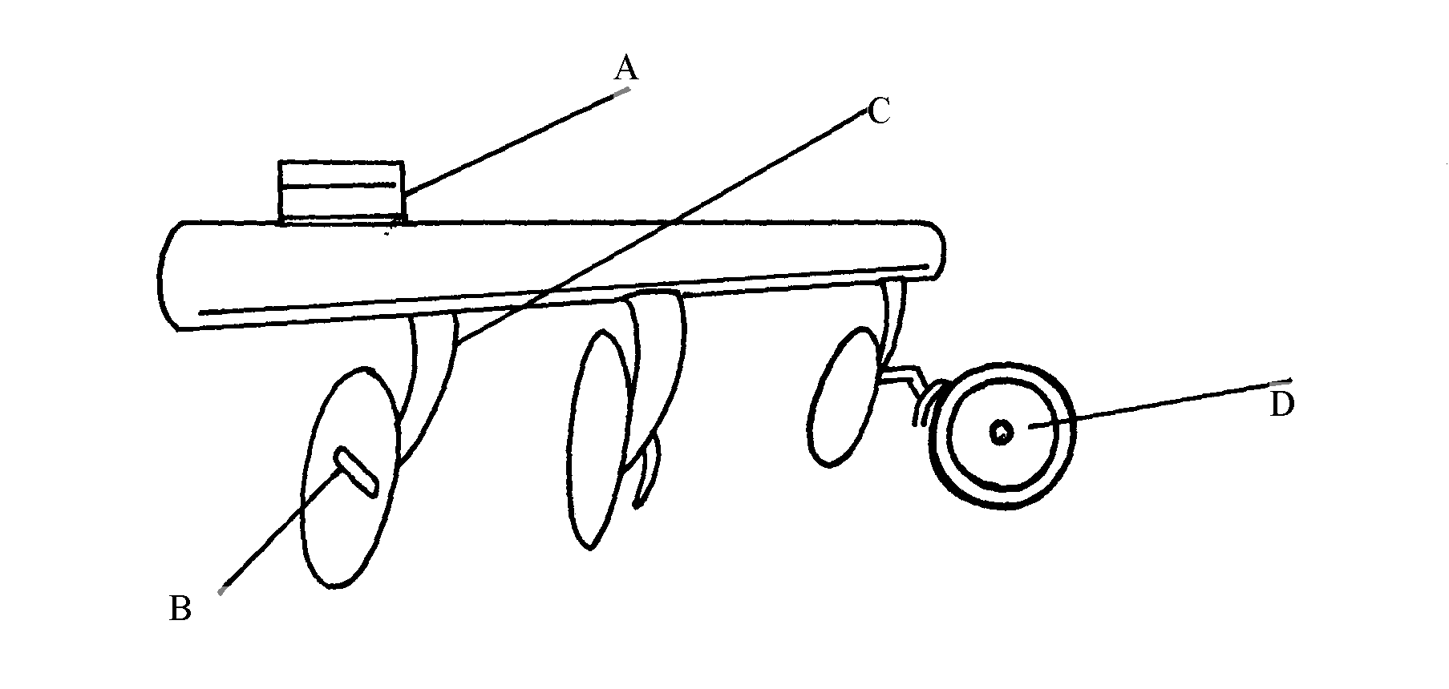
15. (a) Below is a diagram of a farm implement

(i) State the use of the implement shown above
(ii) Name the parts labeled A, B, C, and D
(iii) State two methods of increasing the depth of penetration of the implement

16. State four ways through which a farmer would ensure maximum power output from
ploughing animals

17. State three advantages of a disc plough over mould board plough

18. a) Explain the differences between petrol and chisel engine
b) Describe components of transmission system of a tractor

19. Name four systems of a tractor engine

20. Give one function of the clutch

21. State two adjustments that should be carried out on a tractor – mounted mould board plough
in preparation for ploughing
  - The diagram below illustrates a farm implement. Study it and answer the questions that follow

a) Identify the implement
b) Name the parts labeled X, Y and Z
c) State three maintenance practices that are carried out on a disc plough

23. a) Describe the operational differences of a disc plough and mould board plough
b) Explain six marketing problems affecting dairy farming in Kenya
c) State four reasons for culling a boar

24. Name the role of the following parts of a mould board plough
a) Share .
b) Mould board
c) Land side....

25. a) State five maintenance practices of a mould board plough
b) Explain five structural and functional differences between the petrol and diesel engines c) List five uses of farm fences

26. Give two uses of ox-drawn fine harrow

27. List four care and maintenance of a tractor battery

28. Study the diagram of a farm implement shown below and answer the questions that follow:
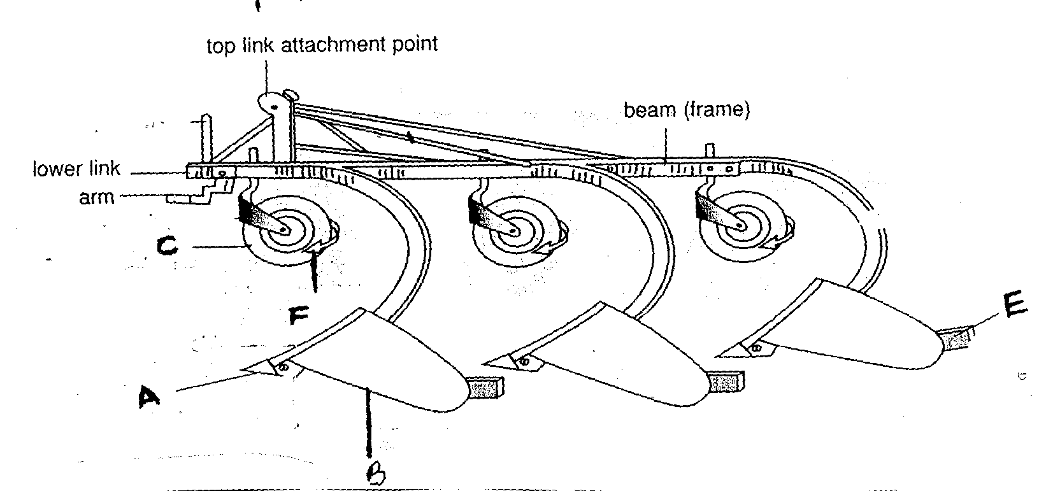

(a) Identify the farm implement illustrated above
(b) Label parts A, B and C
(c) Outline the functions of the parts labeled E and F
(d) Give two care and maintenance of the above implement

29. Outline six uses of live fences on the farm

30. List two possible causes of over heating in a tractor engine

31. List two events occur during induction stroke in a four stroke engine

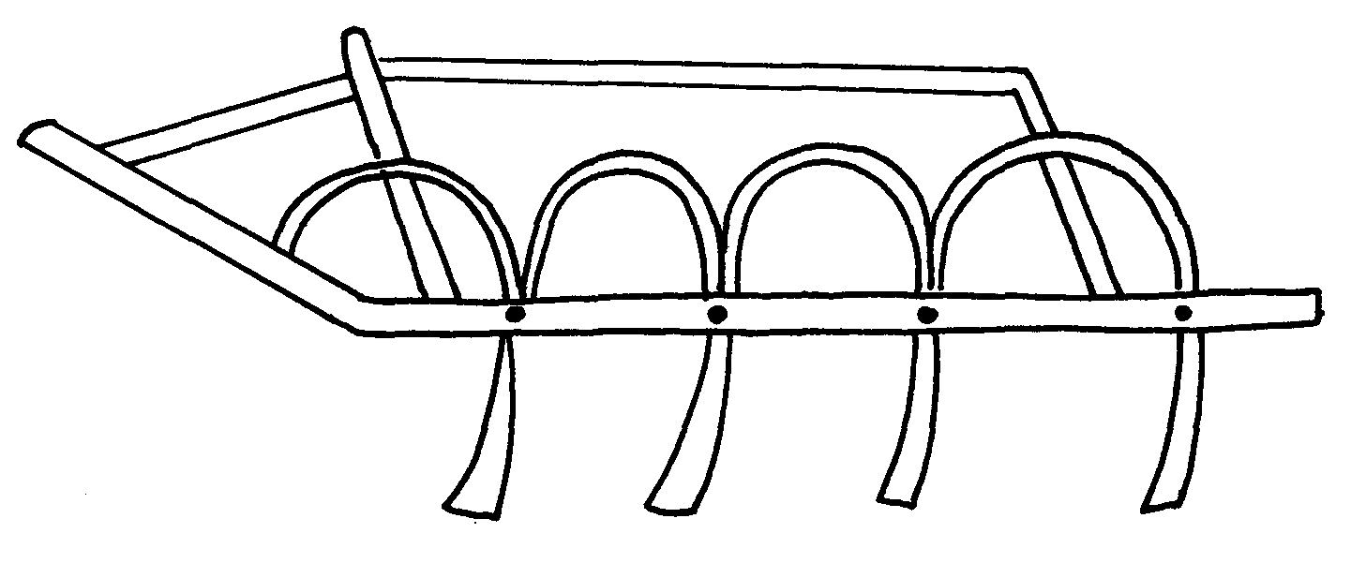
32. i) the diagram below shows a tractor drawn implement.

a) Name the implement
b) Give two uses of the implement above
c) State three maintenance practices carried out on the above implement. ii) Below is an illustration of a farm equipment. Study it and answer questions that follow

a) Identify the farm equipment illustrated above b) What is the use of the equipment c) Name the parts labelled W, X and Y d) What is the functions of Y on the equipment

33. a) Explain the factors that influence the power output of farm animals
b) State the importance of farm fences

34. Study the illustration of a biogas digester plant and answer the questions that follow.

a) Name the major component of biogas that is trapped in part L above
b) Give the name of the material deposited in part labeled M and its use
c) What is the component of K in the biogas production
d) Give three disadvantages of biogas as a source of farm power

35. Other than hydro-electricity mention two sources of electrical energy which can be available
for use in the farm

36. a) Describe the maintenance practices required on a tractor before it is put to daily use
b) Discuss the factors that influence the power output by a draught animal

PAPER ONE AND TWO
SECTION II ANSWERS
FARM TOOLS AND EQUIPMENT
1.
- Store the saw properly after use
- Oil the blade for long storage to avoid rust
- Sharpen the teeth properly
Tighten the handle screw if loose

2. A-Tin snip – cutting thin metal sheets
B-Spokes have – smoothing curved and circular surfaces
C- Ceardeners trowel – uprooting seedlings during transplanting
D-Brace drill – boring/ drilling holes in wood

3. i) Stir up pump/ bucket pump
ii) Spraying livestock with acaricide
iii) A – Nozzle B – lance handle
iv) A – Atomises the acaricide into spray B – Direct the nozzle to the parts to be sprayed

4. Garden fork is a tool used in weeding in the nursery beds/and in carrot fields

5. The tool for checking the vertical straightness of a wall is Plumb bob and plumbline

6. A tool for removing nails from timber is a claw harmer (1mk)

7. Two examples of equipment that a livestock farmer can use in administering oral
anti-helminthes (1mk)
- Narrow necked bottle
- Drenching gun
- Dosing gun

8. (a) L...- Pickaxe M- Adjustable spanner
O.............................................
N..- Ring spanner O..- Pipe wrench
(b) Give one functional advantage of tool M over tool N ( ½

9. Tools used to perform functions on the farm
- Hand drill
- Bit brace

10. - Blockage of nozzles and filters leading to uneven or no release of spray.
- Control pump may slacken or loosen, making it difficult to regulate the rate of spraying.
- Inadequate operating pressure due to leakages in the compressor pump, hoses or control valves.

11. (a) - Elastrator and rubber ring.
- The burdizzo.
- Sharp knife / scalpel.
(iii) Extracting blood samples for laboratory analysis

12. most appropriate set of animal hand tools that a farmer uses for the following operations:-
(i) Restraining large full when taking it around the show ring-bull ring and lead stick (1mk)
(ii) Cutting tail in sheep-rubber ring and elastrator (1mk)
(iii) Extracting blood samples for laboratory analysis-hypodermic needle and syringe

13. Provision of extra and quality feeds to sheep, two or three weeks before mating

14. ai) On the diagram a provided below, draw the mark to indicate a pig number 147,
using the procedure of ear-notching in diagram above
ii) the recommended stage of growth in pigs at which the ear-notching should be carried out?
- before wearing/3-7 weeks of age/21-56 days/1 month-22months)
iii) three reasons why weight is an important routine management practice in pig production
- to determine growth rate i.e. weight gain
- facilitate administration of drugs e.g. drenching
- for feeding i.e. to know the amount of feed to give
- to determine the service/breeding time (1x3=3mks)

b) i)B-entrance
C-top bar/bar
D-top cover/lid(1x3=3mks)

ii) by applying bees wax/honey/molasses on the sides or top of the hive/jaggery/sheep
sorrel/saliva /sugar syrup (Accept concentrated sugar solution-reject-sugar solution) (1x1=1mk)
iii) Outline the procedure of opening the hive to harvest honey
smoke the hive through the entrance using a smoker then light the hid to remove the top bar(the order must be considered) (1x2=2mks)

15. a) i) E-key hole saw/compass saw
F-wood chisel
G-cold/metal chisel
H-plumb bob (1/2x4=2mks)
ii) E-to cut or make key holes F-cutting timber
G-cutting metal H-checking whether a tall wall is vertical
iii) wooden hammer/mallet(1mk)

b)i) open castration/surgical castration (1mk)
ii) procedure you would follow when carrying out the practice named in( i) above in piglets
- restrain the piglets
- sterilize the blade
- disinfect the secretal sac
- slit the secretal sac to expose the testicle
- locate and hold the sperm duct
- cut the sperm dust by scrapping with the slide
- sew up the wound
- sterilize/disinfect the wound
- release the animal(piglet

16. i) A – Sickle
B- Pruning saw
C- Hoof cutter
D- Metal float
ii) A sickle is used in harvesting grass, rice, wheat by cutting
B Pruning saw is used for pruning tree crops, cutting hard stems in coffee
C Hoof cutter – Trimming hoofs in animals e.g. cattle, goats, sheep
D Float (wood or metal) smoothing concrete during plastering
iii) Maintenance on B
- Sharpen and reset the teeth
- Replace broken handle
- Oil the blade for long storage
17.
- Halter
- Rope
- Nose ring and leading stick

18. Mention the use of the following tools.
- Dibber.-making holes for transplanting
- Spoke shaves.-planning curved surface
- Tin snip.-cutting metal/iron sheets
- Burdizzo-castration (4x ½ =2mks)

19. four precautions that should be taken when using workshop tools and equipment.
- Use tools for correct purpose.
- Maintain them in good working conditions.
- Keep them safely after use.
- Handle tools correctly during use.
Use of safety devices / protective clothes

20. a) Bucket pump /stir - up pump (1x1 = 1mk)
b) Spraying acaricide on livestock (1x1 =1mk)
c) W - Nozzle
- X - Trigger
- Y - Pail /bucket
d)For holding acaricide solution during spraying. (1x1 = 1)

21. i) Identify the above diagram (1mk)
- Artificial vagina.
ii) Name the parts labelled A and B (2mks)
- A – warm water
- B – collecting cap

LIVESTOCK PRODUCTION I
COMMON LIVESTOCK BREEDS
1. two reasons for treating water for us on the farm
- Remove chemical impurities
- Remove foreign material
- Remove disease earning organisms
Remove bad smell & taste

2. four advantages of applying lime in clay soil
- Lower soil acidity
- Increase calcium content
- Hastens decomposition of organic matter
- Improve soil structure/ improve drainage
- Facilitates availability and absorption of nitrogen and phosphorous
- Improve legume nodulation and nitrogen fixation
Increase multiplication of micro- organisms

3. four ways by which Re-afforestation help in land reclamation
- Add organic matter from falling leaves
- Recycles soil erosion
- Control soil erosion
- Improve drainage of swampy areas
Play part in hydrological cycle

4. Distinguishing feature between Kenya white and California Kenya white is white all over the body, has pink eyes California white is white with black nose and eras; has black/ brown eyes

5. Reasons why farmers keep livestock in Kenya
- Source of food
- Source of income
- Cultural uses e.g. paying dowry, recreation
- Provide source of power e.g. oxen
- Provides raw material to the industries

6. Ideal conformation features of beef cattle
- Blocky/ square/ rectangular
- Deep well flashed bodies
- Short strong legs to support their heavy bodies
- Compact body

7. (i) Dual purpose cattle in Kenya.
- Sahiwal;
- Red Poll;
- Simmental;
(ii) Uses of Rotavator.
- Mixes trash and the soil;
- Cuts the furrow slices and harrows them; 92 in one pass).
- Break up large soil clods into smaller ones / performs 2⁰ tillage;
- Cut the furrows slices / primary tillage;

8. Large white is the pig with such characteristics

9. Epistasis is s combination of genes which on their own could have been inferior on undesirable(1mk)

10. (a) The role of livestock industry in Kenya’s economy
- Provision of food; various livestock products such as milk, eggs, meat and honey are used as food
- Source of labour: some livestock can be used to provide power for carrying out various activities e.g. oxen, donkeys and camels
- Provides employment; Several people are employed in the livestock industry ether directly of indirectly e.g. those employed by KMC
- Social cultural uses: depending on the culture of the society e.g. dowry, status, symbol e.t.c
- Source of income when livestock and livestock products are sold either locally or internationally: income is earned whish is used for national development which is used for national development
- Industrial development, various products are processed n industries which are taxable to raise income or national development
(stating any 5pts = 1mk x 5; Explanation each 1mk x 5pts =5mks (10mks)
(b) The general characteristics of indigenous cattle
- they have large thoracic humps for storing fat
- they are tolerant to high temperatures
- They are able to resist tropical diseases e.g East Coast fever
- They have relatively long calving interval (beyond one year)
- They have a slow growth rate and mature rate
- They have smooth and short coat of hair
- They have along and narrow head
- they have a relatively short lactation period
- they can walk for long distances without serious loss in condition
- They are relatively small in size even when mature (1mk each for any 10pts = 10mks)

11. (i) Dairy cattle
(ii) five characteristics that tells you that the animal belong to type name in (i) above?
- Straight top line
- Large udder/well develop udder
- Prominent milk vein
- Large swell develop head quarter
- Triangular shape
- Large stomach capacity (any 5x1=5mks)
(iii) three areas on the body of a cow where ticks are commonly found (1½mk)
- Base of ear/inside the ears
- Neck
- Flanks
- Tail switch/tail
- Belly
- Brisket/dew lap (any 3x ½ =1 ½ mks)

12. 4 dairy goats
- Saanen
- Jamnapari
- Anglo- Nubian
- Toggenburg
- British Alphine

13. two distinguishing characteristics of Californian breed of rabbit
- White body
- Black ears /nose/paws/tail (2x ½ =1mk)

14. two common milk breed of goats reared in Kenya
- British Saaren
- The Toggenburg
- Anglo-Nubian
- Jamnapari
- The British alpine ( ½ x2=1mks

15. four dairy cattle breeds reared goats in Kenya.
- Ayrshire
- Friesian
- Guernsey
- Jersey (4x ½ =2mks)

16. Differentiate between breed of animal and type of animal. (2mk)
- Breed-group of animals with similar characteristics and common origin.
- Type –the purpose for which the animal is kept. (2x1mk = 2mks) (mark as whole)
- smothers weeds
- Regulate soil temperature
- Conserve moisture

(LIVESTOCK HEALTH II
(LIVESTOCK PARASITES )

1. - Use of caustic potash stick (potassium hydroxide)
- Use of dehorning collodion

2. a)
- Cause anaemia
- Deprive the hoof animal of food
- Cause injury and damage to animal tissue and organs
- Transmit diseases
- Cause irritation
- Cause obstruction to internal organs
b)
- Human beings drop tapeworm segments/ progloltudes together with their faeces
- Eggs are released from the segment. Once outside the human body
- Eggs are picked by pigs when feeding
- Eggs hatch into embryos in the intestine of pigs
- The embryo penetrate the intestinal wall and enter into the blood stream
- Embryo localize in the liver
- Embryos are disturbed throughout the muscle where they become cyst/ bladder worms
- Bladder worms get into human beings through eating under cooked pork/ bacon
- Once inside the human intestines the cyst wall dissolves and the bladder worm attach themselves to the wall of intestines
- Bladder warm develop into adult tape worm
- Adult tape worm releases segments/ progloltides containing fertilized eggs with human faeces
c)
- Use prophylactic drugs/ deworms to kill the internal parasites
- Keep animal houses clean and disinfected
- Practice rotational grazing
- Use of clean feeding and watery equipment
- Use of latrines/ proper disposal of human faeces
Proper cooking of meat
3. Functions of calcium in dairy cows.
- Milk and egg formation / production;
- Bones / skeleton / teeth formation;
- Blood clotting;

4. Control measures of fleas.
- Keep clean animals sleeping places;
- Dust animal surroundings with appropriate insecticides;
- Cover with petroleum jelly to suffocate stick fast fleas;

5. Control measures of fleas *NYR*
- Dusting with appropriate insecticide in the pen
- Ensuring cleanliness in poultry house
- Dusting of the birds with correct insecticide
- Applying petroleum jelly on infected parts (1mk each for any 2 pts = 2mks)

6. two reasons why drenching alone is not an effective method of controlling internal parasites
- Cannot kill all stages of parasites
- Cannot kill the eggs (2x ½ =1mk)

7. -Embryo
-Cyst/bladder worm (2x ½ =1mk)

8. a) K-tapeworm M-liver fluke
b) a-hooks b-suckers
c-mouth d-digestive glands
c) i) Small intestine
ii) the liver
d) Water snail (1x1=1mk)

9. - External parasites effects
- Transmit diseases
- Causes anemia/ sucks blood
- Causes irritation/ discomfort
- Causes wounds on the skin that may predispose animal to secondary infection
- Loss of hair

10. - Read the manufacturers instructions carefully
- Mix the acaricide appropriately
- Pour the chemical solution into the knapsack sprayer through the sieve/ stir up pump container
- Restore in the animal
- Spray along the back to loin
- Spray the sides
- Spray under the belly including the udder/ scrotum
- Spray the rear/ hind quarters
- Spray fore limbs
- Spray the face, the eras last
- Allow the animal to drain the chemical
- Release the animal

11. a) Feed conversion is ^{90Kg}/_{360Kg} = ¼ = 1 : 4 *MMS*
- Digestion in ruminant animal – 4 stomachs
i) Rumen (A pauch)
- Stores food temporarily
- Fermentation of food
- contains bacteria, fungi, protozoa which breaks down cellulose
- Synthesis of amino acids from ammonia gas
- Synthesis of vitamin B complex
ii) Reticulum (Honey comb)
- Sieves and separates fine from coarse food particles
- Retrains foreign and undigestible materials
iii) Omasum (Many plies or book)
- Stores food temporarily
- Grinds and sieve food particles
- Absorption of water
iv) Abomasum (True stomach)
- Enzymetic digestion takes place
c)
- Prevents rusting of surfaces
- Reduces the rate of wear and tear of moving parts
- Minimizes power loss due to friction
- Acts as a cleaning agent
- Reduces the heat created by the rubbing surfaces and acts as a seal between them

12. Bush clearing to destroy breeding places
- Spraying breeding places with insecticides
- use fly traps with impregnated nets
- use stressing agents e.g. radio isotopes on male file sand then releasing them

13. - Succulent
- Dry

14. two common milk breed of goats reared in Kenya
- British Saaren
- The Toggenburg
- Anglo-Nubian
- Jamnapari
- The British alpine ( ½ x2=1mks

15. the element calcium and phosphorus important in the diet of young livestock?
- For bone formation and development
- For proper teeth development
- For increased conversion of feed
- Increase livestock appetite ( ½ x1=1mk)

16 two parasites of cattle which are also disease vectors
- Ticks
- Tsetse flies
Mosquitoes

17. -training
-Giving incentives/motivation
-Farm mechanization
-Labour supervison

LIVESTOCK PRODUCTION II (NUTRITION)
1. Production ration may be utilized by dairy goats in:
- Milk formation
- Growth
- Foetal/embryo development
2. Use Pearson’s square method to calculate how much of the feedstuffs a 150kg rations (5mks)

Maize bran = 12 x 150 = 90kg maize bran
20
Sunflower 8 x 150 = 60kg sunflower
20

3. i) Water (1mrk)
- Transport medium
- For metabolic processes
- Regulates body temperature
- Maintains shell shape
- Component of livestock product
- Lubricant of body joints (2x ½ = 1mk)
ii) Vitamin A (1mrk)
- Bone formation
- Prevents diseases / Increases disease resistance
- Improves vision
Improves vigour/ for proper growth

4. Rumen.

5. i) A ration containing 18% protein is to be made from maize and sunflower cake. Given
that maize contains 7% protein, and sunflower seed cake 34% protein. Use Pearson square
methods to calculate the value of feedstuffs to be used to prepare 100kgs of the feed (3mks)
ii) two other methods that can be used to formulate
feed ration
- Linear programming
- Trial and error
Graphical method.

6. (a) The daily amount of food given to an animal/ the amount of food given to an animal
per day

(b) Quantity of maize = 12 x 200Kg
18 = 133.33kg
Quantity of cotton seed = 6 x 200
18 = 66.67kg

7. Hormones
Antibiotics
Medicants
8.
- Qualities of roughages
- Availability of the concentrates
- Level of production
- Physiological states of the animals
- Quality of concentrates
- Economic factors
9.
- Qualities of roughages
- Availability of the concentrates
- Level of production
- Physiological states of the animals
- Quality of concentrates
- Economic factors

LIVESTOCK PRODUCTION III
(SELECTION AND BREEDING)
1.
- Steaming up of ewes to have milk to be suckled
- Use of lambing pens
- Ewes as made to recognize lambs after lambs
- Blind folding ewes to activate maternal instinct
- Attend/ treat inflamed udders/ painful
2.
- Pig 112 – 15 days
Rabbits 28 – 32 days
3 (i) Selection.
- It is the process of allowing certain animals to be the parents of the future generations while
culling others;
(ii) Methods used in selection.
- Mass selection;
- Progeny testing;
- Contemporary comparison;

4. - Restless.
- Frequent urination.
- Swollen vulva.
- The doe throws itself on its side.
- She (does rubs herself against the wall or any other solid object.
- The doe tries to contact other rabbits in the next hutch by peeping through the cage walls.

5. four meat breeds of rabbits
- Flemish giant
- California white
- New Zealand white
- Ear lop
- chinchilla

6. four reasons for cutting a breeding boar
- Bareness/loss of Libido
- Loss of sight, limb, cannot mate
- Old age
- Perpetual sickness/contract
- Reproductive diseases
- Aggressiveness/wildness

7. - Mass
- Progerry testing
- Comparison

8. (i) Heterosis- Increased vigour/ performance resulting from mating two superior unrelated Breeds
(ii) Epitasis- Is a combination of genes that individually could have been both undesirable
or inferior
9.
- Heat signs in rabbits (doe)
- The doe throws itself on its sides
- She rubs herself against walls or solid objects
- Tries to contact other rabbits in the next hutch (peeping)
- Restlessness
- Swollen vulva
- Frequent urination
10. Gestation periods of :- Cow 270 – 285 days
Sow – 113 117 days
11. Disadvantages of natural mating
- A lot of semen is wasted
- High chances of inbreeding
- Large males can injure small females
- Expensive to transport bull over long distance
- May need extra pasture, extra cost

12. a) the advantage of battery cage system of rearing layers
- Higher egg production due to less energy wastage by birds
- Accurate egg production records re kept
- Cannibalism and egg eating are controlled
- Eggs are clean
- Allows for mechanization
- Birds do not contaminate food and water
- Makes handling easy as birds are restricted within small areas
- Discourages broodiness
- Increases the sticking rate
- Sick birds can easily be isolated
- The wire floor prevails re-infection on the parasites, worms and coccidiosi
- There is no bully during feedings
- There is low labour requirement (1x10=10mks)
b) Outline ten factors considered when selecting dairy cattle for breeding
- age-young animals have longer productive live and are more productive and
Economical to keep than old animals
- level of performance-animals with highest production level be kept
- health-consider animals which are less susceptive to disease
- body confirmation go for ones well people dairy characteristics
- temperature/behaviour select only decline animals which are easy to handle mothering ability
- adaptable under suitability to the environment
- prolycacy ability to give built to many off springs at a time
- physical defects
- quality of products (1x10=10mks)

13. A type of mating where the female of low grade is mated to a pure bred sire of
superior quality (1mk)

LIVESTOCK PRODUCTION IV
(LIVESTOCK MANAGMENT PRACTICES)

1. Reasons of carrying out crutching in sheep.
- Facilitates easy mating;
- Minimizes blowfly infestation;
- Provides hygienic conditions at lambing time;
- Allows easy access to the teats by the lambs;
- Provides hygienic suckling conditions;

2. Ways of performing closed castration.
- Use of elastrator and rubber ring;
- Use of the burdizzo;

3. (a)
- B – Should take place – Hooks, cheek, rump
- V – Is done - Thigh muscles and the shoulders
- BT – is taken - Anus
- M – May occur - Udder and teats
b) -- Ears (ear lobes)
- Tail switch..
- Under the tail head.
- Both fore and head flanks.
- Between the hooves.
c) 1 – Muzzle
2 – Poll
3 – Shoulder
4 – Heart girth

4. (a) - The removal of the testicles in male livestock or stoppage of production of spermatozoa or
semen.
- It is the rendering of male reproductive organs non- functional.
(b) – To control breeding and inbreeding.
- To make animals, especially the bulls docile.
- To improve quality of meat by removing unpleasant smell especially in goats.
- To encourage faster growth rates of the castrated male animals.
- To control breeding diseases such as brucellosis, vaginitis trichonomiasis and others that area
transmitted through mating.

5. (a) The management of a gilt from weaning to furrowing
- Feed gilt on at least 3kg of sow and weaner meal daily/balanced diet
- Provide clean drinking water
- Control any external parasites by spraying with pestcides or washing
- Treat the gilt next to the bear at the age 12months ready to be served/serve gilt at the right age.
- Keep the pen clean by maintaining clean
- Flush the gilt 3-4weeks before service by feeding high quality diet
- Take the gilt to the boar’s pen for service and let it stay there for at least 12hours
- Observe the return to heat, f any after three weeks, and repeat the services if necessary
- Steaming up should start 1 ½ months before furrowing by giving 3-4kg of feed
- 7-10days furrowing, the gilt should be washed
- The gilt should be moved to disinfected pen/clean en
- provide guard rails or furrowing crate in a furrowing pen
- Provide a source of heat
- Sow and weaner meal should be reduced three days before furrowing and fed with bran
- Observe the signs furrowing and supervise the process of furrowing
- Deworm the gilt 7-10days before furrowing
- Weigh the gilt regularly
- Keep proper records

(b) The preparation a poultry farmer should make before the arrival of day old chicks
- Ensure the brooder is ready 2-3days before arrival of chicks
- Brooder should be cleaned and disinfected to reduce risk of disease infection
- Spreading litter on the floor to provide warmth
- Provide a functional heat source e.g. electric bulb, lantern e.t.c
- Provide adequate feeding equipment
- Ensure adequate floor space considering the number of chicks
- Ensure the chick mash is ready before chicks arrive
- Provide wire guard
- Make holes on the walls of brooder for ventilation
6.
- To identify mated ewes
- To indicate active rams hence help in culling
Identify the sire of each lamb
7.
- Promote docility
- Improve meat quality
- Control breeding diseases
- Control interbreeding/ control hereditary defects
Improve growth rate
8.
- Use of swarm net
- Use of catcher box
Placing the hire in a strategic position for bees to occupy
9.
- Control deficiency diseases
- Impact resistance to diseases
Good physical appearance/ good coat cover

6. two recommended methods of docking lambs
- Use elastrator and rubber ring
- Sharp knife/scalpel (2x ½ =1mk)

7. three disadvantages of inbreeding
- Loss of hybrid vigour
- May lead to decline fertility leading to species extinction
- May bring about reduction in performance
- Leads to high rate of prenatal mortality (any 3x ½ =1 ½ mks)

8. four routine management practices that should be carried out on a lactating ewe
- Inadequate feeding /balance diet
- Spraying/dipping to control external parasite
- Drenching/deworming to control internal parasite
- Provision of clean water ad-lib
- Tugging
- Avoid extensive movement
- Provide mineral licks (any 4x ½ =2mks)
9. the procedure which should be followed to castrate a three weeks old piglet using
surgical Method
- Assemble equipment and sterilize
- Restrain the animal to be castrated
- Thoroughly wash hands before opening up animals skin
- Artery of forces is used to close up the open blood vessel to stop excess bleeding
- Cut the skin of scrotum
- Remove the two tests completely, leaving on empty scrotal sac
- Disinfect the wound
- Animals heals faster since its castrated when young (7x1@=7mks)
(b) (i) State five factors that should be considered when sitting a bee hive in a farm
- Away from homestead, pastures and road
- Sheltered/quiet place
- Near source of water
- Nearest to flowers producing ants
- Safe from predators (5x1=5mks)

(ii) Describe the management practices that would ensure maximum harvest of fish from a fish
pond
- Control stocking rate
- Control water pollution
- Supply enough food to fish
- Aerate the water/constant in flow and out flow of water
- Maintain appropriate depth of water
- Control predators
- Harvest fish art correct maturity stage
- Fertilize the pond/adequate water plants

10. three types of bees found in a bee colony
- The queen
- The drown
- The workers
11. List three methods of castrating farm
- Closed method-use buidizzer
- Open method-use surgical method
- Caponization-use hormones

12. the routine management practices of piglets from the 1st day to the 8th week
- Placenta disposal
- Umbilical cord cutting with sharp and sterilized scalpel
- Disinfecting the umbilical cord with iodine solution
- Extracting needles teeth/teeth clipping/di-tusking
- Keeping piglets in warm creep area
- Weighing the piglets 24hrs after birth
- Feeding the piglets on colostrums
- Iron supplementation through the intra-muscular injection/paste
- Vaccination against diseases
- Feed the piglets with creep feeds
- Water provision at adlibitum
- Nose ringing
- Putting if identification marks e.g. ear notching
- Deworming /drenching with antihelminthes
- Tail cutting of the piglet
- Castration of the male piglet
- Ensure that they are breathing
- Assist the weak piglets to suckle
- Changing the beddings regularly
- Removing dead piglets from the pen
- Providing furrowing crate to avoid crushing of piglets
13.
- Raised pers with slatted floor
- Permanent calf pen with concrete floor
- Movable calf pen
- Temporary calf pen
14. Poor nutrition – infertility
Poor timing of service
15. three advantages of hoof trimming in sheep production
- Facilitate easy movement
- Control foot rot disease
- Prevents the ram from injuring the ewe during mating ( ½ x3=1 ½ mks)
16. State four factors considered when citing an apiary in the farm
- Availability of water
- Availability of flowers
- A sheltered place
- An area free from noise/disturbance
- Away from lime stead and grazing grounds
- Well drained area (2x2=4mks)

17. three methods of stocking a beehive with honey bee
- Use swarm nets
- Use of a catcher box
- Use of an empty hive ( ½ x3=1 ½ mks)

18. three common methods of extracting honey from the combs
- Use of heat
- Crushing and straining
Centrifugal extractor
19. a) i)
ii) before wearing/3-7 weeks of age/21-56 days/1 month-22months)
iii) -to determine growth rate i.e. weight gain
- -facilitate administration of drugs e.g. drenching
- -for feeding i.e. to know the amount of feed to give
- -to determine the service/breeding time (1x3=3mks)

b) i) B-entrance
C-top bar/bar
D-top cover/lid(1x3=3mks)
ii) by applying bees wax/honey/molasses on the sides or top of the hive/ jaggery/sheep
sorrel/salvial/sugar syrup
(Accept concentrated sugar solution-reject-sugar solution) (1x1=1mk)
iii) Outline the procedure of opening the hive to harvest honey
smoke the hive through the entrance using a smoker then light the hid to remove the top bar(the order must be considered) (1x2=2mks)

20. a) i) E-key hole saw/compass saw
F-wood chisel
G-cold/metal chisel
H-plumb bob (1/2x4=2mks)
ii) E-to cut or make key holes
F-cutting timber
G-cutting metal
H-checking whether a tall wall is vertical (1/2x4=2mks)
iii) wooden hammer/mallet(1mk)
b))i) open castration/surgical castration (1mk)
ii) procedure you would follow when carrying out the practice named in( i) above in piglets
- restrain the piglets
- sterilize the blade
- disinfect the secretal sac
- slit the secretal sac to expose the testicle
- locate and hold the sperm duct
- cut the sperm dust by scrapping with the slide
- sew up the wound
- sterilize/disinfect the wound
- release the animal(piglet) (1/2x6=3mks)
- four advantages of age grouping farm animals as a management practice
  - Avoids bullying among the animals
- Facilitate feeding /adequate and economic use of feed
- Facilitate the administration of drugs e.g. drenching
- Easy keeping of management records
- Facilitate breeding/cutting of livestock (2x4=8mks)
b) four major cause of lamb mortality from birth to weaning
- chilling
- scours
- internal parasitic infertation
- loss of mother/lack of foster parents
- inadequate mothers milk/malnutrition
- crushing by t he mother (1x4=4mks)

c) i)cause-bacteria/brucella abortus brucells
ii) Transmission-sexually transmitted/it is a breeding diseases
iiI) Symptoms
- abortion/premature birth
- yellowish slimy and odourless discharge through the vulva
- retained afterbirth/placenta
- the cow may become barren (1x4=4mks)
iv) Control measures
- vaccination
- use of healthy semen/bull/Al
- cull/destroy affected cattle
- proper disposal of foetus and carcass (1x2=2mks)

23. Reasons for castrating animals when young
- Less pain
- Quick healing
- Little loss of blood

24. a) Reasons for dehorning farm animals
- Reduce space occupied by animal
- Making handling easier
- To reduce destruction of farm structures
- To make them
- To reduce risk, injury to farmer and other animals 2x ½ = 1 mark
b) Methods of dehorning livestock
- Use of caustic potash stick (Potassium hydroxide)
- Use of dehorning iron
- Use of dehorning saw or wire
- Use of rubber ring and elastrator
- Use of dehorning collation
25. a)Is the giving of high quality seeds to a gestating animal towards end gestation period
b) Reasons for steaming up
- Increase milk yield after farming
- Help build up body reserves for lactation
- Ensure rapid growth and development foetus
- Ensure healthy and string young at birth

26. four management practices that should be carried on a fish pond in order to obtain maximum
Fish production.(2mrk)
- Control predators.
- Control Water pollution.
- Maintain appropriate water level.
- Maintain correct stocking rate.
- Supply adequate food. (4x ½ =2mks

27. four factors considered when formulating livestock ration. (2mk)
- Body weight / size
- Available feeds
- Cost of feeds
- Nutrient composition of feeds available.
- Ingredients required in the ratio.
- Animals level of production.
- Age / stage of growth.
Type of production.

28. four conditions that necessitate the handling of farm animals. (2mk)
- During treatment
- When spraying or hand dressing
- When milking
- When performing some management practices e.g. dehorning
When inspecting animals for any signs of a disease

28. - Large animals e.g. buffaloes
- man activities e.g. farming
- root pressure of plants
- burrowing animals e.g. moles, termites

29. (a) – Random/zigzag soil sampling-Arrow roots
(b) -Old manure heaps
- Ant hills
- Dead furrows
- Rice
- Fence lines
- Cattle bomas

FARM STRUCTURES
1.
- Steel is expensive
- Require high skilled labour
- Heavy and difficult to transport
- Rusts easily
Low workability
2.
- To prevent termites from rising up to the wall
- To reduce moisture rising up the wall
3. A group of calves kept according to age

4. a) Procedure in construction of a barbed wire fence
- Slash/ clear vegetation around fence line 2 m wide
- Measure and mark spots for holes using pegs
- Dig holes 60cm – 90cm deep depending areas where the poles are to be placed
- Assemble poles and other requirement materials
- Drop pole and struts at respective points
- Prepare concrete mixture
- Erect poles in pole holes
- Align the poles and put concrete using spade or soil
- Compact the concrete in holes
- Allow to settle for a few days while curing
- Put barbed wire around using appropriate tools
- Tighten the wire using wire strainer
- Mail barbed wire using fencing staple at required distance
- Put droppers along the fence as required 12x1=12 mks
b) Wood preservatives
- Creosote
- Old engine oil
- Paint/ far/ tanesc
- Copper sulphate
- Sodium dichromate
- Arsenic pentoxide
- Pentachloroplenol
- Triputyl tin oxide 4x1=4 mks
c) Choice of farm building materials
- Cost of materials
- Availability/ strength of the material
- Workability
Type of enterprise

5. (i) Factors considered when sitting a fish pond.
- Reliable source of water/ water source;
- Soil type / poorly drained clay soil the best;
- Topography / gently sloping;
- Security/ be secure from thieves / predators;
- Water quality / free of pollutants;
- Machine milking;
(ii) Features of a laying nest.
- Dimly lit; dark;
- Spacious / large enough to accommodate bird comfortably;
- Dry clean beddings;
- Have lockable doors;
- Kept in secluded parts of the house;
- Have slanting roofs to prevent birds from perching on;
5. Uses of footbath in cattle dip.
- To wash the foot off mud;
- Contains chemicals for controlling foot rot; CUSO₄ (blue vitriol/ formalin solution;)
6. (a) – A green house is a farm structure made up of glass or translucent material as wall and
roof to enhance and achieve optimum condition for valuable horticultural crop production.
(b) Material used in green house construction.
- Galvanizing iron.
- Aluminium or wooden frame.
- Glass or clear polythene sheet.
- Fibre glass or reinforced panels.
(c) Maintenance practices on green house.
- Dirty polythene sheet should be clear.
- Blocked systems should be repaired and cleared.
- Torn polythene material should be replaced.
- Should be fenced for security.
(d) Importance of maintaining farm structures.
- Last longer/ enhance durability.
- Reduce replacement cost.
- Protect livestock from predator.
- Prevent straying animals.
- To prevent diseases brought by cold winds.
- Make them effective in their use.

7. Disadvantages of barbed wire fence in paddocking:-
- Can remove wool from sheep
- Barbs can injure the animals
- Smaller animals can pass through if the wire strands are widely spread

8. (a) A .Inlet
B – Spillway/ overflow.
C - Drain pipe/outlet (1 ½ mk each = 1 ½ mks)
(b) The most appropriate part for feeding is part X (1mk)
(c) Two reasons why the floor of the pond should be covered with lime
- Facilitate the work of fertilizer in the pond
- Maintain PH of pond water ( ½ mk each 2pts = 1mk)
(d) Why should part marked B be screened?
- Prevent escape of fish
- Prevent entry f foreign /unwanted organisms ( ½ x 1pt = ½mk)
(e) three maintenance practices carried out on the structure
- Removing weeds
- Unblocking inlet and outlets
- Maintaining same water level
- repairing leakages on walls, floor e.t.c
- Draining of water during harvesting

9. (a)Stille ( ½ mk x 1pt = ½ mk)
(b) A pass allows only human passage while gate allows for both human and livestock in and
out of the farm ( ½mk mark as a whole)
(c) One type of live fence
- Electric
- Hedges

10. four requirements of a good maize store
- Leak proof
- Rat proof
- Properly ventilated
- Easy to clean
- Raised off the ground properly drained
- easy to load and unload/spacious (any 4x ½ =2mks)

11. three factors that determine the depth and size of foundation in a farm building
- Function of building
- Soil type
- Soil depth
- Drainage of area (any 3x ½ =1 ½ mks)

12. (a) the uses of various hand tools in the construction of a poultry house
- Jembe- levelling the ground
- Spade-scooping soil
- Tape-measuring distance
- Wheel barrow-carrying small load
- Spirit level-checking whether surface is vertical or horizontal
- Rip-saw/tenor saw-cutting timber
- Hand drill/bit brace-boring in wood
- Claw hammer-driving in/hitting and removing nails
- G-clamp-holding objects /wood when joining
- Tin-snip-cutting iron sheet
- Chisel
- Mallet (any 10x1=10mks)
(b) the procedure of erecting wooden rail fence(7mks)
- Locate the area to be fenced off
- Determine the amount of material needed
- Treat the post
- Clear the area
- Measure the distance 3-4m apart and place pegs
- Dig holes up to 60cm deep
- Put fencing post in hole and reinforce with concrete
- Place 3-4 horizontal rails
- Space at about 125mm,175mm, 225mm and 275mm from ground
- Fixed them onto post using nail (10x1pt=10mks)
(c) factors considered when choosing the construction materials for farm building
- Purpose of building determine strength and durability of material
- Availability of capital; depends on ability to purchase
- Aesthetic aspect:-determine by economic status of farmers
- Availability of material: easily obtained
- Durability: good quality .not be repaired often
- Resistant to extreme weather condition
- Safely of farm animals and farmer:- not have side effects/workability
- Suitability of the material.(any5pointsx2mks=10mks)

13. - Have adequate space
- single housing ( 1caf per pen)
- Properly lit
- Have proper drainage
-Well ventilated
- Drought free

14. - Demarcates boundaries of farms
- Prevents intruders, wild animals, thieves in the farms
- Facilitate mixed farming
- Enhance paddocking of farm for effective rotational grazing
- Control unnecessary movement in the farm
- Control inbreeding
- Isolate sick animal

15. (a) (i) A – Wall plate/team beam/lintel
B – Damp proof coarse
C- Hard core
(ii) - Prevents termite invasion
- Prevents water capillarity /dampness
(b) (i) 1 bag of cement
3 parts/wheel barrows of sand
5 parts /wheel barrows of ballasts or gravel
(ii) Sand
3 parts of sand = 24m³
1 bag = 1x24 = 8m³
3
ballast
parts = 24m³
5 parts = 5x24 = 40m³ (½mk)
3
16. (a) Maintenance of the fish pond
- Protection of the pond – regularly check pond walls, plant grass on the walls to help control soil erosion
- Pond bottom repair- check water seepage problems regularly, It can be done introducing an even layer of clay to seal off the bottom of pond properly
- Removal of weeds; -regularly remove all weeds that grow on the walls and around the ponds
- Maintenance of appropriate water level: Maintain the same level of water in the pond by use of inlet and outlets
- Inspection of pond: - Regularly check for cracks in the walls and seal immediately
- Cleaning the pond- once n a while to drain out the pond water, remove all stones, silt or roots that may have settled at the pond bottom, lime the water before refilling it with water
- removal of organic materials – any vegetative matter or food remains should be removed as soon as they are noticed to ensure they do not start decomposing
- Repair fence around the pond- In case of worn out posts, repair/replace immediately
(b) Ways of controlling of fish predators in a fish pond
- Put a strong wire fence around the pond
- Provide a wire screen above the pond to guard against prevatory birds
- A sire screen is put in the inlet, outlet and in the spillway
- Scare away in the binds as necessary
- occasionally drain the ponds to kill all unwanted predatora in the pond bottom

17. four reasons of treating timber before roofing farm buildings
- Prevent attack from insects
- Prevent attack from fungi (rotting)
- Resist weather condition:-extreme temperature
- Resist water penetration
- To harden woo-make it durable and more strong
- To avoid warping

18. four uses of crushing in the farm
- Spraying livestock against external parasites
- Identifying animals by use of such methods as branding ,ear-tagging and ear notching
- Vaccination
- Administering prophylactic drugs to the animals
- Treating sick animals
- Dehorning
- Pregnancy test
- Artificial insemination
- Taking body temperature
- Hoof trimming
- Milking

19. a) A fence is a structure that encloses a designated area and forms a physical barrier for
animals and human
b) List various types of fences
- live fence
- electric fence
- barbed wire fence
- chicken wire fence
- wooden fence
- pole and rail fence
- plain wire fence
- trench fence
- wall fence
c) Describe advantages of fences
- keep off intruders/thieves
- prevent damage of crops by animals
- control grazing in paddocks
- control breeding by separating male and female
- acts as wind break
- control pests and disease by controlling wild animals
- add aesthetic value
- provide livestock feed or human fruits or firewood
- add value to the farm
- provide security to the house stead and farm animas
- they form perimeter fence along the boundary to demarcate farm land from the neighbours
- used to isolate sick animals from the rest of the herd to prevent spread of diseases
- separate crop field from pasture facilitating mixed farming

20. i) E – rafter F- Struct
G- Eaves H- Wall plate
ii) E (Rafter) – To provide support for the roofing materials
F (Strut) – To support the rafter/ holding the weight of the roof
G (Eaves) – Prevent rain from falling on the wall
H- (wall plate)- To support the roof
iii) Chemicals for treating timber
- Tar
- Sodium dichromate
- Copper sulphate
- Arsenic pentoxide
- Old engine oil
- Pentachlorophenox
- Tributyl tin oxide
- Creosote
- Paint

21. i) K- Spill way (reject over flow pipe)
L- Drainage channel
ii) M is deeper to provide breeding place for the fish
iii) Maintenance of the pond
- Cleaning the pond by removing all foreign materials
- Repairing the dyke (bunds)
- Maintain good level of water
- Control predators
- Weed control around the pond
- Plant grass on dykes to prevent erosion
- Remove the silt if accumulated
- Regular pond fertilization
- Apply lime before refilling

22. a) Siting a fish pond
i) Soil type- clay soil is the best
ii) Topography – requires gentle slope not Lilly and flat
iii) Source of water – near reliable source
iv) Marketing centre should be close
v) Accessibility from the homestead
vi) Security – protected against predators
vii) far from natural source of fish
b)
- General farm hygiene, cleanliness of houses, equipment proper carcass disposal by burning/ burying/
- Disinfection to destroy pathogens e.g. Anthrax and calf diseases
- Isolation of sick animals – separated from healthy ones to avoid spread of diseases e.g. foot mouth
- Drenching/ deworming to control internal parasites e.g. tapeworms and roundworms
- Treatment of the sick animal – to prevent spread of diseases
- Vaccination to create resistance to diseases on regular basis e.g. foot and mouth, anthrax, new castle
- Control vectors – to avoid disease transmission e.g. ECF, nagana/ specific method
- Prophylactic approach/ use of drugs to avoid injection e.g dry cow therapy against mastitis
- Trypanocidal drugs to control trypanosomiasis
- Proper breeding to control breeding diseases e.g. brucellosis
- Proper feeding to prevent nutritional disorders e.g. milk fever, anaemia
- Slaughtering/ killing – to prevent spread of contagious diseases e.g. anthrax
- Quarantine – to avoid spread of diseases
- - prevent introduction of diseases
- Proper housing to avoid predisposing the animal to diseases e.g. ventilation, spacing
- Foot trimming to minimize occurrence foot rot

23. four factors which influence the selection of materials for constructing a diary shed
- Kind of dairy shed i.e. permanent or temporary
- Availability of materials
- Cost of materials
- Environment conditions of climate and soil type
- Durability of materials a
- Availability of killed labour for construction
- Capital available (1/2x4=2mks)

24. a)i) On the diagram a provided below, draw the mark to indicate a pig number 147,
2
using the procedure of ear-notching in diagram above
ii)the recommended stage of growth in pigs at which the ear-notching should be carried out?
- before wearing/3-7 weeks of age/21-56 days/1 month-22months)
iii) State any three reasons why weight is an important routine management practice in pig production
- to determine growth rate i.e. weight gain
- facilitate administration of drugs e.g. drenching
- for feeding i.e. to know the amount of feed to give
- to determine the service/breeding time (1x3=3mks)

b) i) B-entrance
C-top bar/bar
D-top cover/lid(1x3=3mks)

ii) by applying bees wax/honey/molasses on the sides or top of the hive/ jaggery/sheep
sorrel/salvial/sugar syrup
(Accept concentrated sugar solution-reject-sugar solution) (1x1=1mk)
iii) Outline the procedure of opening the hive to harvest honey
smoke the hive through the entrance using a smoker then light the hid to remove the top bar(the order must be considered) (1x2=2mks)

25. a) State five maintenance practice of a mould board plough
- Lubricate the moving pests
- Sharpen blunt share
- Tighten bolts and nuts
- Clean the plough after use
- Coat the unpainted parts with old engine oil before any storage
- Replace worn out parts (1x5=5mks)
b) Explain five structural and functional differences between the petrol and diesel engines
Petrol engine | Diesel engine
i)has a carburetor  ii)fuel and air mixed in the carburetor  iii)fuel ignited by an electric spark  iv)produces little smoke  v)is light in weight | i)Has an injector pump  ii)Fuel and air mixed within the cylinder  iii)fuel ignited by compression of air and fuel  mixture in the cylinder  iv)produces a lot of smoke  v)relatively heavy

c) List five uses of farm fences
- keep of wild life ,predation and intruders
- demarcates boundaries
- separate crop field from pasture land
- divide pasture land into paddock
- control movement of animals and people within the farm and prevent formation of unnecessary pests
- control disease and parasites helps in isolate sick animals
- helps in controlling breeding
- provide security
- act as wind break (1x5=5mks)

26. Uses of farm buildings
- Protect the farm animals from predators
- Provide shelter to the farmer and livestock
- Used to store farm produce and valuable inputs
- Controls livestock diseases and parasites
- Enhances efficiencies in farm planning, budgeting and production

27. Structural requirements for proper housing
- Well ventilation
- Free from cold/ draught
- Adequate space
- Proper drainage
- Leak proof roof
- Well lighting
- Easy to clean/ concrete floor

28. a) - roof
b) P- purklin Q- Rafter
R- Cross tie S- Gutter
c) P- Support roofing material/ iron sheet
Q – Collect water and safely directs it away from building

29. a) Honey
b) Crushing and straining
c) Procedure of harvesting the named product
- Wear protective clothes
- Approach hive quietly from behind
- Blow smoke around hive then through entrance
- Lower hive
- Remove lid/ cover
- Lift top bars and brush off with bees
- Cut honey combs with honey leaving 3cm of wax
- Put combs in container
- Place back bars
- Put lid
- Return hive in position
d) Factors that affect quality of product harvested
- Type of plant from which nectar is obtained
- Maturity stage
- Method of harvesting
- Method of processing
28. i)Docking
ii) Reasons for carrying out the operation
- Avoid incidences of blowfly
- Make mating easy
- Even distribution of fat in body
- Avoid dirtifying wool
iii) Age of operation
- within two weeks from lambing
iv) Methods used for operation
- use of rubber ring and elastrator
- cutting with sterilized docking knife
- use of burdizzo
- use of hot iron bar
v) Routine management practice carried out on part B
- hoof trimming

29. a) Five parts of plunge dip
  - Holding yard- Hold animal before dipping
  - Foot bath- Wash animal feet off dung, mud
-Prevent foot rot/ contain copper sulphur,
  - Jump- Narrow entrance allow single animal easily to jump in dip wash
  - Draining race- Animal held while dip wash drain back in dip tank
  - Drying yard- Animals need to dry before allowed to pasture, avoid contamination
  - Silt trap-raps mad, dung before dip wash flow back to dip tank, prevent siltation of dip tank
  - Shelter-Prevent evaporation
-Prevent dilution of dip wash with rains
b) Six uses of live fences
- Thorn species prevent wild animals and other invaders into the farm
- Tall varieties act as wind breakers
- Add aesthetic value to the homestead
- Roots holds soil firmly controlling soil erosion
- Species such as lantana canara can be used to feed livestock
- Provide shade to livestock and man
- Trimmed branches can be used as organic manure, wood fuel
- Some species have medicinal value 1x6=6 marks

c) Four factors that influence power output of drought animal
i) Training- Proper training of oxen will plough better and faster than untrained animal
ii) Feeding- Well fed animals work better than poorly fed animals
iii) Rest-Animals given enough rest work better than those that are not
iv) Honestly-Animals housed are protected from harsh condition e.g. cold thus work better
v) Disease control- Animals treated when sick, vaccinated, sprayed/ dipped against
external parasites/ dewormed against internal parasites are more efficient
vi) Age of animals- Young and very old animals give low output than averagely aged

LIVESTOCK HEALTH III
(LIVESTOCK DISEASES)
1. -Mastitis
- Milk fever
2. Pre-disposing factors of foot rot.
- Overgrown / untrimmed hooves;
- Tick infestation between hooves;
- Muddy / filthy living / grazing areas;
- Presence of sharp objects e.g. stones;
3. (i) Causative agents of Brucellosis.
-Brucella abort – Cattle
- Brucella suis - Pigs
- Brucella malitensis – sheep and goats; (½ x 1 = ½ mk)
(ii) Symptoms of contagious abortions.
- Retained after birth;
- Sterility in cows;
- Spontaneous abortion;
- Yellowish – brown, slimy discharge, odourless discharge from the vulva after abortion;

(iii) Methods of controlling contagious abortion.
- Use of artificial insemination (A.I).
- Vaccination against the disease in young animals;
- Avoid contact with the aborted fetus;
- Blood tests of all breeding animals before mating;
Cull, slaughter infected animals;

4. A vaccine is an active disease pathogen reduced in strength /virulence or killed and is
introduced into an animals body to induce immunity

5. (a) Discuss black quarter under control predators under the following sub-headings:-
(i) animal affected-cattle, sheep, goats
(ii) casual organism-clostridium chauvei
(iii) Symptoms of disease (5mks)
- Rise in body temperature
- Lameness and swelling of upper part of limbs, making animals lie on side
- Swollen shoulders on either side of body, chest or back, formation of gas under skin
- Difficulties in breathing
- Muscle appear black and spongy
- Grunting and grinding of teeth
- Failure to chew cud
- On exposure to air, muscle of body rapidly darken
(iv) control measures (3mks)
- Annual vaccination using black quarter vaccine
- Burning of carcass
- Carcass should not be skinned or opened
- Cleaning and treating of all wounds with antiseptics (any 3x1=3mks)
(b) (i) Explain four measures used to control liver flukes (4mks)
- Controlling liver flukes
- Draining swampy areas
- Avoid grazing animals in swamps area
- Burning heavily infested pastures
- Apply chemicals (copper sulphate) to kill snails
- Remove and kill snails
- Fencing off swampy area (any 4x1=4mks)
(ii) Name an intermediate host of liver fluke
Water snail (limnea sp.)
(c) Explain the following terms as used in livestock production
(i) Embryo transfer
- Method of breeding which involve removal of ova from a superior animal, fertilize externally in a test tube then transfer to a foster mother which carry pregnancy to term
(ii) Artificial insemination
- Introduction of semen in to the females reproductive system by use of a tube
(iii) Line breeding
- Is mating of distantly related animals but within the same breed
(iv) Cross breeding
- Mating of animals belonging to different breeds e.g. fresian bull and jersey cow
(v) Up-grading
- Is the mating of high grade bull/sire to a low grade cow/dam (05x1=5mks)

6. - Overgrown hooves
- Presence of sharp objects/stores
- Muddy living/grazing areas
- Living infestation between hooves
7. (a) (i) Coccidia
(ii) Poultry, calves, young rabbits, kids, lambs
(iii) -Diarrhea
- Dysentery in the dung
- Euraciation
- Ruffled feathers
- Birds become dull with dropping wings
- sudden death in birds, rabbits and kids
(iv) Drugs such as coccidiostats mixed with food or water
- Isolation of infected animals
- Avoid filthy, unhygienic animal surroundings
- Avoid common dunking points for livestock from different farms
- Avoid overcrowding in poultry houses
(b) (i) – Able to kill ticks
- Harmless to both human beings and livestock
- stable – remains effective even after contamination by dung, mud or hair
(ii) – Spraying animals
- dipping – involves immersing the animal into the acaricide or wetting the animal by the acaricide
- Hand dressing – involves smearing pyegrene on areas not likely to be reached by the acaricide
e.g. in the ears
8. four ways of controlling coccidiosis in the farm
- Avoid overcrowding in poultry
- Provision of coccidiostat in feeds and water
- Use of portable calf pen
- Practicing proper hygiene
9. four predisposing factors of scour in calves
- Unhygienic condition in the house of the young ones
- Feeding the calves on cold milk
- Lack of colostrums and
- Feeding at irregular intervals
10. four notifiable diseases of livestock
- Rinderpest
- Foot and mouth
- Anthrax
- Rift valley fever
- New castle disease: mud cow disease
11. New castle, fowl pox, fowl typhoid, gumboro, marek – injections, pursaa disease
12.
- Signs of anthrax in carcasses
- Blood does not clot
- No rigormatics after death
- Stomach swells/ bloat
- Darkened blood oozes out through the natural opening
13. Differentiate
- Active immunity – animal producing antibodies
- Acquired/ passive immunity – external source of immunity
14.
- Fuel system
- Electrical system
- Cooling
- Lubrication
- Transmission
- Ignition
- Hydraulic

15. 2 adjustment on mould board plough
- Adjust the plough depth
- Front furrow depth
- Lowering/ raising ploughing pitch
- Front furrow width

16. a) Disc plough reject disc alone
b) X – Disc scrapper
Y- Rear wheel/ furrow wheel
Z - Disc
c) - Replace broken discs
- Clean plough after use reject wash plough
- Lubricate hubs and furrow wheel bearing/ moving parts reject movable parts
- Lighten loose nuts and bolts
- Store in a cool dry place
- Apply old engine oil to prevent rusting during long storage/ paint implement
17. Causes of ruminal tympany (Bloat)
- Obstruction of esophagus due to bulky food e.g. potatoes
- Abnormal pressure exerted on esophagus by swelling in wall of chest
Indigestion due to eating poisonous herbs, soft young green foliage

18. a) Symptoms of milk fever
- Muscular twitching
- Staggering
- Animal lies down on its side most of the time
- Animals lies on sternum with rock twisted on one side
- General paralysis
- Breathing becomes slow and weak 4x ½ =2 marks
b) Control measures of milk fever
- Feed animal o diet rich in calcium
- Give intramuscular injection of calcium 2-3 days before cavity
- Partial milking
- Cull susceptible animal

19. East coast fever (ECF)
i) cattle 1x1=1 mark
ii) Theirelia parva Reject if not underlined, spellings are wrong
iii)
- Fever/ high temperature
- Salivation
- Lachrimentim/ tears from eyes
- Difficult in breathing
- Haemorrhages in vulva/ mouth
- Coughing
- Sight impairment 6x1=6 marks
iv)
- Regular spraying/ dipping/ hand dressing with acaricide
- Fencing/ rotational grazing
- Treatment using appropriate drugs 2x1=2 marks

b) Ten measures used to control livestock diseases
i) Proper breeding and selection
- Animals fed on balanced ration adequate in quantity and quality are strong and able to resist diseases
ii) Proper breeding and selection
- Animals selected that are free from diseases or resistant to diseases will prevent transmission of diseases

iii) Proper housing and hygiene’s
- Animals houses should be built to meet construction requirement e.g. ventilation, space, drainage, leak proof, lighting and will prevent and protect animals from contracting diseases
iv) Isolation of sick animals
- Is separation and confinement of animals from health ones while undergoing treatment, this prevents spread of the diseases
v) Imposition of quarantine
- Is restriction of movement of animals and their products from and into affected areas, thus prevents spreads of diseases
vi) Prophylactic measure and treatment
- Involves use of drugs before disease attack to prevent occurrence e.g. use of coccidiostat to control coccichosis, drenching to prevent anti helminites
- Also involve vaccination, spraying with appropriate acaricize and treatment to restore good health
vii) Slaughtering affected animla
- Highly infection and contagious diseases e.g. rinderpest, new cattle foot and mouth animals should be slaughtered and carcasses will dispose to prevent spread
viii) Use of antiseptics and disinfectants
- Applied on skin to kill germs or clean livestock to maintain hygiene
- Vaginitis.
- Brucellosis.
- Trichomaniasis.
20.
- Vaginitis.
- Brucellosis.
- Trichomaniasis.
- Leptospirosis. (2x ½ = 1mk)

21. (a) injection (b)oral

LIVESTOCK PRODUCTION V
(POULTRY)
1. One bird occupies 0.27m²
Area available 9m x 3m= 27m²
1 bird 0.27m²
? 27m²
= 27m² = 100 birds 1x2=2mis
0.27m²

2. Functions of isthmus.
- Shell membranes formed/ determines shape of egg;
- Water mineral salts and vitamins added;

3. Features of a laying nest.
- Dimly lit; dark;
- Spacious / large enough to accommodate bird comfortably;
- Dry clean beddings;
- Have lockable doors;
- Kept in secluded parts of the house;
- Have slanting roofs to prevent birds from perching on;
Have an appropriate height from floor;

4. Qualities of marketable eggs.
- Smooth texture;
- Right shape, colour, size and weight;
- Right shell hardness;
Clean and fresh;

5. (a) A - Too high temperature
B- draught C chilliness from left side
C – Inadequate heat supply /low temperatures ( ½ x 3 = 1 ½ mk)
(b) Explain why the brooder guard is rounded as shown in the diagram
To avoid overcrowding in the corners which can lead the suffocation and death

6. - Fertilized
- Medium size (55-60gm)
- oval shaped
- free form abnormalities e.g. double yolk/ blood spots
- Be freshly collected (not more than 1 week)
- Have smooth shells
- Be free from cracks in the shells
- Be clean

7. Adequate space
- Litter to be kept dry and free form dust
- Turn the liter frequently
- Perches and rosters should be adequate and well spaced
- Adequate waterers
- Well distributed waterers
- Provide clean and adequate water
- equipment to be kept clean
- Replenish soft litter in the nest
- ensure the nest is dark
- Collect eggs regularly
- Feed the birds well
- Supply gut to assist in digestion
- Keep the birds busy by hanging greens
- Curl the birds and pool layers
- De-beak birds to prevent cannibalism
- Vaccinate birds regularly
- Check birds for disease symptoms
- control parasites
- Avoid stress factors
- Discourage broodiness
- Maintain and repair the houses
- Provide enough fed troughs
- Keep proper records
- Dispose off dead birds

8. four reasons for egg breaking and drinking by layers in a deep litter rearing System Bright light in the laying boxes/over corroding/few laying boxes
- Poor feeding without mineral rich feeds
- Undebeaked birds
- Irregular egg collection

9. a) a-infertile (clear)
b-fertile egg
c-damage yolk
b) Identify the egg which suitable for incubation and give a reasons for your answer Egg b-it is fertile and will develop into a chick
c) Name the practice which used to determine the state of eggs above
Candling

10. a) Brooding of chicks (1x1=1mk)
b) four preparations that should be carried out structure U before arrival of day old chicks
cleaning the house and brooder with disinfectant
- dusting with chemical to kill etoparasites
- placing the polythene paper on fresh and clean saw dust
- fixing and setting of sources of heat and light
- Fixing the feed and water troughs and putting fresh feed and water.
c) List down one behaviouristic activity which would indicate that the chicks are under stress Moving away or close to the heat source
- Fighting
- Cannibalism

11. - Litter gives comfort and warmth to the birds
- Helps in drying dropping
- keeps birds bust
12. Reasons for castrating animals when young
- Less pain
- Quick healing
- Little loss of blood

13. a) Reasons for dehorning farm animals
- Reduce space occupied by animal
- Making handling easier
- To reduce destruction of farm structures
- To make them
- To reduce risk, injury to farmer and other animals 2x ½ = 1 mark
b) Methods of dehorning livestock
- Use of caustic potash stick (Potassium hydroxide)
- Use of dehorning iron
- Use of dehorning saw or wire
- Use of rubber ring and elastrator
- Use of dehorning collation
14. four abnormalities of eggs that can be detected during egg candling. (2mk)
- Absence of yolk.
- Double / triple yolk.
- Air space in wrong position.
- Excessively large air space.
- Cracks on egg shell.
- Blood / meat spots.
- Deformed / broken yolk.
15. The management of day old chicks in a deep litter system from preparation
of brooder up to eight (8)weeks old (20mks)
- ensure brooder is working well 2-3days before arrival of chicks
- provide brooded with litter for warmth and moisture absorption
- provide heat source
- put wire gauze around the heat source
- make holes on the brooder to provide fresh air
- provide dim light to prevent cannibalism
- cover litter with polythene sheet or newspaper and place feeds on them to discourage chicks from eating litter
- check the temperature at above 15cm above the floor to ensure that the temperature is appropriate
- from 4th -6th week withdraw the heat source gradually
- feed chicks on chicks mash
- provide plenty of clean water
- vaccinate against Newcastle disease after 2-3 weeks
- keep proper records
- dust birds with insecticide to control external parasites
- at 6 weeks introduce growers mash
- isolate sick birds from healthy ewes
- remove and treat sick birds
- clean and disinfect the house
- provide greens
- remove dead chicks from the house
- provide foot bath with disinfectants

16. (a)- Piglets are weaned at the age of 8 weeks and feet on sow and weaner meal.
- Deworming should be done to control internal parasites.
- Vaccinate to control diseases e.g African swine Fever.
- Spray to control external parasites
- Identification is done by ear notching
- Take it to pork when it shows signs of being heat
-Trim over grown hooves.
- Gestation period is 4 months
- Prepare furrowing pen by disinfecting the walls
- Sow brought to furrowing pen 3 days to.

(b) -Age
-Mothering ability be good
-Physical fitness
-Health of gut
-Body confirmation
-Temperament of behaviour
-Adaptability
-prolificacy

17. (i) M- Chalaza L- Space
N- Yolk O- Inner shell membrane P- Shell
(ii) M- Hold the yolk in position at centre of the egg.
L- Air trappd in this space used by developing embryo
(iii) – To avoid germinal disc sticking on the egg shell

18. - Move away from the source of heat to the periphery

19. -saw dust
Wood shavings
Crushed maize cobs
Coffee husks
Rice husks
20.
- Be fertilized
- Should be medium in size i.e 50-65 gm in weight
- Have smooth shells
- Be oval in shape
- Be free of any cracks in shells
- Be clean to ensure that pores are clean
- Not have any fresh i.e collected withine one week
- Should be fresh i.e collected within one week

LIVESTOCK PRODUCTION III
(LIVESTOCK REARING PRACTICES)
1. A group of calves kept according to age

2. (a) - Assemble all milking equipments such as buckets, milking can and towels.
- Put animals in milking shed and restrain appropriately.
- Wash udder and teat using warm water mixed with an appropriate sanitizing agent.
- Dry the udder using a towel.
- Use trip cup to test the first few drops of milk for mastitis.
- Carry out milking by squeezing out the milk / teats.
- Strip the udder dry.
- Dip the teats in ant-mastitis solution after milking.
- Apply milking jelly 9milk salve) on the teats.
- Release the cow.
- Weigh and record the milk.
- Strain the milk into the milking can to cover immediately.
-Cool the milk rapidly to a temperature of 4⁰c.
(b) - Keep cow healthy/ free from diseases.
- Wash cow flanks, udder and region around the udder using clean water then dry using clean
towels.
- Milking shed should be clean, wash after every milking and disinfect.
- Clean and sterilize milking utensils.
- Keep milk in a dust free environment.
- Deliver milk to collecting centres.
- Don’t feed cows on feeds which may taint milk a few hours to milking e.g. Mexican marigold, silage, garlic e.t.c.
- Do not expose milk to direct sun.
- Milk should be carried in aluminium container.
Copper and iron containers may cause oxidation of milk fats.

3. Reasons for washing a cow’s udder with warm water
- To remove dirt
- To stimulate milk let down ( ½ mk each = 1mk)

4. two roles of uterus in egg formation process
- Additional of calcium which harden egg shell
- Additional of egg pigmentation (2x ½ =1mk)

5. (a) M – Alveolus N – Gland cistem O – Teat ( ½ x 3= 1½mks)
(ii) Oxytocin – Controls the muscle fibres surrounding alveoli to allow milk secretion
adrenalin – A hormone that relaxes the udder muscles to all milk let down (1x2=2mks)
(b) Free from disease causing organisms
- Has no hair/dirt dust
- Its of high keeping / lasting quality
- Chemical composition is within the expected standards ( ½ x3=1 ½mks)

6. four characteristics of clean milk
- Has normal taste
- Free from physical materials
- Free from pathogens
- Free from foul smell
- It is of high keeping quality
- Is chemical composition is within the expected standards

7. three maintenance practices carried out on a milking machine
- Flushing the tubes under high pressure to deblock it
- Greasing/orling the rotating parts in the pump
- Storing it to dry upside down after through washing

8. four reasons for feeding Colostrums to calves immediately after calving
- Easily digested
- Has high nutritive value
- Contains antibodies which protect the calf from diseases
- Has laxative effect

9.
- Presence of milk man/ milky parlour
- Washing/ massaging udder
- Feeding
- Sounds associated with milking
- Maintain regular milking time
10. a) Differences operational
Disc plough | Mould board plough
Can be used in fields with obstacles | Cannot be used in fields with obstacles
Ploughs/ cuts at varying depths | Ploughs/ cuts at constant depths or confirm depth
Requires less skills to operate | Requires more skills to operate
Works well in sticky soils | Does not work well in sticky soils
Rotates and not easily broken since rolls over obstacles | Easily broken by obstacles
Requires more harrowing | Requires fewer harrowing
Poor furrow slice inversion | Proper furrow slice inversion
Does not require constant replacement of parts | More power to pull
b)
- Poor communication network/ poor infrastructures
- Lack of cooling/ handling facilities/ processing facilities
- Competition with non- dairy products/ cheap imported dairy products
- Prevalence of Zoonotic diseases
- Inefficient/ poor management of marketing society/ dairy boards
- Late/ non- payment by marketing agents/ exploitation by marketing agents/ middle men
- Lack of capital to finance marketing activities
- Price fluctuation due to changes in supply
- Lack of market information
c) Reasons for culling livestock
- Old age
- Poor health
- Low libido/ infertile
- Physical deformities
- Hereditary defects
- To avoid inbreeding

11. three advantage of artificial method of calf rearing
- Accurate records of milk yield may be kept
- It is easy to regulate the amount of milk taken by the calf
- Cows produce milk eve in the absence of the calf
- It is easy to maintain high standard of cleanliness/sanitations
- The farmer is likely to sell more milk hence maximizing profit (1/2x3=1 1/2mks)

12. three methods that may be used to improve milk production in a breed of indigenous goats
- Proper selection/culling
- Proper breeding/upgrading/ cross breeding
- Maintaining good health
- Proper feedings
- Proper milking methods
- Proper housing ( ½ x3=1 ½ mks)

13. a) Physical characteristics between good layer and poor layer
Part/feature | Good | Poor
Comb/wattle | Large warm,wavy | Small, shrunken, dry, scaly pace, cold
Eyes | Bright, orange, alert race | Dark, pace, yellow
Beak | Oval, moist, reddish, active | Yellowish
Vent | Soft, pliable, wide | Round, dry, less active
abdomen | Soft, pliable,wide | Hard, full
Space between keel and petric bone | Wide fits 3-4 fingers | Small fits 1-2 fingers
Temperate | Alert- active | Dull, less active
Moulting | Start late | Start early
Plumage | Dry,rugged, rough | Preened, glossy, smooth
Shanks | Pace | Yellowish
broodiness | rare | common

b) i) - Young animals produce with high butter fat content than older animals
ii) Pregnant, emaculated animals have lower butter fat content than normal animals
iii) early and late stage of lactation has lower butter fat content while middle phase has higher butter fat content
iv) last drawn milk from udder has more butter fat
v) - Different breeds of animals produce milk with different % composition e.g. Jersey produces milk with high butter fat content than fresian
vi) Season of the year
- Fat % increases during cold season of year but decreases during dry season
vii) Animals fed roughages produce milk with high fats, protein and lactase than those fed on
grains
viii) mastitis reduces lactose composition in milk
ix) Certain drugs are known to lower milk composition if animal is under treatment

14. a) - Remove dirt.
- Stimulate milk letdown (2x ½ =1mk)
b) i) Milk letdown – oxytocin
ii) Lacto genesis – Prolactin (2x ½ = 1mk

15. four methods of increasing the depth of penetration of a disc harrow
- Exert more hydraulic force.
- Use fewer discs.
- Increase space between discs.
- Add weights.
Increase cutting angle of discs
16.
- Boom sprayer
- Spray race
- Rotavator
- Maize Sheller
Mowers
17.
- Chisel plough
Sub soiler
18.
- Combine harvester
- Forage harvester
- Potato lifter
Mowers

19. a)
- Oil bath air cleaner – check for oil level and add more if low
- Check for cleanliness in oil bath and wash bowl – replace oil if dirty
- Battery – check for electrolyte level and top up if low
- Fuel – check and fill if low
- Radiation- check for water level and top up with clean water if low
- Check for trash in tins and remove if any
- Fan belt- checks for tension and tighten if loose
- Engine oils – check oil level using a dip stick and add more if level is low
- Tyres- check for tyre pressure and add if low
- Bolts, nuts and pins- check for tightness and tighten if loose
- Grease all the moving parts
- Check for any physical abnormalities and rectify accordingly
- Check sediment bowl and drain if dirty
- Use of right type of oil 15x1=15 mks
b) i) Flywheel – maintain the rotational motion of the crankshaft
ii) Ignition coil – steps up the voltage from the battery
iii) thermostat – controls engine temperature
iv) Injector – Atomises the fuel into very fine spray/ injects fuel into cylinder
v) Piston – compresses air/ fuel mixture in the cylinder/ expels exhaust gases/ transmits power

FARM POWER AND MACHINERY
1. Farm operations powered by Engines.
- Ploughing and harrowing / land preparations;
- Transporting farm produce;
- Spraying of herbicides/ pesticides.
- Mowing the grass;
- Lighting of homes;
- Pumping water for irrigation.
- Harvesting farm produce;
- Machine milking.

2. (a) Maintenance practices required on a tractor before setting out to work.
- Check the engine oil daily using dip stick.
- Check fuel and add if necessary.
- Nuts and bolts are tightened whenever they loosen.
- Water level in the radiator be checked and added if necessary.
- Battery electrolyte be checked daily and if below level, top up be done using distilled water.
- Greasing be done on the bearings.
- Tyre pressure be checked and if low, should be added.
- Fan belt tension be checked.
- Break shaft bearing should be greased.
- Ensure break fluid and clutch fluid levels are maintained.
- Sediments from the sediment bowls should be removed.
- Check battery terminals and grease.
- Oil cleaner be cleaned.
(b) Factors that influence power output by a draught animal.
- Age – Mature animals produce more power output than young ones.
- Breed & Type – Indigenous animals are more hardy than exotic.
- Training Level – better trained animals have better work output.
- Body Weight – A draught animal can pull 10 – 20% of its body not for 6 – 8 hours.
(The bigger the animal, the more output).
- Harnessing of the animal – well harnesses animal is more efficient at work than poorly
harnessed work.
- Condition of working equipment on well maintained equipment have higher work output with the draught animal than poorly maintained ones.
- Environmental/ Ambient temperature – Cool temperatures lead to higher work output with a draught animal than high temperature.
- Health Status – A healthy draught animal has higher workout put than a sick animal.

3. Uses of a gearbox:-
- Stops the tractor without switching off engine
- Provides different forward speeds
- Enables reversing ( ½ x 2pts = 1mk)

4. Two uses for which wind power is harnessed
- To pump water
- To generate electricity
- For processing /winnowing of grains e.g. millet, rice e.t.c
5. Name three implements that are connected to the power take-off shaft
- Sprayers
- Rotarators
- Reciprocating (1mk each = 3mks)

6. (a) Implement identity – Disc plough
(b) L – Furrow wheel M - Beam
(c) - Adds weight
- Forms attachment of all the other parts ( ½ x 1pt = ½ mk)
(d) Where there are hidden obstacles e.g. stumps , rocks e.t.c
- Heavy soils

7. (a) Factors that a farmer should consider in ensuring fast and efficient cultivation by oxen
- A well trained personnel
- Using well trained animals
- use of efficient implement
- Avoiding overworking the animals (allow them to rest
- Good working environment should be created for the animals
- Animals should be handled well
- Feeding the animals properly
- Using of males animals to do the work
- Using healthy animals only to do the work (1mk x 8pts = 8mks)

(b) The importance of lubrication system in a tractor
- Prevents rusting i.e when oiling is done
- It pacts as a cleaning agent as it washes off the dirt, dust
- Reduces the heat/cooling
- Increases efficiency of the machine and reduces the rate of wear and tear on moving parts

(c) The daily maintenance and servicing of a tractor
- Checking of maintenance and servicing of a tractor
- Checking of engine oil by use of dip stick and add if low
- The level of electrolyte in battery should be checked daily and add if low
- Inspect the H2O level in radiator and add if low
- Loose nuts and bolts should be tightened
- Tyre pressure should be checked and added if low
- Level of fuel should be checked and added if low
- Removal of large sediments from the sediment bowl
- Greasing should be done by use of grease on nipples of bearings
- Fan belt tension should be checked to ensure that it deflects between 1.9–2.5cm when pushed
- Break shaft should be greased
- Maintain break fluid level (1mk each for any 9pts= 9mks)

8. (i) Hydraulic system-raise and lower mounted implements like plough
(ii) Draw bar-attachment of trail implement
(iii) Propeller shaft-connect gearbox to differential which has axle to drive wheel
making tractors to move backwards or forward.(@ 1mkx3=3mks

9. (i)Hiring of tractors and implements by farmers who do not have them(correct definition=
(ii) three sources of tractor hire service (1½mks)
- Government tractors hire service
- Private contractors
- Individual farmers
- Cooperative societies (any 3x ½ =1 ½ mks)

10. (a) A-ring pinion gear
B-bevel side gear
C-wheel exle
D-drive pinion gear
(b) State two functions of differential system of a tractor (2mks)
- Change direction of drive to right angle for power to be transmitted to rear wheel
- Enable rear wheel to travel faster/slower than other when negotiation corner (1x2=2mks)
(c) Give two reasons why wheel skidding of a tractor is not allowed (1mk)
- To make tyres last longer
- To make it easy to control the tractor
11. Wind , water, human, animal, biogas, wood fuel, charcoal, kerosene, fossil fuel, petroleum,
ethane (natural gas), hydroelectric power, nuclear , Geothermal, storage battery
12. Induction, compression, power exhaust
13. - Keeping them healthy
- Proper feeding
- Proper handling e.g not over working /not beating them
- Proper training
- Not overloading them
14. Individual owners
- Government tractor hire service
- Co-operative societies
- Companies
15. (i) Primary cultivation
A- To link bracket
B _ scrapper
C- Standard/disc hanger
D – Rear finow wheel / thrust wheel 2mks
(ii) Adding weight on beam
- exerting more hydraulic force
- - Sharpen the disc blade
- - Increased space between the disc
- - Loosen the area of disc contact with the soil
- Increase the cutting angle
16. four ways through which a farmer would ensure maximum power output from
Ploughing animals
- Feeding and watering animals well before working
- Training animals on draft techniques
- Allowing animals to rest well after a day work/avoid overworking the animals
- Keeping the animals in good health while working
17. three advantages of a disc plough over mould board plough
- Tears and wear is less
- Needs less power to pull
- It can ride over obstacle
18. a) the differences between petrol and diesel engine
Diesel | Petrol
i)use diesel as fuel  ii)has injector pump  iii)has no spark plug  iv)fuel is ignites by compression  v)air and fuel first meet in cylinder before ignition  vi)specific fuel consumption is low  vii)higher air compression ratio  viii)air/fuel ratio is not constant  ix)has sediment bowls  x)operation cost is lower  xi)it is heavy in weight and suited to heavy machines  xii)produces a lot of smoke | Use petrol as fuel  Has carburetor  Has spark plug for ignition  Fuel ignites by spark plug  Air and fuel meet in carburetor before ignition  Specific fuel consumption is high  Lower air compression ratio  Air/fuel ratio is constant  No sediments bowls  Operation cost is high  Operation cost is high light in weight and suited to light machines  Produce minimal smoke
b) Describe components of transmission system of a tractor
i) Clutch- It disconnects the engine from the rest of the transmission system. It is mounted on the
flywheel and made up of pressure plates and clutch plate in the middle. The clutch
allows the driver to temporarily interrupt the power flow from the engine to the fear
box and shift from one gear to the other
ii) Gear- These are toothed wheels. They provide towards speed or reverse. The set of gears are
housed in the gear box.
iii) Differential- it is located between the wheel axial. it enables one wheel to move faster than the
other while negotiating a corner
iv) Driving axial- The final drive is brought about by driving axial which gets the power from the
differential.
When the axial rotates they rotate the wheels making the tractor to move either engorged gear
v. Wheels- Comprises of the tyres, tubes rims nuts and bolts. They must be inflated to the
movement of the tractor
19.
- Fuel system
- Electrical system
- Cooling
- Lubrication
- Transmission
- Ignition
- Hydraulic

20. Functions of clutch
- Connects or disconnects the drive shaft to or from the engine
- Facilitates smooth and gradual take off
- Provides power from the engine to the P.T.O (Power Take Off)
21. 2 adjustment on mould board plough
- Adjust the plough depth
- Front furrow depth
- Lowering/ raising ploughing pitch
- Front furrow width
22. a) Disc plough reject disc alone
b) X – Disc scrapper Y- Rear wheel/ furrow wheel
Z – Disc

c) - Replace broken discs
- Clean plough after use reject wash plough
- Lubricate hubs and furrow wheel bearing/ moving parts reject movable parts
- Lighten loose nuts and bolts
- Store in a cool dry place
- Apply old engine oil to prevent rusting during long storage/ paint implement
23. a) Differences operational
Disc plough | Mould board plough
Can be used in fields with obstacles | Cannot be used in fields with obstacles
Ploughs/ cuts at varying depths | Ploughs/ cuts at constant depths or confirm depth
Requires less skills to operate | Requires more skills to operate
Works well in sticky soils | Does not work well in sticky soils
Rotates and not easily broken since rolls over obstacles | Easily broken by obstacles
Requires more harrowing | Requires fewer harrowing
Poor furrow slice inversion | Proper furrow slice inversion
Does not require constant replacement of parts | More power to pull
b)
- Poor communication network/ poor infrastructures
- Lack of cooling/ handling facilities/ processing facilities
- Competition with non- dairy products/ cheap imported dairy products
- Prevalence of Zoonotic diseases
- Inefficient/ poor management of marketing society/ dairy boards
- Late/ non- payment by marketing agents/ exploitation by marketing agents/ middle men
- Lack of capital to finance marketing activities
- Price fluctuation due to changes in supply
- Lack of market information
c) Reasons for culling livestock
- Old age
- Poor health
- Low libido/ infertile
- Physical deformities
- Hereditary defects
- To avoid inbreeding
24. a) Share-makes a horizontal cutting on the furrow slice
b) Mould board-completes the turning of the furrow slice
c) Land side-stabilizes the plough by absorbing the side pressure ( ½ x3=1 ½ mks)
25. a) five maintenance practice of a mould board plough
- Lubricate the moving pests
- Sharpen blunt share
- Tighten bolts and nuts
- Clean the plough after use
- Coat the unpainted parts with old engine oil before any storage
- Replace worn out parts (1x5=5mks)
b) five structural and functional differences between the petrol and diesel engines
Petrol engine | Diesel engine
i)has a carburetor  ii)fuel and air mixed in the carburetor  iii)fuel ignited by an electric spark  iv)produces little smoke  v)is light in weight | i)Has an injector pump  ii)Fuel and air mixed within the cylinder  iii)fuel ignited by compression of air and fuel  mixture in the cylinder  iv)produces a lot of smoke  v)relatively heavy
c) List five uses of farm fences
- keep of wild life ,predation and intruders
- demarcates boundaries
- separate crop field from pasture land
- divide pasture land into paddock
- control movement of animals and people within the farm and prevent formation of unnecessary pests
- control disease and parasites helps in isolate sick animals
- helps in controlling breeding
- provide security
- act as wind break (1x5=5mks)
26. Uses of ox-dram tine harrows
- Leveling of seed bed
- Breaking large soils clod
- Mixing up soil with organic matter
- Destroy weeds
- Cover seeds
Collecting trash
27. Care and maintenance of tractor battery
- Maintain correct level of electrolyse by topping up with distilled water
- Scrap corroded terminals and smear with grease
- Fix battery tightly in box to avoid spillage and damage
- Charge regularly and periodically
- Under storage empty battery and keep it upside down
- Generator belt should always be functioned to charge
28. a) moulboard
b) A – Shaire B- Mouldboard C- Disc coulter
c) E- Stabilize the plough
- absorb side thrust by pressing against furrow wall
F- Scrapes of mind from disk coulter
d) Care and maintenance
- Lubrication of moving parts
- Loose nuts and bolts should be tightened
- Clean after use/ remove trash and wet soil
- For long shortage paint with old engine to prevent
- Replace/ repair worn out parts
29. Six uses of live fences
- Thorn species prevent wild animals and other invaders into the farm
- Tall varieties act as wind breakers
- Add aesthetic value to the homestead
- Roots holds soil firmly controlling soil erosion
- Species such as lantana canara can be used to feed livestock
- Provide shade to livestock and man
- Trimmed branches can be used as organic manure, wood fuel
- Some species have medicinal value
30. two possible causes of over heating in a tractor engine
- Slack fan belt
- Low oil level
Low water level in radiator
- Deformed / broken yolk.
31. two events occur during induction stroke in a four stroke engine. (1mk)
- Piston moves down from TDC
- Exhaust valve is closed
- Inlet valve is open
- Air / fuel mixture get into combustion chamber
- Piston reaches BDC. (4x ½ = 2mks)
32. i) a) Spike tooth harrow (1x1 =1 m k)
b) two uses of the implement above.(2mks)
- Level seed bed
- Break soil clods
- Stir soil
- Destroy weeds
- Incorporate fertilizer in the soil
- Removing trash from the field. (2x1 = 2)
c) three maintenance practices carried out on the above implement.(3mk)
- Replace worn out parts
- Clean after work
- Tighten loose bolts and nuts
- Oil unpainted parts for storage. (3x1 = 3mks)
ii) a) Bucket pump /stir - up pump (1x1 = 1mk)
b) Spraying acaricide on livestock (1x1 =1mk)
c) W – Nozzle X – Trigger Y - Pail /bucket
d) For holding acaricide solution during spraying. (1x1 = 1)
33. a) the factors that influence the power output of farm animals (8mks)
- Training
- Level of nutrition
- Harnessing animals properly
- Body weight
- Age-mature ones produce more power than young
- Handling of animals
b) State the importance of farm fences (12mks)
- demarcates farm land from that of neighbours
- keeps wild animals and other intruders from entering the farm
- separates crop field from pastures facilitating mixed cropping
- used to divide pastures into paddocks facilitating controlled grazing
- controls movement of animals and people preventing formation of unnecessary paths in the farm
- helps control spread of diseases and parasites in the farm by keeping wild animals away
- helps isolate sick animals from the rest of the herd preventing the spread of diseases
- enables farmer to control breeding rearing different animals in different paddocks
- provide security to the homestead
- they have aesthetic value
- live fences act as animal feeds
- live fences act as wind breakers (1x12=12mks)
34. (a) Methane
(b) slurry
(c) Fresh mixture of waste material
(d) Initial capital investment is high hence very expensive
Requires management skills that may not be available & it available expensive
Requires large number of farm animals to produce animal waste.
35 . – Solar panels
- Petrol and diesel generators
- wind mills
- steam production form boilers using organic or inorganic
36. (a) Check engine oil, fuel, water level, electronic in the battery
-Tighten nuts and bolts
-Apply grease
-Remove large sediments from sediment bowl
-Check the tyre pressure and inflated or deflated appropriately
-Fan belt tension should be checked to ensure it defients between 1.9cm to 2.5cm when punched
-Grease the brake shaft and maintain brake fluid level
(b) -Health of animal
-Level of feeding
-Animal slpeciesa
-Care and handling

