NAME…………………………………………………………………… INDEX NO:………………

CANDIDATE’S SIGNATURE:………………………… DATE:…………………………………....

443/1
AGRICULTURE
PRE MOCKS
PAPER 1
2 HOURS

INSTRUCTIONS TO CANDIDATES
1. Write your name and date in the spaces provided above.
2. This paper consists of three sections A, B, and C.
3. Answer all the questions in section A and B any two questions from section C.
4. Answers should be written in the spaces provided.

FOR EXAMINERS USE ONLY

Section | Question | Maximum score | Candidates score
A | 1 - 14 | 30
B | 15 - 18 | 20
C | 19 - 21 | 20
 |  | 20
Total score |  | 90

This paper consists of 12 printed pages.
Candidates should check the question paper to ensure that all pages are printed as indicated

SECTION A (30MARKS)
ANSWER ALL QUESTIONS IN THIS SECTION IN THE SPACES PROVIDED

- State four disadvantages of extensive farming. (2 marks)
……………………………………………………………………………………………………………………………………………………………………………………………………………………………………………………………………………………………………………………………………………………………………………………………………………………………………………………………………………………………………………………………………………………
- State four human factors that lead to low crop production. (2 marks)
……………………………………………………………………………………………………………………………………………………………………………………………………………………………………………………………………………………………………………………………………………………………………………………………………………………………………………………………………………………………………………………………………………………
- State four characteristics of soil that influence crops planted. (2 marks)
……………………………………………………………………………………………………………………………………………………………………………………………………………………………………………………………………………………………………………………………………………………………………………………………………………………………………………………………………………………………………………………………………………………
- State four factors that influence the number of secondary cultivation. (2 marks)
……………………………………………………………………………………………………………………………………………………………………………………………………………………………………………………………………………………………………………………………………………………………………………………………………………………………………………………………………………………………………………………………………………………

- Mention four reasons for ridging in crop production. (2 marks)
……………………………………………………………………………………………………………………………………………………………………………………………………………………………………………………………………………………………………………………………………………………………………………………………………………………………………………………………………………………………………………………………………………………
- State four practices that encourage minimum tillage. (2 marks)
………………………………………………………………………………………………………………………………………………………………………………………………………………………………………………………………………………………………………………………………………………………………………………………………………………………………………………………………………………………………………………………………………………………………………………………………………………………………………………………………
- (a) Name three non chemical methods of water treatment. (1½ marks)
…………………………………………………………………………………………………………………………………………………………………………………………………………………………………………………………………………………………………………………………………………………………………………………………………………………………………………
(b) State four advantages of trickle irrigation. (2 marks)
……………………………………………………………………………………………………………………………………………………………………………………………………………………………………………………………………………………………………………………………………………………………………………………………………………………………………………………………………………………………………………………………………………………

- State four importance of organic matter in sandy soil. (2 marks)
……………………………………………………………………………………………………………………………………………………………………………………………………………………………………………………………………………………………………………………………………………………………………………………………………………………………………………………………………………………………………………………………………………………
- Name four types of records kept by a poultry farmer. (2 marks)
……………………………………………………………………………………………………………………………………………………………………………………………………………………………………………………………………………………………………………………………………………………………………………………………………………………………………………………………………………………………………………………………………………………
- (a) Name two forms of nitrogen element is absorbed by plants. (1 mark)
………………………………………………………………………………………………………………………………………………………………………………………………………………………………………………………………………………………………………………………………
(b) Name any two methods of harvesting agro forestry trees. (1 mark)
………………………………………………………………………………………………………………………………………………………………………………………………………………………………………………………………………………………………………………………………
- (a) State four importance of nursery practice in vegetable crop production. (2 marks)
……………………………………………………………………………………………………………………………………………………………………………………………………………………………………………………………………………………………………………………………………………………………………………………………………………………………………………………………………………………………………………………………………………………

(b) Name three vegetative propagation material used to propagate pineapples. (1½ marks)
…………………………………………………………………………………………………………………………………………………………………………………………………………………………………………………………………………………………………………………………………………………………………………………………………………………………………………
- State four effects of excessive application of nitrogen fertilizer on growing crops. (2 marks)
……………………………………………………………………………………………………………………………………………………………………………………………………………………………………………………………………………………………………………………………………………………………………………………………………………………………………………………………………………………………………………………………………………………
- State four cultural ways of controlling nematodes in a field of bananas. (2 marks)
……………………………………………………………………………………………………………………………………………………………………………………………………………………………………………………………………………………………………………………………………………………………………………………………………………………………………………………………………………………………………………………………………………………
- Distinguish between Pricking out and Rogueing. (1 mark)
………………………………………………………………………………………………………………………………………………………………………………………………………………………………………………………………………………………………………………………………

SECTION B: (20 MARKS)
ANSWER ALL THE QUESTIONS IN THIS SECTION IN THE SPACES PROVIDED

- The diagram below illustrates an investigation on property of soil using soil samples labeled J, K, and L
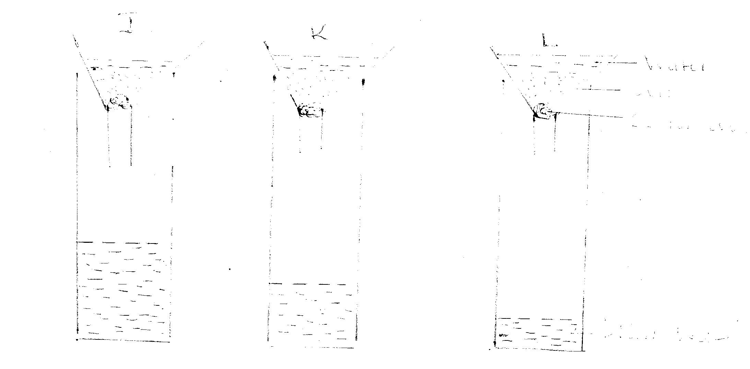
- If the levels of water drained in the diagram were observed after two hours, name the property of soil being investigated. (1 mark)
………………………………………………………………………………………………………………………………………………………………………………………………………………
- What is the relationship between the soil property named in (a) above and the size of soil particles. (1 mark)
………………………………………………………………………………………………………………………………………………………………………………………………………………
- Which soil sample would be suitable for growing paddy rice? (1 mark)
………………………………………………………………………………………………………………………………………………………………………………………………………………
- Name the type of soil. (2 marks)
J ………………………………………………………………
L ………………………………………………………………
- Use the diagrams below that show pruned plants after budding to answer the questions that follow
- Which diagram shows the correct pruning cut? (½ mark)
…………………………………………………………………………………………………………
- Explain why the other three cuttings are wrong? (1½ marks)
……………………………………………………………………………………………………………………………………………………………………………………………………………………………………………………………………………………………………………………………………………………………………………………………………………………………………………………………………………………………………………………………………………………
- State three importance of pruning coffee. (3 marks)
……………………………………………………………………………………………………………………………………………………………………………………………………………………………………………………………………………………………………………………………………………………………………………………………………………………………………………………………………………………………………………………………………………………

- Use the diagram below that show maize cob attacked by a disease. Study it and answer the questions that follow.

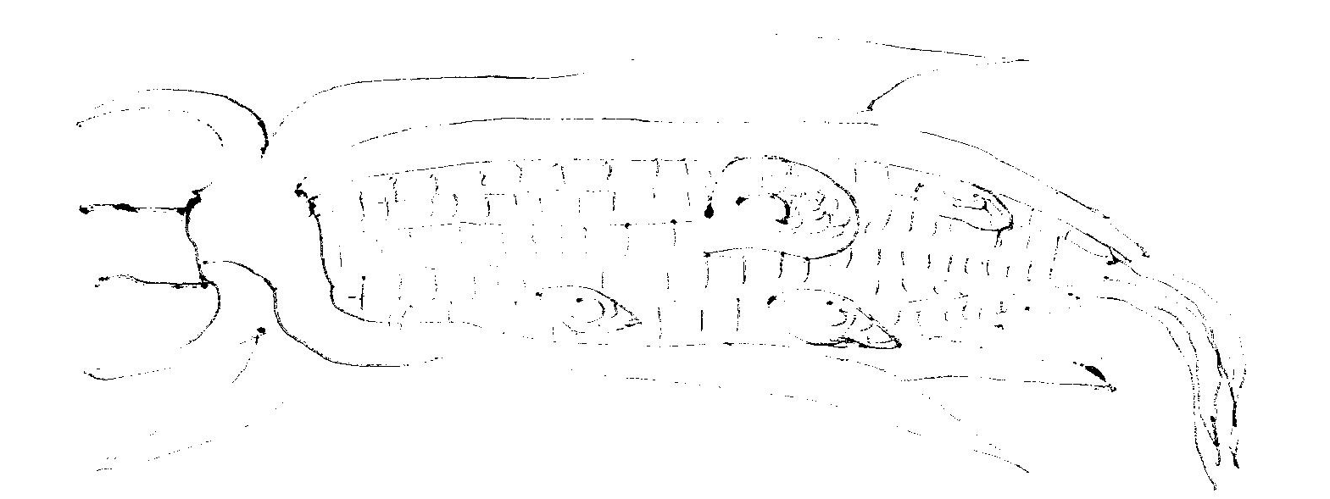
- Identify the crop disease illustrated above. (1 mark)
……………………………………………………………………………………………………
- A part from maize name other two crops attacked by the same disease. (2 marks)
………………………………………………………………………………………………………………………………………………………………………………………………………………………………………………………………………………………………………………
- State two control measure of the disease in (a) above. (2 marks)
………………………………………………………………………………………………………………………………………………………………………………………………………………………………………………………………………………………………………………
- Below is a graph representing the law of diminishing returns. Study it carefully and answer the questions that follow.

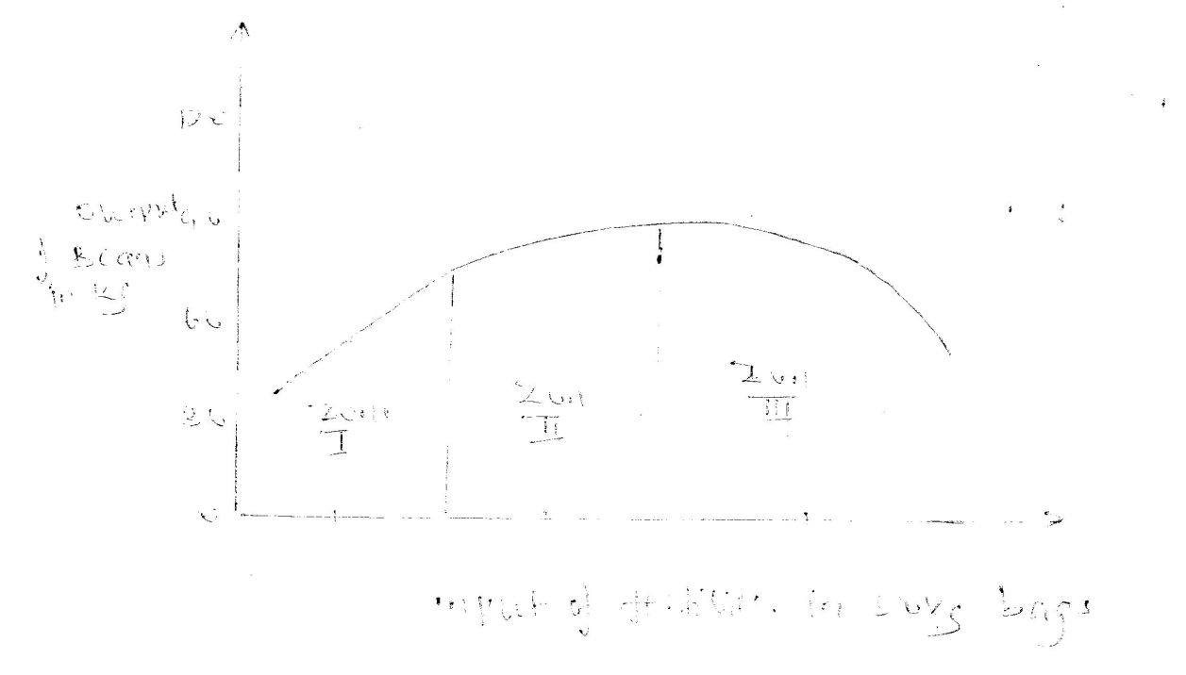
- Explain what would happen to each of the three zones marked I, II, and III in relation to fertilizer input to beans output. (3 marks)

………………………………………………………………………………………………………………………………………………………………………………………………………………………………………………………………………………………………………………………………………………………………………………………………………………………………………………………………………………………………………………………………………………………………………………………………………………………………

- Which is the rational zone among three zones and why? (2 marks)
………………………………………………………………………………………………………………………………………………………………………………………………………………………………………………………………………………………………………………………………………………………………………………………………………………………………

SECTION C: (40MARKS)
Answer any two questions from this section in the spaces provided after question 21

- (a) Describe five agencies involved in marketing of Agricultural products. (10 marks)
(b)Explain six practices carried out in the field that control maize diseases. (6 marks)
(c) State four importance of irrigation. (4 marks)

- (a) Outline five farming activities which may encourage soil erosion. (5 marks)
- (i) Describe harvesting of cotton. (5 marks)
( ii) Explain the precaution during harvesting of sugarcane. (3 marks)
(c) Describe the production of carrots under the following sub-headings.
(i) Seedbed preparation (3 marks)
(ii) Field management (4 marks)

- (a) Explain seven factors that influence seed rate during planting. (7 marks)
- Outline five factors necessary for proper functioning of farmers’ co-operative societies in
Kenya. (5 marks)
- Explain 8 ways farmers can overcome risks and uncertainties in a farming business.
(8 marks)

…………………………………………………………………………………………………………………………………………………………………………………………………………………………………………………………………………………………………………………………………………………………………………………………………………………………………………………………………………………………………………………………………………………………………………………………………………………………………………………………………………………………………………………………………………………………………………………………………………………………………………………………………………………………………………………………………………………………………………………………………………………………………………………………………………………………………………………………………………………………………………………………………………………………………………………………………………………………………………………………………………………………………………………………………………………………………………………………………………………………………………………………………………………………………………………………………………………………………………………………………………………………………………………………………………………………………………………………………………………………………………………………………………………………………………………………………………………………………………………………………………………………………………………………………………………………………………………………………………………………………………………………………………………………………………………………………………………………………………………………………………………………………………………………………………………………………………………………………………………………………………………………………………………………………………………………………………………………………………………………………………………………………………………………………………………………………………………………………………………………………………………………………………………………………………………………………………………………………………………………………………………………………………………………………………………………………………………………………………………………………………………………………………………………………………………………………………………………………………………………………………………………………………………………………………………………………………………………………………………………………………………………………………………………………………………………………………………………………………………………………………………………………………………………………………………………………………………………………………………………………………………………………………………………………………………………………………………………………………………………………………………………………………………………………………………………………………………………………………………………………………………………………………………………………………………………………………………………………………………………………………………………………………………………………………………………………………………………………………………………………………………………………………………………………………………………………………………………………………………………………………………………………………………………………………………………………………………………………………………………………………………………………………………………………………………………………………………………………………………………………………………………………………………………………………………………………………………………………………………………………………………………………………………………………………………………………………………………………………………………………………………………………………………………………………………………………………………………………………………………………………………………………………………………………………………………………………………………………………………………………………………………………………………………………………………………………………………………………………………………………………………………………………………………………………………………………………………………………………………………………………………………………………………………………………………………………………………………………………………………………………………………………………………………………………………………………………………………………………………………………………………………………………………………………………………………………………………………………………………………………………………………………………………………………………………………………………………………………………………………………………………………………………………………………………………………………………………………………………………………………………………………………………………………………………………………………………………………………………………………………………………………………………………………………………………………………………………………………………………………………………………………………………………………………………………………………………………………………………………………………………………………………………………………………………………………………………………………………………………………………………………………………………………………………………………………………………………………………………………………………………………………………………………………………………………………………………………………………………………………………………………………………………………………………………………………………………………………………………………………………………………………………………………………………………………………………………………………………………………………………………………………………………………………………………………………………………………………………………………………………………………………………………………………………………………………………………………………………………………………………………………………………………………………………………………………………………………………………………………………………………………………………………………………………………………………………………………………………………………………………………………………………………………………………………………………………………………………………………………………………………………………………………………………………………………………………………………………………………………………………………………………………………………………………………………………………………………………………………………………………………………………………………………………………………………………………………………………………………………………………………………………………………………………………………………………………………………………………………………………………………………………………………………………………………………………………………………………………………………………………………………………………………………………………………………………………………………………………………………………………………………………………………………………………………………………………………………………………………………………………………………………………………………………………………………………………………………………………………………………………………………………………………………………………………………………………………………………………………………………………………………………………………………………………………………………………………………………………………………………………………………………………………………………………………………………………………………………………………………………………………………………………………………………………………………………………………………………………………………………………………………………………………………………………………………………………………………………………………………………

