NAME ------------------------------------------------------------------ INDEX NO---------------------------------
DATE_________________________ CANDIATES SIGNATURE _____________

SECTION A (40MKS)

- Name three conditions under which shifting cultivation is practicable. (3mks)

- List four disadvantages associated with the burning of land in shifting land preparation.(4mks)

- Outline four environmental conditions that may lead to poor crop yields. (4mks)

- Name four human factors that influence production and distribution of crops and livestock (4mks)

5a) What is sub –soiling? (1mk)

b) Give four advantages of minimum tillage. (4mks)

6. Mention three types of pumps. (3mks)

7. Outline four properties of clean and safe water. (4mks)

8. Name three methods of surface irrigation. (3mks)

9a) Define drainage. (1mk)

b) Give three causes of poor drainage. (3mks)

10. There are several agricultural practices that causes water pollution. Briefly mention them
(4mks)

11. Name a tool used for each of the following operations.(2mks)
i)Testing mastitis

ii) Cut overgrown hooves

SECTION B( 30MKS)
Answer all the questions in this section.
12. Diagram D and E below are illustrations of workshop tools. Study them and answer the questions that follow.
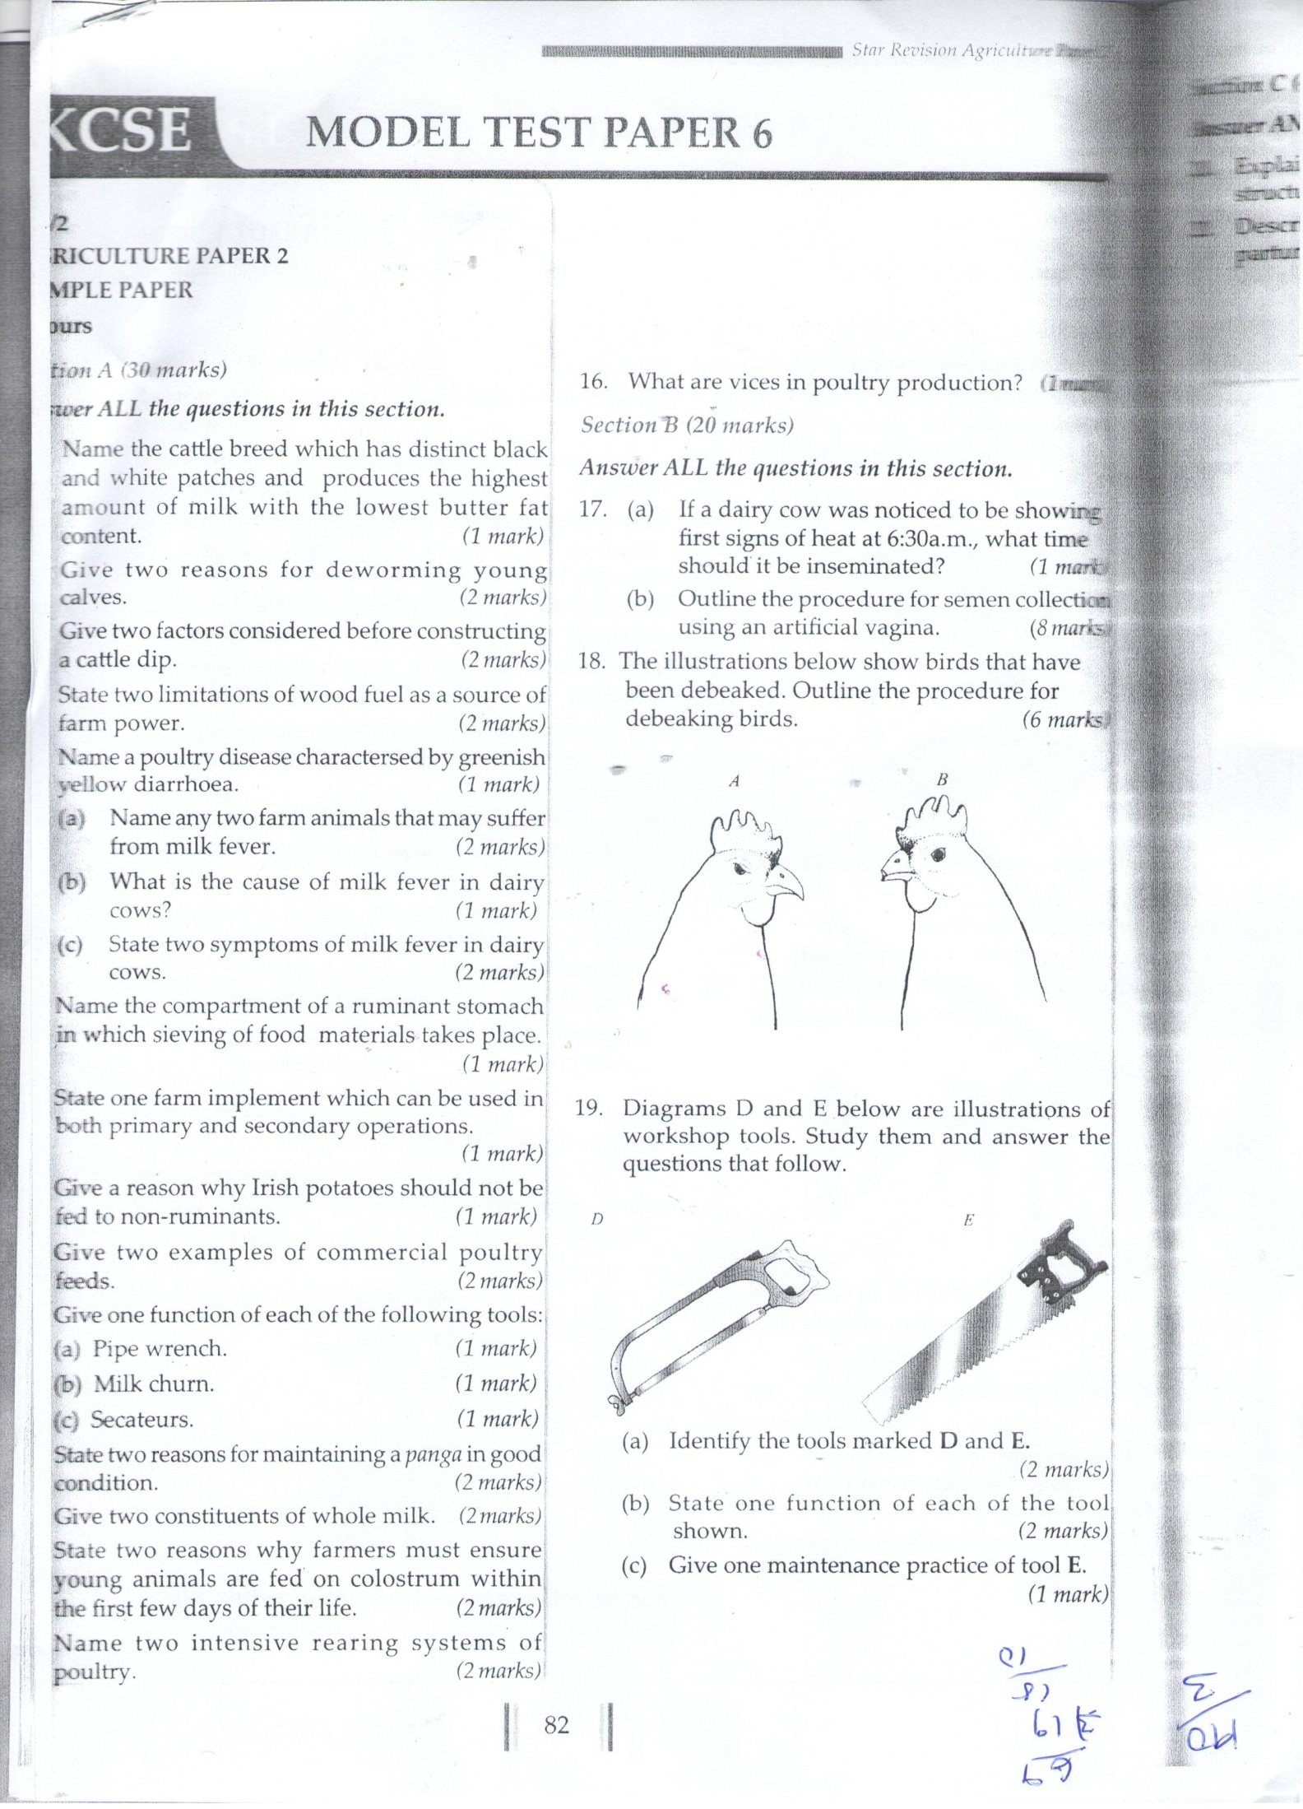
- Identify the tools marked D and E. (2mks)
D

E
- State one function of each of the tool shown. (2mks)
D

E

- Give one maintenance practice of tool E. (1mk)

13a) Identify the method of drainage shown below. (1mk)
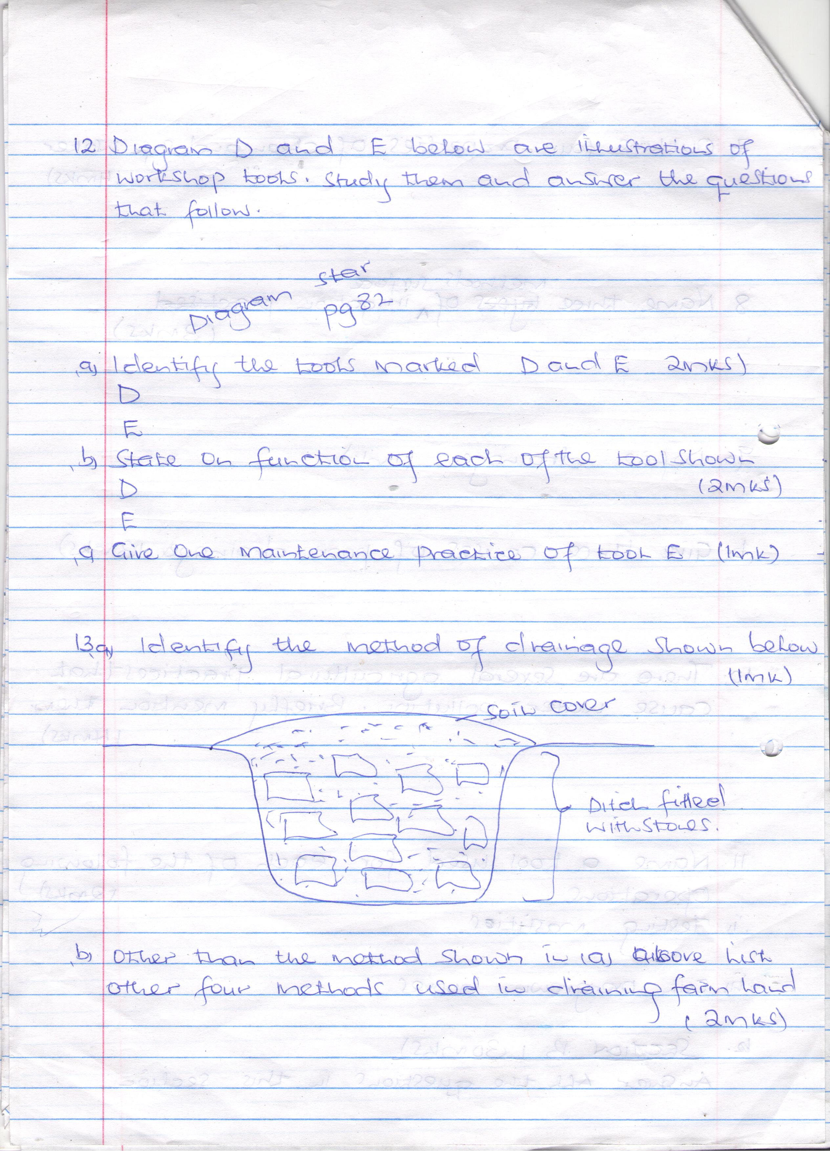

b) Other than the method shown in (a) above list other four methods used in draining farm land.
(2mks)
C) Outline four reasons for draining farm land. (2mks)

14. The illustrations below represent an experiment to compare the porosity and water holding capacity of three of soils. Carefully study the experiment and then answer the questions that follow.
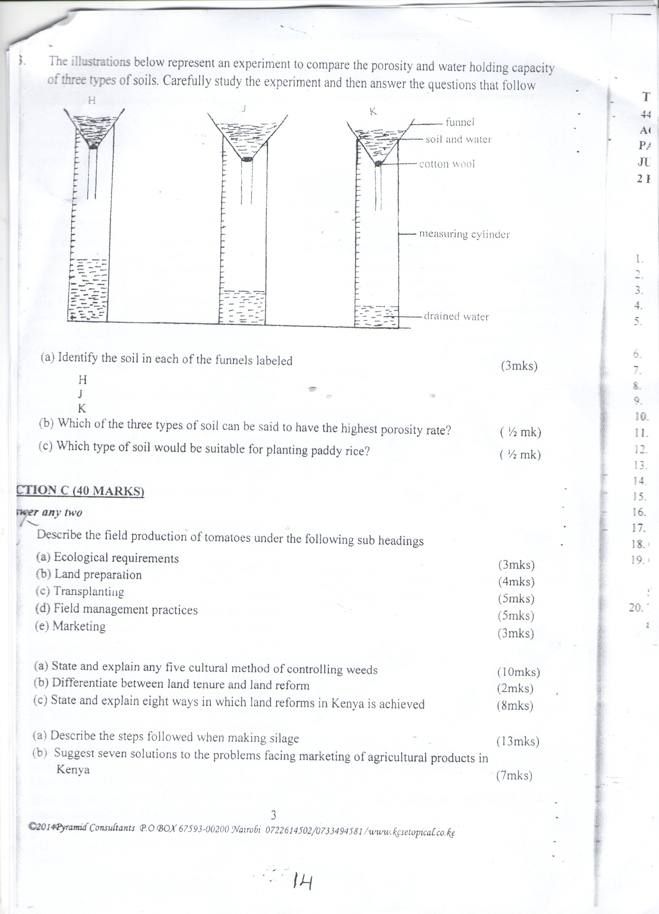
a i) Identify the soil in each of the funnel labeled. (3mks)
H
J
K
b) Which of the three types of soil can be said to have the highest porosity rate? (1mk)

C)Which type of soil would be suitable for planting paddy rice? (1mk)

15. Complete the table below that attempts to classify soil based on the sizes of soil particles. (5mks)
Particles | Size (diameter) in MM
 | Above 2.0mm
 | Between 0.20mm and 2.00mm
 | Between 0.20mm and 0.20mm
 | Between 0.002mm and 0.02mm
 | Below 0.002mm

16. Below is a diagram of farm equipment. Use it to answer the questions that follows.
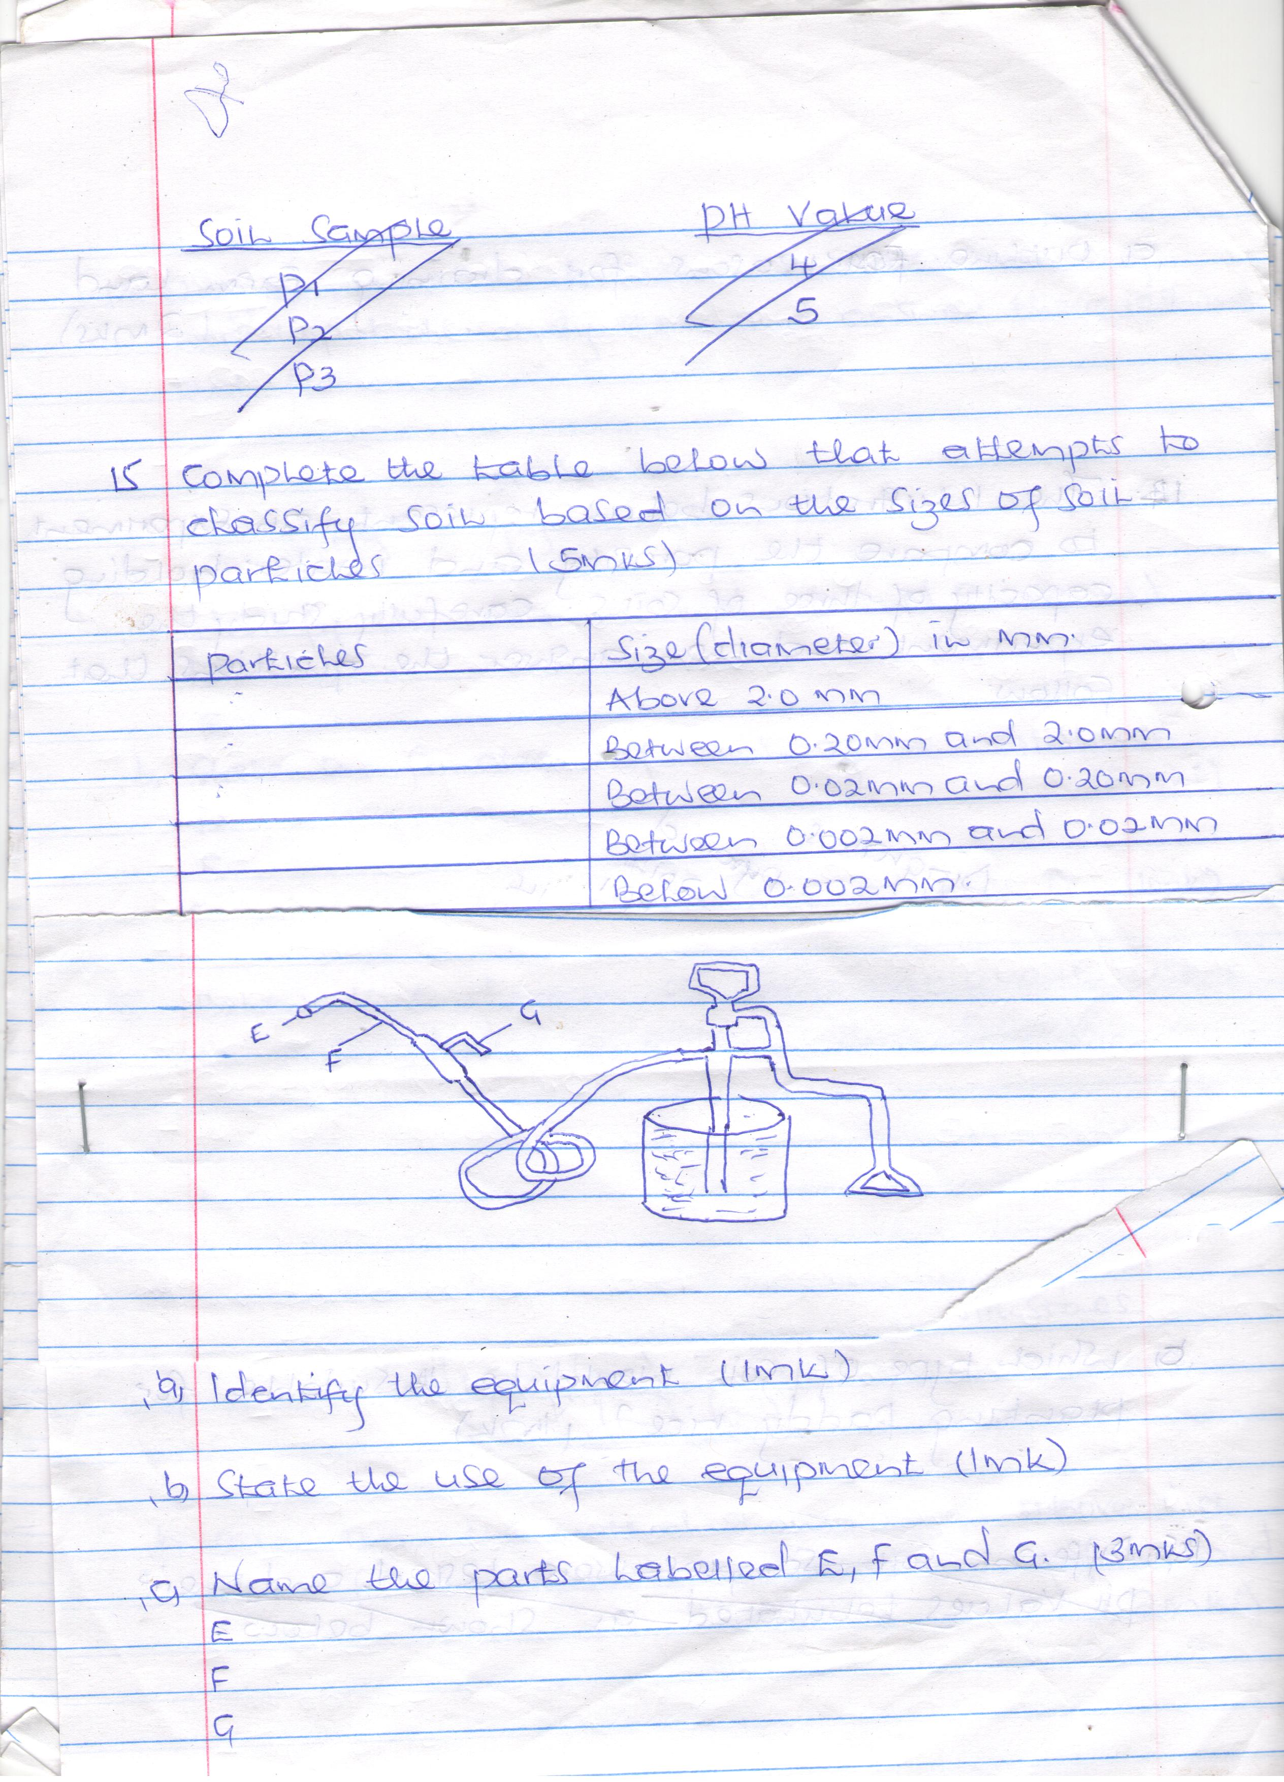
- Identify the equipment. (1mk)

- State the use of the equipment. (1mk)

- Name the parts labeled E, F and G. (3mks)

17a) Identify the method of irrigation shown below. (1mk)
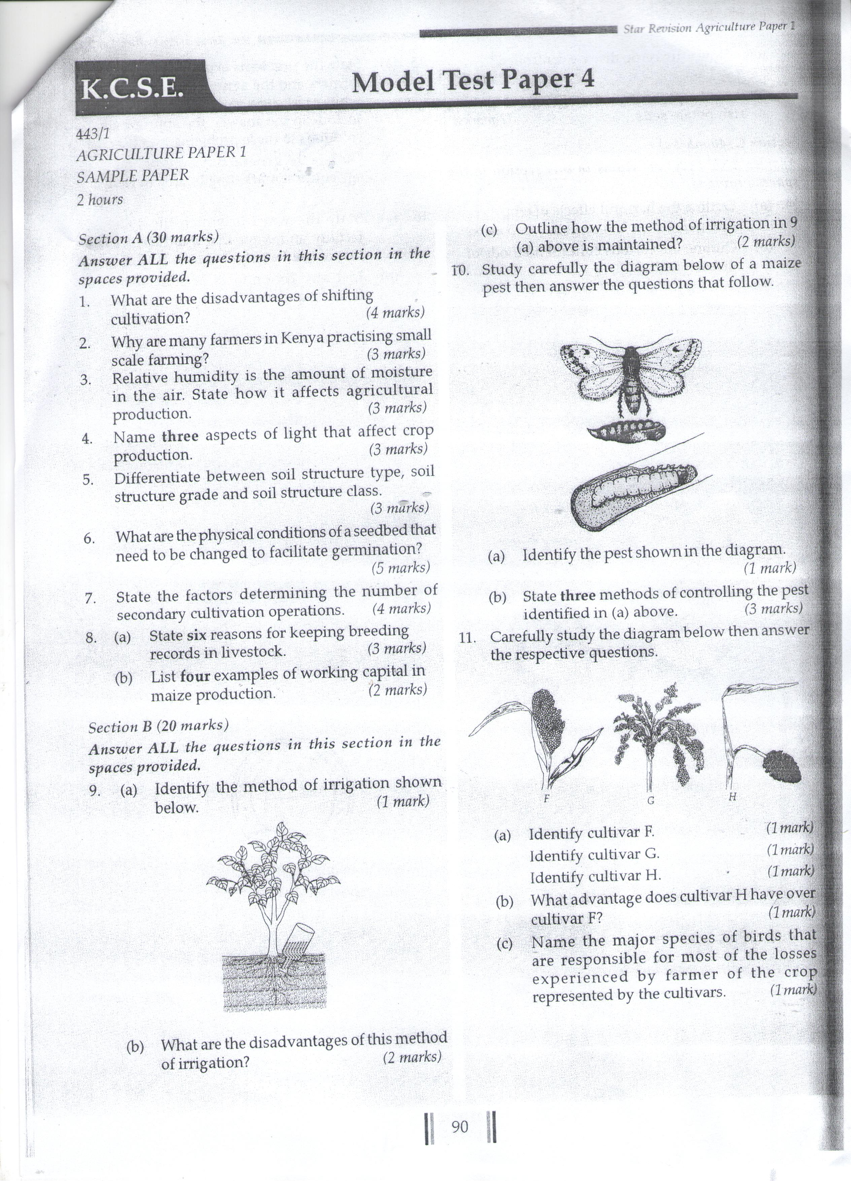
b) What are the disadvantages of this method of irrigation? (2mks)

c)Outline how the method of irrigation in (a) above is maintained? (2mks)

SECTION C( 30MKS)
Answer all question in this section.
18a) Outline six biotic factors influencing agriculture. (6mks)

b) State the four aspects of rainfall that are important for crop growth . (4mks)

19a) State five factors that determine the number of times secondary cultivation is done.(5mks)

b)Outline the advantages of minim tillage. (5mks)

20a) State four importance of water treatment. (4mks)

b) What factors determine the choice of the type of irrigation used? (6mks)

