NAME………………………………………………….CLASS…………………..ADM……..
FORM 2 AGRICULTURE EXAM
END OF TERM 2
TIME .2HRS

INSTRUCTIONS
ANSWER ALL THE QUESTIONS IN SECTION A,B,C.
ALL ANSWERS MUST BE WRITTEN IN THE SPACES PROVIDED.

SECTION A (30MKS)
- What is Health (1mk)

- State 4 symptoms of potassium deficiency in crops.(2mks)

- State the information contained in a composite sample of soil before being taken to the laboratory. (1½mks.)

- Give 4 disadvantages of using vegetative propagation materials.(2mks)

- Given that maize is planted at a spacing of 75 by 25 cm. calculate the plant population in a plot of land measuring 8 by 6m. (3mks)

- Differentiate between monocropping and intercropping (1mk)

- Define the following terms as used in agriculture
Rogueing (1mk)

Gapping (1mk)

- State any four disadvantages of using non capped multiple stem pruning in coffee.(2mks)

- Give 4 characteristics of a good grain store.(2mks)

- 10. State the intermediate host of the following livestock parasite.
- Taenia solium ½mk

- Taenia sagnata ½mk

- Liver fluke ½mk

- Give 4 control measures of Tse tse flies.(2mks)

- State disadvantages of overhead irrigation.(2mks)

- State the uses of the following farm tools and equipment
- Dibber(1mk)

- Garden trowel (1mk)

- Stock and die (1mk)

- Pipe wrench (1mk)

- State the function of the following materials in preparation of compost manure.
- Well rotten manure (1mk)

- Wood ash (1mk)

- Top soil (1mk)

- Differentiate between Essex saddleback and Wessex saddleback.(1mk)

SECTION B (30MKS)

- The diagram below shows a method of soil sampling

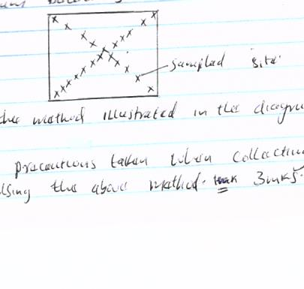

- Name the method illustrated in the diagram above.(1mk)

- State 3 precautions taken when collecting the soil for testing using the above method.(3mks)

- Give 4 reasons why soil from the farm is tested.(4mks)

- The diagram below shows a practice carried out on various crops on the farm. Study them carefully and answer the questions that follow.

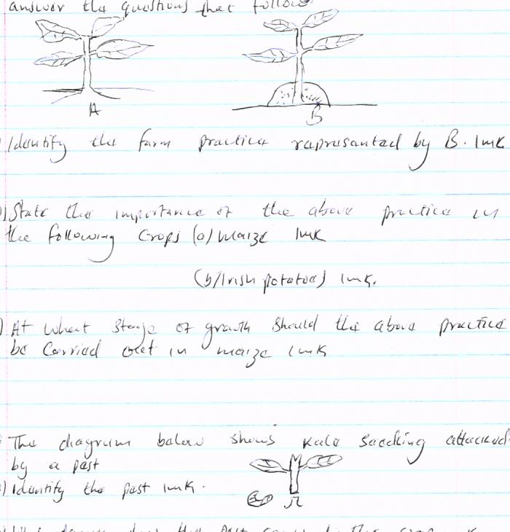

- Identify the farm practice represented by B.(1mk)

- State the importance of the above practice in the following crops
- Maize(1mk)

- Irish potatoes (1mk)

- At what stage of growth should the above practice be carried out in maize. (1mk)

- The diagram below shows Kale seedling attached by a pest.

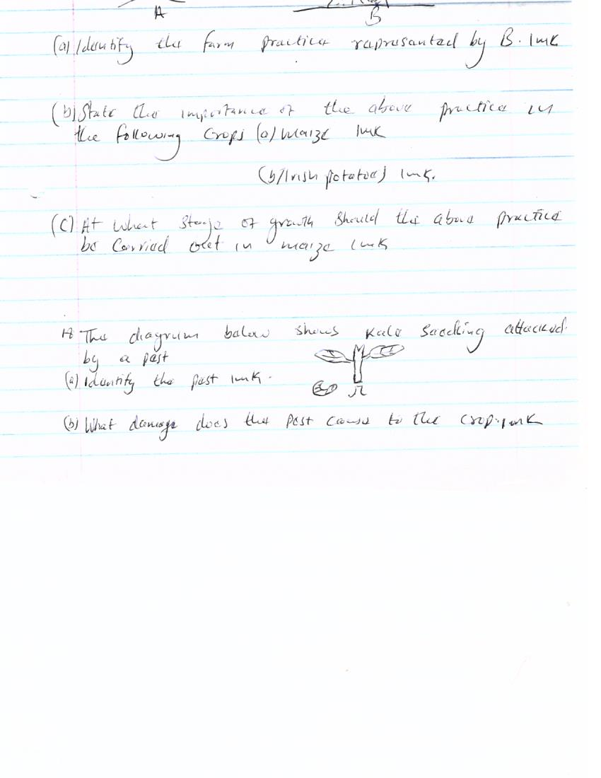

- Identify the pest.(1mk)

- What damage does that pest causes to the crop.l(1mk)

- State two methods of controlling the pest.(2mks)

- State any 5 general characteristics of indigenous breed of cattle.(5mks)

- State any 5 factors considered when selecting a nursery site.(5mks)

- State conditions that necesiate land clearing (4mks)

SECTION C(40mks)

22.a) State and explain 5 characteristics of a fertile soil (10mks)
b) State symptoms of attack by a liver flukes in livestock.(5mks)
c) describe any five factors influencing crop rotation.(5mks)

- Describe reasons for prunning in crops. 5x 2=10mks.
b)discuss 5 effects of HIV/AIDS and ill-health on Agriculture.(5mks)
c) discuss 5 problems associated with the use of organic manure.(5mks)

