NAME_________________________________ADM NO__________CLASS__________
GEOGRAPHY
FORM 3
END OF TERM 2 2026
TIME: 2 ¾ HOURS
SECTION A
Answer all questions in this section (25 marks)
- The diagram below represents structure of the earth.

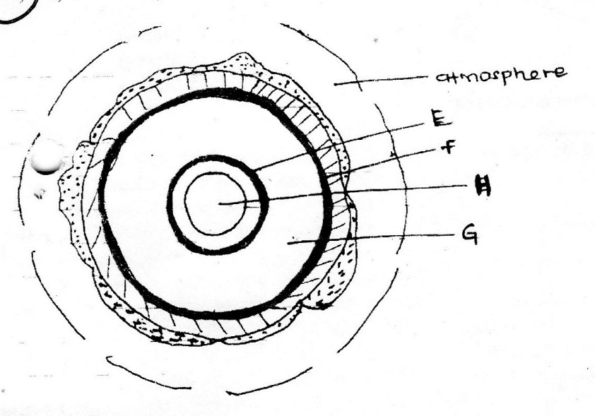
- Use it to answer questions that follow.
- Name the boundaries marked E and F. (2 marks)
- Identify two minerals that make up the layer marked H. (2 marks)
- Give two effects of the rotation of the earth on its axis. (2 marks)
- .
- Define the term magmatic water (2 marks)
- List three surface features on Karst landscape (3 marks)
- .
- Define vegetation (2 marks)
- Explain how the following factors influence the distribution of vegetation
- Relief (2 marks)
- Soils (2 marks)
- State four indicator of occurrence of soil creep in an area (4 marks)
- a)Name two types of submerged highland coasts (2 marks)
b)Identify two resultant features of the emerged highland coasts (2 marks)

SECTION B
Answer question 6 and any other two questions in this section

- Study the map of Taita Hills 1: 50,000 (sheet) 189/4 provided and answer the following questions.
- i)Identify the above map (1 mark)
ii) Convert the ratio scale given on the map to statement scale (Give your answer in meters and kilometers) (2 marks)
- i)List three natural vegetation found in the area covered by the map . (3 marks)
ii)Citing evidence from the map, identify three economic activities in the area covered by the map . (6 marks)
- Describe the drainage of the area covered by the map (6 marks)
- i)Determine the area covered by Ronge Forest (2 marks)
ii)Give the longitudinal extent of the area covered by the map (2 marks)
iii) Determine the length of the railway line from Mwatete to Voi (2 marks)
- Identify the Meridian of the origin of the above map. (1 mark)
- .
- i) Name the two major types of earth movements that occur within the earth’s crust. (2 marks)
ii) Give four effects of the movement of tectonic plates. (4 marks)
- Describe the origin of the continents according to the theory of continental drift. (5 marks)
- The diagram below shows a composite Volcano.
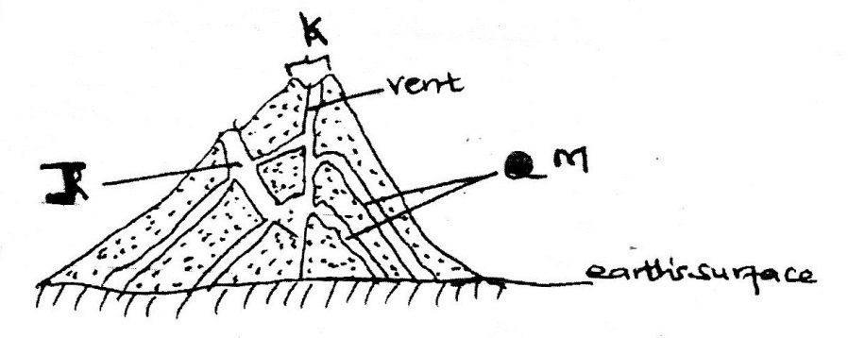

- Name the features marked J,K and M. (3 marks)
- Describe how a parasitic cone is formed? (6 marks)
- Explain three negative effects of earthquakes. (5 marks)

- The map below shows some climatic regions of Kenya. Use it to answer question (a)
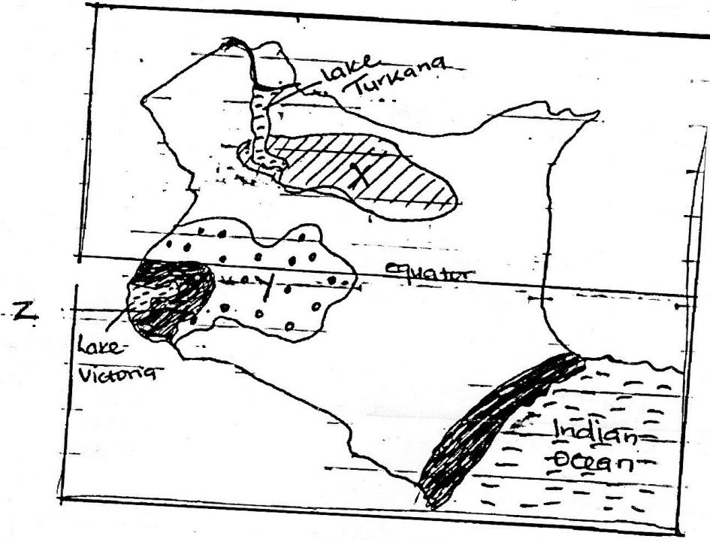

- i)Name the climatic regions marked X and Y. (2 marks)
ii) State three characteristics of the climatic region marked Z. (3 marks)
- Explain how each of the following factors influence climate :-
- Altitude (4 marks)
- Ocean currents (4 marks)
- The table below represents rainfall and temperature figures for a town in Kenya.
Use it to answer the question that follow.
Months | J | F | M | A | M | J | J | A | S | O | N | D
Temp in º C | 27 | 28 | 28 | 28 | 27 | 25 | 25 | 24 | 25 | 26 | 27 | 26
Rainfall in mm | 25 | 38 | 99 | 140 | 277 | 439 | 277 | 69 | 142 | 201 | 71 | 21
- Calculate the annual rainfall for the town. (1 mark)
- Calculate the total annual rainfall for the town (1 mark)
- State two characteristics of the climate experienced in the town (2 marks)
- You are required to carry out a field study on the weather within your school compound
- Give three reasons why you needed permissions from the administration (3 marks)
- Describe how you would use the following instruments during the field study
- Raingauge (3 marks)
- State two ways in which the information collected during the field study would be useful to the local community (2 marks)

- a)
- Give two factors that influence the development of drainage patterns (2 marks)
- State five characteristics of a river in its youthful stage. (5 marks)
b) Describe three processes of river erosion (6 marks)
c) The diagram below shows river meanders. Use it to answer question (i)
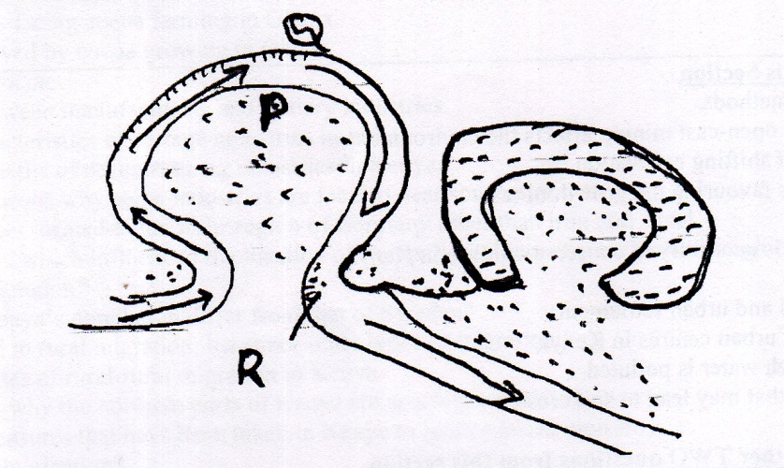

- Name the processes that take place at each of the points marked P and Q (2 marks)
- Name the feature formed at the point marked R (1 marks)
- Describe how an ox-bow lake is formed (5 marks)
d) Explain two negative effects of rivers to the human environment. (4 marks)

- Name three types of desert landscapes. (3 marks)
- Explain three ways through which the wind carries out erosion in the desert. (6 marks)
- With an aid of a well labeled diagram, describe how a rock pedestal is formed. (6 marks)
- State two factors which influence transportation of materials by wind in deserts (2 marks)
- Explain four ways through which desert influence human activities (8 marks)

