Name……………………………………………School ……………………..ADM No …………..
443
AGRICULTURE Candidate’s Signature……………………………….
July-August 2026 DATE……………………………………….
2 hours
KENYA CERTIFICATE OF SECONDARY EDUCATION

FORM III
INSTRUCTION TO CANDIDATES
- Write your name, school and admission number in the space provided
- Sign and write the date of examination in the space provided above
- This paper consist of three sections A,B and C(100mks)
- Answer all the questions in sections A and B
- Answer any two questions from section C
- All answers should be written in the spaces provided
- Candidates should check the question paper to ascertain that all the pages are printed as indicated and that no questions are missing.

For Examiners’ Use Only
Section | Questions | Maximum score | Candidates score
A | 1-18 | 30
B | 19-24 | 30
C |  | 20
 |  | 20
 |  | 20
Total score |  | 100

This paper has 11 printed pages

SECTION A (30 MARKS)
ANSWER ALL QUESTION IN THE SPACES PROVIDED
- Name four activities carried out in agriculture as an art (2 mks)
______________________________________________________________________________________________________________________________________________________
______________________________________________________________________________________________________________________________________________________
______________________________________________________________________________________________________________________________________________________

- Differentiate between pastoralism and aquaculture 1mk)
______________________________________________________________________________________________________________________________________________________
______________________________________________________________________________________________________________________________________________________

- Name four physical agents of weathering (2mks)
______________________________________________________________________________________________________________________________________________________
______________________________________________________________________________________________________________________________________________________
- State four characteristics of a fertile soil (2mks)
______________________________________________________________________________________________________________________________________________________
______________________________________________________________________________________________________________________________________________________

- State four care and maintenance practices carried out on jack-planes (2 mks)
______________________________________________________________________________________________________________________________________________________
______________________________________________________________________________________________________________________________________________________

- State four reasons for keeping correct and accurate farm records (2mks)
______________________________________________________________________________________________________________________________________________________
______________________________________________________________________________________________________________________________________________________
______________________________________________________________________________________________________________________________________________________
______________________________________________________________________________________________________________________________________________________
______________________________________________________________________________________________________________________________________________________
______________________________________________________________________________________________________________________________________________________

- Name the breeds of the livestock animals with the following characteristics
Cattle with fluffy umbilical fold, large, dewlap produces 3000 kgs of milk per lactation and tolerates high temperatures (1/2 mks)
______________________________________________________________________________________________________________________________________________________
Black pig, baconer, bear white colour on feet, nose and tail (1/2 mks)
______________________________________________________________________________________________________________________________________________________
White rabbit, ears, nose, paws/ and tail are black and very prolific (1/2 mks)
______________________________________________________________________________________________________________________________________________________
Sheep that is white, bear blackhead, is polled with long legs and fat tail (1/2 mks)
______________________________________________________________________________________________________________________________________________________
- State four uses of fences in the farm (2mks)
______________________________________________________________________________________________________________________________________________________
______________________________________________________________________________________________________________________________________________________
______________________________________________________________________________________________________________________________________________________

- State four importance of soil pH in crop production (2mks)
______________________________________________________________________________________________________________________________________________________
______________________________________________________________________________________________________________________________________________________
______________________________________________________________________________________________________________________________________________________

- State two functions of water in the body of livestock animals (1mks)
______________________________________________________________________________________________________________________________________________________
______________________________________________________________________________________________________________________________________________________
______________________________________________________________________________________________________________________________________________________

- List four factors that affect the digestibility of feeds (2mks)
______________________________________________________________________________________________________________________________________________________
______________________________________________________________________________________________________________________________________________________
______________________________________________________________________________________________________________________________________________________
______________________________________________________________________________________________________________________________________________________

- Differentiate between essential and non-essential amino acids (1mk)
______________________________________________________________________________________________________________________________________________________
______________________________________________________________________________________________________________________________________________________
- State four characteristics of an effective acaricide (2mks)
______________________________________________________________________________________________________________________________________________________
______________________________________________________________________________________________________________________________________________________
______________________________________________________________________________________________________________________________________________________
- State four disadvantages of multiple stem pruning (2mks)
______________________________________________________________________________________________________________________________________________________
______________________________________________________________________________________________________________________________________________________
______________________________________________________________________________________________________________________________________________________

- Give four advantages of row planting (2mks)
______________________________________________________________________________________________________________________________________________________
______________________________________________________________________________________________________________________________________________________
______________________________________________________________________________________________________________________________________________________
- State two effects of pathogens in crops (1mks)
______________________________________________________________________________________________________________________________________________________
______________________________________________________________________________________________________________________________________________________
______________________________________________________________________________________________________________________________________________________
- Define the term rock catchment as used in agriculture (1mk)
______________________________________________________________________________________________________________________________________________________
______________________________________________________________________________________________________________________________________________________
- Name two cropping systems that promote conservation of soil and water in crop production
(1mk)
______________________________________________________________________________________________________________________________________________________
______________________________________________________________________________________________________________________________________________________
______________________________________________________________________________________________________________________________________________________

SECTION B (30 MARKS)
ANSWER ALL THE QUESTIONS IN THE SPACES PROVIDED
- Study the diagrams below carefully and answer the questions that follow
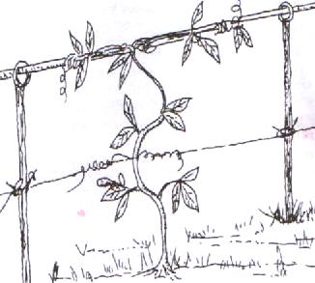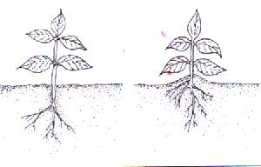
Before B after
A B
  - Name the practice illustrated in A and B (1mk)
A_________________________________________________________________
B__________________________________________________________________
  - State two importance of practice B in irish potatoes other than providing support
(2mks)
______________________________________________________________________________________________________________________________________________________
______________________________________________________________________________________________________________________________________________________

  - Name practices similar to that in A done in; (1mk)
    - Bananas __________________________________________________
    - Tomatoes __________________________________________________
  - Define the term used to collectively refer to all the practices named in (a) and (c)
(1mk)
______________________________________________________________________________________________________________________________________________________
- Study the diagram below and answer the questions that follow
P
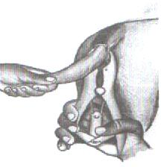A 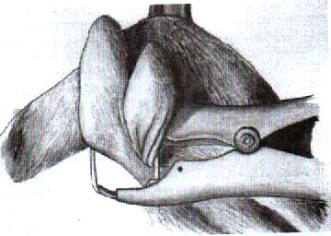B

  - Name the practice being carried out in A and B (1mk)
A ________________________________________________________________
B ________________________________________________________________
  - Give the timing when the practice should be done in lambs in A and B (1mk)
A_________________________________________________________________________B_________________________________________________________________________
  - State two importance for each of the practices A and B (2mks)
A.
___________________________________________________________________________
______________________________________________________________________________________________________________________________________________________
___________________________________________________________________________
B.
______________________________________________________________________________________________________________________________________________________
______________________________________________________________________________________________________________________________________________________
  - Name the livestock production tool and equipment labeled P above (1mk)
______________________________________________________________________________________________________________________________________________________

- The diagram below shows farm structures used in livestock production

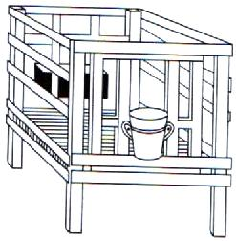
F
L
G
  - Name the structure illustrated above (1mk)
______________________________________________________________________________________________________________________________________________________
  - State one routine practice carried out in part G and F respectively (1mk)
G____________________________________________________________________________________________________________________________________________________F_________________________________________________________________________
___________________________________________________________________________________________________________________________________________________

  - With a reason state two structural requirements of the above structure to ensure better production (2mks)
______________________________________________________________________________________________________________________________________________________
______________________________________________________________________________________________________________________________________________________
______________________________________________________________________________________________________________________________________________________
  - List down two maintenance practices carried out on the part labeled L in the structure (1mk)
______________________________________________________________________________________________________________________________________________________
- (a) Prepare 200kg sow and weaner meal 30% DCP using maize germ 10% DCP and fish meal 35% DCP. Show all your working (3mks)
______________________________________________________________________________________________________________________________________________________
______________________________________________________________________________________________________________________________________________________
______________________________________________________________________________________________________________________________________________________
______________________________________________________________________________________________________________________________________________________
______________________________________________________________________________________________________________________________________________________

A suckling sow weighs 100kilogram (kg) body weight and she has 10 piglets. For every kilogram of body weight the sow receives 25 grammes of feed and for every piglet the sow receives 500grammes of the feed, calculate the quantity of ration given in equal portions in the morning and the afternoon per day (2mks)
______________________________________________________________________________________________________________________________________________________
______________________________________________________________________________________________________________________________________________________
______________________________________________________________________________________________________________________________________________________
______________________________________________________________________________________________________________________________________________________
______________________________________________________________________________________________________________________________________________________
___________________________________________________________________________
___________________________________________________________________________
___________________________________________________________________________
___________________________________________________________________________
___________________________________________________________________________

- Study the following diagrams of weeds and answer the question that follows
A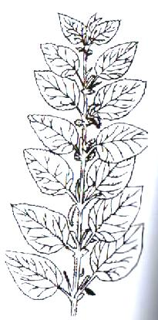 B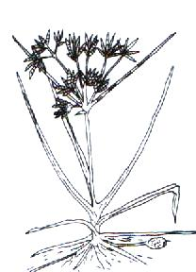
  - Name the weeds A and B (2mks)
A ________________________________________________________________
B ________________________________________________________________
  - (i)State the class of weed A based on plant morphology (1 mk)
______________________________________________________________________________________________________________________________________________________
(ii) State the class of weed B based on growth cycle (1 mk)
______________________________________________________________________________________________________________________________________________________
  - What is the effect of weed A to farmers during crop production?
______________________________________________________________________________________________________________________________________________________
  - Why is it difficult to control weed B
______________________________________________________________________________________________________________________________________________________
- Study the crop pests shown below
F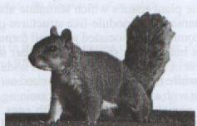 G 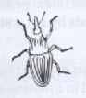
(a) Name pests F and G (1mk)
F__________________________________________________________________________G_________________________________________________________________________
(b) Classify the pests according to their habitat (1mk)
F__________________________________________________________________________G_________________________________________________________________________
(c) State the effect of the pests in crop production (2mks)
F
______________________________________________________________________________________________________________________________________________________

G
______________________________________________________________________________________________________________________________________________________

(d) State two control measures of pest G to reduce damage
______________________________________________________________________________________________________________________________________________________

SECTION C (60 MARKS)
Answer any two questions in the space provided
- (a)State and explain four importance of high level of education and technology in agriculture
(8mks)
______________________________________________________________________________________________________________________________________________________
______________________________________________________________________________________________________________________________________________________
______________________________________________________________________________________________________________________________________________________
______________________________________________________________________________________________________________________________________________________
___________________________________________________________________________
_________________________________________________________________________________________________________________________________________________________________________________________________________________________________
_________________________________________________________________________________________________________________________________________________________________________________________________________________________________
___________________________________________________________________________
______________________________________________________________________________________________________________________________________________________
(b)State and explain four importance of using drainage in land reclamation (8mks)
______________________________________________________________________________________________________________________________________________________
______________________________________________________________________________________________________________________________________________________
______________________________________________________________________________________________________________________________________________________
______________________________________________________________________________________________________________________________________________________
______________________________________________________________________________________________________________________________________________________
____________________________________________________________________________________________________________________________________________________________________________________________________________________________________________________________________________________________________________
(c) State four advantages of drip irrigation (4mks)
______________________________________________________________________________________________________________________________________________________
______________________________________________________________________________________________________________________________________________________
______________________________________________________________________________________________________________________________________________________
______________________________________________________________________________________________________________________________________________________
______________________________________________________________________________________________________________________________________________________
______________________________________________________________________________________________________________________________________________________
______________________________________________________________________________________________________________________________________________________
- State and explain five factors considered when selecting replacement stock in a breeding program (10mks)
______________________________________________________________________________________________________________________________________________________
______________________________________________________________________________________________________________________________________________________
______________________________________________________________________________________________________________________________________________________
______________________________________________________________________________________________________________________________________________________
______________________________________________________________________________________________________________________________________________________
______________________________________________________________________________________________________________________________________________________
____________________________________________________________________________________________________________________________________________________________________________________________________________________________________________________________________________________________________________
_________________________________________________________________________________________________________________________________________________________________________________________________________________________________
_________________________________________________________________________________________________________________________________________________________________________________________________________________________________
___________________________________________________________________________
___________________________________________________________________________
___________________________________________________________________________
___________________________________________________________________________
___________________________________________________________________________
___________________________________________________________________________

b. Explain five factors considered during site selection for construction of farm structures
(10 mks )
______________________________________________________________________________________________________________________________________________________
______________________________________________________________________________________________________________________________________________________
______________________________________________________________________________________________________________________________________________________
______________________________________________________________________________________________________________________________________________________
______________________________________________________________________________________________________________________________________________________
_______________________________________________________________________________________________________________________________________________________________________________________________________________________________________________________________________________________________________________________________________________________________________________________
______________________________________________________________________________________________________________________________________________________
______________________________________________________________________________________________________________________________________________________
______________________________________________________________________________________________________________________________________________________
______________________________________________________________________________________________________________________________________________________
______________________________________________________________________________________________________________________________________________________
_________________________________________________________________________________________________________________________________________________________________________________________________________________________________
___________________________________________________________________________
___________________________________________________________________________
___________________________________________________________________________
___________________________________________________________________________
___________________________________________________________________________
___________________________________________________________________________
___________________________________________________________________________
___________________________________________________________________________
___________________________________________________________________________
___________________________________________________________________________
___________________________________________________________________________
___________________________________________________________________________
___________________________________________________________________________
___________________________________________________________________________
___________________________________________________________________________

- (a) Define the term land tenure (2mks)
______________________________________________________________________________________________________________________________________________________
_________________________________________________________________________________________________________________________________________________________________________________________________________________________________
(b) Explain five problems brought about by land fragmentation and subdivision (10mks)
______________________________________________________________________________________________________________________________________________________
_________________________________________________________________________________________________________________________________________________________________________________________________________________________________
______________________________________________________________________________________________________________________________________________________
_________________________________________________________________________________________________________________________________________________________________________________________________________________________________
_________________________________________________________________________________________________________________________________________________________________________________________________________________________________
_________________________________________________________________________________________________________________________________________________________________________________________________________________________________
_________________________________________________________________________________________________________________________________________________________________________________________________________________________________

(b) State and explain four advantages of having a land title deed. (8 marks)
______________________________________________________________________________________________________________________________________________________
_________________________________________________________________________________________________________________________________________________________________________________________________________________________________
______________________________________________________________________________________________________________________________________________________
_________________________________________________________________________________________________________________________________________________________________________________________________________________________________
______________________________________________________________________________________________________________________________________________________
_________________________________________________________________________________________________________________________________________________________________________________________________________________________________
___________________________________________________________________________
___________________________________________________________________________
___________________________________________________________________________

END

