NAME……………………………………………………………………………………………………CLASS……………………ADM NO………………………
80

FORM THREE PHYSICS
MID TERM 2 - 2026 EXAMS
Answer all question in the spaces provided

SECTION A (25 MARKS)
- The figure below shows a system of pulleys.

load = 300N

Effort=200N

Determine
- the mechanical advantage of the system. (1mark)
…………………………………………………………………………………………………………
…………………………………………………………………………………………………………
…………………………………………………………………………………………………………
…………………………………………………………………………………………………………

- the velocity ratio of the system. (1mark)
…………………………………………………………………………………………………………
…………………………………………………………………………………………………………

- Define the following terms as used in machines (3marks)
    - Velocity ratio
…………………………………………………………………………………………………………
…………………………………………………………………………………………………………

    - Efficiency
…………………………………………………………………………………………………………
…………………………………………………………………………………………………………

    - Mechanical advantage

- A Ginyali matatu whose mass is 1250kg drives past the school gate at 80km/h. calculate its momentum
(3marks)
………………………………………………………………………………………………………………
………………………………………………………………………………………………………………
………………………………………………………………………………………………………………
………………………………………………………………………………………………………………

- Explain why the front part of a car is fitted with a soft collapsible bumper made of plastic (2marks)
………………………………………………………………………………………………………………
………………………………………………………………………………………………………………

- A footballer kicks a ball of mass 0.4kg using a force of 200N. if the foot stays in contact with the ball for
0.02 seconds. Calculate the take off speed of the ball (3marks)
………………………………………………………………………………………………………………
………………………………………………………………………………………………………………
………………………………………………………………………………………………………………
………………………………………………………………………………………………………………

- State Newton’s third law of motion (1mark)
………………………………………………………………………………………………………………
………………………………………………………………………………………………………………
………………………………………………………………………………………………………………
………………………………………………………………………………………………………………

Differentiate between the following types of flow (1mark)
Streamline flow | Turbulent flow

- The diagram below shows two papers parallel ton each other, state and explain the observation made when air is blow through the space between the papers (2marks)
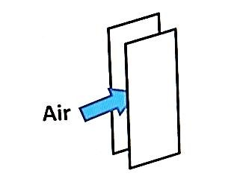
………………………………………………………………………………………………………………
………………………………………………………………………………………………………………
………………………………………………………………………………………………………………
………………………………………………………………………………………………………………
- Water flow from a raised tank through a pipe of cross sectional area 320cm² at a velocity of 0.8m/s. calculate the velocity with which the water will eject out of a tap of cross sectional area 0.78cm²
connected to to it (3marks)
………………………………………………………………………………………………………………
………………………………………………………………………………………………………………
………………………………………………………………………………………………………………
………………………………………………………………………………………………………………

- State two factors that affect the spring constant of a spring (2marks)
………………………………………………………………………………………………………………
………………………………………………………………………………………………………………
………………………………………………………………………………………………………………

- A spring has a constant of 800N/m. Calculate the force required to stretch if by 20cm (3marks)
………………………………………………………………………………………………………………
………………………………………………………………………………………………………………
………………………………………………………………………………………………………………
………………………………………………………………………………………………………………

SECTION B (55 MARKS)
- a) A machine is a device that enables work to be done more easily and conveniently.
State two ways in which a machine ensures this. (2 marks)
………………………………………………………………………………………………………………
………………………………………………………………………………………………………………
………………………………………………………………,……………………………………………

b) The figure below shows a simple machine being used to raise a load W by applying an effort E.
R
W
r
E
    - Name the machine. (1 mark) ……………………………………………………..

    - Show that the velocity ratio (V.R) of the machine is given by ^{R}⁄r. (2marks)

    - Given that r =11cm and R = 99cm, determine the effort E required to raise a load of 2800N if the efficiency () of the machine is 95%. (4 marks)

c) Explain why as the load increases the efficiency of the machine increases also (1 mark)
………………………………………………………………………………………………………………
………………………………………………………………………………………………………………

- The diagram below shows a pendulum bob swinging freely to and fro.

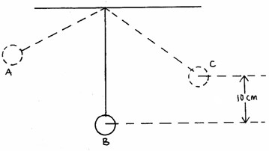

(a) (i) State the position where the pendulum bob has maximum kinetic energy.
(1mk)
………………………………………………………………………………………………………………
………………………………………………………………………………………………………………

(ii) Determine the velocity of the bob at the position identified in (a)i above if the maximum vertical displacement of the bob is 10cm. (3mks)
………………………………………………………………………………………………………………
………………………………………………………………………………………………………………
………………………………………………………………………………………………………………
………………………………………………………………………………………………………………
………………………………………………………………………………………………………………
………………………………………………………………………………………………………………

      - A bullet of mass 20g moving with a velocity of 1000m/s hits a stationery wooden block of mass 12kg. The bullet imbeds and the two move in one direction. Calculate its final velocity.
(3mks)

      - A block of mass 200g rests on a rough horizontal table. A force of 0.6N pulls the block so that it moves with a constant acceleration of 1m/s². Calculate
        - the time it takes to travel a distance of 200m. (2mks)

………………………………………………………………………………………………………………
………………………………………………………………………………………………………………
………………………………………………………………………………………………………………
………………………………………………………………………………………………………………
………………………………………………………………………………………………………………
………………………………………………………………………………………………………………
        - the friction force between the block and the table. (2mks)
………………………………………………………………………………………………………………
………………………………………………………………………………………………………………
………………………………………………………………………………………………………………
………………………………………………………………………………………………………………
………………………………………………………………………………………………………………

- a) Define frequency. (1mark)
………………………………………………………………………………………………………………
………………………………………………………………………………………………………………
………………………………………………………………………………………………………………

b) The figure below represents a displacement time graph wave.

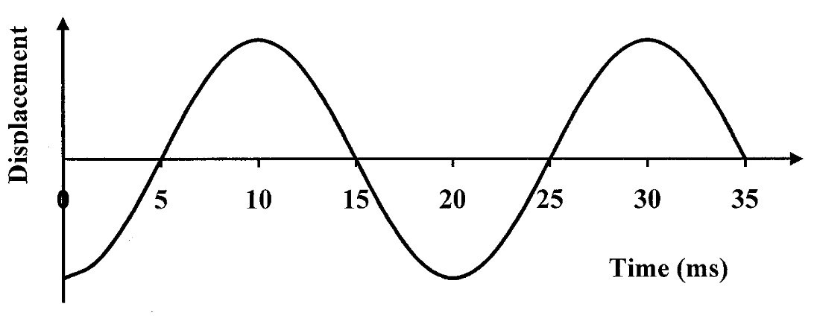

- On the graph draw a line marking the amplitude of the wave . (1mark)
- Determine the period of the wave. ( 1mark)
……………………………………………………………………………………………………
……………………………………………………………………………………………………
……………………………………………………………………………………………………

Calculate the frequency of the wave. (3marks)
……………………………………………………………………………………………………
…………………………………………………………………………………………………… …………………………………………………………………………………………………… ………………………………………………………………………………………………..

Given that the wavelength of the wave is 0.2m, find the speed of the wave. (3marks) ……………………………………………………………………………………………………
……………………………………………………………………………………………………
……………………………………………………………………………………………………

c) On the same axes in (b) above, sketch another wave with double the frequency and half the
amplitude. (2marks)

13. Ian has a mass of 70kg. He dives from a high diving pond. His vertical velocity at different times is shown in the graph in figure 8.

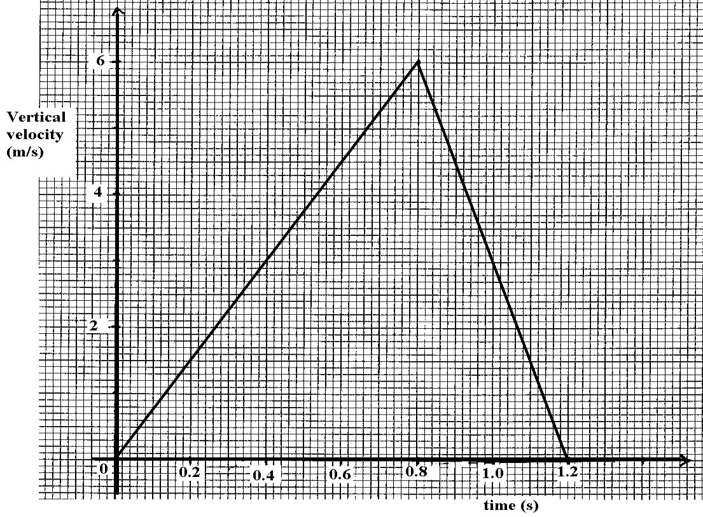

a). From the graph
- Determine the height of the diving board. (3 marks)
------------------------------------------------------------------------------------------------------------
------------------------------------------------------------------------------------------------------------
------------------------------------------------------------------------------------------------------
- Determine the retarding force on Ian in the water. (3 marks)
------------------------------------------------------------------------------------------------------------
------------------------------------------------------------------------------------------------------------
------------------------------------------------------------------------------------------------------
b) i) Calculate the loss of Ian’s Potential energy after 0.5sec diving. (3 marks)
------------------------------------------------------------------------------------------------------------
------------------------------------------------------------------------------------------------------------
------------------------------------------------------------------------------------------------------
ii). Determine Ian’s kinetic energy 0.5s after he started the dive. (3 marks)
------------------------------------------------------------------------------------------------------------
------------------------------------------------------------------------------------------------------------
------------------------------------------------------------------------------------------------------ iii) Give an explanation for the differences between the answer to part b) (i) and (ii).
(2 marks)
14. The diagram below shows four identical springs s₁, s₂ and s₃ supporting a load of 400N. if each spring has constant of 500N/m
- calculate the total extension produced (3marks)
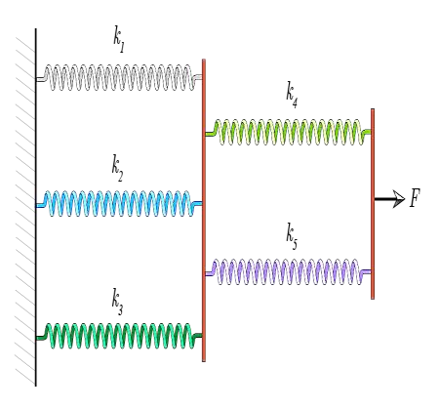

- define elastic limit as used in springs (1mark)
………………………………………………………………………………………………………
………………………………………………………………………………………………………
………………………………………………………………………………………………………

- one spring from the above network is compresses by 5cm. calculate the elastic potential energy
stored in the spring (3marks)
………………………………………………………………………………………………………
………………………………………………………………………………………………………
……………………………………………………………………………………………………… ……………………………………………………………………………………………………..

- state two methods of reducing friction (2marks)
………………………………………………………………………………………………………
………………………………………………………………………………………………………
……………………………………………………………………………………………………… …………………………………………………………………………………………………..

