MATHEMATICS FORM 4

MID TERM 2 EXAM2026

2½ HOURS

NAME………………………………………ADM. N0…………….…

DATE……………………….……………SIGN………………………

INSTRUCTIONS TO CANDIDATES.

- Write your name, admission number, signature and date in the spaces provided above.
- This paper consists of TWO sections. Section I and Section II
- Answer ALL the questions in section I and only FIVE questions from Section II
- All answers and working must be written on the question paper in the spaces provided below each question.

- Without using calculators, evaluate √−52÷(−5+5 0𝑓−5)
5−1+50
(3 marks)

- Given that (0.25)^{2𝑡+1} = 64, find the value of t. (3 marks)

- Without using mathematical tables or calculators, find 𝑡𝑎𝑛𝜃 given the equation,
𝑠𝑖(3𝜃 − 45)⁰ = 𝑐𝑜𝑠(𝜃 + 15)⁰. (3 marks)

- Shoppers at a supermarket are served by three tellers, Nadia, Prisca and Queenter. The three tellers take averagely 30 seconds, 36 seconds and 48 respectively to serve a shopper. Find the shortest time, in minutes, it takes the three tellers to serve 236 shoppers. (3 marks)

- Two similar tanks have capacities of 2560 litres and 8640 liters. The height of the smaller tank is 1.8m. What is the height of the larger tank? (3 marks)

- KLM is an equilateral triangle of sides 6.4√3𝑐𝑚. Calculate the exact radius of a circle that passes through the vertices K, L and M. (2 marks)

- Below is a diagram of Kerubo’s farm (not drawn to scale).

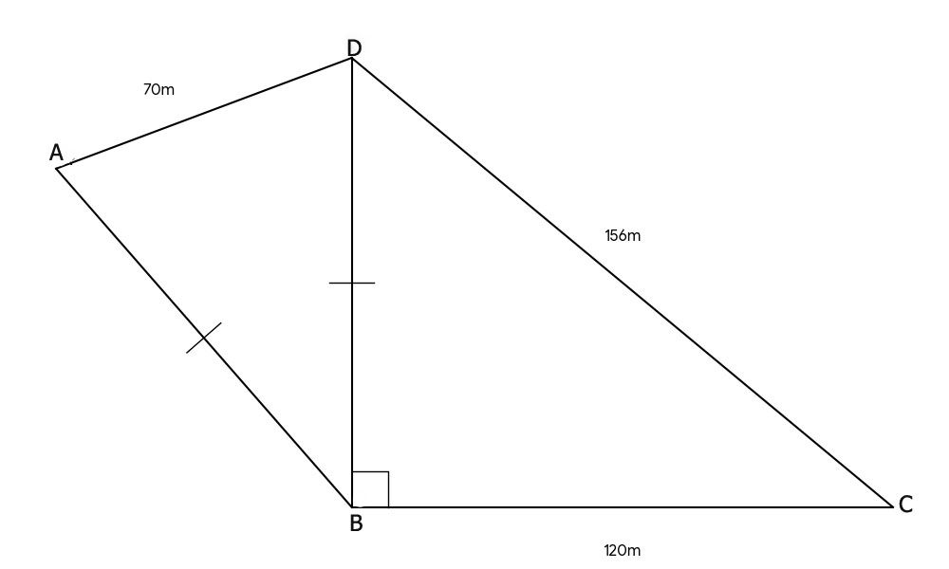

The side BC is perpendicular to DB, AD = 70m, BC = 120m, CD = 156m and AB = DB. Find the area of Kerubo’s farm, in hectares, to 2 significant figures. (4 marks)

- Given that 𝑂𝑃 = 𝑖 − 3j and 𝑃𝑸 = 4𝑖 − 2j. Determine;
  - The coordinates of Q. (2 marks)

  - |𝑃𝑸| in surd form. (1 mark)

- Simplify ^{6𝑎}2−𝑎𝑏−𝑏2
2𝑏2+𝑎𝑏−2𝑎2−4𝑎𝑏
÷ 2(3𝑎+𝑏)
𝑎
(3 marks)

- Using mathematical tables, find the possible values of t if 𝑡² = 6
0.4567
(3 marks)

- Robin sells cars on commission. On a day when he sold a car worth Ksh. 4.8 million at a discount of 2½%, he got a commission of Ksh. 70,200. What percentage of the sales made does Robin earn as commission? (3 marks)

- Using a ruler and pair of compasses only, construct a regular octagon of sides 4cm.
(3 marks)

- A boat sails 4.5km on a bearing of 135⁰ and then 5.3km on a bearing of 210⁰. Calculate the:
  - Distance the boat is from its starting point, to 1 decimal place. (2 marks)

  - The bearing, to the nearest degree, of the boat from the starting point. (2 marks)

- Given that 𝑘( ² ) + ℎ(²) = ( ² ), find the scalars h and k. (3 marks)
−2 3 −7

- The volume of a cone having a vertical height of 10cm is 1155cm³. Calculate the area of its curved surface. (Take π = ²²) (4 marks)
7

- The sum of interior angles of a regular polygon is 1440⁰. Express the size of an exterior angle of the polygon as a percentage of an interior angle of the polygon. (3 marks)

- A line L₁ passing through the points P(3, -2m) and Q(3m, -3) is parallel to a line whose equation is 2𝑦 − 𝑥 = 10. Find the:
  - Gradient of line L₁. (1 mark)

  - Value of m. (2 marks)

  - Equation of line L₂, in the form, 𝑦 = 𝑚𝑥 + 𝑐, which is perpendicular to line L₁ and passes through point Q. (2 marks)

  - Y-intercept of line L₁ (2 marks)

  - Obtuse angle that line L₁ makes with the x-axis. (3 marks)

- ABCDEF is a triangular based prism whose cross-section, ABC, is an equilateral triangle of sides 4cm. CD = AE = BF = 6cm.
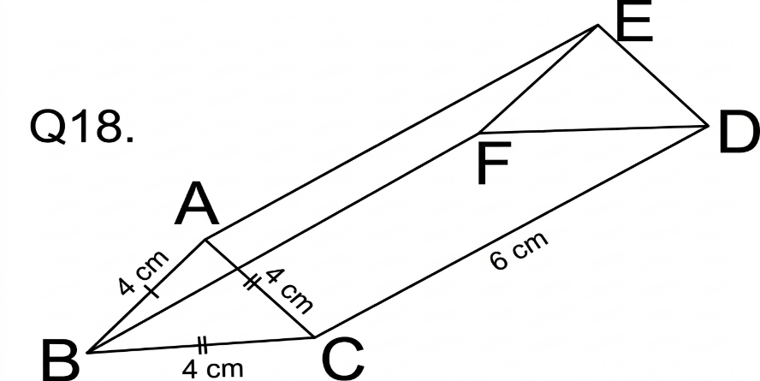

  - Calculate, to 1 decimal place;
    - The volume of the prism. (3 marks)

    - The length of CF (2 marks)

  - State the:
    - Number of lines of symmetry that the prism has. (1 mark)

    - Order of rotational symmetry that the prism has. (1 mark)

  - Draw the net of the prism. (3 marks)

- In making a slab, Mijengo Contractors mix sand, cement and ballast such that the ratio, by mass, of sand to cement is 9:5 while that of ballast to sand is 2:1. To make the slab, 14.4 tonnes of the mixture is required.
  - Find the mass, in kilograms, of cement needed to make the slab. (4 marks)

  - A bag of 50kg of cement costs Ksh.960. Calculate the cost of cement needed to make the slab given that cement can only be bought in bags of 50kg. (3 marks)

  - On the day when Mijengo Contractors were to buy cement to make the slab, the price

of a bag of cement was reduced by
6 1 %
4
. How many more bags of sand were

Mijengo Contractors able to purchase using the amount they had originally budgeted for? (3 marks)

- The distance between two towns, A and B is 156km. A truck left Fort at 7:35a.m towards B at an average speed of 48km/h. 45 minutes later, a car left A at an average speed of 72km/h towards B.
  - How far from B was the truck by the time of the car’s departure? (2 marks)

  - The car caught up with the truck at town C.
    - How long did it take the car to reach C? (3 marks)

    - How far from town B is town C? (2 marks)

  - The car had a 12-minute stop-over at C before proceeding to B. If the car reached town B 9 minutes earlier than the truck, what was the average speed of the car between towns C and B? (3 marks)

- Heights of 100 seedlings at Miche tree nursery were measured and recorded as below:
Heights (cm) | 15-24 | 25-34 | 35-44 | 45-54 | 55-64 | 65-74 | 75-84 | 85-94
Frequency | 6 | 14 | 4n | 14 | 2(2n-1) | 10 | 6 | 4
- Determine the value of n (2 marks)

- State the modal class (1 mark)

- Calculate the:
  - Median height (3 marks)

  - Mean height (4 marks)

- The triangles KLM and K’L’M’ have co-ordinates K(-2,5) L(-1,6) M(-4,7) and K¹(4,2), L¹(2,0) M¹(8,-2)
  - On the grid provided plot KLM and K¹L¹M¹ (2 marks)
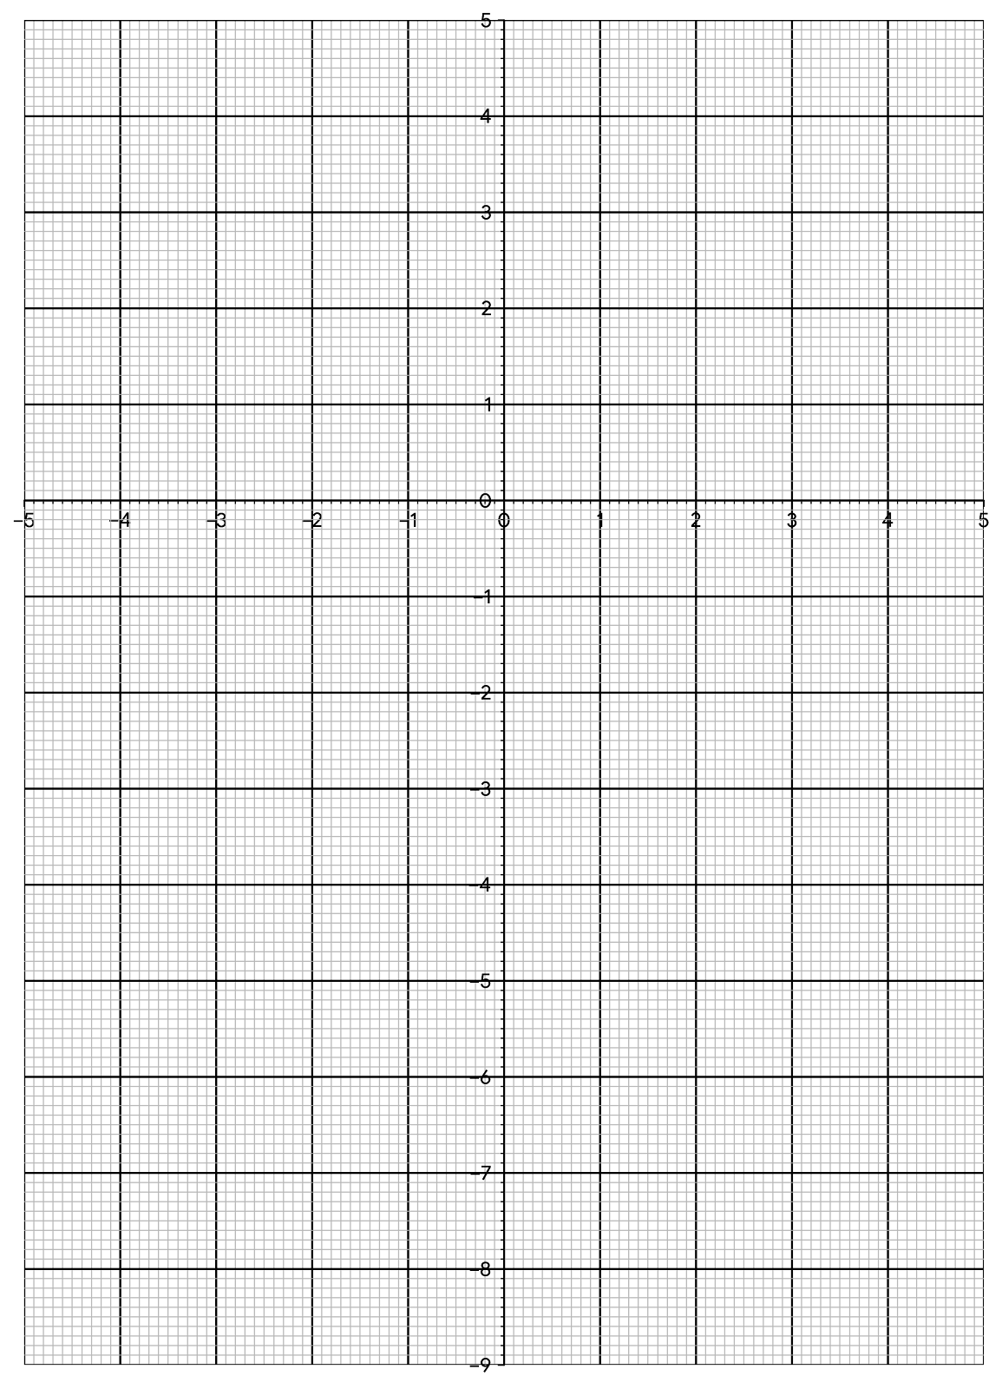

  - Given that K¹L¹M¹ is image of KLM after an enlargement. Find the co-ordinates of the centre and the scale factor of enlargement. (2 marks)

  - On the same axes plot K¹¹L¹¹M¹¹ the image of K¹L¹M¹ after a rotation centre (0, -1) through – 90º. Write down the co-ordinates of the vertices of K¹¹L¹¹M¹¹ (3 marks)

  - K¹¹¹L¹¹¹M¹¹¹ is the image of K¹¹L¹¹M¹¹ after a translation vector (−4). Plot

K¹¹¹L¹¹¹M¹¹¹on the same set of axes and state its coordinates.
2
(3 marks)

- a) Given that A = (4 5 ), find A⁻¹, the inverse of A. (2 marks)
6 −2

- Melissa bought 4 pineapples and 5 apples spending a total of Ksh. 440. Nyokabi bought 3 pineapples while Cherop bought an apple. Nyokabi spent Ksh 140 more than Cherop.
  - Form a matrix equation for the above information. (2 marks)

  - Using A⁻¹ in (a) above, find the price of a pineapple. (3 marks)

2𝑡 8 − 𝑡

- Find the possible values of t for which the matrix ( 2

3
1 ) is singular.
(3 marks)

- A rhombus has its vertices PQRS. The co-ordinates of the vertex P, Q, and S of the rhombus are P(-1,3) Q(2,4) and S(0, y).
  - On the grid below, draw rhombus PQRS. (2 marks)

  - The diagonals QS and PR meet at point M. State the coordinates of M. (2 marks)

  - Find the equation of diagonal QS in the form of ay+bx=c, where a, b and c are integers.
(3 marks)

  - Calculate the area of rhombus PQRS. (3 marks)

