GEOGRAPHY FORM 4
MID TERM 2 EXAM 2026
Time: 2 hours 30 minutes

NAME…………………………………………….ADM NO…………………………

DATE……………………………………………………SIGN………………………

INSTRUCTIONS TO CANDIDATES
- This paper consists of TWO sections: A and B
- Answer ALL questions from Section A
- Answer ANY FOUR questions from Section B
- Show all your working where calculations are required

SECTION A (60 MARKS)
Answer ALL questions in this section.
1. The diagram below shows a population pyramid for a country in 2026.
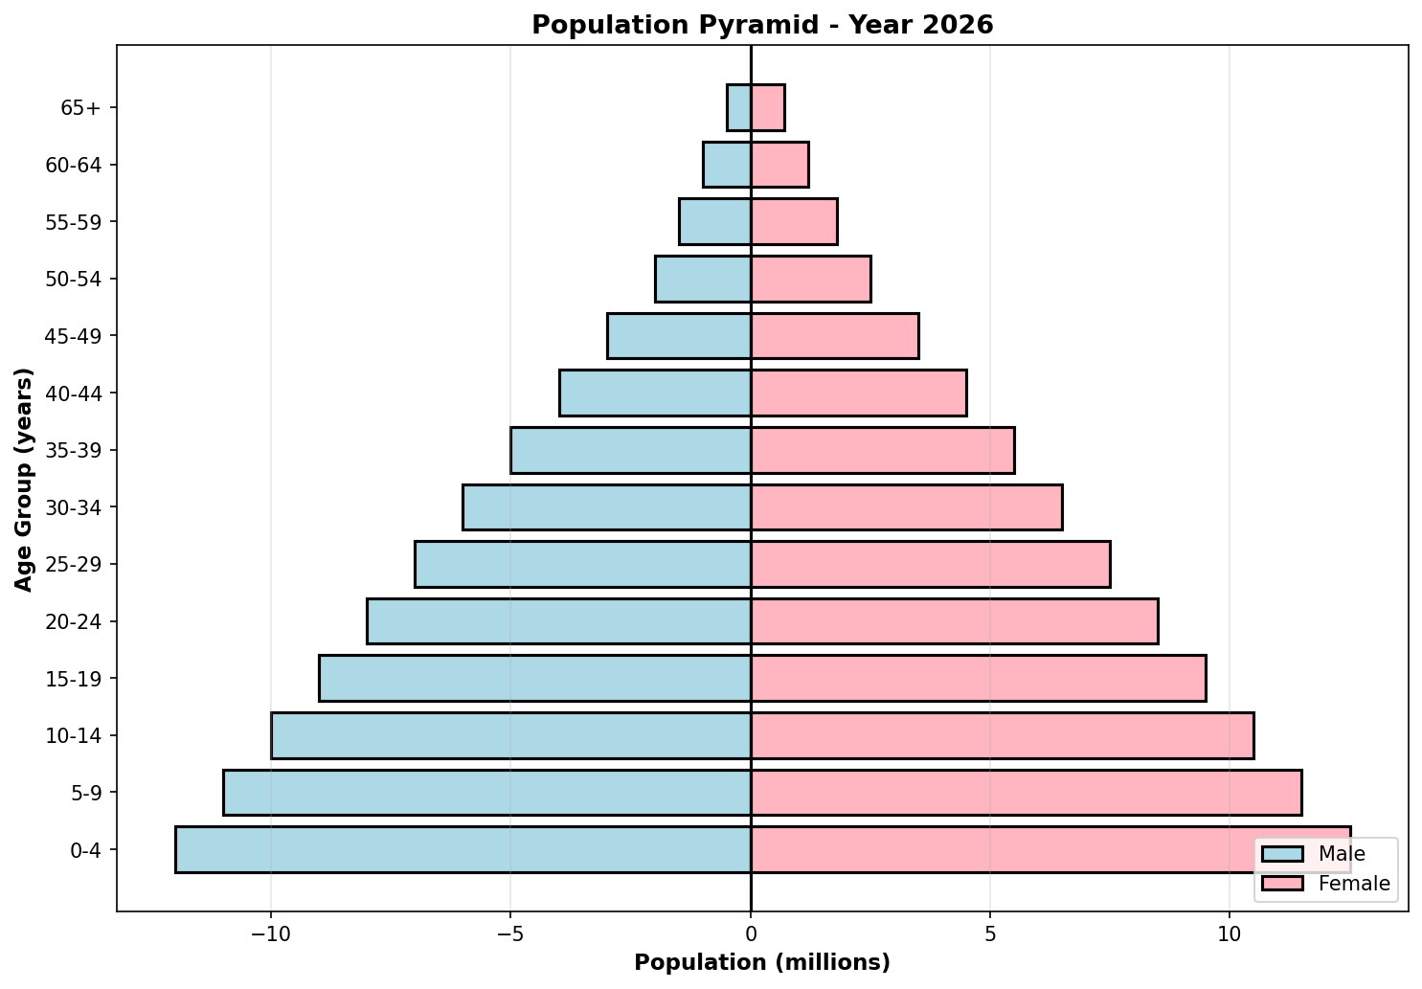
(a) State three reasons why the population pyramid has a wide base. (3 marks)

(b) What is the approximate total population in the 10-14 age group? (2 marks)

(c) Calculate the ratio of males to females aged 0-4 years and explain what this ratio tells us about the population. (4 marks)

2. The diagrams below show climographs for two different climate stations.
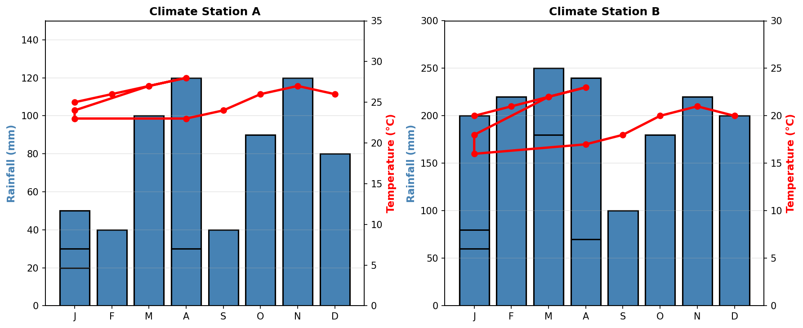
(a) Calculate the total annual rainfall for both Climate Stations A and B. (4 marks)

(b) Compare the temperature patterns of the two climate stations and explain the differences. (4 marks)

(c) Classify both climate stations according to Köppen climate classification and justify your answer. (4 marks)

3. Study the soil profile diagram below and answer the questions that follow.
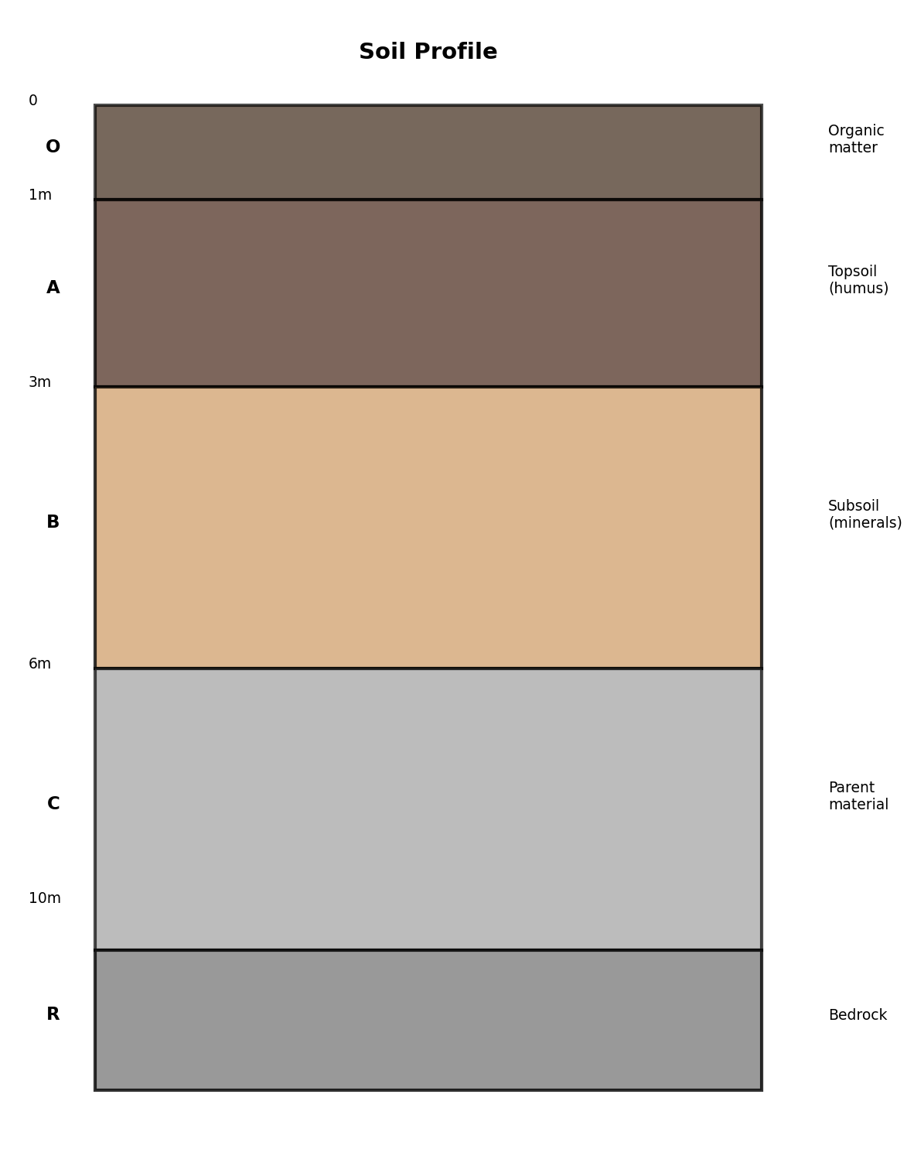
(a) Name the soil horizons labeled A, B, C, and D. (4 marks)

(b) Explain the differences between horizon A and horizon B in terms of their composition and formation. (4 marks)

(c) Describe two major processes that contribute to soil formation and explain how they work. (4 marks)

4. The diagram below illustrates the water cycle.
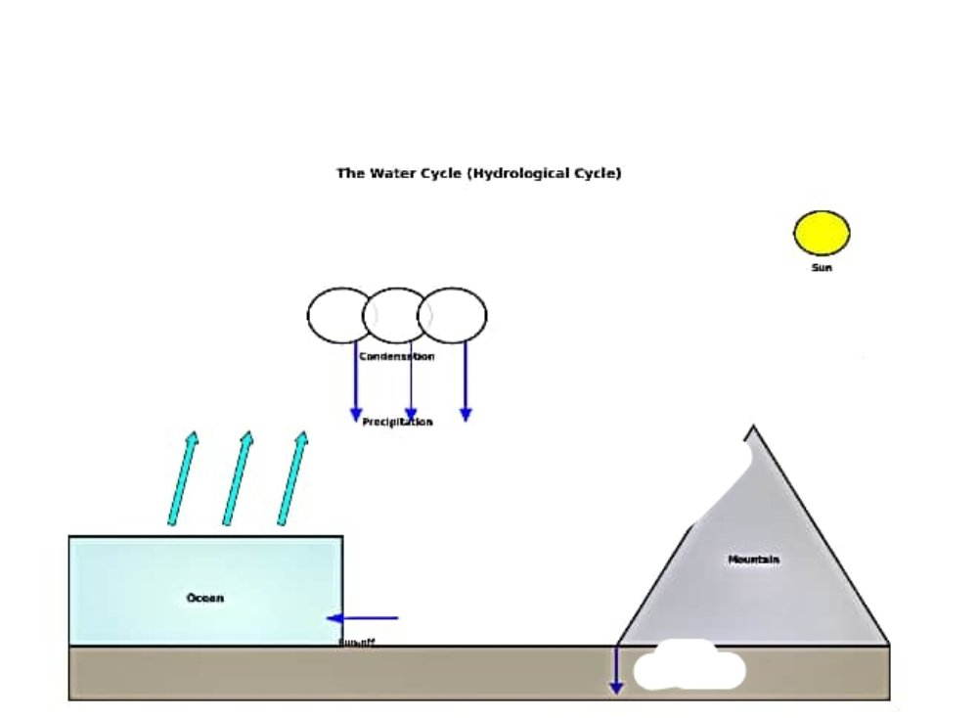
(a) Identify and name the five major processes involved in the water cycle. (5 marks)

(b) Explain how human activities such as deforestation and urbanization disrupt the water cycle. (4 marks)

(c) Calculate the percentage of Earth's water that is freshwater suitable for human use. Show your working. (3 marks)

5. The diagrams show cross-sections of two types of mountains.
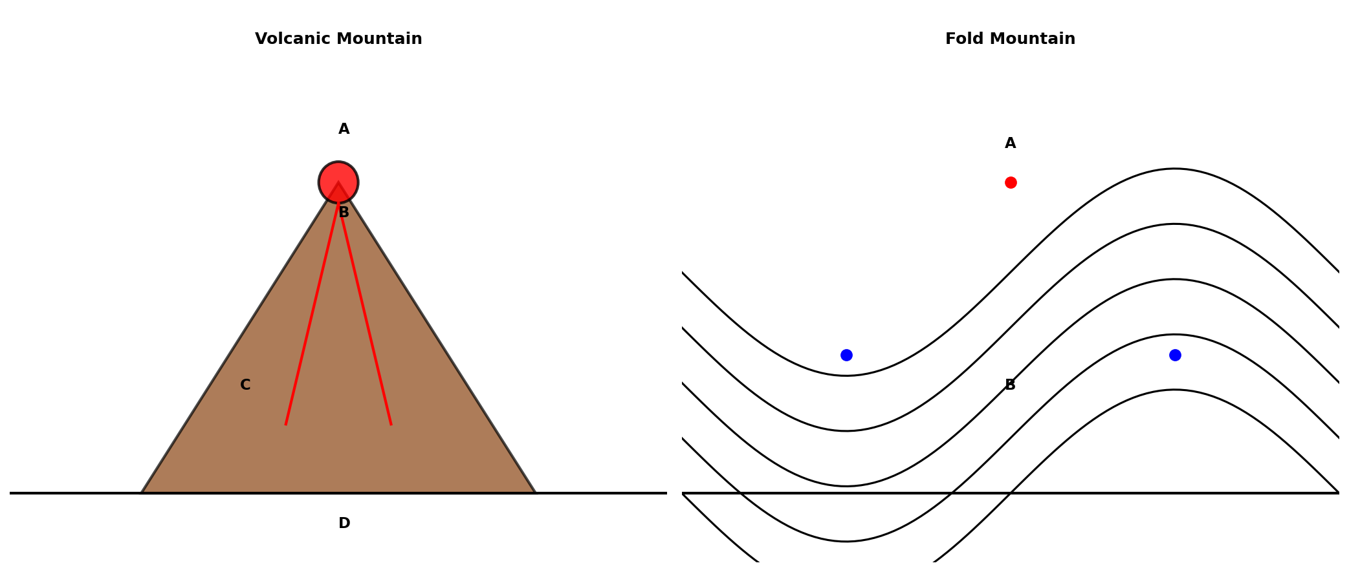
(a) Name the parts labeled A, B, C, and D in the volcanic mountain diagram. (2 marks)

(b) Differentiate between volcanic and fold mountains in terms of their formation, composition, and characteristics. (6 marks)

(c) Explain three ways in which mountains influence climate and weather patterns. (5 marks)

6. The diagram below illustrates the rock cycle.
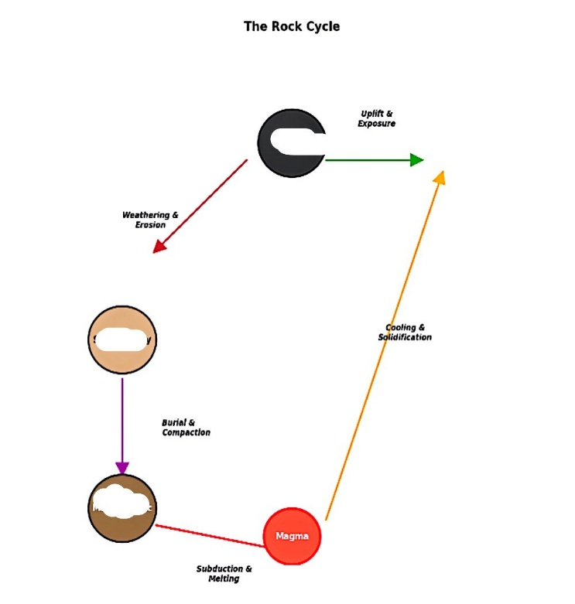
(a) Name the three main types of rocks shown in the diagram and give one example of each. (6 marks)

(b) Explain the processes by which: (i) igneous rocks are transformed into metamorphic rocks, and (ii) sedimentary rocks are transformed into metamorphic rocks. (6 marks)

SECTION B (40 MARKS)
Answer ANY FOUR questions from this section. Each question carries 10 marks.
7. Discuss the causes and effects of climate change on natural ecosystems and human societies. Provide specific examples in your answer. (10 marks)

8. Analyze the impact of rapid urbanization on the physical environment and social structure of developing countries. What strategies can be used to make cities more sustainable? (10 marks)

9. Examine the factors that influence population distribution globally. Using specific examples from at least two continents, explain why some areas are densely populated while others are sparsely populated. (10 marks)

10. Evaluate the role of sustainable development in managing natural resources. How can countries balance economic development with environmental conservation? (10 marks)

11. Discuss the characteristics, distribution, and conservation strategies for tropical rainforest biomes. What are the major threats facing these ecosystems and what measures are being taken to protect them? (10 marks)

12. Analyze the relationship between plate tectonics and the occurrence of earthquakes and volcanoes. Explain how understanding this relationship helps in disaster risk reduction and preparedness. (10 marks)

13. Assess the factors that affect human settlement patterns and the challenges faced by different types of settlements (rural, urban, and mixed). How can planning and management address these challenges? (10 marks)

